1. Number of Programme by Ministry

* Data for particular ministry not tally with system

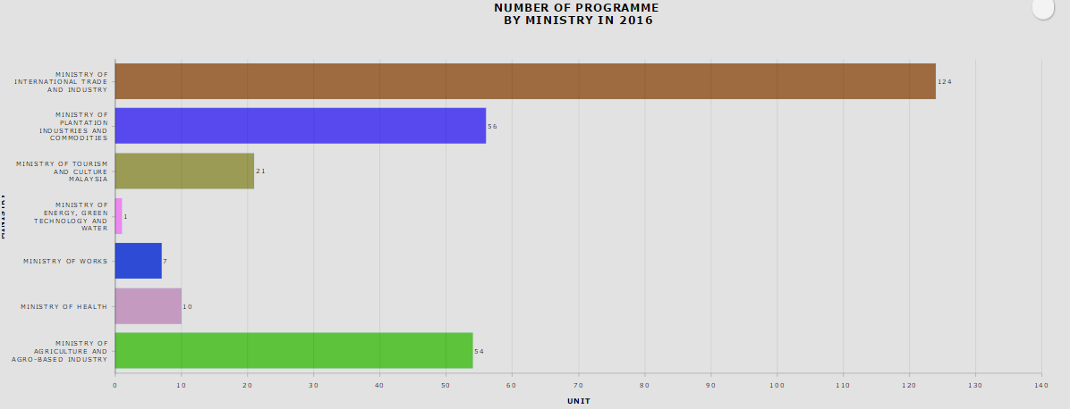

System display 52 records

System display 20 records

System display 54 records

System display 123 records

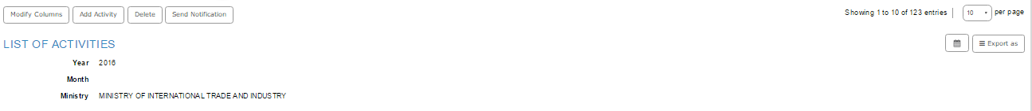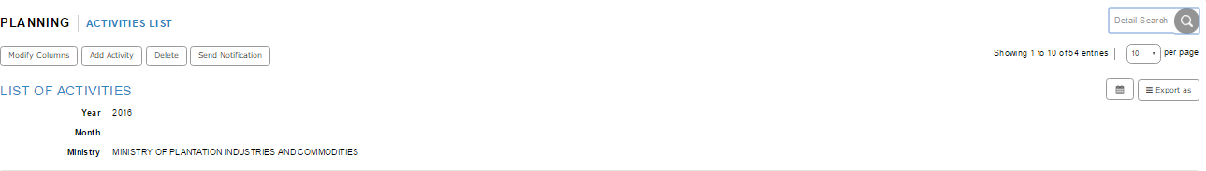

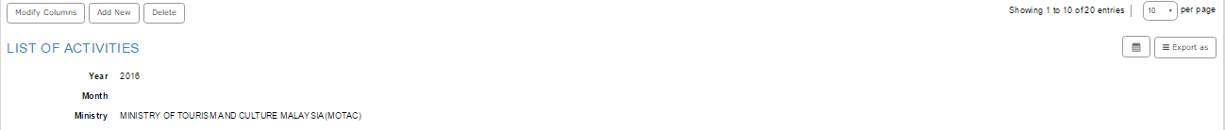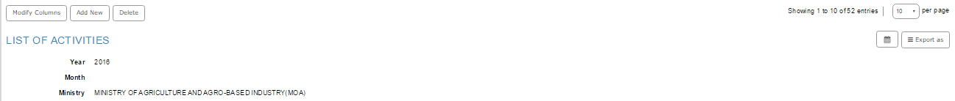

1. Impact by Ministry – By Actual Sales

* No value display at impact dashboard, but in the system do display value for actual sales

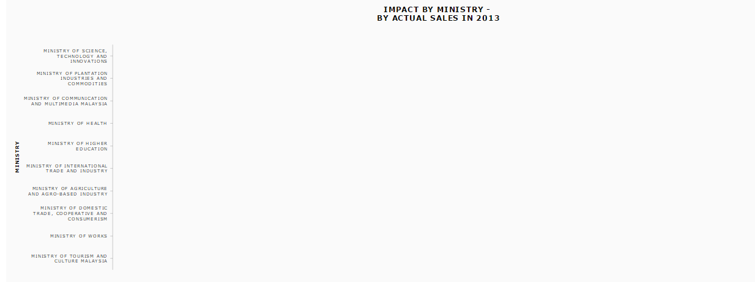

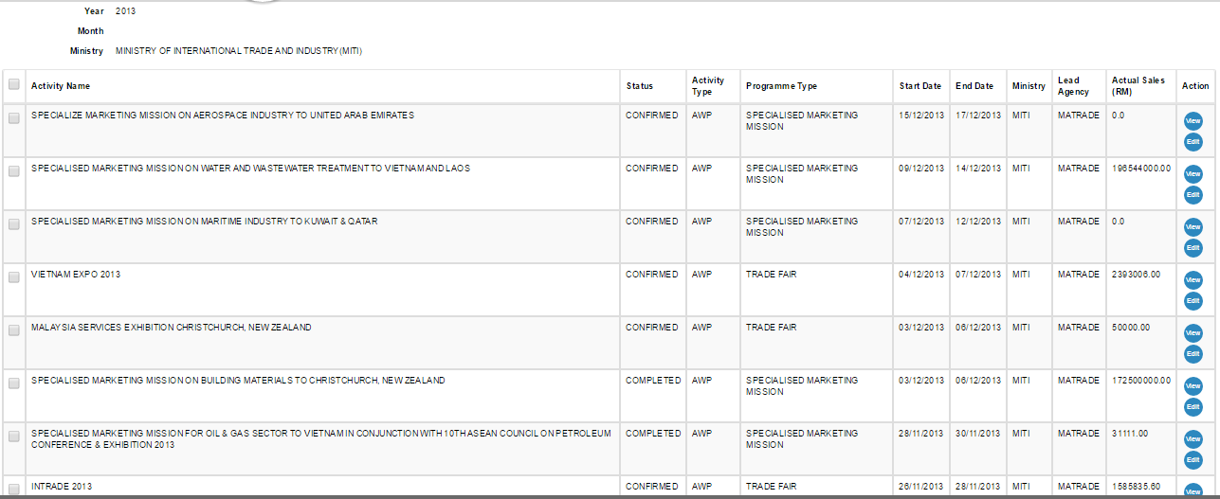

1. Number of Programme by Sector

* Data for particular sector not tally with system

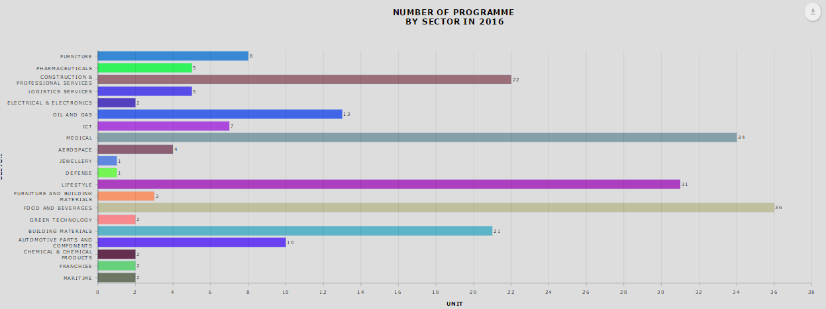

System display 35 records

System display 29 records

System display 12 records

System display 4 records

System display 7 records

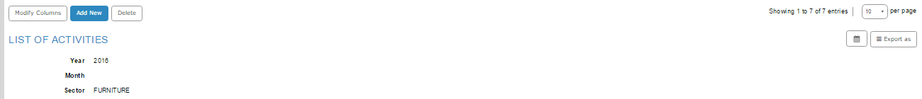

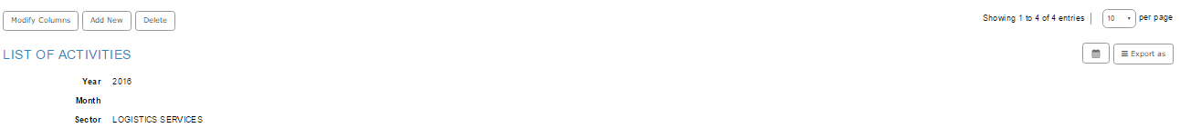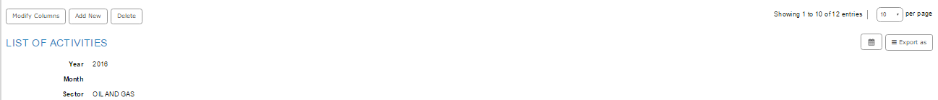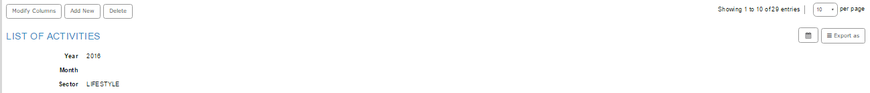

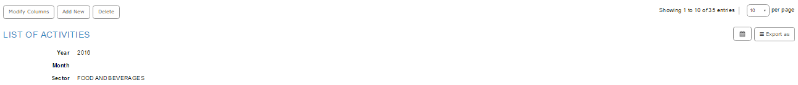

1. Impact by Sector – by Actual Sales

* No value display at impact dashboard, but in the system do display value for actual sales

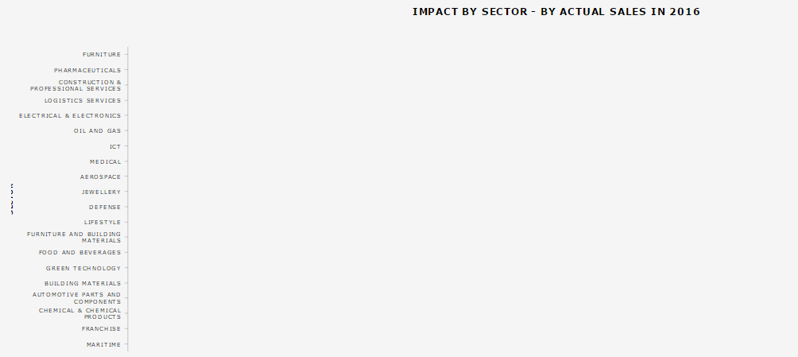

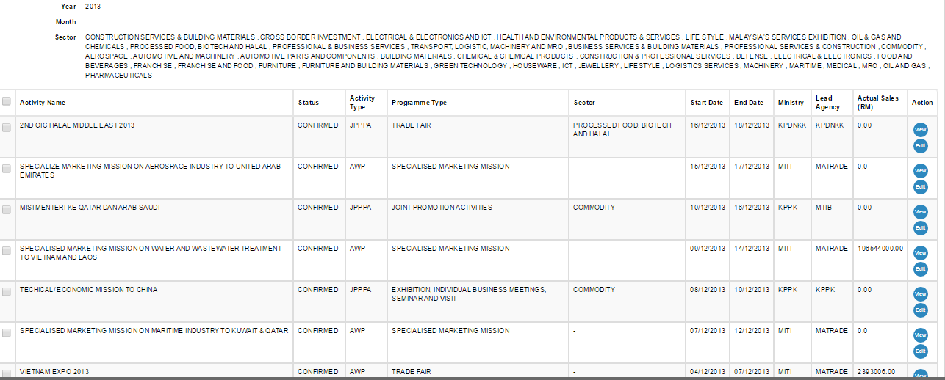

1. Number of Program by Region
2. Data for Africa region not tally with system

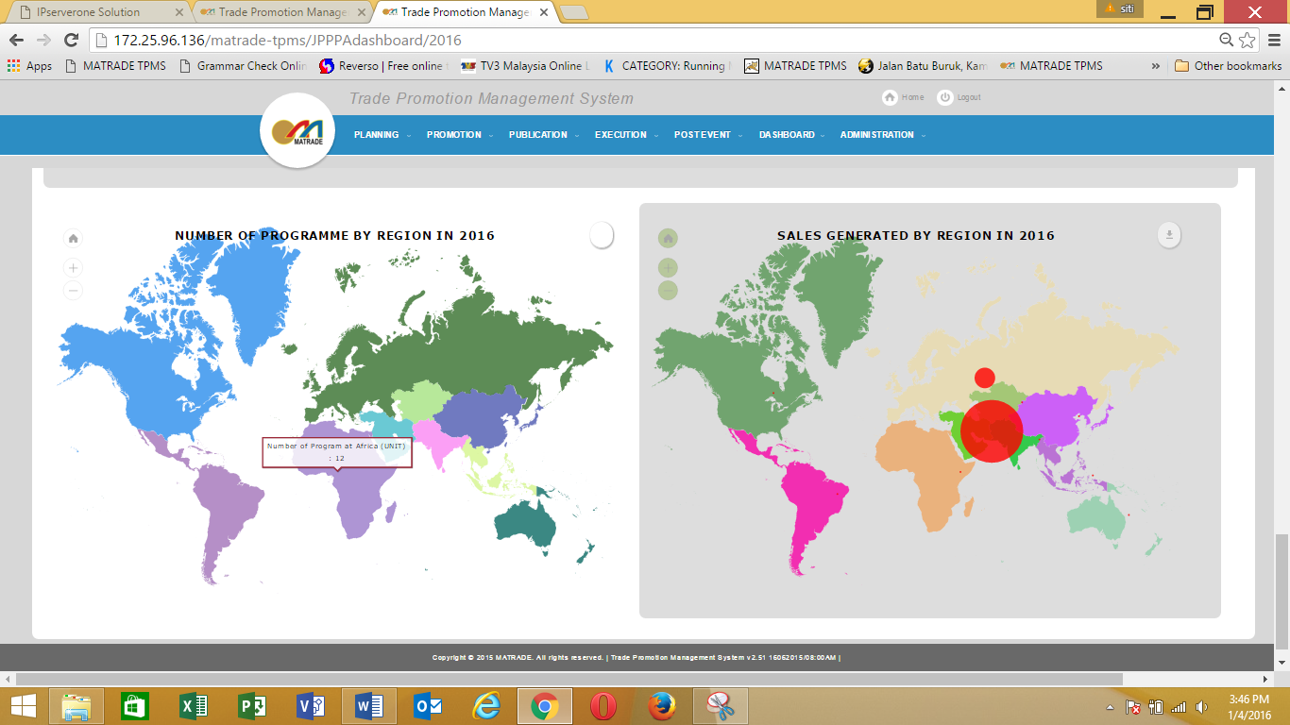

System display 10 records for Africa region