

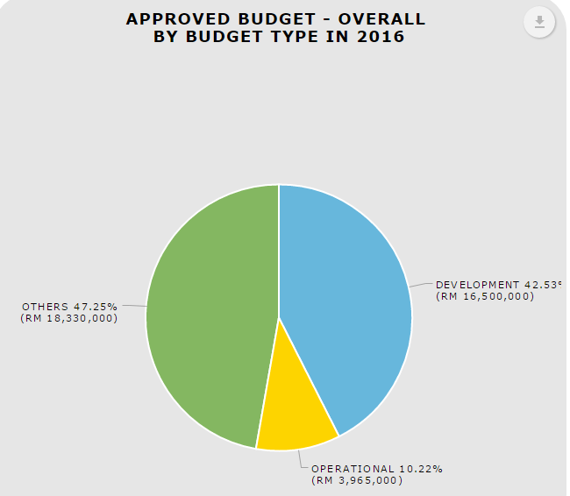

1. ‘Download as image’ (PNG, JPG, SVG, and PDF). Please hide SVG. Please apply to budget utilized as well.
2. Make the pie chart (in Overall tab) bigger. (Comment by Pn.Raja)

**Download data (CSV)**

1. When “Download as Image”, “Download Data” and “Print Chart”, put the date and timestamp. (Comment by Pn.Raja)

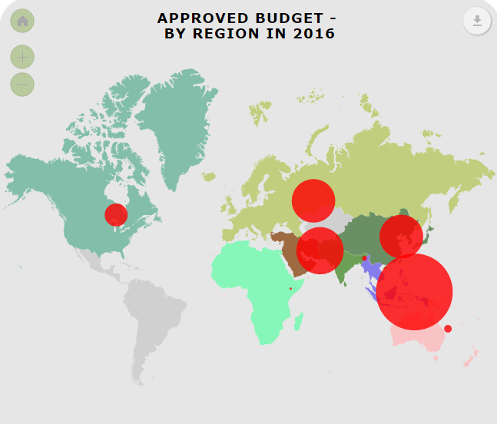

When display information in map, need to display value in the map by bullet/dot. The bigger the value, the bigger the bullet/dot. This to make the map more meaningful to view. (Comment by Pn.Raja)

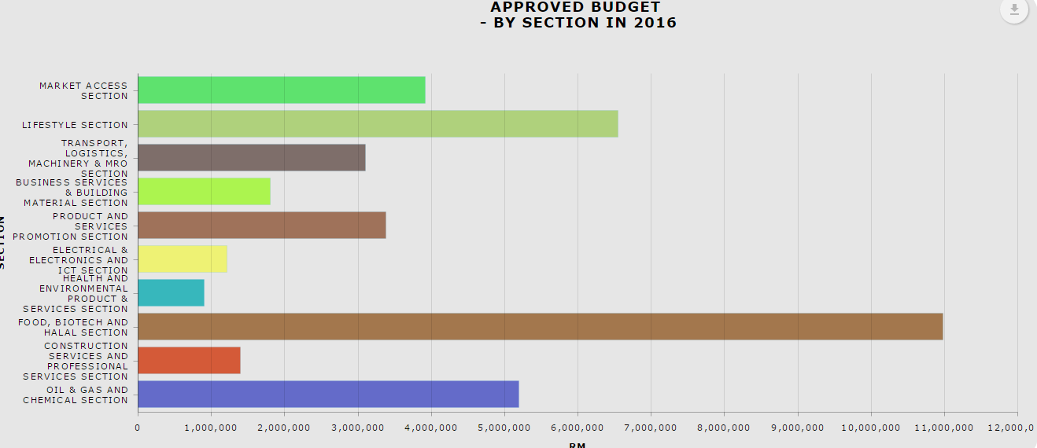

To display Section in proper view.

If the x/y axis is currency and the value is million. Example: 400,000,000 need to display as 400M. (Comment by Pn.Raja)

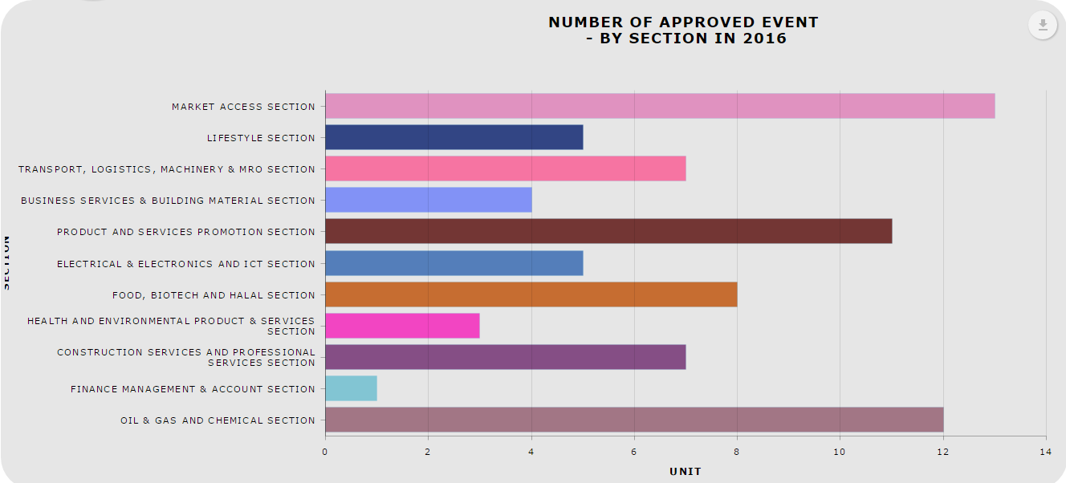

Wording for Section not display in full

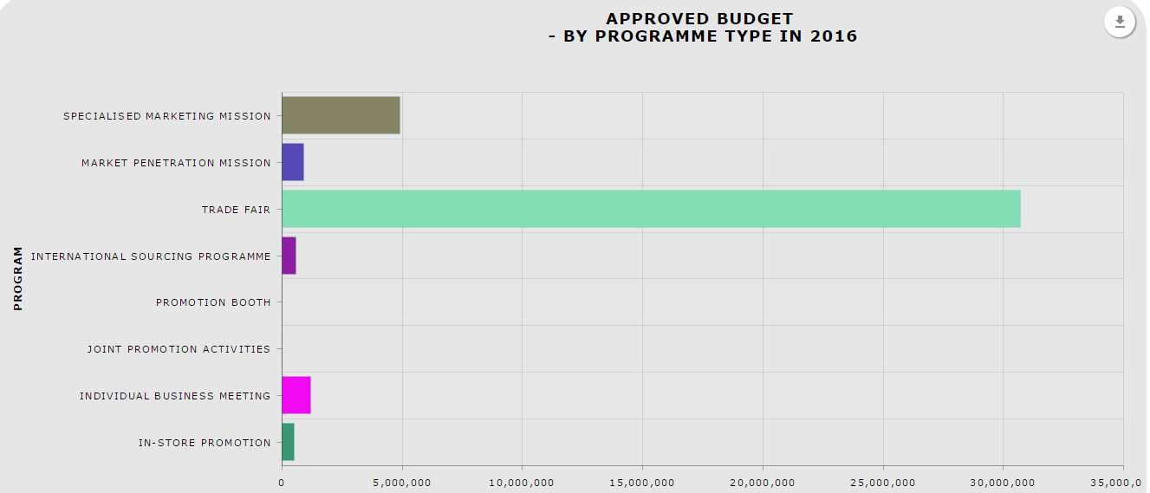

1. The colour of the bar/pie of category should be the same in other chart. Example, Trade Fair use green and SMM use blue in chart 1, then other chart Trade Fair and SMM also should use the same colour green and blue. This to avoid misinterpretation. (Comment by Pn.Raja)
2. Change Program Type to Programme Type. (Comment by Pn.Raja)
3. Need to know the details of the chart. Example, can click bar chart of sales by programme type, and then display the list of event with their sales.