**Services 🡪 IBG**

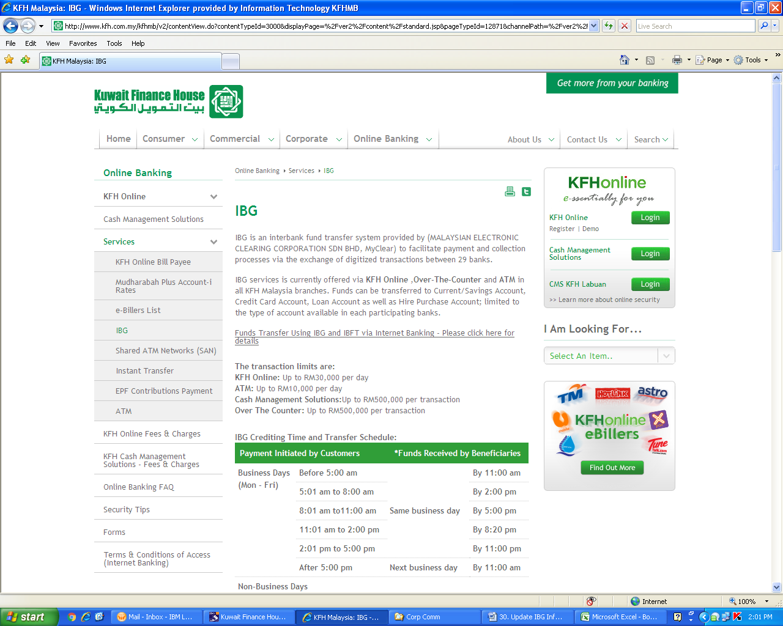

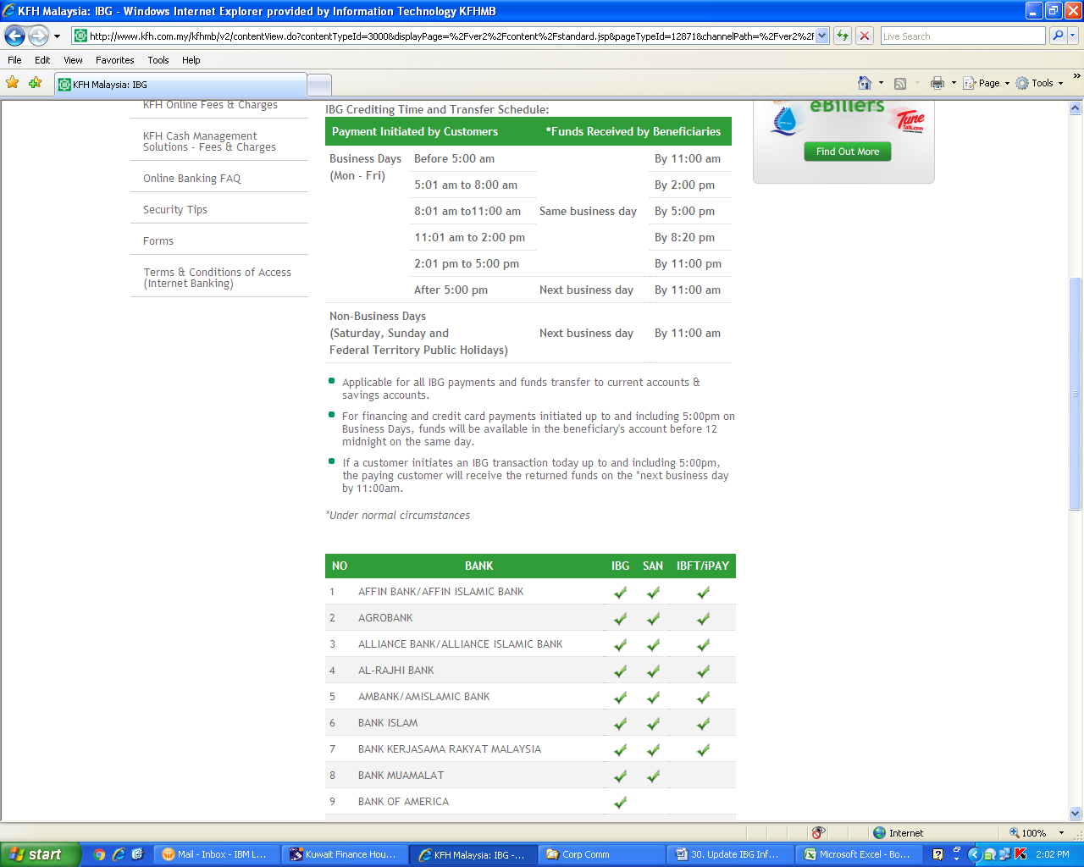

**To remove this item.**

**To add info on “IBG Refund Time” as per table appended below.**

|  |  |  |  |  |
| --- | --- | --- | --- | --- |
| **IBG Refund Time:** | |  |  | |
| **Payment Initiated by Customers** | | **\*Refund for Unsuccessful Transactions** | | |
| **Business Days** | **Before 5:00 am** | **Same business day** | | **By 5:00 pm** |
| **(Mon - Fri)** | **5:01 am to 8:00 am** | **By 8:20 pm** |
|  | **8:01 am to11:00 am** | **By 11:00 pm** |
|  | **11:01 am to 2:00 pm** | **Next business day** | | **By 11:00 am** |
|  | **2:01 pm to 5:00 pm** | **By 11:00 am** |
|  | **After 5:00 pm** | **By 5:00 pm** |
| **Non-Business Days** | | **Next business day** | | **By 5:00 pm** |
| **(Saturday, Sunday and** | |
| **Federal Territory Public Holidays)** | |

**KFH Online Fees & Charges**

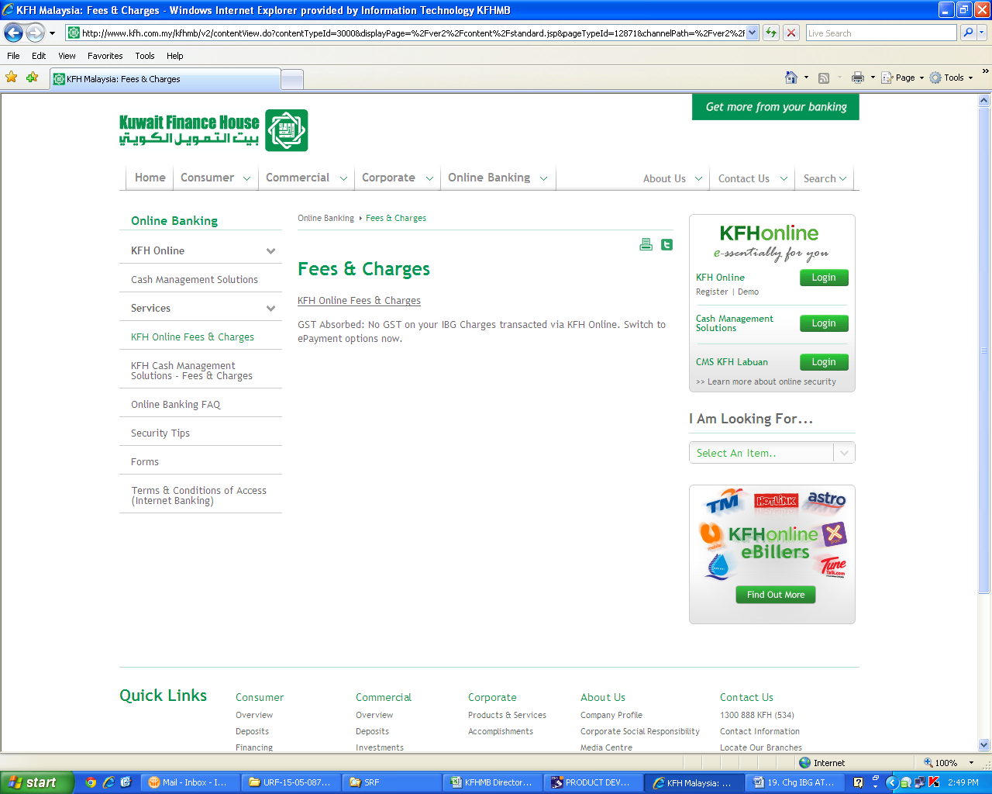

**Update with the amended version as attached below**

* **To upload the amended pdf file**



**KFH Cash Management Solutions – Fees & Charges**

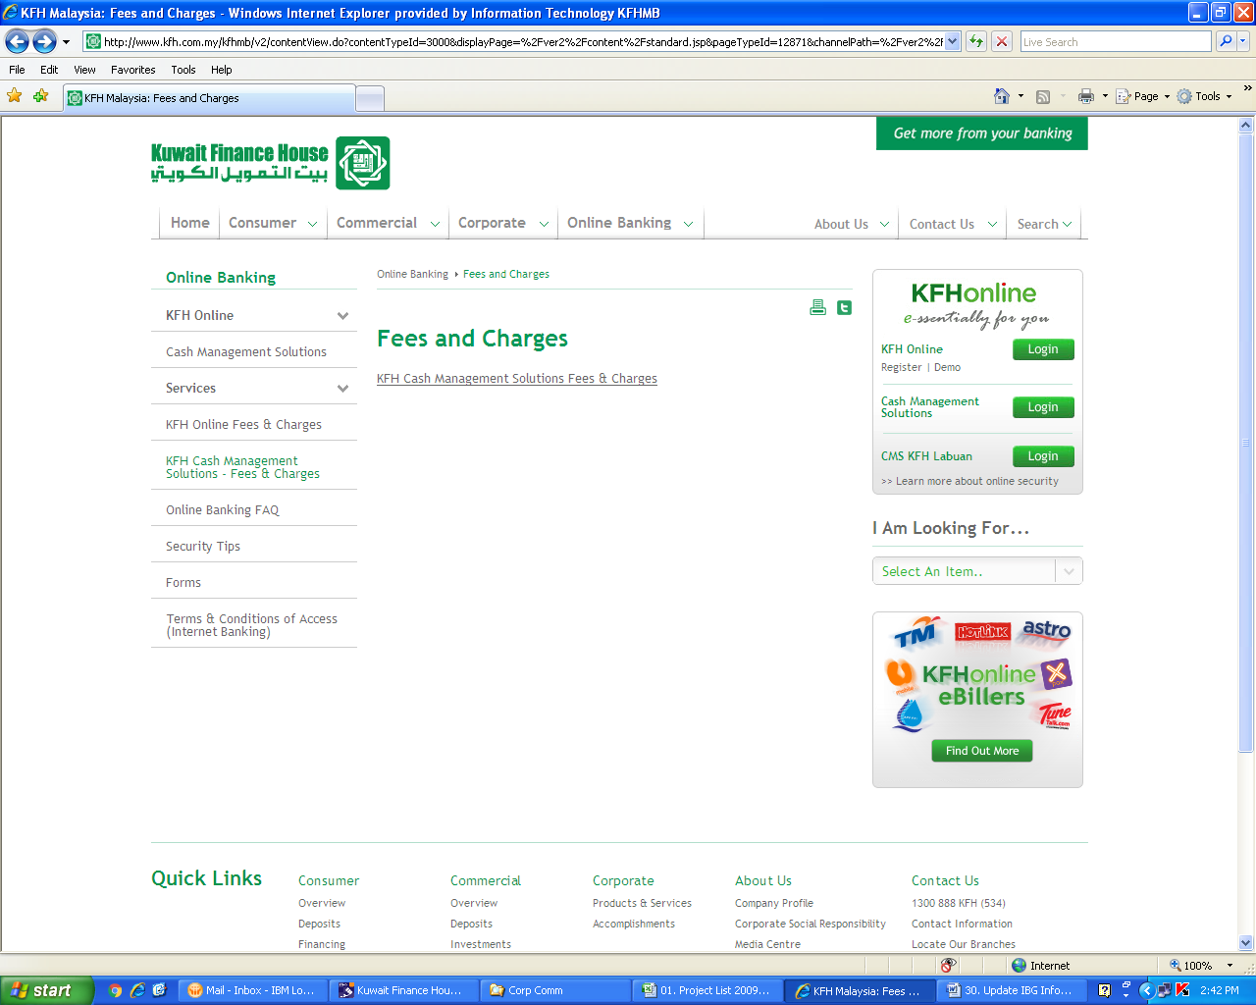

**Update with the amended version as attached below**

* **To upload the amended pdf file**

