1. Foreign Currency Current Account-i

<http://www.kfh.com.my/kfhmb/v2/contentView.do?contentTypeId=3000&displayPage=%2Fver2%2Fcontent%2Fstandard.jsp&pageTypeId=12852&channelPath=%2Fver2%2Fv2_Navigation%2FConsumer+Banking%2FDeposits&programName=02_Current+Account&contentId=13043>

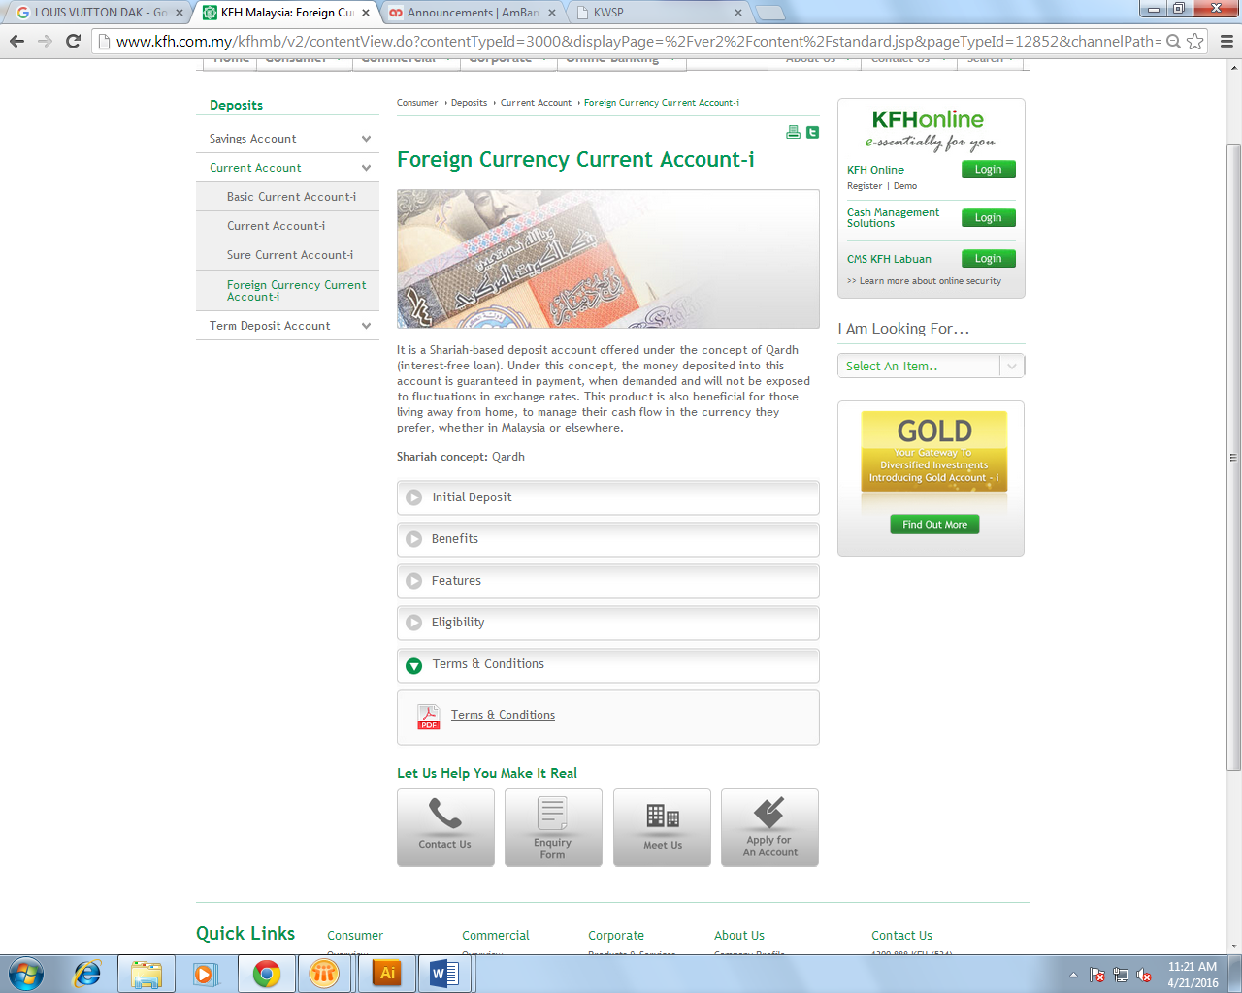

1. Change name to Terms & Conditions for Deposits
2. Add “Specific Foreign Currency Account-i Terms & Conditions”
3. Foreign Currency ICM

<http://www.kfh.com.my/kfhmb/v2/contentView.do?contentTypeId=3000&displayPage=%2Fver2%2Fcontent%2Fstandard.jsp&pageTypeId=12852&channelPath=%2Fver2%2Fv2_Navigation%2FConsumer+Banking%2FDeposits&programName=03_Investment+Acct&contentId=14708>

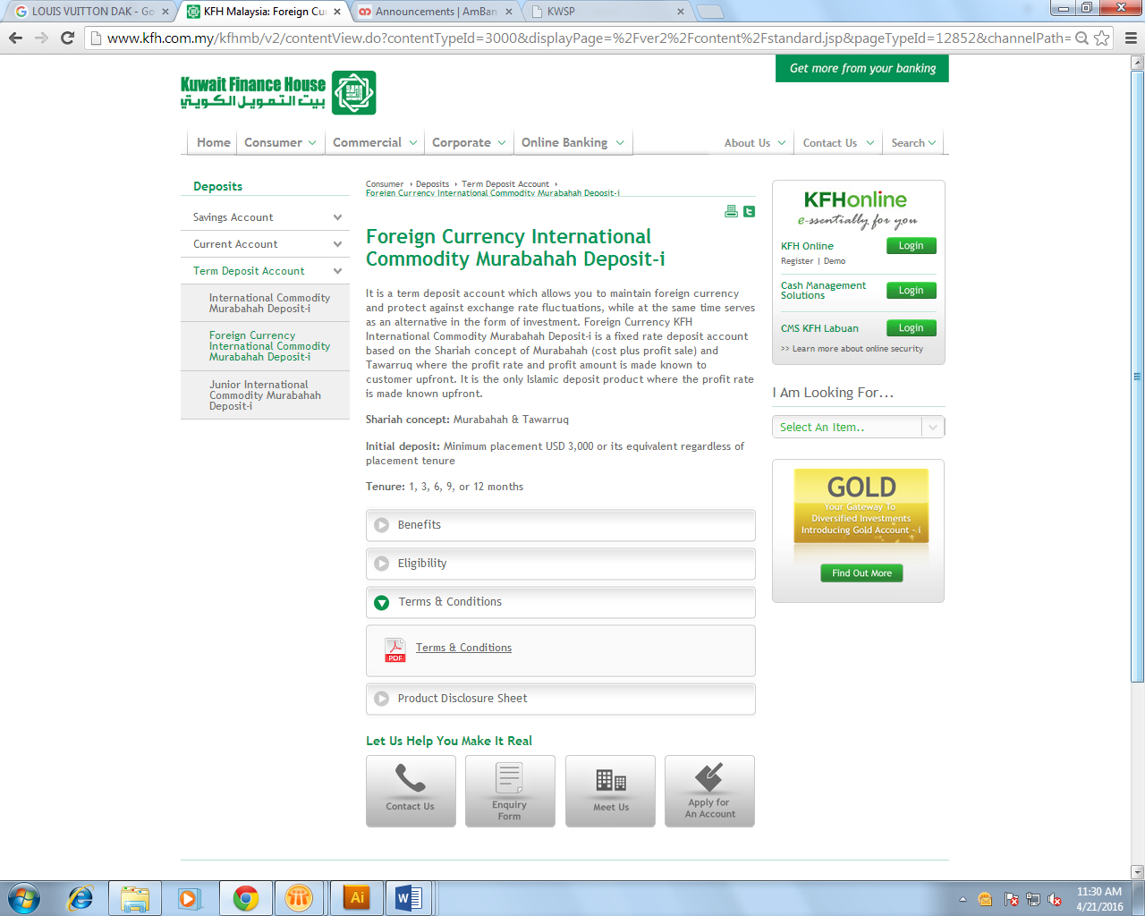

1. Change name to Terms & Conditions for Deposits
2. Add “Specific Foreign Currency Account-i Terms & Conditions”

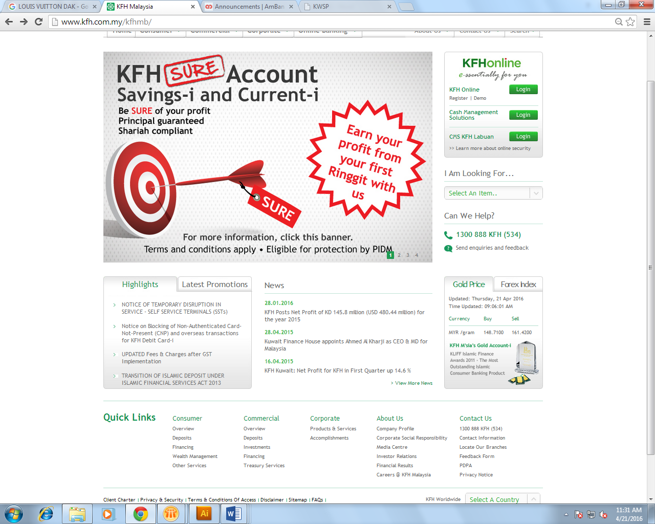

New item in Highlights section:

UPDATED Terms & Conditions for Foreign Currency Account-i

Under highlights section:

**Revision of Terms and Conditions for Foreign Currency Account**

Dear Valued Customers,

Please be informed that the following Terms and Conditions will be revised effective 21 April 2016. Click the links below for the revised Terms and Conditions:

Link with PDF file

1. Specific Terms and Conditions for Foreign Currency Account

Thank you.

***Pindaan Terma dan Syarat***

*Pelanggan Yang Dihargai,*

*Harap maklum bahawa Terma dan Syarat berikut akan dipinda berkuat kuasa 21 April 2016. Klik pautan di bawah untuk Terma dan Syarat yang telah dipinda:*

1. *Terma dan Syarat Khusus untuk Akaun Mata Wang Asing*

*Terima kasih.*