Retail Internet Banking (RIB)

ELECTRONIC BANKING GROUP

Project Name | Retail Internet Banking (RIB)
SR No. | 2793
Prepared by | Gabbytian Rayvandy | Version | 1.0

Test Case No : |  | BII-RIB-ENHANCE / Task #5488 / ##2793##
Test Objectives : |  | Fix Description while Host Batch  - To change account summary description while host doing batch without hiding the account.
Step No. | Actions |  | Steps | Expected Result | Pass / Fail | Actual Result
1 | Perform Account Summary while host is doing batch |  | - Access URL: http://10.247.12.51:9080/bii-rib-enhance/common/Login.do,  - Login RIB as user : ribuser1.  - Password : Bii123456 / Bypass.  Accounts and Banking Module:  - Click accounts and banking. | - Confirm page shall show:  - Account list wihout account holder name and underline (hyperlink),  - Balance shall show:  - Sistem sedang dalam proses (EN),  - Sistem sedang dalam proses (ID). | Pass | - OK
Remark :
- Test has been done with following case:
  - Test was done locally using developer’s laptop,
  - ESB connection to “Account List” and “Account Information” is established using mockup via SOAP UI mockup.

Attachment :
Account Summary

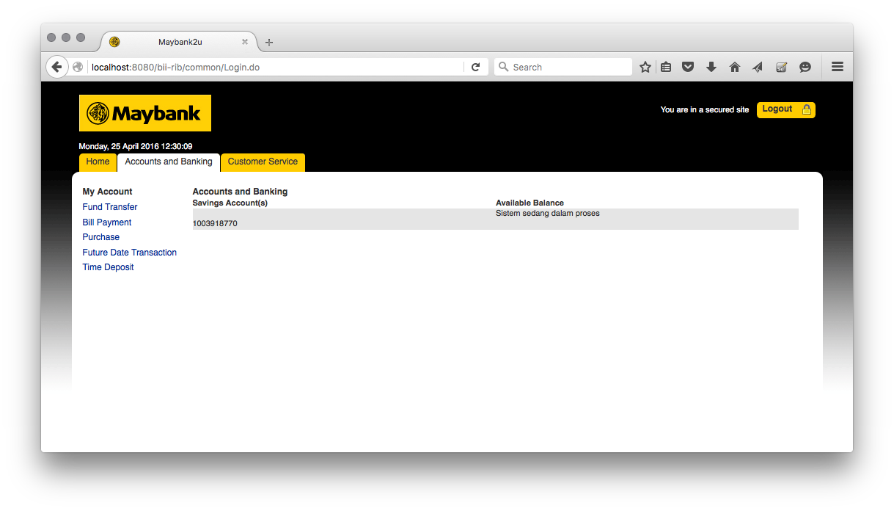

[25/04/2016] [12:29:49:981] [INFO] [ESBAccountListServices]:344 - <<<<<<<<<<<<<<<<< Header >>>>>>>>>>>>>>>>>>>
[25/04/2016] [12:29:49:981] [INFO] [ESBAccountListServices]:345 - Message ID: F10AD3DD-185A-4390-A976-12DB433972D5
[25/04/2016] [12:29:49:982] [INFO] [ESBAccountListServices]:346 - Branch Code: 270
[25/04/2016] [12:29:49:982] [INFO] [ESBAccountListServices]:347 - Channel ID: M2U
[25/04/2016] [12:29:49:982] [INFO] [ESBAccountListServices]:348 - Client Supervisor ID: 0000
[25/04/2016] [12:29:49:983] [INFO] [ESBAccountListServices]:349 - Client UserID: 0000
[25/04/2016] [12:29:49:983] [INFO] [ESBAccountListServices]:350 - Reference No: F514AE3C-5192-47A0-927D-579EECF9D41F
[25/04/2016] [12:29:49:983] [INFO] [ESBAccountListServices]:351 - Sequence No: 8495
[25/04/2016] [12:29:49:984] [INFO] [ESBAccountListServices]:352 - Transaction Date: 25-04-2016
[25/04/2016] [12:29:49:984] [INFO] [ESBAccountListServices]:353 - Transaction Time: 12:29:49
[25/04/2016] [12:29:49:984] [INFO] [ESBAccountListServices]:116 - <<<<<<<<<<<<<<<<< Request >>>>>>>>>>>>>>>>>>>
[25/04/2016] [12:29:49:985] [INFO] [ESBAccountListServices]:142 - CIF No: 0002768476
[25/04/2016] [12:29:50:024] [INFO] [ESBAccountListServices]:168 - <<<<<<<<<<<<<<<<< Response >>>>>>>>>>>>>>>>>>>
[25/04/2016] [12:29:50:025] [INFO] [ESBAccountListServices]:170 - Response Code: 00
[25/04/2016] [12:29:50:025] [INFO] [ESBAccountListServices]:172 - Response Description: CHRISTOPHER PAUL WHALEY
[25/04/2016] [12:29:50:026] [INFO] [ESBAccountListServices]:194 - GCIF No: G500522198
[25/04/2016] [12:29:50:026] [INFO] [ESBAccountListServices]:195 - CIF Type: 01
[25/04/2016] [12:29:50:027] [INFO] [ESBAccountListServices]:196 - Customer Name: CHRISTOPHER PAUL WHALEY
[25/04/2016] [12:29:50:027] [INFO] [ESBAccountListServices]:197 - Birth Date: 01/27/1947
[25/04/2016] [12:29:50:028] [INFO] [ESBAccountListServices]:198 - Salutation: MR.
[25/04/2016] [12:29:50:028] [INFO] [ESBAccountListServices]:199 - Gender: M
[25/04/2016] [12:29:50:029] [INFO] [ESBAccountListServices]:200 - Mobile No: 08158981111
[25/04/2016] [12:29:50:029] [INFO] [ESBAccountListServices]:201 - Email: etaxonline@biilab.net
[25/04/2016] [12:29:50:030] [INFO] [ESBAccountListServices]:202 - Address 1: C/O. PREMIER OIL NATUNA SEA
[25/04/2016] [12:29:50:030] [INFO] [ESBAccountListServices]:203 - Address 2: JL. KEMANG UTARA 4 NO.9
[25/04/2016] [12:29:50:030] [INFO] [ESBAccountListServices]:204 - Address 3: JAKARTA SELATAN
[25/04/2016] [12:29:50:031] [INFO] [ESBAccountListServices]:205 - Zip Code: 12560
[25/04/2016] [12:29:50:031] [INFO] [ESBAccountListServices]:206 - Resident Phone No:
[25/04/2016] [12:29:50:031] [INFO] [ESBAccountListServices]:207 - CIF No: 0002768476
[25/04/2016] [12:29:50:031] [INFO] [ESBAccountListServices]:208 - Customer No:
[25/04/2016] [12:29:50:032] [INFO] [ESBAccountListServices]:227 - ### Account Record Type ###
[25/04/2016] [12:29:50:033] [INFO] [ESBAccountListServices]:228 - Account No: 1003918770
[25/04/2016] [12:29:50:033] [INFO] [ESBAccountListServices]:229 - Account Currency: 016
[25/04/2016] [12:29:50:033] [INFO] [ESBAccountListServices]:230 - Branch Code: 003
[25/04/2016] [12:29:50:034] [INFO] [ESBAccountListServices]:231 - Appl Code: ST
[25/04/2016] [12:29:50:034] [INFO] [ESBAccountListServices]:232 - Product Code: 100
[25/04/2016] [12:29:50:034] [INFO] [ESBAccountListServices]:233 - Status: 00
[25/04/2016] [12:29:50:035] [INFO] [ESBAccountListServices]:234 - Relation Code: 01
[25/04/2016] [12:29:50:035] [INFO] [WsIntegrationService]:104 -
<<<<<<<<<<<<<<<<< Performance Calculate Result >>>>>>>>>>>>>>>>>>>
Class: {http://www.bankbii.com/AccountServices/}AccountServices
MessageID: F10AD3DD-185A-4390-A976-12DB433972D5
Start Time: Mon Apr 25 12:29:49 WIT 2016
End Time: Mon Apr 25 12:29:50 WIT 2016
Time Used to complete whole service (in miliseconds): 55
[25/04/2016] [12:29:50:285] [INFO] [ESBAccountInformationServices]:405 - <<<<<<<<<<<<<<<<< Header >>>>>>>>>>>>>>>>>>>
[25/04/2016] [12:29:50:286] [INFO] [ESBAccountInformationServices]:406 - Message ID: 97FF0B22-B1F3-4348-B2B8-31D102567C8B
[25/04/2016] [12:29:50:286] [INFO] [ESBAccountInformationServices]:407 - Branch Code: 270
[25/04/2016] [12:29:50:287] [INFO] [ESBAccountInformationServices]:408 - Channel ID: M2U
[25/04/2016] [12:29:50:287] [INFO] [ESBAccountInformationServices]:409 - Client Supervisor ID: 0000
[25/04/2016] [12:29:50:287] [INFO] [ESBAccountInformationServices]:410 - Client UserID: 0000
[25/04/2016] [12:29:50:288] [INFO] [ESBAccountInformationServices]:411 - Reference No: F514AE3C-5192-47A0-927D-579EECF9D41F
[25/04/2016] [12:29:50:288] [INFO] [ESBAccountInformationServices]:412 - Sequence No: 8495
[25/04/2016] [12:29:50:289] [INFO] [ESBAccountInformationServices]:413 - Transaction Date: 25-04-2016
[25/04/2016] [12:29:50:289] [INFO] [ESBAccountInformationServices]:414 - Transaction Time: 12:29:50
[25/04/2016] [12:29:50:290] [INFO] [ESBAccountInformationServices]:122 - <<<<<<<<<<<<<<<<< Request >>>>>>>>>>>>>>>>>>>
[25/04/2016] [12:29:50:290] [INFO] [ESBAccountInformationServices]:123 - Account No: 1003918770
[25/04/2016] [12:29:50:290] [INFO] [ESBAccountInformationServices]:124 - Account Branch Code: 003
[25/04/2016] [12:29:50:291] [INFO] [ESBAccountInformationServices]:125 - Account Currency: 016
[25/04/2016] [12:29:50:298] [INFO] [ESBAccountInformationServices]:134 - <<<<<<<<<<<<<<<<< Response >>>>>>>>>>>>>>>>>>>
[25/04/2016] [12:29:50:298] [INFO] [ESBAccountInformationServices]:136 - Response Code: -1
[25/04/2016] [12:29:50:299] [INFO] [ESBAccountInformationServices]:138 - Response Description:
[25/04/2016] [12:29:50:300] [INFO] [WsIntegrationService]:104 -
<<<<<<<<<<<<<<<<< Performance Calculate Result >>>>>>>>>>>>>>>>>>>
Class: {http://www.bankbii.com/AccountServices/}AccountServices
MessageID: 97FF0B22-B1F3-4348-B2B8-31D102567C8B
Start Time: Mon Apr 25 12:29:50 WIT 2016
End Time: Mon Apr 25 12:29:50 WIT 2016
Time Used to complete whole service (in miliseconds): 15

