impact sales

## TARGET SALES VS SALES GENERATED – BY PROGRAMME TYPE

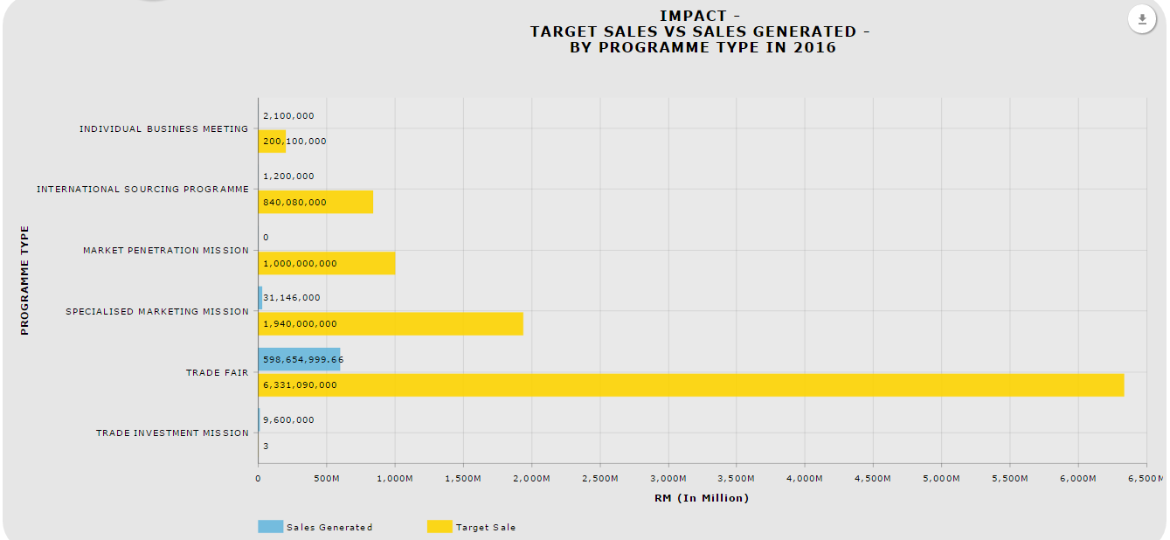

### Download as image - PDF

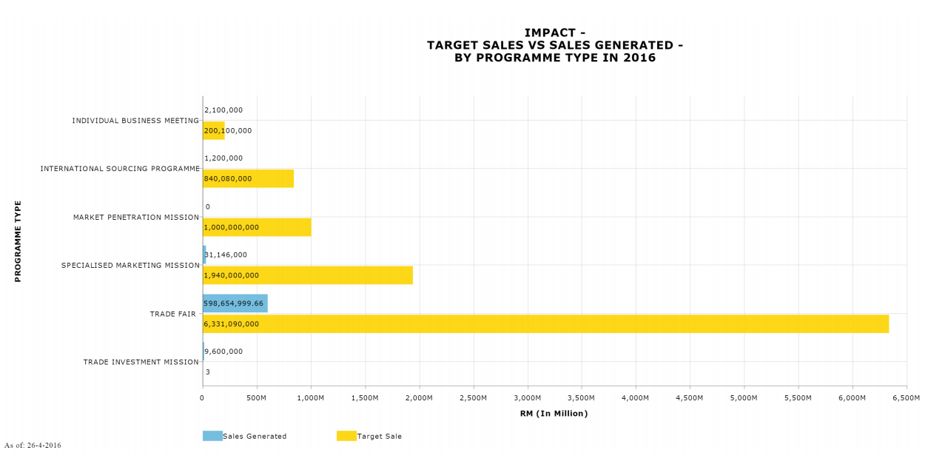

### *Download Data – CSV*

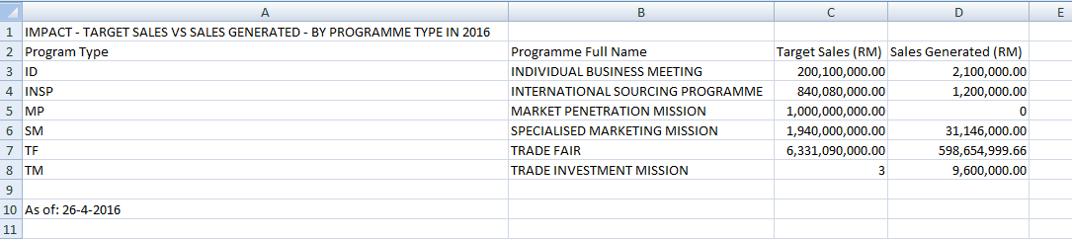

### *Download Data – XLSX*

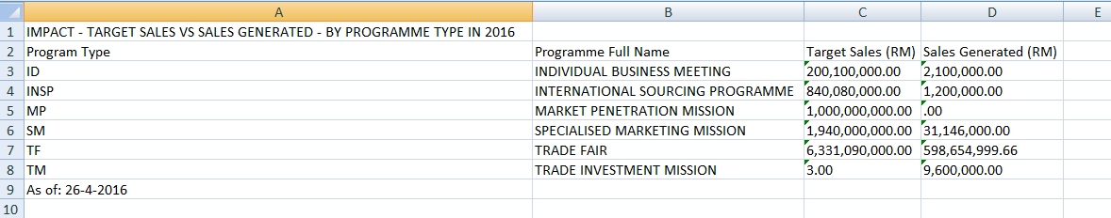

### *Print Chart*

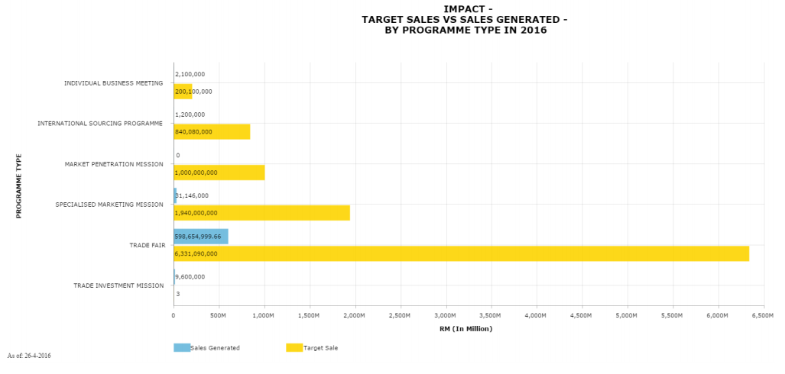

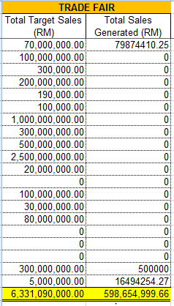

## TARGET SALES VS SALES GENERATED – BY SECTOR

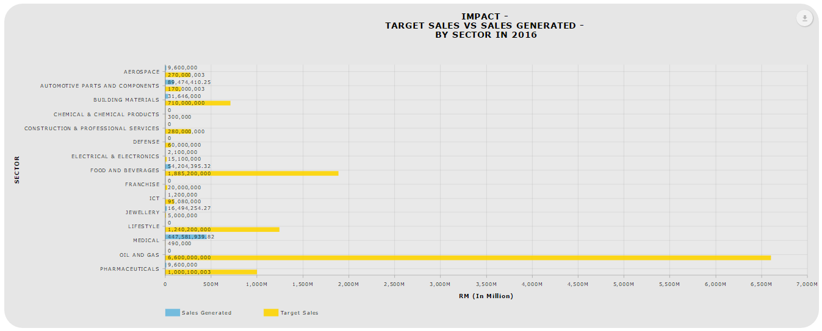

This graph for status CONFIRMED, COMPLETED, POSTPONED, CANCELLED & TENTATIVE only

### Download as image - PDF

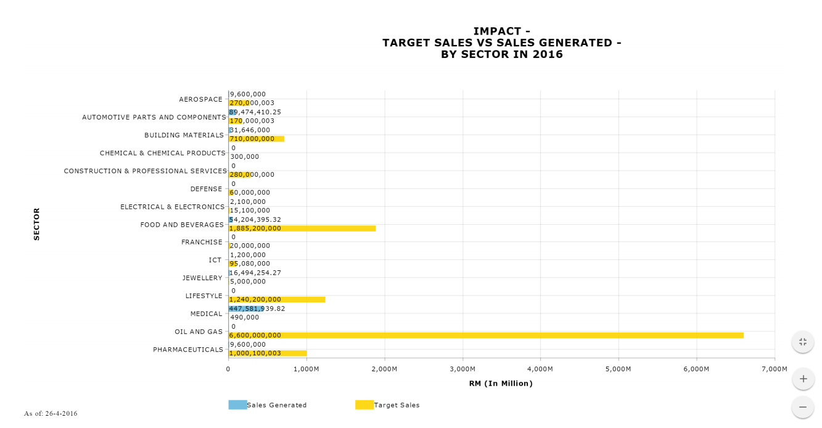

### *Download Data – CSV*

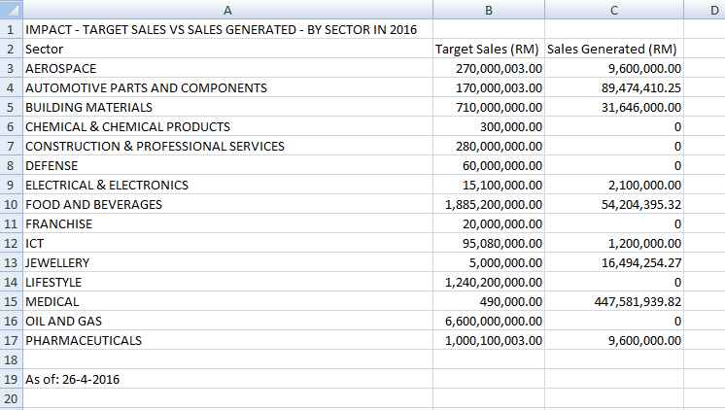

### *Download Data – XLSX*

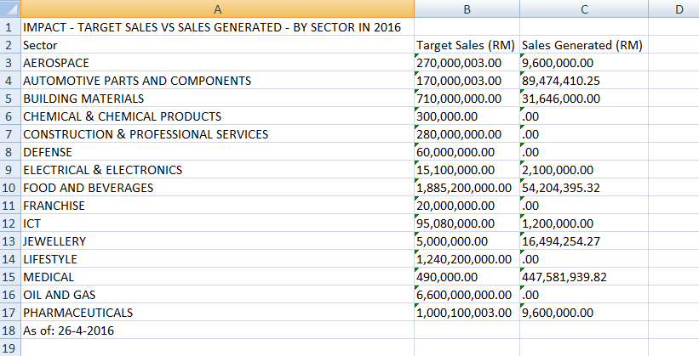

### *Print Chart*

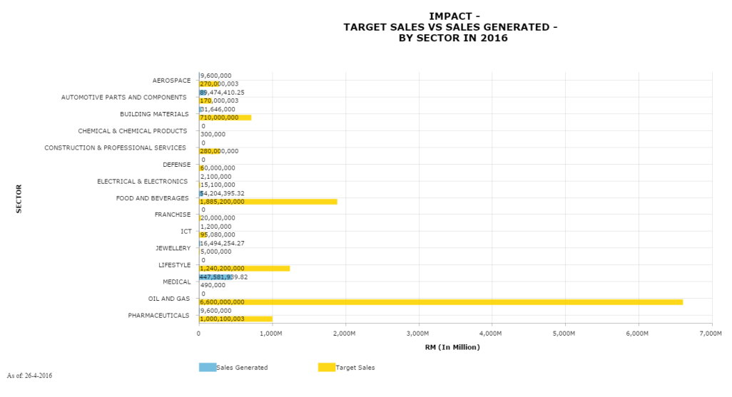

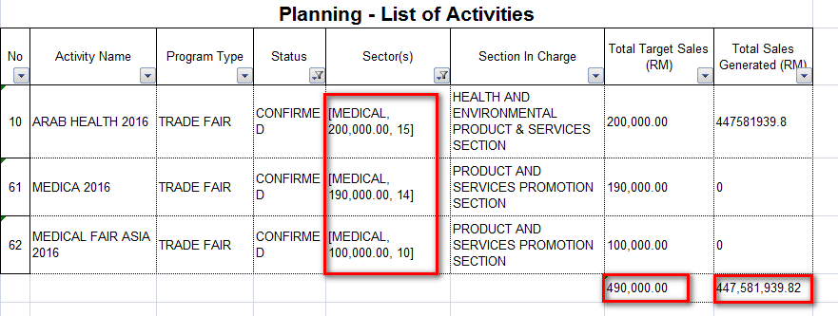

## TARGET SALES VS SALES GENERATED – BY SECTION

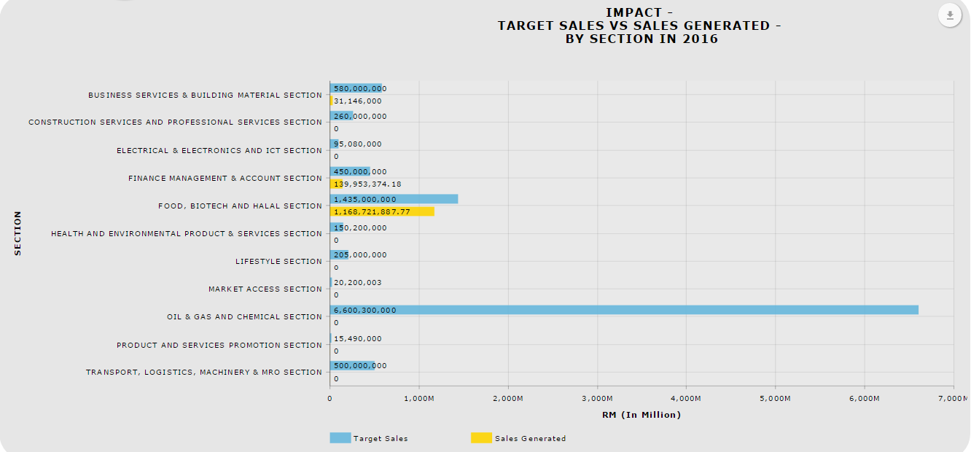

### Download as image – PDF

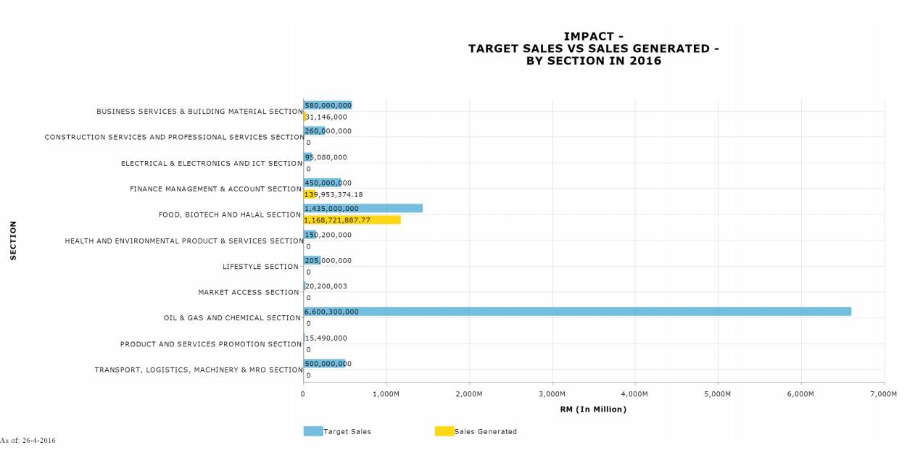

### *Download Data – CSV*

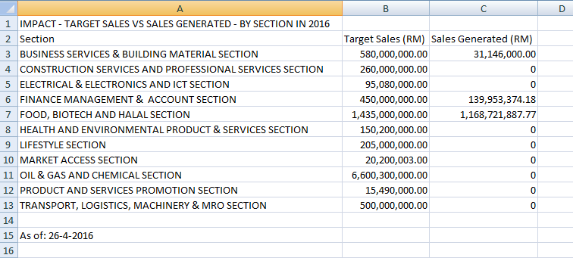

### *Download Data – XLSX*

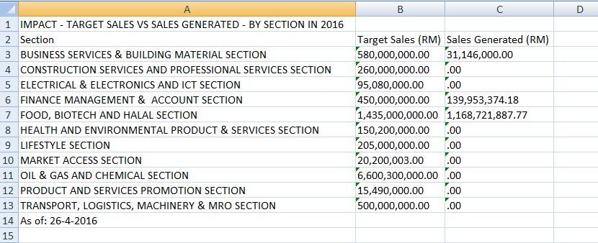

### *Print Chart*

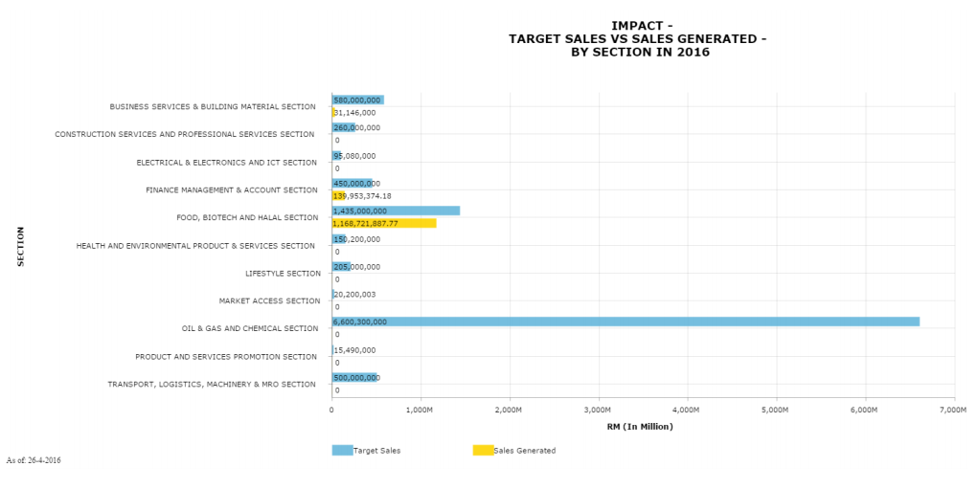

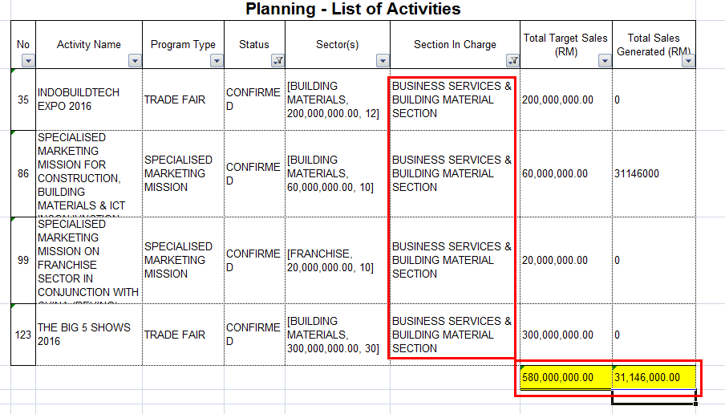

## TARGET SALES VS SALES GENERATED – BY REGION

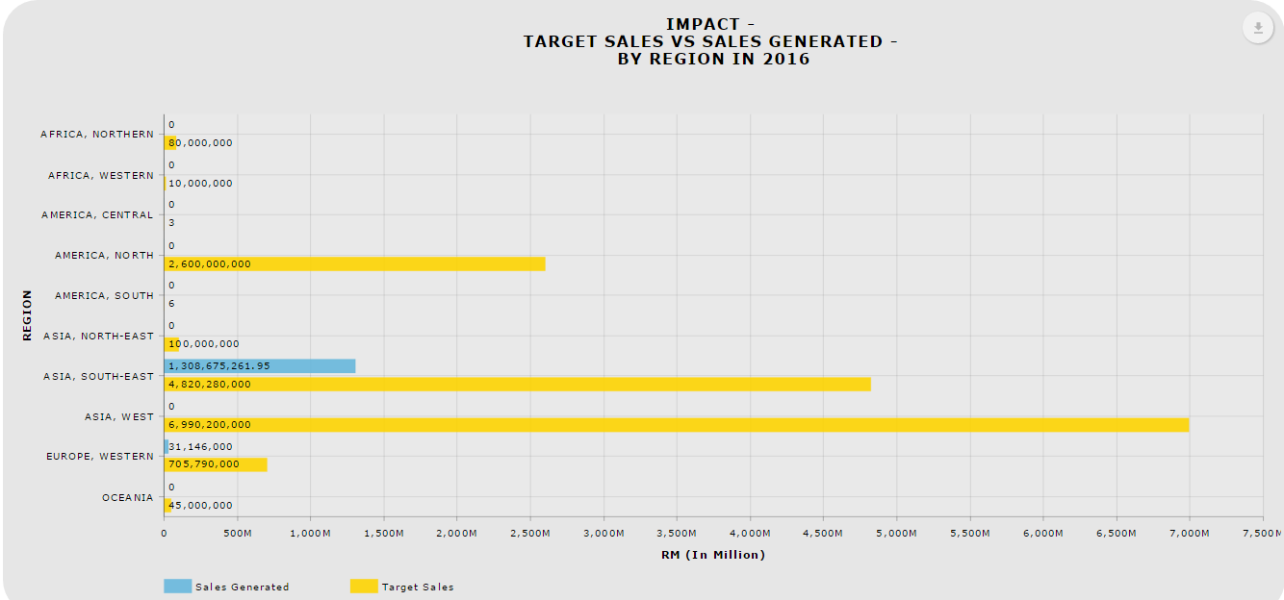

### Download as image – PDF

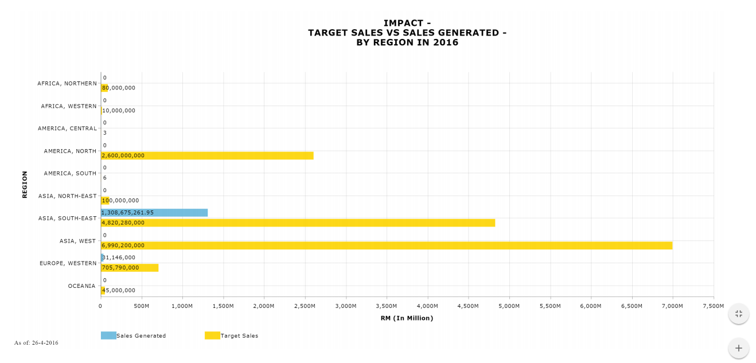

### *Download Data – CSV*

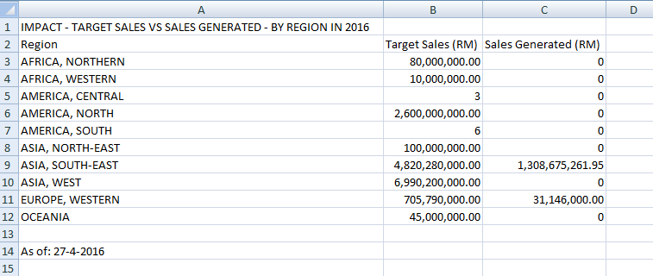

### *Download Data – XLSX*

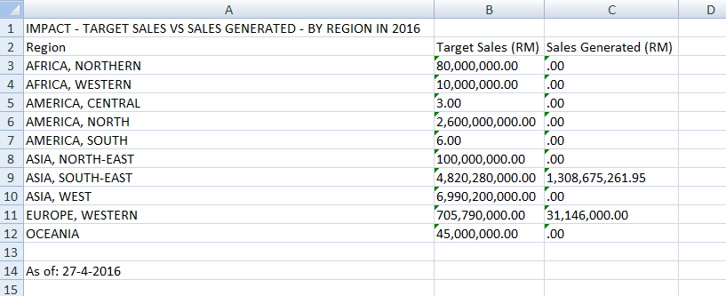

### *Print Chart*

