OVERALL

## APPROVED BUDGET – OVERALL

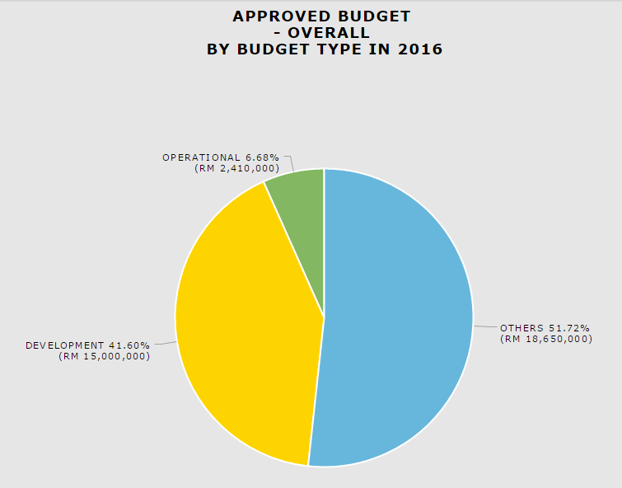

### Download as image – PDF

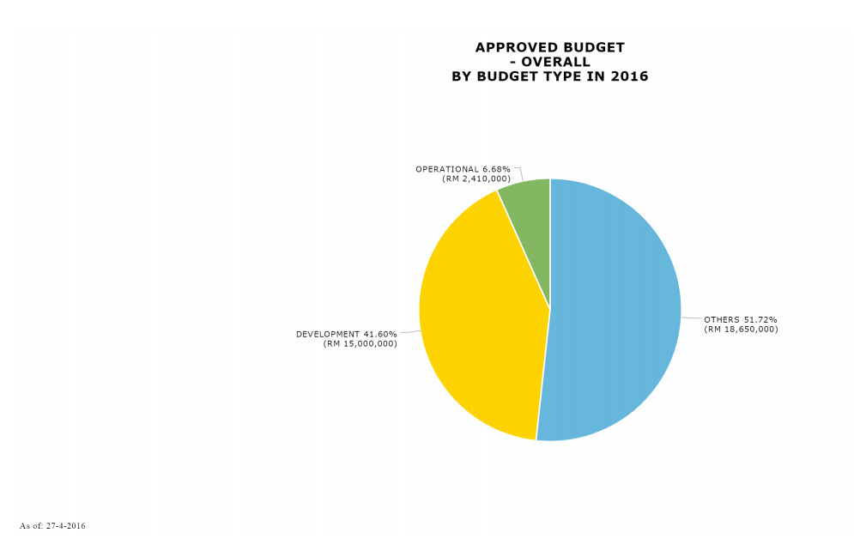

### *Download Data – CSV*

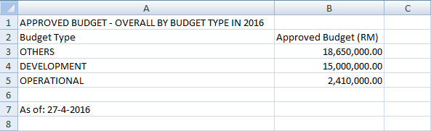

### *Download Data – XLSX*

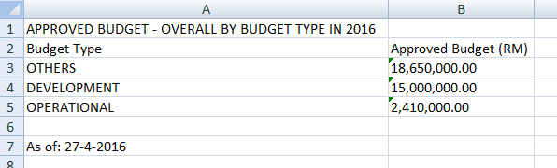

### *Print Chart*

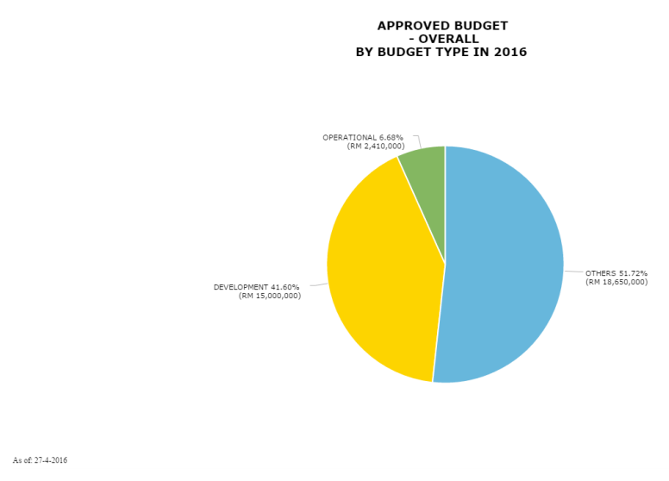

DATA SAMPLING

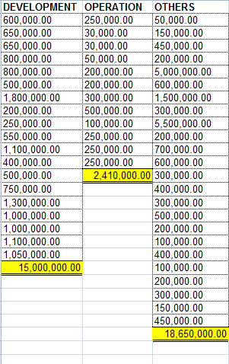

## NUMBER OF APPROVED EVENT BY PROGRAMME TYPE

### Download as image – PDF

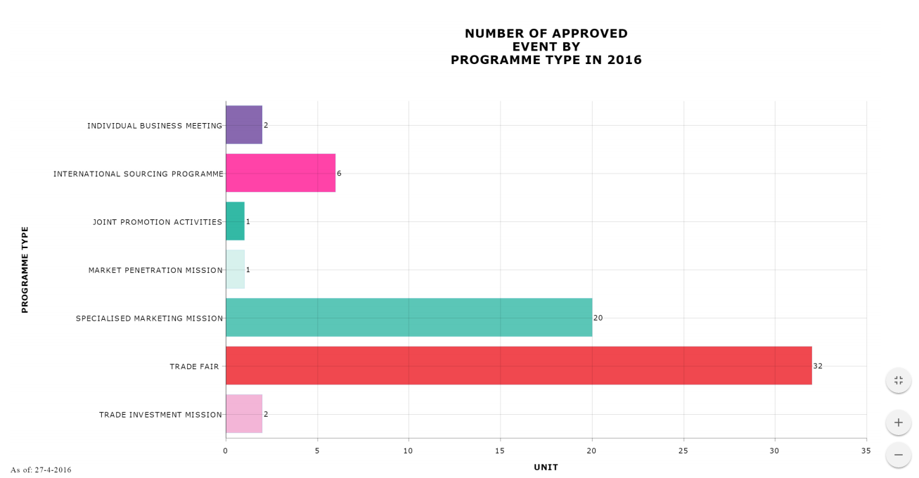

### *Download Data – CSV*

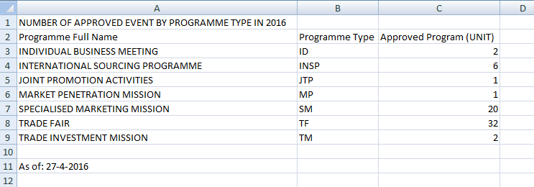

### *Download Data – XLSX*

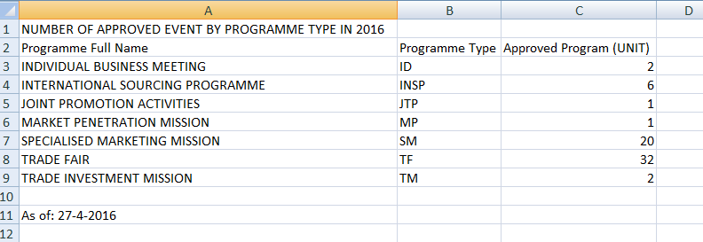

### *Print Chart*

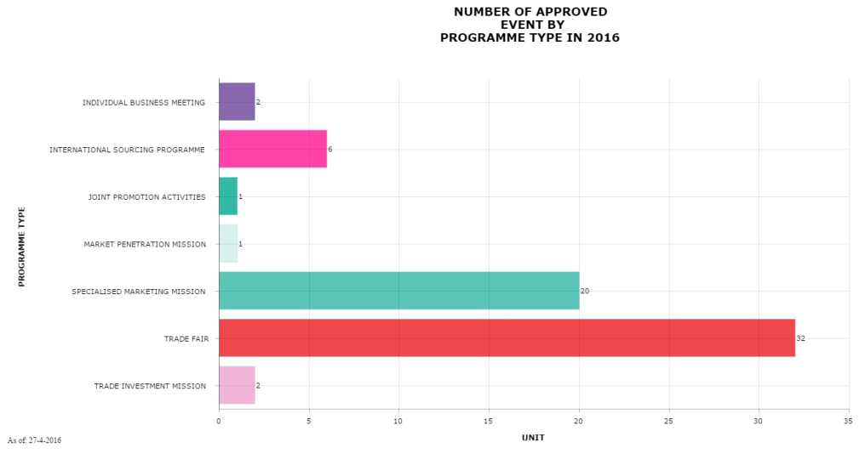

DATA SAMPLING

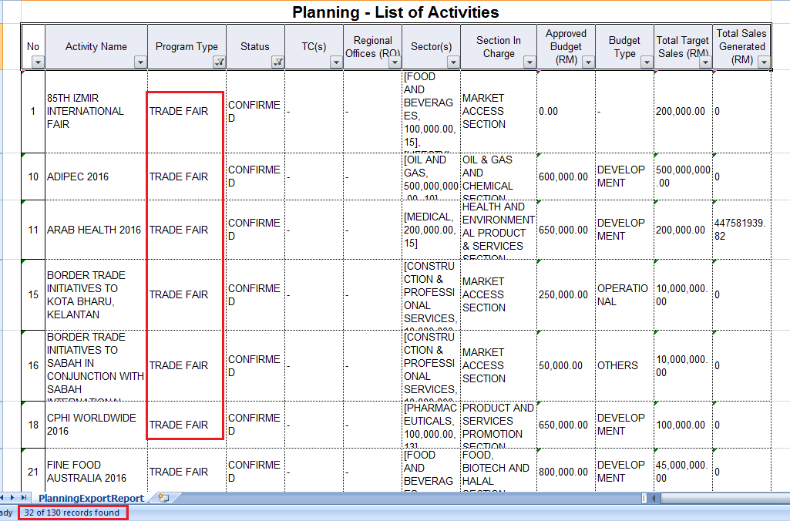

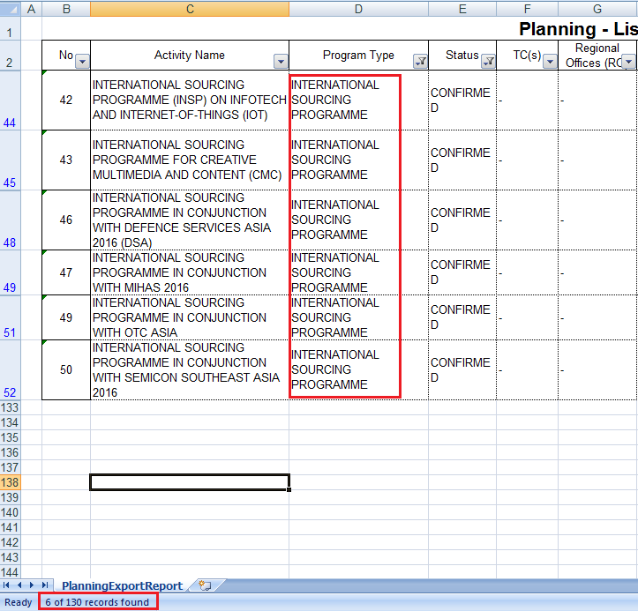

## IMPACT – TARGET SALES VS SALES GENERATED BY PROGRAMME TYPE

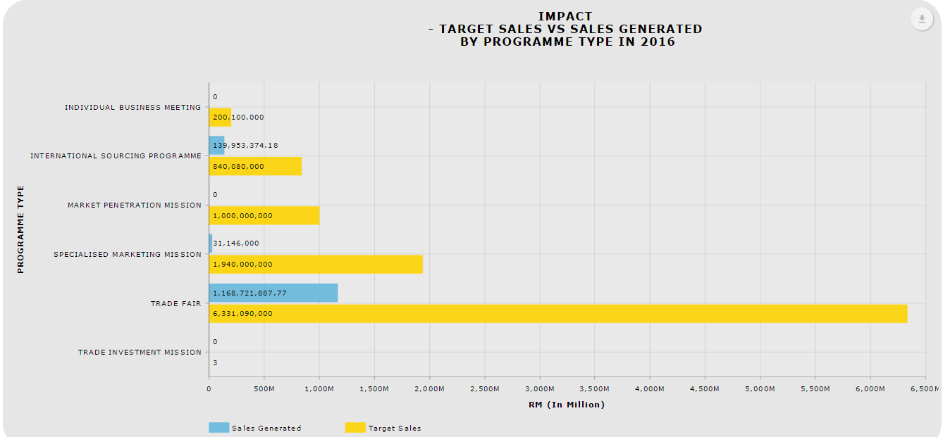

### Download as image – PDF

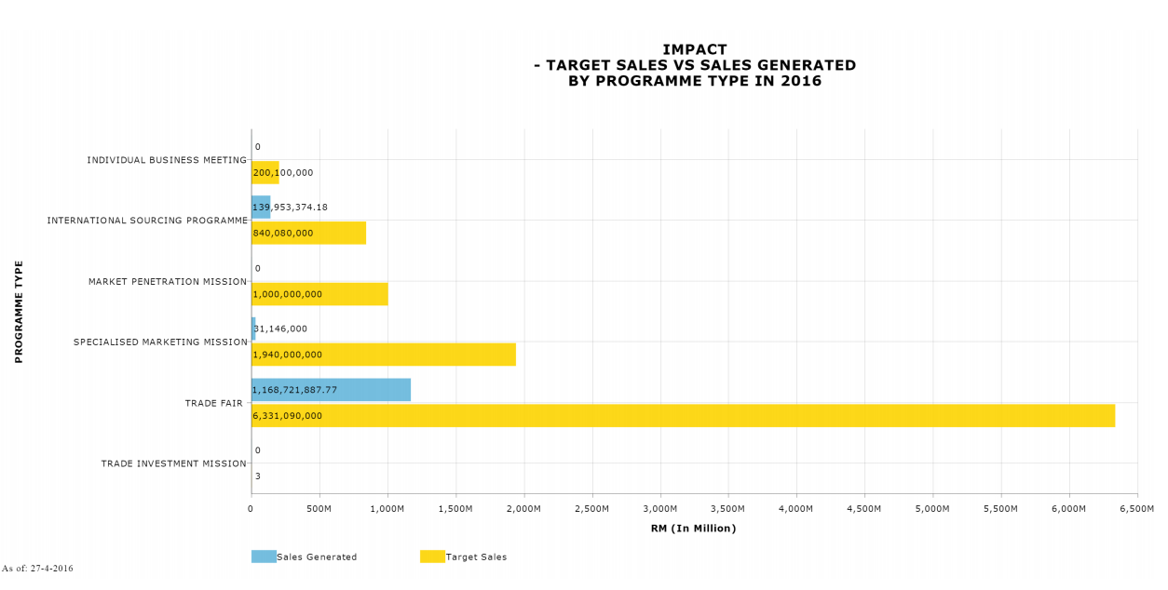

### *Download Data – CSV*

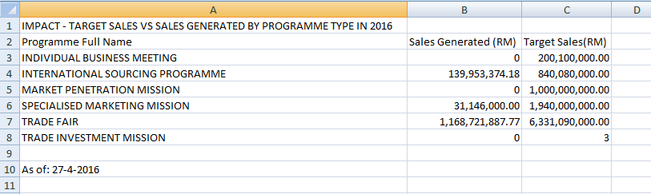

### *Download Data – XLSX*

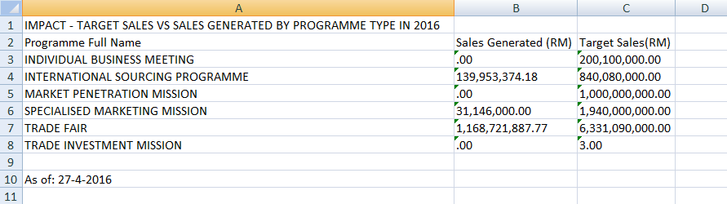

### *Print Chart*

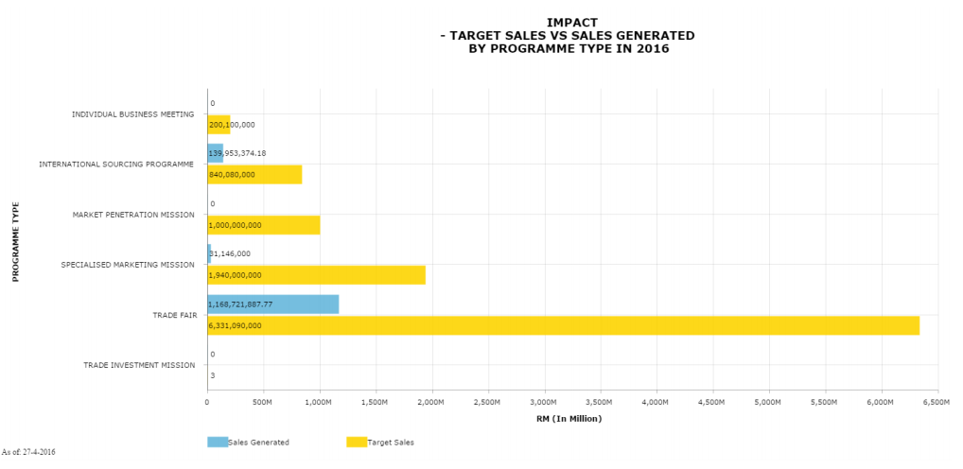

DATA SAMPLING

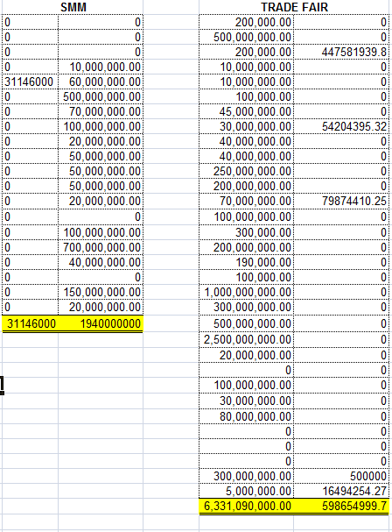

## IMPACT – ROI BY PROGRAMME TYPE

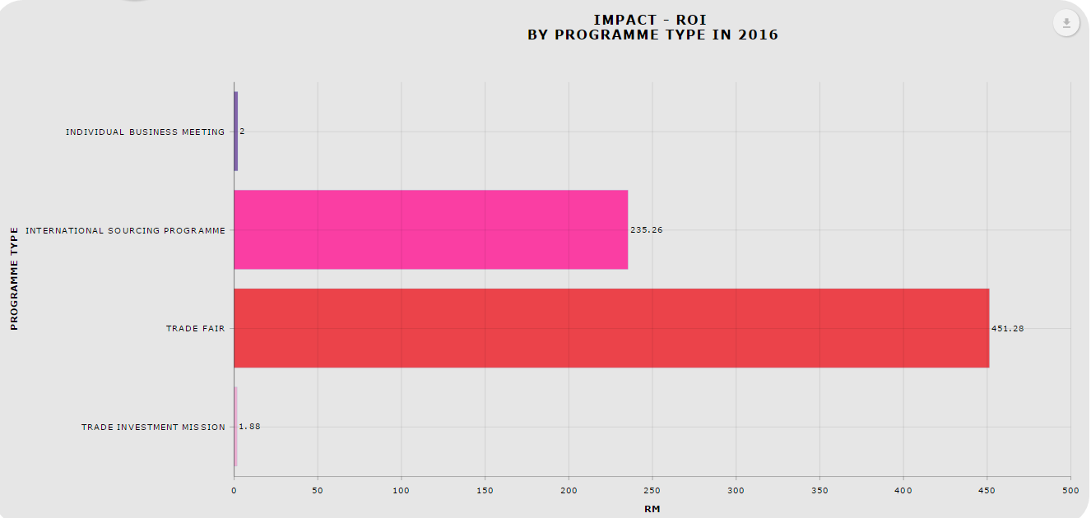

### Download as image – PDF

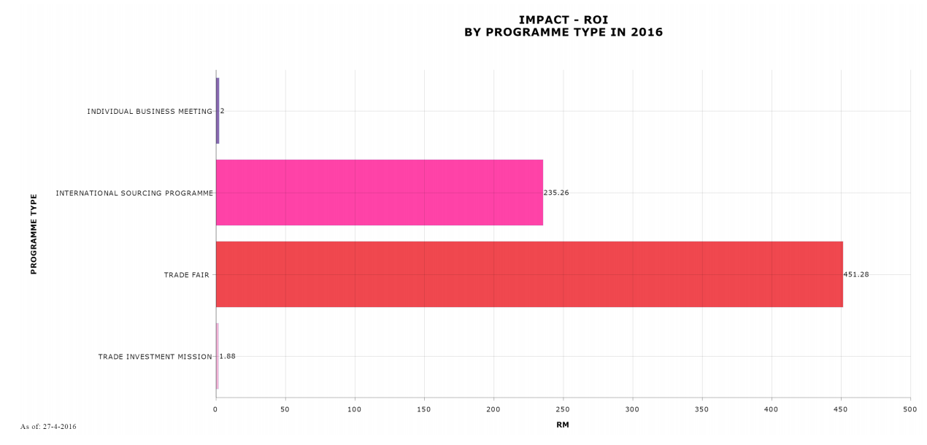

### *Download Data – CSV*

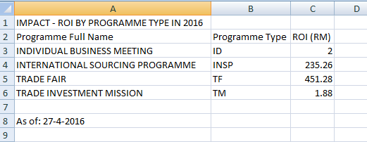

### *Download Data – XLSX*

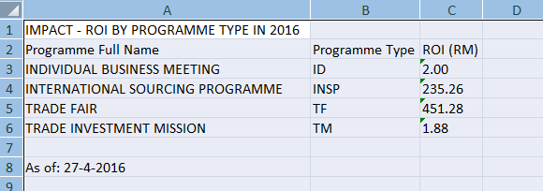

### *Print Chart*

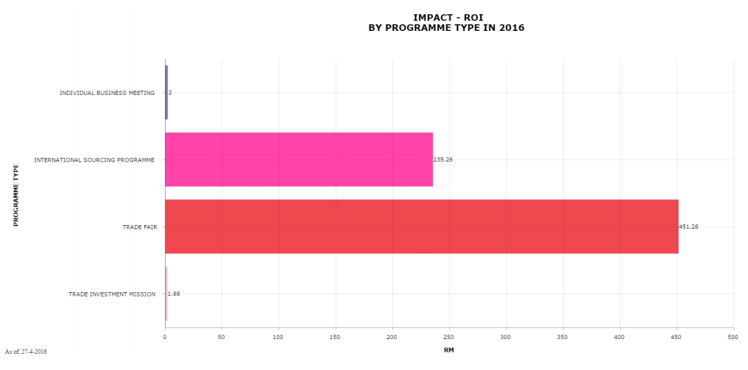

DATA SAMPLING

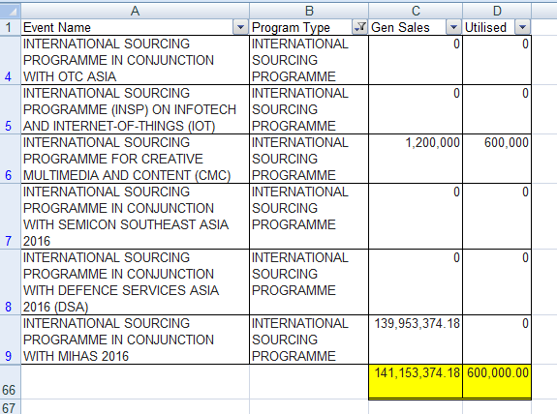

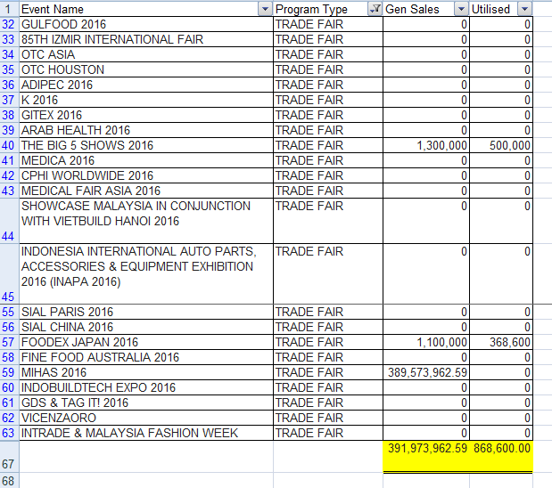

## PROGRAMME TYPE BY STATUS

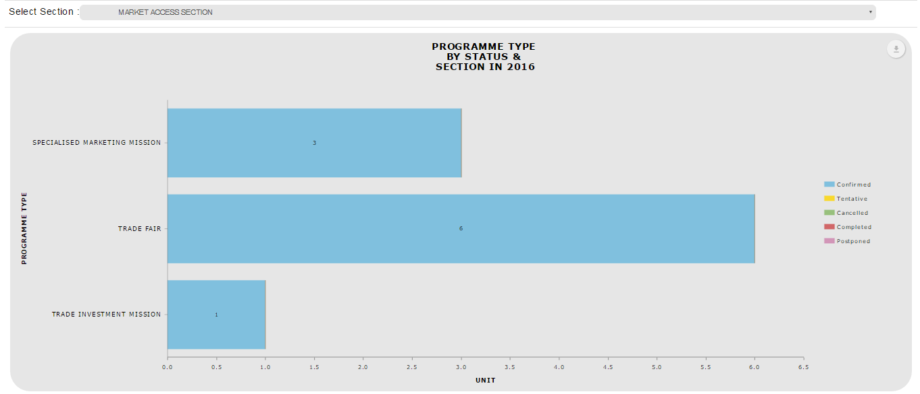

### Download as image – PDF

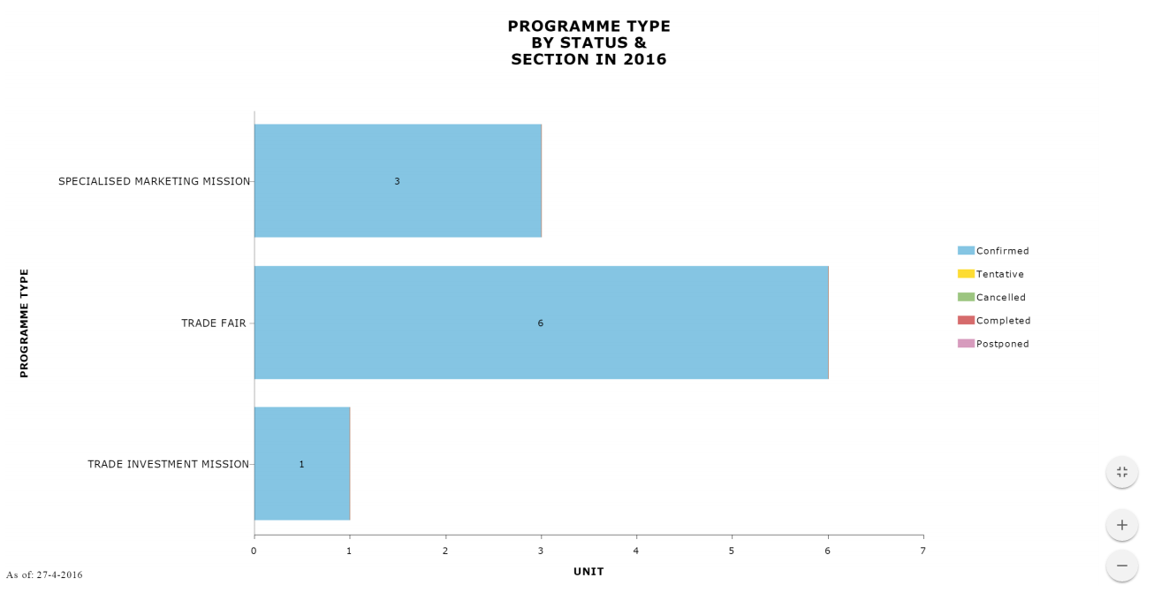

### *Download Data – CSV*

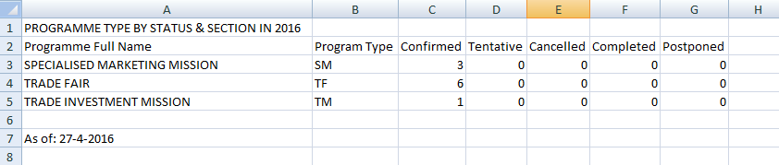

### *Download Data – XLSX*

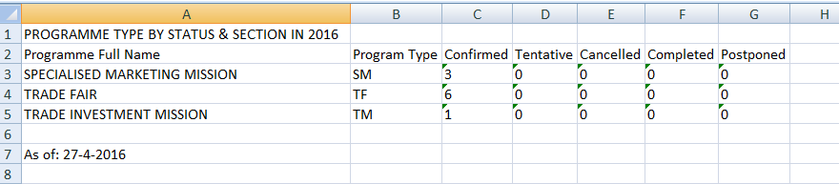

### *Print Chart*

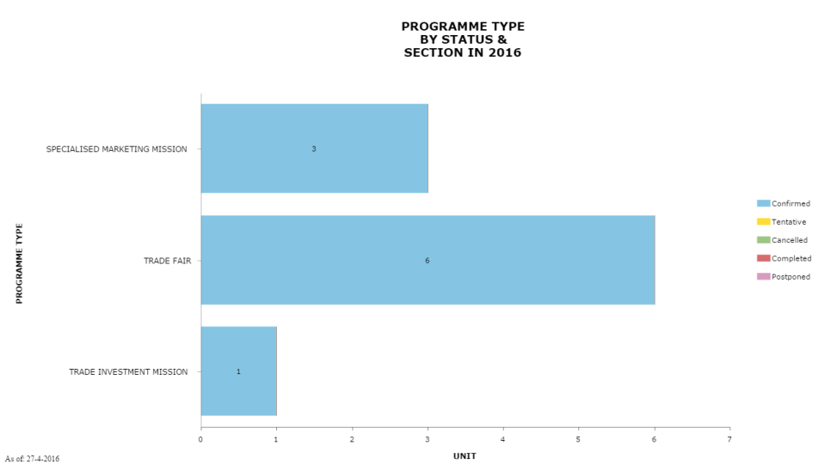

DATA SAMPLING

