Test Issue Log |  |  |  |  |  | Issue ID# : TPMS_Prod125
Project Name: | Trade Promotion Management System (TPMS)
Test Stage: | Unit Functionality Integration System Interface  Performance Regression Acceptance Pilot
Test Case Number: | Support # 6232 |  |  | Test Started Date: |  |  | 09/05/2016
Test Title: | 1. Report format not display accordingly redundant rows).  2. Wrong numbering for list of companies (number should continue from previous page and row)
Test Description: | To test on report format & numbering display accordingly.
Test Functionality: | Post Event >> Reports - Event Report
Test Procedure: | - Click on Promotion Post Event >> Reports – Event Report – Feedback by Participant.
Test Result: | Pass: Fail:  Conditional Pass: : |  | Tested by: |  | Siti Norahayu Binti Mohd Desa
Reason for Failure:
TEST DESCRIPTION
Issue:
To test on report format & numbering display accordingly.
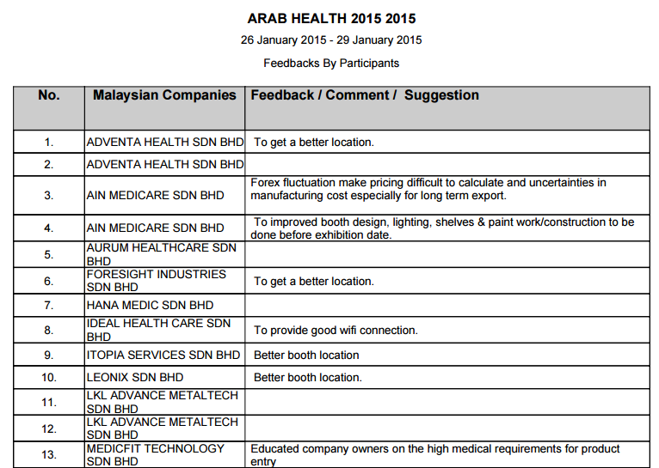
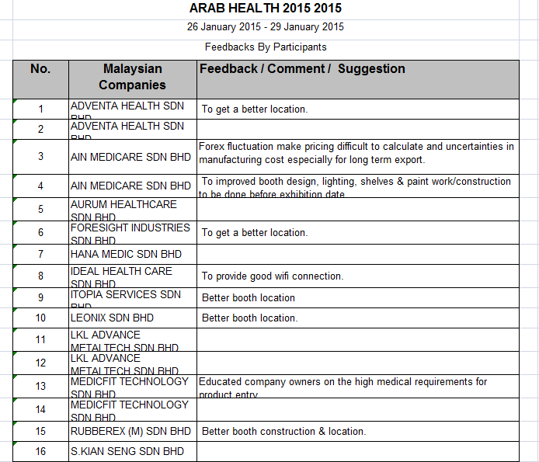

Reviewed By: (PMO)
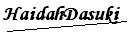 |  | Name/Position : Norhaidah Binti Md Dasuki / Senior Manager, Quality Assurance and Support  Date :09/05/2016

