Test Issue Log |  |  |  |  |  | Issue ID# : TPMS_Prod124
Project Name: | Trade Promotion Management System (TPMS)
Test Stage: | Unit Functionality Integration System Interface  Performance Regression Acceptance Pilot
Test Case Number: | Support # 6230 |  |  | Test Started Date: |  |  | 09/05/2016
Test Title: | To sort product sub-category ascending order in the registration form for all program type.
Test Description: | To test on product sub-category sorting in all registration form.
Test Functionality: | Promotion > Registration
Test Procedure: | - External - Click on Promotion > Event Publication List > Register  - Existing Company  - New Company  - Internal - Click on Promotion > View > Registration > New Registration  - Existing Company  - New Company  - Registration Form – Edit
Test Result: | Pass: Fail:  Conditional Pass: : |  | Tested by: |  | Siti Norahayu Binti Mohd Desa
Reason for Failure:
TEST DESCRIPTION
Issue:
To test on product sub-category sorting in all registration form.

- External - Click on Promotion > Event Publication List > Register
- Existing Company
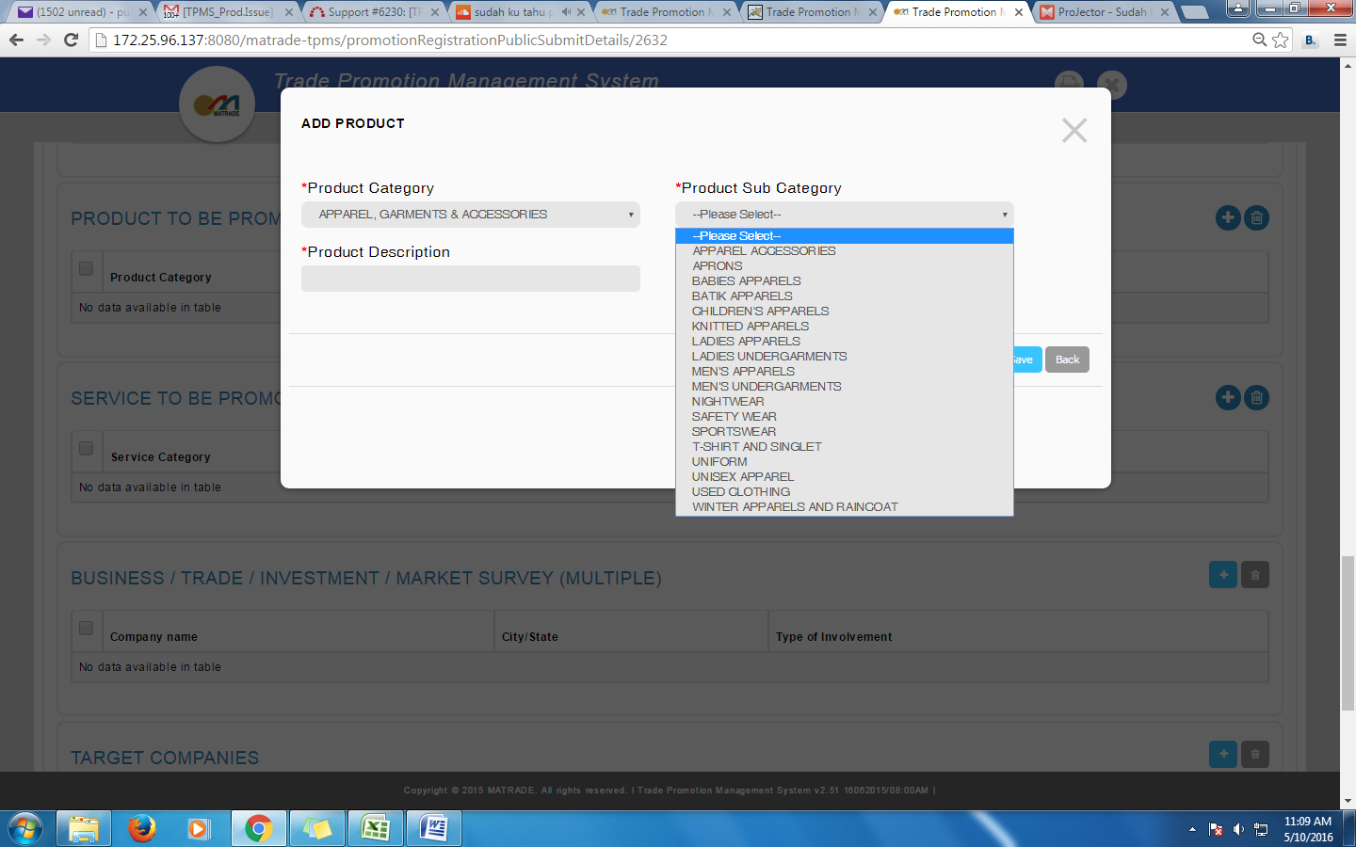

- New Company

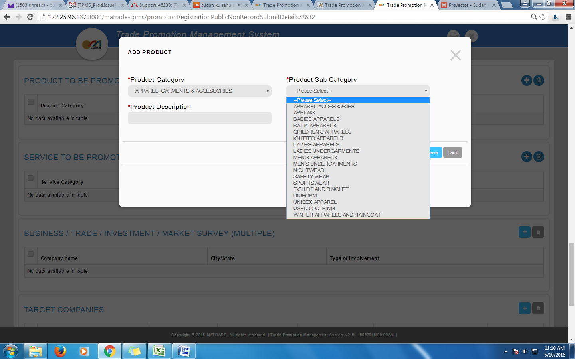

- Internal - Click on Promotion > View > Registration > New Registration
- Existing Company
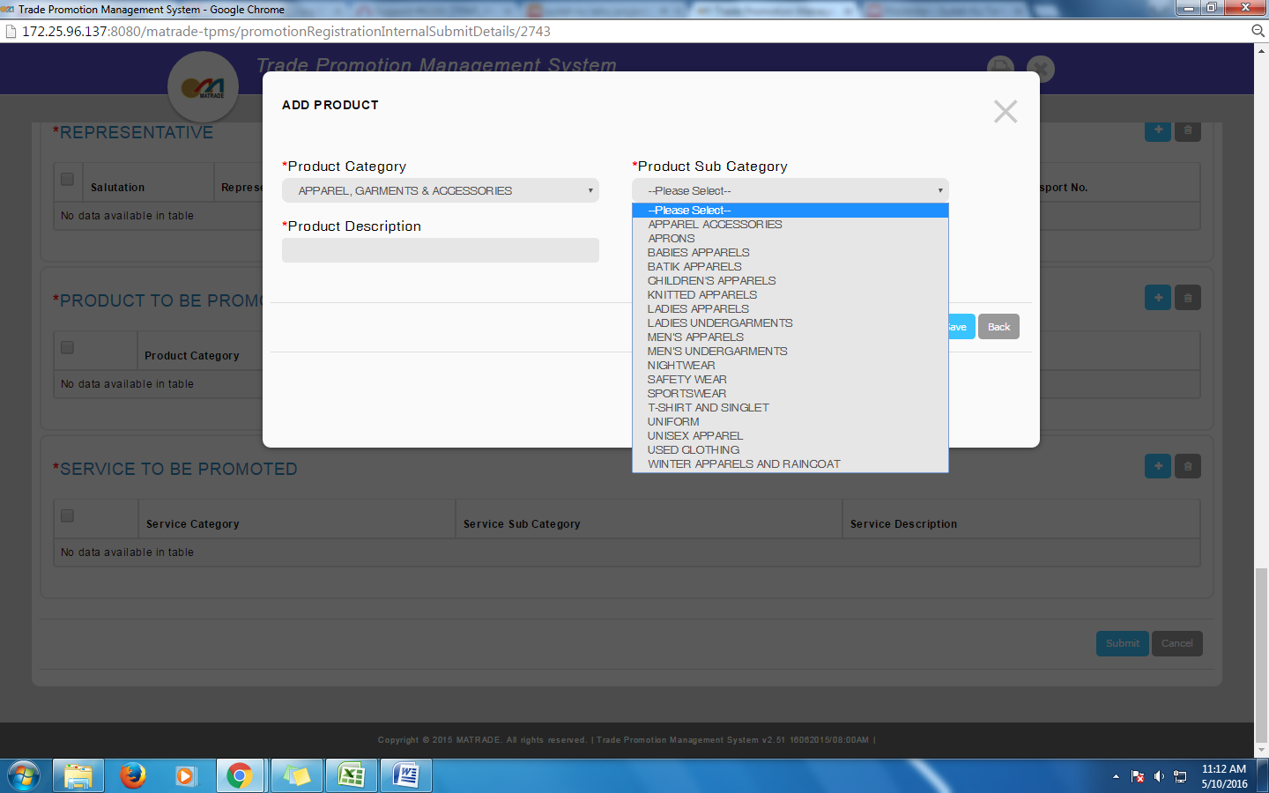

- New Company
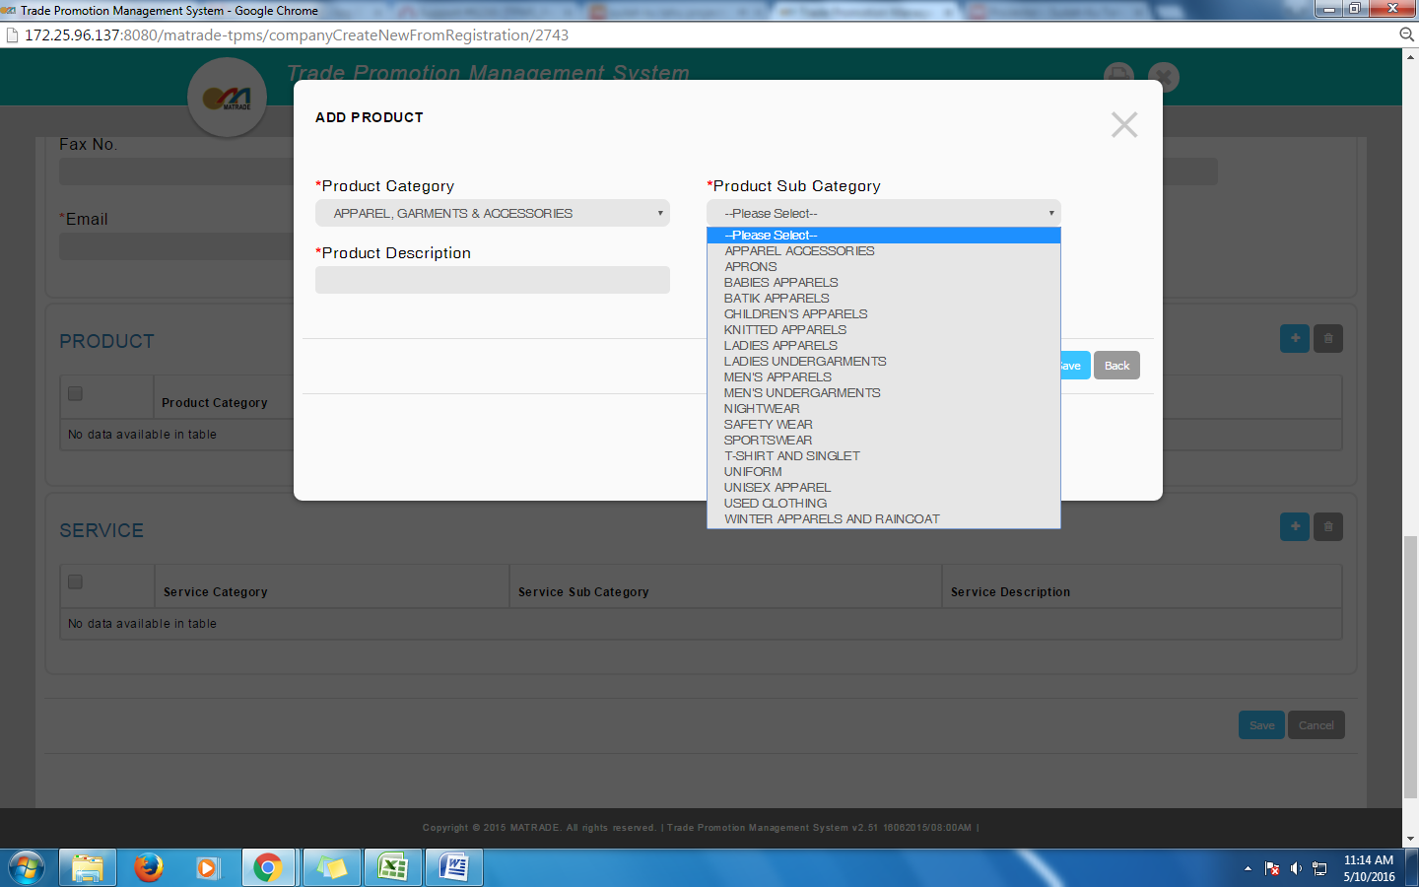

- Registration Form – Edit

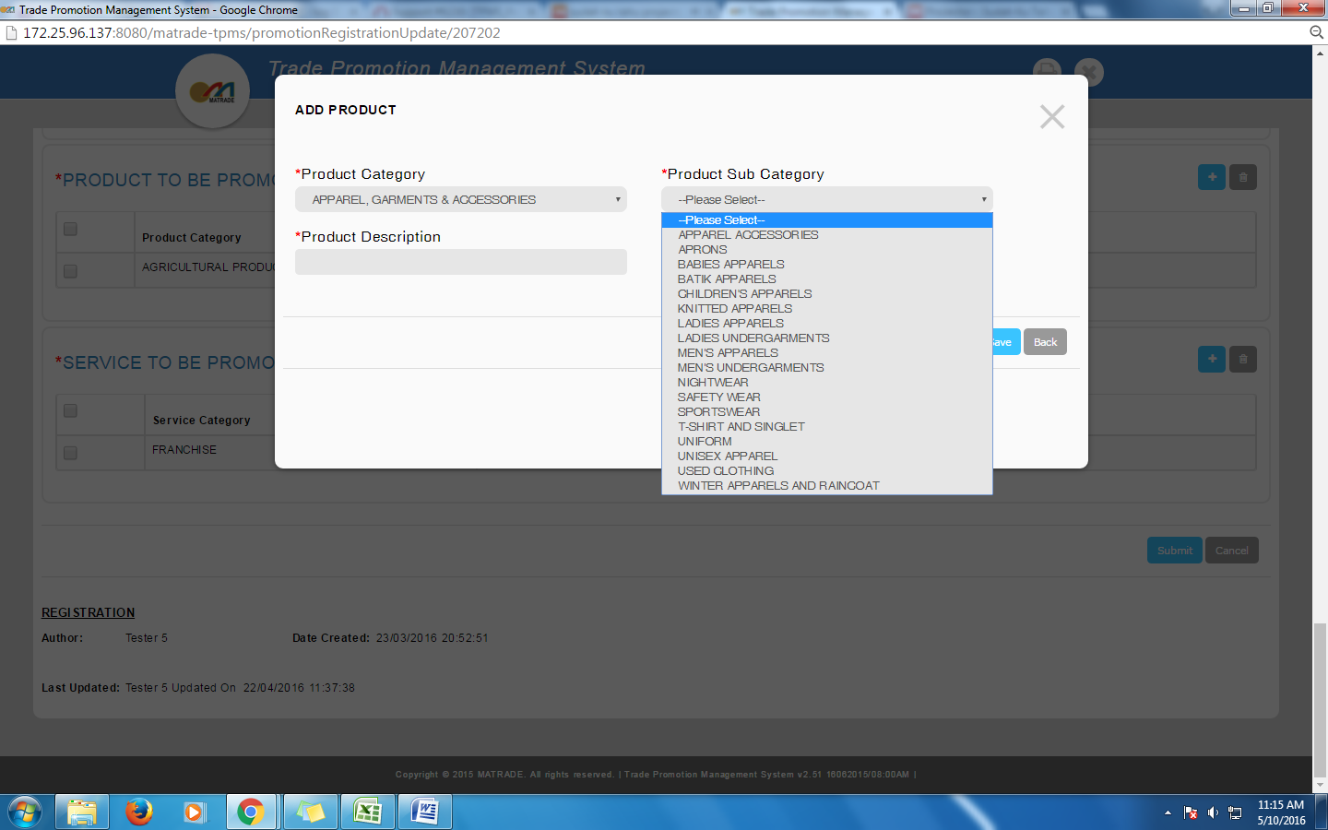
Reviewed By: (PMO)
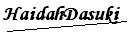 |  | Name/Position : Norhaidah Binti Md Dasuki / Senior Manager, Quality Assurance and Support  Date :09/05/2016

