Test Issue Log |  |  |  |  |  | Issue ID# : TPMS_Prod126
Project Name: | Trade Promotion Management System (TPMS)
Test Stage: | Unit Functionality Integration System Interface  Performance Regression Acceptance Pilot
Test Case Number: | Support # 6233 |  |  | Test Started Date: |  |  | 10/05/2016
Test Title: | Format report - Data not display in one row.
Test Description: | To test on report format to display accordingly in PDF & Excel.
Test Functionality: | Promotion > Reports - Promotions Report
Test Procedure: | - Click on Promotion > Reports - Promotions Report > Foreign Buyer – Details By Company Name
Test Result: | Pass: Fail:  Conditional Pass: : |  | Tested by: |  | Siti Norahayu Binti Mohd Desa
Reason for Failure:
TEST DESCRIPTION
Issue:
To test on report format to display accordingly in PDF & Excel
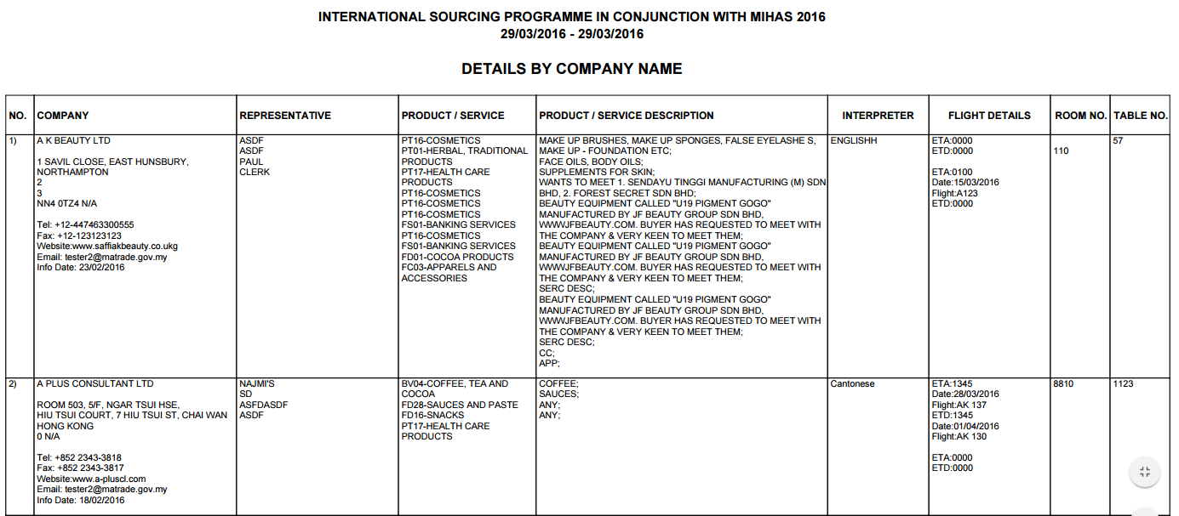
Reviewed By: (PMO)
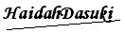 |  | Name/Position : Norhaidah Binti Md Dasuki / Senior Manager, Quality Assurance and Support  Date :10/05/2016

