Issue 1)

To display only Company Name with Approved Write-up in the "List of Companies" table.

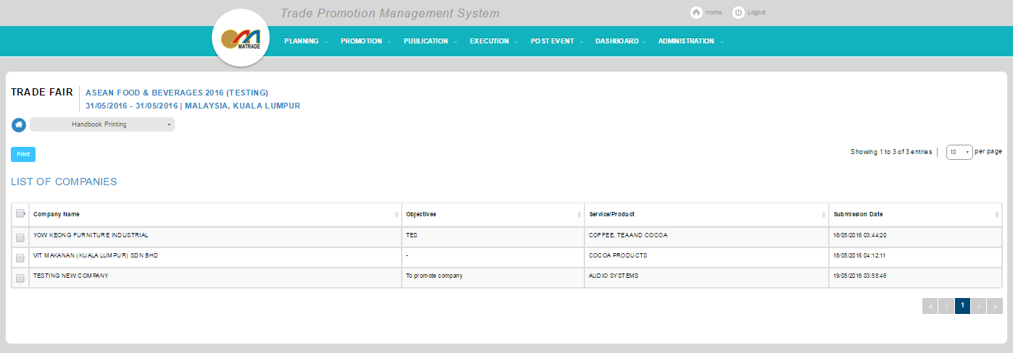

Expected Result: Should only display Yon Keong Furniture in the screen.

