Test Issue Log |  |  |  |  |  | SCP ID# :
Project Name: | BIB PREPROD
Test Stage: | Unit Functionality Integration System Interface  Performance Regression Acceptance Pilot
Test Case Number: |  |  |  | Test Started Date: |  |  | 20/05/2016
Test Title: | BIB PREPROD
Test Description: | To ensure all module functioning well.
Test Functionality: | Account and Banking  - Transaction History
Test Procedure: | - Login to BIB PREPROD  - Click on Account and Banking navigation  - Choose Transaction History  - Test on date filter
Test Result: | Pass: Fail: | Tested by: |  |  | Erni Suhaireen binti Zulkifli
Reason for Failure: | Date filter does not function correctly. It still display information from month May even filer only on month March/April.
TEST DESCRIPTION
Date filter does not function correctly. It still display information from month May even filer only on month March/April.
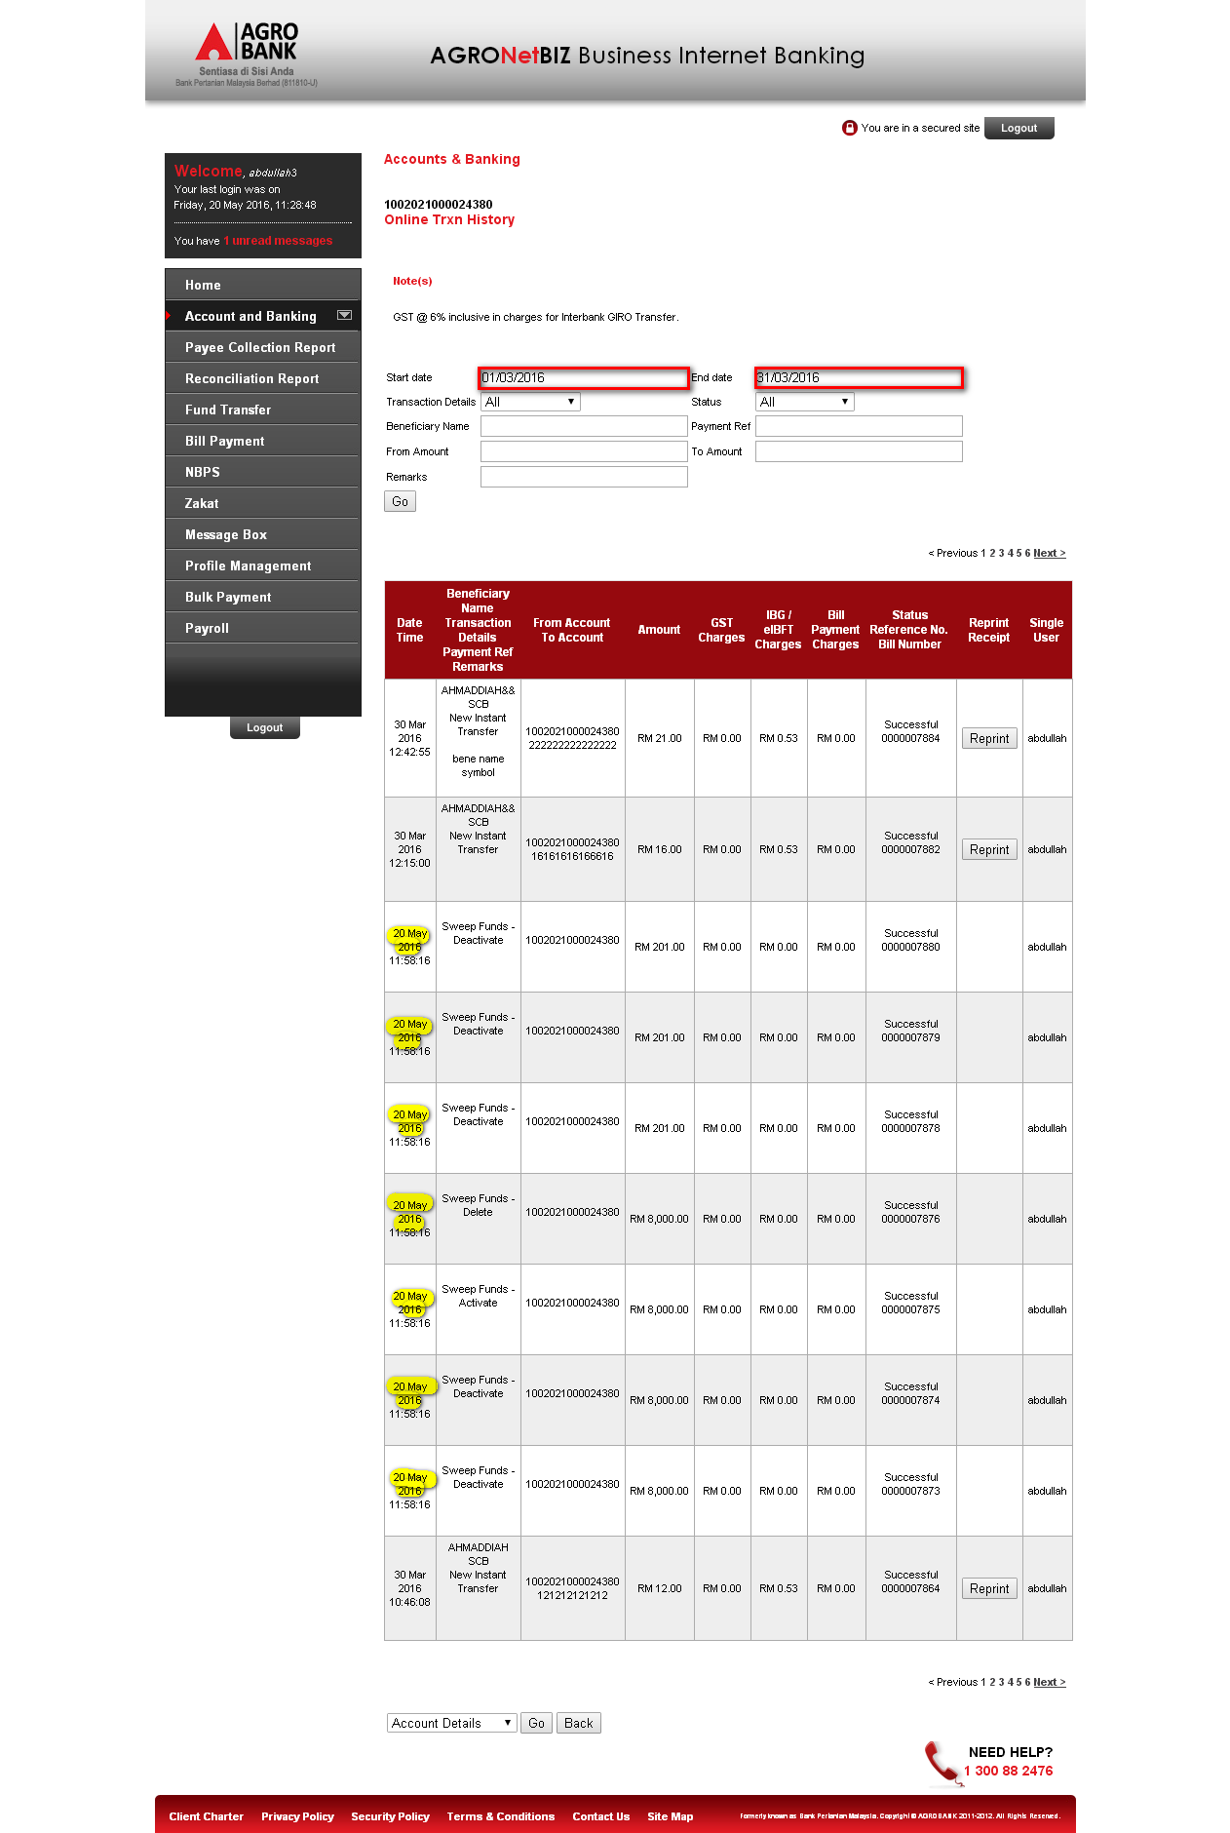
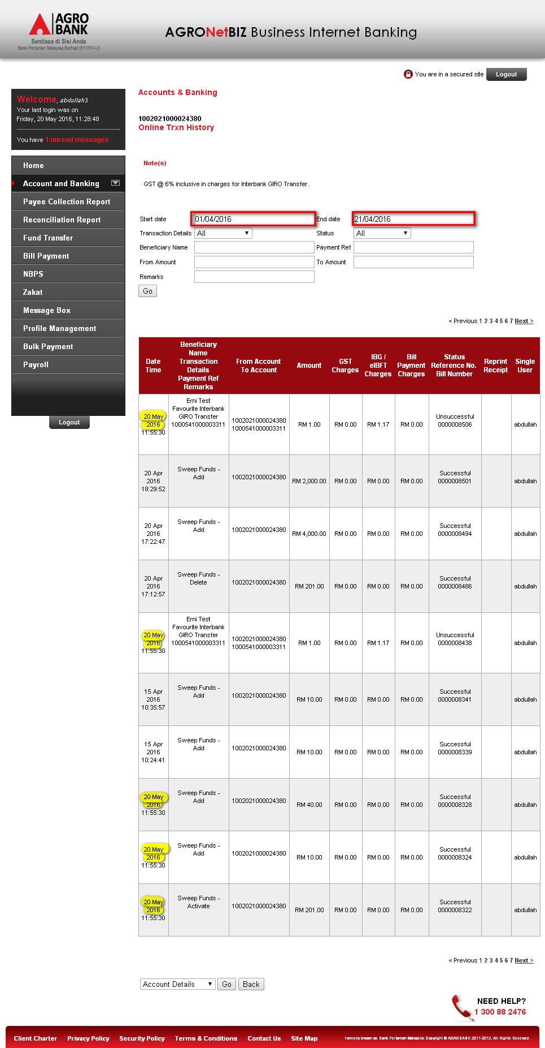

Reviewed By: (PMO)
Lizahwati |  |  | Name/Position : Lizahwati binti Basirun  Date :

