PROGRAMMED

## NUMBER OF APPROVED EVENT – BY PROGRAMME TYPE

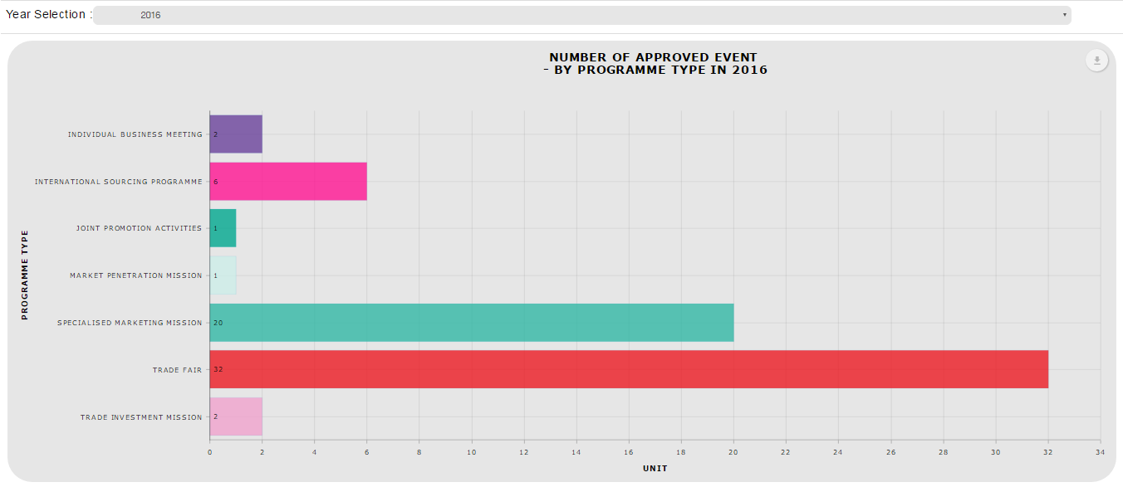

### **Download as image - PDF**

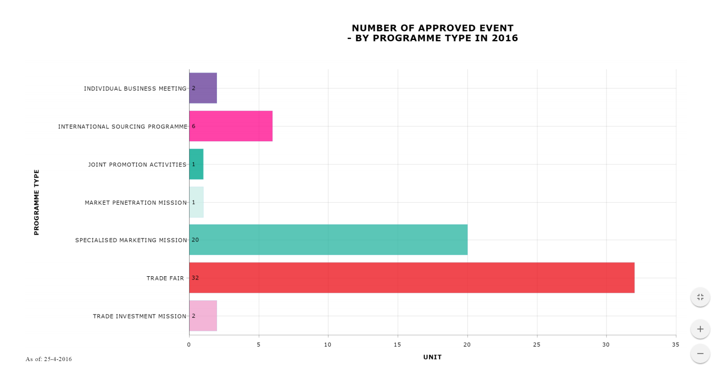

### *Download Data – CSV*

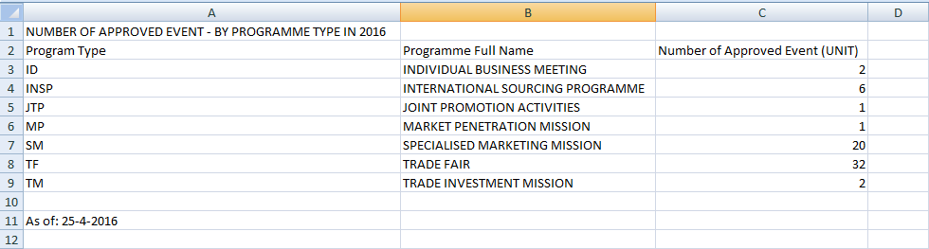

### *Download Data – XLSX*

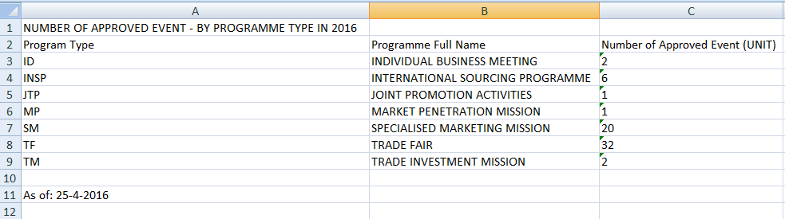

### ***Print Chart***

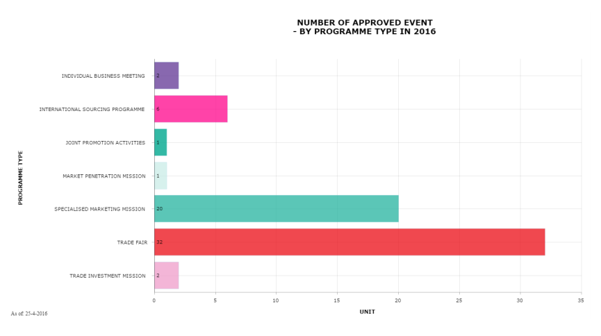

### ***Data Sampling***

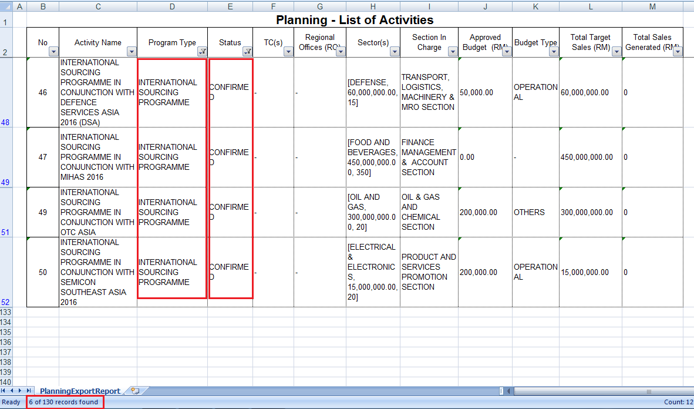

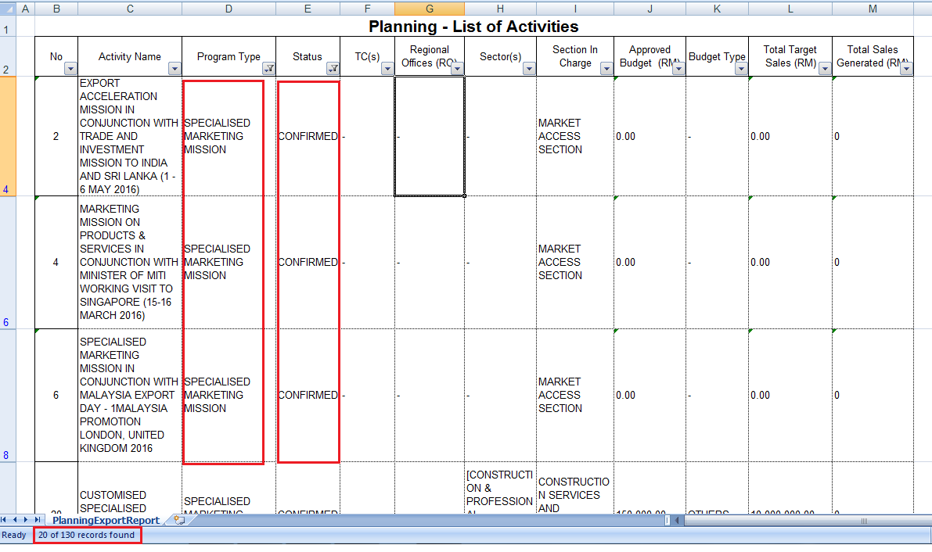

## NUMBER OF APPROVED EVENT – BY REGION

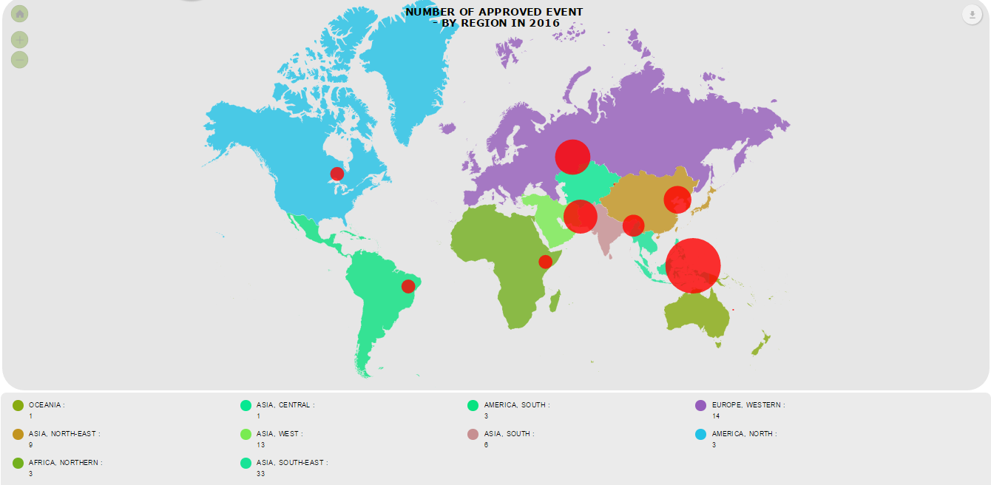

For Number of approved event by region, there is some conflict when same event are located to the other region. Already raise this problem on 8 April 2016 to en.Rizal but still no feedback.

Replied by En.Rizal on 28 April 2016:

If the event was organized more than one country, then the map or chart should display more than one country.

### **Download as image – PDF**

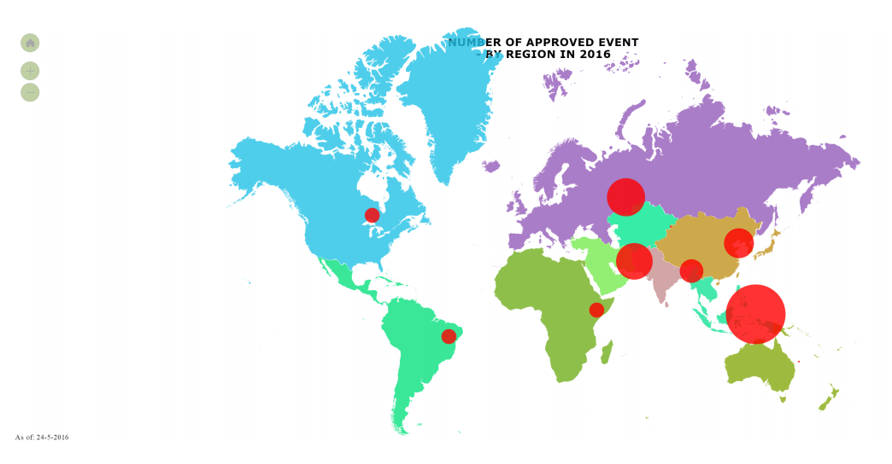

### ***Print Chart***

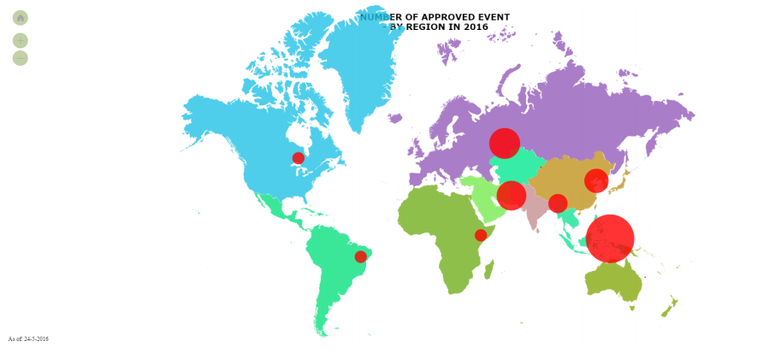

Notes: Unable to print maps with legend. Pending from amcharts

## NUMBER OF APPROVED EVENT – BY SECTION

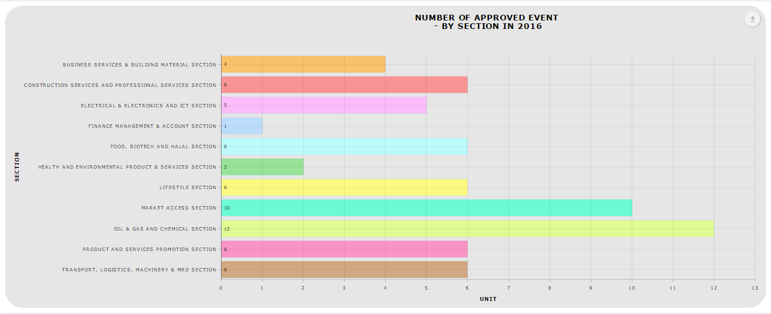

### **Download as image – PDF**

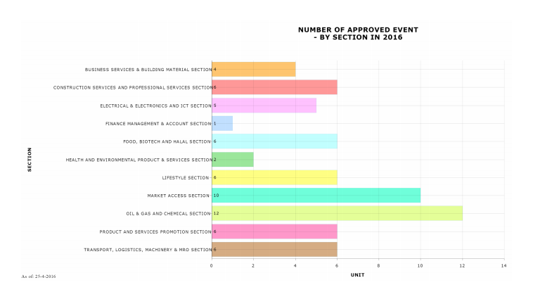

### *Download Data – CSV*

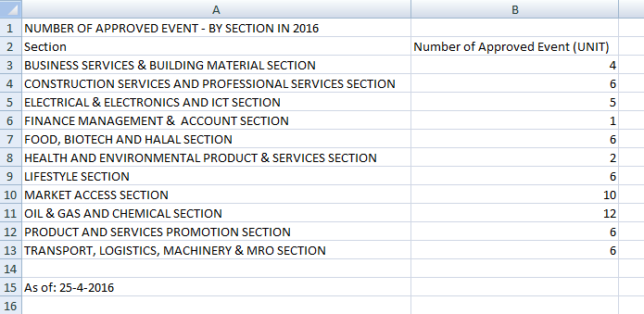

### *Download Data – XLSX*

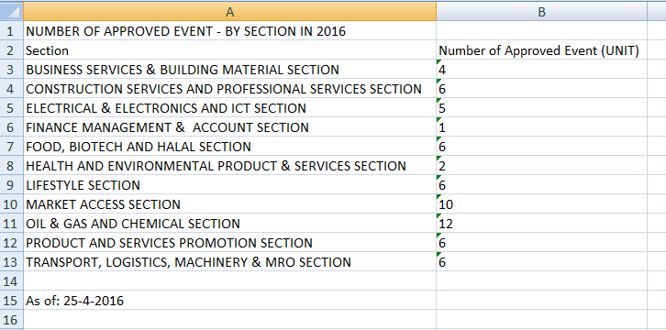

### ***Print Chart***

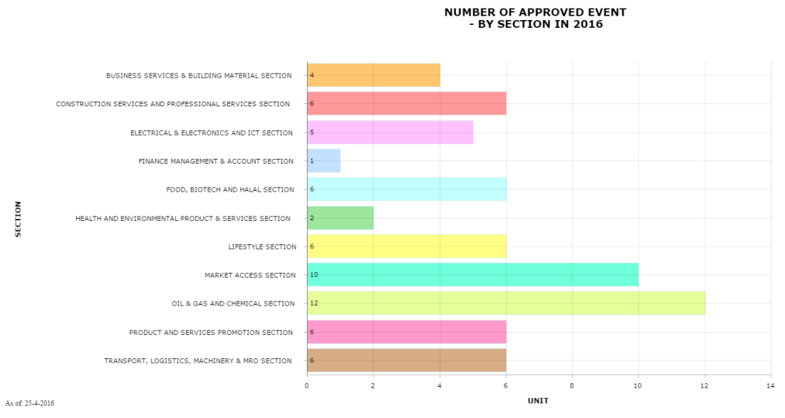

### ***Data Sampling***

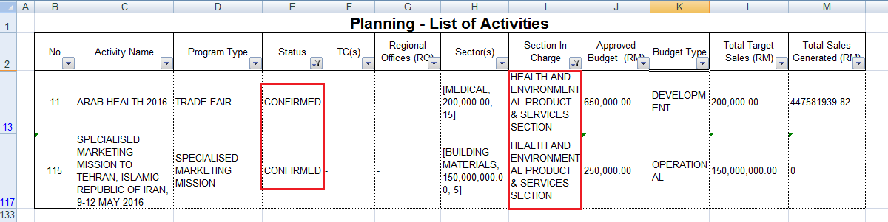

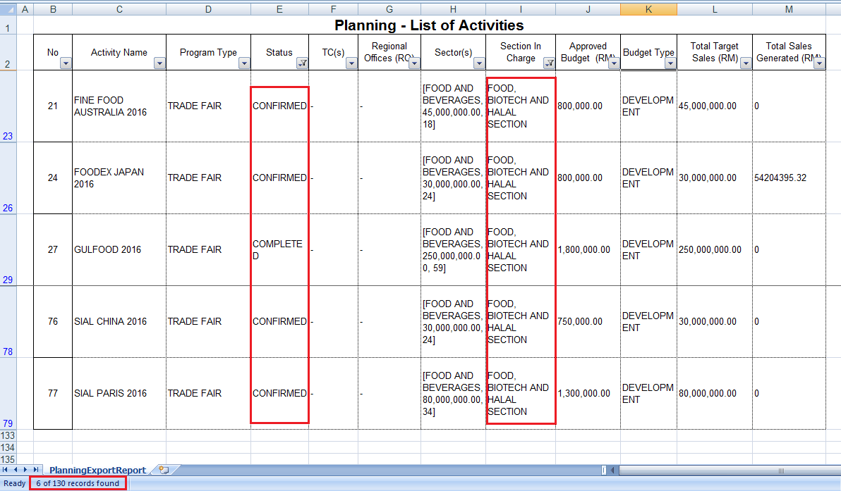

## NUMBER OF APPROVED EVENT – BY SECTOR

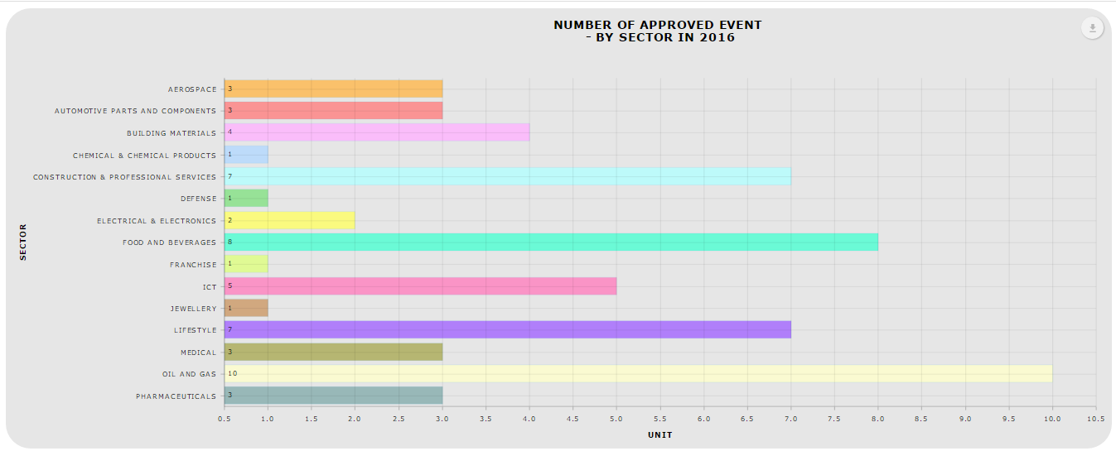

### **Download as image – PDF**

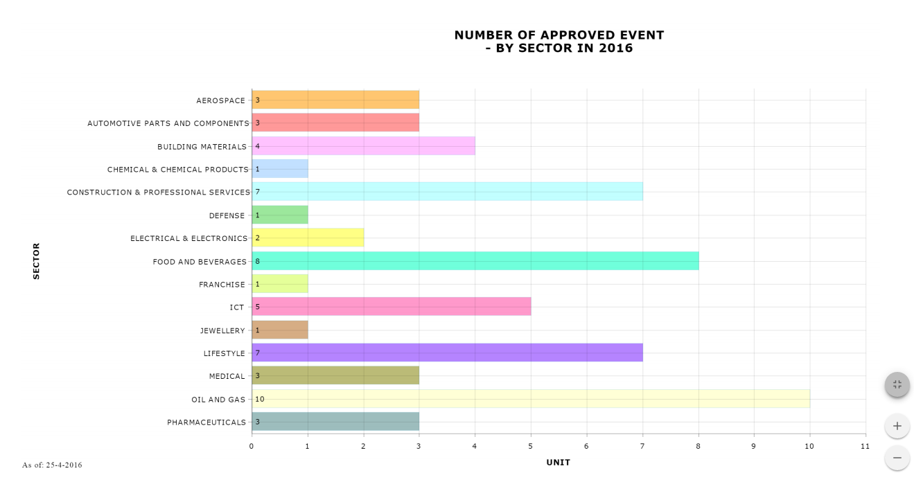

### *Download Data – CSV*

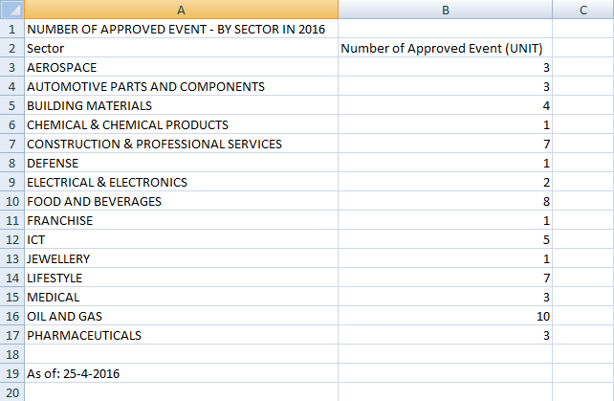

### *Download Data – XLSX*

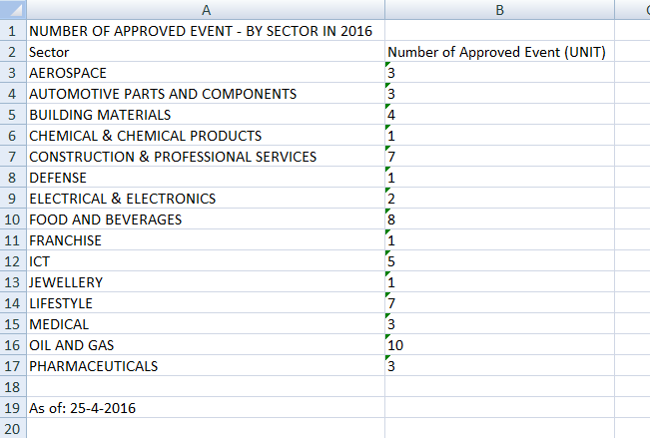

### ***Print Chart***

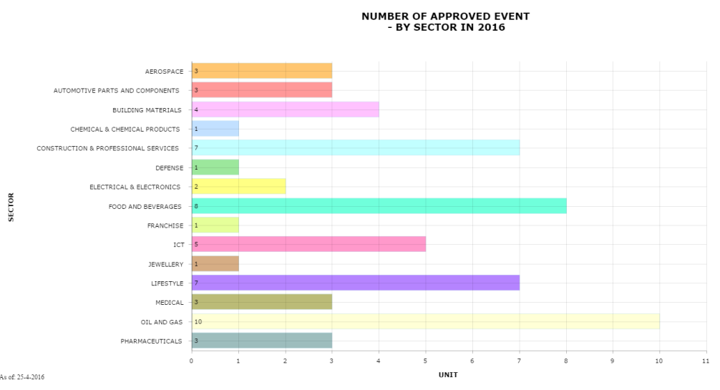

### ***Data Sampling***

