BUDGET

## APPROVED BUDGET – OVERALL

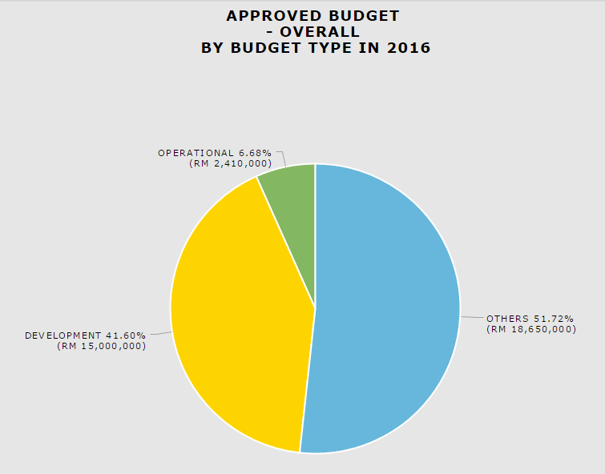

### **Download as image – PDF**

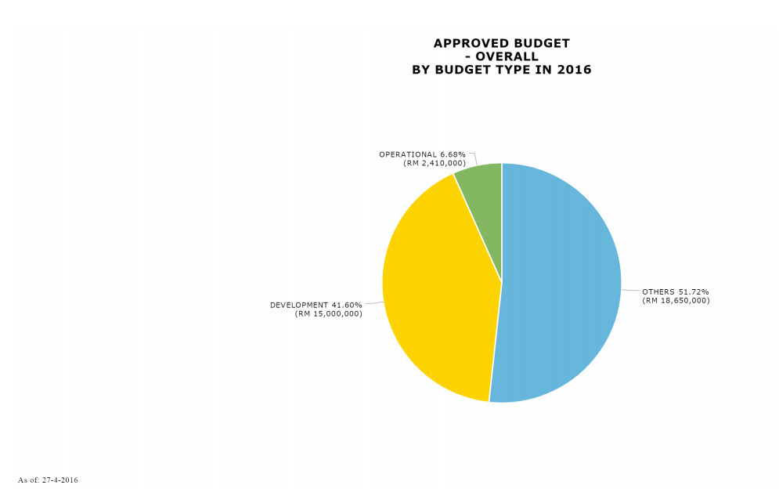

### *Download Data – CSV*

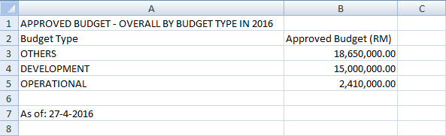

### *Download Data – XLSX*

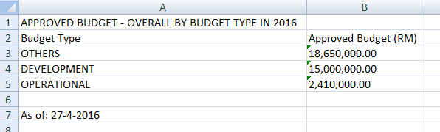

### ***Print Chart***

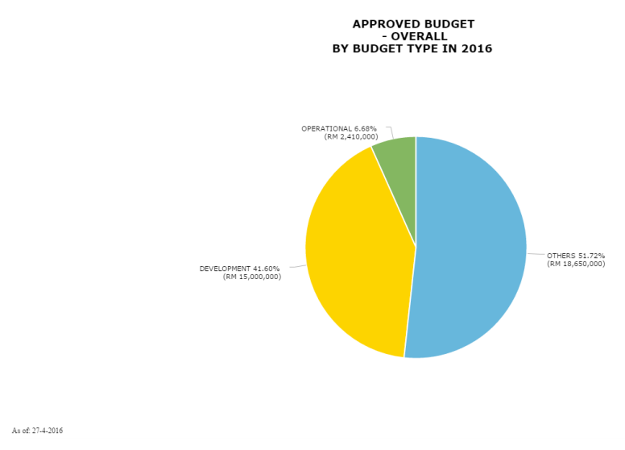

### ***Data Sampling***

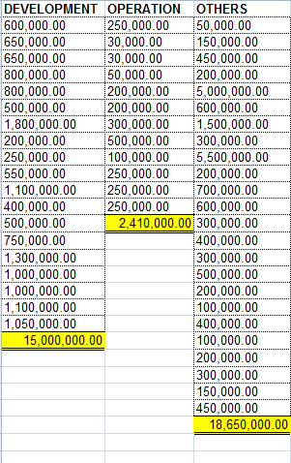

## **APPROVED BUDGET BY REGION**

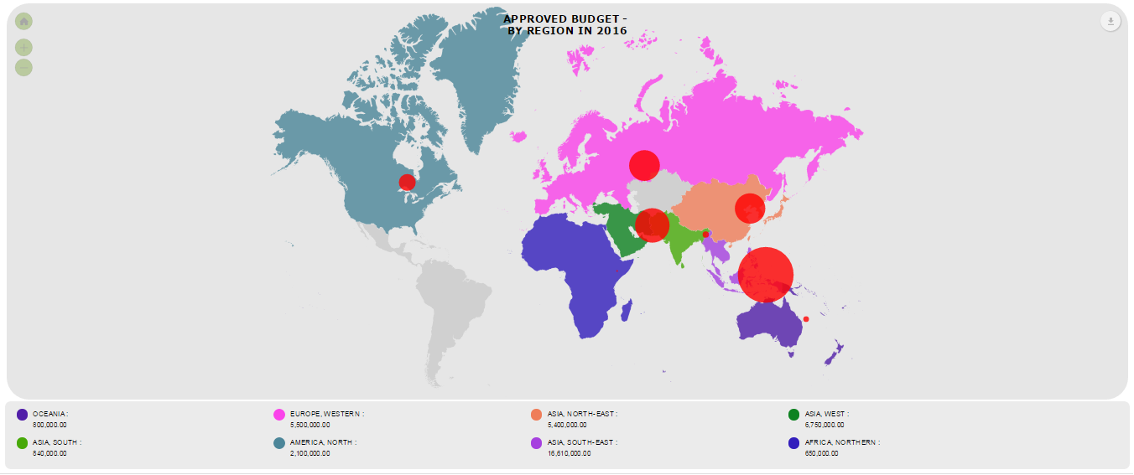

### **Download as image – PDF**

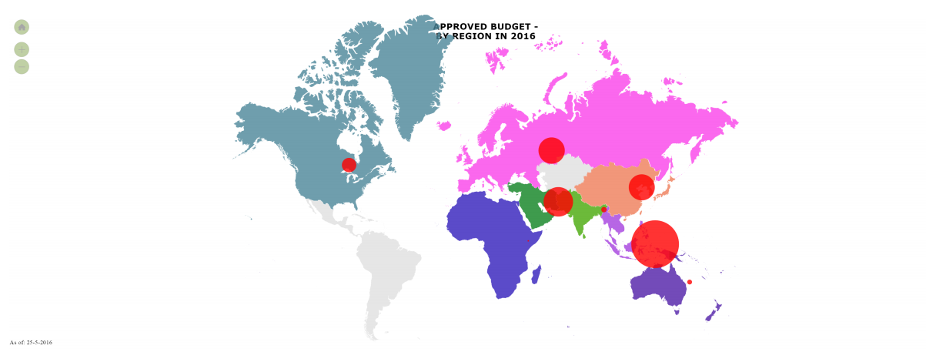

### ***Print Chart***

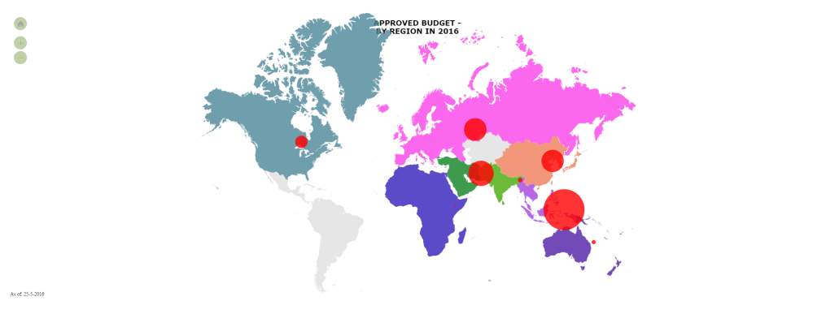

### ***Data Sampling***

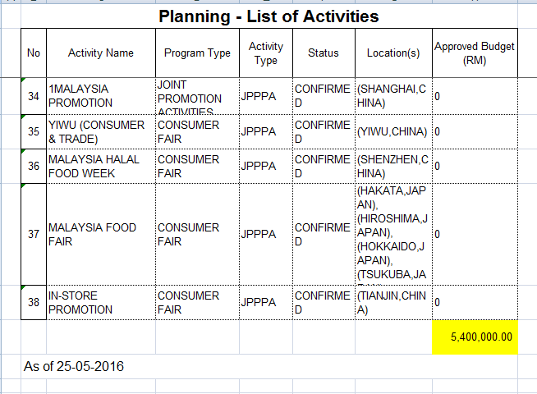

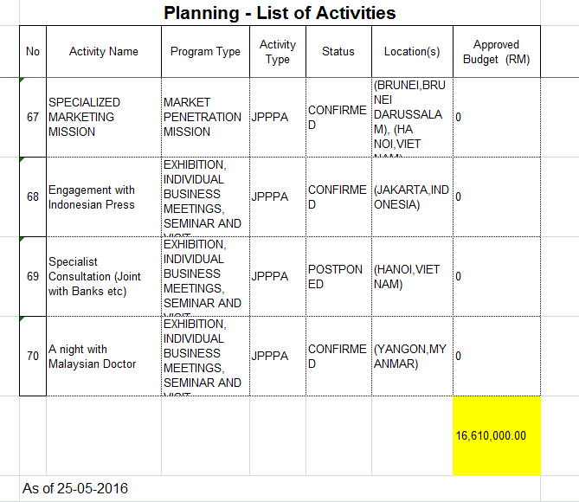

## **APPROVED BUDGET BY SECTION**

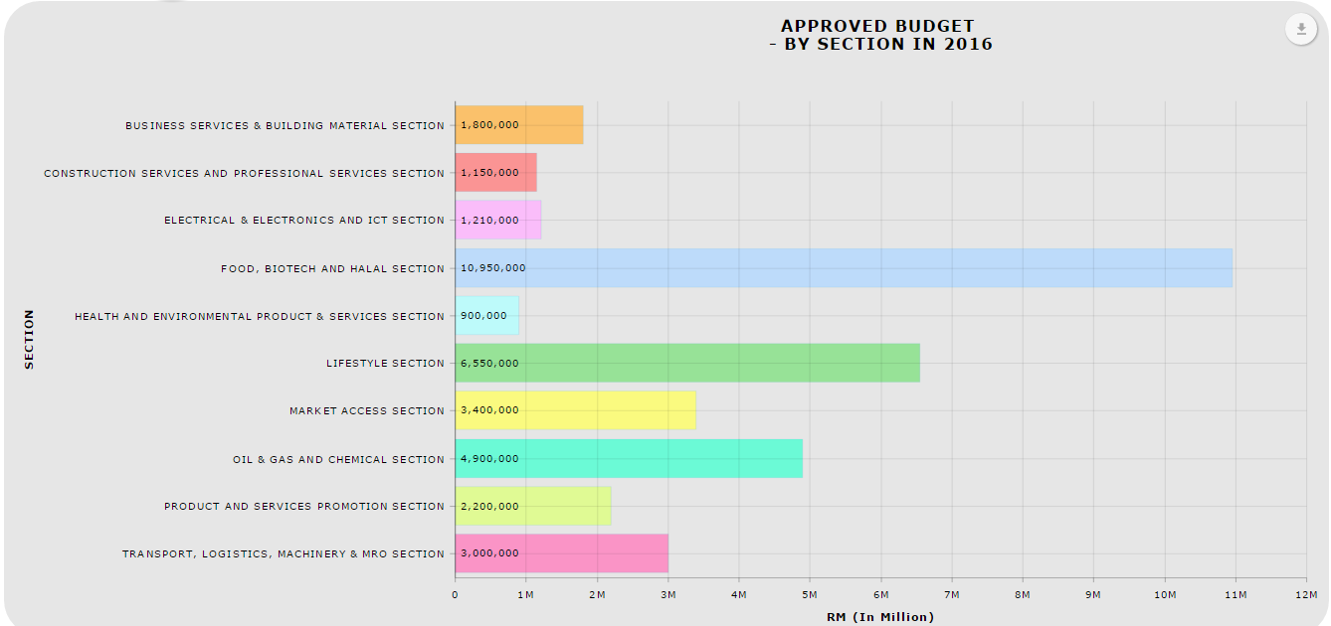

### **Download as image – PDF**

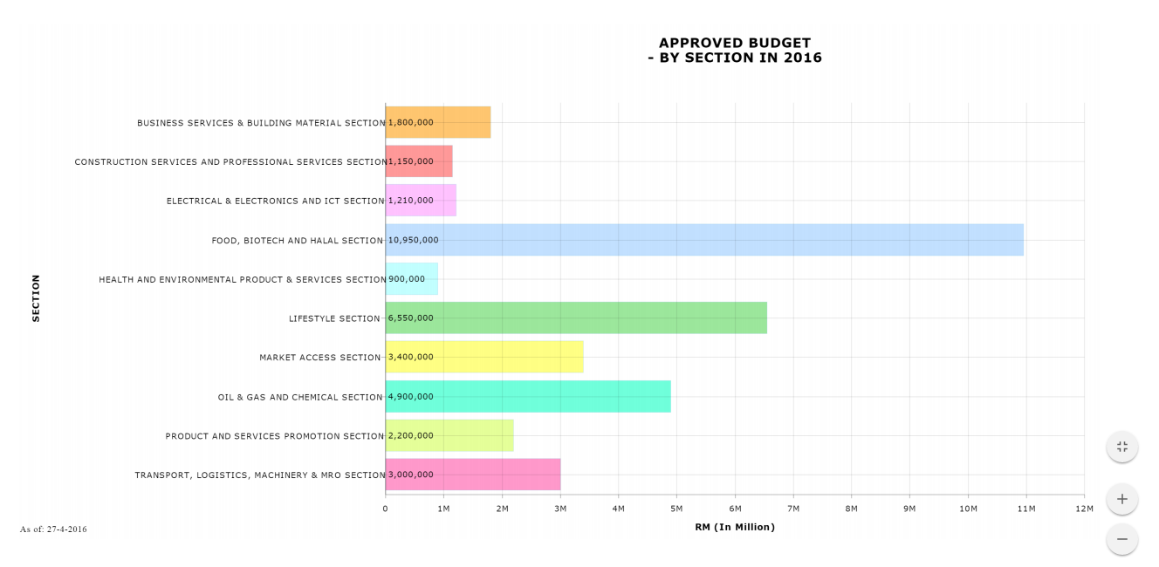

### *Download Data – CSV*

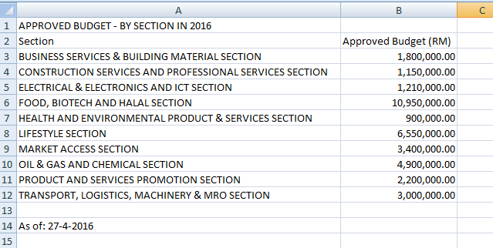

### *Download Data – XLSX*

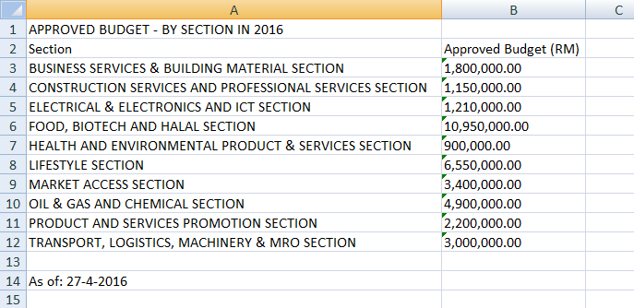

### ***Print Chart***

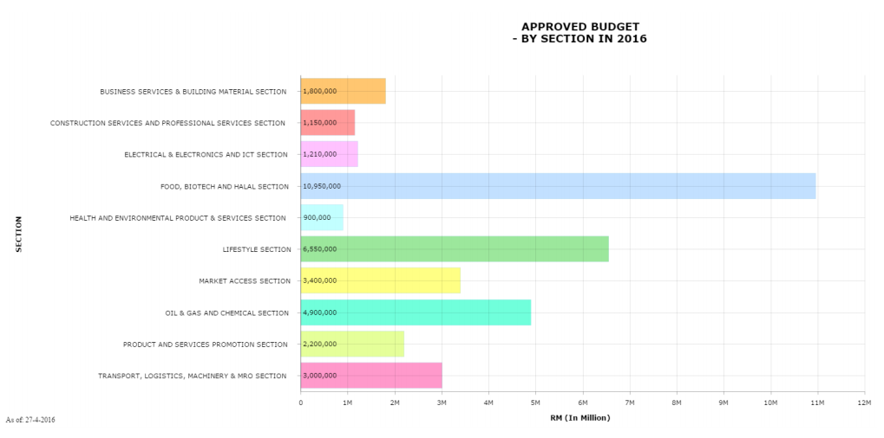

### ***Data Sampling***

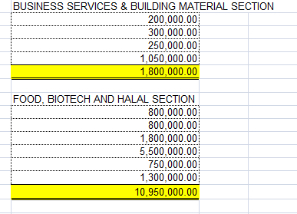

## **APPROVED BUDGET BY PROGRAMME TYPE**

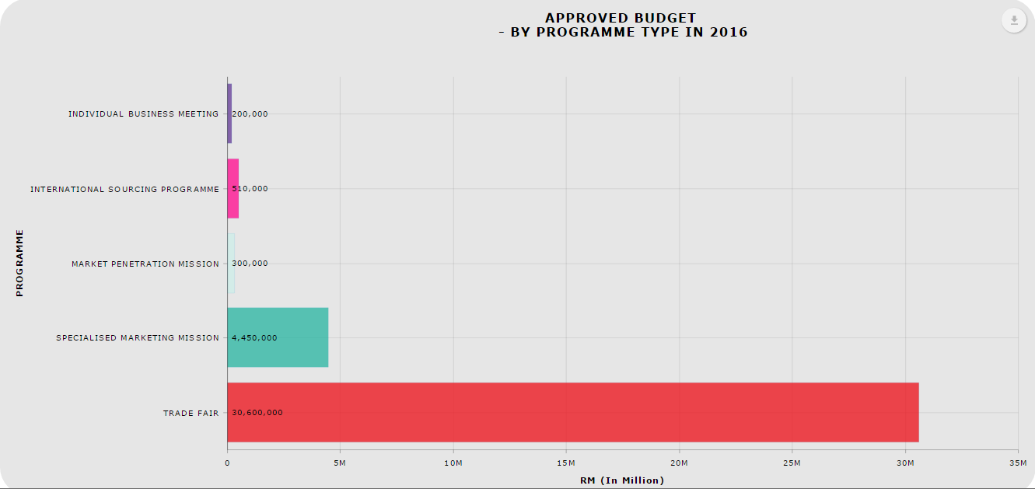

### **Download as image – PDF**

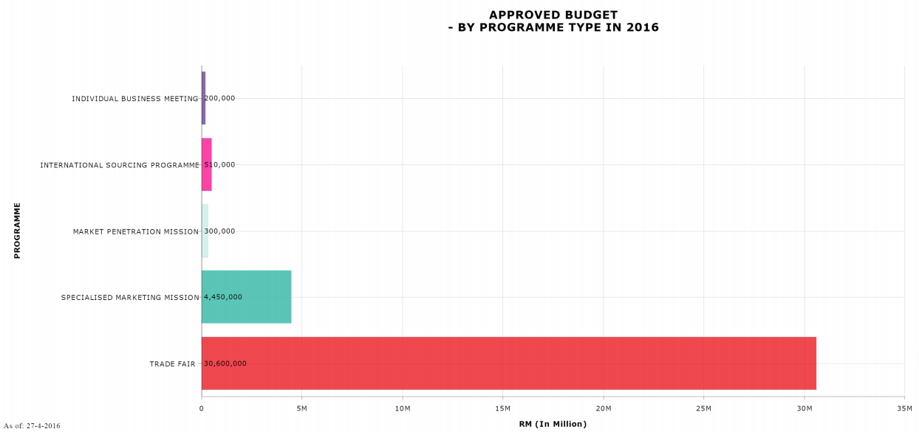

### *Download Data – CSV*

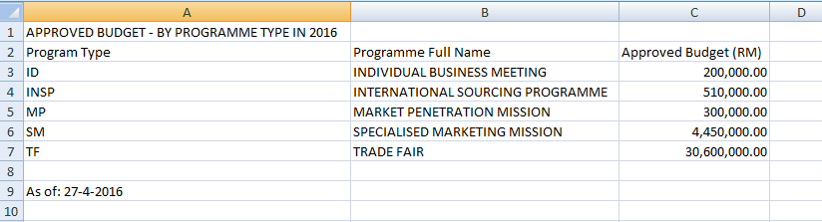

### *Download Data – XLSX*

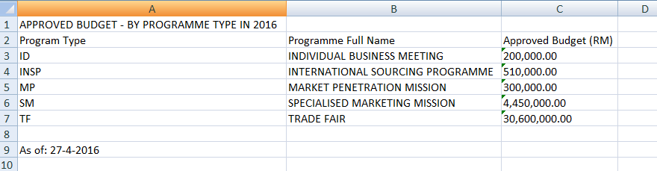

### ***Print Chart***

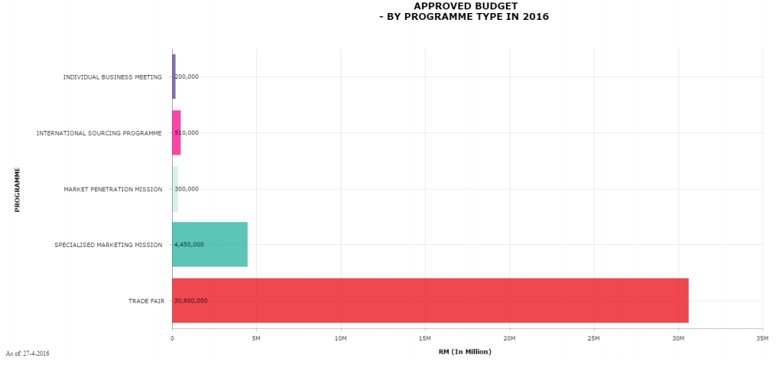

### ***Data Sampling***

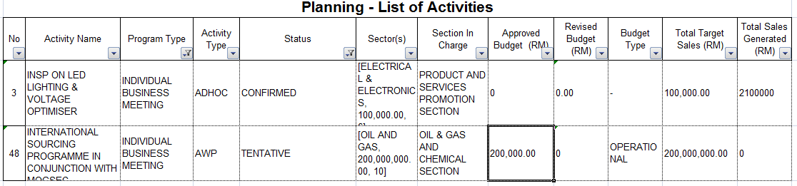

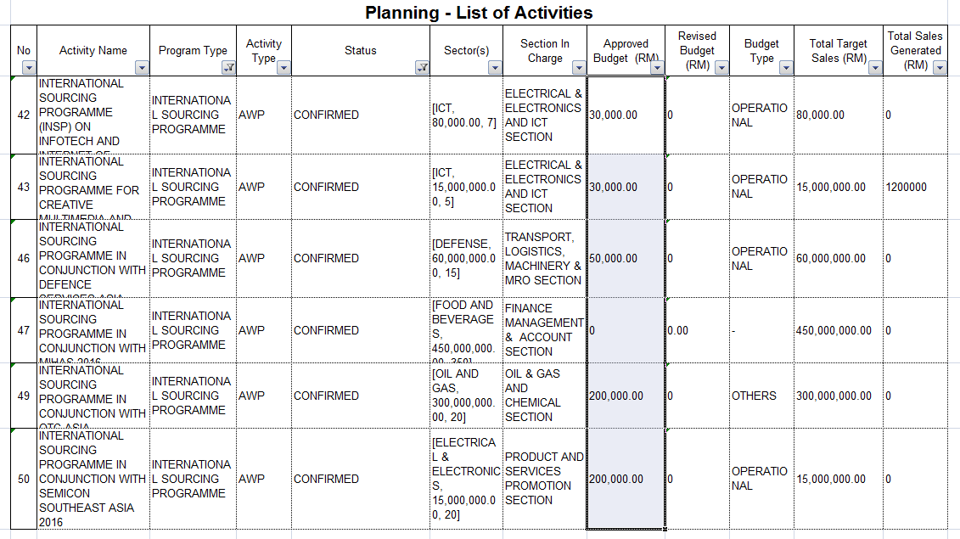

## **APPROVED BUDGET BY SECTOR**

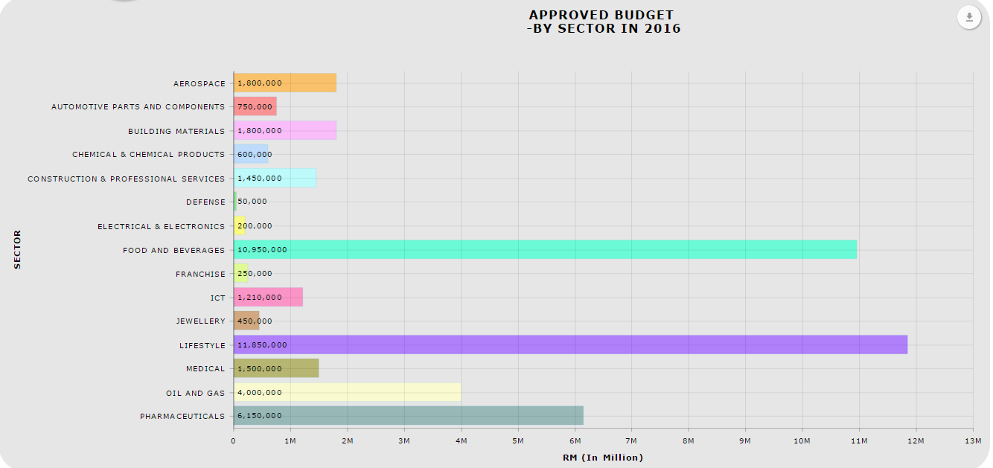

### **Download as image – PDF**

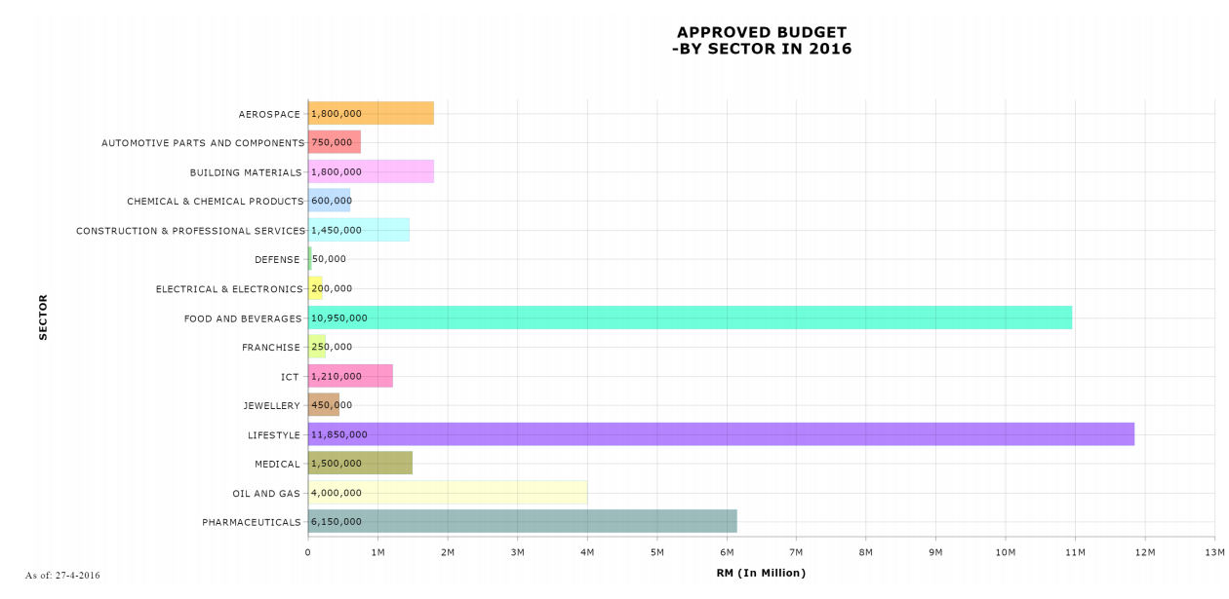

### *Download Data – CSV*

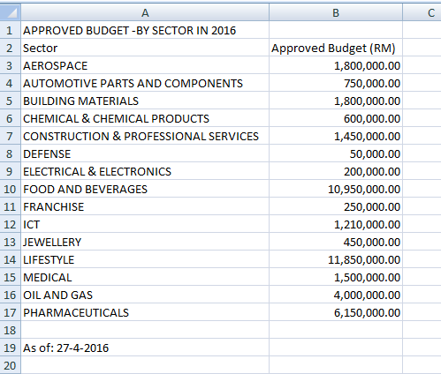

### *Download Data – XLSX*

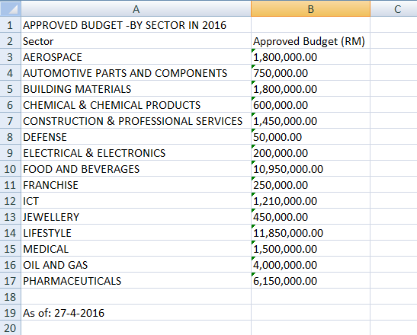

### ***Print Chart***

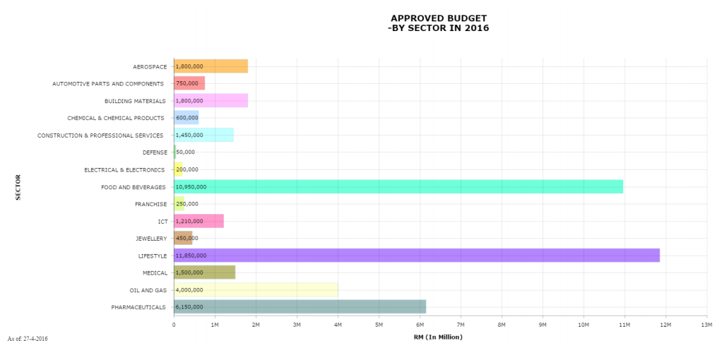

### ***Data Sampling***

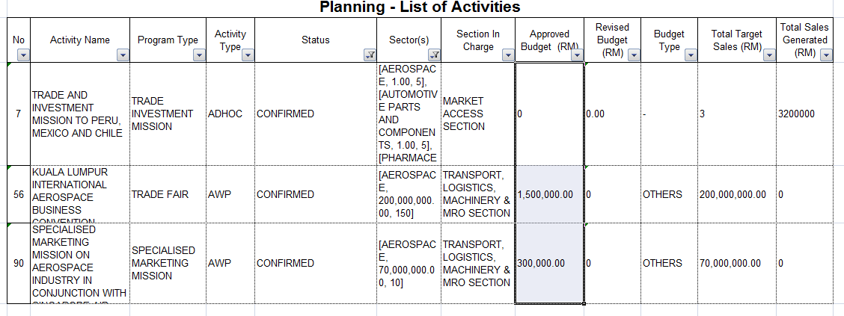

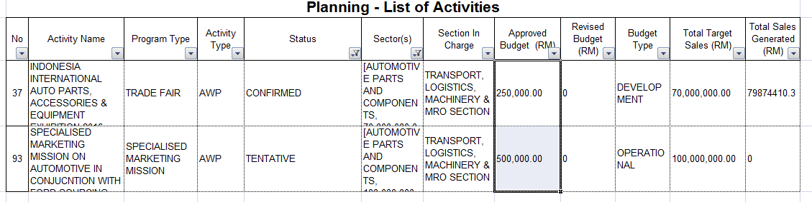

## **APPROVED BUDGET VS UTILIZED BUDGET BY SECTION**

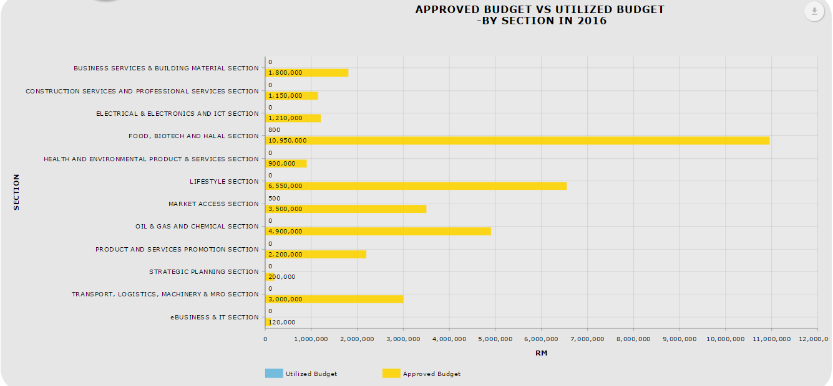

### **Download as image – PDF**

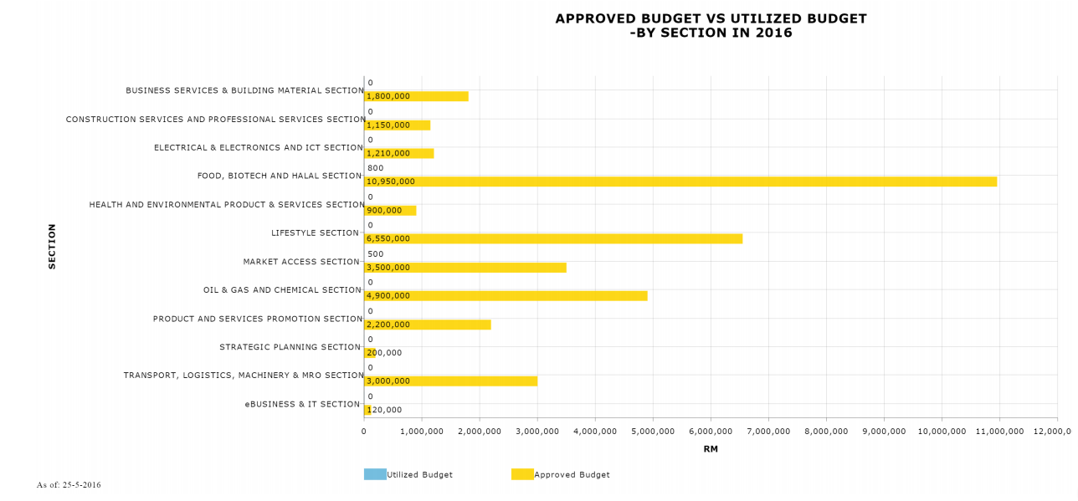

### *Download Data – CSV*

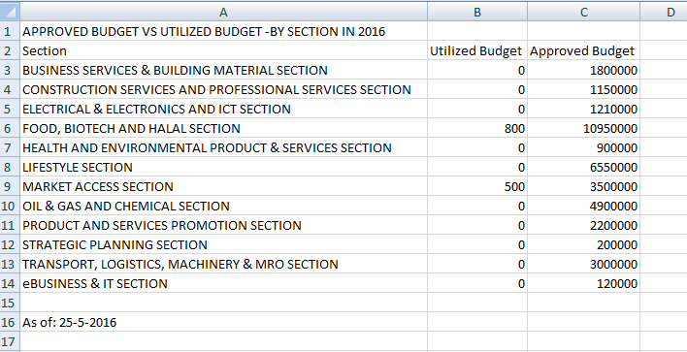

### *Download Data – XLSX*

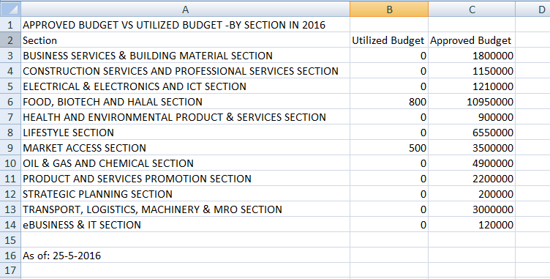

### ***Print Chart***

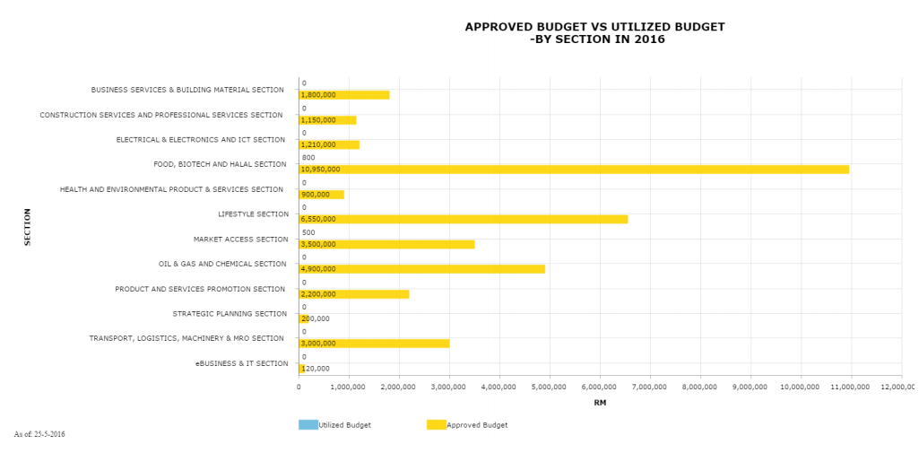

### ***Data Sampling***

|  |  |  |  |  |
| --- | --- | --- | --- | --- |
| **em_title** | **r_sect_eng** | **eb_budget_year** | **sum_ed_budget_approved** | **ebp_utilize_hq_amount** |
| SPECIALISED MARKETING MISSION FOR CONSTRUCTION, BUILDING MATERIALS & ICT INCONJUNCTION WITH ECOBUILD LONDON, UK | BUSINESS SERVICES & BUILDING MATERIAL SECTION | 2016 | 300,000 | 0 |
| SPECIALISED MARKETING MISSION ON FRANCHISE SECTOR IN CONJUNCTION WITH CHINA (BEIJING) FRANCHISE EXPO | BUSINESS SERVICES & BUILDING MATERIAL SECTION | 2016 | 250,000 | 0 |
| INDOBUILDTECH EXPO 2016 | BUSINESS SERVICES & BUILDING MATERIAL SECTION | 2016 | 200,000 | 0 |
| THE BIG 5 SHOWS 2016 | BUSINESS SERVICES & BUILDING MATERIAL SECTION | 2016 | 1,050,000 | 0 |
|  |  |  | 1,800,000.00 | - |

|  |  |  |  |  |
| --- | --- | --- | --- | --- |
| **m_title** | **r_sect_eng** | **eb_budget_year** | **sum_ed_budget_approved** | **ebp_utilize_hq_amount** |
| FINE FOOD AUSTRALIA 2016 | FOOD, BIOTECH AND HALAL SECTION | 2016 | 800,000 | 0 |
| GULFOOD 2016 | FOOD, BIOTECH AND HALAL SECTION | 2016 | 1,800,000 | 0 |
| SIAL CHINA 2016 | FOOD, BIOTECH AND HALAL SECTION | 2016 | 750,000 | 0 |
| MIHAS 2016 | FOOD, BIOTECH AND HALAL SECTION | 2016 | 5,500,000 | 0 |
| FOODEX JAPAN 2016 | FOOD, BIOTECH AND HALAL SECTION | 2016 | 800,000 | 800 |
| SIAL PARIS 2016 | FOOD, BIOTECH AND HALAL SECTION | 2016 | 1,300,000 | 0 |
|  |  |  | 10,950,000 | 800 |