Test Issue Log |  |  |  |  |  | Issue ID# : TPMS_Prod133
Project Name: | Trade Promotion Management System (TPMS)
Test Stage: | Unit Functionality Integration System Interface  Performance Regression Acceptance Pilot
Test Case Number: | Support # 6271 |  |  | Test Started Date: |  |  | 27/05/2016
Test Title: | Foreign Buyer Registration
Test Description: | To test on Foreign Buyer Registration.
Test Functionality: | Promotion >> View >> Business Meeting >> Register Buyer
Test Procedure: | - Click on Promotion >> View >> Business Meeting >> Register Buyer
Test Result: | Pass: Fail:  Conditional Pass: : |  | Tested by: |  | Siti Norahayu Binti Mohd Desa
Reason for Failure:
TEST DESCRIPTION
Issue:
TC able to register foreign buyer successfully.
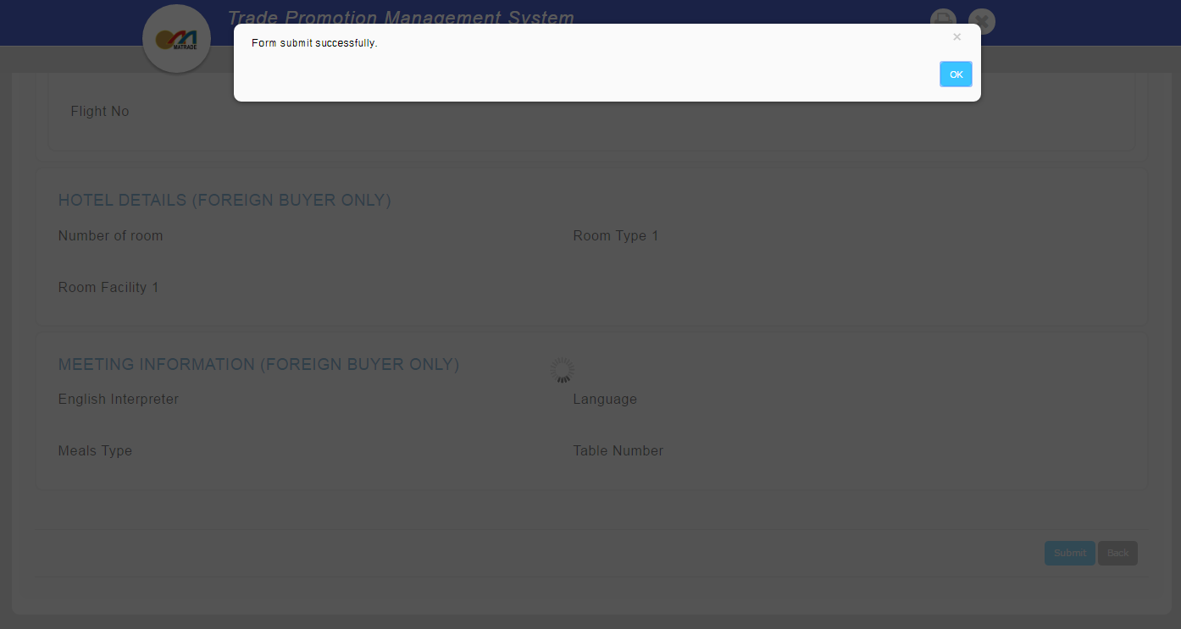
Reviewed By: (PMO)
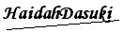 |  | Name/Position : Norhaidah Binti Md Dasuki / Senior Manager, Quality Assurance and Support  Date : 27/05/2016

