Gold Account-i

<http://www.kfh.com.my/kfhmb/v2/contentView.do?contentTypeId=3000&displayPage=%2Fver2%2Fcontent%2Fstandard.jsp&pageTypeId=12852&channelPath=%2Fver2%2Fv2_Navigation%2FConsumer+Banking%2FInvestments&programName=01-Investments&contentId=15731>

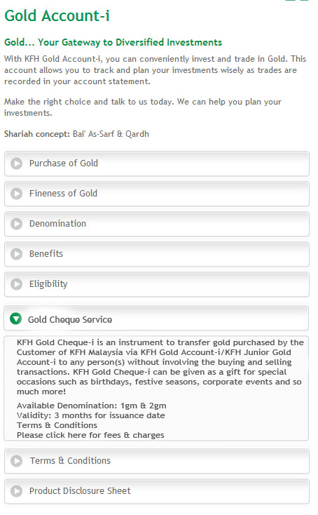

<http://www.kfh.com.my/kfhmb/v2/contentView.do?contentTypeId=3000&displayPage=%2Fver2%2Fcontent%2Fstandard.jsp&pageTypeId=12873&channelPath=%2Fver2%2Fv2_Navigation%2FRates%2C+Fees+and+Charges&programName=00_Fees&contentId=13611>

KFH Gold Cheque-i is an instrument to transfer gold purchased by the Customer of KFH Malaysia via KFH Gold Account-i/KFH Junior Gold Account-i to any person(s) without involving the buying and selling transactions. KFH Gold Cheque-i can be given as a gift for special occasions such as birthdays, festive seasons or corporate events.Available Denomination: 1gm & 2gmValidity: 3 months for issuance dateTerms & ConditionsPlease click here for fees & charges

Jr Gold

<http://www.kfh.com.my/kfhmb/v2/contentView.do?contentTypeId=3000&displayPage=%2Fver2%2Fcontent%2Fstandard.jsp&pageTypeId=12852&channelPath=%2Fver2%2Fv2_Navigation%2FConsumer+Banking%2FInvestments&programName=01-Investments&contentId=15832>

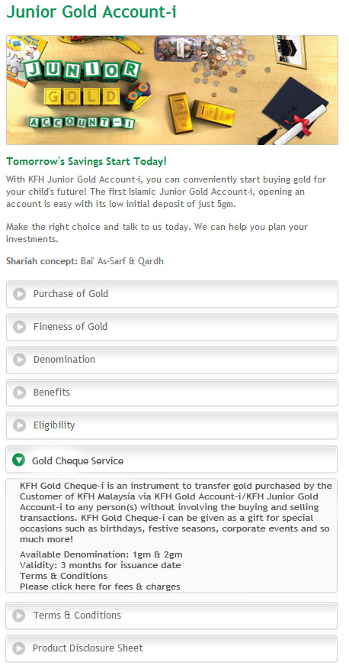

<http://www.kfh.com.my/kfhmb/v2/contentView.do?contentTypeId=3000&displayPage=%2Fver2%2Fcontent%2Fstandard.jsp&pageTypeId=12873&channelPath=%2Fver2%2Fv2_Navigation%2FRates%2C+Fees+and+Charges&programName=00_Fees&contentId=13611>

KFH Gold Cheque-i is an instrument to transfer gold purchased by the Customer of KFH Malaysia via KFH Gold Account-i/KFH Junior Gold Account-i to any person(s) without involving the buying and selling transactions. KFH Gold Cheque-i can be given as a gift for special occasions such as birthdays, festive seasons or corporate events.Available Denomination: 1gm & 2gmValidity: 3 months for issuance dateTerms & ConditionsPlease click here for fees & charges

Fees & Charges

<http://www.kfh.com.my/kfhmb/v2/contentView.do?contentTypeId=3000&displayPage=%2Fver2%2Fcontent%2Fstandard.jsp&pageTypeId=12873&channelPath=%2Fver2%2Fv2_Navigation%2FRates%2C+Fees+and+Charges&programName=00_Fees&contentId=13611>

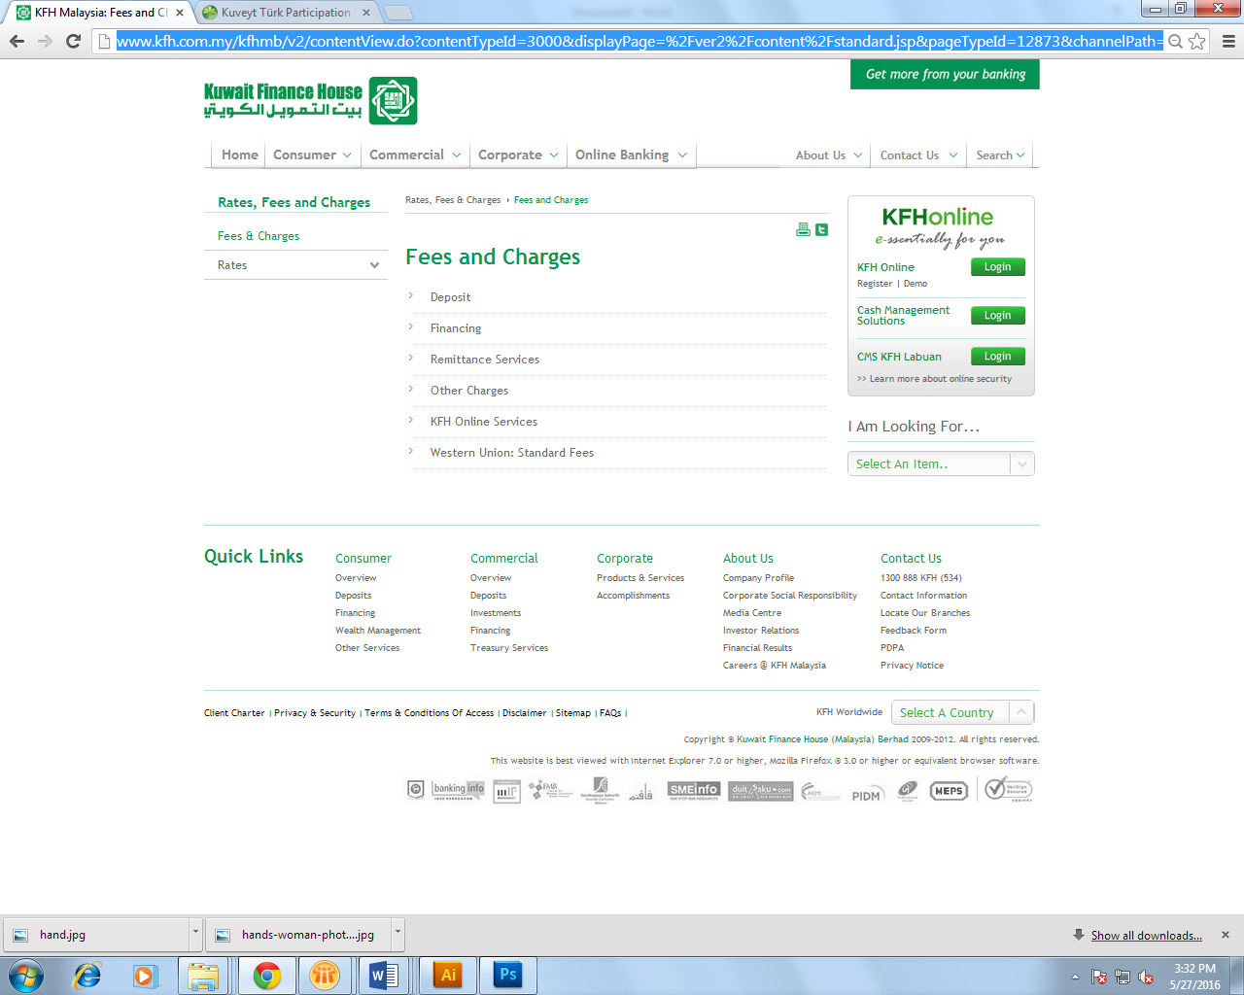

Change to Deposits & Investments