Update table at:

<http://www.kfh.com.my/kfhmb/v2/contentView.do?contentTypeId=3000&displayPage=%2Fver2%2Fcontent%2Fstandard.jsp&channelPath=%2Fver2%2Fv2_Navigation%2FI+am+looking+for&programName=06_PIDM&tabId=7&cntName=05-PIDM>

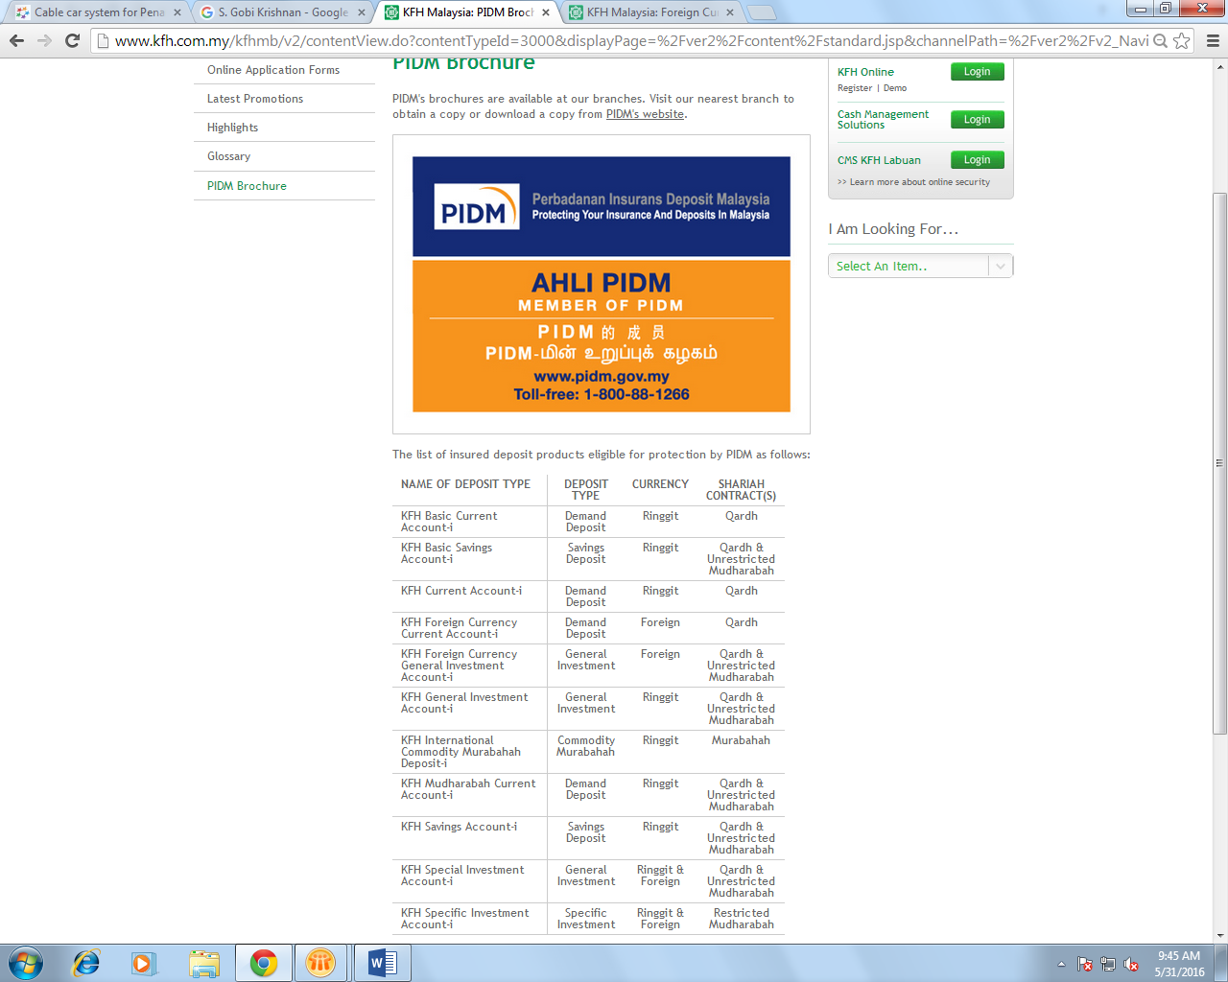

|  |  |  |  |
| --- | --- | --- | --- |
| **NAME OF DEPOSIT TYPE** | **DEPOSIT TYPE** | **CURRENCY** | **SHARIAH CONTRACT(S)** |
| KFH Basic Current Account-i | Demand Deposit | Ringgit | Qardh |
| KFH Current Account-i | Demand Deposit | Ringgit | Qardh |
| KFH Sure Current Account-i | Demand Deposit | Ringgit | MurabahahTawarruq |
| KFH Foreign Currency Current Account-i | Demand Deposit | Foreign | Qardh |
| KFH Basic Savings Account-i | Savings Deposit | Ringgit | Qardh |
| KFH Savings Account-i | Savings Deposit | Ringgit | Qardh |
| KFH Sure Savings Account-i | Savings Deposit | Ringgit | MurabahahTawarruq |
| KFH International Commodity Murabahah Deposit-i | Term Deposit | Ringgit | MurabahahTawarruq |
| KFH Foreign Currency International Commodity Murabahah Deposit-i | Term Deposit | Foreign | MurabahahTawarruq |
| KFH Junior International Commodity Murabahah Deposit-i | Term Deposit | Ringgit | MurabahahTawarruq |