**Main Page**

1. To create new TAB **“Discounts and Privileges”** under **“Cards”** product

2. To rearrange the Tabs

3. To add word “Tips” after “Safe Banking” sentence

**Cards**

Debit Card-i

Promotions

Discounts and Privileges

Get Started

Safe Banking Tips

MyDebit

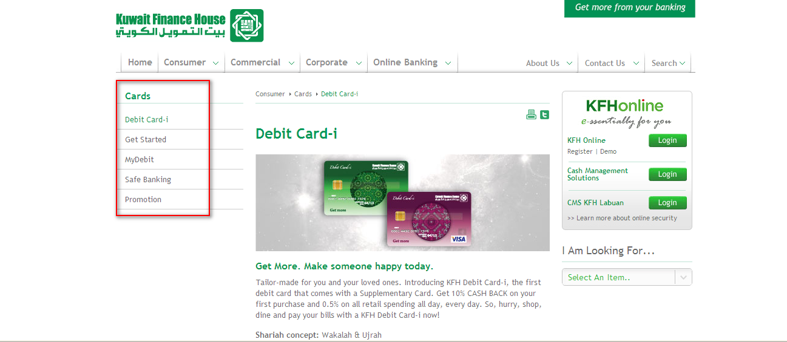

**Discounts and Privileges**

The KFH Debit Card-i Get More! program strives to create greater value for our cardmembers. Our efforts have always been to meet your lifestyle expectations and to ensure that our cardmembers do not miss out any good deals.

Our discounts and privileges includes various leading and prominent merchants, covering F&B and Dining, Health and Wellness, IT and Gadget, Fashion and Accessories, Beauty and many more.! Just spend and swipe with your KFH Debit Card-i at any of the participating merchants, to enjoy a range of exciting shopping deals created for your family and you.



|  |  |  |  |  |  |  |  |
| --- | --- | --- | --- | --- | --- | --- | --- |
| **Exclusive discounts**  **reserved**  **FOR**  **KFH Debit Card-i**      Kfh.com.my 1300 888 KFH (534) | See a discounts and privileges you like?  Page   |  | | --- | | F&B and Dining 2 |  |  | | --- | | Health and Wellness 3 |  |  | | --- | | IT and Gadget 4 |  |  | | --- | | Fashion and Accessories 5 |  |  | | --- | | Beauty 5 |  |  | | --- | | Others |   * Able to click the icon and it will direct to the next page |

|  |  |
| --- | --- |
| **F&B and Dining** |  |
| |  |  | | --- | --- | | Logo | **Name of the merchant**  **Details of the deal**  i.e  GNC LIVE WELL  **15%** discount on GNC and LAC products |   * Able to click the icon and it will direct to the artwork and details of the T&C |  |