Test Issue Log |  |  |  |  |  | Issue ID# : TPMS_Prod130
Project Name: | Trade Promotion Management System (TPMS)
Test Stage: | Unit Functionality Integration System Interface  Performance Regression Acceptance Pilot
Test Case Number: | Support # 6248 |  |  | Test Started Date: |  |  | 01/06/2016
Test Title: | Pre-arrangement preparation by MATRADE information display null
Test Description: | To test on Pre-Arrangement preparation by MATRADE
Test Functionality: | Post Event >> Event Report >> Evaluation by Event
Test Procedure: | - Post Event >> Event Report >> Evaluation by Event
Test Result: | Pass: Fail:  Conditional Pass: : |  | Tested by: |  | Siti Norahayu Binti Mohd Desa
Reason for Failure:
TEST DESCRIPTION
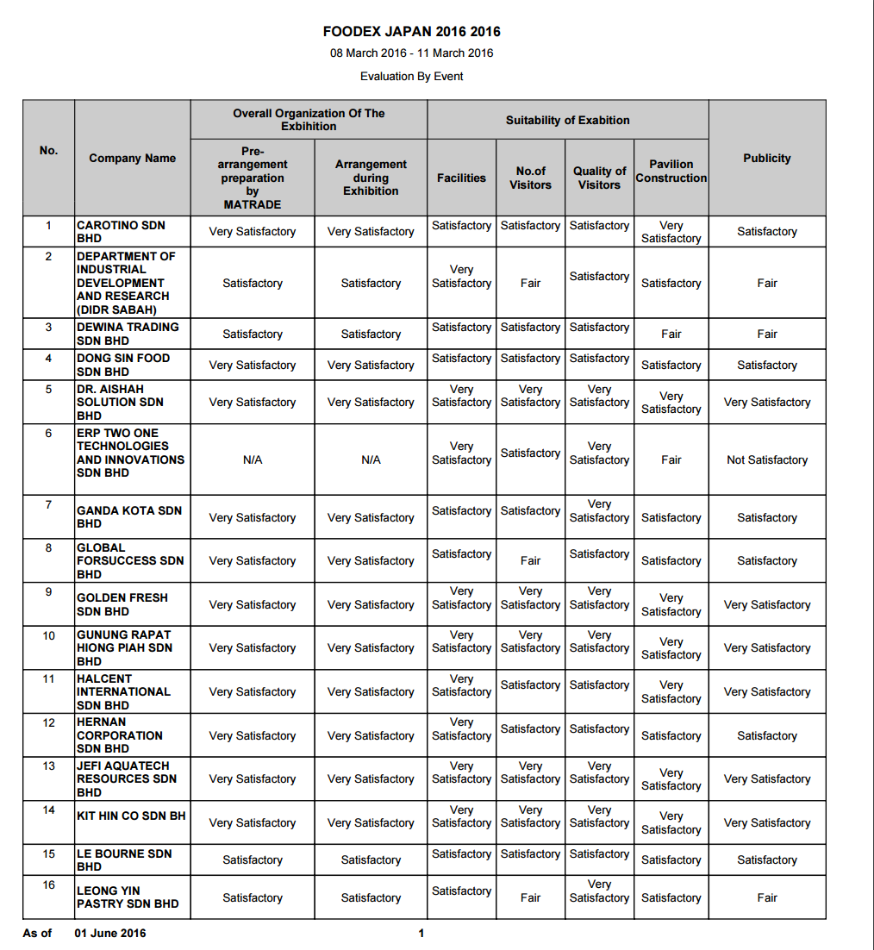

Reviewed By: (PMO)
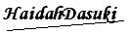 |  | Name/Position : Norhaidah Binti Md Dasuki / Senior Manager, Quality Assurance and Support  Date : 30/05/2016

