Test Issue Log |  |  |  |  |  | Issue ID# : TPMS_GL001
Project Name: | Trade Promotion Management System (TPMS)
Test Stage: | Unit Functionality Integration System Interface  Performance Regression Acceptance Pilot
Test Case Number: | Support #6307 |  |  | Test Started Date: |  |  | 07/06/2016
Test Title: | TC value not appear when export in PDF and Excel.
Test Description: | To test on TC value in export PDF and Excel function.
Test Functionality: | Planning >> Activity List >> Export as option
Test Procedure: | Planning >> Activity List >> Export as option
Test Result: | Pass: Fail:  Conditional Pass: : |  | Tested by: |  | Siti Norahayu Binti Mohd Desa
Reason for Failure:
TEST DESCRIPTION
List activities display at the system
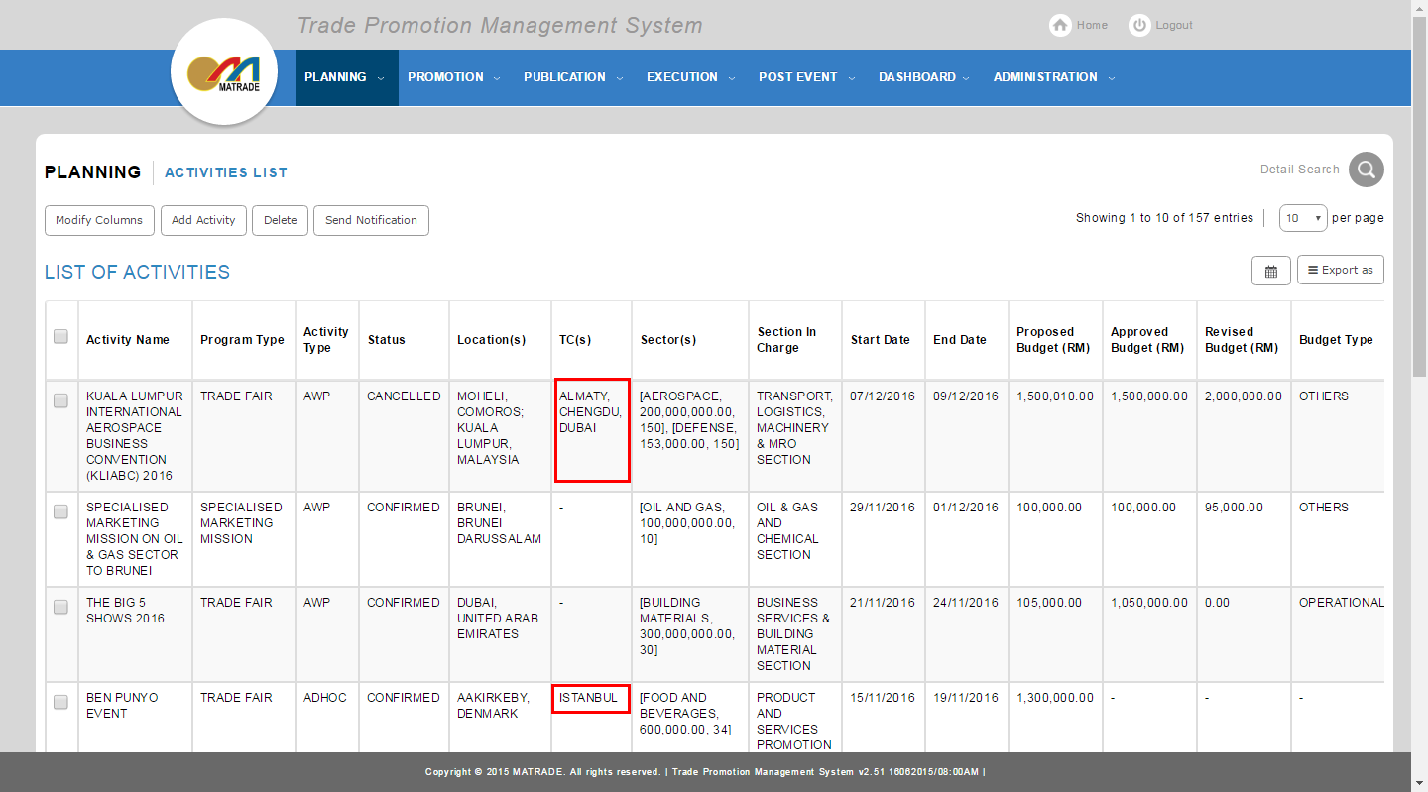

Export as PDF
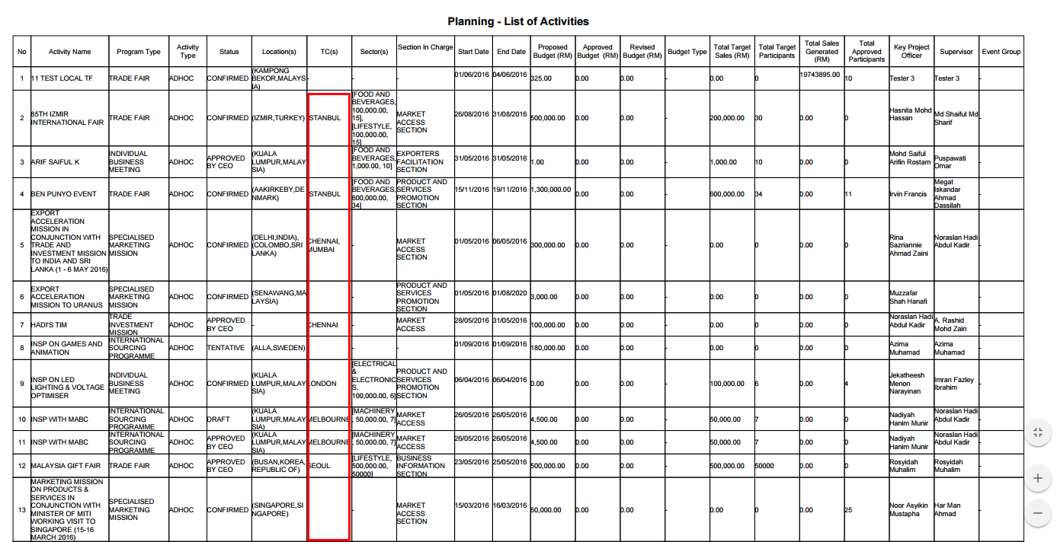

Export as Excel
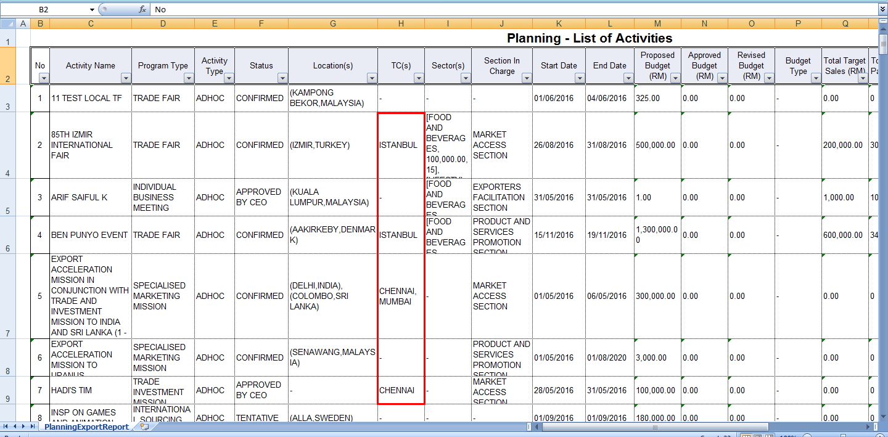

Reviewed By: (PMO)
 |  | Name/Position : Norhaidah Binti Md Dasuki / Senior Manager, Quality Assurance and Support  Date : 07/06/2016

