Test Issue Log
Project Name: | CMS Labuan
Test Stage: | Unit Functionality Integration System Interface  Performance Regression Acceptance Pilot
Test Case Number: | Task#6004 |  |  | Test Started Date: |  | 08/06/2016
Test Title: | CMS Labuan - Ordering Customer Country of Origin map to Swift 50K
Test Description: | To test Ordering Customer Country of Origin field map to Swift 50K fifth line.
Test Functionality: | Open Foreign Telegraphic Transfer  Registered Foreign Telegraphic Transfer
Test Procedure: | - Perform Open & Registered FTT transaction: Fill all field including optional & mandatory fields.  - Print Receipt  - Generate Swift File.
Test Result: | Pass: Fail: | Tested by: |  |  | Nurul Akmal binti Yusof
Reason for Failure:
TEST DESCRIPTION

Open FTT

Confirm page
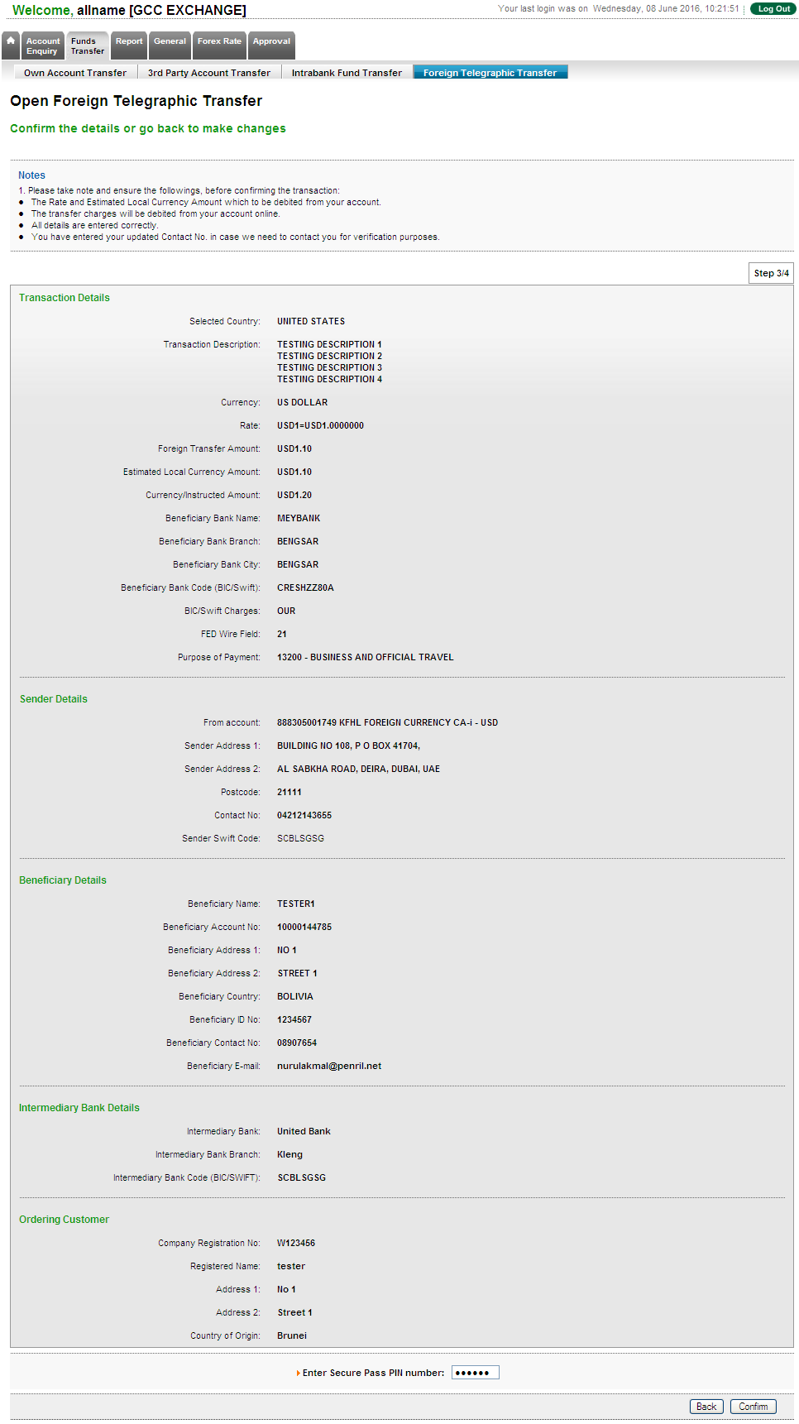

Result page
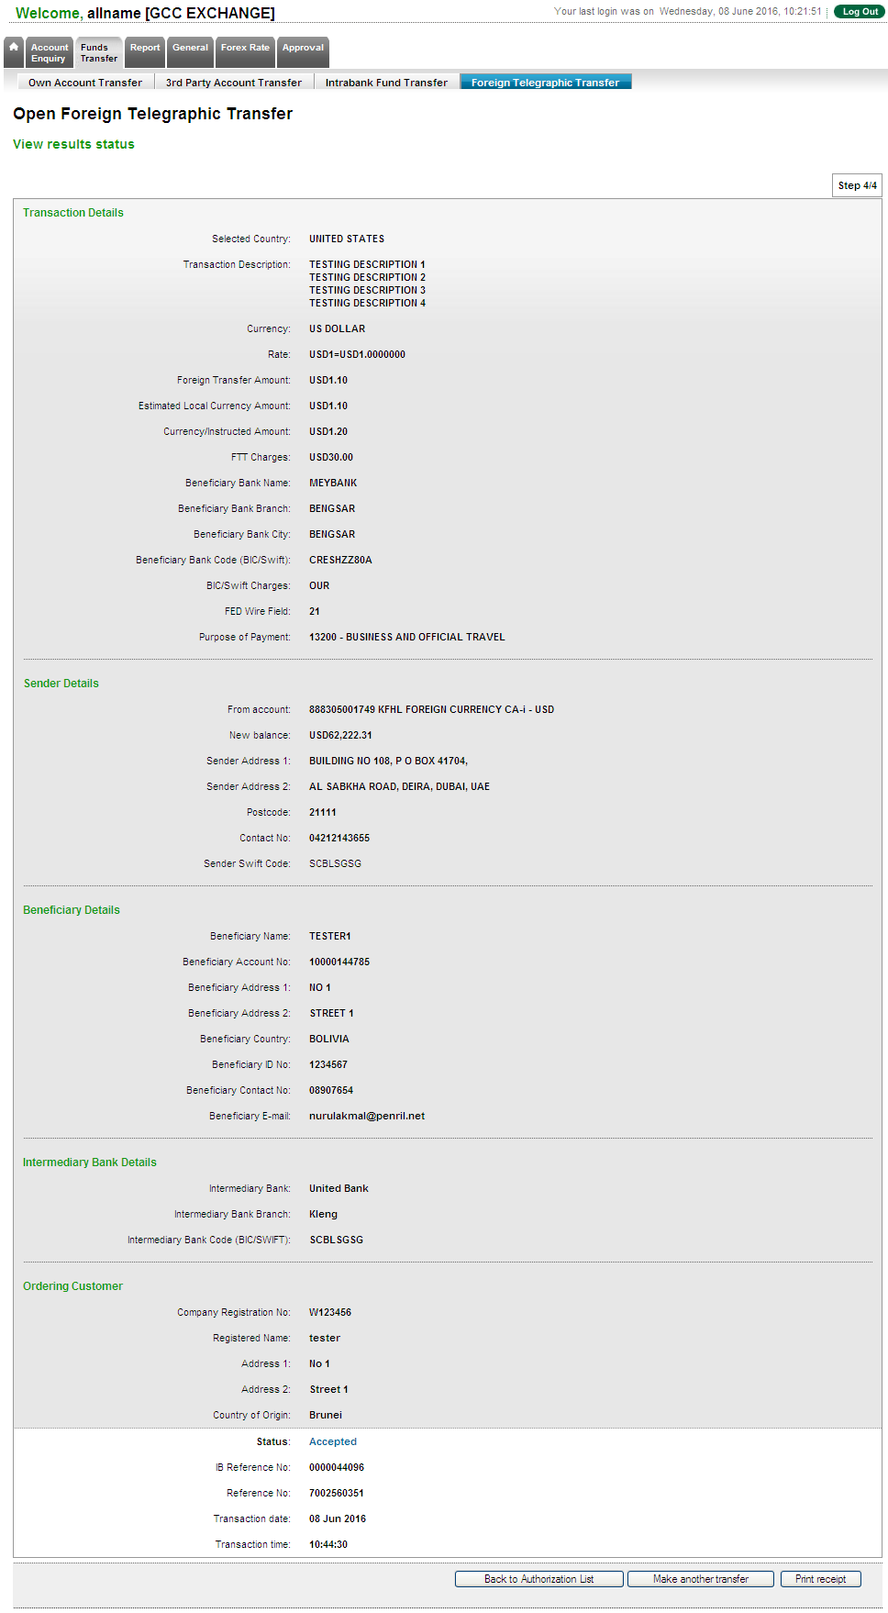

Print Receipt
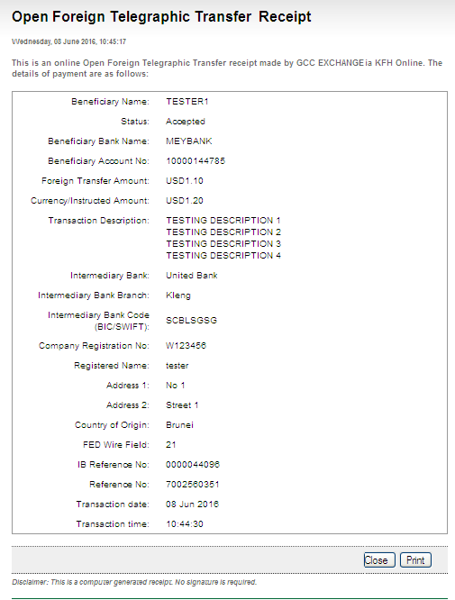

Generated SWIFT103 Text File
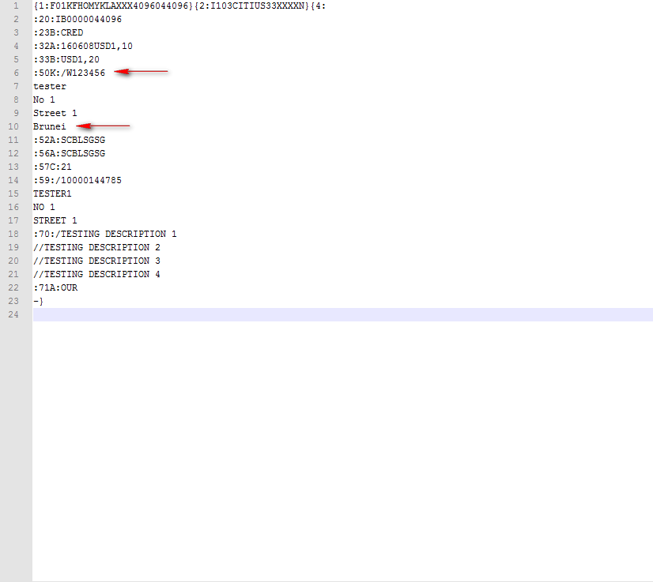

Registered FTT

Confirm page
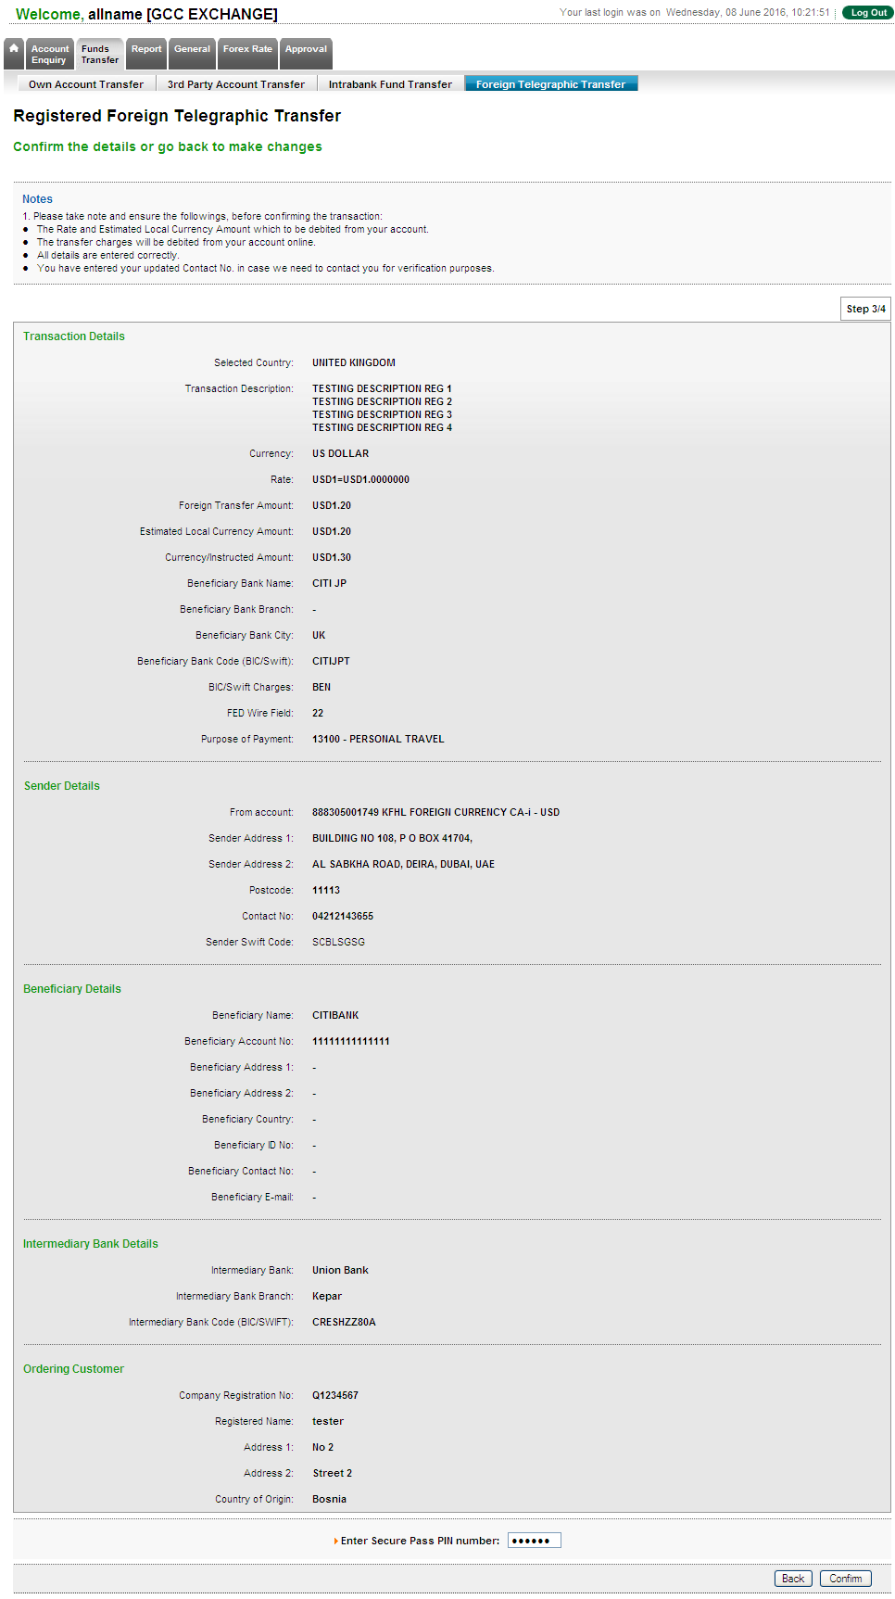

Result page
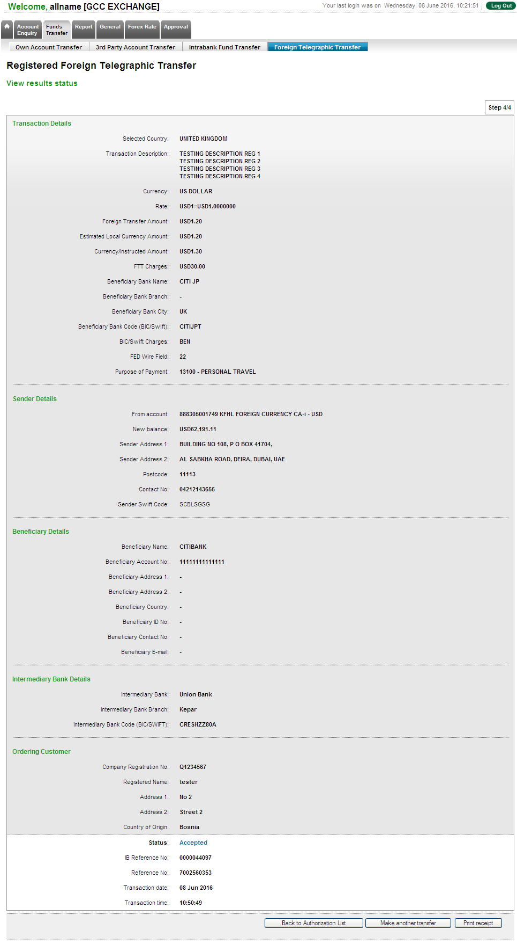

Print Receipt
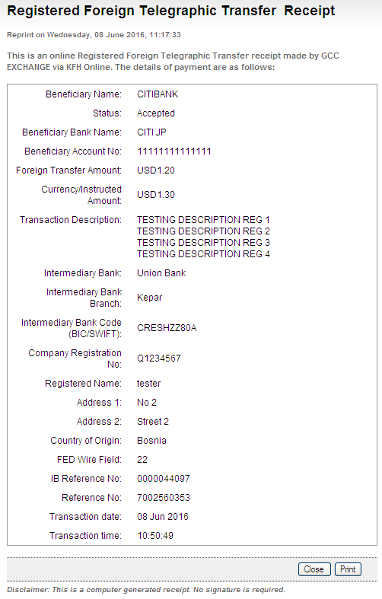

Generated SWIFT103 Text File
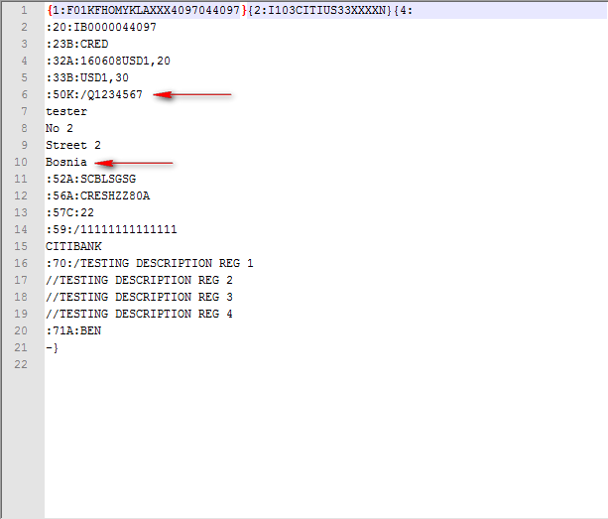

 |  |  | Name/Position : Norhaidah Binti Md Dasuki / Senior Manager, Quality Assurance and Support  Date :

