Test Issue Log |  |  |  |  |  | Issue ID# : TPMS_GL007
Project Name: | Trade Promotion Management System (TPMS)
Test Stage: | Unit Functionality Integration System Interface  Performance Regression Acceptance Pilot
Test Case Number: | Support #6341 |  |  | Test Started Date: |  |  | 14/06/2016
Issue: | TPMS have problem in add new MATRADE activity in Planning Module. The system does not allow ‘saving as Draft’ and showing message "The deadline for submitting Annual Work Programs has ended". But deadline set in KPI SETTING still not passed.
Test Description: | To test on ‘Save as draft’ during creating activity list with KPI deadline was on 2016 and activity list was on 2017
Test Functionality: | Planning >> Activity List >> Add Activity
Test Procedure: | Test scenario:  1. Access Planning > KPI setting.  2. Edit year 2017. Make sure dateline is in 2016.  3. Access Planning > Activities List > Add Activity.  4. Fill in mandatory field and set date as 2017.  5. Click 'Save as Draft'.  Expected result:  1. Program can be saved as draft  2. Program with status draft can be search and edit again as draft.
Test Result: | Pass: Fail:  Conditional Pass: : |  | Tested by: |  | Siti Norahayu Binti Mohd Desa
Reason for Failure:
TEST DESCRIPTION
Planning > KPI setting.
Edit year 2017. Make sure dateline is in 2016.
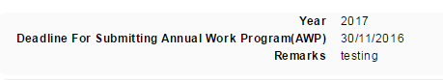

Planning > Activities List > Add Activity
Fill in mandatory field and set date as 2017.
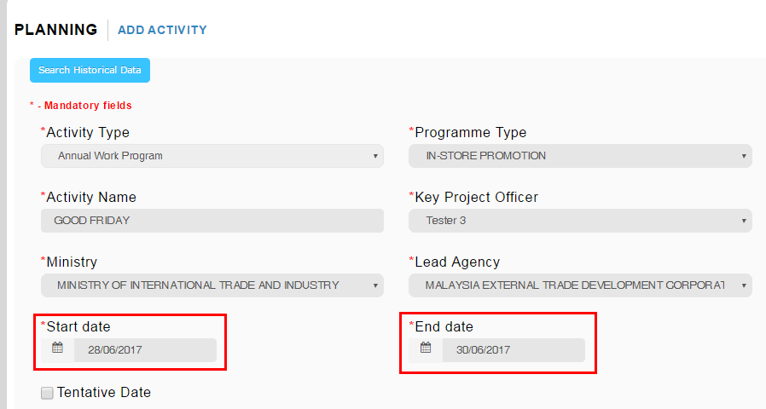

Click 'Save as Draft'.
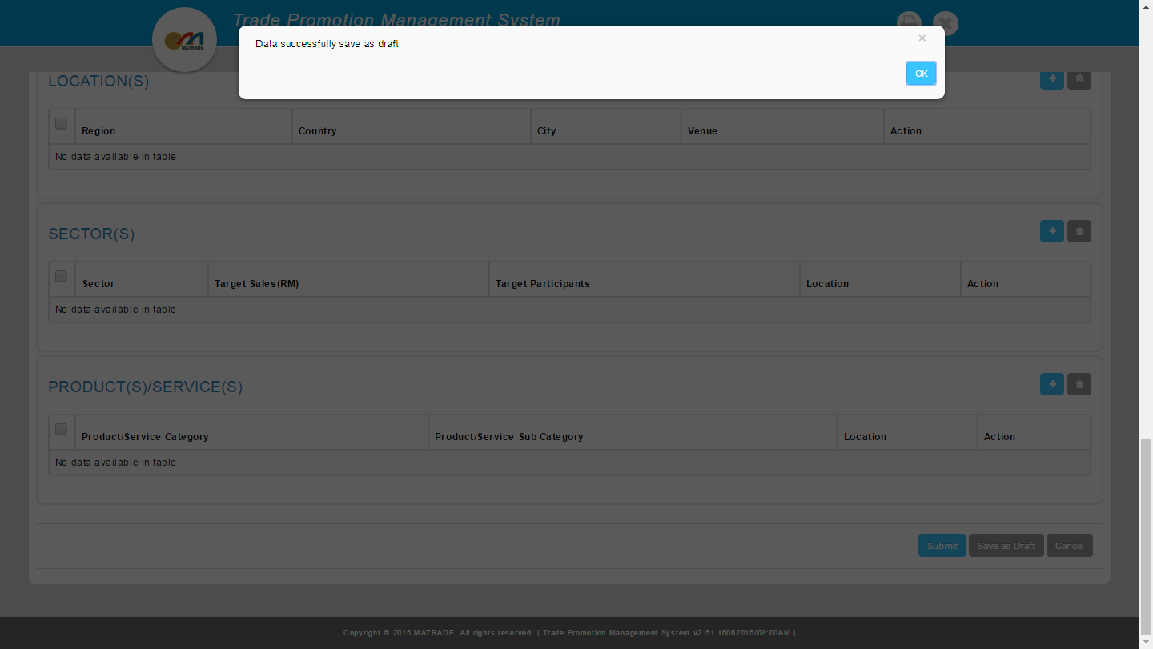
Expected result:
1. Program can be saved as draft
2. Program with status draft can be search and edit again as draft.

Reviewed By: (PMO)
 |  | Name/Position : Norhaidah Binti Md Dasuki / Senior Manager, Quality Assurance and Support  Date : 14/06/2016

