

USER REQUIREMENT SPECIFICATION (URS) DOCUMENT

BIB

Payroll > Statutory Bodies File Upload Module

Authors

Name | Designation & contact email | Remark
Anis Fatina bte Mat Saleh | Executive, Virtual Banking Section

Amendment Record

Version | Date | Status | Description of Revision
1.0 | 11.04.2016 | New
1.1 | 11.04.2016 | Review | Requirement Definition  - To add a new requirements for the Statutory Bodies under Payroll Module.  Listing of Report  - Updates on the BIB reports requirement  General Ledger  - Updates on the accounting entries

Table of Contents

1.0 INTRODUCTION / SYSTEM OVERVIEW 4
2.0 PROBLEM STATEMENT 4
3.0 OBJECTIVE 4
4.0 SCOPE OF WORK 4
5.0 CHANNEL INVOLVED 5
6.0 PROCESS FLOW 5
7.0 REQUIREMENT DEFINITION 6
8.0 LIST OF REPORTS 16
9.0 LIST OF TRANSACTION CODE 19
10.0 FILE/DATA 19
11.0 GENERAL LEDGER ACCOUNT 19
12.0 ACCESS MATRIX & AUTHORIZATION 20
13.0 RECONCILATION 20
14.0 INTERFACES 21
15.0 FORMS AND VOUCHERS 26
16.0 FUTURE REQUIREMENTS 26
17.0 ATTACHMENT 26

- INTRODUCTION

Agrobank will be an agent collection for Lembaga Hasil Dalam Negeri Malaysia (LHDNM), Employees Provident Fund (EPF), and Pertubuhan Keselamatan Sosial (PERKESO) for paying SOCSO in making online statutory bodies payments by using Business Internet Banking AGRONetBIZ. This service allow customer to make Potongan Cukai Bulanan payment and EPF contribution. Any changes to these requirements will require full consent from these parties. In order to have this service Business Internet Banking is required to add new sub module which is Statutory Bodies File Upload under Payroll module.

- PROBLEM STATEMENT

Currently, we are not providing the service of the making online statutory bodies’ payment by using Business Internet Banking AGRONetBIZ. So, this service will be added under BIB payroll module.

- OBJECTIVE

Add new sub module Statutory Bodies File Upload under Payroll module via BIB to enable online PCB payment, SOCSO, and EPF payment to beneficiary accounts within Agrobank or other banks.

- SCOPE OF WORK

The scope of works involves:

- Add new sub module for Statutory Bodies File Upload under Payroll module and details as per below:
- Add new sub module Statutory Bodies File Upload under Payroll in the BIB that enable customer make PCB, SOCSO, and EPF payment by upload file format.
- Allow file format upload by the customer via BIB and send to the Payroll System for checking, processing and crediting.
- Payroll System to debit Saving/Current Account of the customer and credit the fund to Statutory Bodies accounts based on crediting date has been assigned.
- BIB (BIB>Payroll Module> Statutory Bodies Payment File Upload > Statutory Bodies History) to display Statutory Bodies History status for customer reference.
- BIB (BIB>Account & Banking) to display status of the customer account in the AGRONetBIZ Transaction History and Transaction History once the account has been debited for payroll payment transaction > Statutory Bodies.
- IBAM (IBAM>Company Enquiry>Company Details) to display status online/offline of Payroll for company and VB is able to edit online/offline of Statutory Bodies for company.
- IBAM (IBAM>Company Enquiry>Charges) to display charges of Payroll > Statutory Bodies File Upload for company and VB is able to set charges of Statutory Bodies for each company.
- IBAM (IBAM>BIB Report) to generate new separate reports related to Payroll > Statutory Bodies Payment transactions i.e. Statutory Bodies Payment Report Daily and Salary Report Payment Daily.
- IBAM (IBAM>BIB Report) to extract Payroll > Statutory Bodies transactions has been executed on crediting date into Interbank Fund Transfer Report, Consolidated Transaction IB Report Monthly and BNM Financial Transactions Corporate Report Monthly.
- IBAM (IBAM>BIB Transaction Enquiry) to display Statutory Bodies transaction.
- Demo Page
- Type of collection:

- PCB
- EPF
- SOCSO

- Method of collection:

- Account Debiting

- CHANNEL INVOLVED

- Business Internet Banking [BIB]

6.0 PROCESS FLOW

6.1 Payroll > Statutory Bodies Upload File
Start

Initiator / Single user login AGRONetBIZ
Choose Payroll module

Click Statutory Bodies File Upload

Initiator / Single user choose the upload file format by using payroll module

YES
Error occurs during uploading the file?
NO
For Single user, Payroll request > statutory bodies is accepted.

For Initiator, payroll request > statutory bodies is pending approval

Approval successful approve the request

The file sending to the payroll system > statutory bodies file upload to execute payroll transactions.

End

BIB terminate the request

- REQUIREMENT DEFINITION –AGRONetBIZ

Module | Remarks
Statutory Bodies | - To add new sub module Statutory Bodies File Upload under Payroll module.  - Types of Statutory Bodies available are LHDNM, EPF and SOCSO.  - Under this module, it will include the Statutory Bodies file upload format, Statutory Bodies history and failed Statutory Bodies transaction records.  1.1 LHDNM requirements details as per below:  - LHDNM will open 3 collections account with Agrobank which are:  - Agrobank Kuala Lumpur branch – xxxxxxxxxxxxxxxx  - Agrobank Kuching branch – 1006741000123763  - Agrobank Kota Kinabalu branch – 1006911000099100  - Once transaction performed, it will directly debit customer accounts and credited to LHDNM collection account at Agrobank.  - There will be customer charges inclusive GST charges for this transaction. Bank will earn RM 1.00 for each transaction per file upload.  - Bank will send gross (total) amount to ‘Jabatan Akauntan Negara Malaysia’ (JANM) on next day (T + 1) at 10.30 am to the transaction branch. Debit Advice need to be submitted at 11.00 am via email to LHDNM once transferred process completed.  - BIB need to validate each file uploaded by the customer and the transaction will be rejected if any errors occurred during validation process.  - There are ten (10) types of report required to be submitted to LHDNM on the next day by 8.30 am in text file format. Only three (3) reports required to follow the specification format such as ‘Data Transaksi (OPM), Laporan Maklumat Pekerja (PPM), and Penyata Bank (BSR)’.  - In OPM transaction report, the file format as per below:  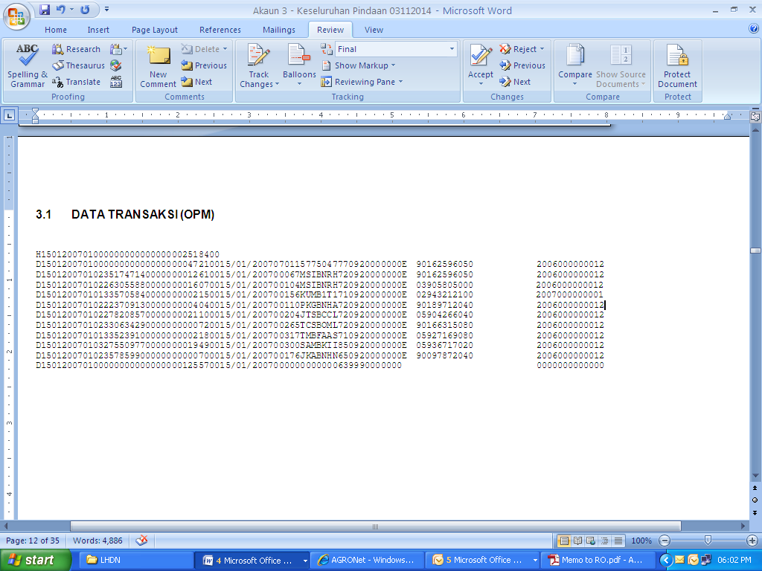  - Report for PPM as per below:  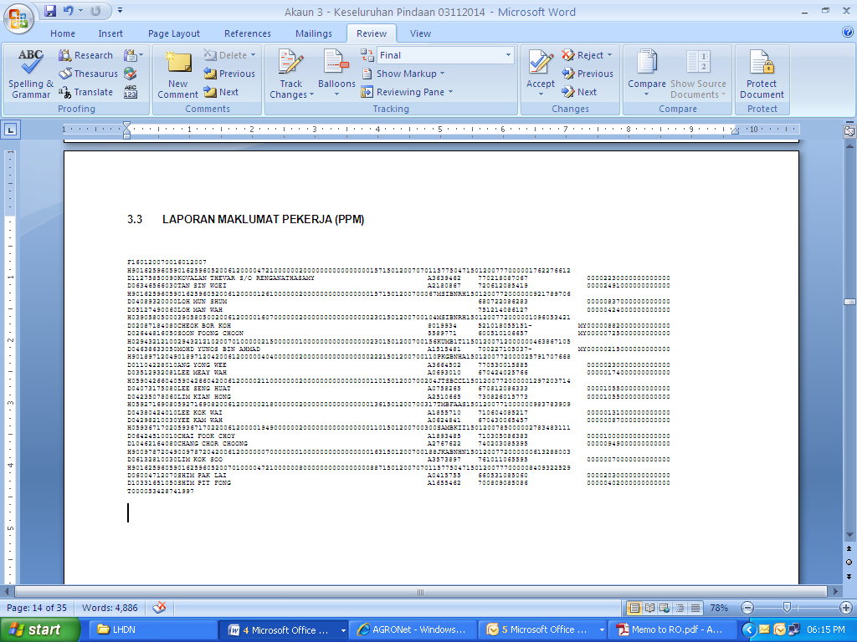  - The Bank statement (BSR) to the LHDNM as below:  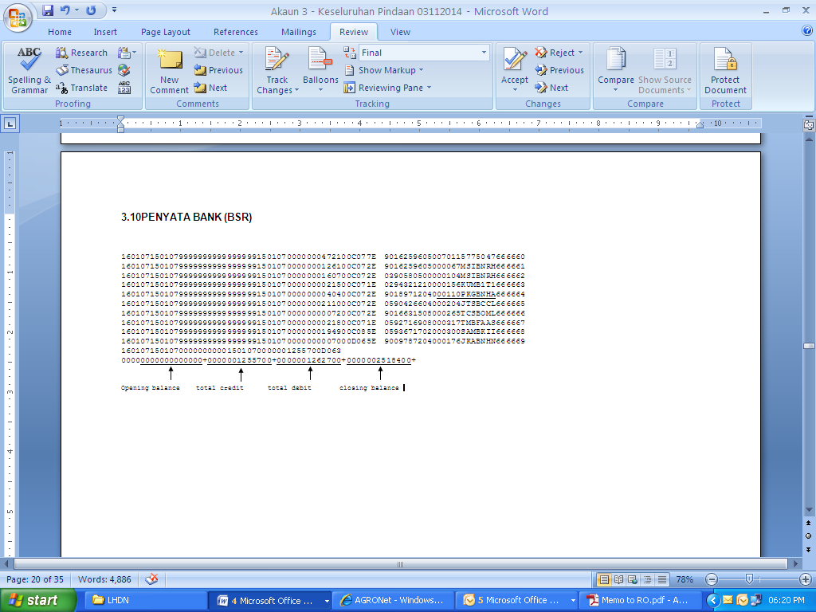  - The ten (10) type’s of reports on each account by state required to be submitted on daily basis to LHDNM’s Kuala Lumpur, LHDNM’s Sabah, and LHDNM’s Sarawak and these reports need to submit on daily basis.  - The ten list of report as below:  - ‘Data Transaksi (OPM)’ – (follow LHDNM format)  - ‘Laporan Maklumat Pekerja (PPM)’ – (follow LHDNM format)  - ‘Penyata Bank (BSR)’ – (follow LHDNM format)  - ‘Laporan Kawalan (ONR) – (contains number of transactions and amount debit and credit –depends on the bank’s format)  - ‘Laporan Perincian Item (PNR)’ – ( depends on the bank’s format)  - ‘Laporan Mod Bayaran (OSR)’ – (showing the payment data which is float day mode. Float days OPM,PPM and OSR must be standardize – depends on the bank’s format)  - ‘Laporan CTL (OCR)’ – (List of CTL transaction based on the OPM report, payment mode: 64,65,66, & 69, - depends on the bank’s format)  - ‘Laporan Reversal (OER)’ – (List of reversal transaction in payment mode code is 62. This report based on the OPM report – depends on the bank’s format)  - ‘Laporan Senarai A (PUR)’ – (Differentiate between OPM report and PPM report which is payment data available in the OPM report but not available in PPM report – depends on the bank’s format)  - ‘Laporan Senarai B (PFR)’ – (Differentiate between OPM report and PPM report which is payment data available in PPM report but not available in OPM report –depends on the bank’s format)  - All text file reports require to be sending via eBank LHDNM server to LHDNM.  - Bank request to provide two ID to allow access LHDNM’s server  - Bank need to provide Public IP to LHDNM for e-Bank Server registration purpose.  *Refer Appendix 1 for details requirements from LHDNM  1.2 LHDNM, EPF, and SOCSO requirements details as per below:  - Bank will use Maybank’s requirement to process LHDNM, EPF, and SOCSO by using their Maybank 2E, host to host (Secured File Transfer Protocol SFTP) channel.  - Agrobank will push the pay file to Maybank 2E STFP folder.  - There are two types of file which are File Outgoing and File Incoming in the Agrobank folder.  - Agrobank require providing Maybank 2E the public key and IP Address.  - The Hardware / Software requirement as per below:  - Application : SSH Tectia (Latest Version)  - Platform : WINDOWS operating system (XP, Vista and Win 7)  - Disk Space : 100MB  - Minimum Memory : 256MB  - Maximum File Size : 50MB  - Process flow Maybank2E Host to Host Implementation as below:  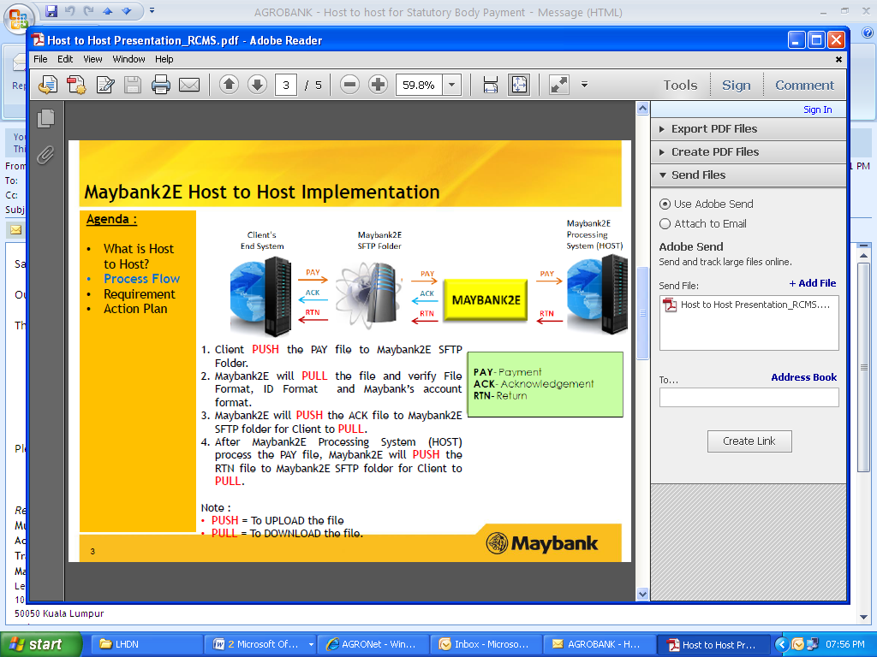  - Customer performs EPF payment using AGRONetBIZ channel in Statutory Bodies under Payroll module by uploading the file.  - Once Agrobank received the acknowledge report activity from Maybank, Agrobank will proceed to complete the transaction.  - The text file report provided will refer to the scheduler given by Maybank.  - Maybank will provide the return statement reporting which contain failure and success status to Agrobank.  - Host to Host provides a straight through processing via Secure File Transfer Protocol (SFTP) where Agrobank process the transactions, generated file based on the Maybank2e format and transmit file to the Maybank2E.  - Maybank will process the transactions once received and provide status feedback to Agrobank.  - Host to Host uses Secure Socket Shell (SSH) as network protocol to allow data to be exchanged using a secure between Agrobank and Maybank2E.  - The file will be encrypted both command and data to prevent password and sensitive information from being exposed over the network.  - To create new commission code for code statutory bodies’ payment and it will utilize for all transaction in future under Payroll module.  File Format for LHDNM as below:-  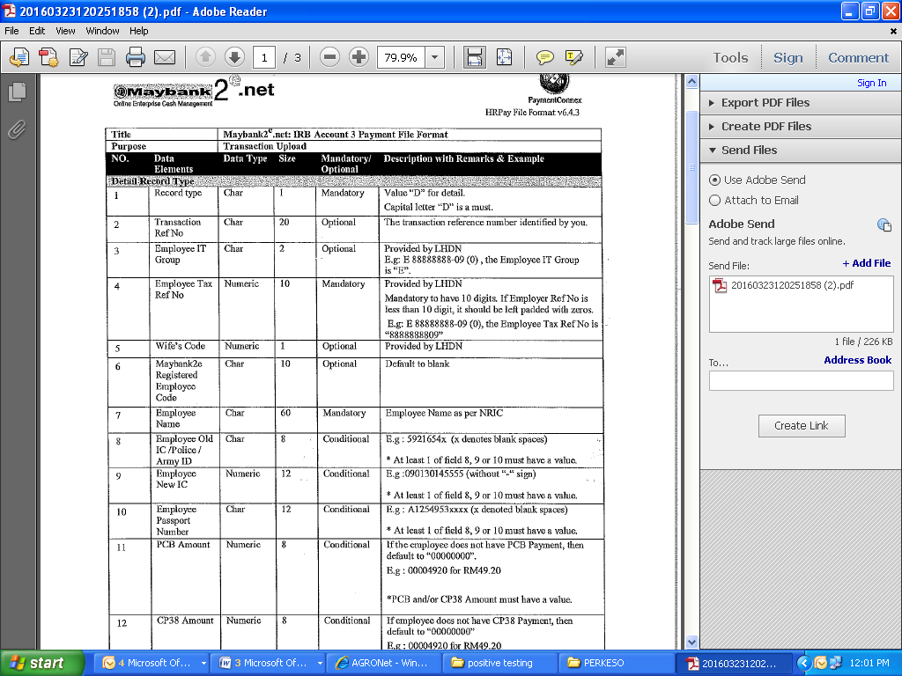  File Format for EPF as below:-  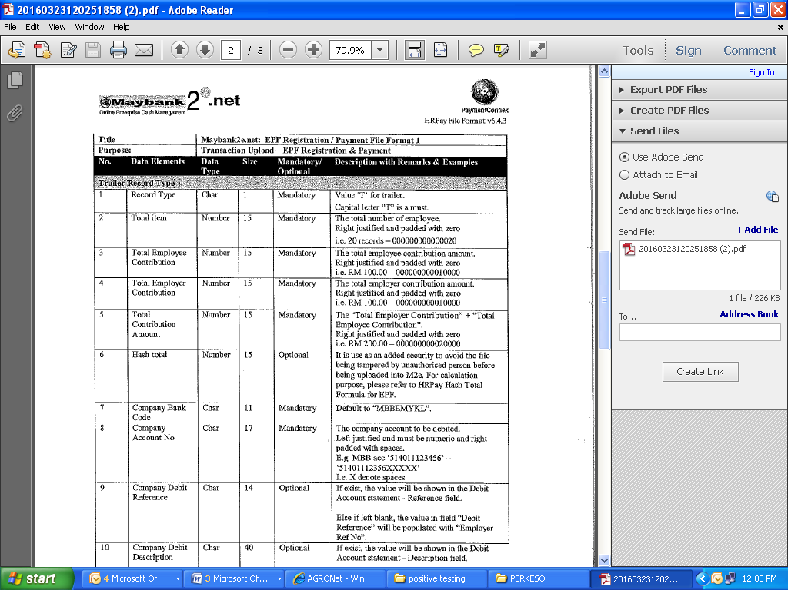  File Format for SOCSO as below:-  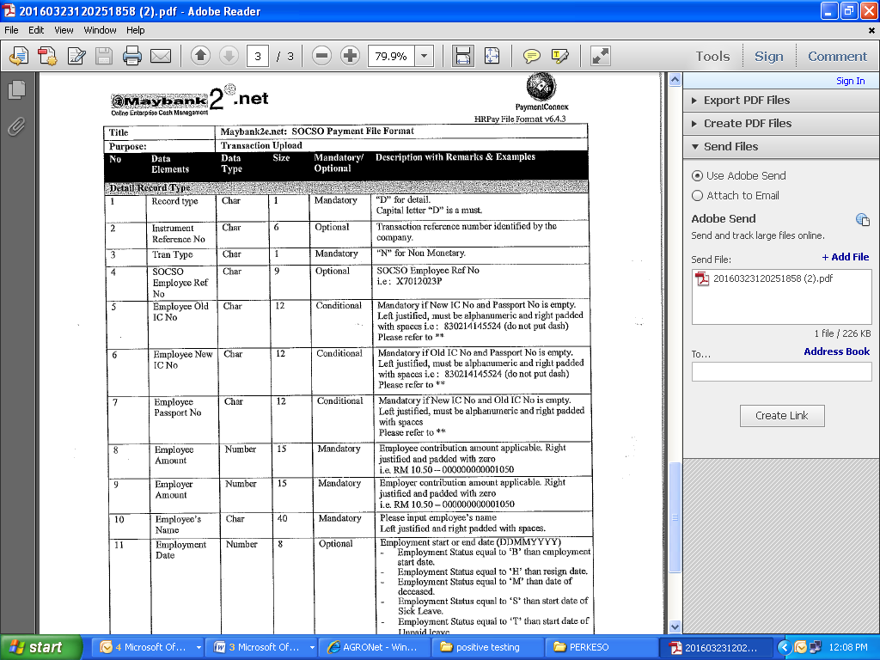  *Refer Appendix 2 for the details requirements and file format for LHDNM, EPF, and SOCSO from Maybank
Account & Banking | - Transaction History remains as per existing.  - AGRONetBIZ Transaction History required to display details as below:  - Module  - Transaction Number  - Customer Name  - Contact Number  - Statutory Bodies Payment types – LHDNM, EPF,SOCSO

  - Features in Payroll Module
- New sub module Statutory Bodies under Payroll modules
- Payroll module for company such as Salary and Statutory Bodies.
- For Payroll menu, customer able to send fund to beneficiary account within Agrobank, recipient account at other banks, Statutory Bodies (ILHDNM /EPF/SOCSO) and Zakat/Tabung Haji.
- The modules also have Payroll History to display Statutory Bodies History status for customer reference when the customer intends to do inquiry and check status of Statutory Bodies transactions.
- VB will assign Payroll menu or both based on customer request upon registration.

  - Initiate Statutory Bodies by customer
- Initiator/Single User to initiate Statutory Bodies by Upload the Statutory Bodies File.
- For file upload, the file will be verified (follow standard verification for Payroll System)
- Once the file is successful verified, status of the request is successful at BIB for Single User. For Multiple User, status at BIB is Pending for Approval and Approver will approve the request.
- After Single User/Approver approved the file, BIB sends the file format to the Payroll System for processing.
- Any rejection during the uploading will follow standard rejection set by Payroll System.
- Any rejection on crediting date will follow standard rejection set by the Payroll System.
- Upload more than one file in same day is allowed for different crediting date.
- Upload more than one file in same day is allowed for same crediting date.

  - Differentiate uploaded file
- BIB Reference Number is required to differentiate uploaded files.
- A Reference Number is referring to an uploaded file.
- Once Single User and Initiator uploaded a file, BIB auto generates a Reference Number at Statutory Bodies result screen.
- The Reference Number also will be displayed at Single User/Approver screen, Print Receipt screen and Statutory Bodies Transfer History screen and these are referring to the uploaded file.

  - Statutory Bodies Crediting
- There are 2 types of crediting i.e. today and future date.
- The Payment System will credit to beneficiary accounts based on crediting date defines in the Statutory Bodies screen of the BIB.
- Single User key-in crediting date and approve Statutory Bodies transactions.
- For Multiple, Initiator key-in crediting date and Approver approve Statutory Bodies transactions.

  - Approval by Single User/Approver in Payroll Module
- Accepted uploaded file – if approve before crediting date or on crediting date
- Failed uploaded file – if approve after crediting date

  - Type of Funds Transfer
- Funds transfer to the beneficiary accounts via 3rd Party Transfer and Interbank GIRO only.
- Future interbank transfer to include is RENTAS and EIBFT.

  - Customer view AGRONetBIZ Transaction History (BIB>Account & Banking> AGRONetBIZ Transaction History)
- View successful and unsuccessful of posted transaction per upload file only via BIB (do not view list of every single transaction of the upload file)
- Print Receipt for successful transaction

  - Customer view Transaction History (BIB>Account & Banking> Transaction History)
- View total amount of debiting of posted transaction as per upload file via BIB and Over the Counter channels (do not view list of every single transaction of the upload file)

  - View/Set/Edit status of Statutory Bodies for company(IBAM>Company Enquiry>Company Details)
- View status online/offline of Statutory Bodies for company in the IBAM
- VB is able to set and edit online/offline of Payroll for company
- Enable Checker & Maker

  - View/Set/Edit charges of Statutory Bodies for company(IBAM>Company Enquiry>Charges)
- View 2 different charges of Statutory Bodies for company in the IBAM
- VB is able to set and edit charges of Statutory Bodies for company
- Enable Checker & Maker

  - VB do inquiry related to Statutory Bodies transactions in IBAM (IBAM> BIB Transaction Enquiry)
- 4 inquiries in the Transaction Type dropbox as below:-
- Upload Statutory Bodies (upload file before crediting)
- Posted Statutory Bodies (crediting was performed)
- If choose Upload Statutory Bodies, IBAM displays dropbox for Status contain “Accepted”, “Pending”, “Expired” and “Failed” only.
- If choose Posted Statutory Bodies, IBAM displays dropbox for Transaction Status contain “Successful” and “Unsuccessful” only.
- Sample inquiry 1

Transaction Type : Upload Statutory Bodies File

Status Uploaded File : Accepted

> View Accepted of Statutory Bodies uploaded

> Sample as below:-

Date / Time Uploaded File | Status Uploaded File / Manual Entry | Reference Number  Channel | Date of Crediting  Debiting Account Number | No. of Account Accepted for Crediting | Total Amount Accepted for Crediting  (RM) | Total Amount Rejected for Crediting  (RM) | Details Rejected Crediting
9/2/2016  10:00:01 | Accepted | 0000027831  IB / LHDN/EPF | 10/2/2016  1005491000012750 | 8 | 13,000 | 2,000 | Details

> Click the Details link to view details as below:-

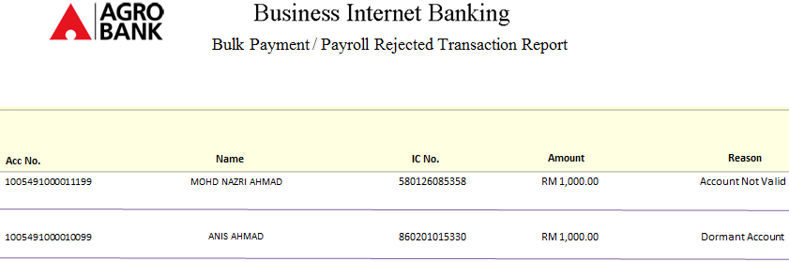
Statutory Bodies Report

- Sample inquiry 2

Transaction Type : Upload Statutory Bodies File

Status Uploaded File : Failed

> View Failed of Statutory Bodies uploaded

> Sample as below:-

Date / Time Uploaded File | Status Uploaded File / Manual Entry | Reference Number  Channel | Date of Crediting  Debiting Account Number | No. of Account Accepted for Crediting | Total Amount Accepted for Crediting  (RM) | Total Amount Rejected for Crediting  (RM) | Details Rejected Crediting
9/2/2016  09:00:01 | Failed | 0000027830  IB / LHDN/EPF | 10/2/2016  1005491000012750

- Sample inquiry 3

Transaction Type : Posted Statutory Bodies

Transaction Status : Successful

> View Successful of Statutory Bodies crediting

> Sample as below:-

Date / Time Uploaded File | Reference Number  Channel | Date of Crediting  Debiting Account Number | No. of Account Accepted for Crediting | Total Amount Accepted for Crediting  (RM) | Total Amount Rejected for Crediting  (RM) | Details Rejected Crediting | Crediting Status
9/2/2016  10:00:01 | 0000027831  IB / LHDN/EPF | 10/2/2016  1005491000012750 | 8 | 13,000 | 2,000 | Details | Successful

> Click the Details link to view details as below:-

Statutory Bodies Report

- Sample inquiry 4

Transaction Type : Posted Statutory Bodies

Transaction Status : Unsuccessful

> View Unsuccessful of Statutory Bodies crediting

> Sample as below:-

Date / Time Uploaded File | Reference Number  Channel | Date of Crediting  Debiting Account Number | No. of Account Accepted for Crediting | Total Amount Accepted for Crediting  (RM) | Total Amount Rejected for Crediting  (RM) | Details Rejected Crediting | Crediting Status
9/2/2016  10:00:01 | 0000027831  IB / LHDN/EPF | 10/2/2016  1005491000012750 |  |  |  |  | Unsuccessful

  - Customer do inquiry in Payroll Module (BIB>Payroll Module> Statutory Bodies History)
- Initiator/Single User/Viewer using Statutory Bodies History to view status of Statutory Bodies as below:
- File uploaded status
- Crediting status
- For Upload Statutory Bodies inquiry, customer able to know status of uploaded file. Status of uploaded file will be tagged as Accepted and Failed in the Statutory Bodies History.
- They use the BIB Reference Number to check the status of uploaded files required.
- Customer can view rejected account for crediting when upload Statutory Bodies file was accepted.
- Customer also able to view status of Statutory Bodies uploads which has been initiated via Internet Banking and Over the Counter channels.
- Sample Upload Statutory Bodies inquiry before crediting date (the crediting date set on 10/7/2016) as below:-

Date / Time Uploaded File | Status Uploaded File / Manual Entry | Reference Number  Channel | Date of Crediting  Debiting Account Number | No. of Account Accepted for Crediting | Total Amount Accepted for Crediting  (RM) | Total Amount Rejected for Crediting  (RM) | Details Rejected Crediting
9/2/2016  10:00:01 | Accepted | 0000027831  IB / LHDN/EPF | 10/2/2016  1005491000012750 | 8 | 13,000 | 2,000 | Details
9/722016  09:00:01 | Failed | 0000027830  IB / LHDN/EPF | 10/2/2016  1005491000012750
9/2/2016  08:00:01 | Failed | 0000027810  IB / LHDN/EPF | 10/2/2016  1005491000012750
8/2/2016  09:00:01 | Accepted | XXXXXX  OTC / LHDN/EPF | 10/2/2016  1005491000012750 | 20 | 20,000

- For account has been rejected for crediting, customer click the Details link to view details as below:-

Statutory Bodies Report

- For Posted Payroll inquiry, customer able to know status of Statutory Bodies crediting. Status of crediting will be tagged as Successful and Unsuccessful.
- For account has been rejected for crediting, customer click the Details link view sample same as above.
- Customer also able to view status of Statutory Bodies crediting has been initiated via Internet Banking and Over the Counter channels.
- Sample Posted Statutory Bodies inquiry (the crediting date set on 10/2/2016) as below:-

Date / Time Uploaded File | Reference Number  Channel | Date of Crediting  Debiting Account Number | No. of Account Accepted for Crediting | Total Amount Accepted for Crediting  (RM) | Total Amount Rejected for Crediting  (RM) | Details Rejected Crediting | Crediting Status
9/2/2016  10:00:01 | 0000027831  IB / LHDN/EPF | 10/2/2016  1005491000012750 | 8 | 13,000 | 2,000 | Details | Successful
9/2/2016  08:00:01 | 0000027810  IB / LHDN/EPF | 10/2/2016  1005491000012750 |  |  |  |  | Unsuccessful
8/2/2016  10:00:01 | 0000020000  IB / LHDN/EPF | 10/2/2016  1005491000012750 | 15 | 15,000 |  |  | Successful
8/2/2016  09:00:01 | XXXXXX  OTC / LHDN/EPF | 10/2/2016  1005491000012750 |  |  |  |  | Unsuccessful

  - Charges and GST for Statutory Bodies
- Statutory Bodies transaction via 3rd Party Fund Transfer

Charges – Refer to IBAM>Company Enquiry>Charges

GST – 6% of the charges

- Statutory Bodies transaction via Interbank GIRO Fund Transfer

Charges – Refer to IBAM>Company Enquiry>Charges

GST – 6% of the charges

IBG – 11cent (inclusive GST)

- Statutory Bodies charges based on number of transaction in the uploaded file / per uploaded file.
- Charges will be determined by the business owner based on customer deal.

- LIST OF REPORT

  - Daily Reports related to Statutory Bodies transactions in IBAM (IBAM> BIB Report)
- Extract daily Statutory Bodies transactions via Interbank GIRO into BIB IBG Report Daily (single transaction will be counted for BIB IBG Report on the crediting date has been determined).
- Sample existing report as below:-

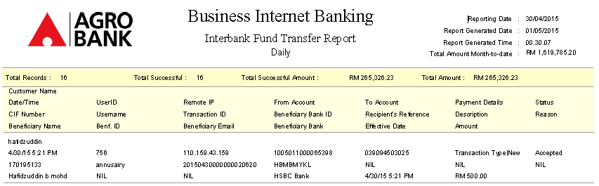

- Extract daily Statutory Bodies transactions via both 3rd Party Transfer and Interbank GIRO into BIB Internet Transaction Report Daily (single transaction will be counted for BIB Internet Transaction Report Daily on the crediting date has been determined).
- On the crediting date, the “Transaction Type” in the report will be tagged as below:-
  - Statutory Bodies – 3rd Party : if Statutory Bodies transaction via 3rd Party Transfer
  - Statutory Bodies – IBG : if Statutory Bodies transaction via Interbank GIRO
- Sample existing report as below:-

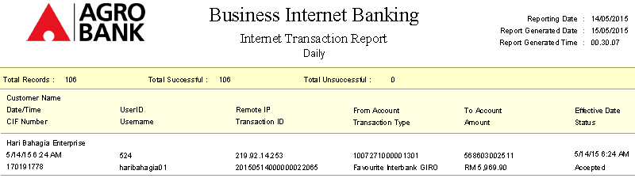

- Create new reports in the IBAM> BIB Report i.e. BIB Statutory Bodies Report Daily with conditions as below:-
- For Statutory Bodies transaction, per upload file will be counted for BIB Statutory Bodies Report Daily and will be displayed in the BIB Statutory Bodies Report Daily on the crediting date has been determined.
- Assume the crediting date is 10/7/2016 and sample report as below:

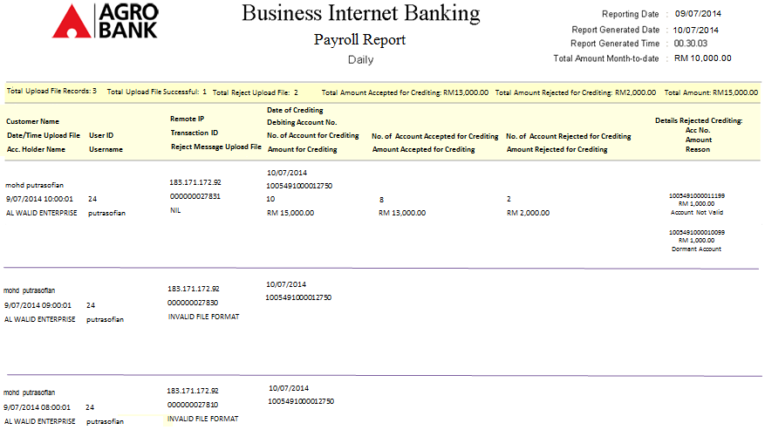
Statutory Bodies Report

  - Monthly Reports related to Statutory Bodies transactions in IBAM (IBAM> BIB Report)
- Extract monthly Statutory Bodies transactions via 3rd Party Transfer into Consolidated Transaction IB Report Monthly (the data put under Statutory Bodies - 3rd Party Fund Transfer)
- Extract monthly Statutory Bodies transactions via Interbank GIRO into Consolidated Transaction IB Report Monthly (the data put under Statutory Bodies - Interbank GIRO Fund Transfer)
- Sample amendment to existing Consolidated Transaction IB Report Monthly as below:-

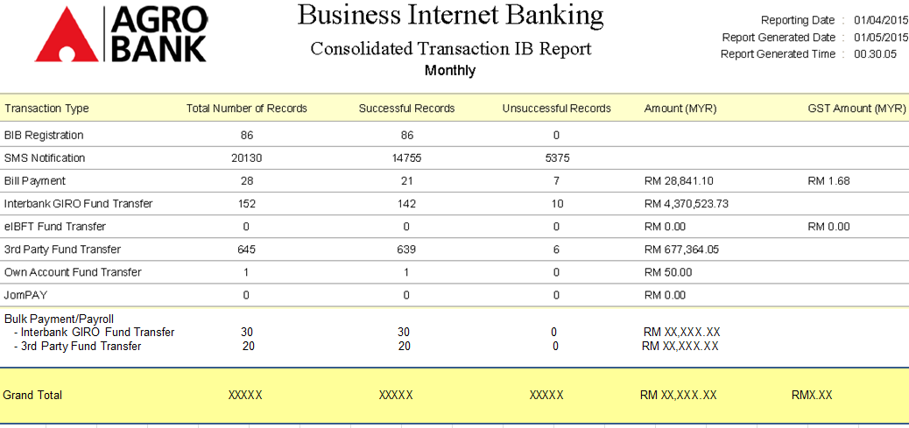

- Extract monthly Statutory Bodies transactions via 3rd Party Transfer into BNM Financial Transactions Corporate Report Monthly (the data put under Fund Transfer: Third Party).
- Extract monthly Statutory Bodies transaction via both 3rd Party Transfer & Interbank GIRO Fund Transfer into BNM Financial Transactions Corporate Report Monthly (the data put under Statutory Bodies Payment)
- Sample existing report as below:-

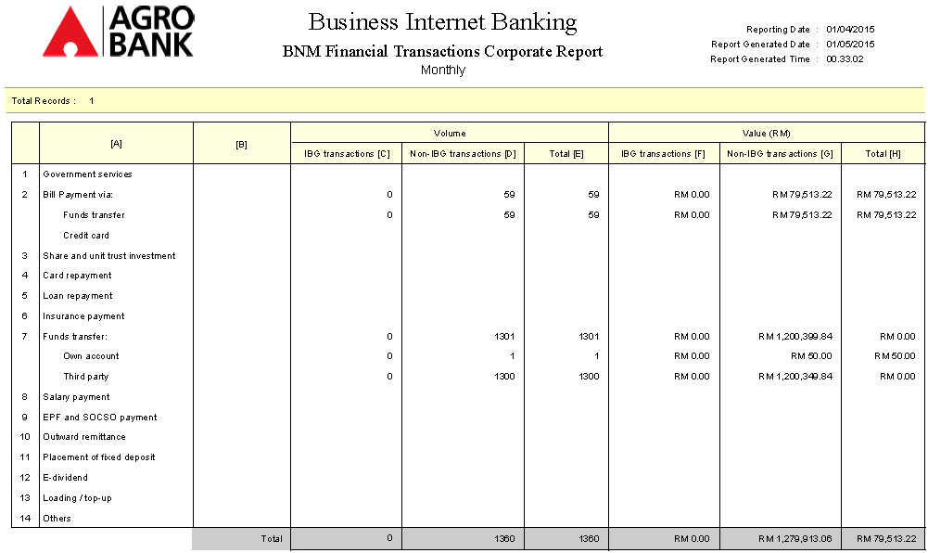
Pcb payment

  - Additional Reports for Statutory Bodies transaction
- Report shows listing of rejected crediting
- Report shows listing of successful crediting

- LIST OF TRANSACTION CODE

Create a new transaction code for statutory bodies to indicate and identify the type of transactions.

- FILE/DATA

- Use standard file format for Payroll System.
- Use file format for other agencies such as LHDNM EPF, SOCSO.

- GENERAL LEDGER ACCOUNT

  - Entries will involve IB branch code 8551. Entries apply for AGRONetBIZ (E Banking & B Banking)

- Entries for LHDNM AGRONetBIZ

Dr CASA RM101.06

(Customer Account)

Cr (LHDNM collection account) RM100.00

BIB Commision RM1.00

GST output clearing RM0.06

- Entries for EPF AGRONetBIZ

Dr CASA RM101.06

(Customer Account)

Cr (Maybank collection account) RM100.00

BIB Commision RM1.00

GST output clearing RM0.06

- Entries for SOCSO AGRONetBIZ

Dr CASA RM101.06

(Customer Account)

Cr (Maybank collection account) RM100.00

BIB Commision RM1.00

GST output clearing RM0.06

- Entries for LHDNM AGRONetBIZ

Dr CASA RM101.06

(Customer Account)

Cr (Maybank collection account) RM100.00

BIB Commision RM1.00

GST output clearing RM0.06

- ACCESS MATRIX & AUTHORIZATION

- Corporate Administrator

- Corporate Administration to allow Statutory Bodies to be accessible by Initiator/Approver/Viewer/Single User using IB Service Management module via BIB as below:-

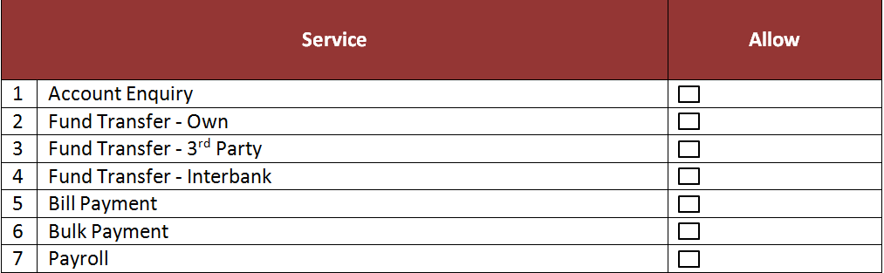

- If company subscribe to Statutory Bodies, CA able to edit no.7 in the Service Table as above.
- However, if company subscribe Statutory Bodies, only one service will be displayed in the Service Table for CA.

- VB Checker/Maker in IBAM

- VB is able to set and edit online/offline of Statutory Bodies for company
- VB is able to set and edit charges of Statutory Bodies for company

- RECONCILATION

- Reports are required for reconciliation by VB.
- For 3rd Party Fund Transfer, reports are required for Statutory Bodies transactions as below:
- BIB Statutory Bodies Report Daily
- DDI220P – Pre Processing Successful Transactions Report
- DDI221P – Pre Processing Rejected Transactions Report
- DDI224P – Pre Processing Batch File Detail Transactions Report
- DDI222P – Post Processing Successful Transactions Report
- DDI223P – Post Processing Rejected Transactions Report
- Host Report for successful/unsuccessful CASA transaction

- For Interbank GIRO Fund Transfer, reports are required for Statutory Bodies transactions as below:
- BIB Payroll Report Daily
- BIB IBG Report Daily
- DDI220P – Pre Processing Successful Transactions Report
- DDI221P – Pre Processing Rejected Transactions Report
- DDI224P – Pre Processing Batch File Detail Transactions Report
- DDI222P – Post Processing Successful Transactions Report
- DDI223P – Post Processing Rejected Transactions Report
- Host Report for successful/unsuccessful IBG transaction

- INTERFACES

[All screen designs provided are samples and only illustration purpose for easy understanding. The screen designs are not final]

  - Payroll Menu

14.1.1 Payroll for Statutory Bodies

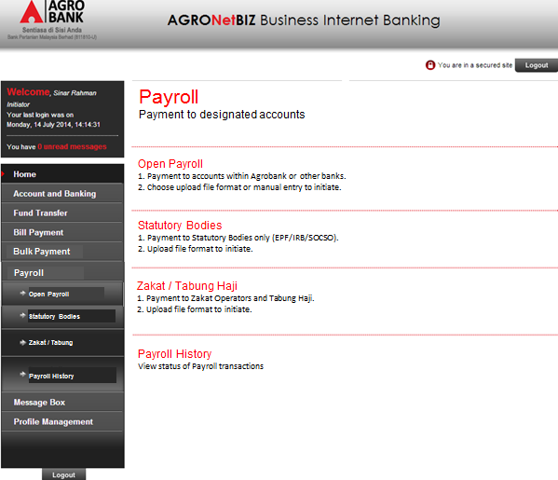

*SAMPLE for illustration - Initiator/Single User initiates File Upload for Open Statutory Bodies

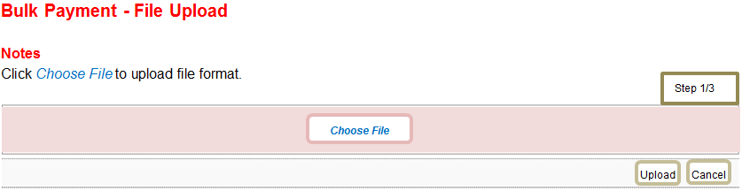
Statutory Bodies – File Upload

Initiator Screen Single User Screen

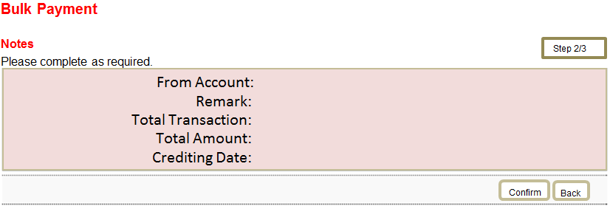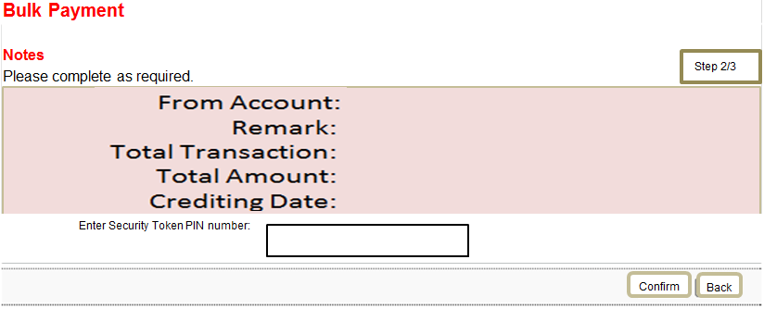
Statutory Bodies
Statutory Bodies

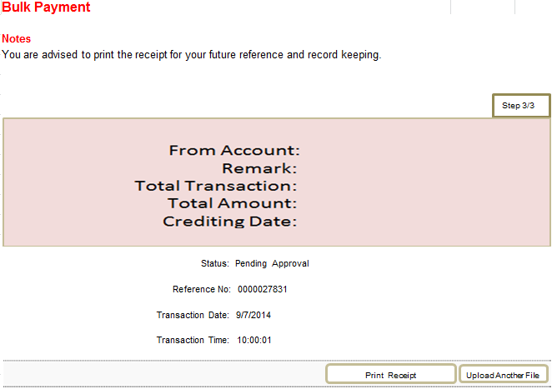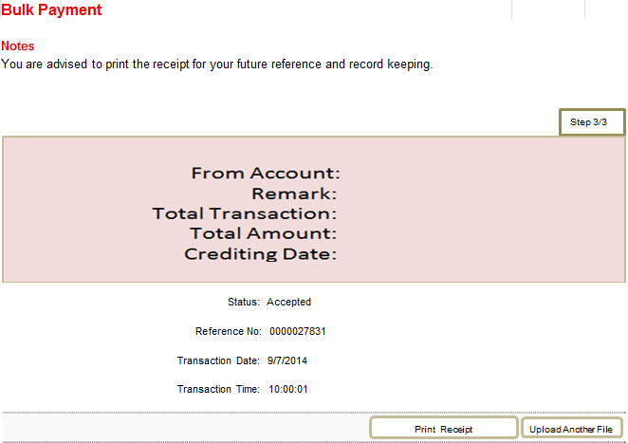
Statutory Bodies
Statutory Bodies

END

Approval by Approver

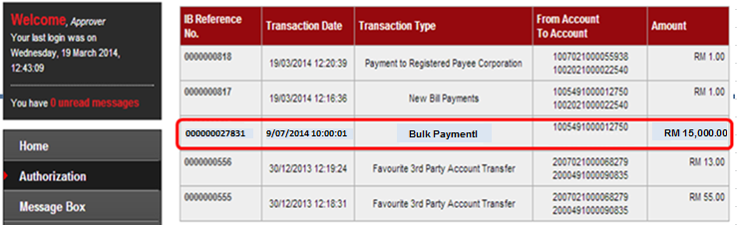
Statutory Bodies Payment – LHDN / EPF

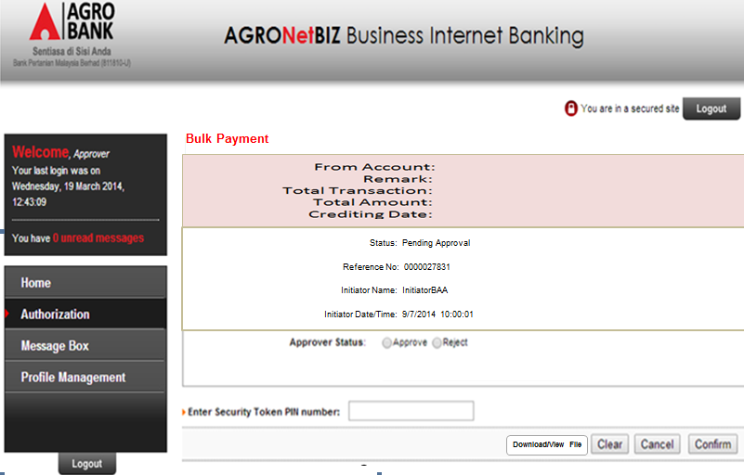
Statutory Bodies

* Download/View File – Approver to view transaction of Statutory Bodies as reference

-View/Download the file for Approval to View and Check

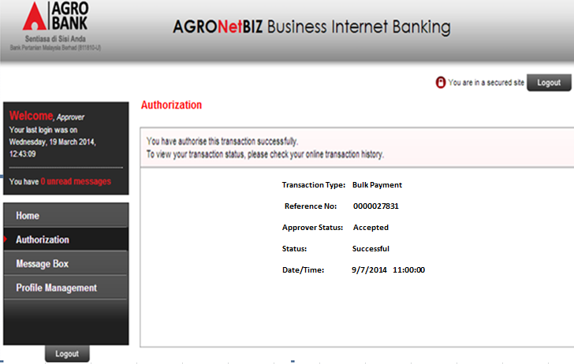
Statutory Bodies

  - Statutory Bodies History

View status of uploaded file

Date / Time Uploaded File | Status Uploaded File / Manual Entry | Reference Number  Channel | Date of Crediting  Debiting Account Number | No. of Account Accepted for Crediting | Total Amount Accepted for Crediting  (RM) | Total Amount Rejected for Crediting  (RM) | Details Rejected Crediting
9/2/2016  10:00:01 | Accepted  IB / LHDN/EPF | 0000027831  IB | 10/2/2016  1005491000012750 | 8 | 13,000 | 2,000 | Details
9/2/2016  09:00:01 | Failed  IB / LHDN/EPF | 0000027830  IB | 10/2/2016  1005491000012750
9/2/2016  08:00:01 | Failed  IB / LHDN/EPF | 0000027810  IB | 10/2/2016  1005491000012750
8/2/2016  09:00:01 | Accepted  OTC / LHDN/EPF | XXXXXX  OTC | 10/2/2016  1005491000012750 | 20 | 20,000

View status of Statutory Bodies crediting

Date / Time Uploaded File | Reference Number  Channel | Date of Crediting  Debiting Account Number | No. of Account Accepted for Crediting | Total Amount Accepted for Crediting  (RM) | Total Amount Rejected for Crediting  (RM) | Details Rejected Crediting | Crediting Status
9/2/2016  10:00:01 | 0000027831  IB / LHDN/EPF | 10/2/2016  1005491000012750 | 8 | 13,000 | 2,000 | Details | Successful
9/2/2016  08:00:01 | 0000027810  IB / LHDN/EPF | 10/2/2016  1005491000012750 |  |  |  |  | Unsuccessful
8/2/2016  10:00:01 | 0000020000  IB / LHDN/EPF | 10/2/2016  1005491000012750 | 15 | 15,000 |  |  | Successful
8/2/2016  09:00:01 | XXXXXX  OTC / LHDN/EPF | 10/2/2016  1005491000012750 |  |  |  |  | Unsuccessful

  - Sample Print Receipt – Statutory Bodies

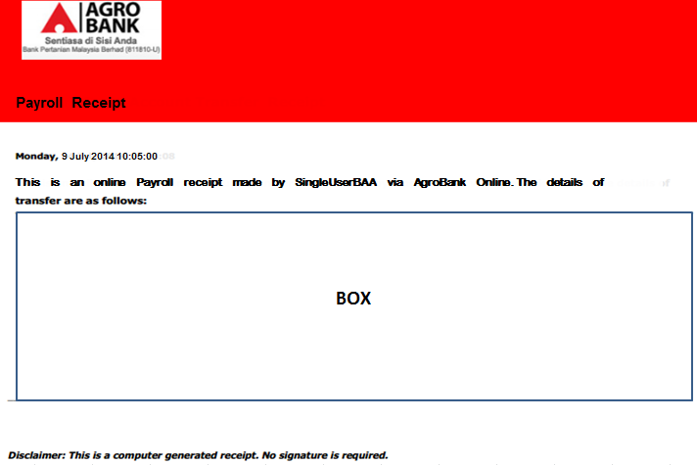

- If Statutory Bodies requires transfer fund to the beneficiary accounts via 3rd Party Transfer only, message in the BOX as below:

Company Name :BA1005

From Account :XXXXXXXXXXXXXXXX

Remark :ZZZZZZZZZZ

Total Transaction :YYY

Total Amount :RM 15,000.00

Crediting Date :30/7/2014

Reference :0000027831

Transaction Date :9/7/2014

Transaction Time :11:00:00

---------------------------------------------------------------------------------------------------------------

Statutory Bodies Charges :RM XX.00 (Subject to 6% GST Charges)

- If Statutory Bodies requires transfer funds to the beneficiary accounts via Interbank GIRO only, message in the BOX as below:

Company Name :BA1005

From Account :XXXXXXXXXXXXXXXX

Remark :ZZZZZZZZZZ

Total Transaction :YYY

Total Amount :RM 15,000.00

Crediting Date :30/7/2014

Reference :0000027831

Transaction Date :9/7/2014

Transaction Time :11:00:00

---------------------------------------------------------------------------------------------------------------

Statutory Bodies Charges :RM XX.00 (Subject to 6% GST Charges)

IBG Charges :RM 00.11

- If Statutory Bodies requires transfer funds to the beneficiary accounts via both 3rd Party Transfer and Interbank GIRO, message in the BOX as below:

Company Name :BA1005

From Account :XXXXXXXXXXXXXXXX

Remark :ZZZZZZZZZZ

Total Transaction :YYY

Total Amount :RM 15,000.00

Crediting Date :30/7/2014

Reference :0000027831

Transaction Date :9/7/2014

Transaction Time :11:00:00

---------------------------------------------------------------------------------------------------------------

Statutory Bodies Charges :RM XX.00 (Subject to 6% GST Charges)

IBG Charges :RM 00.11

- FORM AND VOUCHERS

Not applicable.

- FUTURE REQUIREMENT

Not applicable.

- ATTACHMENT

Refer Appendix as per attach.

