Test Issue Log |  |  |  |  |  | SCP ID# : 6368
Project Name: | [Internal Testing] Sahabat Agro
Test Stage: | Unit Functionality Integration System Interface  Performance Regression Acceptance Pilot
Test Case Number: |  |  |  | Test Started Date: |  |  | 15/03/2016
Test Title: | [Internal Testing] Sahabat Agro
Test Description: | To ensure changes made on Payee Collection Report checkbox and Reconciliation Report checkbox after click on ‘Update’ button.  https://10.6.6.20/bib.sit.sahabat/common/Login.do
Test Functionality: | - Initiator  - Approver  - Viewer  - Single User
Test Procedure: | - Log in to BIB.SIT.SAHABAT as Corporate Admin.  - Click on IB Service Administration > User Maintenance.  - Choose on user.  - Click on ‘Edit’ button.  - Make changes on Payee Collection Report checkbox and Reconciliation Report checkbox.  - Click on ‘Update’ button.
Test Result: | Pass: Fail: | Tested by: |  |  | Erni Suhaireen binti Zulkifli
Reason for Failure: | No changes made after tick or untick the Payee Collection Report checkbox and Reconciliation Report checkbox.
TEST DESCRIPTION
Initiator
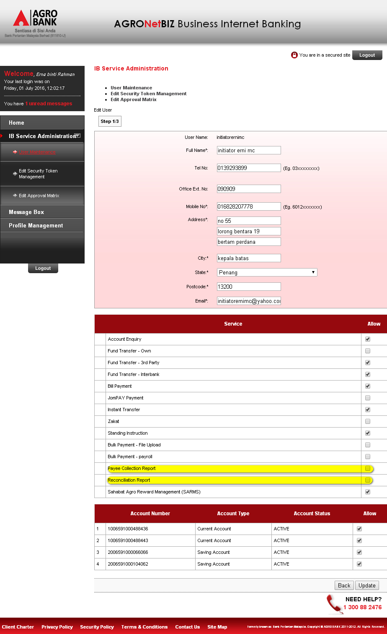
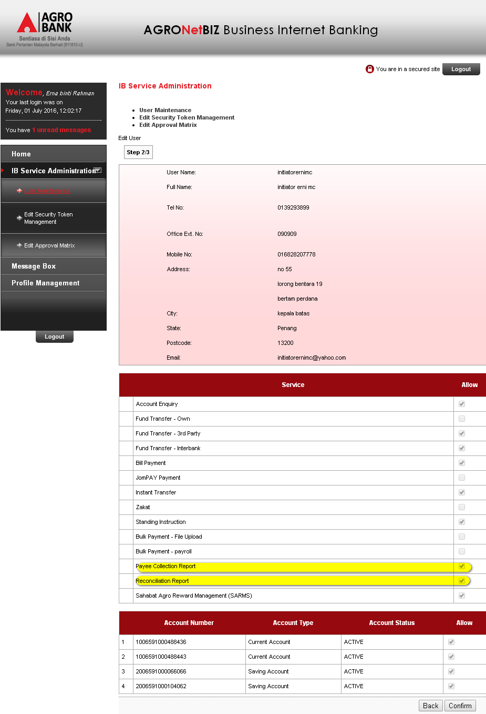
Approver
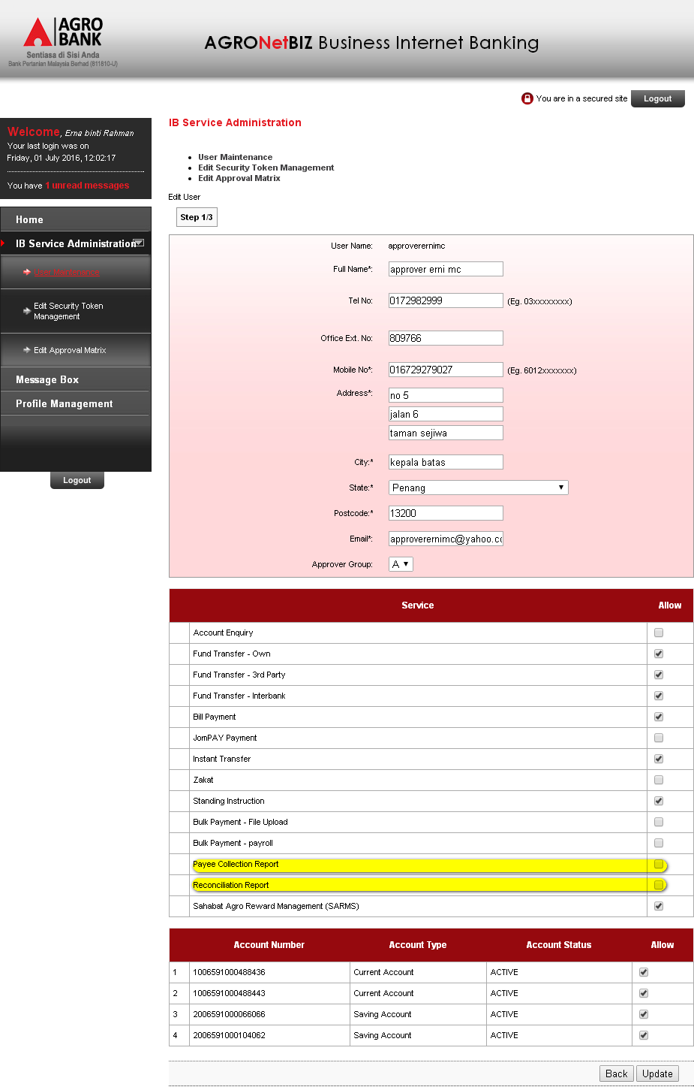
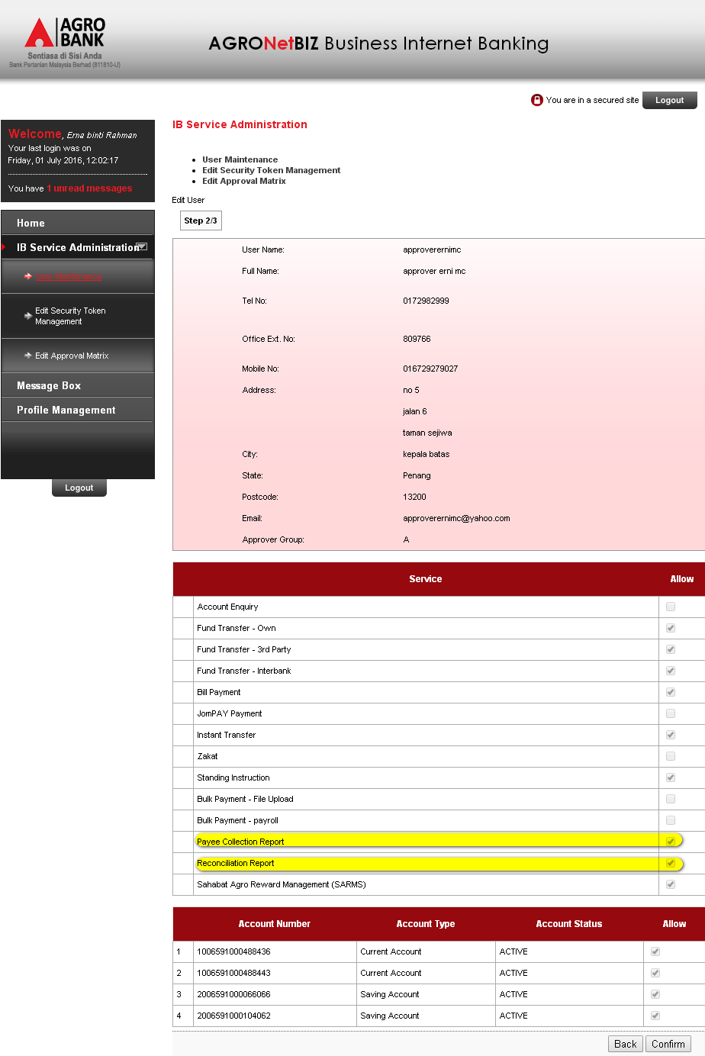
Viewer
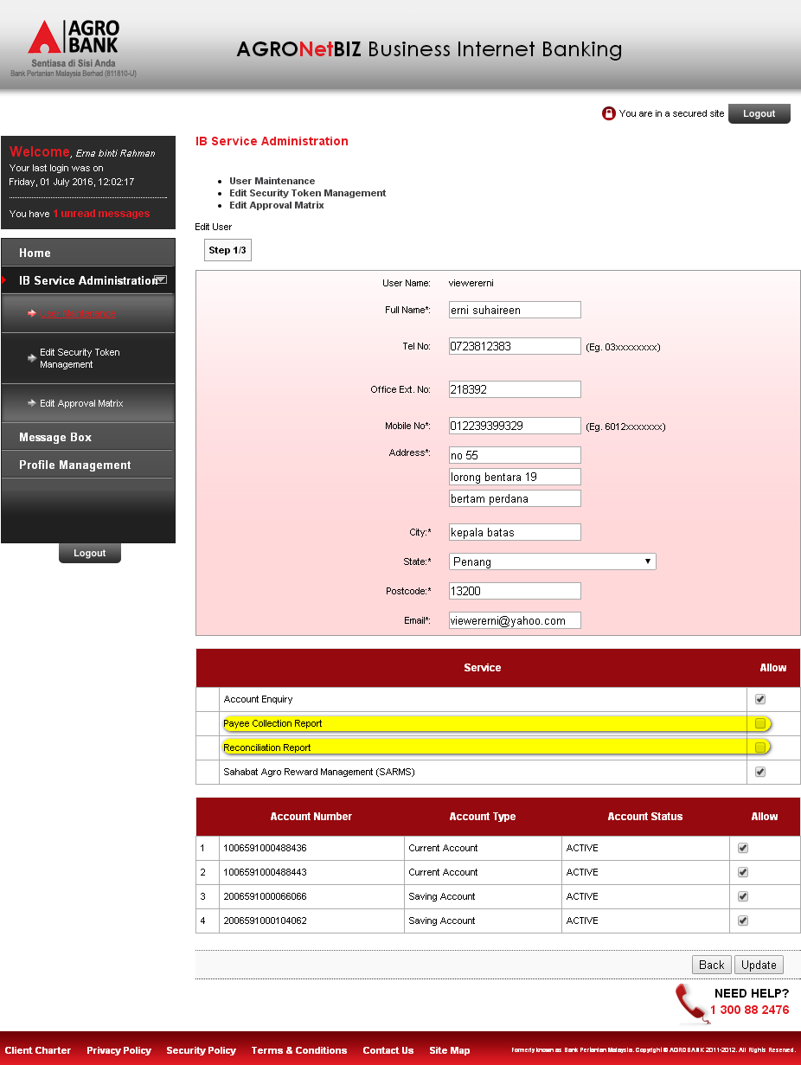
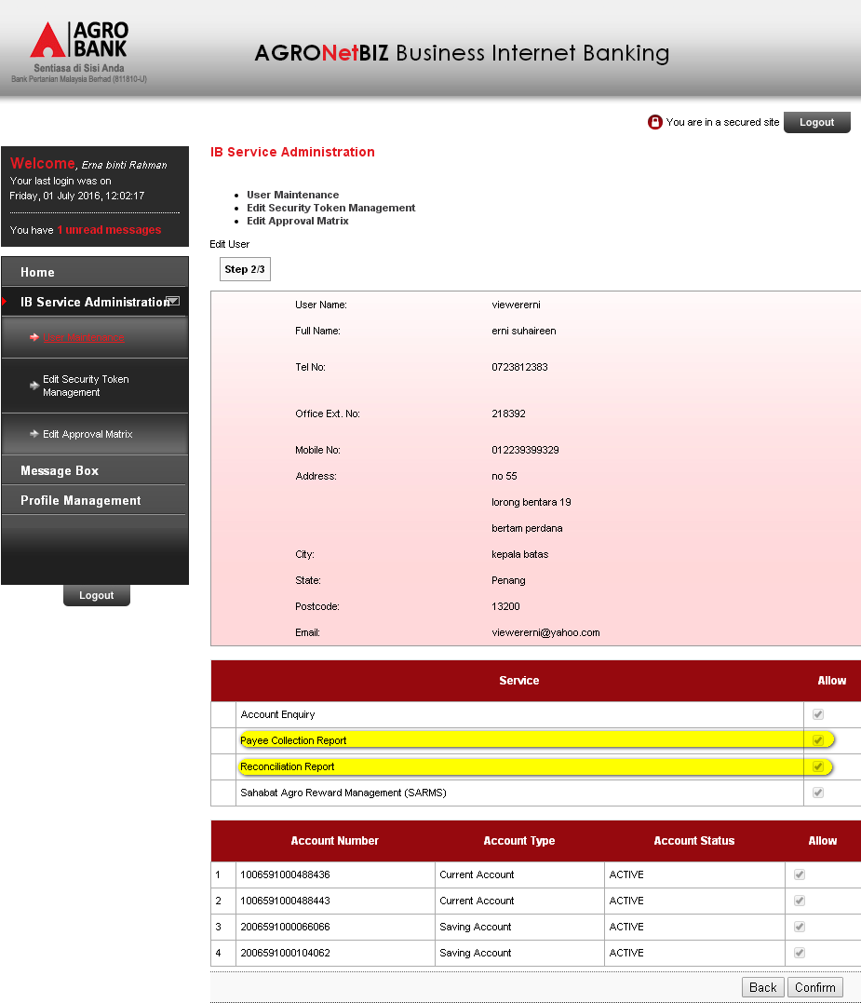

Single User
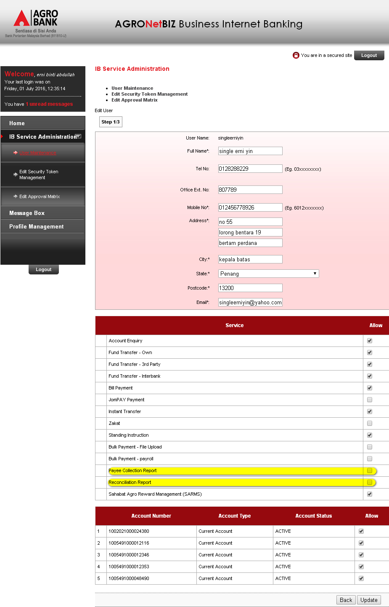
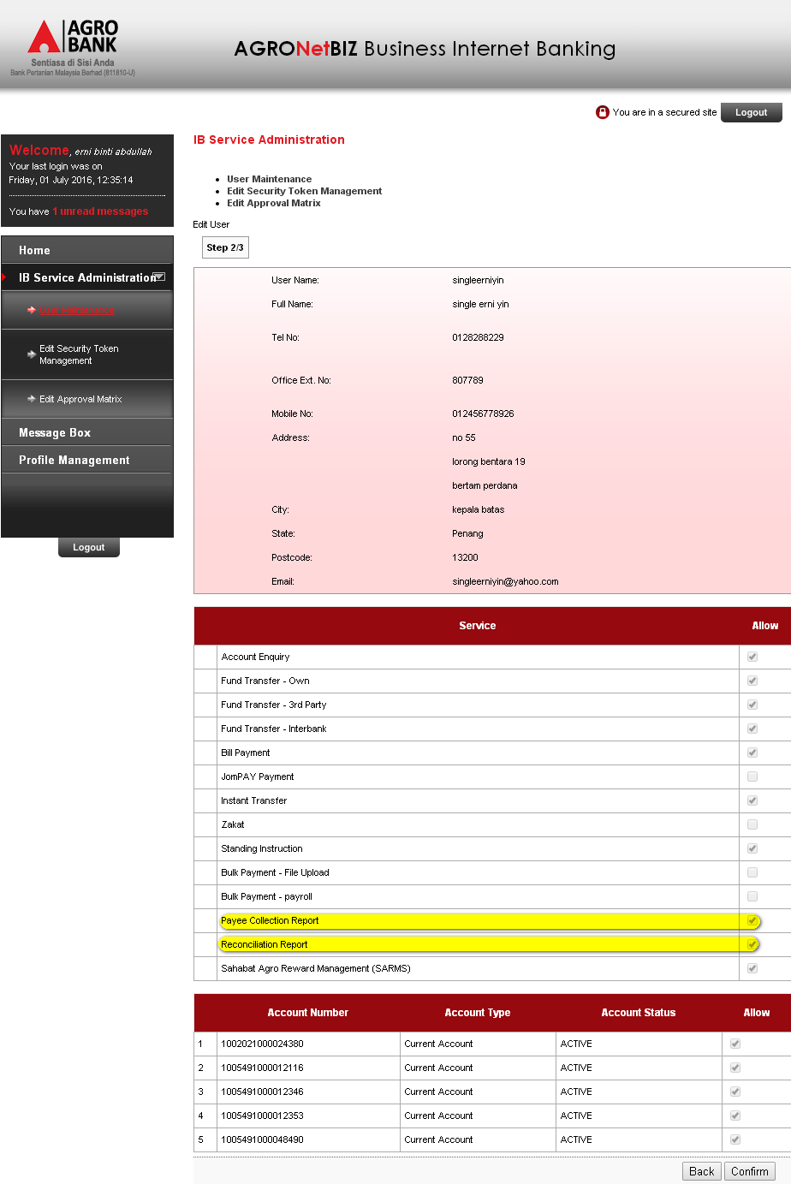

Reviewed By: (PMO)
Lizahwati |  |  | Name/Position : Lizahwati binti Basirun  Date :

