Test Issue Log |  |  |  |  |  | SCP ID# : 6369
Project Name: | [Internal Testing] IBAM SIT SAHABAT
Test Stage: | Unit Functionality Integration System Interface  Performance Regression Acceptance Pilot
Test Case Number: |  |  |  | Test Started Date: |  |  | 24/06/2016
Test Title: | [Internal Testing] IBAM SIT SAHABAT
Test Description: | To ensure all module functioning well.  https://10.6.6.20/bib.sit.sahabat/common/Login.do
Test Functionality: | BIB CA - Create User Single User  BIB CA - Create User Initiator  BIB CA - Create User Approver  BIB CA - Create User Viewer  BIB CA - Edit User Single User  BIB CA - Edit User Initiator  BIB CA - Edit User Approver  BIB CA - Edit User Viewer  IBAM CA - Create User CA  IBAM CA - Create User Single User  IBAM CA - Create User Initiator  IBAM CA - Create User Approver  IBAM CA - Create User Viewer  IBAM CA - Edit User CA  IBAM CA - Edit User Single User  IBAM CA - Edit User Initiator  IBAM CA - Edit User Approver  IBAM CA - Edit User Viewer
Test Procedure: | BIB  - Login to BIB and create user: Single User/Initiator/Approver/Viewer  - Login to BIB and edit user: Single User/Initiator/Approver/Viewer  - Login to BIB as Single User/Initiator/Approver/Viewer to display changes made.  ADMINISTRATOR/MAKER CHECKER  - Login to IBAM and create user: CA/Single User/Initiator/Approver/Viewer  - Login to IBAM and edit user: CA/Single User/Initiator/Approver/Viewer  - Login to BIB as CA/Single User/Initiator/Approver/Viewer to display changes made.
Test Result: | Pass: Fail: | Tested by: |  |  | Erni Suhaireen binti Zulkifli
Reason for Failure:
TEST DESCRIPTION

BIB

Corporate Admin

Create User

Single User
Login as Corporate Admin on BIB and create Single User.
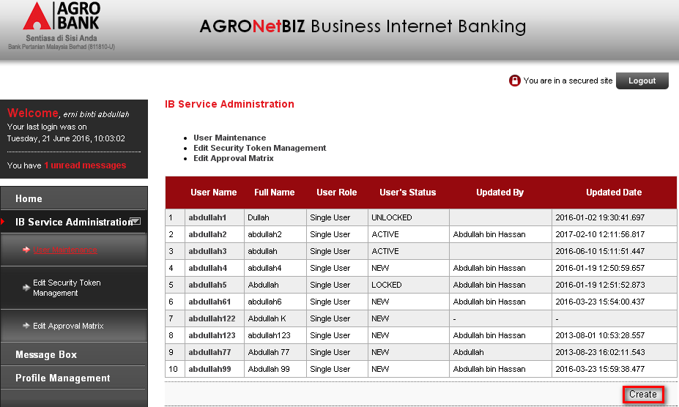
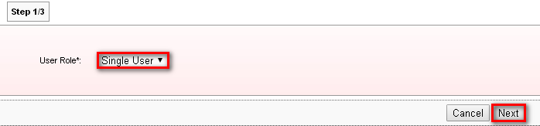
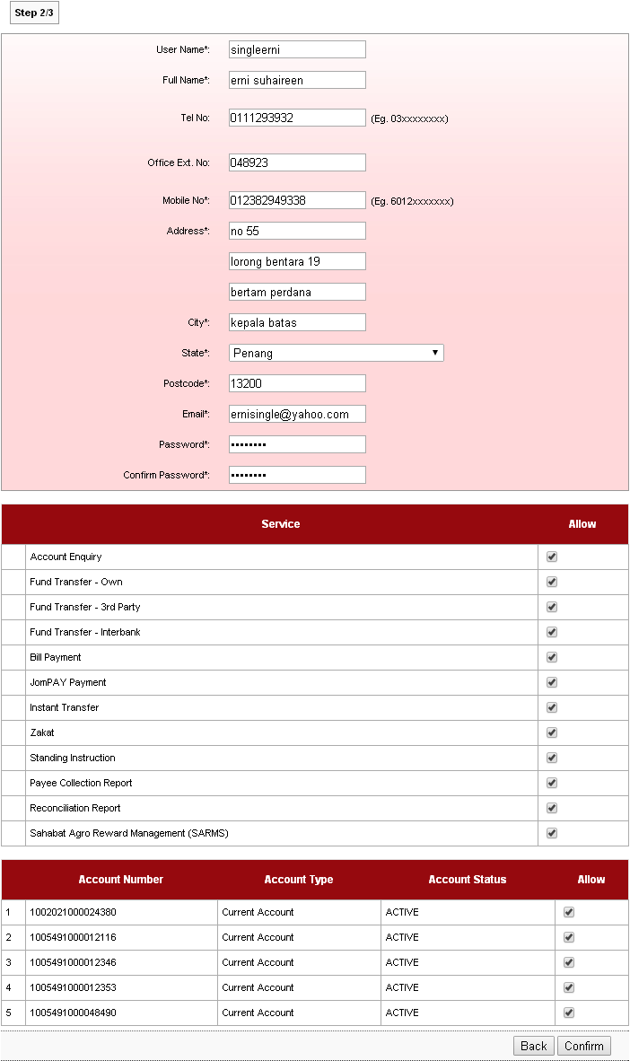
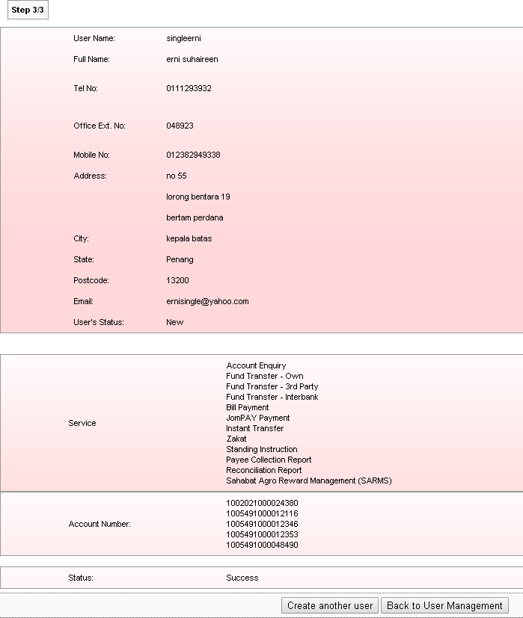

Result page:
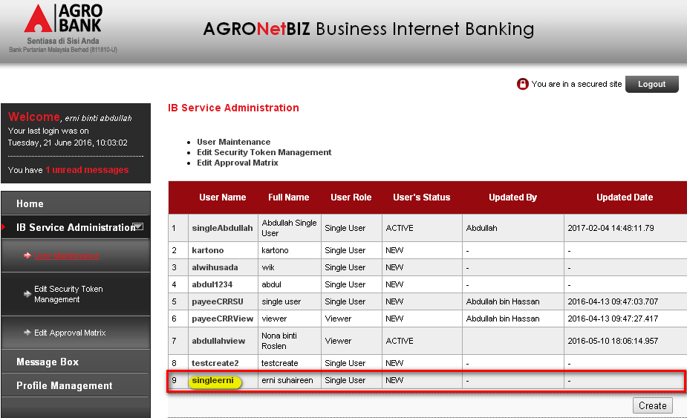

Initiator
Login as Corporate Admin on BIB and create Initiator.
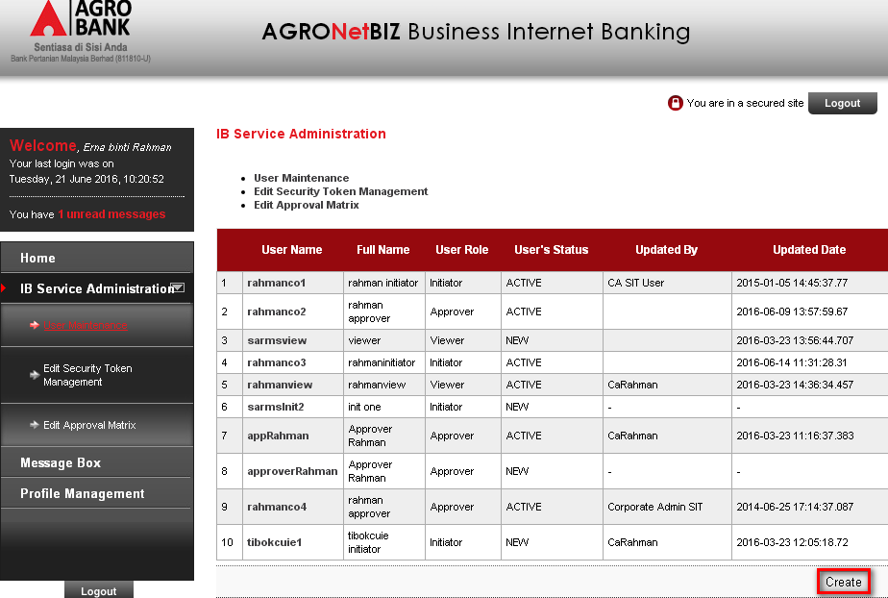
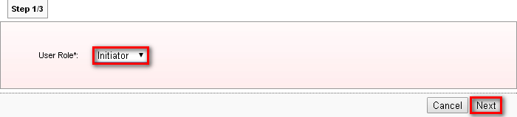
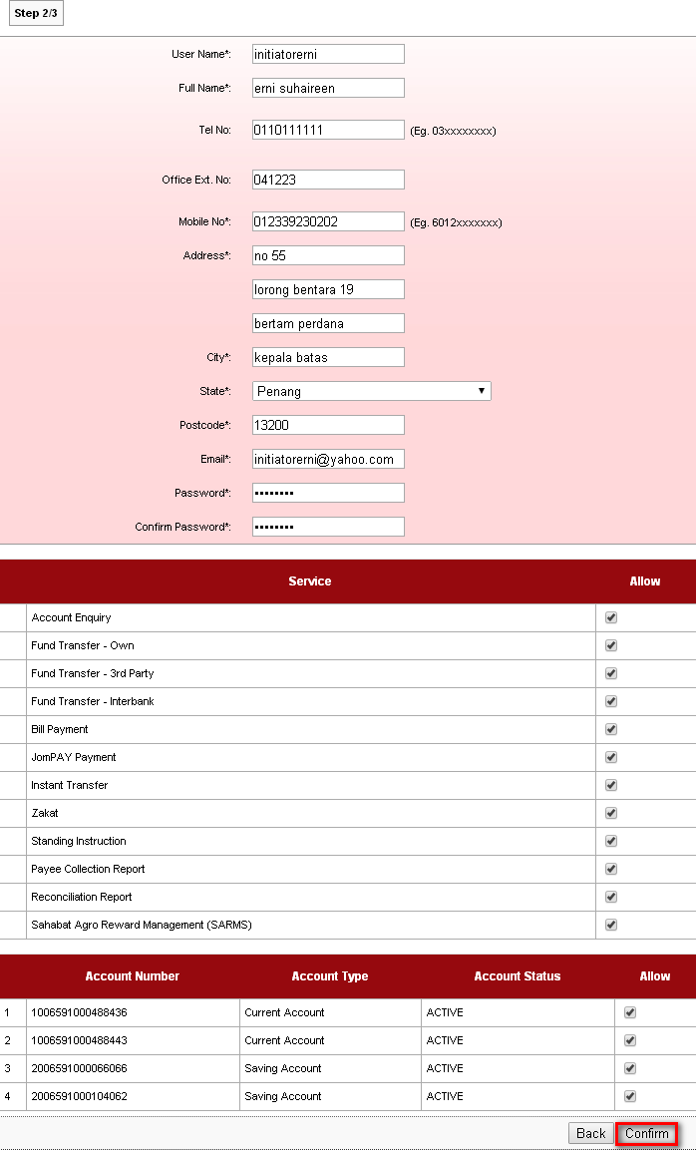
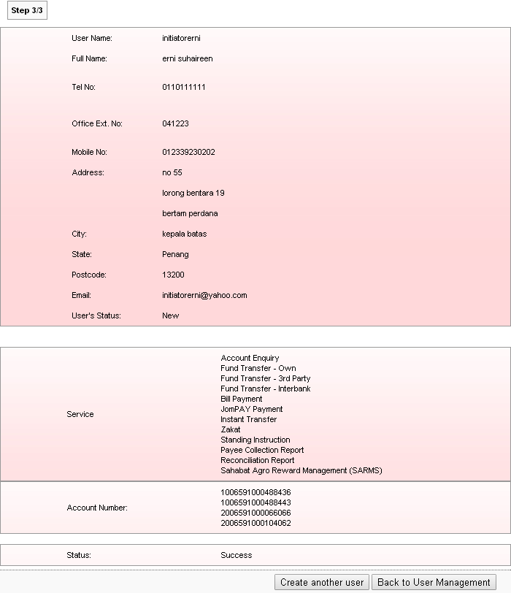

Result Page:

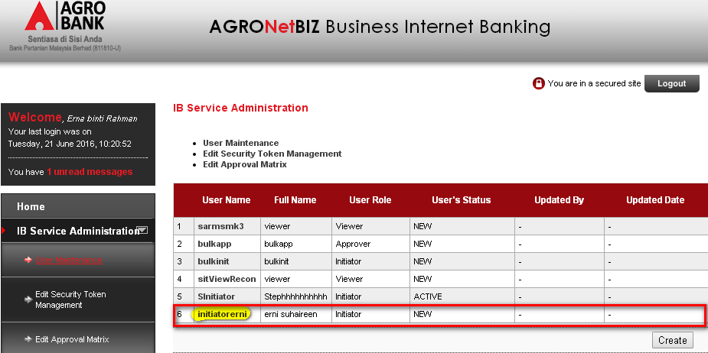

Approver
Login as Corporate Admin on BIB and create Approver User.
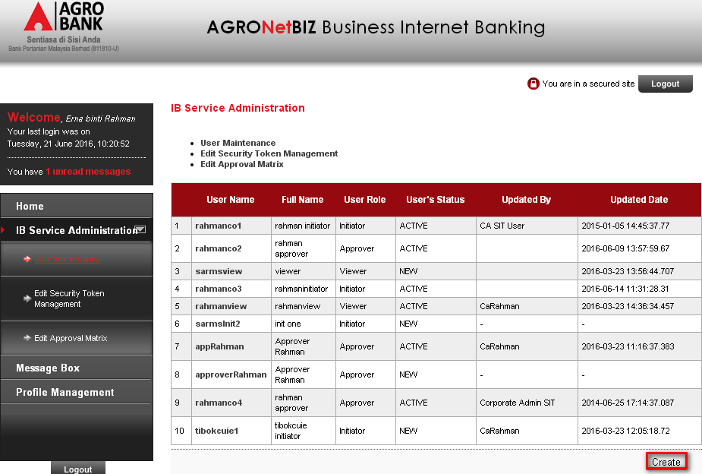
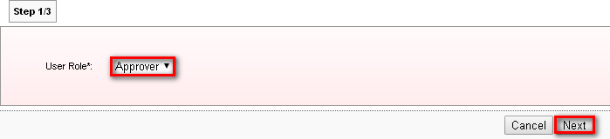
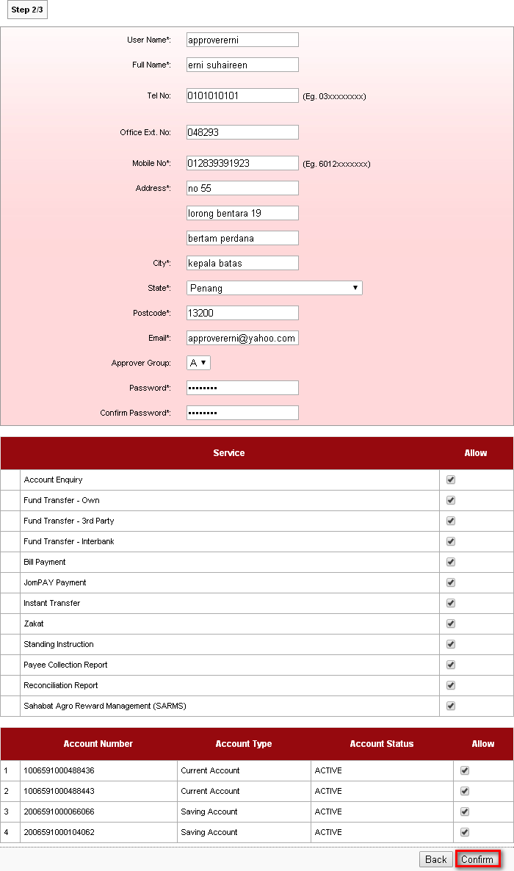
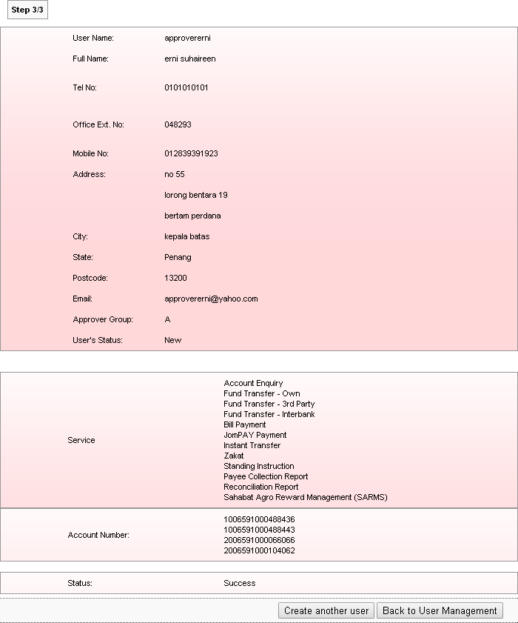

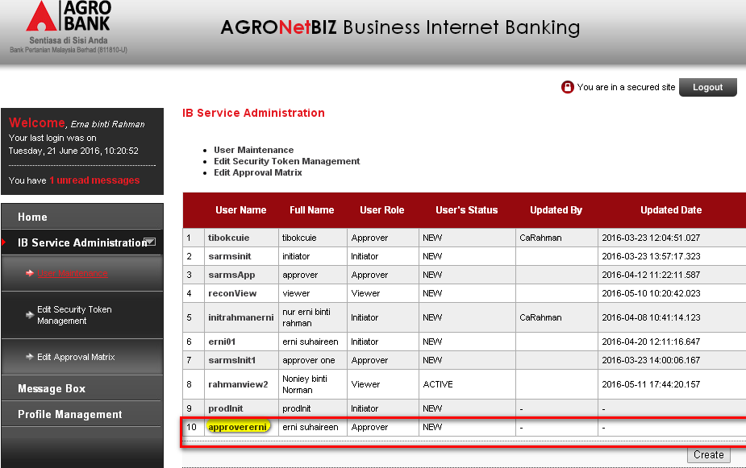

Viewer
Login as Corporate Admin on BIB and create Viewer user.
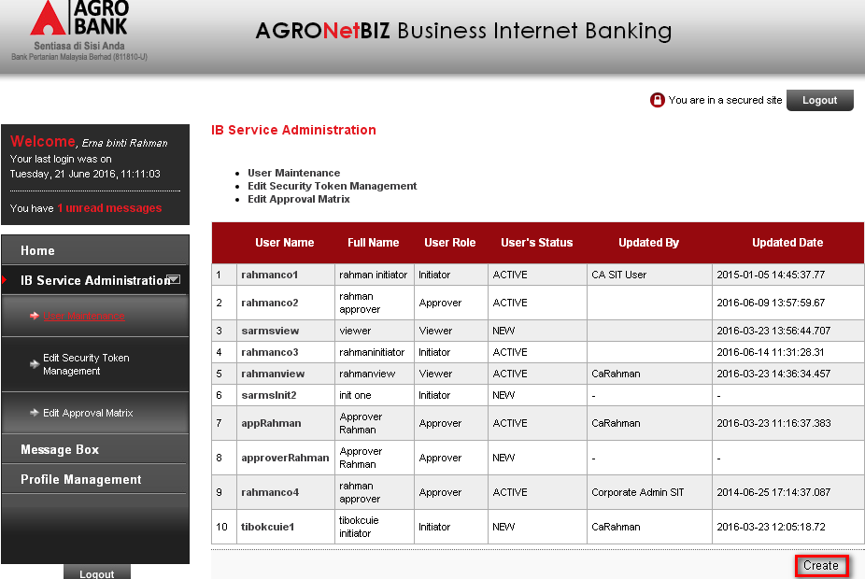
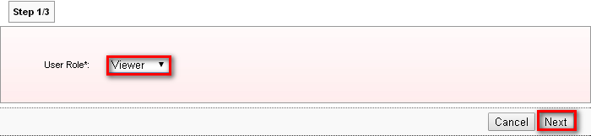
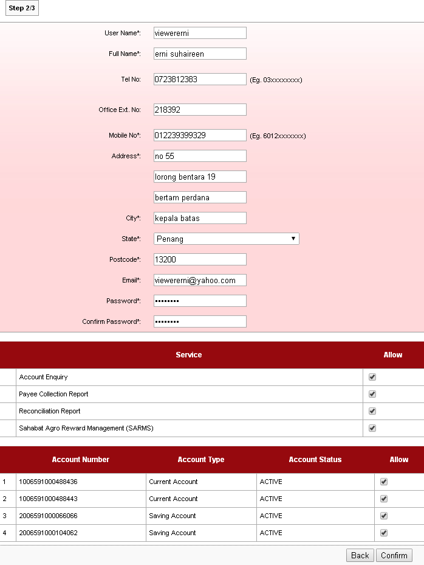
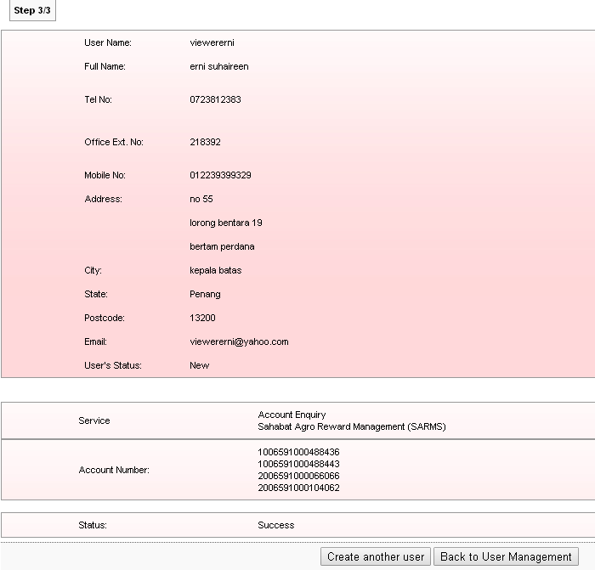

Result Page:
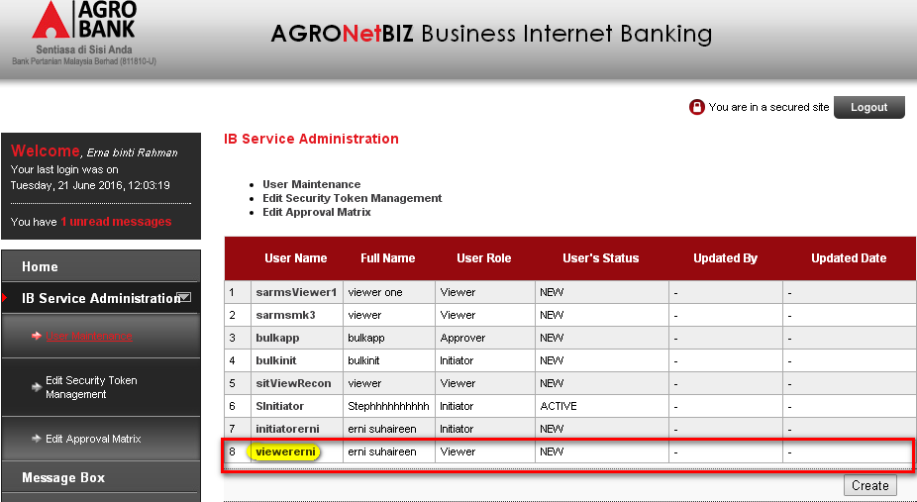

Edit User

Single User
Remove Zakat and Joompay Payment services.
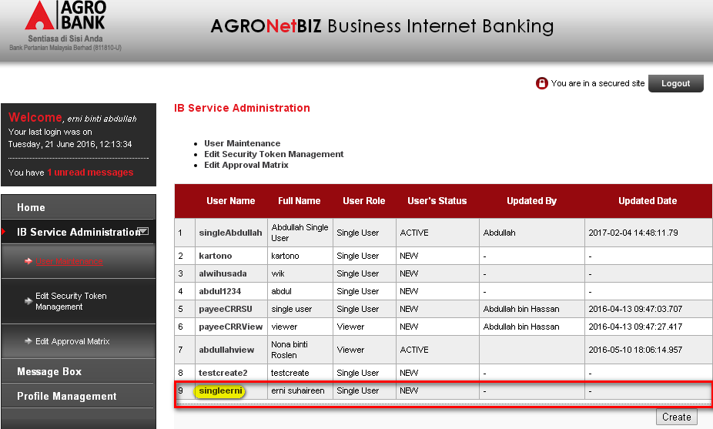
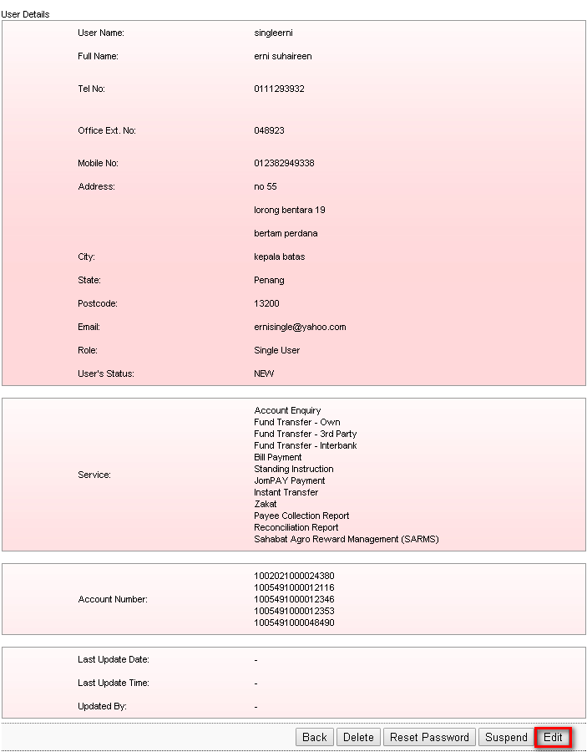
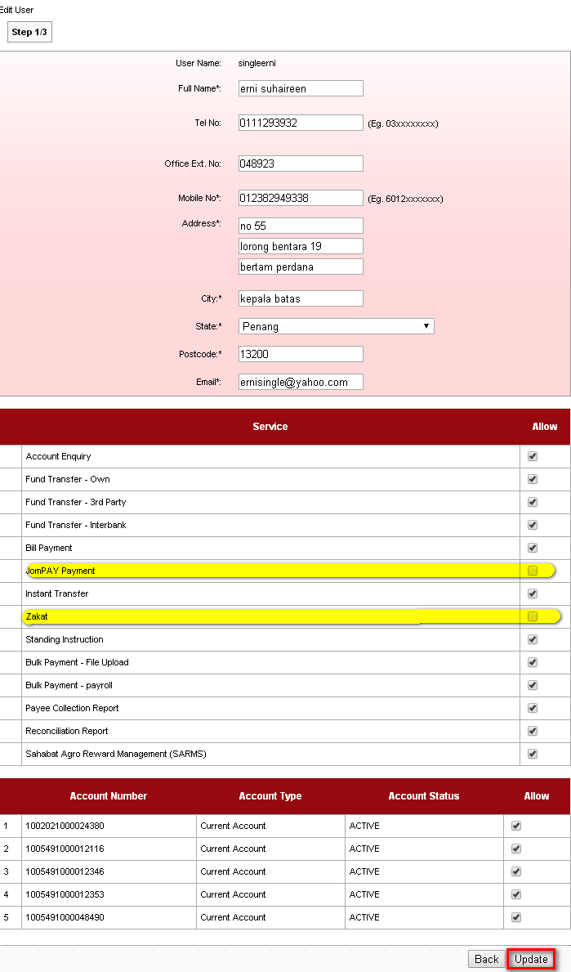
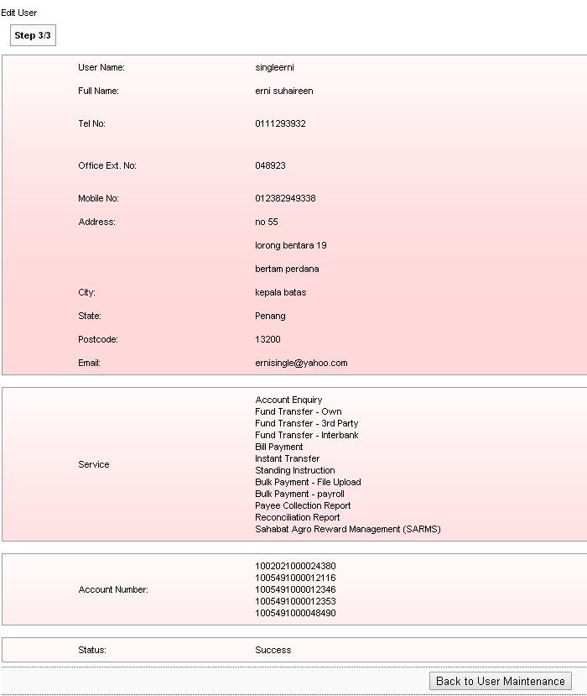

Result Page:
Login to BIB.SIT.SAHABAT as Single User to view navigation that has been allow to display on BIB. Result Page display that Zakat and Joompay Payment has been removed.
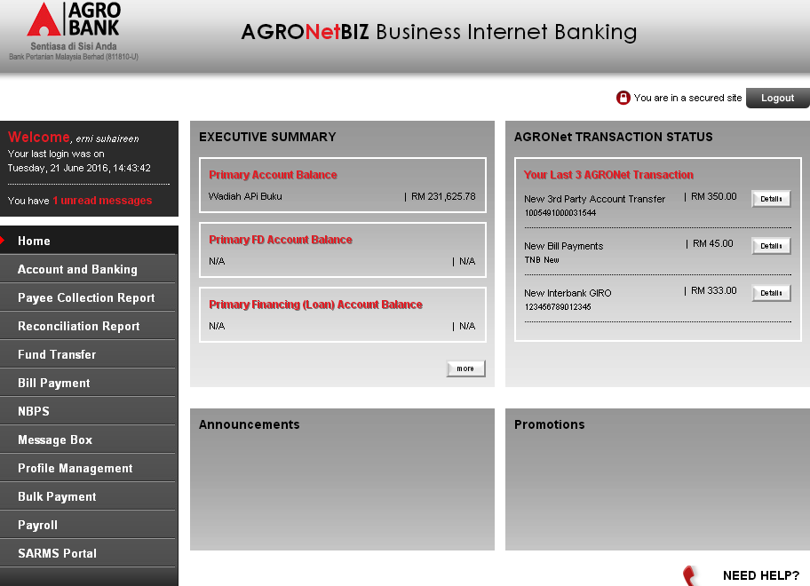

Initiator
Remove Zakat and Joompay Payment services.
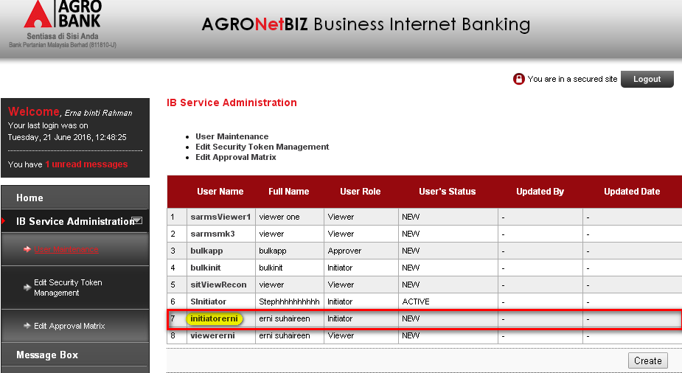

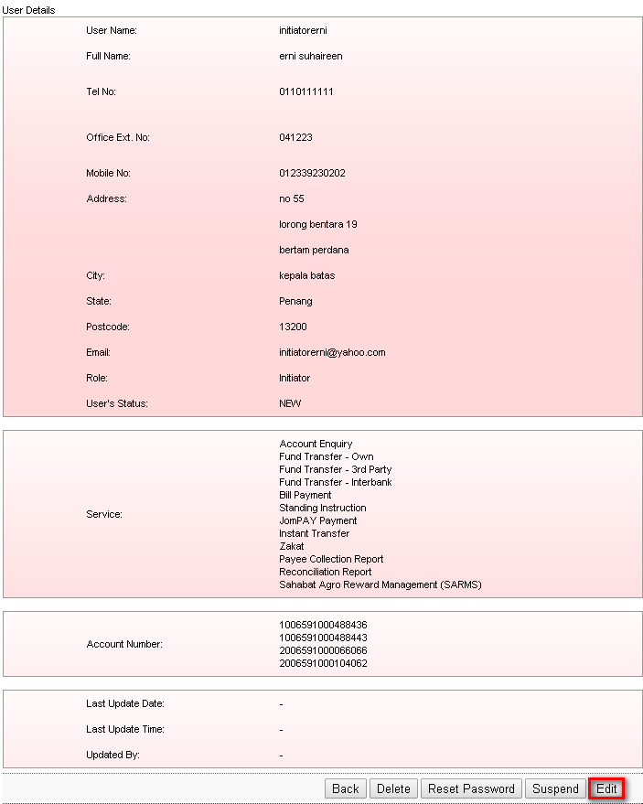
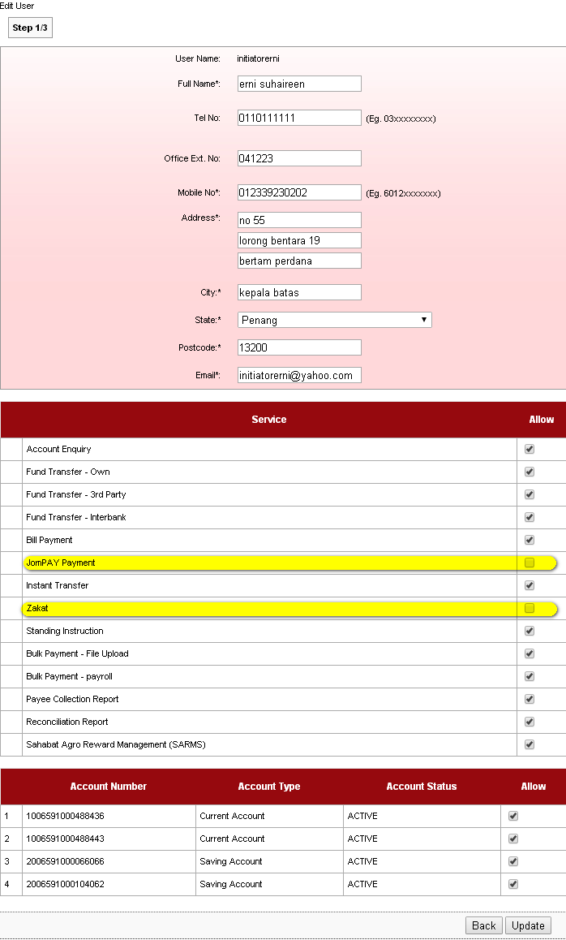
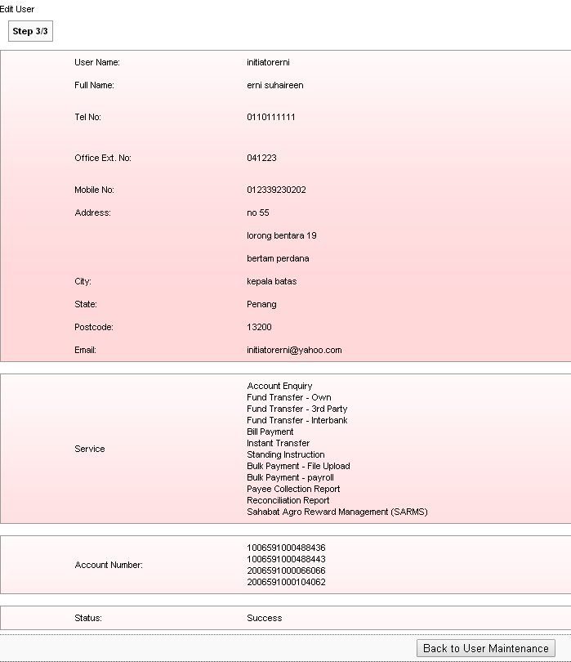

Result Page:
Login to BIB.SIT.SAHABAT as Initiator to view navigation that has been allow to display on BIB. Result Page display that Zakat and Joompay Payment has been removed.
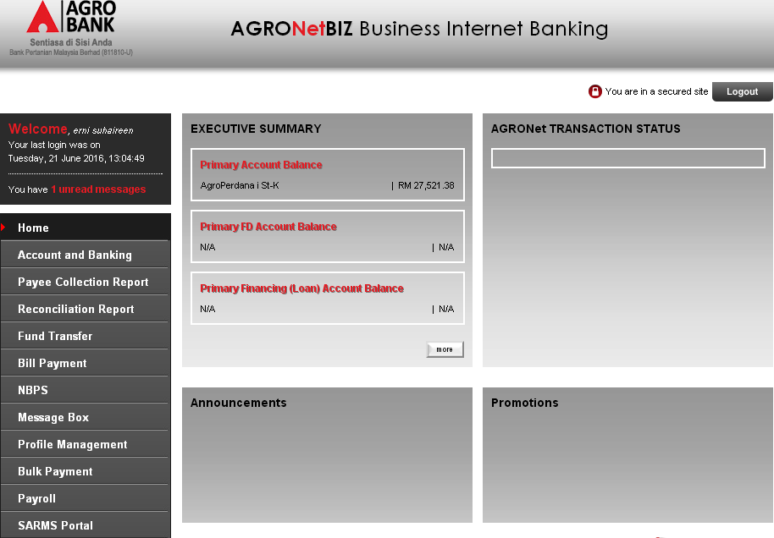

Approver
Remove Zakat and Joompay Payment services.
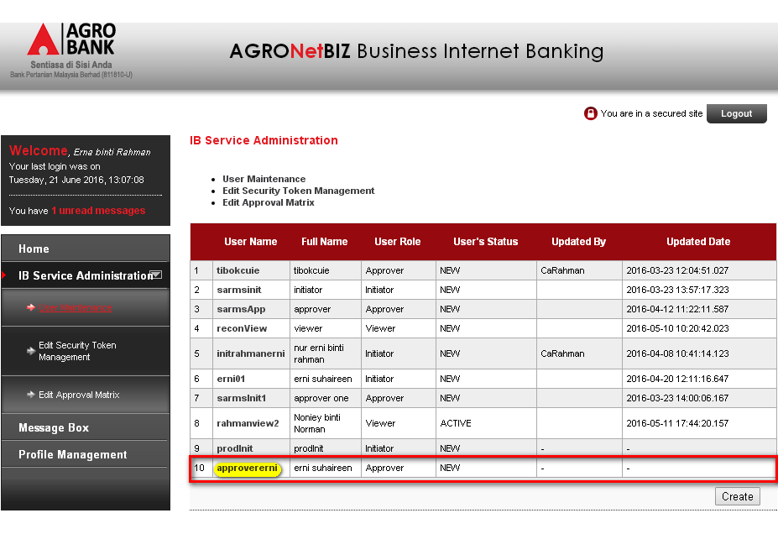

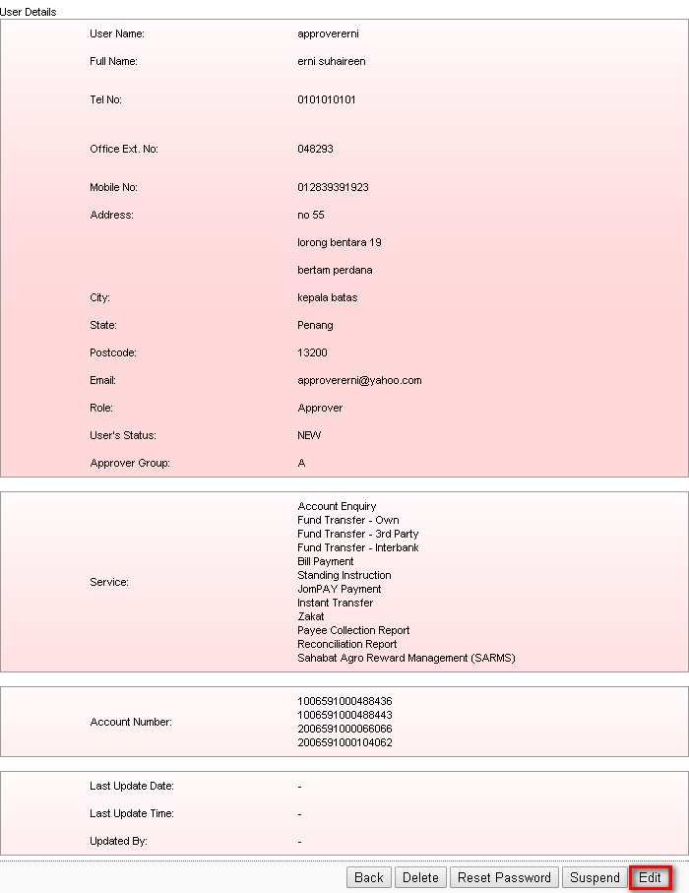
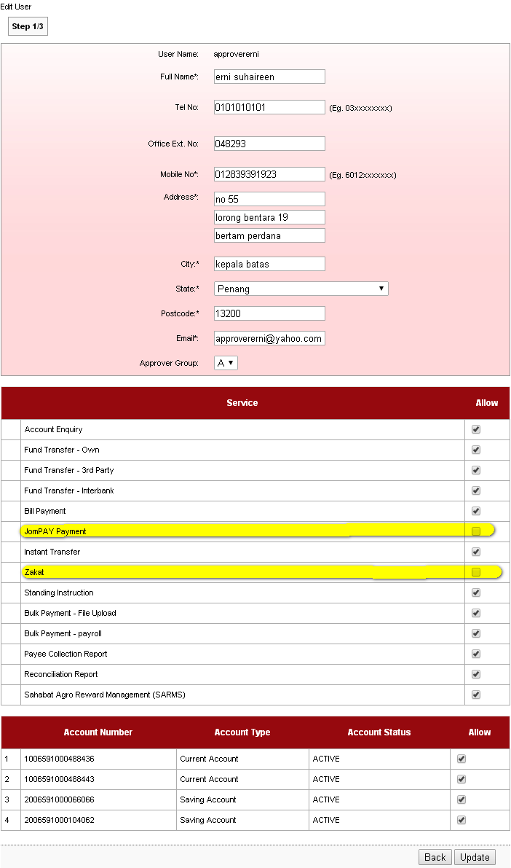
Result Page:
Login to BIB.SIT.SAHABAT as Approver to view navigation that has been allow to display on BIB. Result Page display that Zakat and Joompay Payment has been removed.
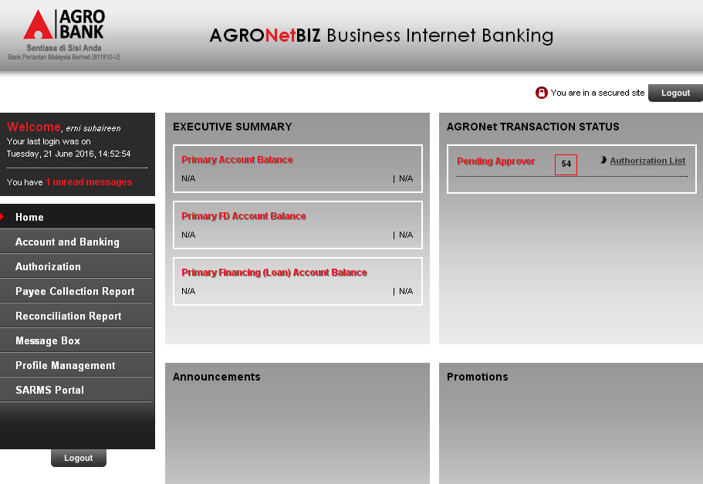

Viewer
Remove Payee Collection Report and Reconciliation Report services.
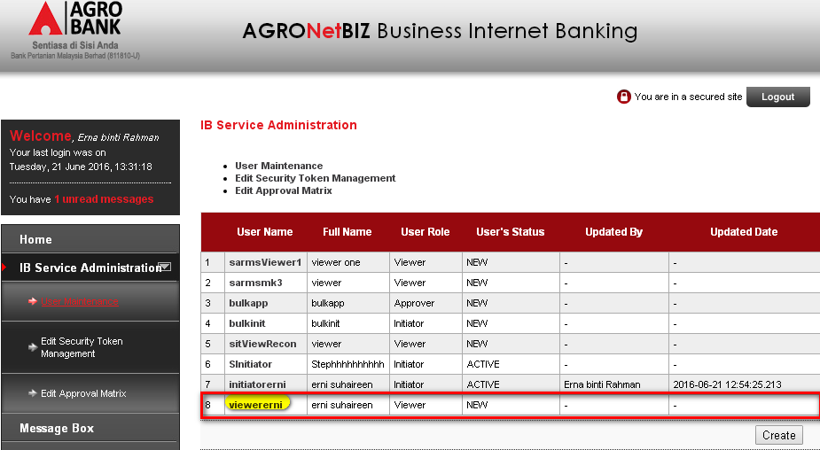
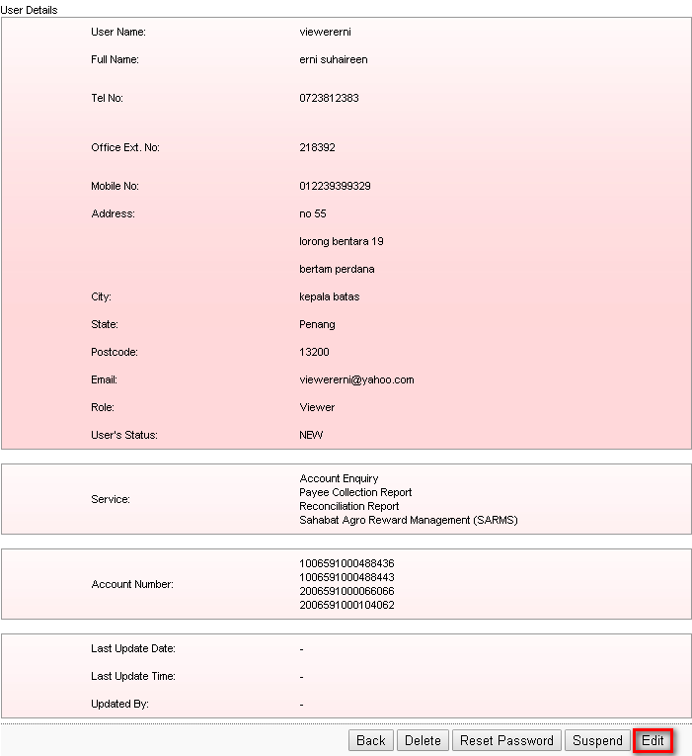
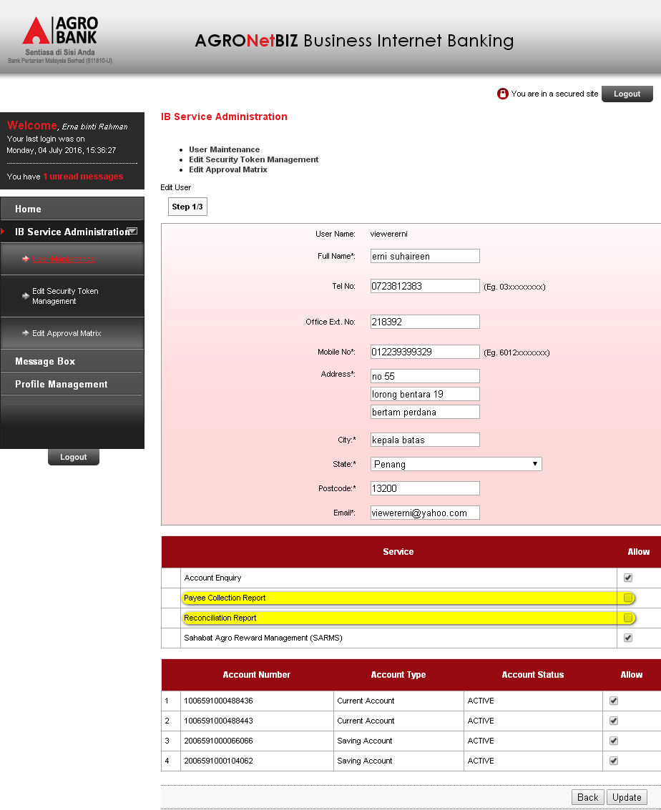

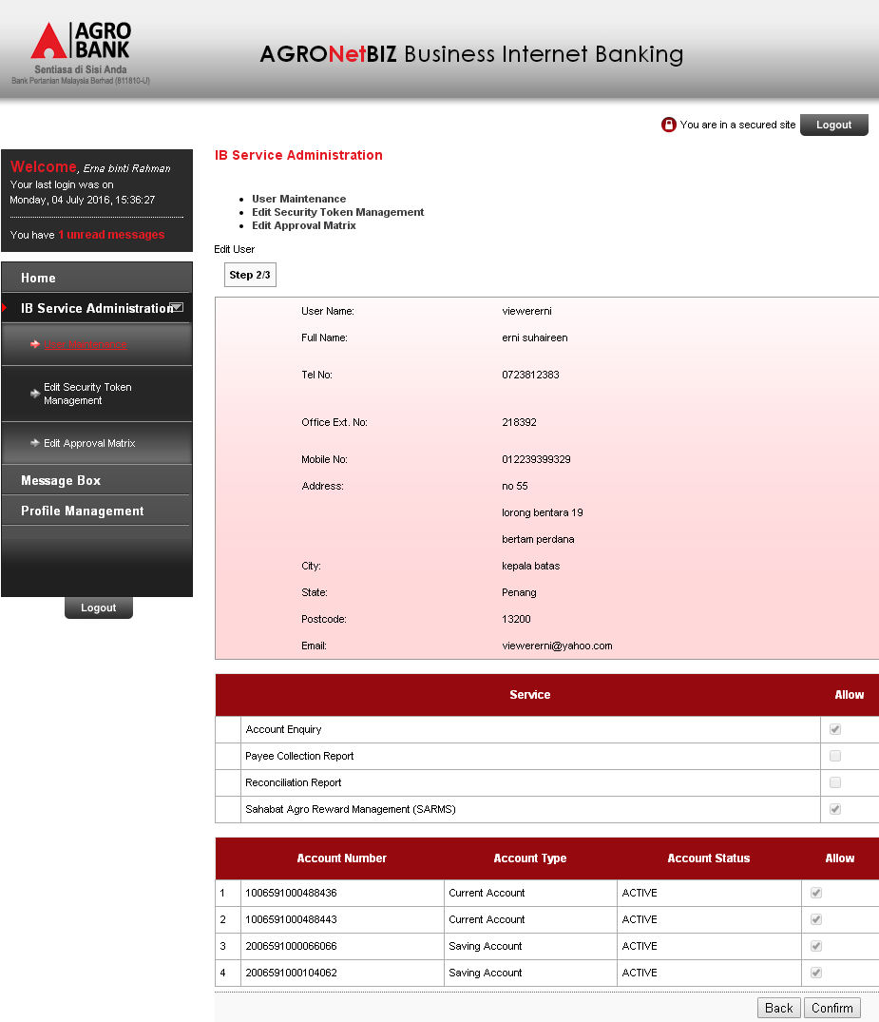

Result Page:
Login to BIB.SIT.SAHABAT as Viewer to view navigation that has been allow to display on BIB. Result Page display that Payee Collection Report and Reconciliation Report has been removed
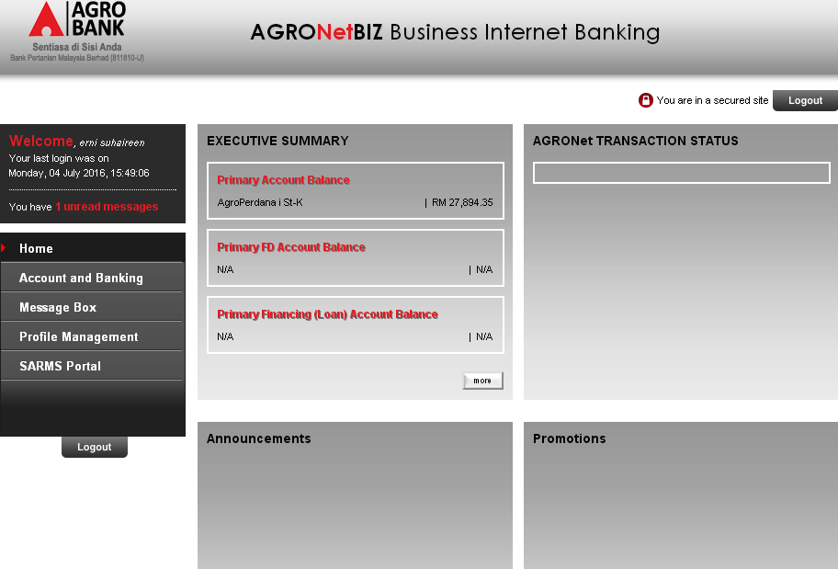

IBAM

Administrator

Create User

Corporate Admin
Login to IBAM as Administrator and create Corporate Admin.
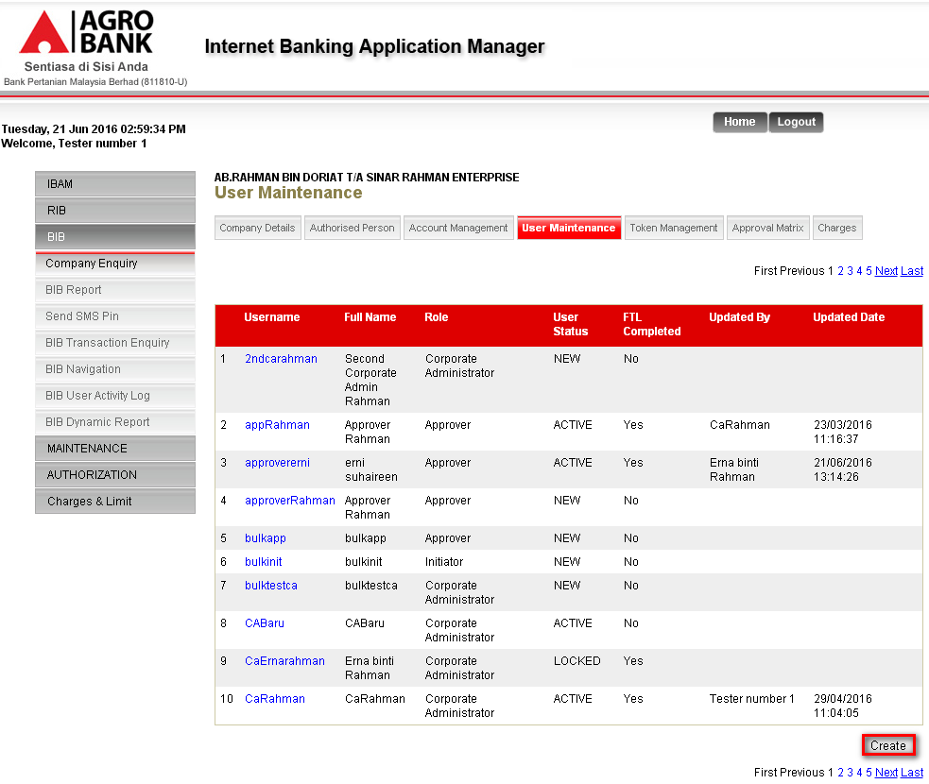
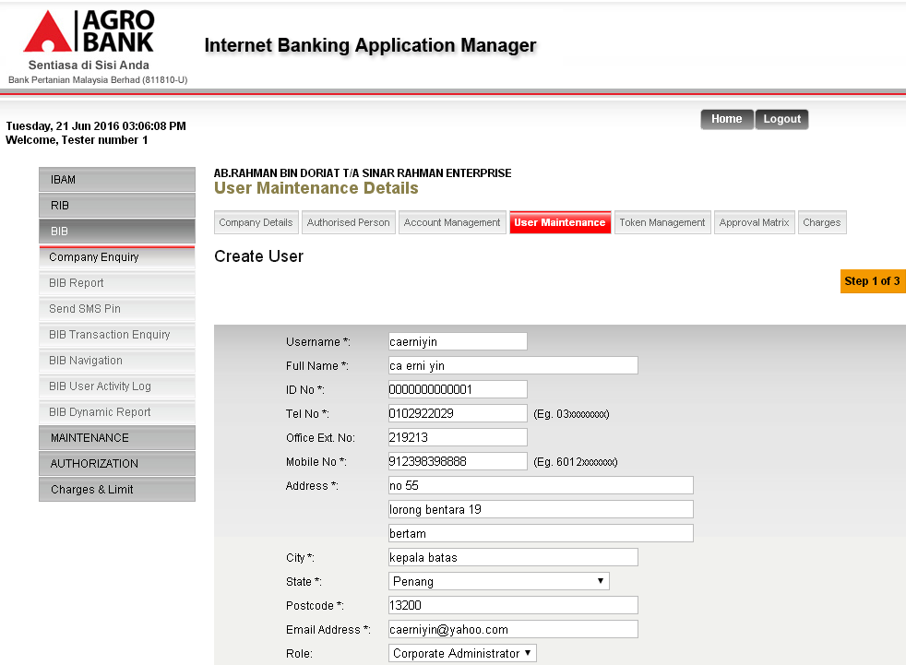

Result Page:
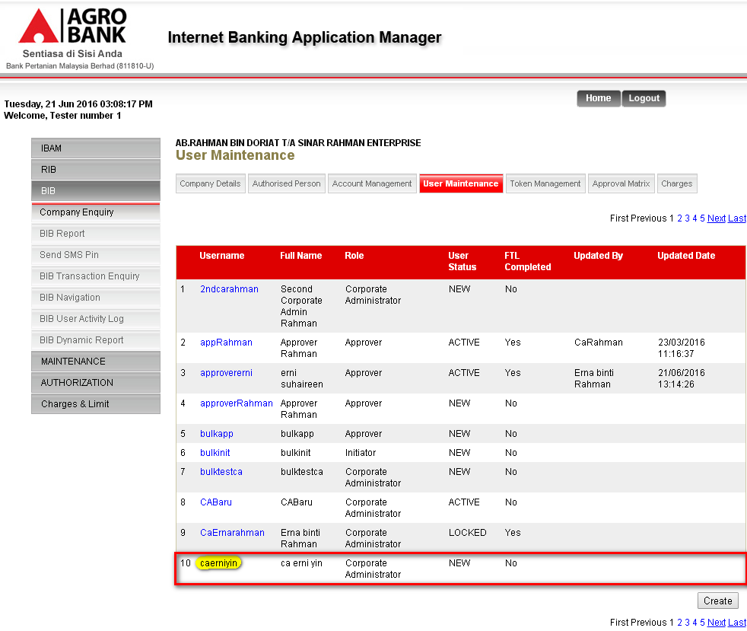

Single User
Login to IBAM as Administrator and create Single User.
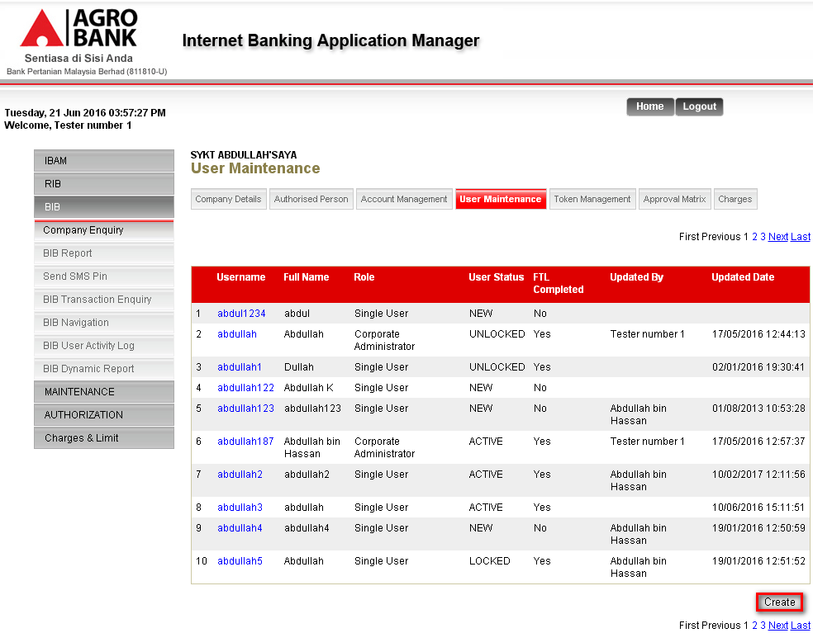
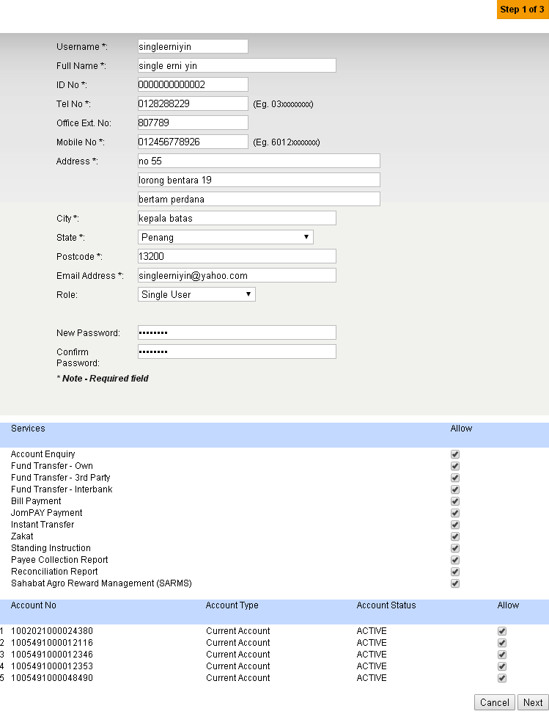
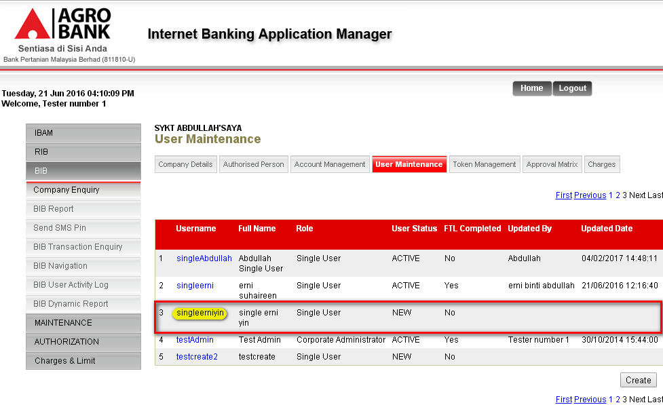

Initiator
Login to IBAM as Administrator and create Initiator.
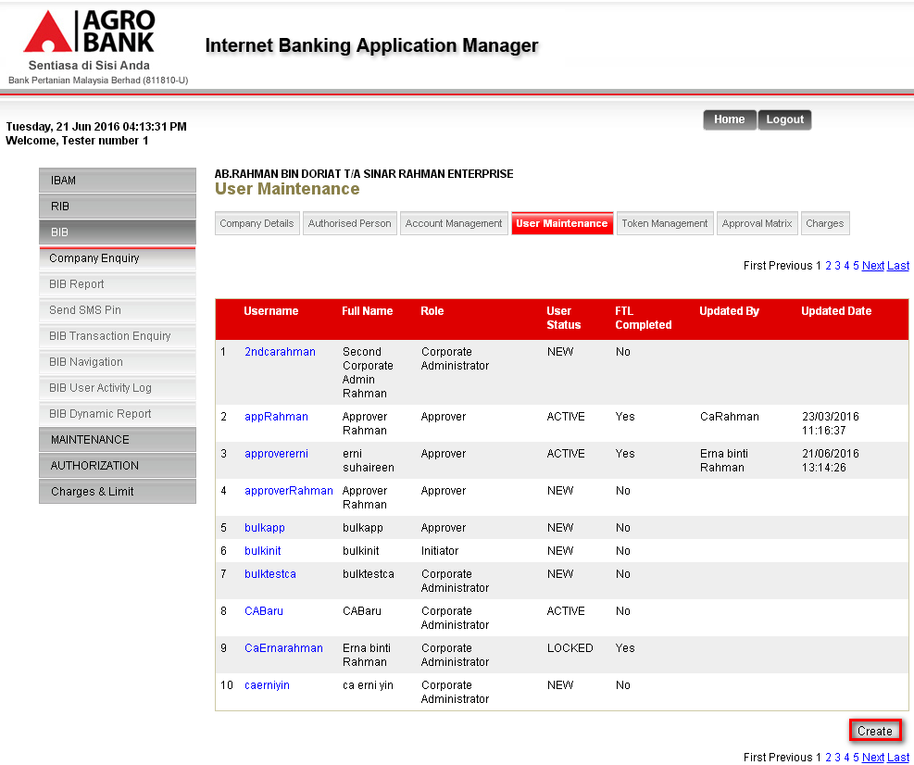
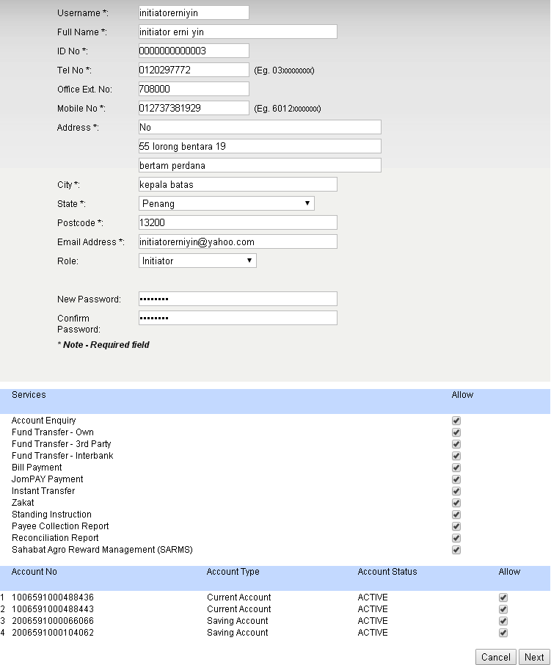
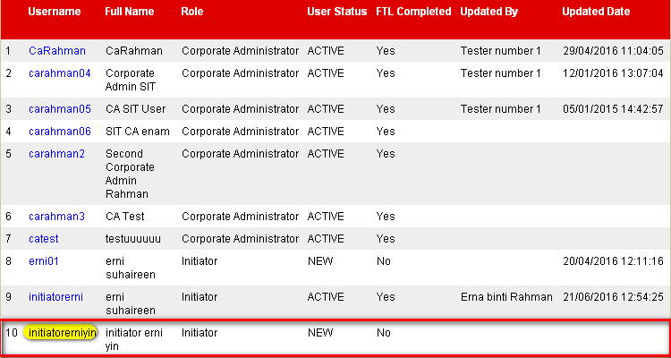

Approver
Login to IBAM as Administrator and create Approver.
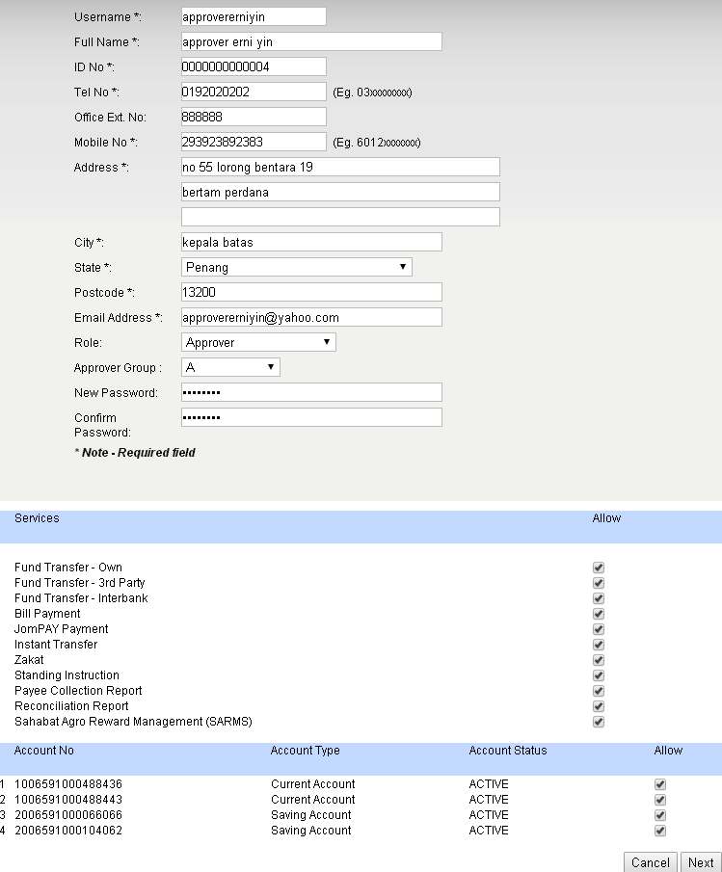
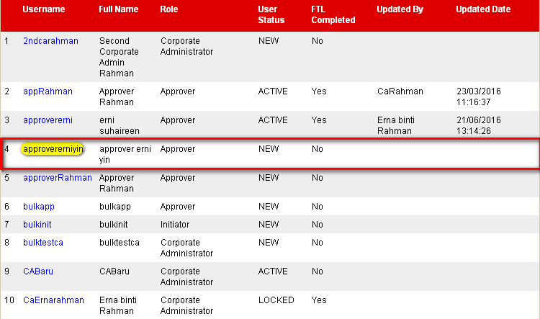

Viewer
Login to IBAM as Administrator and create viewer.
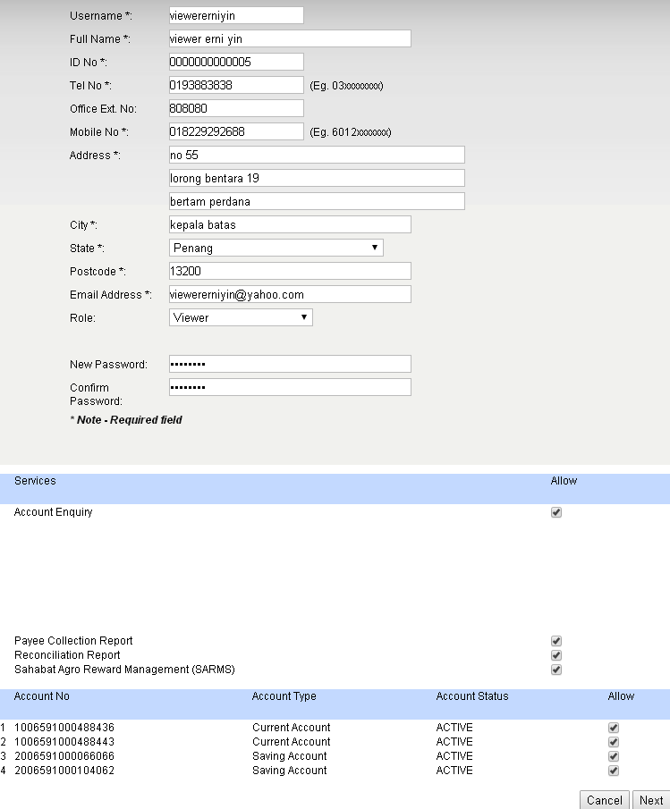
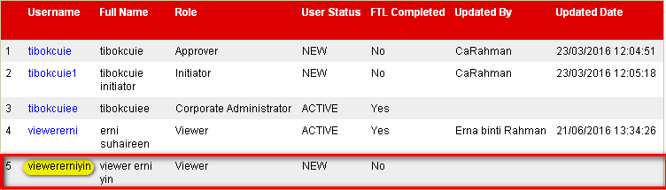

Edit User

Corporate Admin
Login to IBAM as Administrator and edit the the full name of Corporate Admin.
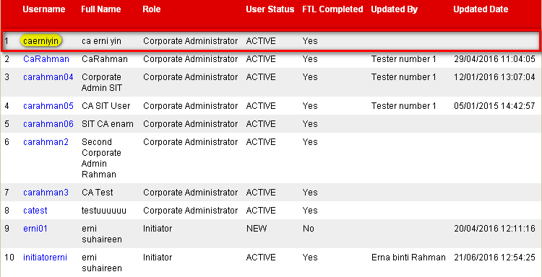
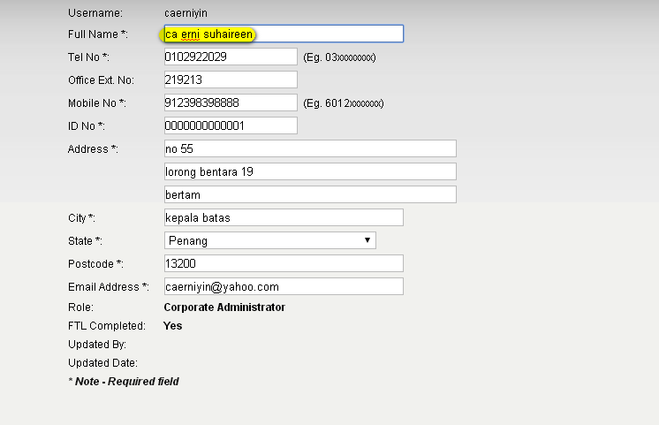
Result Page:
Full Name has successfully been changed to ‘ca erni suhaireen’.
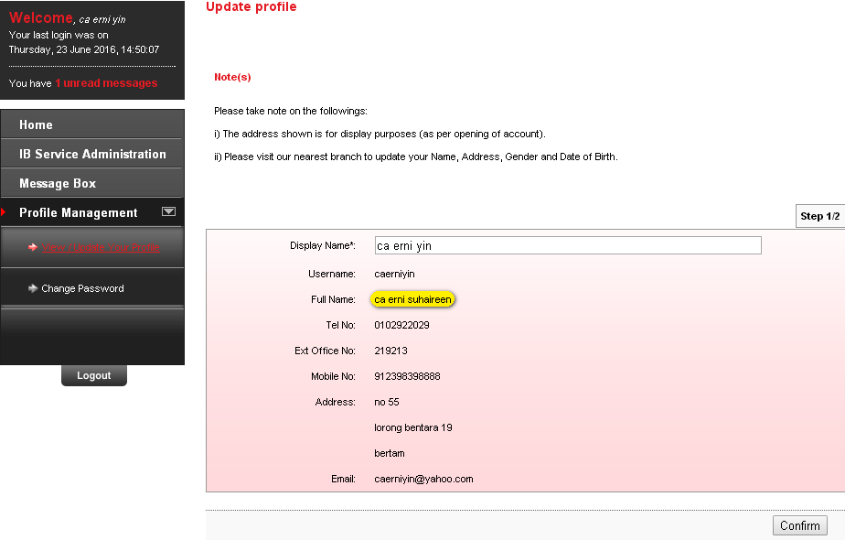

Single User
Login to IBAM as Administrator and edit to not assign Joompay and Zakat services of Single User.
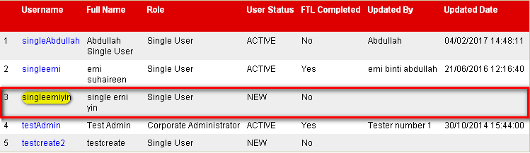
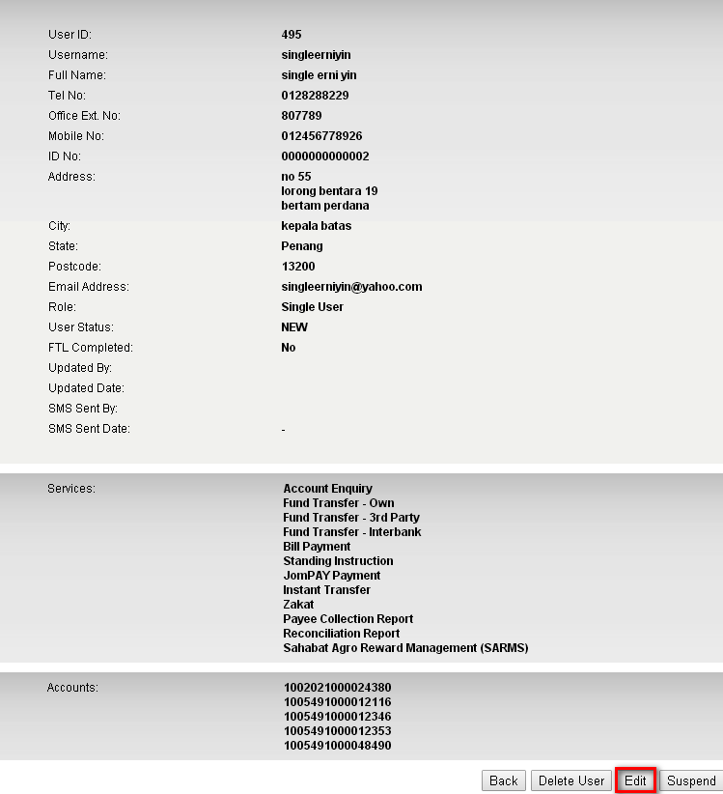
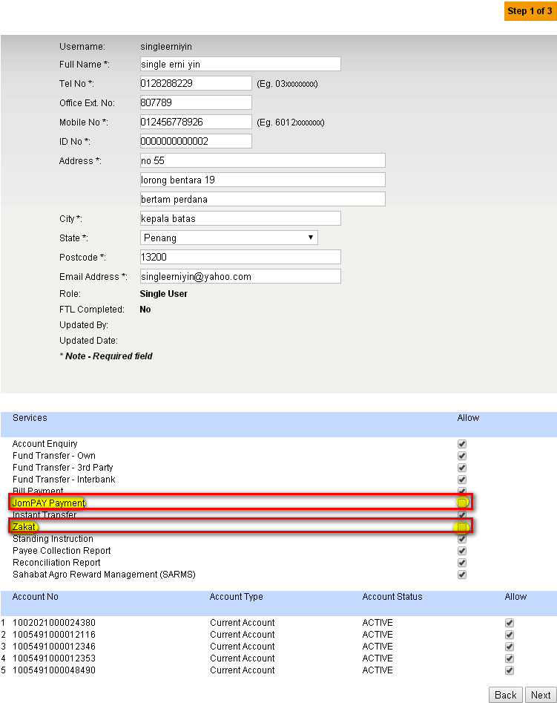

Test Result:
Login to BIB.SIT.SAHABAT as Single User to view navigation that has been allow to display on BIB. Result Page display that Zakat and Joompay Payment has been removed.
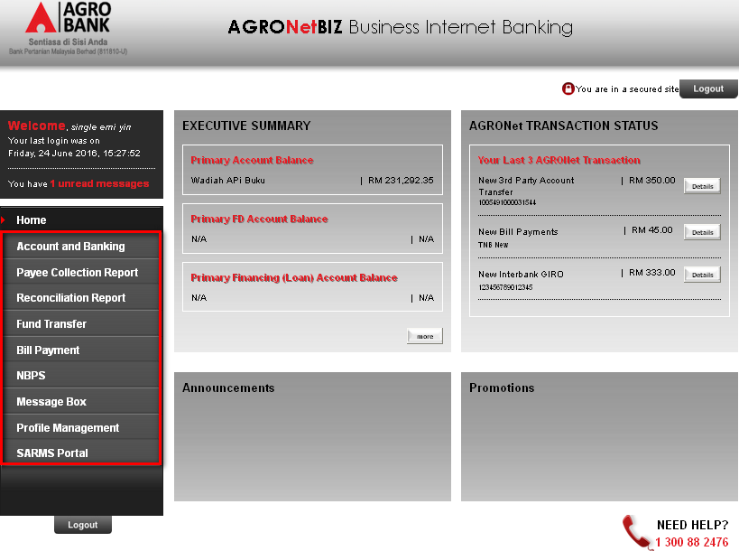

Initiator
Remove Zakat and Joompay Payment services.

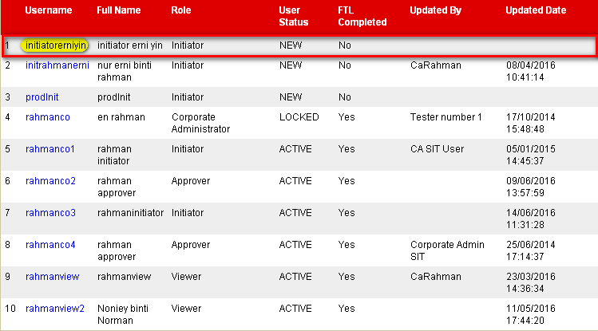
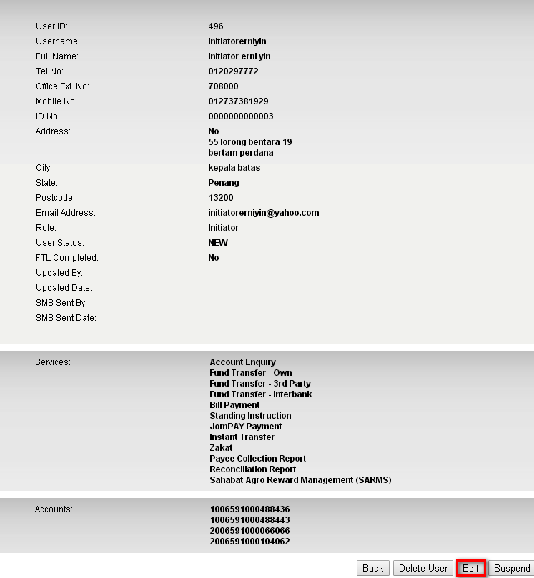
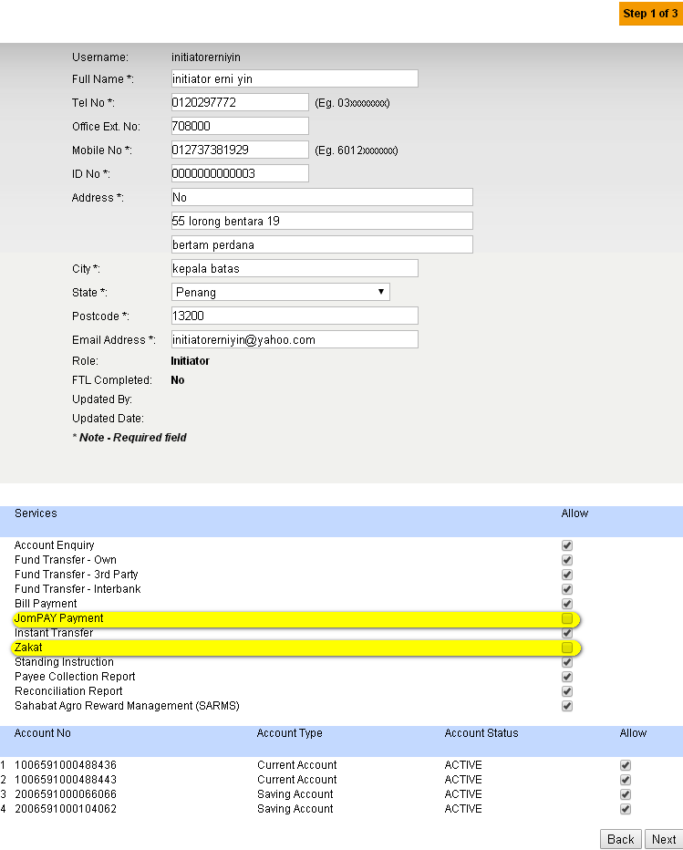

Result Page:
Login to BIB.SIT.SAHABAT as Initiator to view navigation that has been allow to display on BIB. Result Page display that Zakat and Joompay Payment has been removed.

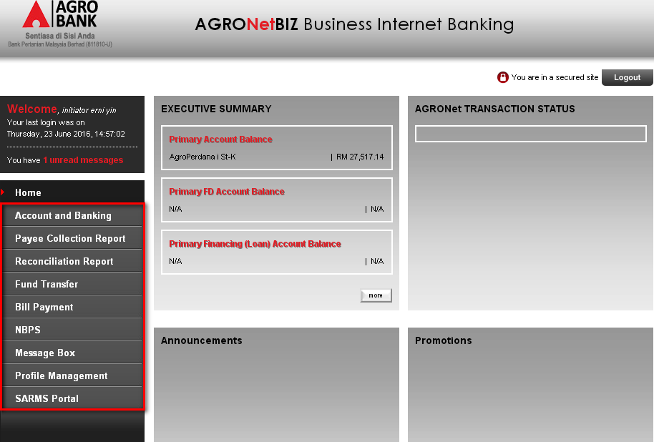

Approver
Remove Zakat and Joompay Payment services.
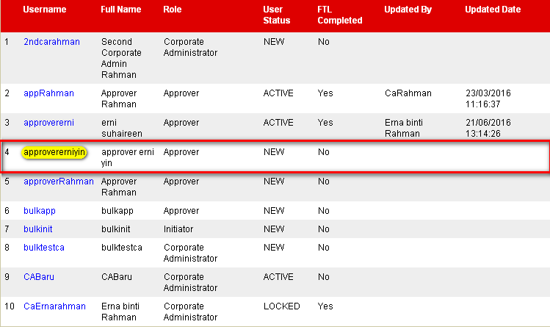
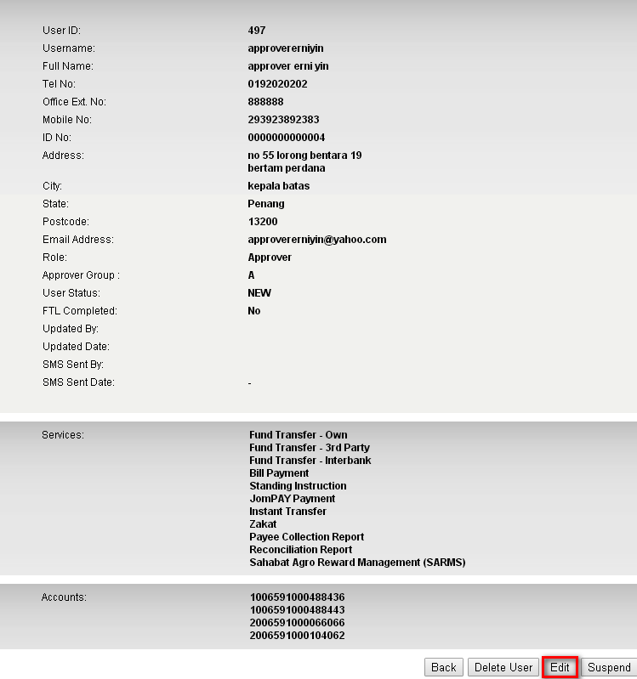
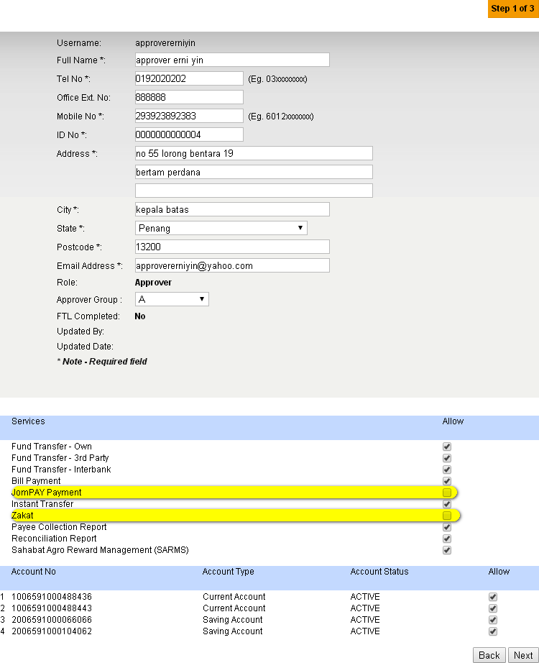

Test Result:
Login to BIB.SIT.SAHABAT as Approver to view navigation that has been allow to display on BIB. Result Page display that Zakat and Joompay Payment has been removed.
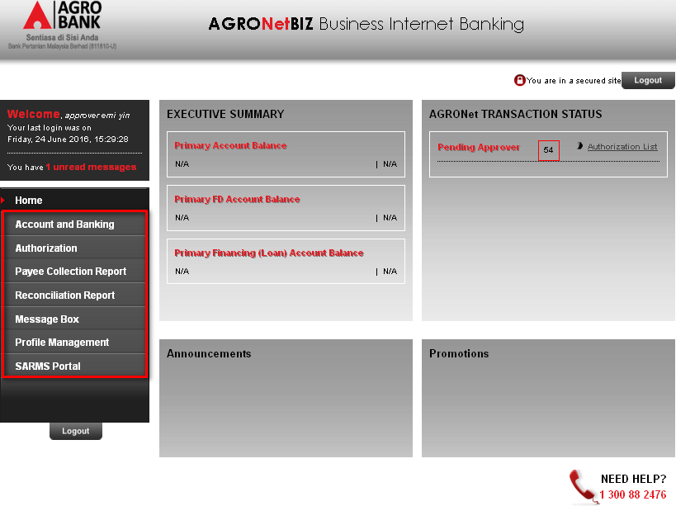

Viewer
Remove Payee Collection Report and Reconciliation Report services.
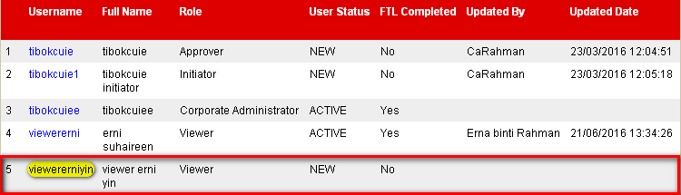
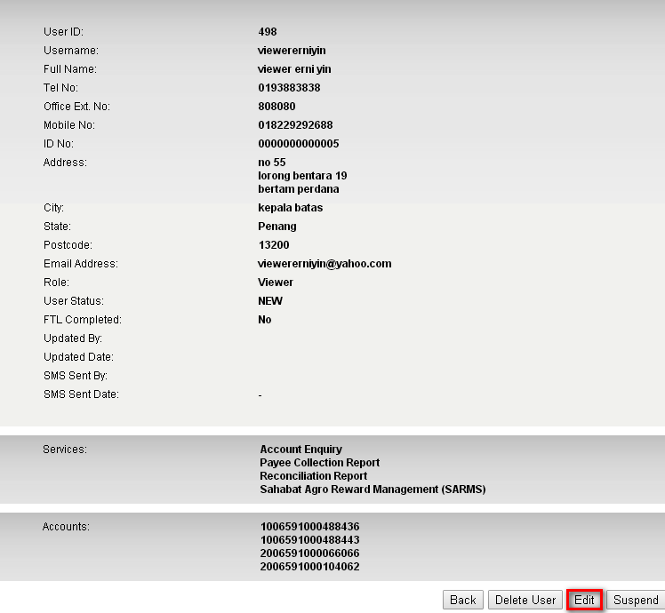
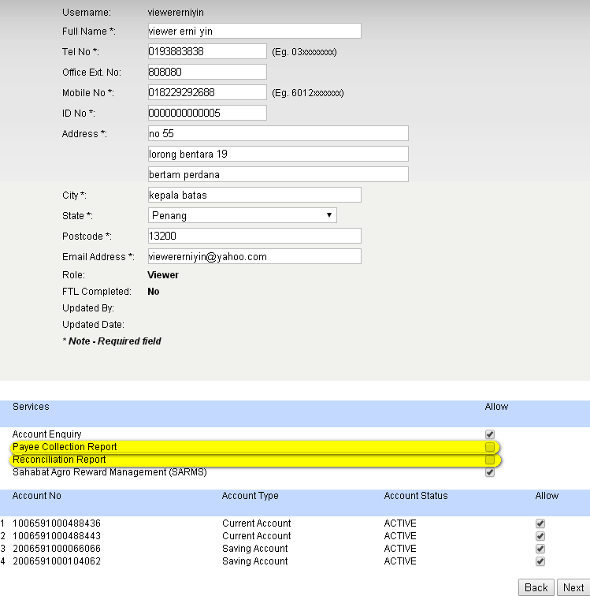

Login to BIB.SIT.SAHABAT as Viewer to view navigation that has been allow to display on BIB. Result Page display that Payee Collection Report and Reconciliation Report has been removed.
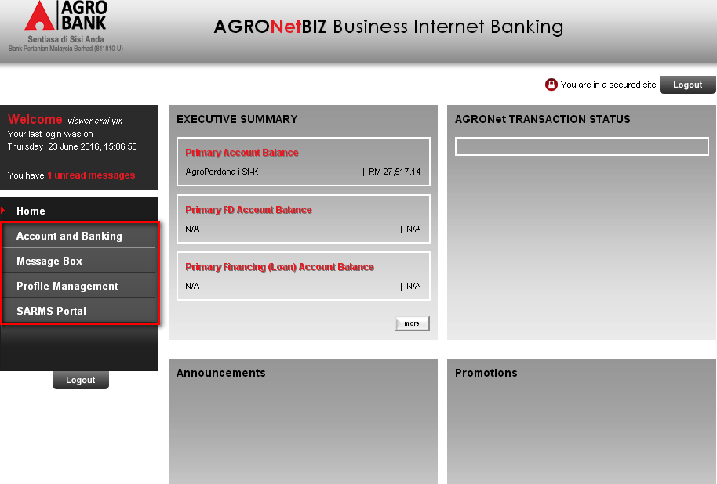

Maker/Checker

Create User

Corporate Admin
Login as Maker on IBAM to create Corporate Admin.

Maker
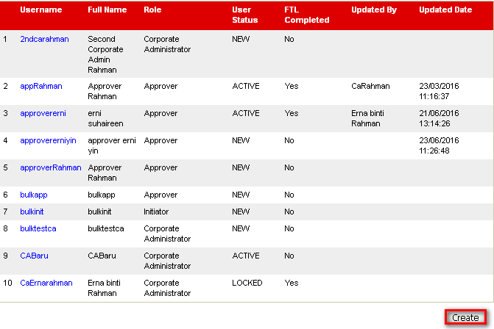
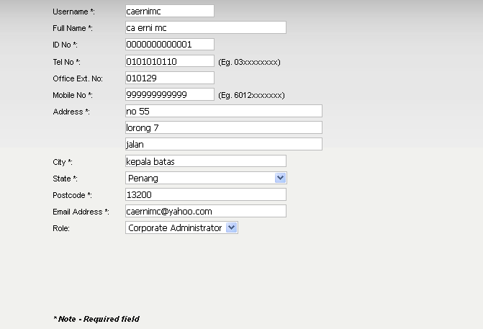

Checker
Login as Checker to approve the created user.
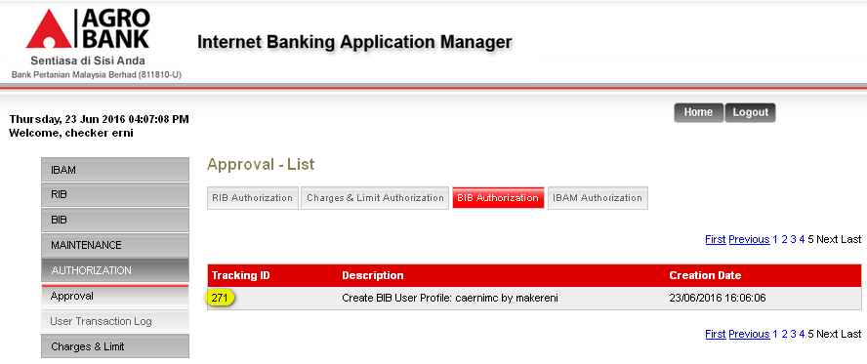
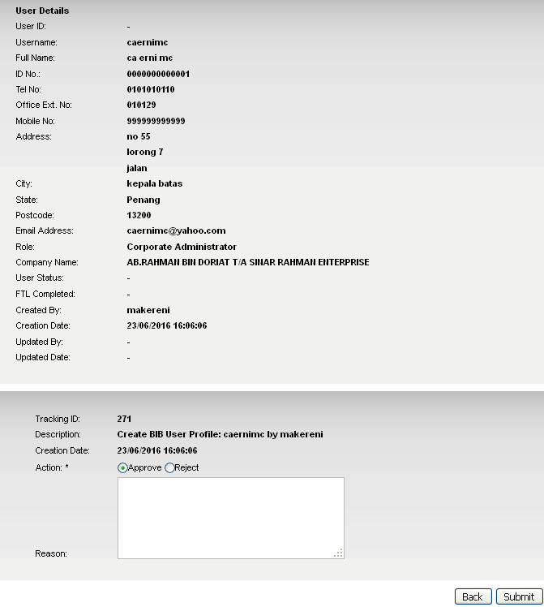

Result Page:
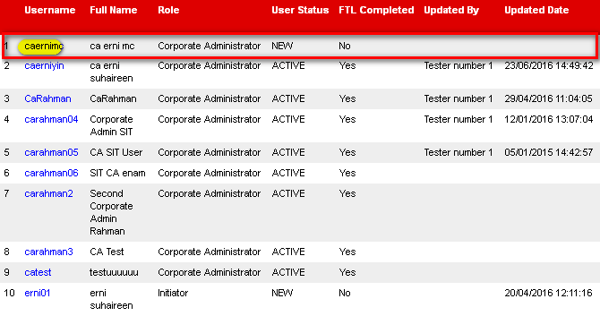

Single User

Maker
Login as Maker on IBAM and create Single User.
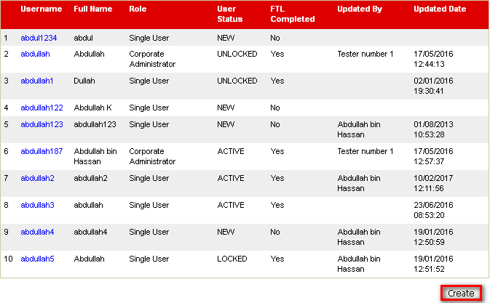
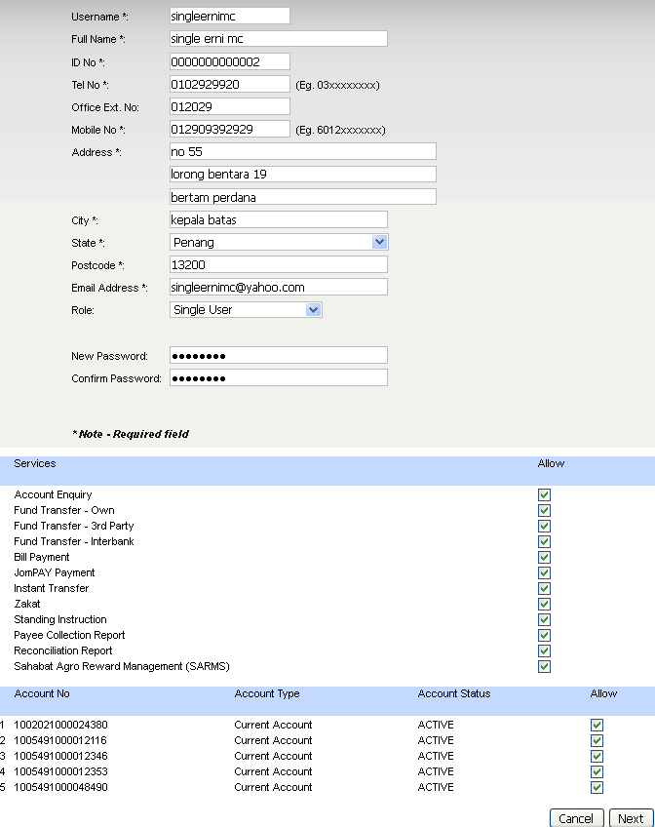

Checker

Login as Checker to approve the created user.

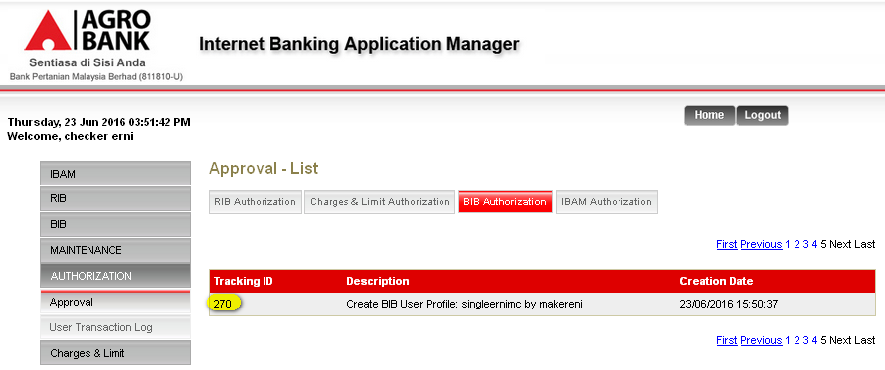

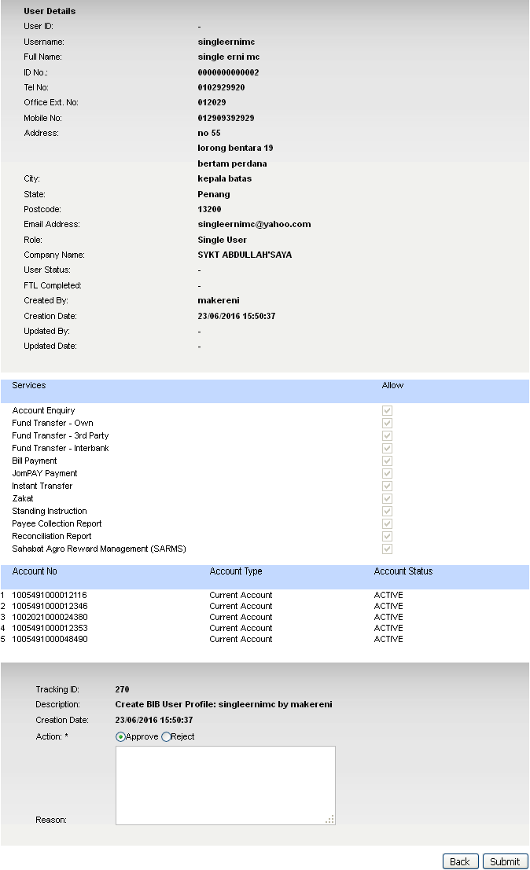
Result Page:
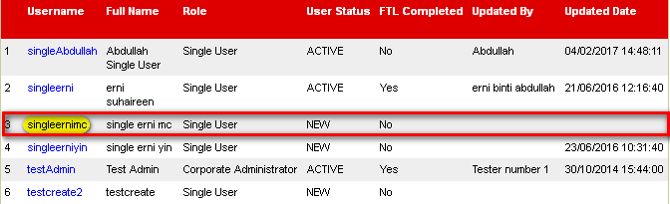

Initiator

Maker
Login as Maker on IBAM and create Initiator.
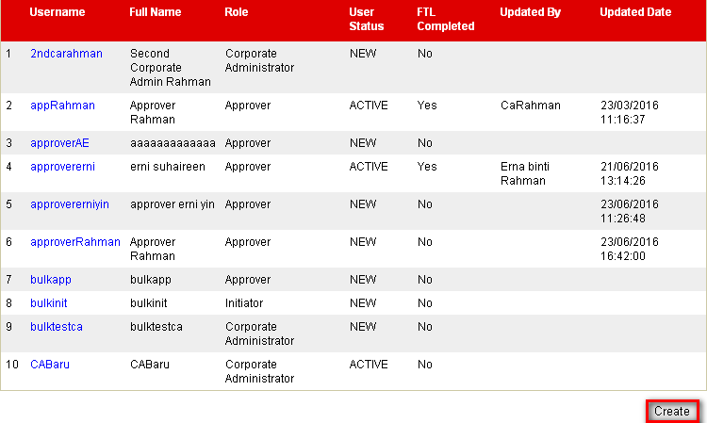

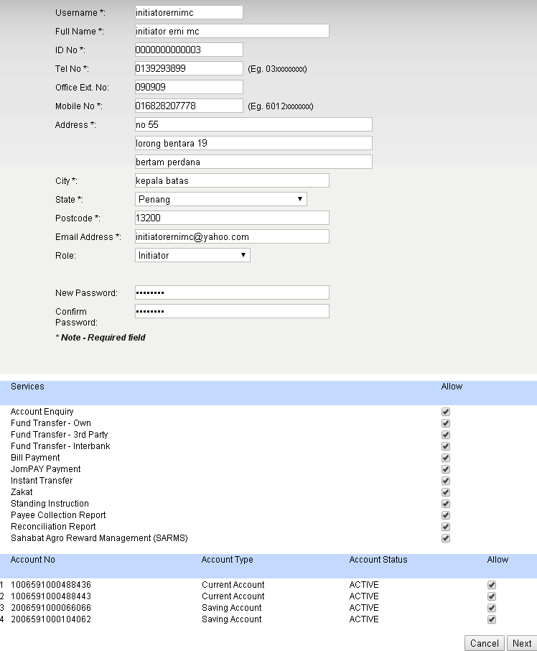

Checker
Login as Checker to approve the created user.
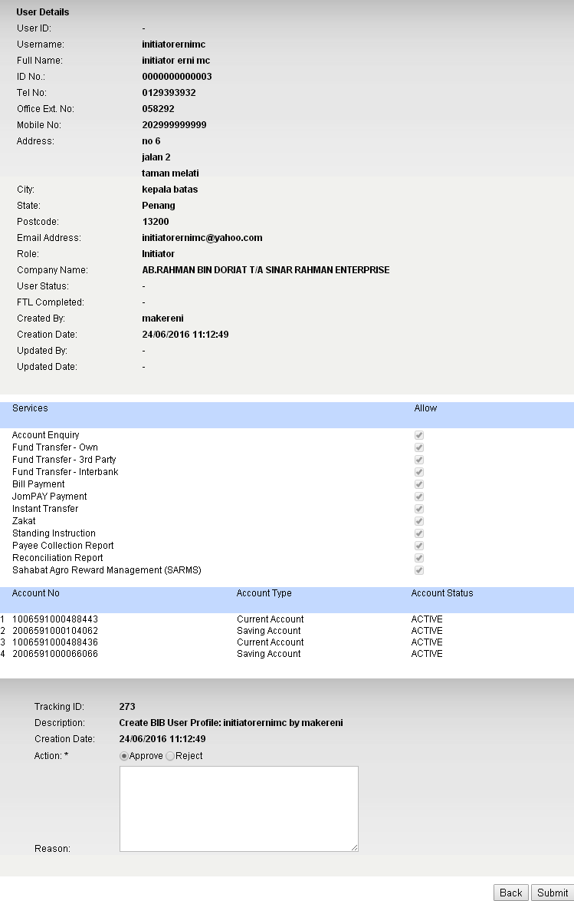

Result Page:
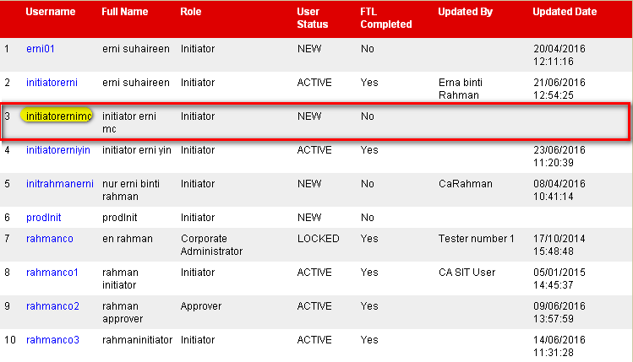

Approver

Maker
Login as Maker on IBAM and create Approver.
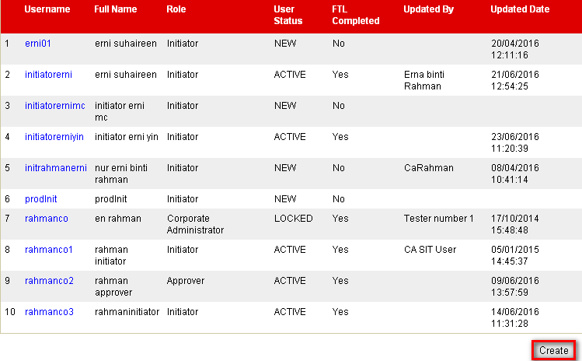

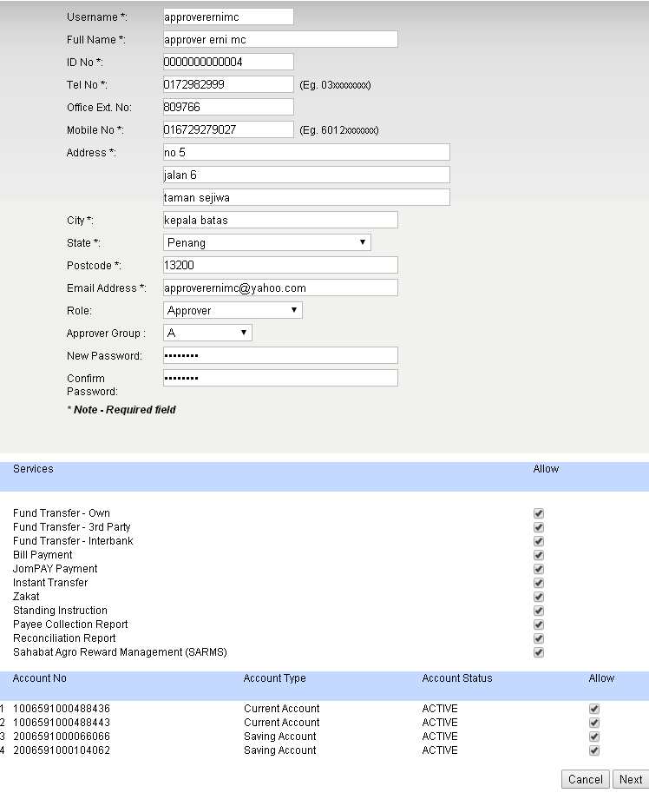

Checker
Login as Checker to approve the created user.
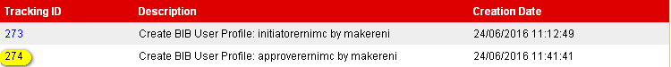
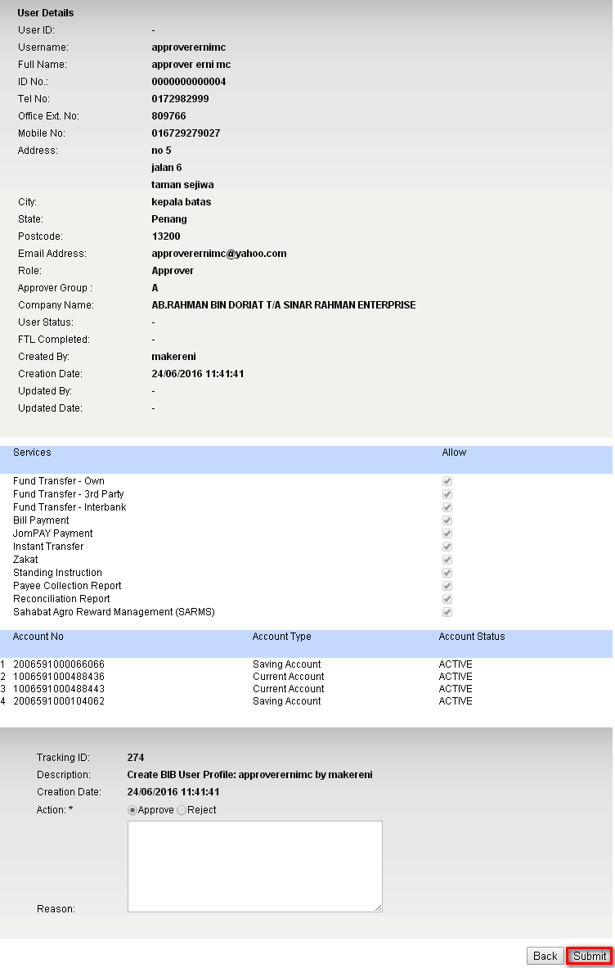

Result Page:
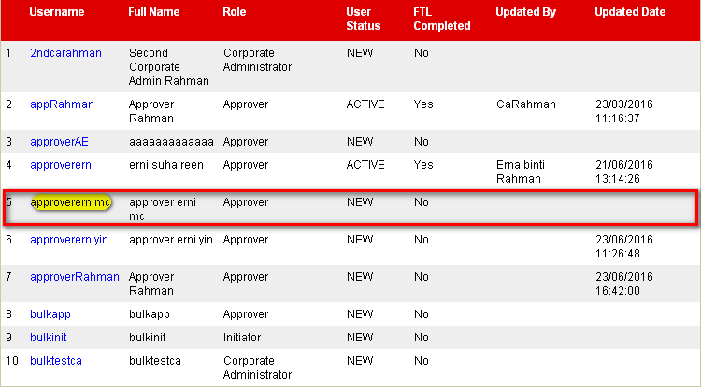

Viewer

Maker
Login as Maker on IBAM and create Viewer.
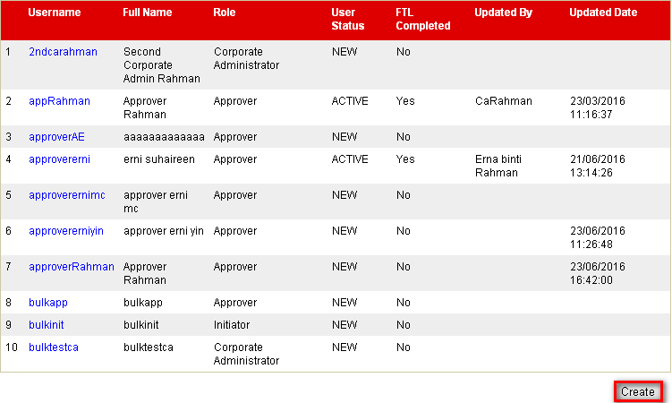

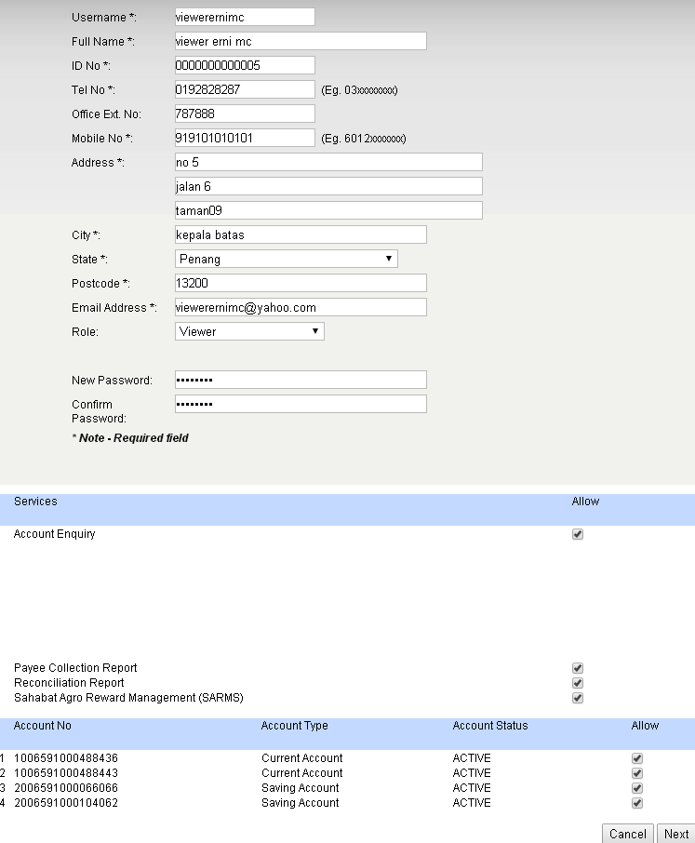

Checker
Login as Checker to approve the created user.
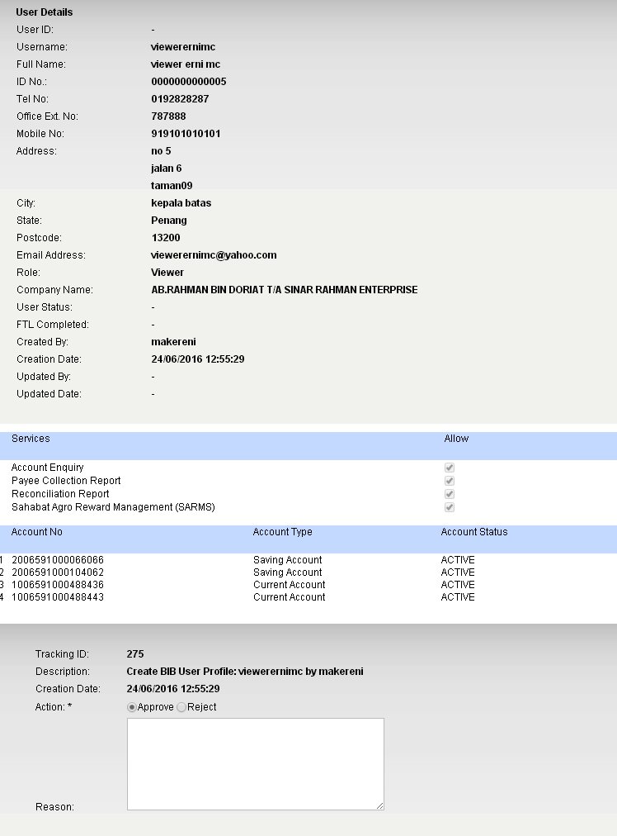

Result Page:
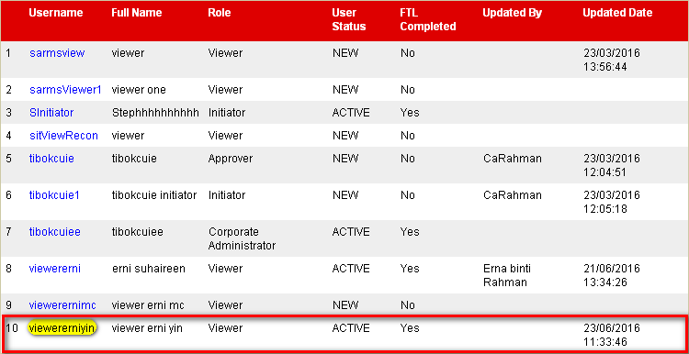

Edit User

Corporate Admin

Maker
Login as Maker on IBAM and edit the full name of Corporate Admin.
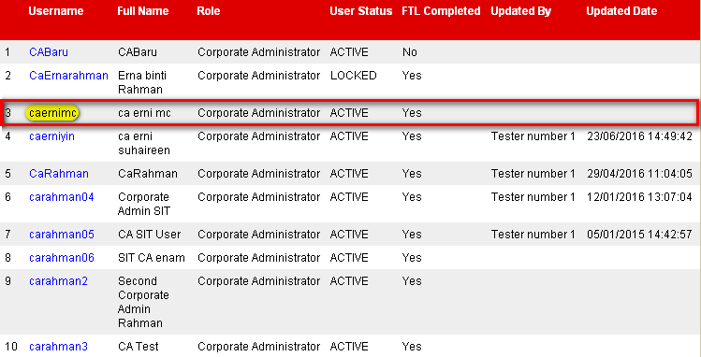

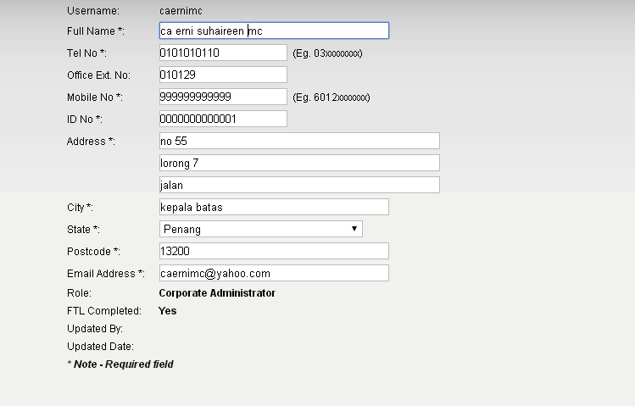

Checker
Login as Checker and approve on the changes made.

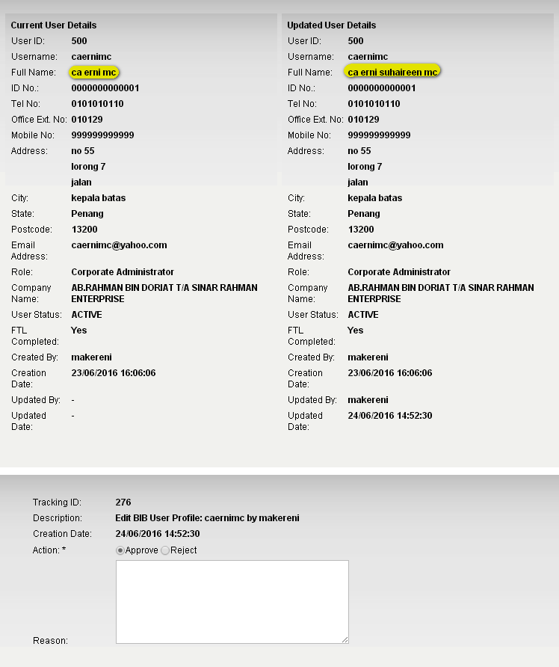

Result Page:
Login on BIB SIT SAHABAT and view the Full Name of Corporate Admin.
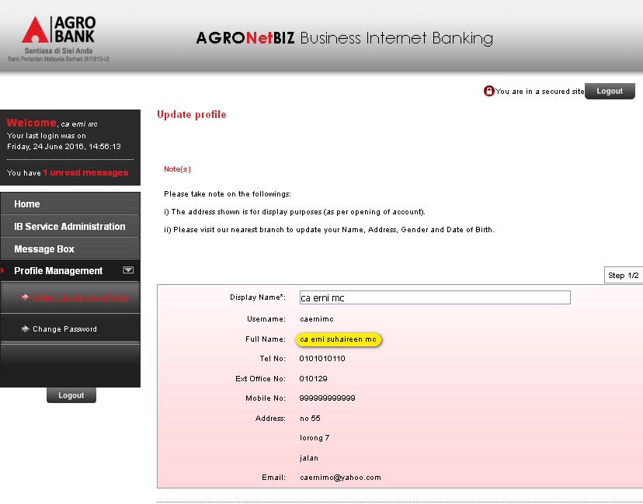

Single User

Maker
Login as Maker and remove Zakat and Joompay Payment services on Single User.
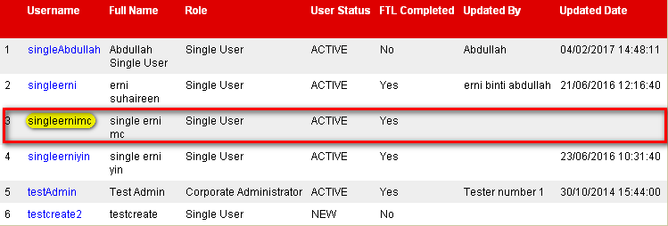

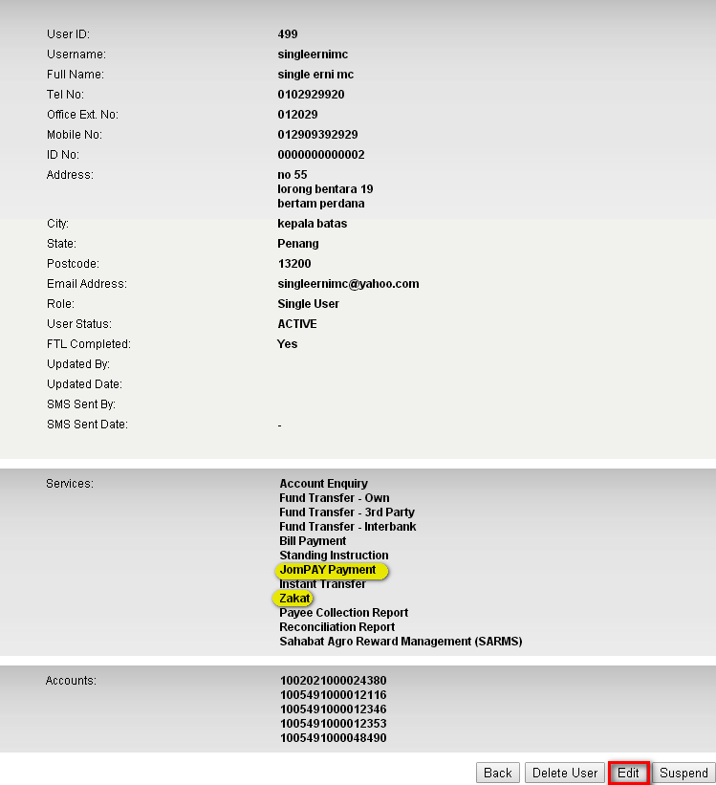

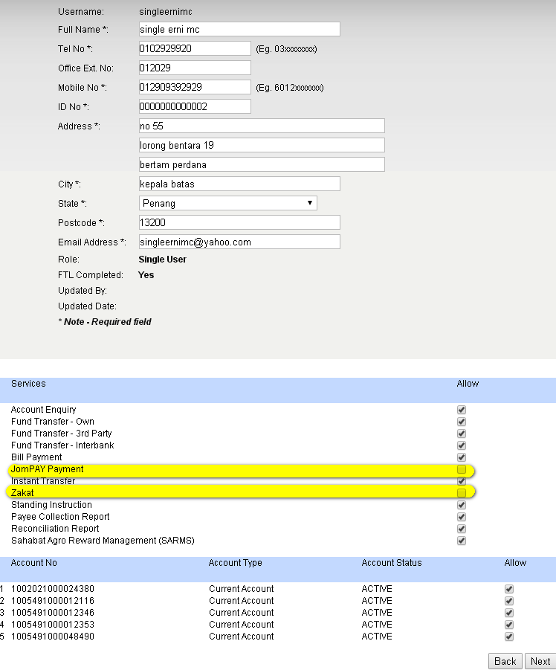

Checker
Login as Checker and approve the changes made.
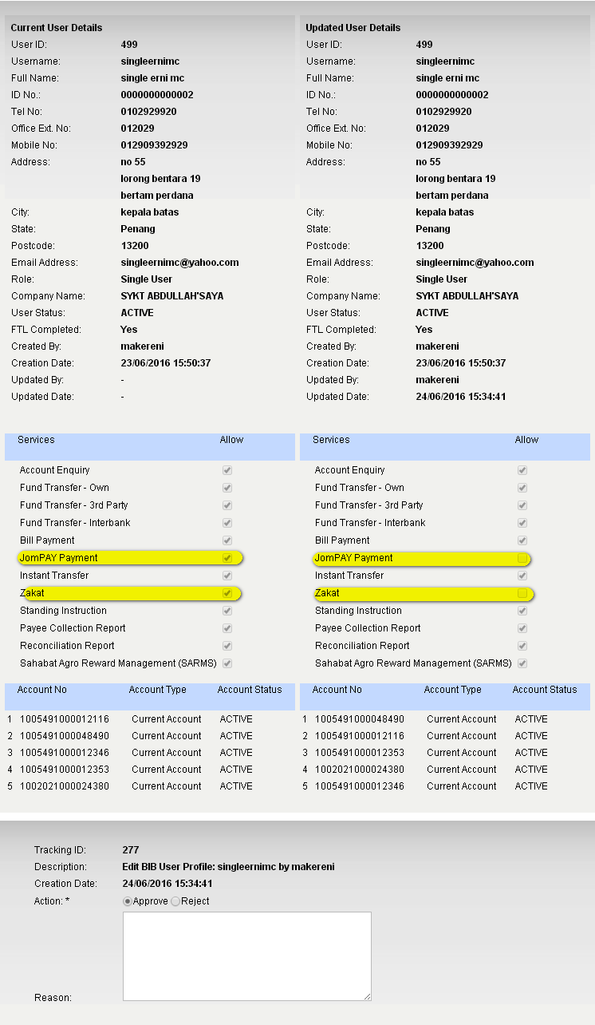

Result Page:
Login to BIB.SIT.SAHABAT as Single User to view navigation that has been allow to display on BIB. Result Page display that Zakat and Joompay Payment has been removed.
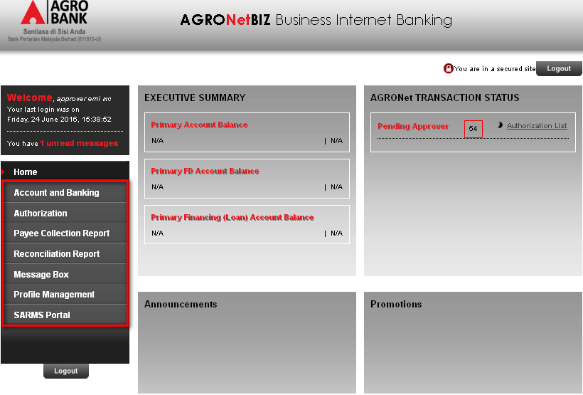

Initiator

Maker
Login as Maker and remove Zakat and Joompay Payment services on Initiator.
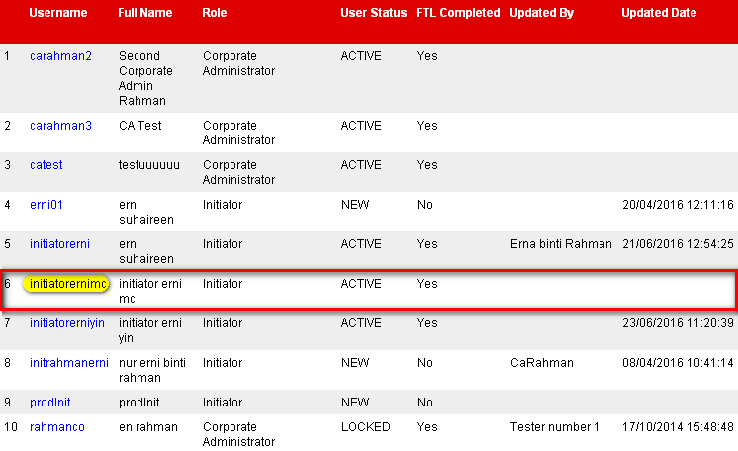

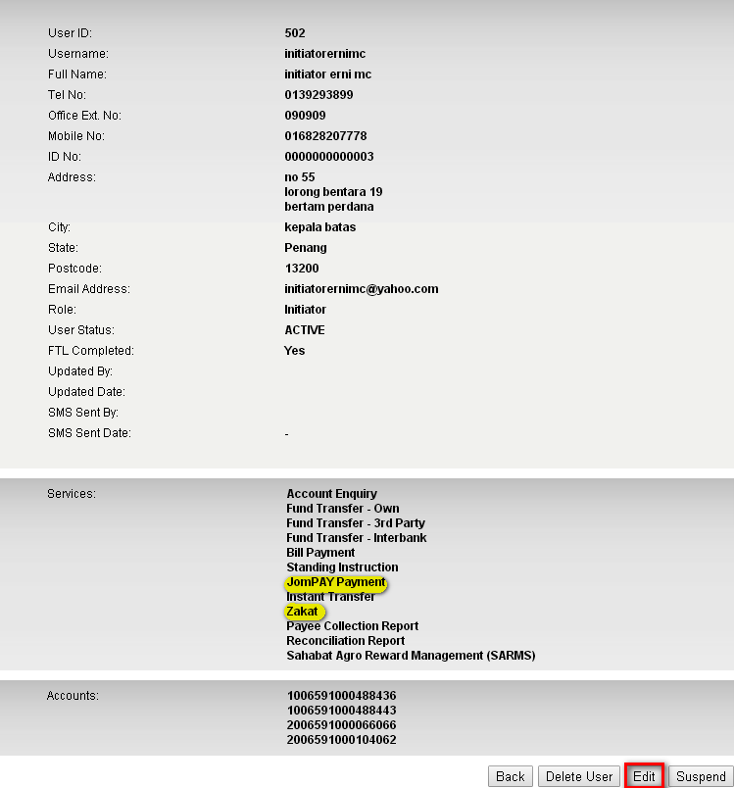

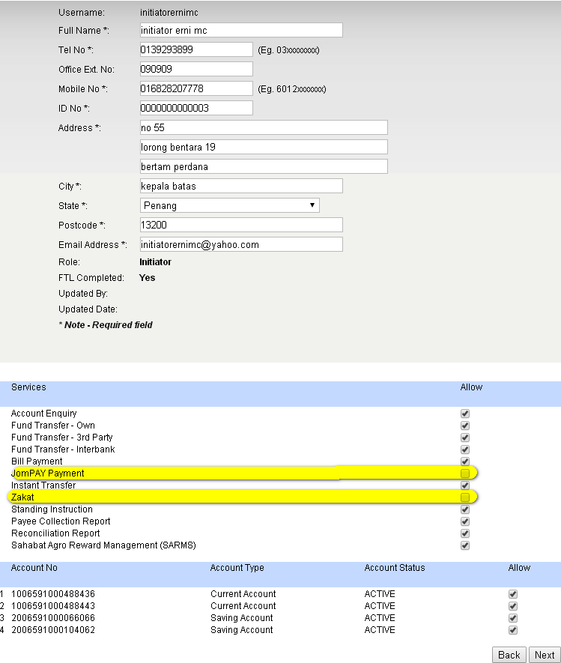

Checker
Login as Checker and approve on the changes made.
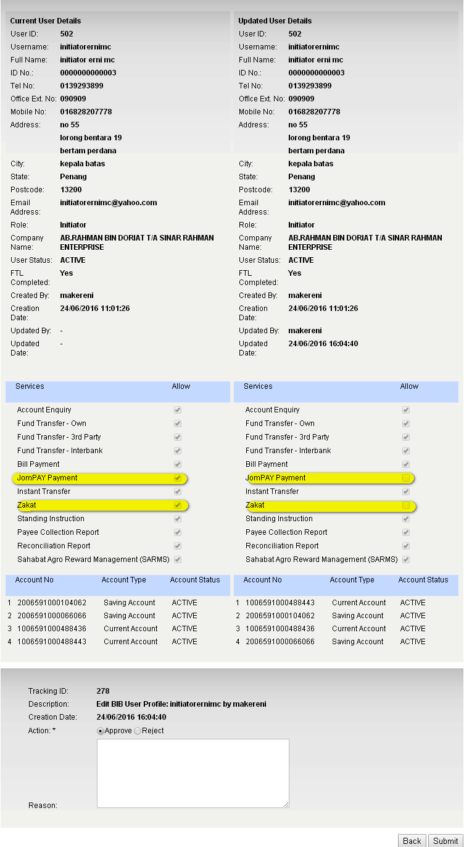

Result Page:
Login to BIB.SIT.SAHABAT as Initiator to view navigation that has been allow to display on BIB. Result Page display that Zakat and Joompay Payment has been removed.
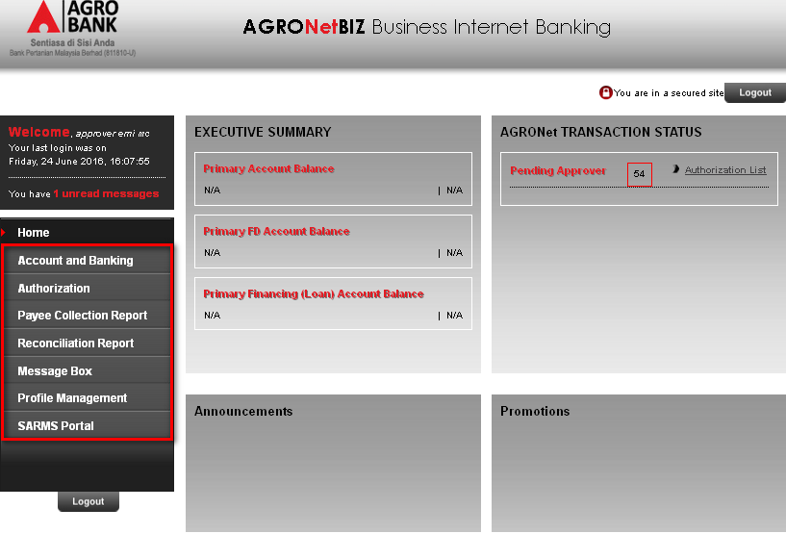

Approver

Maker
Login as Maker and remove Zakat and Joompay Payment services on Approver.
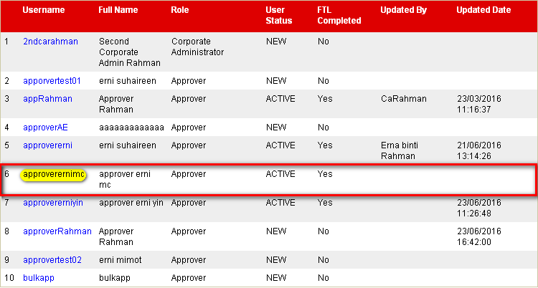

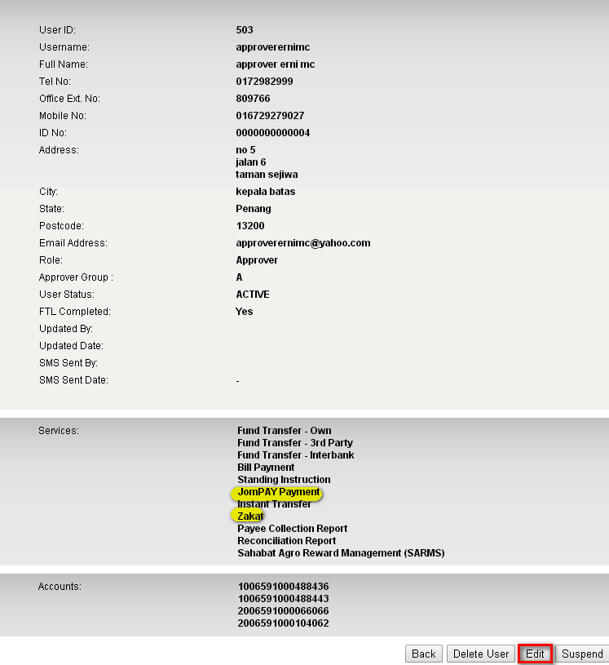
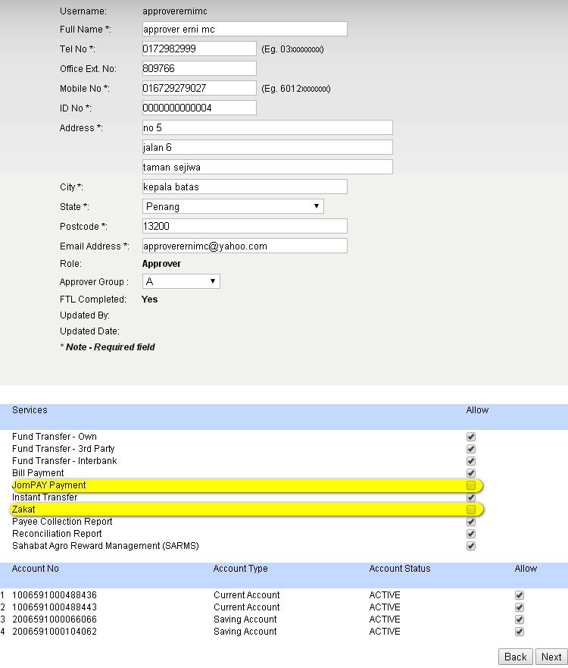

Checker
Login as Checker to approve the changes made.
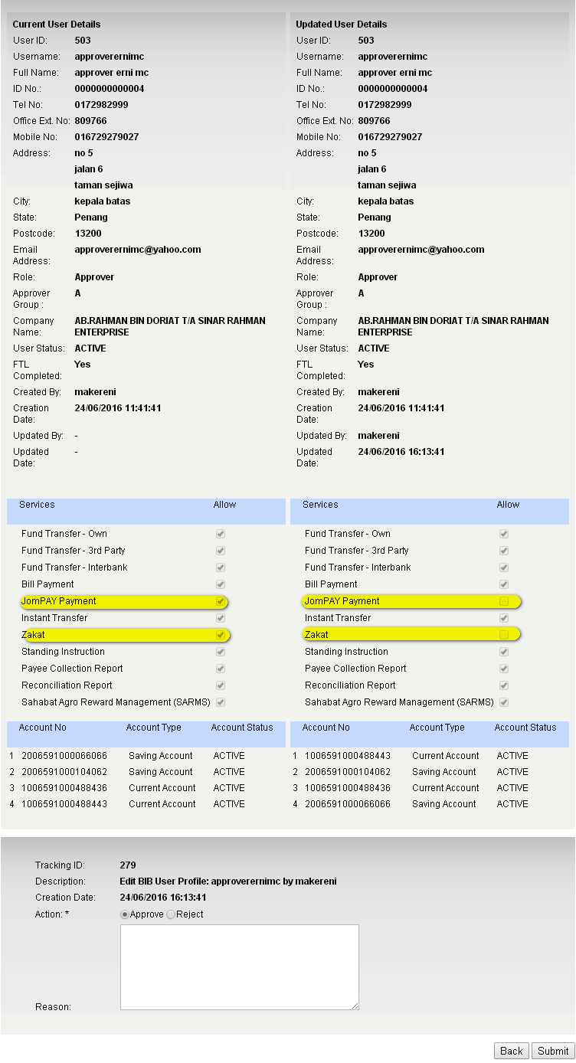

Result Page:
Login to BIB.SIT.SAHABAT as Approver to view navigation that has been allow to display on BIB. Result Page display that Zakat and Joompay Payment has been removed.
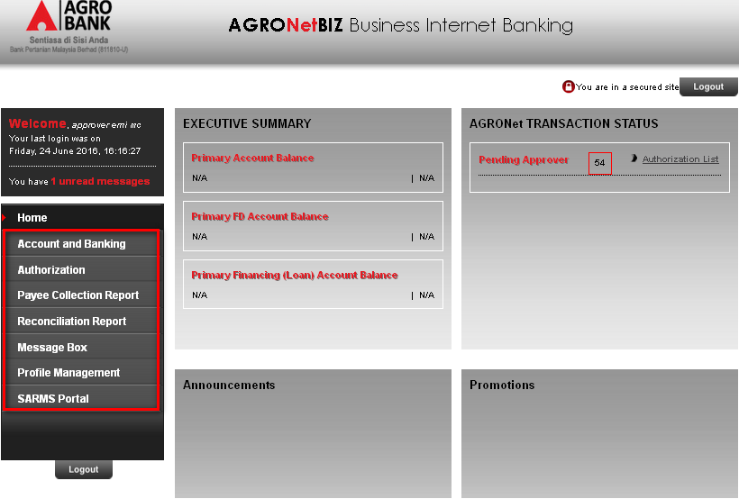

Viewer

Maker
Login as Maker to remove Payee Collection Report and Reconciliation Report on Viewer.
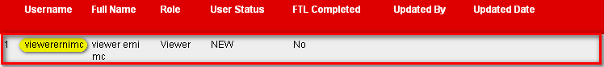
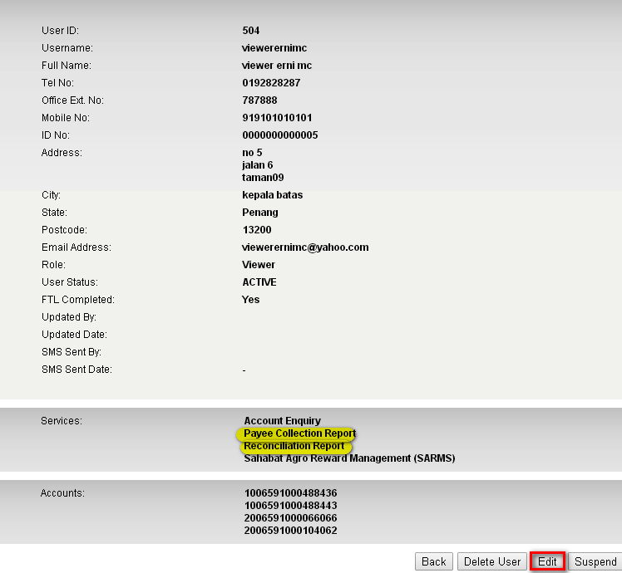

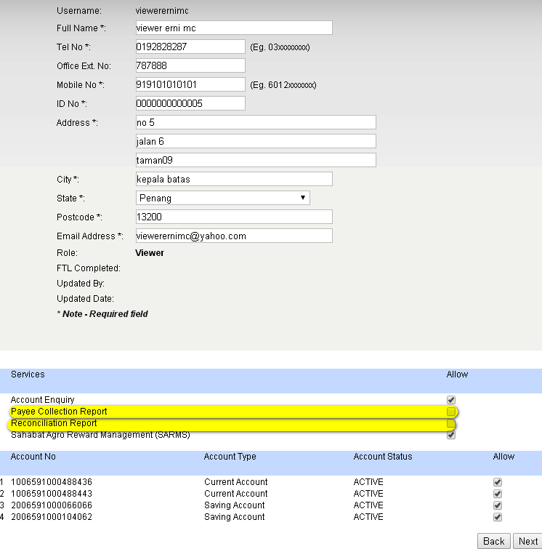

Checker
Login as Checker to approve the changes made.
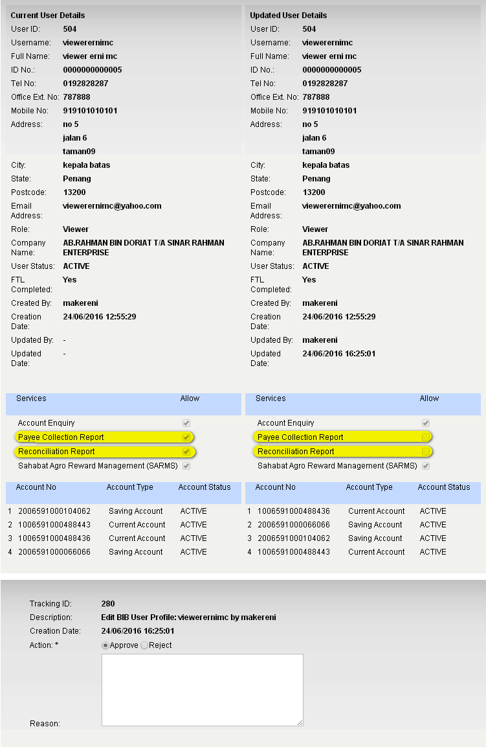

Result Page:
Login to BIB.SIT.SAHABAT as Viewer to view navigation that has been allow to display on BIB. Result Page display that Payee Collection Report and Reconciliation Report has been removed.
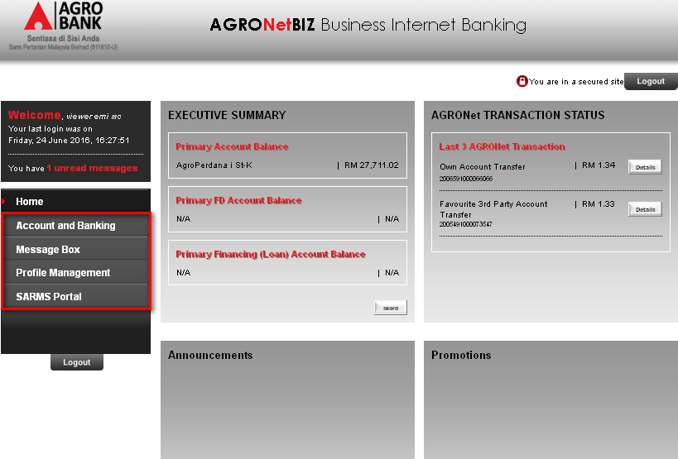

Reviewed By: (PMO)
Lizahwati |  |  | Name/Position : Lizahwati binti Basirun  Date :

