2. At event status filter choose "Completed,Cancelled, Postponed,Tentative".   
3. Click at Generate Excel. In Excel files, it will show what filter is selected. (Cancelled , Confirmed)

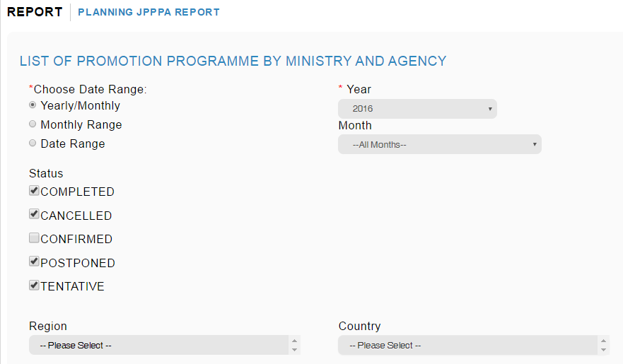

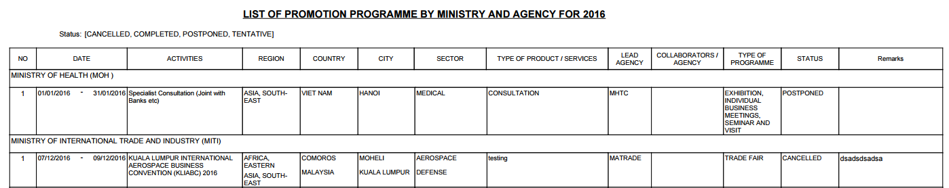

4. After completed download, remove filter at event status without refresh page.   
5. Click at Generate Excel. In Excel files, it will list all event without any filter on status but will display Canceled filter is active (refer below) even though user had not selected filter in 2nd attempt to download report.

