1. **Bulk Upload - Customer provided the an invalid Payment Date 20161725**

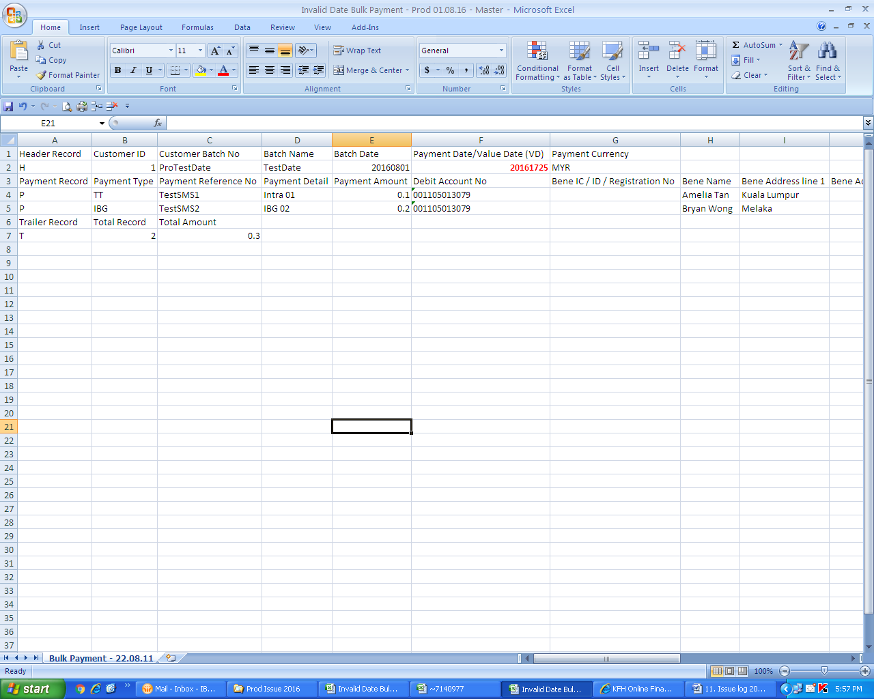

**System should prompt error message on the Invalid Payment Date however it translated the invalid Payment Date into 25 May 2017.**

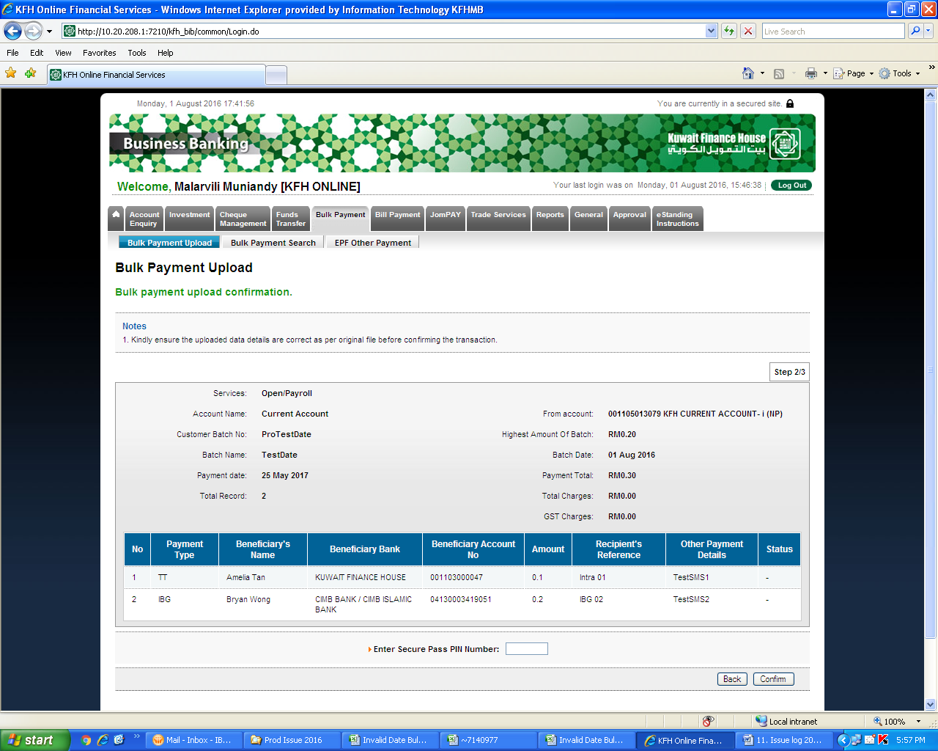

1. **EPF Bulk Upload - Customer provided the an invalid Payment Date 20161725**

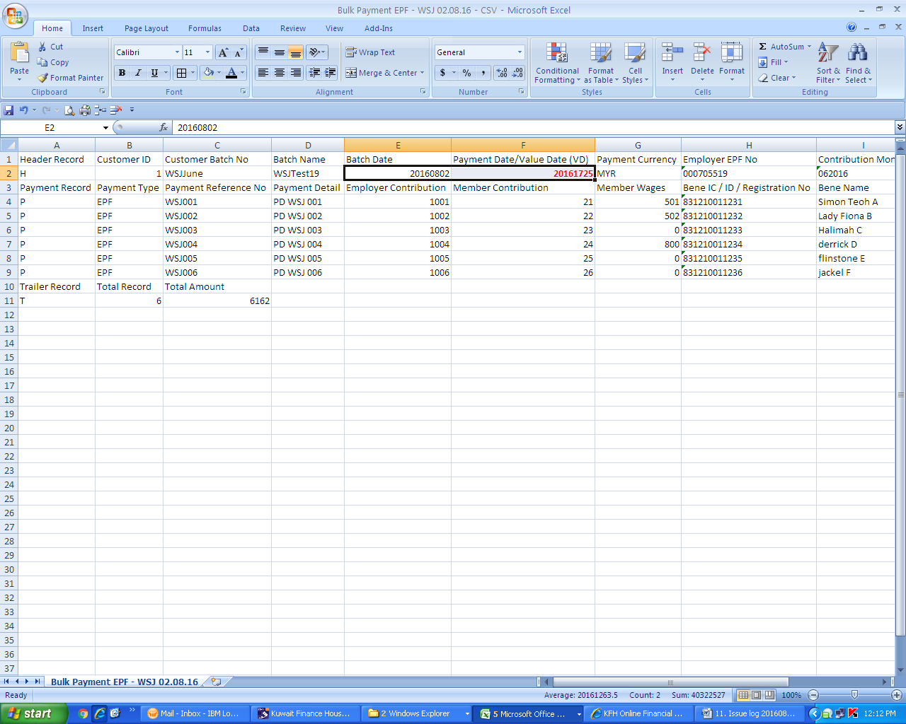

**System should prompt error message on the Invalid Payment Date however it translated the invalid Payment Date into 25 May 2017.**

