Test Issue Log |  |  |  |  |  | SCP ID# : 6523
Project Name: | [Internal Testing] Statutory Body
Test Stage: | Unit Functionality Integration System Interface  Performance Regression Acceptance Pilot
Test Case Number: |  |  |  | Test Started Date: |  |  | 18/08/2016
Test Title: | [Internal Testing] Statutory Body
Test Description: | - To ensure all documents LHDN/EPF/SOCSO can successfully be uploaded.  - To ensure LHDN/EPF/SOCSO fees can successfully be deducted from account.  https://10.6.6.20/bib.sit.lhdn/common/Login.do
Test Functionality: | - Multiple User:  - LHDN  - EPF  - SOCSO  - Single User:  - LHDN  - EPF  - SOCSO
Test Procedure: | - Multiple User  - Login as Initiator and perform LHDN/EPF/SOCSO payment.  - Login as Approver to approve the payment made.  - Login back to Initiator to display transaction history  - Single User.  - Login as Single User and perform LHDN/EPF/SOCSO payment.  - Display the transaction history.
Test Result: | Pass: Fail: | Tested by: |  |  | Erni Suhaireen binti Zulkifli
Reason for Failure:
TEST DESCRIPTION

Multiple User

LHDN

Initiator
Login to BIB as initiator to test the Statutory Bodies - LHDN.
Perform the transfer.
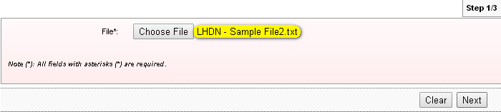
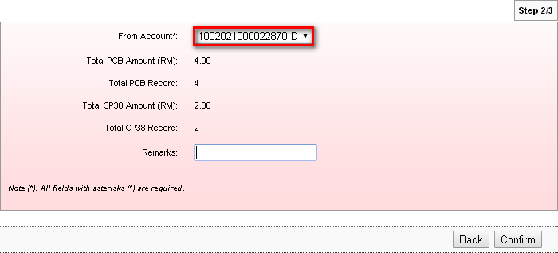
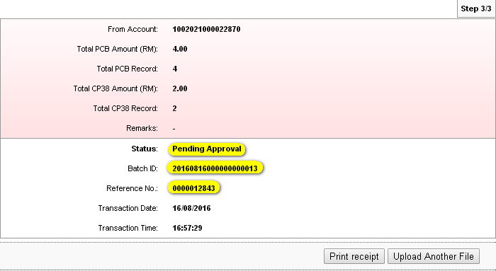

Click on Print Receipt button to print or save the receipt.
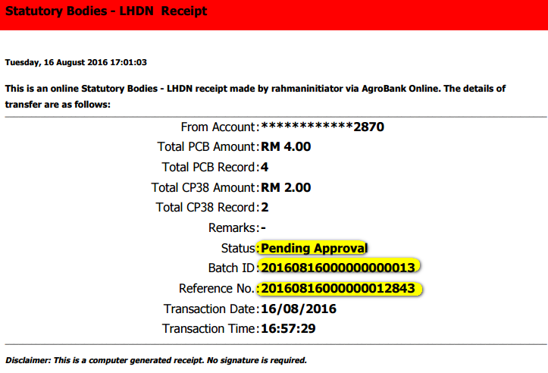

LHDN Transfer History before Approve
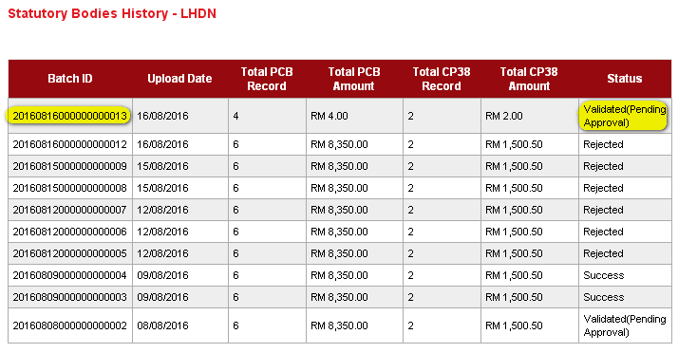

Approver
Login to BIB as Approver to approve the transfer.
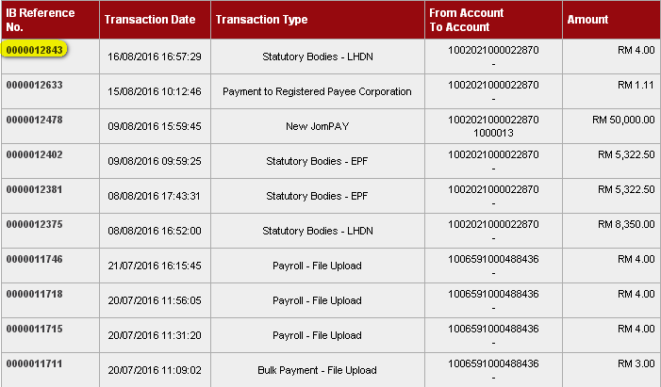
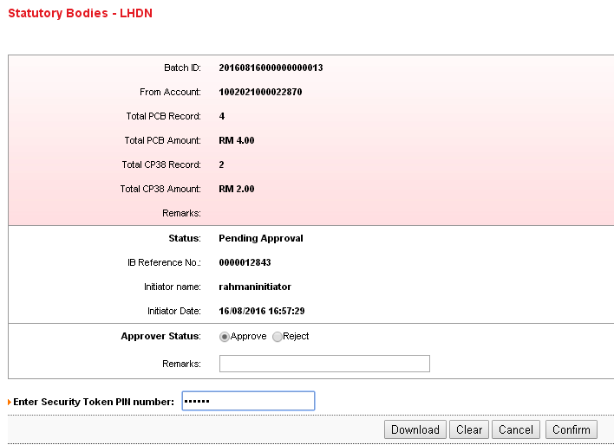


LHDN Transfer History after Approve
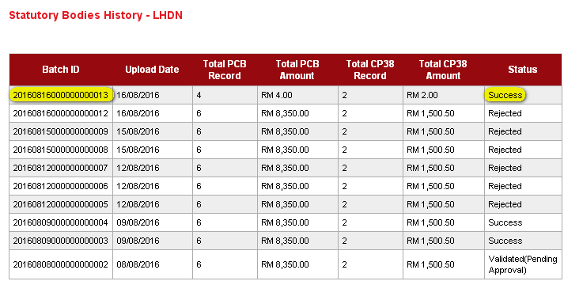

EPF

Initiator
Login to BIB as initiator to test the Statutory Bodies - EPF.
Perform the transfer.
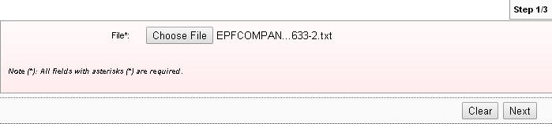
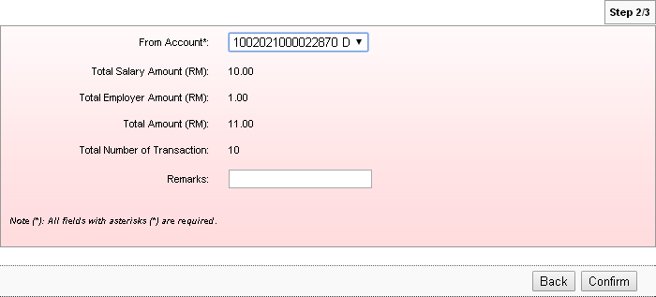
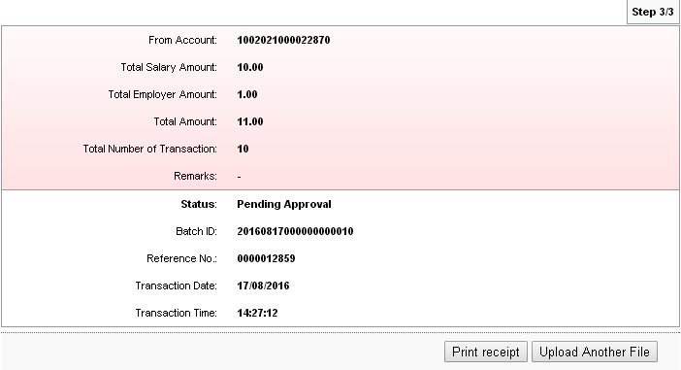
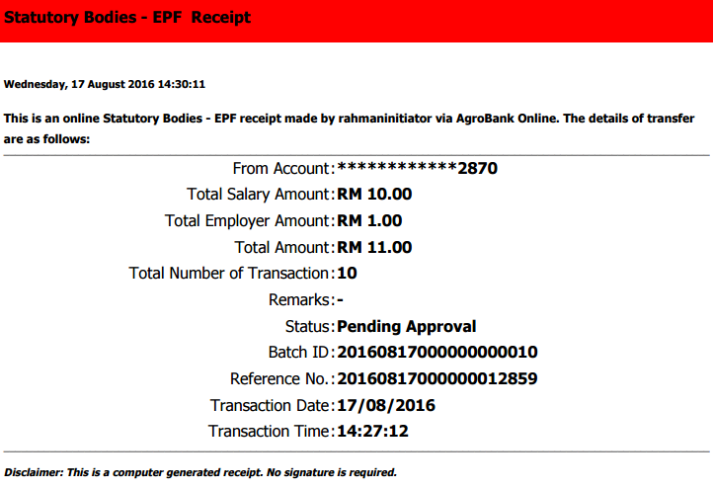

EPF Transfer History before Approve
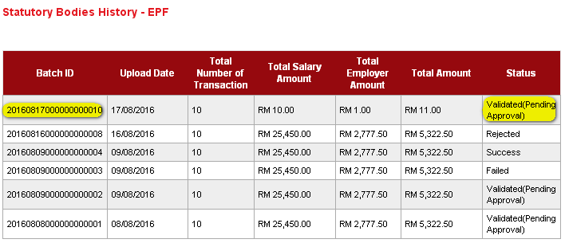

Approver
Login to BIB as Approver to approve the transfer.
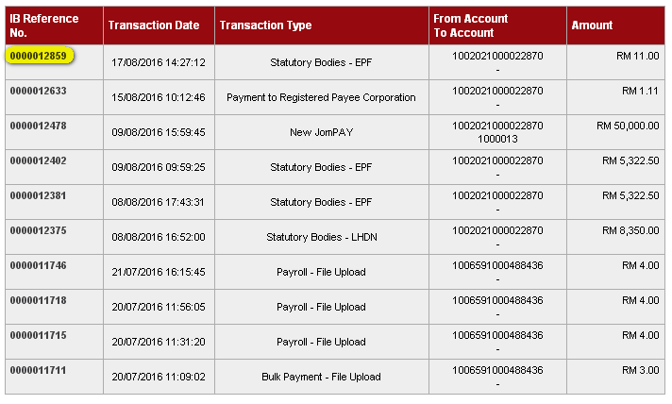
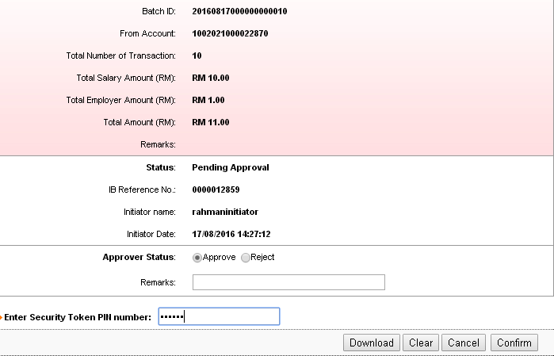

EPF Transfer History after Approve
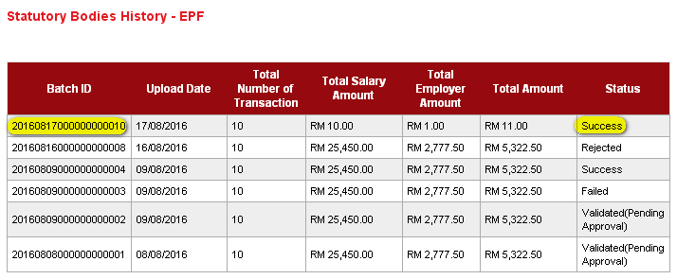

SOCSO

Initiator
Login to BIB as initiator to test the Statutory Bodies - SOCSO.
Perform the transfer.
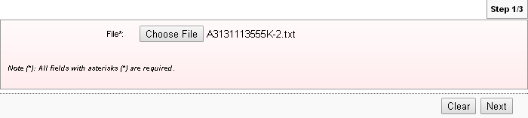
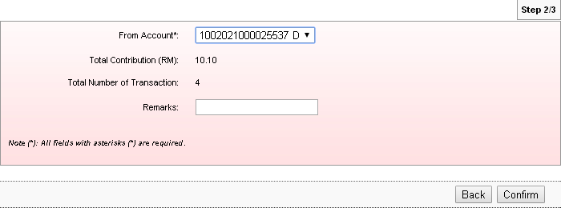
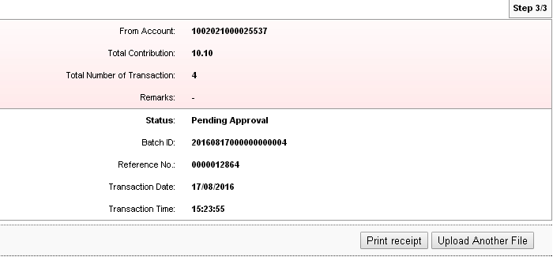
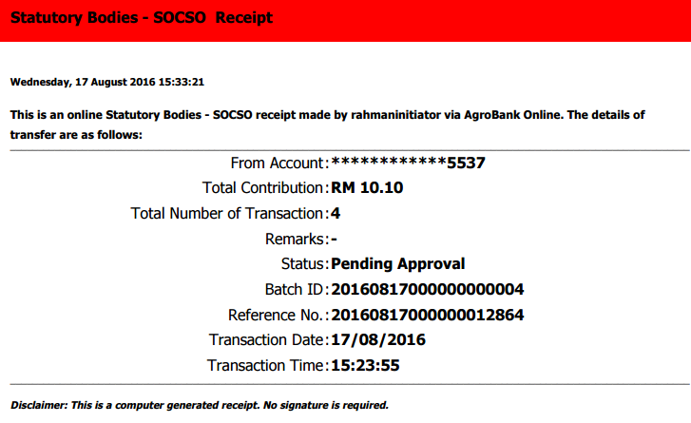
SOCSO Transfer History before Approve
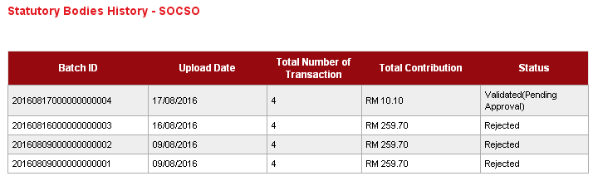

Approver
Login to BIB as Approver to approve the transfer.
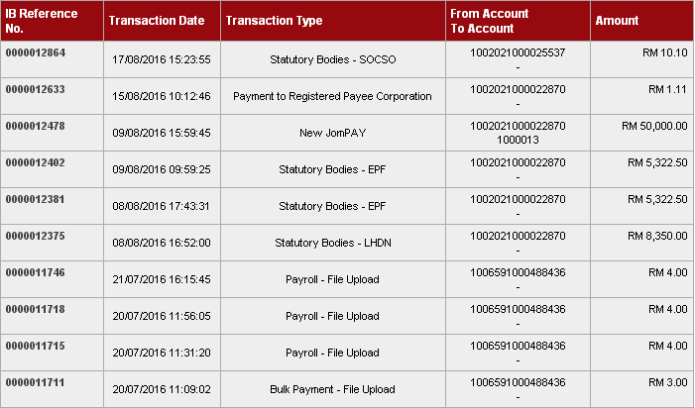
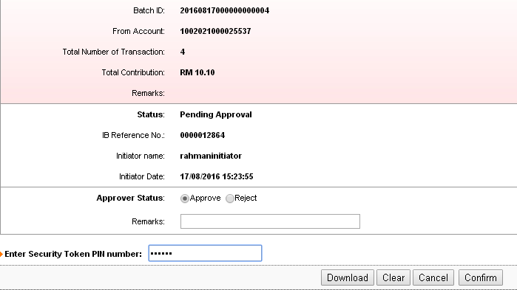


EPF Transfer History after Approve
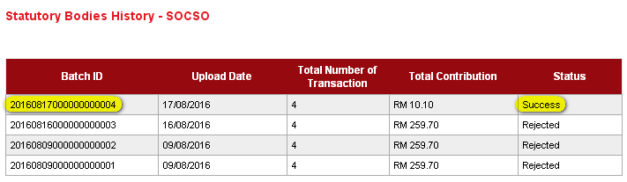

Single User

LHDN
Login to BIB as Single User to test the Statutory Bodies - LHDN.
Perform the transfer.
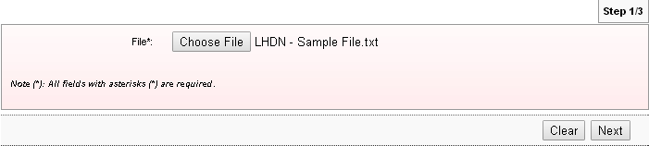
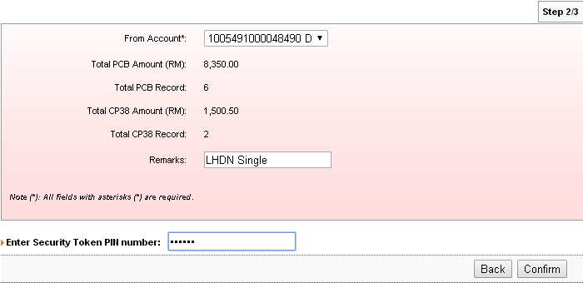
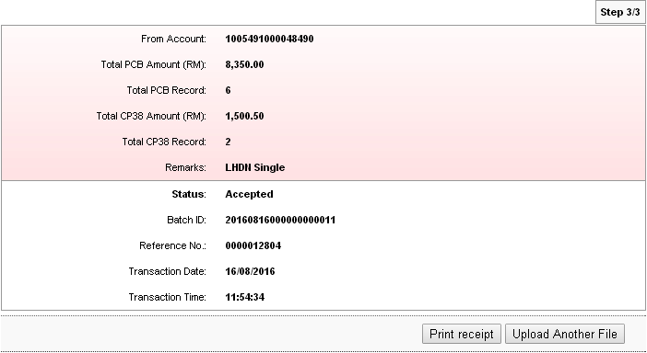

LHDN Transfer History
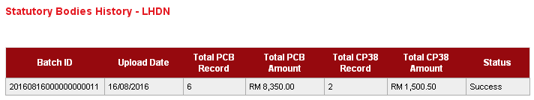

EPF
Login to BIB as Single User to test the Statutory Bodies - EPF.
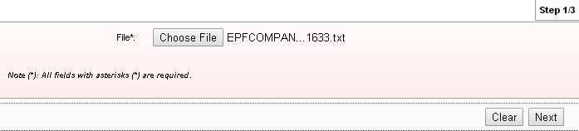
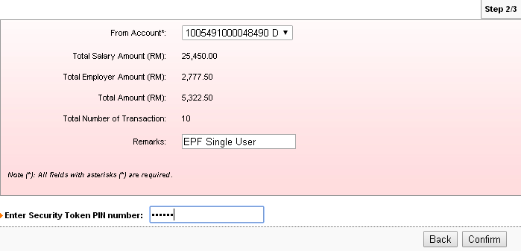
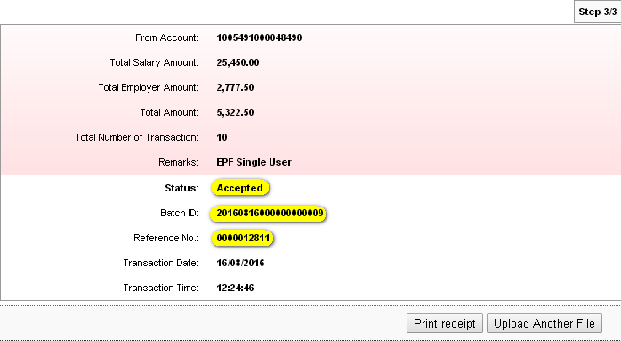
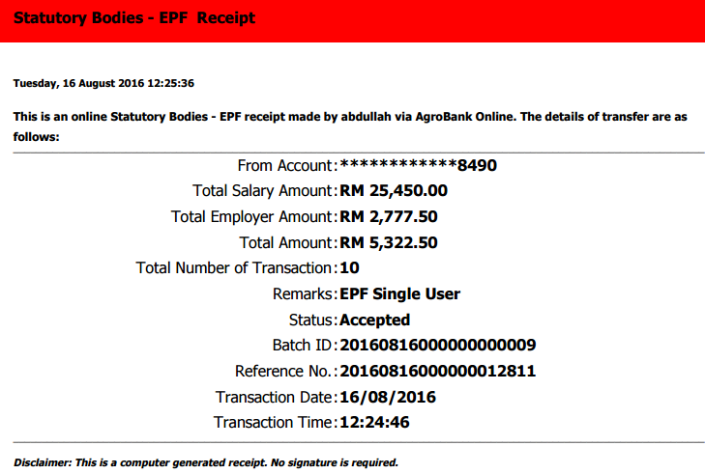

EPF Transfer History
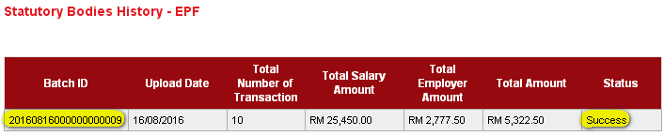

SOCSO
Login to BIB as Single User to test the Statutory Bodies - SOCSO.
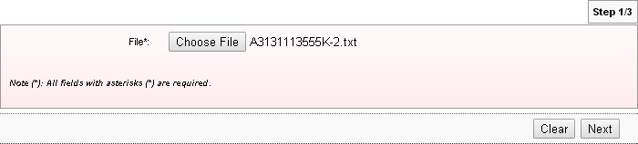
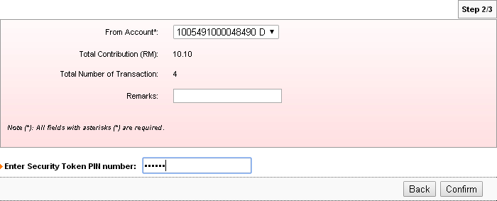
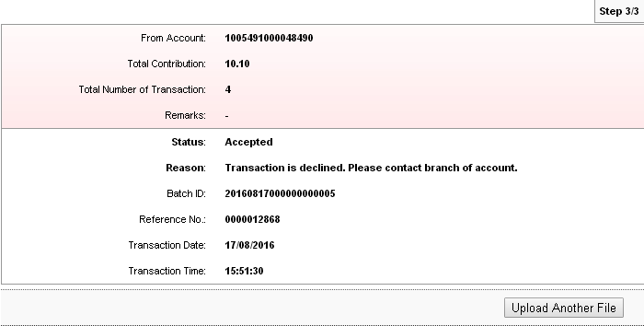

EPF Transfer History
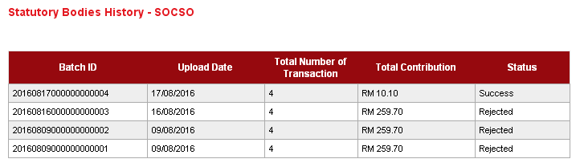

Reviewed By: (PMO)
Lizahwati |  |  | Name/Position : Lizahwati binti Basirun  Date :

