Test Issue Log |  |  |  |  |  | SCP ID# : 6367
Project Name: | [Internal Testing] Bulk Payment CR Upload Encrypted File
Test Stage: | Unit Functionality Integration System Interface  Performance Regression Acceptance Pilot
Test Case Number: |  |  |  | Test Started Date: |  |  | 15/03/2016
Test Title: | [Internal Testing] Bulk Payment CR Upload Encrypted File
Test Description: | - To ensure Payroll and Bulk Payment can upload encrypted file.
Test Functionality: | - Bulk Upload  - Payroll Upload
Test Procedure: | - Bulk Upload  - Login to BIB  - Perform Bulk Upload by uploading encrypted file  - Display transaction history  - Payroll Upload  - Login to BIB  - Perform Payroll Upload by uploading encrypted file  - Display transaction history
Test Result: | Pass: Fail: | Tested by: |  |  | Erni Suhaireen binti Zulkifli
Reason for Failure:
TEST DESCRIPTION

Bulk Payment
Test to upload Encrypted File on Bulk Payment.
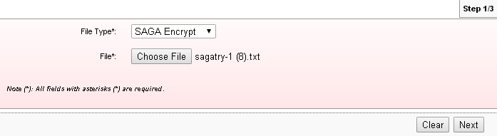

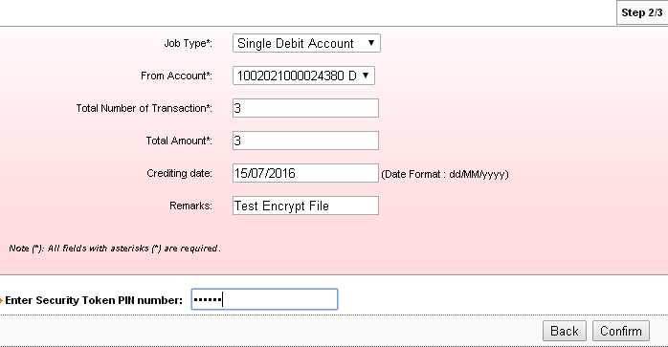
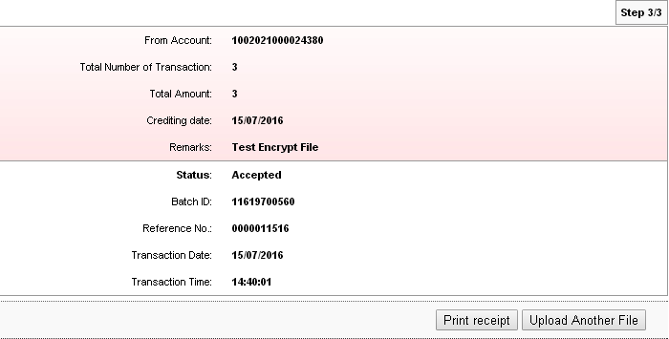

Agronet Transaction History :
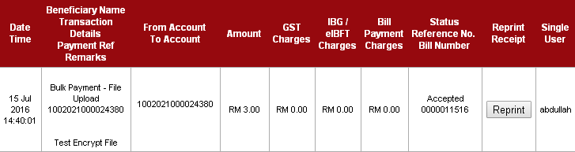

Payroll
Test to upload Encrypted File on Payroll.
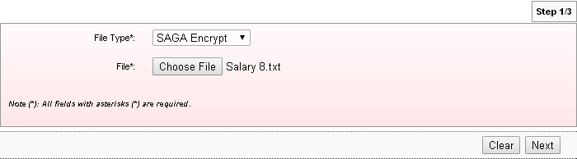
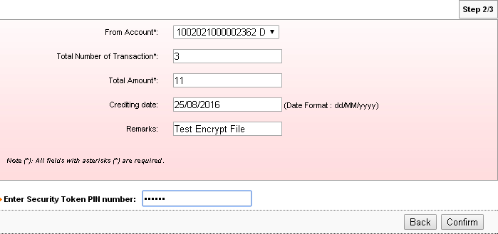
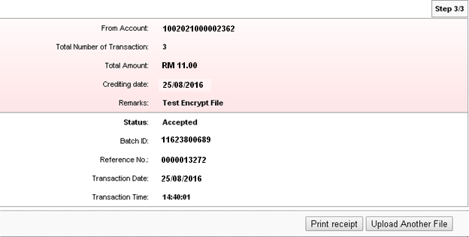

Payroll History Page.
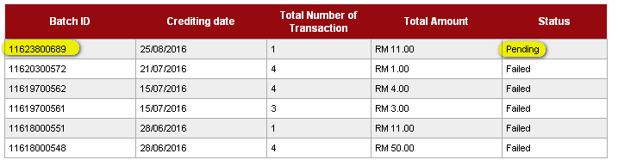

Reviewed By: (PMO)
Lizahwati |  |  | Name/Position : Lizahwati binti Basirun  Date :

