
Maybank2U
e-Application Mortgage

Functional Specification Document

(PENRIL/M2U-FSD/RMBP/20160617/01)

Version 1.1

5th August 2016

Prepared By:


Penril Datability (M) Sdn Bhd (816792-X)
Suite A-07-07 Plaza Mon’t Kiara
No. 2, Jalan Kiara, Mon’t Kiara
50480 Kuala Lumpur, Malaysia
Tel: (603) 6201 2622Fax: (603) 6201 7622

Document Amendment Log
Rev. No | Date Update | Description of Change | Initiated By | Approved By
1.0 | 17/06/2016 | Initial Release | Gabbytian Rayvandy,  Penril Datability (M) Sdn Bhd | Tan Lee Yong,  Penril Datability (M) Sdn Bhd
1.1 | 5/08/2016 | Update translation  Add captcha  Add information:  M2U Hyperlink | Gabbytian Rayvandy,  Penril Datability (M) Sdn Bhd

Table of Contents
Document Amendment Log 2
Section A: Introduction 4
1.1 Objective 4
1.2 Scope of Delivery 4
Section B: Functional Specifications 5
2 Middle Service & RESTful API Integration 5
3 Mortgage e-Application Module 5
3.1 Mortgage e-Application Submission Process 5
Appendix 2: AMOS Message 13
Appendix 3: Reference Documents 14

Section A: Introduction
This document served as the business requirement and system specification of integrating a Mortgage eApplication Module in RMBP Application to AMOS. Mortgage eApplication serves potential customers who wants to apply a loan by keying in their data via online instead of paper based application.

This document shall explain all the features and functionalities, which is elaborating with screen captures, process flow, descriptions, input fields specifications and error messages. All screen designs provided in this document are samples and only illustration purpose for easy understanding. The screen designs are not final.

Objective
The objective of this document is to capture the requirements and specification of submission process of Mortgage Application and integration to backend.

Scope of Delivery
- Changes on existing “Loan Calculator” label to “Loan Products” label,
- Add new tab to cater for different products in the future (E.g.: mortgage, hire purchase, etc)
- Adding button to open Mortgage e-Application,
- Introduction of new module containing mortgage application related information:
  - Building new page,
  - Input validation,
  - Label, disclaimer, information and/or any text that requires dual language,
  - Provide pop up message.
- Middle Service Integration & RESTful API to AMOS using Web Service.

Section B: Functional Specifications

Middle Service & RESTful API Integration
- Add new RESTful service to get and map any field and value displayed in Mortgage e-Application to be later redirected to the Middle Service (core logic of M2U).
- Add new AMOS message integration to Middle Service:
  - Develop new web service core to integrate with AMOS system,
  - Process the input and submit the mapping of Mortgage e-Application fields and values to AMOS,
  - Response handling in middle service and RMBP.

Mortgage e-Application Module
Access to e-Application will be done by adding button in RMBP Loan Products.

Mortgage e-Application Submission Process

Process Flows
Diagram 1: Mortage e-Application Flow
There are 3 participants involved in this process which is Customer, RMBP App, and AMOS.
Step 1:
- Customer accesses the Loan Products by clicking the button in Landing page on RMBP,
- RMBP shows different Loan Products (currently, only mortgage application is available).
Step 2:
- Customer accesses Mortgage tab (default choice),
- RMBP shows Loan Calculator,
- Customer clicks on Mortgage e-Application button,
- RMBP shows Mortgage e-Application form.
Step 3:
- Customer keys in all the necessary details,
- Customer clicks on submit button,
- RMBP shows pop up message that application is being processed,
- Customer clicks on OK Button,
- RMBP clears up all the input,
- Customers can key in more application, go back to previous screen, or login to Internet Banking.

Screen Designs
Step 1:
- Customer accesses the Loan Products by clicking the button in Landing page on RMBP,
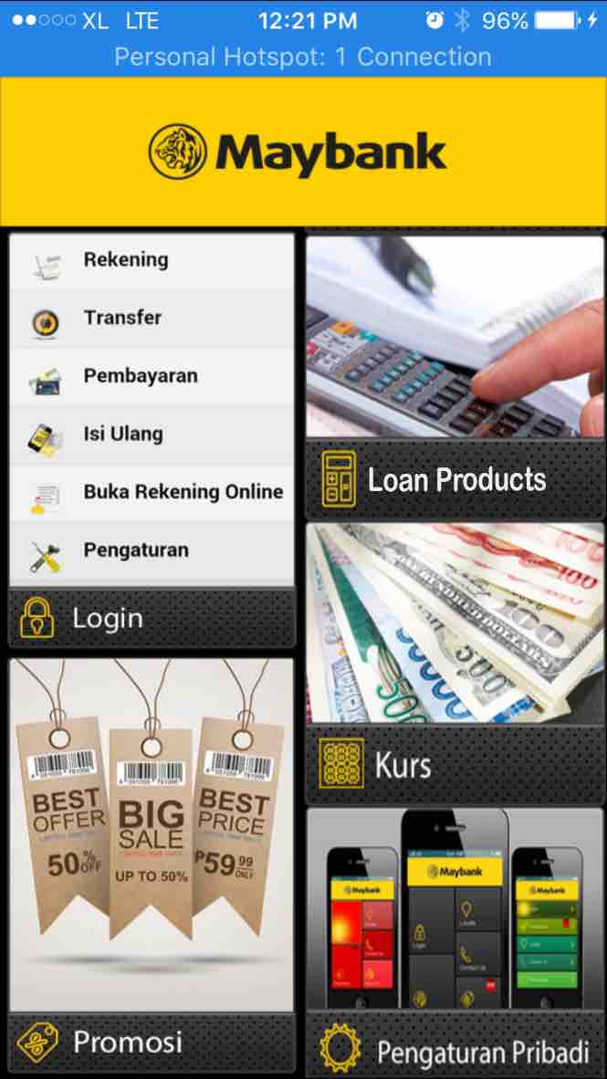
Figure 1: RMBP Landing Page
- RMBP shows different Loan Products (currently, only mortgage application is available).
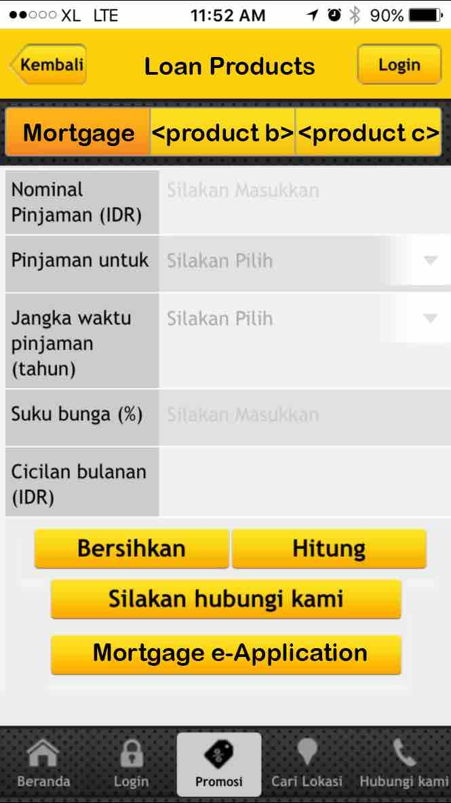
Figure 2 Loan Products Module
Action:
No | Action | Type | Description
 | Loan Products Options:  - Mortgage,  - Product b,  - Product c, etc. | Tab Menu | - Contains different type of loan products.  - Mortgage is the default option when open this Loan Products Module.  - Maximum of 3 products can be catered.  - Only Mortgage product that is available for this implementation. Hence, there will be only 1 tab.
 | Mortgage e-Application | Buttons | Links to Mortgage e-Application Menu.
Table 1 Loan Products Actions
Step 2:
- Customer accesses Mortgage tab (default choice),
- RMBP shows Loan Products,
- Customer clicks on Mortgage e-Application button,
- RMBP shows Mortgage e-Application form.
Figure 3 Mortgage e-Application Button
Step 3:
- Customer keys in all the necessary details,
- Customer clicks on submit button,
- RMBP shows pop up message that application is being processed,
- Customer clicks on Next Button,
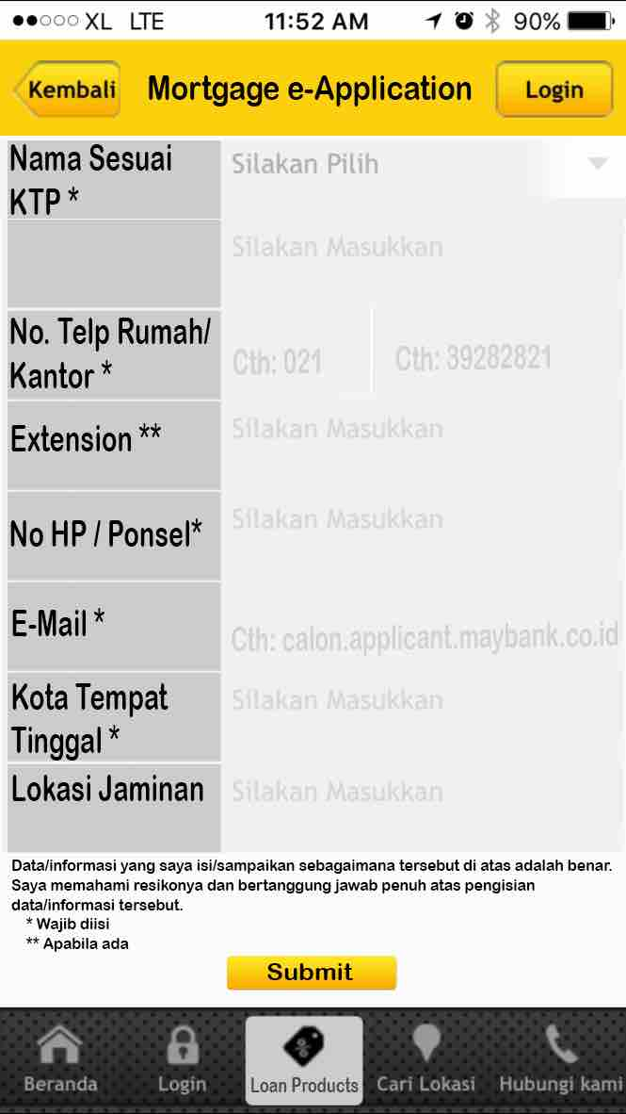
Figure 4 Mortgage e-Application Form
Input Fields:
No | Field | Format | Description | M/O
 | ID:  Nama sesuai KTP *  EN:  Name on ID * | Drop Down | Shows the account holder name or the product name of the account.  Options (ID):  - Silakan Pilih (Default)  - Tuan  - Nyonya  - Nona  Options (EN):  - Choose one (Default)  - Mr.  - Mrs.  - Ms. | M
 | ID:  Nama sesuai KTP *  EN:  Name on ID * | Text Box  Max length: 255 | Default (ID): Silakan Masukkan  Default (EN): Fill in | M
 | ID:  No Telp Rumah / Kantor *  EN:  Home / Office Phone Number * | Numeric  Max length: 4 | Default (ID): Cth: 021  Default (EN): E.g : 021 | M
 |  | Numeric  Max length: 10 | Default (ID): Cth: 1234567  Default (EN): E.g : 1234567 | M
 | ID:  Extension **  EN:  Extension ** | Numeric  Max length: 10 | Default (ID): Silakan Masukkan  Default (EN): Fill in | O
 | ID:  No HP / Ponsel *  EN:  Cellular Phone * | Numeric  Max length: 10 | Default (ID): Silakan Masukkan  Default (EN): Fill in | M
 | ID:  Email *  EN:  Email * | Text  Max length: 16 | Default (ID): Cth: calon.applicant@maybank.co.id  Default (EN): E.g : customer@maybank.co.id | M
 | ID:  Kota Tempat Tinggal *  EN:  City * | Text  Max length: 32 | Default (ID): Silakan Masukkan  Default (EN): Fill in | M
 | ID:  Lokasi Jaminan  EN:  Collateral Location | Text  Max length: 128 | Default (ID): Silakan Masukkan  Default (EN): Fill in | O
 | ID:  Salin Kode  EN:  Captcha | Picture, alphabet only  Text Box  Max length: 5 | To prevent DDOS or robotic attack. | M
Table 2 Mortgage e-Application Form Input Specification

Display Fields:
No | Field | Format | Description
 | ID:  Data / informasi yang saya isi / sampaikan sebagaimana tersebut di atas adalah benar.  Saya memahai resikonya dan bertanggung jawan penuh atas pengisian data / informasi tersebut.  * Wajib diisi  ** Apabila ada  EN:  All data / information that I declare is right. I do understand the risks and take full responsible of those data / information.  *Mandatory  **If any | Text | Contains disclaimer.  Contains legend of mandatory / non mandatory fields.  This is maintained in service info by MSS.
Table 3 Mortgage e-Application Form Display Fields
Action:
No | Action | Type | Description
 | Next | Button | To validate all the input messages and proceed to next page.
Table 4 Mortgage e-Application Form Actions
Validaton Message:
No | Event | Error Description in English | Error Description in Bahasa Indonesia
 | Did not key in the value for  - Nama sesuai KTP  - No Telp Rumah / Kantor  - Extension  - No HP / Ponsel  - Email  - Kota Tempat Tinggal  - Lokasi Jaminan  - Captcha | Nama sesuai KTP is required. | Nama sesuai KTP dibutuhkan.
 |  | No Telp Rumah / Kantor is required | No Telp Rumah / Kantor dibutuhkan
 |  | Extension is required | Extension dibutuhkan
 |  | No HP / Ponsel is required | No HP / Ponsel dibutuhkan
 |  | Email is required | Email dibutuhkan
 |  | Kota Tempat Tinggal is required | Kota Tempat Tinggal dibutuhkan
 |  | Lokasi Jaminan is required | Lokasi Jaminan dibutuhkan
 |  | Captcha is required | Captcha dibutuhkan
 | Key in wrong format for  - Nama sesuai KTP  - No Telp Rumah / Kantor  - Extension  - No HP / Ponsel  - Email  - Captcha | Nama sesuai KTP is incorrect. | Nama sesuai KTP salah.
 |  | No Telp Rumah / Kantor is incorrect | No Telp Rumah / Kantor harus numerik
 |  | Extension is incorrect | Extension salah
 |  | No HP / Ponsel is incorrect | No HP / Ponsel salah
 |  | Email is incorrect | Email salah
 |  | Captcha is incorrect | Captcha salah
Table 5 Mortgage e-Application Input Validation
Step 4:
- RMBP shows the confirmation page,
- Customers shall key in the displayed capctha,
- Customer clicks submit
- System shows successful message.

Display Fields:

No | Field | Format | Description
 | ID:  Data / informasi yang saya isi / sampaikan sebagaimana tersebut di atas adalah benar.  Saya memahai resikonya dan bertanggung jawan penuh atas pengisian data / informasi tersebut.  * Wajib diisi  ** Apabila ada  EN:  All data / information that I declare is right. I do understand the risks and take full responsible of those data / information.  *Mandatory  **If any | Text | Contains disclaimer.  Contains legend of mandatory / non mandatory fields.  This is maintained in service info by MSS.
 | ID:  Aplikasi Permohonan Kredit Properti Anda sudah kami terima. Kami akan hubungi Anda untuk proses selanjutnya.  EN:  Your Mortgage e-Application has been received and we will contact you for next process. | Text | To inform customer whether application has been accepted / failed / timeout, etc.
 | ID:  Your Mortgage e-Application has not sent yet. Please check your data that you have been filled in dan submit again.  EN:  Aplikasi Permohonan KPR Anda belum terkirim. Silakan periksa kembali data-data yang Anda masukkan dan kirim ulang. |  | To inform customer whether application has failed / been timeout, etc.

No | Action | Type | Description
 | Submit | Button | To send the information from customer input to AMOS via webservice.

Appendix 2: AMOS Message
Webservice spec is to be provided by Maybank.

Appendix 3: Reference Documents
No. | Document
 | BRD Pengembangan e-Application Mortgage via Mobile Banking.docx
via Email:
RE: MoM Mortgage - eApplication Maybank Website dan M2U Apps --- please review design from Penril

Previously the module is called “Loan Calculator”. It is now changed to “Loan Products”.
Previously this tab is not available. The Loan Products module will be enhanced with this tab menu to cater for different products in the future (max. 3 items). “Mortgage e-Application” will be added.
Default text is meant to be used as an suggestion or example.

