Test Issue Log |  |  |  |  |  | SCP ID# : 6523
Project Name: | [Internal Testing] Statutory Body
Test Stage: | Unit Functionality Integration System Interface  Performance Regression Acceptance Pilot
Test Case Number: |  |  |  | Test Started Date: |  |  | 06/09/2016
Test Title: | [Internal Testing] Statutory Body
Test Description: | - To ensure Approver role can approve successfully
Test Functionality: | - BIB.PROD.KADA:  -Bulk Payment  -Payroll  - BIB.SIT.LHDN:  -Statutory Body
Test Procedure: | - BIB.PROD.KADA  - Login as Initiator and perform transaction (Bulk Payment/Payroll/Statutory Body)  - Login as Approver to approver created transaction. Status reply : Rejected by Approver  - BIB.SIT.LHDN  - Login as Initiator and perform transaction (Bulk Payment/Payroll/Statutory Body)  - Login as Approver to approver created transaction. Status reply : Rejected by Approver
Test Result: | Pass: Fail: | Tested by: |  |  | Erni Suhaireen binti Zulkifli
Reason for Failure: | Approver fails to approve transaction. Status reply : Rejected by Approver
TEST DESCRIPTION
- BIB.PROD.KADA
- Bulk Payment
Perform Multiple Payment transaction in Bulk Payment.

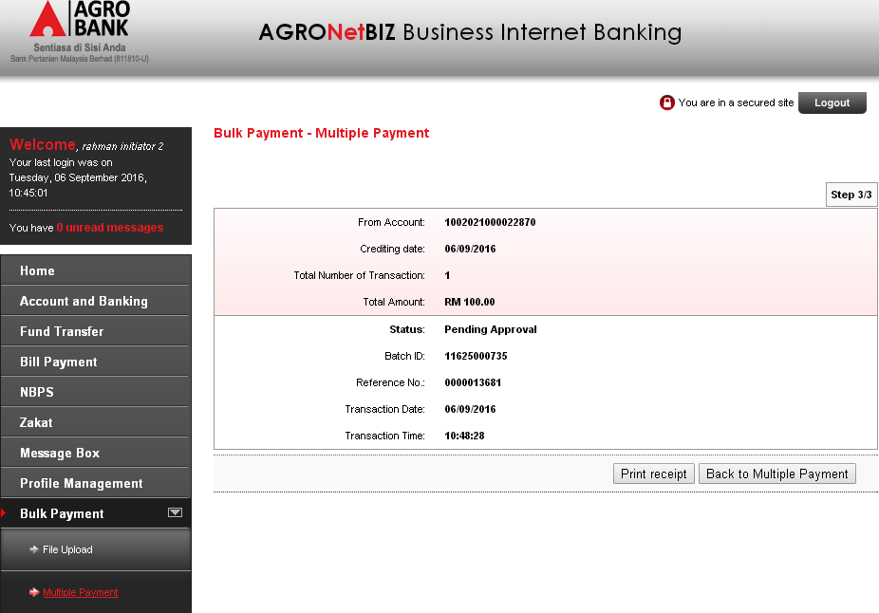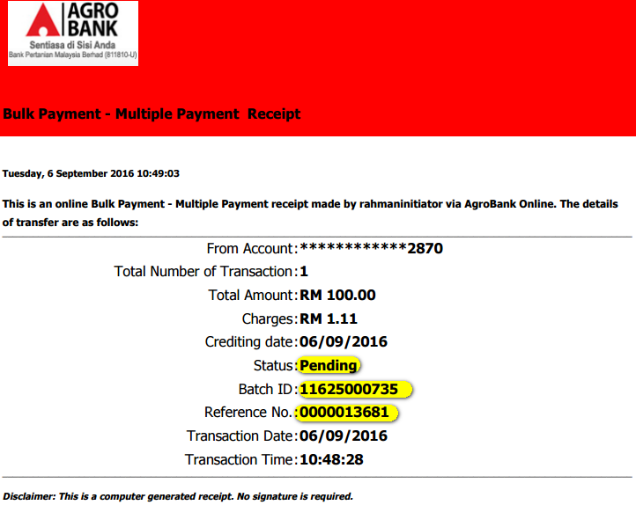

Login as Approver to approve the created transaction.
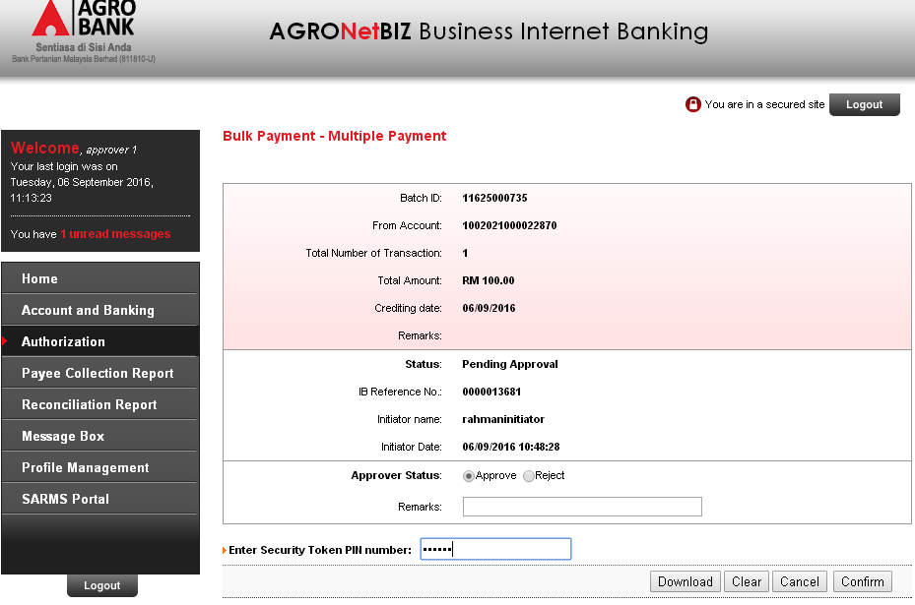
Status reply : Rejected by Approver
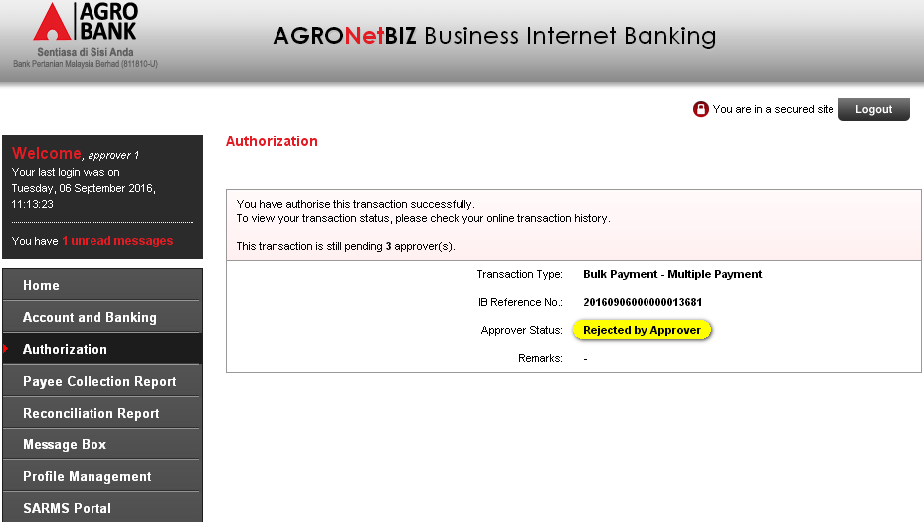

- Payroll
Login as Initiator and perform Payroll Multiple payment.
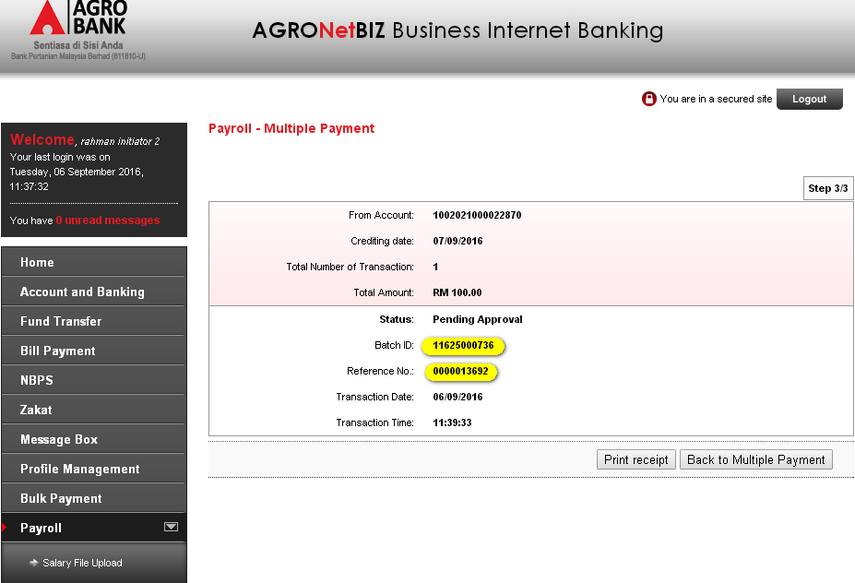
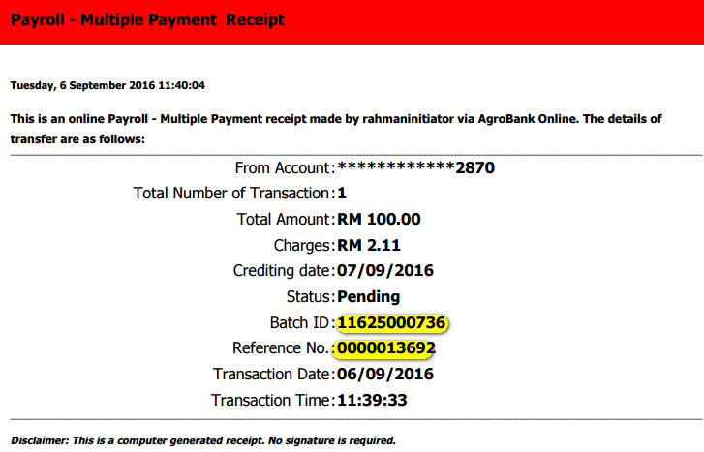

Login as Approver to approve on created transaction.
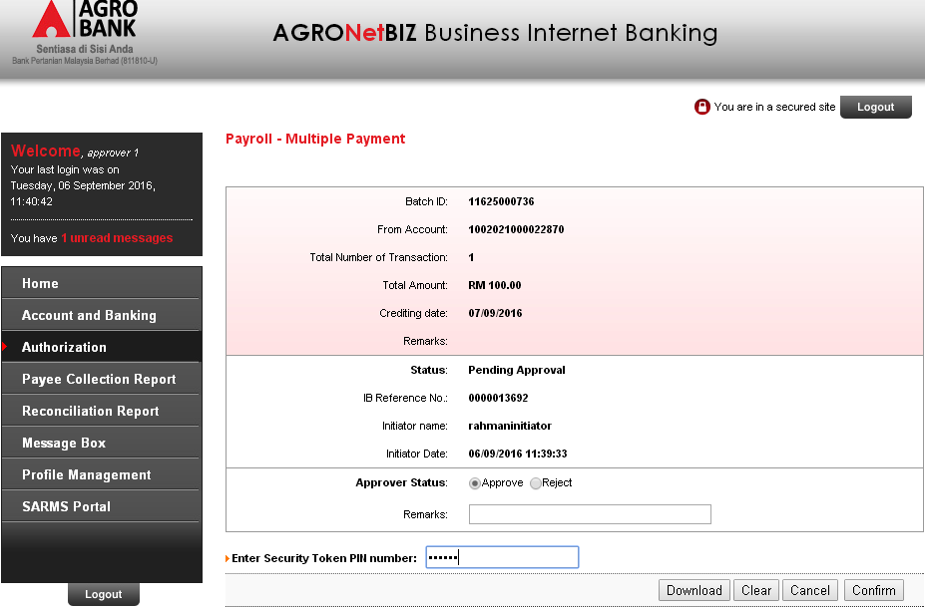
Status reply: Rejected by Approver
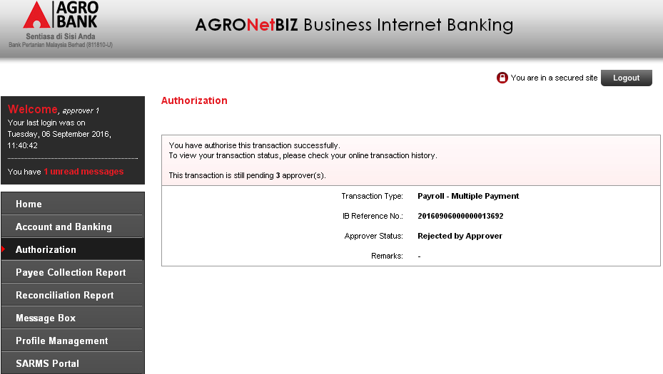

- BIB.SIT.LHDN
- Statutory Body
Login as Initiator and perform Statutory Body payment.
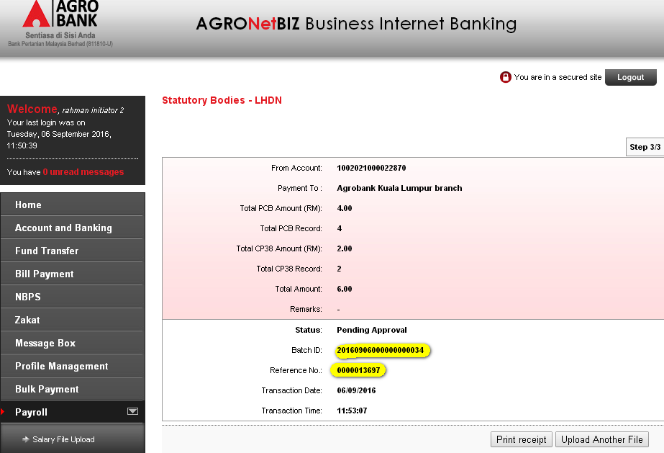
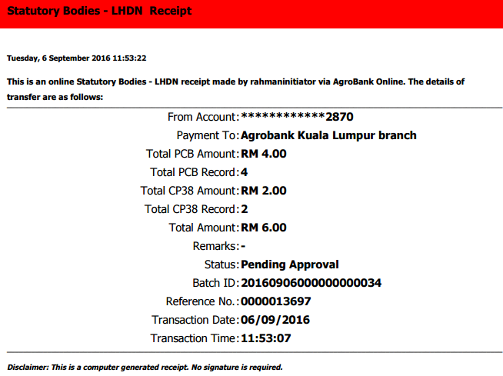

Login as Approver to approve on created transaction.
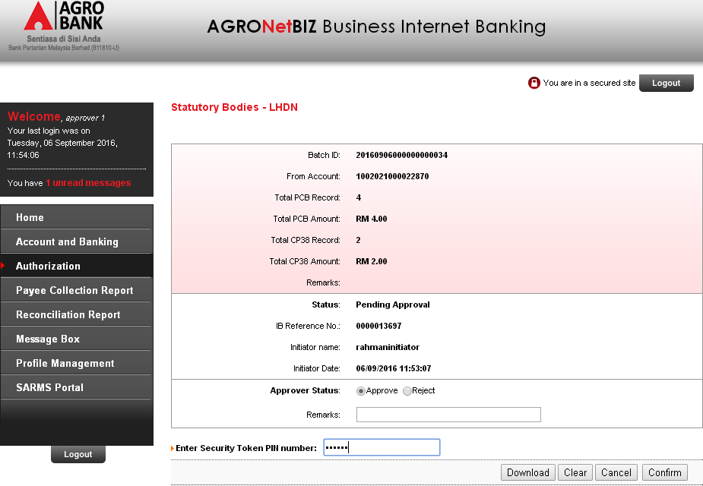

Status reply: Rejected by Approver
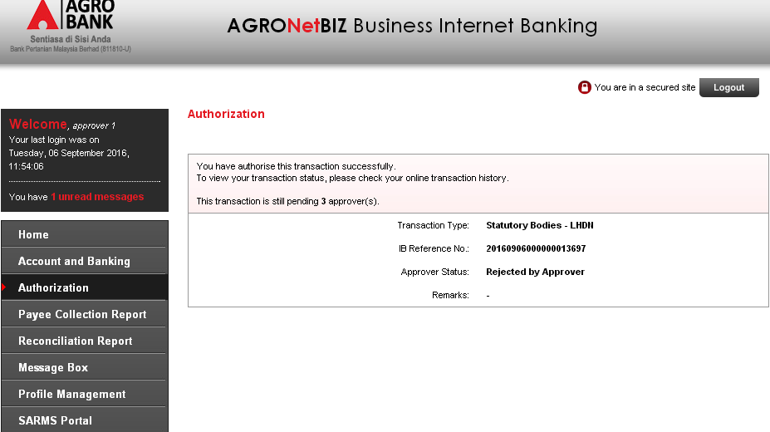

Reviewed By: (PMO)
Lizahwati |  |  | Name/Position : Lizahwati binti Basirun  Date :

