Test Issue Log |  |  |  |  |  | SCP ID# : 5987
Project Name: | [Internal Testing] Bulk Payment – Multiple Payment
Test Stage: | Unit Functionality Integration System Interface  Performance Regression Acceptance Pilot
Test Case Number: |  |  |  | Test Started Date: |  |  | 15/03/2016
Test Title: | [Internal Testing] Bulk Payment – Single User
Test Description: | - To ensure all function in Bulk Payment module can successfully performed.  https://10.6.6.20/bib.prod.kada/common/Login.do
Test Functionality: | - Bulk Payment:  -Single Debit Account  -Multiple Debit Account  -Duplicate  -Edit  -Delete
Test Procedure: | - Single Debit Account  - Login as Single User and create new transaction with Single Debit Account Job Type.  - Submit the created transaction.  - View Bulk Payment History status.  - Add (duplicate) new transaction to the submitted transaction.  - Submit the added transaction.  - View Bulk Payment History status.  - Multiple Debit Account  - Login as Single User and create new transaction with Multiple Debit Account Job Type.  - Submit the created transaction.  - View Bulk Payment History status.  - Add (duplicate) new transaction to the submitted transaction.  - Submit the added transaction.  - View Bulk Payment History status.  - Edit  - Choose the Reference Number of the transaction.  - Click on the No. of the transaction  - Edit the details.  - Submit the edited transaction.  - View Bulk Payment History status.  - Delete  - Choose the Reference Number of the transaction then click on Duplicate button.  - Click on checkbox of the transaction that need to be deleted.  - Click on delete button.  - On the confirm page, click on confirm button.  - Submit the transaction.
Test Result: | Pass: Fail: | Tested by: |  |  | Erni Suhaireen binti Zulkifli
Reason for Failure:
TEST DESCRIPTION

Multiple Payment

Single Debit Account

Create New
To create new transaction
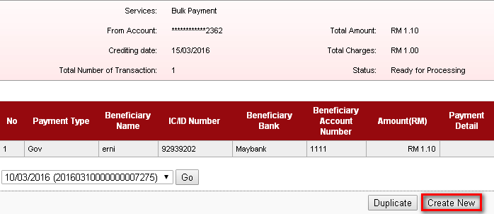
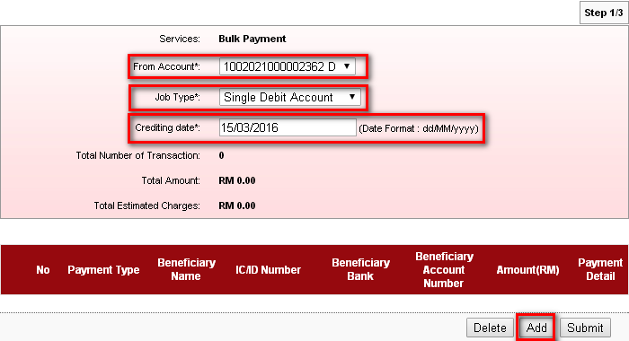

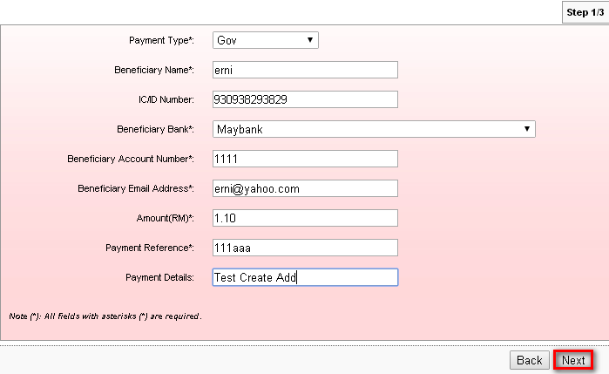
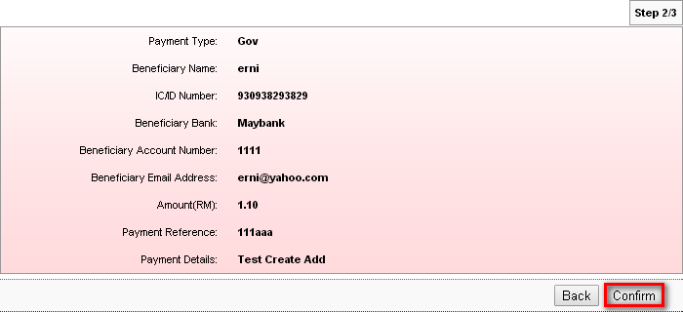
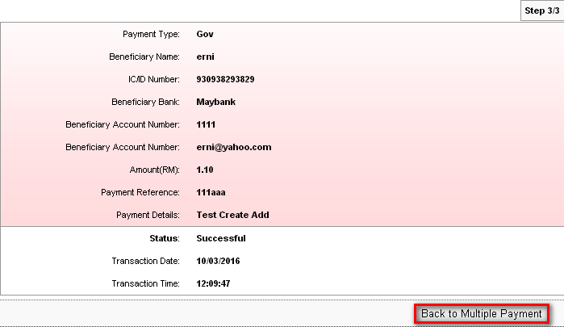

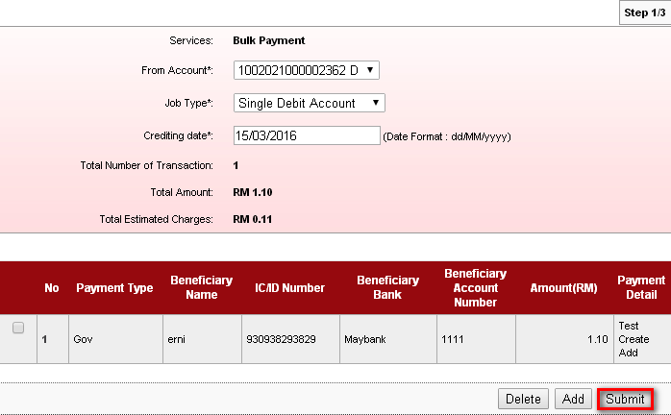
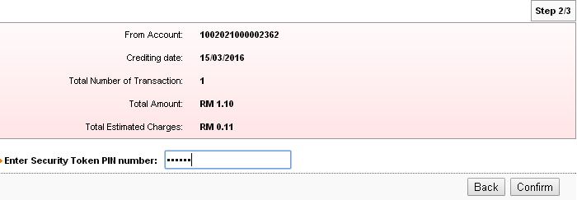
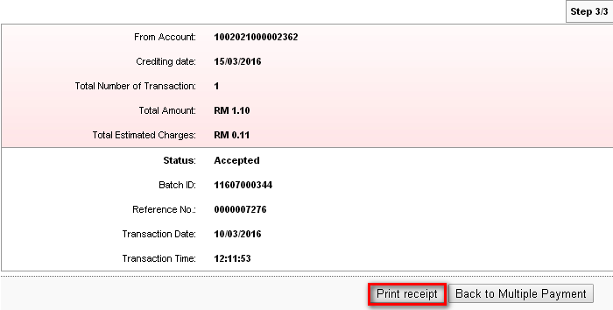
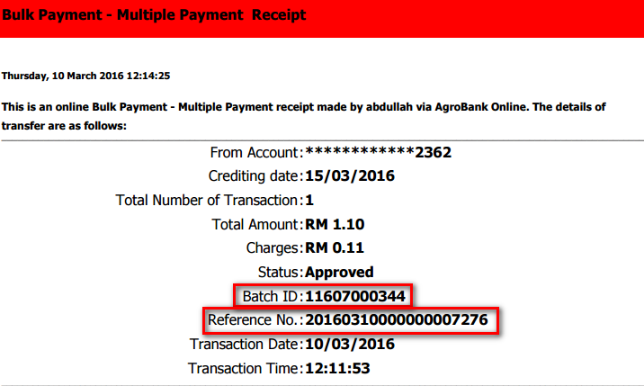
Bulk Payment History :
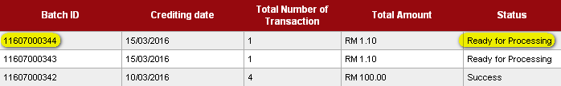

Add
To add another payment in one transaction.
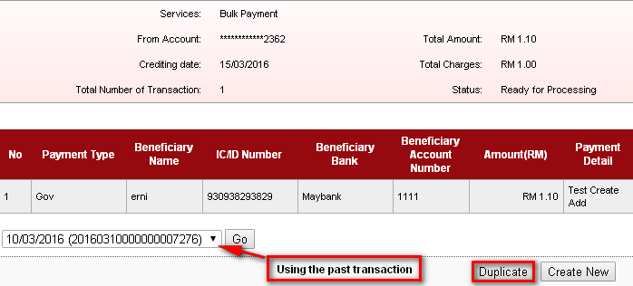
Choose from account number, job type and crediting date before click on Add.
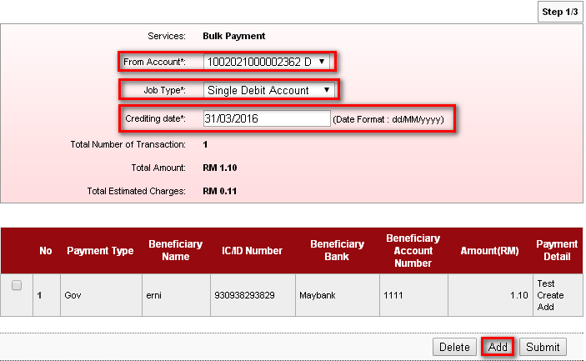

Fill on the blank space. Payment Reference number must be unique and not as same as previous submitted transaction.
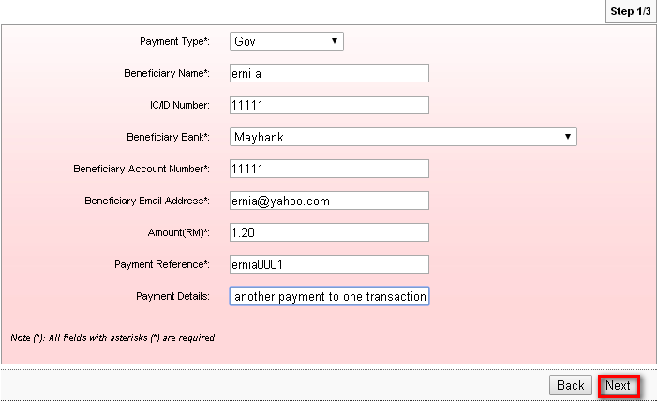
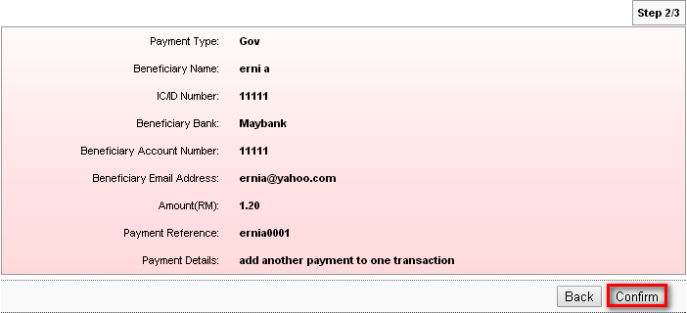

Click on ‘Back to Multiple Payment’ to add another one payment transaction or to submit added transaction.
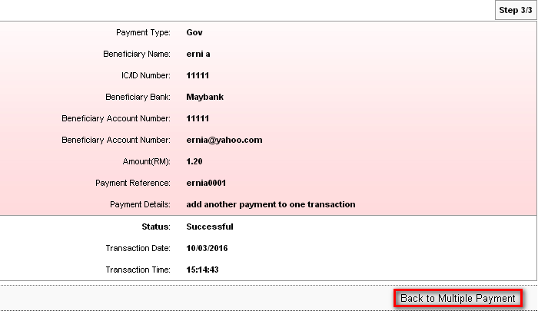
Add another one payment transaction with difference details.
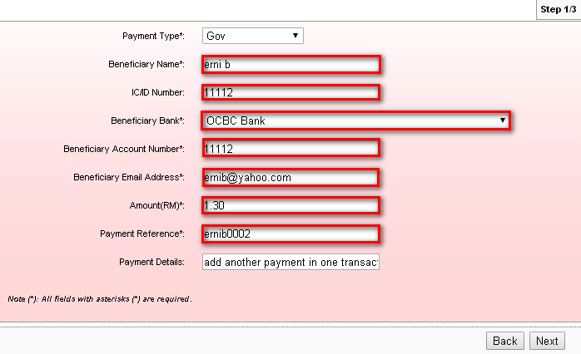
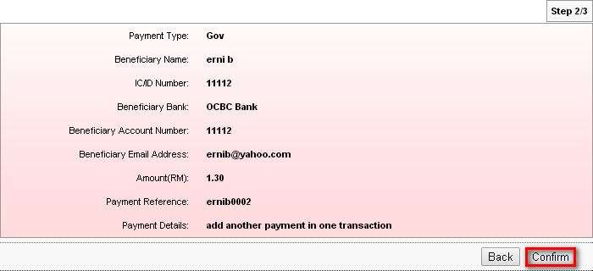
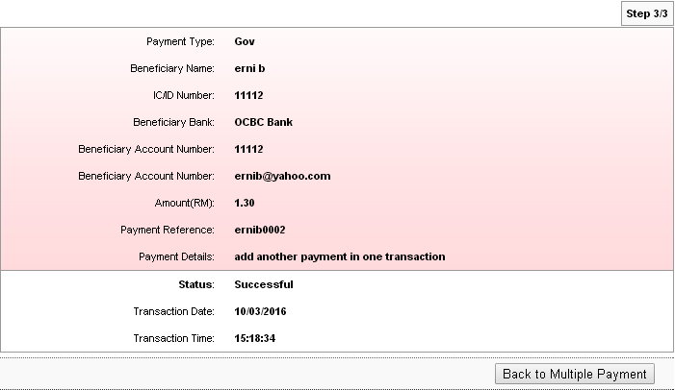

Submit

The following results are transaction that has been added and ready to be submit.
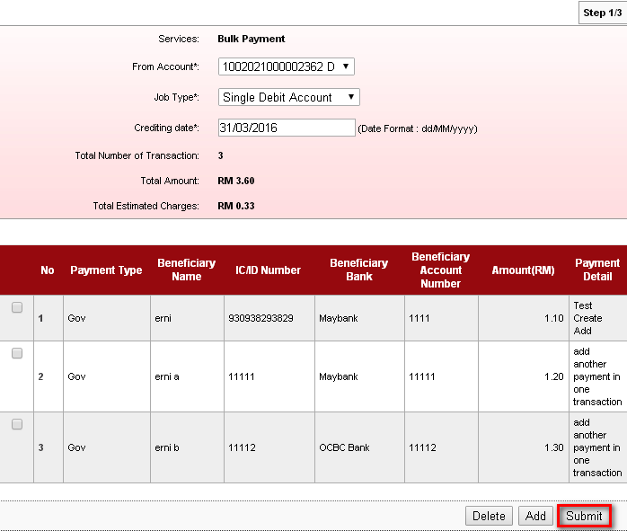
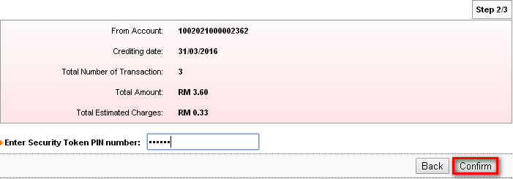
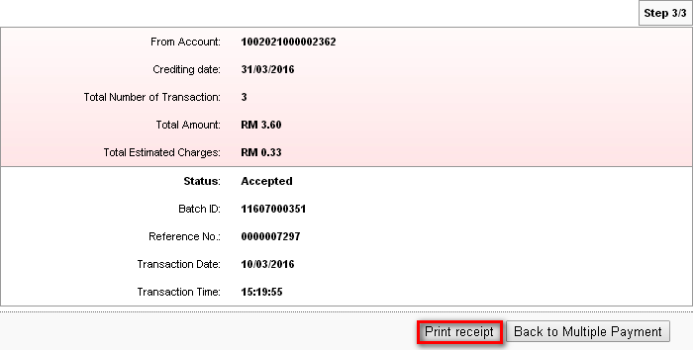
After added another transaction into one transaction, the payment reference number and batch id will not copy previous payment reference number and batch id. It will create new payment reference number and new batch id.
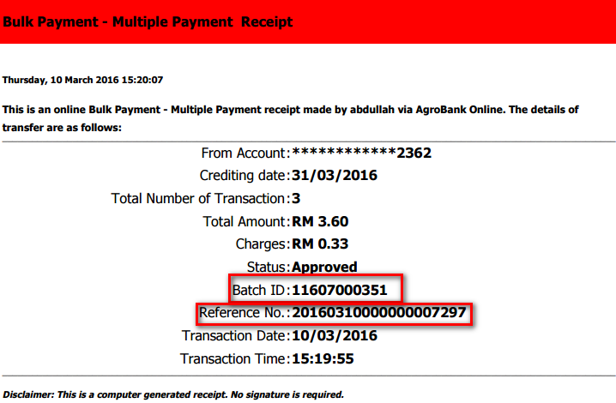

Result :
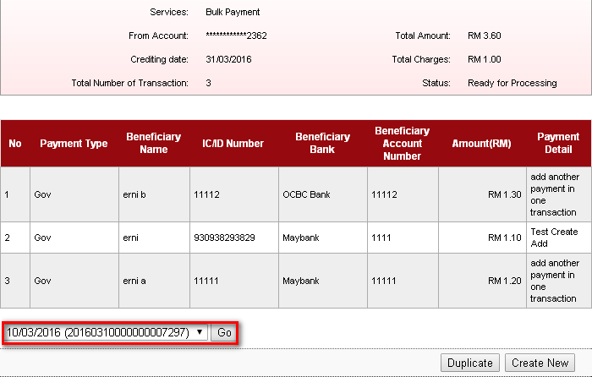
Bulk Payment History :
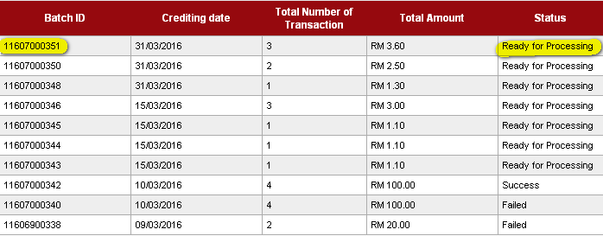

Multiple Debit Account

Create New
To create new transaction
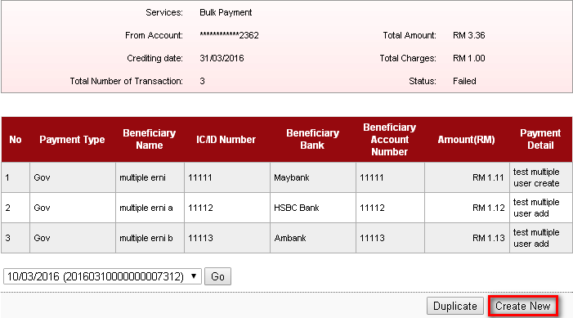
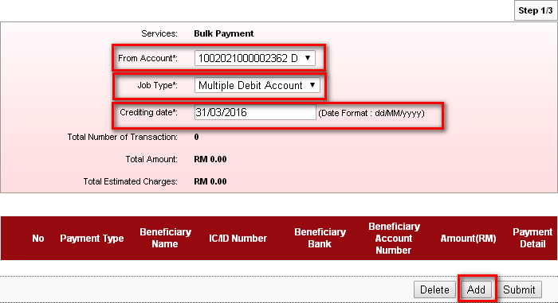
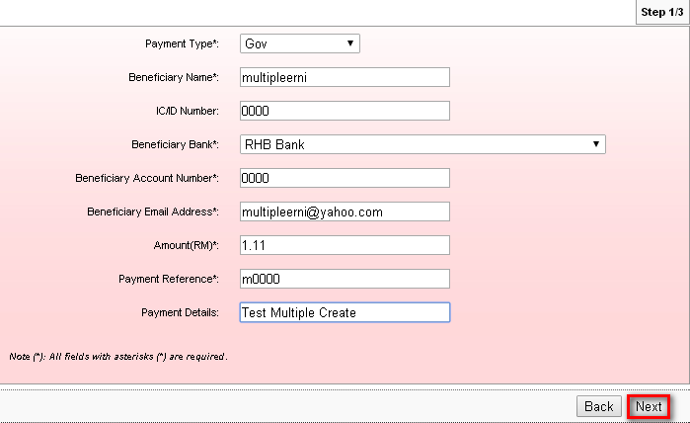
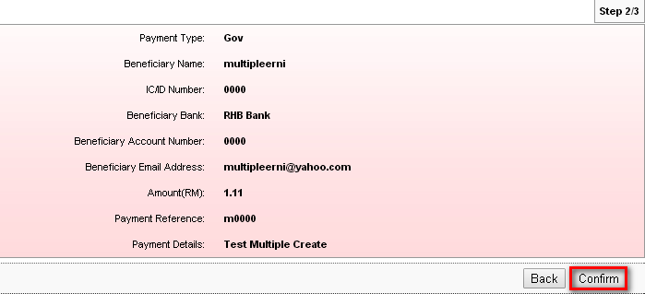
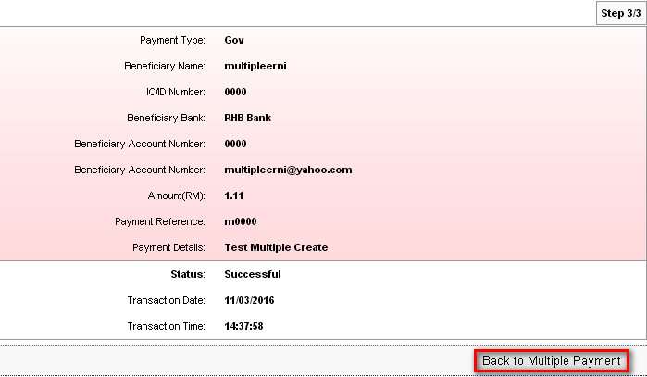
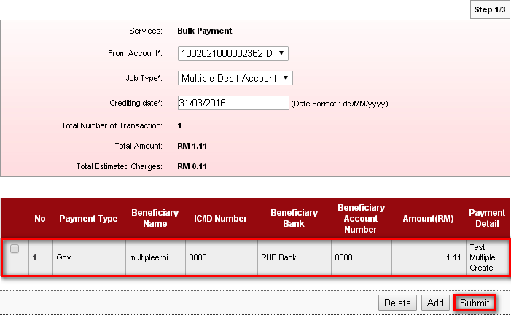
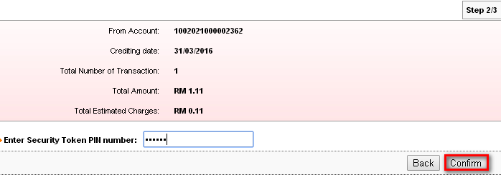
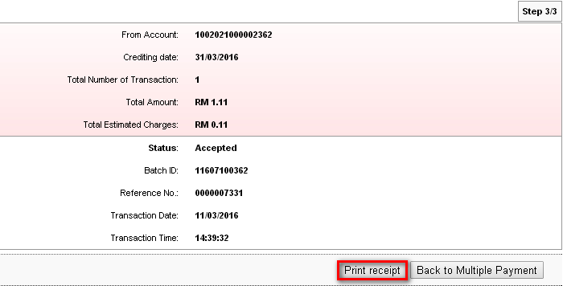
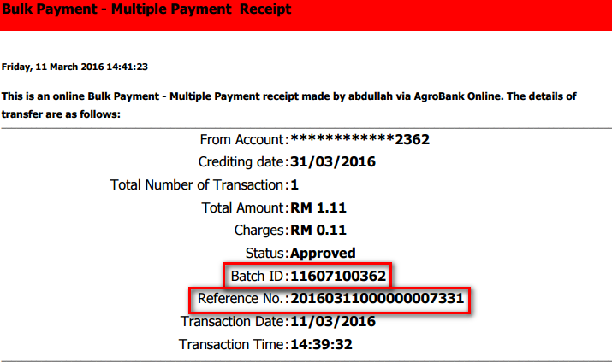

Bulk Payment History :
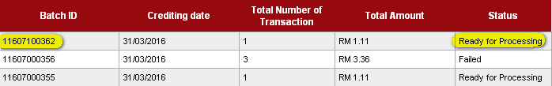
Result :
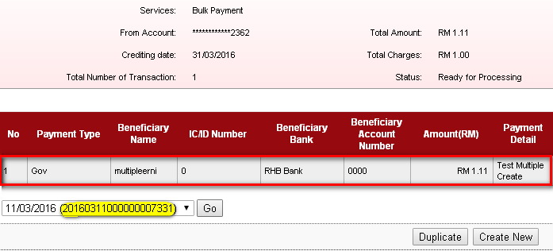

Add
To add another payment in one transaction.
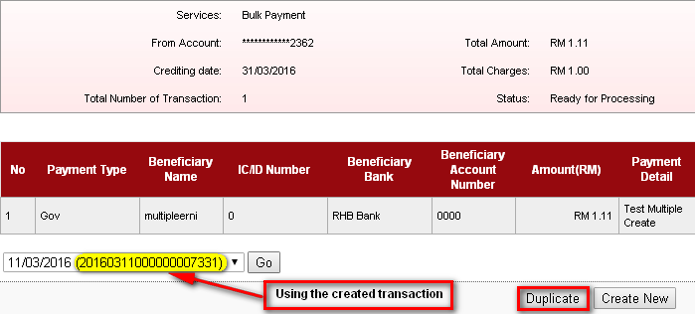
Choose from account number, job type and crediting date before click on Add.
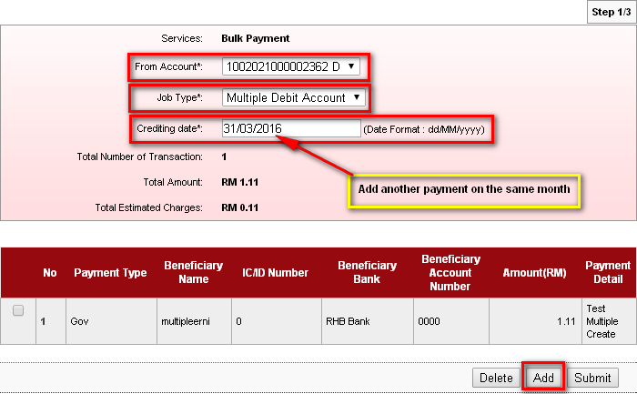

Fill on the blank space. Payment Reference number must be unique and not as same as previous submitted transaction.
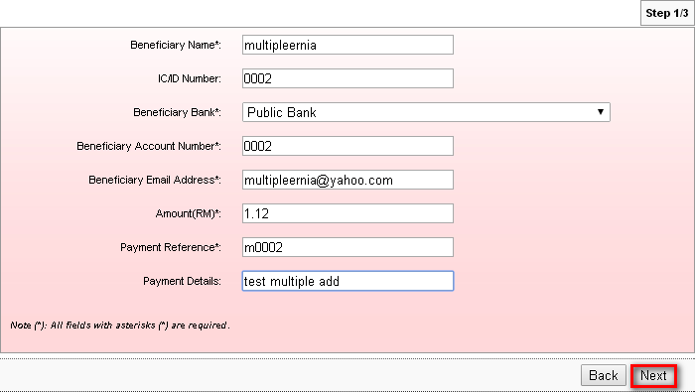
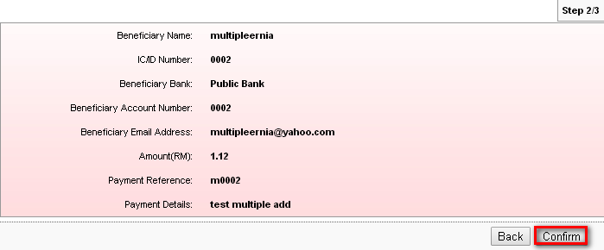

Click on ‘Back to Multiple Payment’ to add another one payment transaction or to submit added transaction.
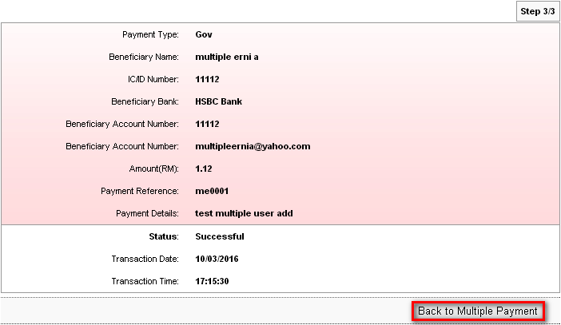

To add another one transaction.
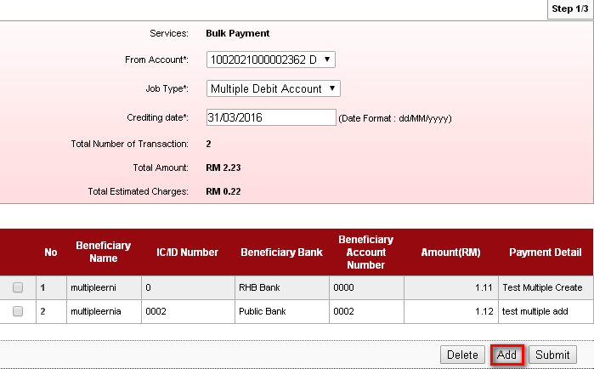

Add another one payment transaction with difference details.
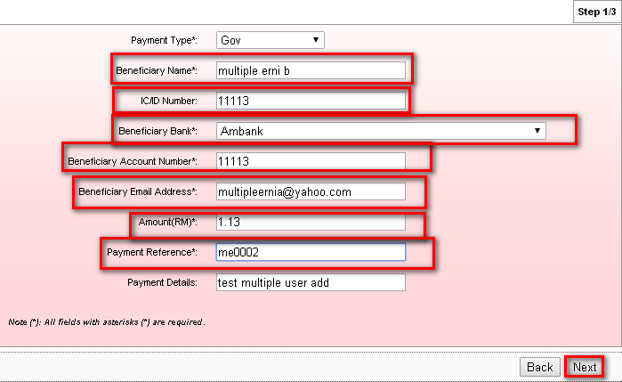
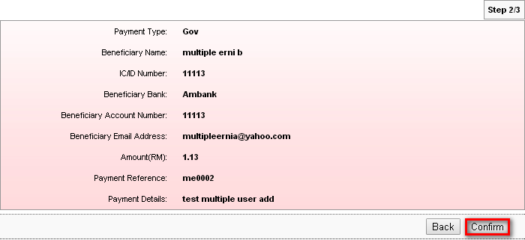
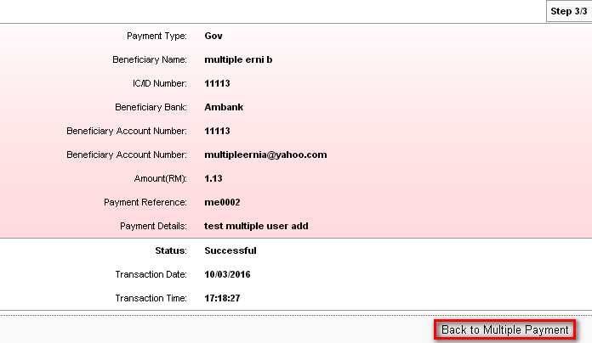

Submit
The following results are transaction that has been added and ready to be submit.
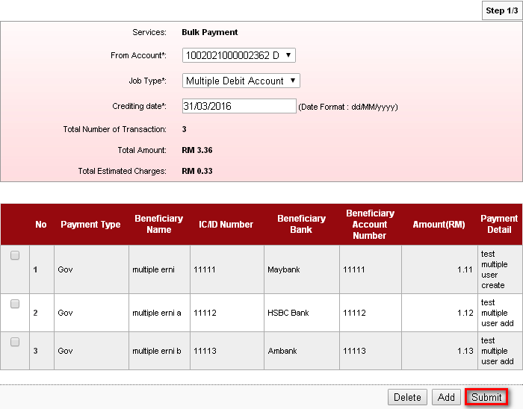
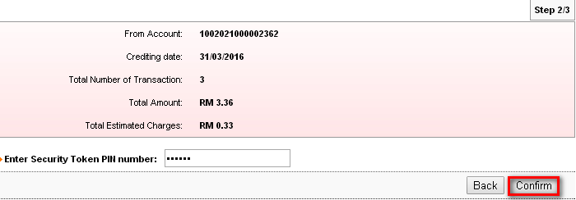
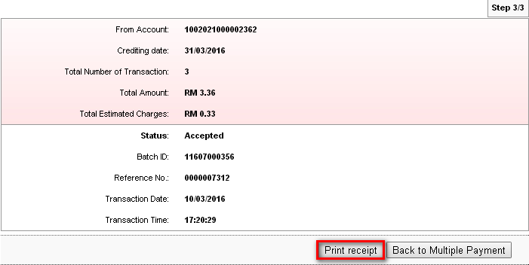
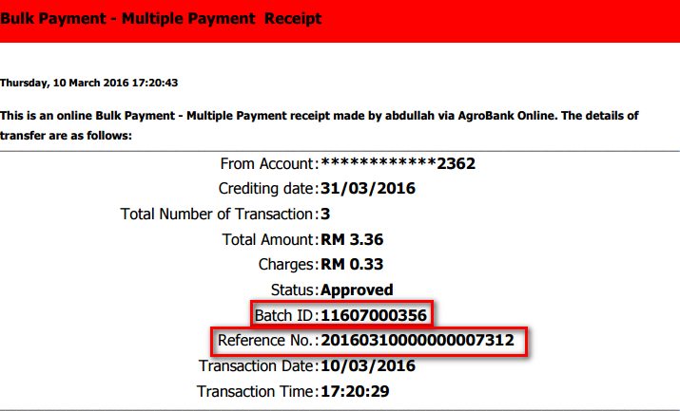

Bulk Payment History :
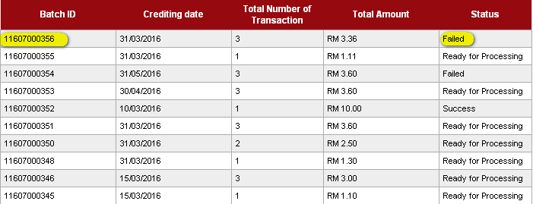
Result :
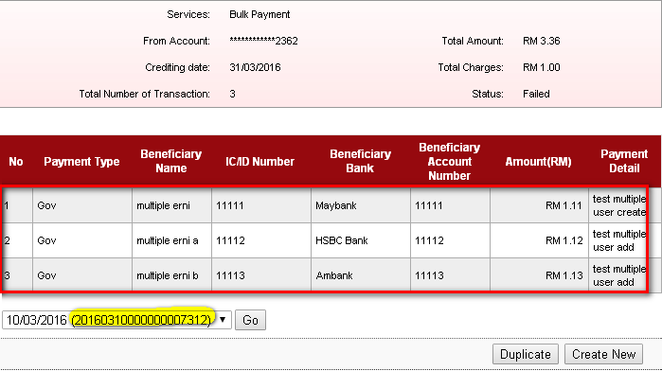

Duplicate
Duplicate function are used to submit all payment for next time.(example: next month salary payment)
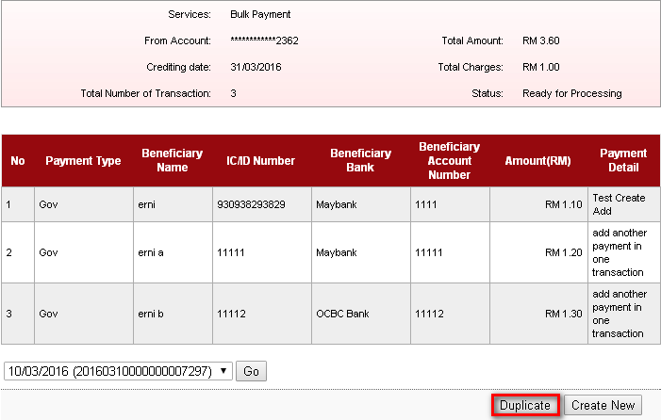

Choose from account number, job type and crediting date.
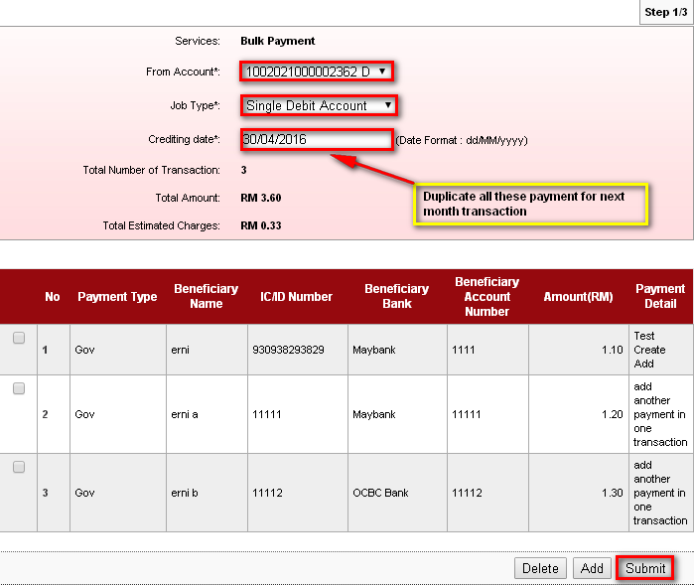
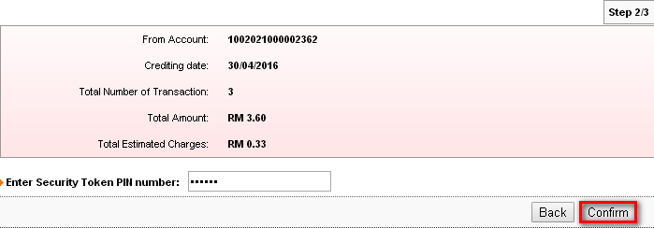
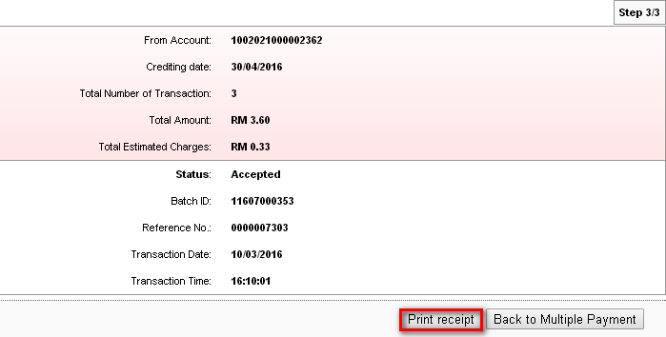
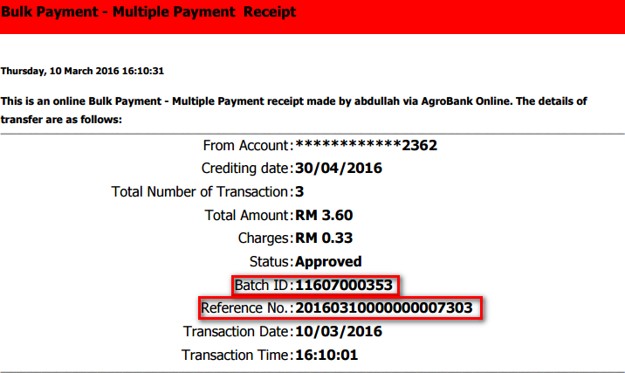

Bulk Payment History :
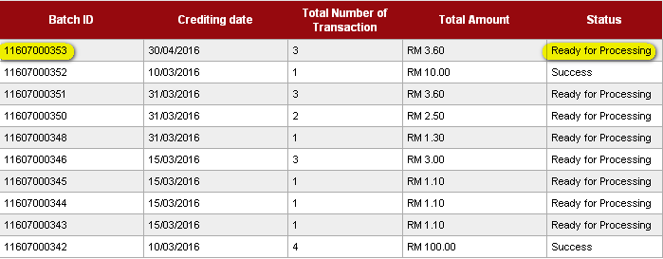
Result :
Duplicated transaction will not carry the same payment reference number and batch id. It will create its own transaction with new reference number and batch id.
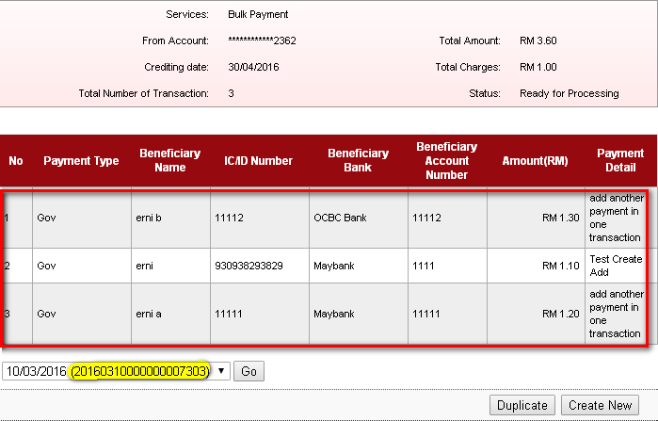

Edit
Edit can be done by clicking on the number of the transaction at the duplicate function. Edit can be used to edit the payment before proceed to duplicate the transaction. The transaction cannot proceed with same previous Payment Reference number. In this case, user need to edit the payment reference number with another unique reference number in order to proceed the transaction.
Negative testing :
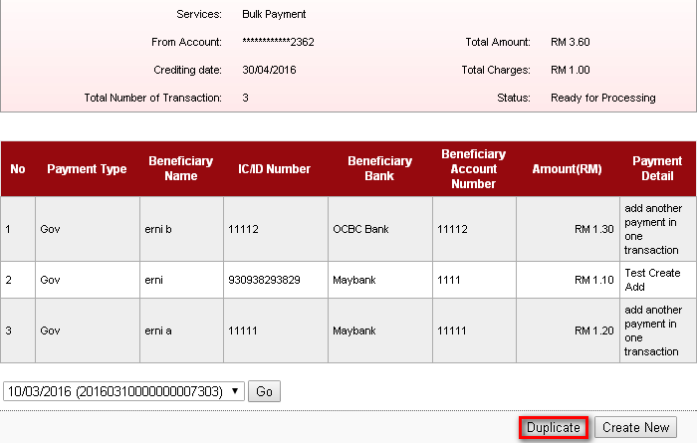
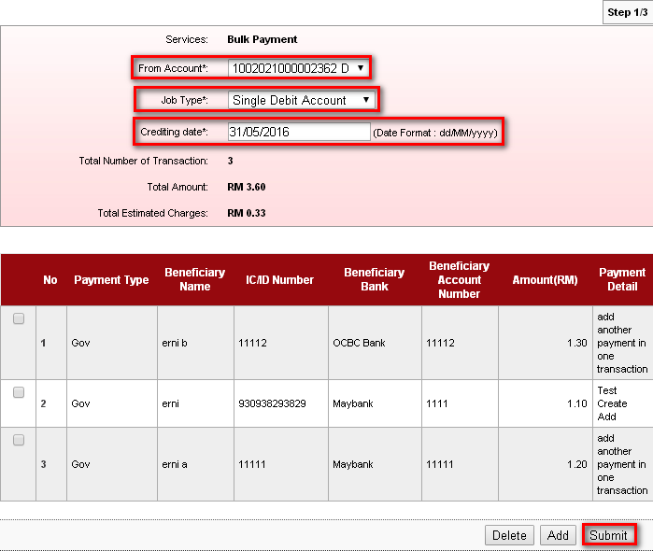
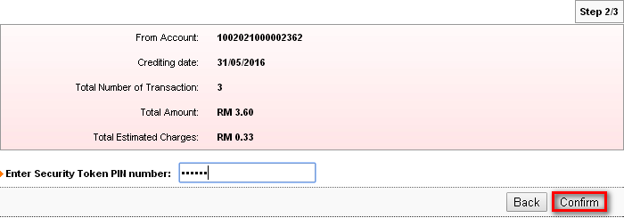

The transaction cannot proceed with same previous Payment Reference number. In this case, user needs to edit the payment reference number with another unique reference number in order to proceed the transaction. Click on back to edit.
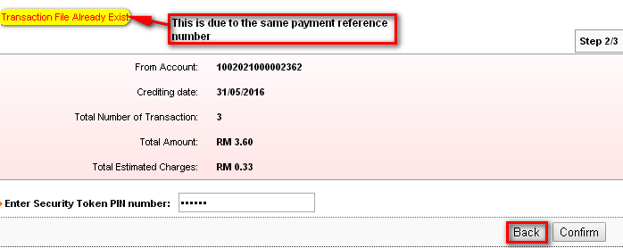

Positive Testing:
Click on the number of the transaction that need to be edit (on No. column).
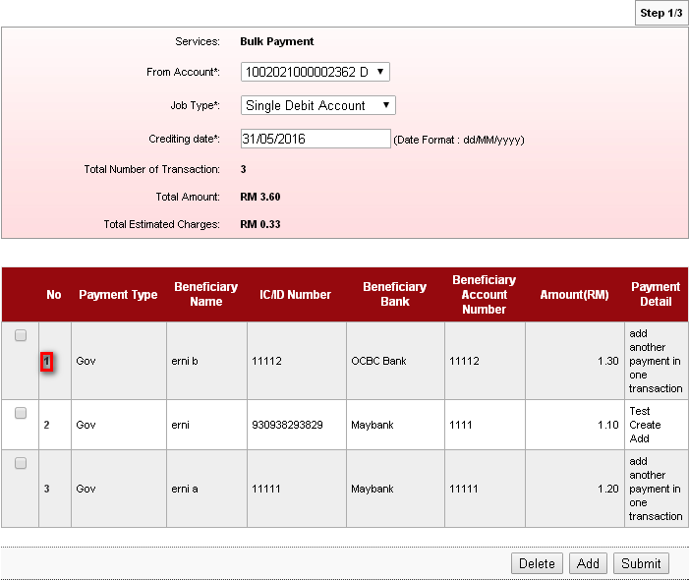

Change the Payment Reference Number with unique number that never been added before.
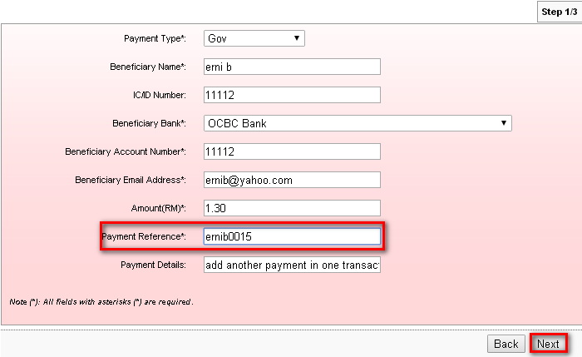
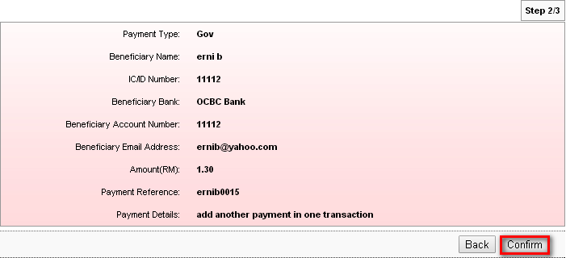
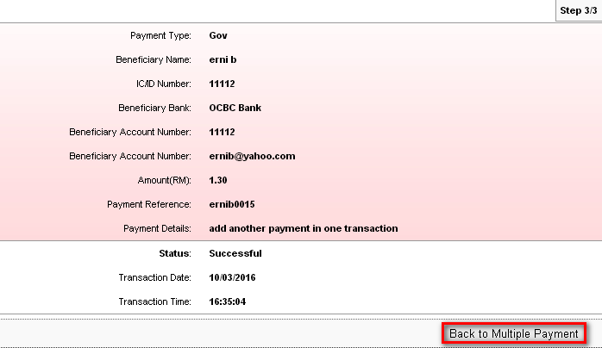

Continue with next payment number.
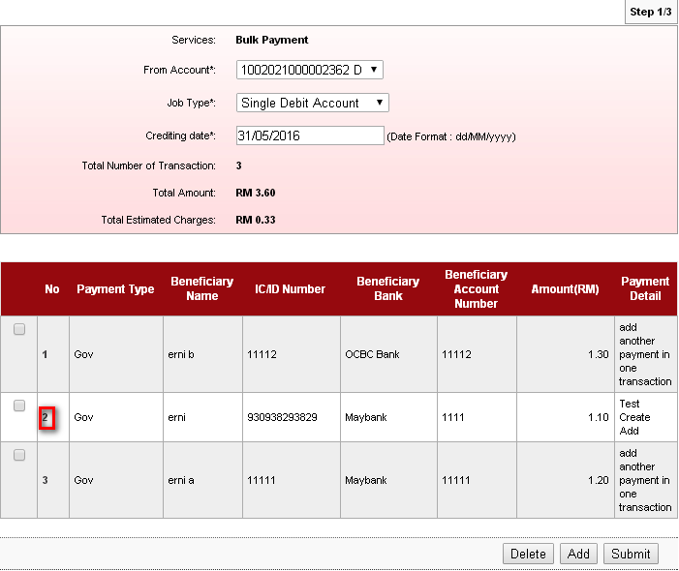
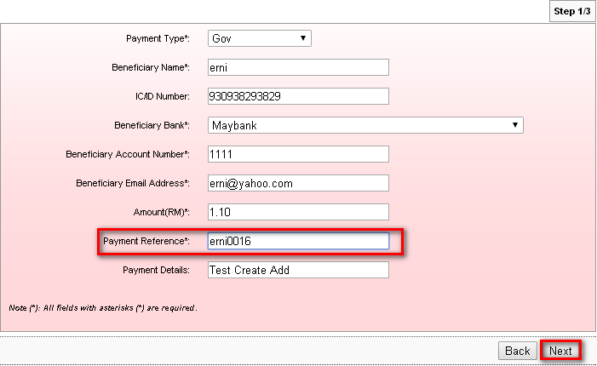
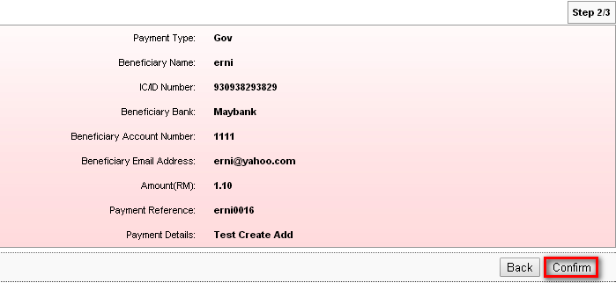
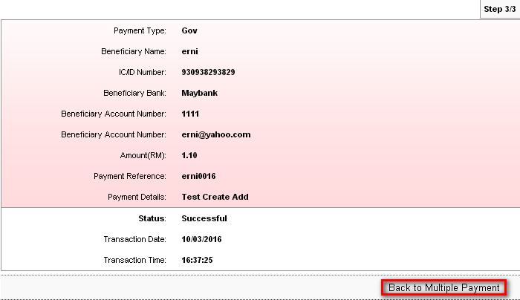
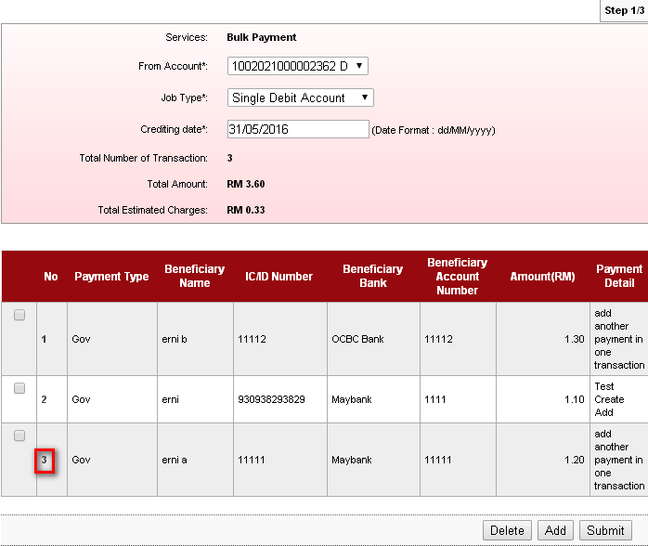
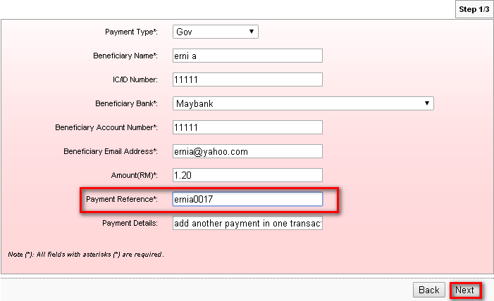
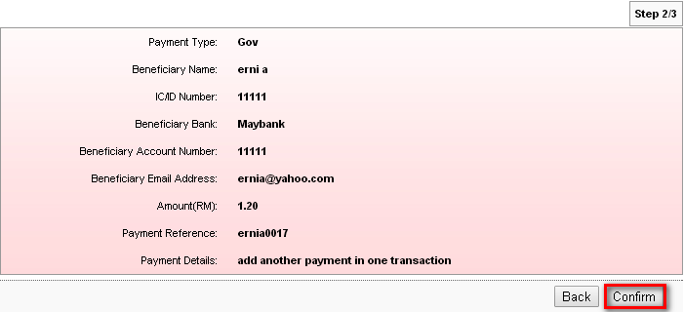
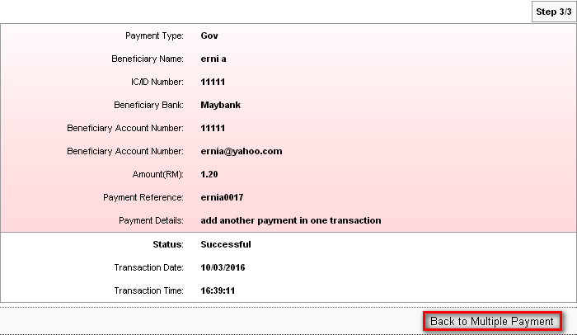

After done with edit, click on Submit to proceed.
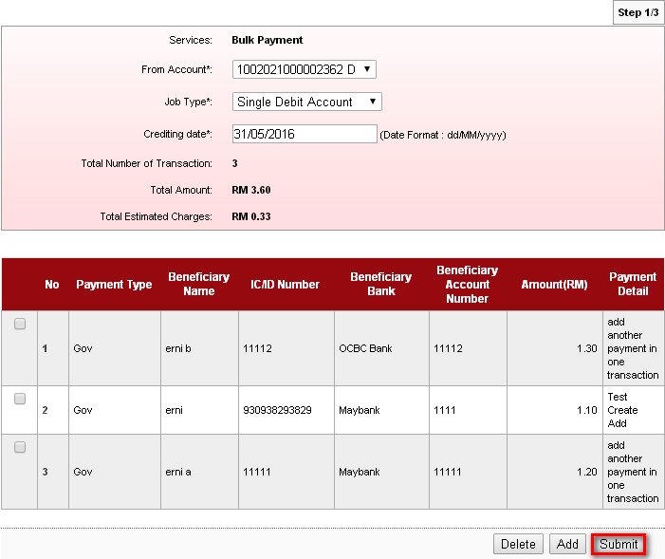
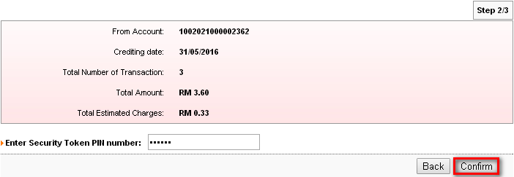
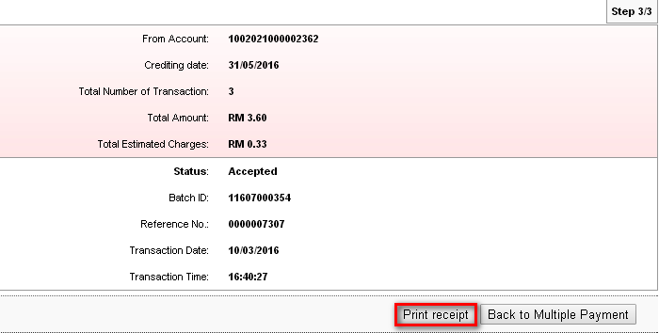
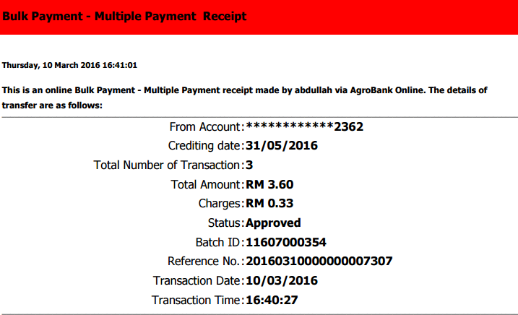

Bulk Payment History : 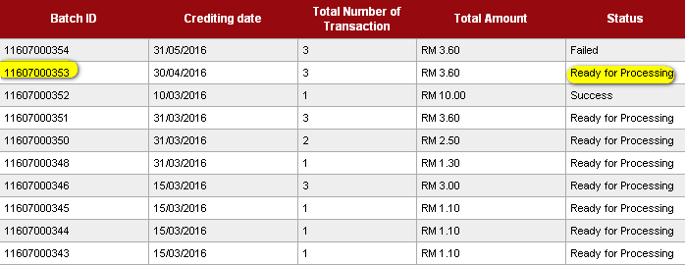

Delete
Delete function only can be done in duplicate function. Where in case, user want to delete one payment before duplicate the transaction.
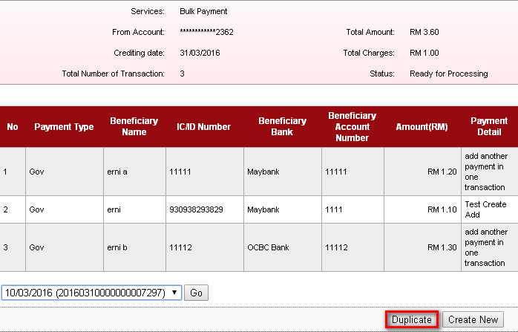

Click on the box of the transaction that wants to delete.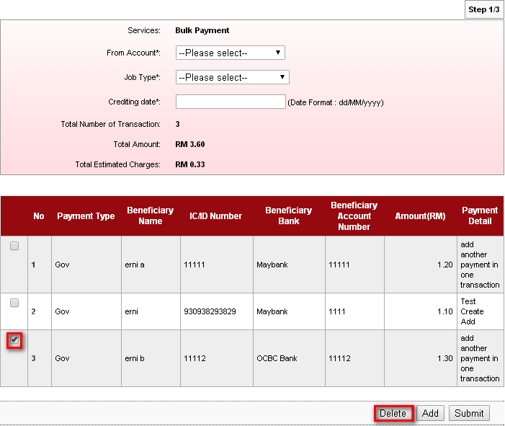
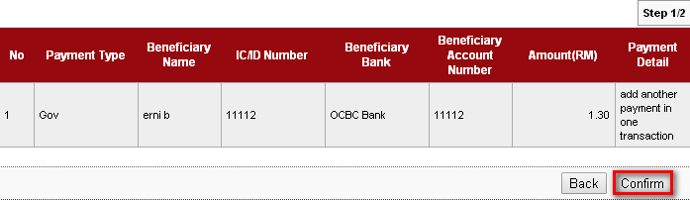
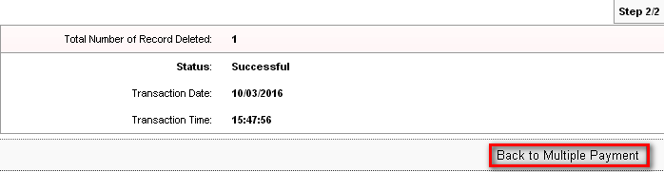

Result :
The transaction [Batch id: 11607000351 / Payment Reference Num.: 00007297] is now only have two transaction only and ready to be duplicate for next transaction.
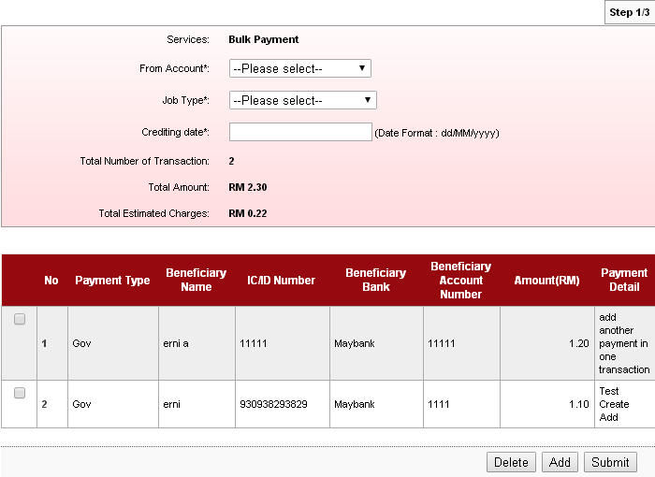

Reviewed By: (PMO)
Lizahwati |  |  | Name/Position : Lizahwati binti Basirun  Date :

