Test Issue Log |  |  |  |  |  | SCP ID# : 5987
Project Name: | [Internal Testing] Payroll
Test Stage: | Unit Functionality Integration System Interface  Performance Regression Acceptance Pilot
Test Case Number: |  |  |  | Test Started Date: |  |  | 15/03/2016
Test Title: | [Internal Testing] Payroll
Test Description: | - To ensure all function in Payroll module can successfully performed.  https://10.6.6.20/bib.prod.kada/common/Login.do
Test Functionality: | - Salary File Upload  - Multiple Payment
Test Procedure: | - Login as single user and performed salary payment on Salary File Upload module.  - Upload file and performed the salary payment.  - View Payroll History  - Performed multiple payments.  - Create new transaction.  - Submit the created transaction.  - View Payroll History to the submitted transaction.  - Added (duplicate) new payment at the submitted transaction.  - View Payroll History to the submitted transaction.
Test Result: | Pass: Fail: | Tested by: |  |  | Erni Suhaireen binti Zulkifli
Reason for Failure:
TEST DESCRIPTION

Payroll

Salary File Upload
Upload the file.
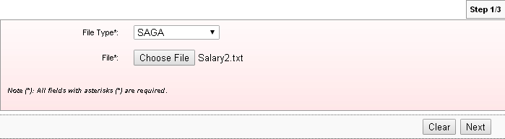
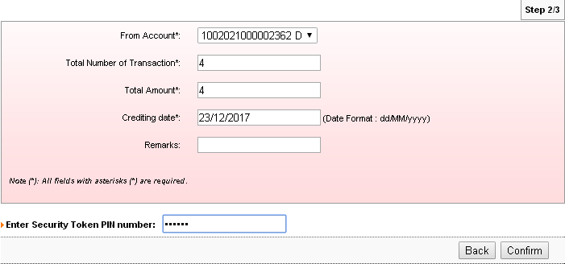
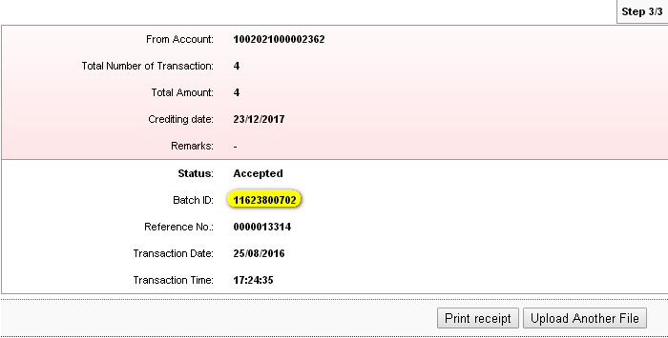
Display Payroll History page. Transaction has successfully accepted and pending.
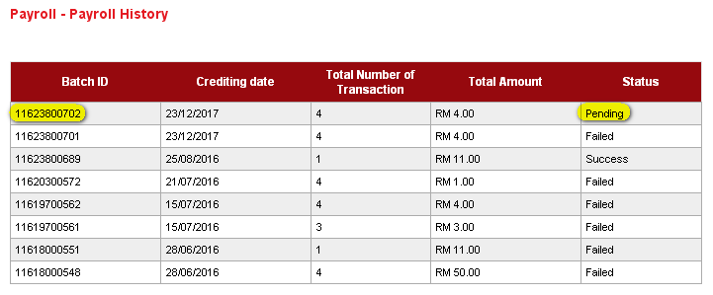

Multiple Payment

Create New
Create new transaction.
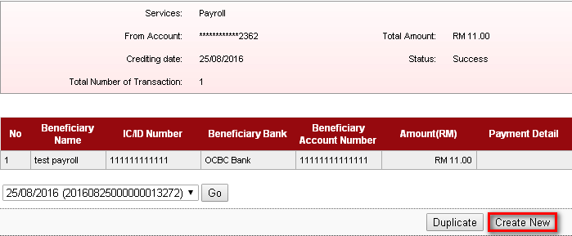
Choose on From Account and Crediting Date. Then click on Add button.
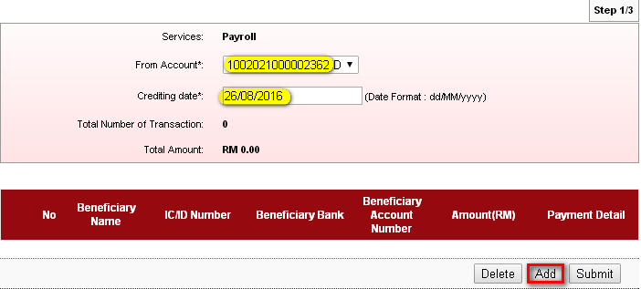

Fill on the blanks space.
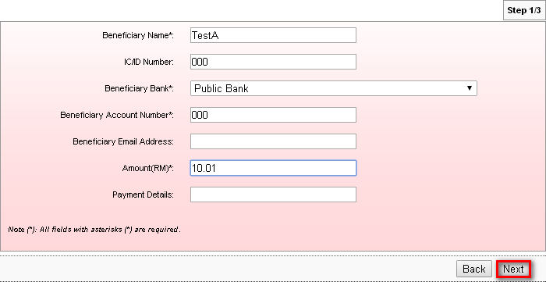
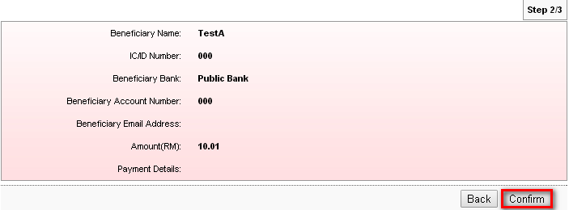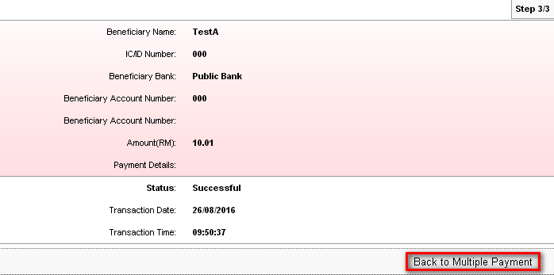

Submit the created transaction. If user sign out or go to other site before submit the created transaction. The transaction will lose.
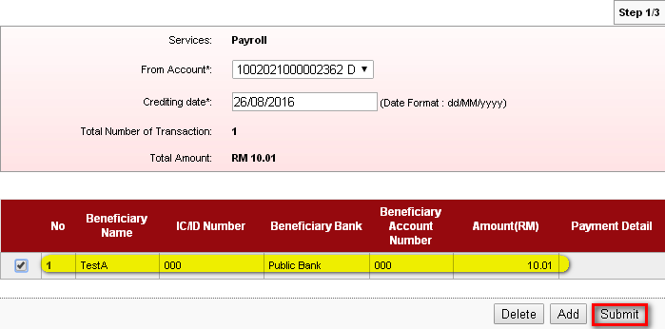
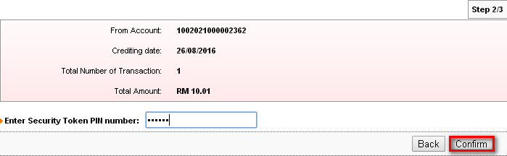
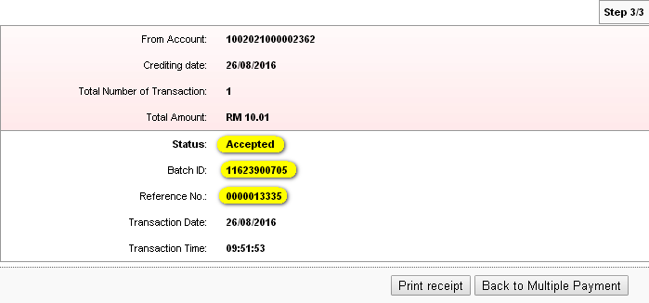
Payroll History Page
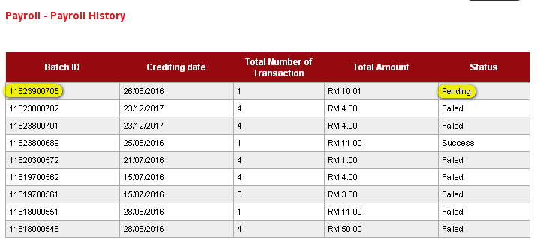

Add
To add another payment in one transaction, on the dropdown navigation (as highlighted), choose on created transaction by refer on the Reference No. that have been given. Then click on ‘duplicate’.
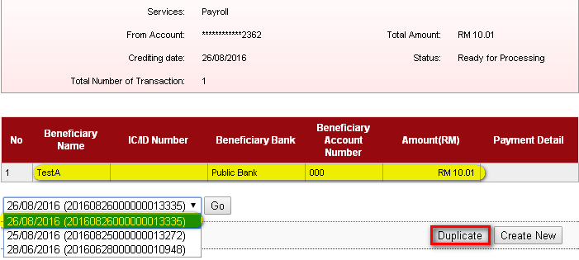
Choose job type and crediting date before click on Add.
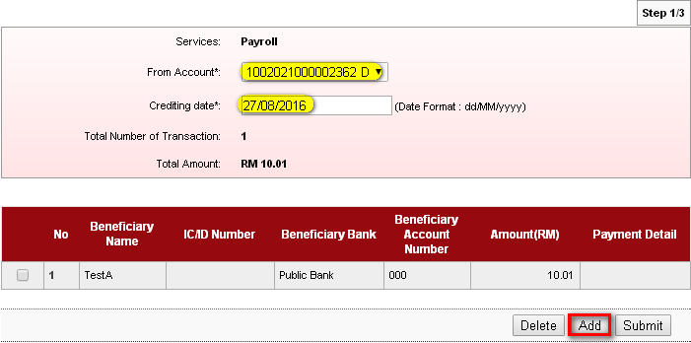

Fill on the blank space.
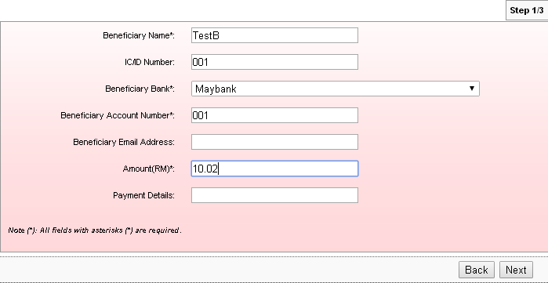
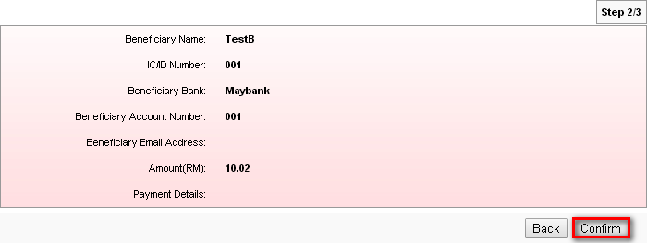

Adding new transaction has successfully done. Click on Back to Multiple Payment to add another transaction or to submit the created transaction.
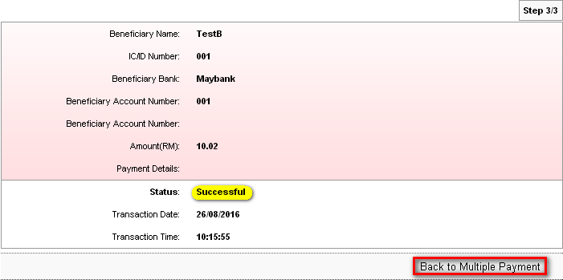
Screen display transaction that has been added before. Click on ‘Add’ to add another transaction.
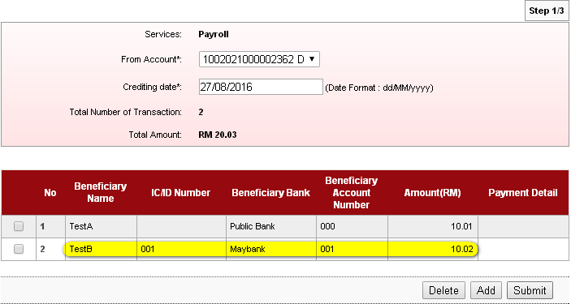

Proceed with the same step to add another transaction.
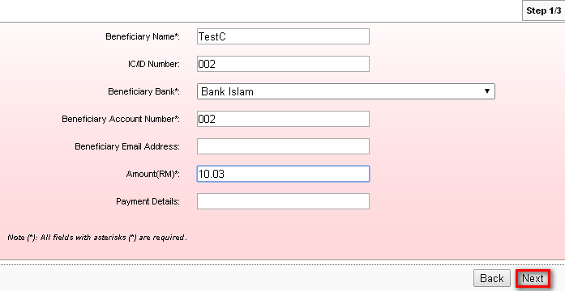
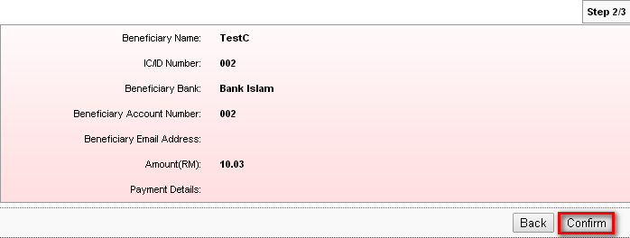
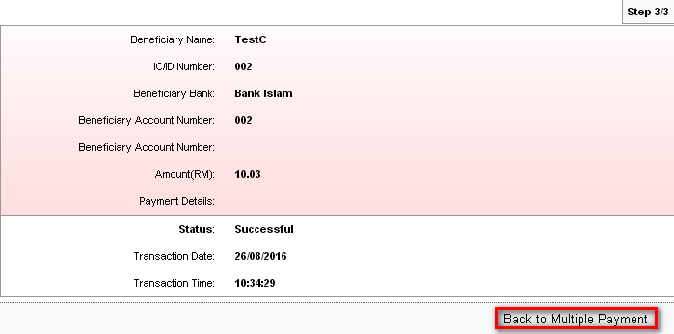

Submit
Added another transaction has successfully performed. Click on Submit button to submit all the added transaction.
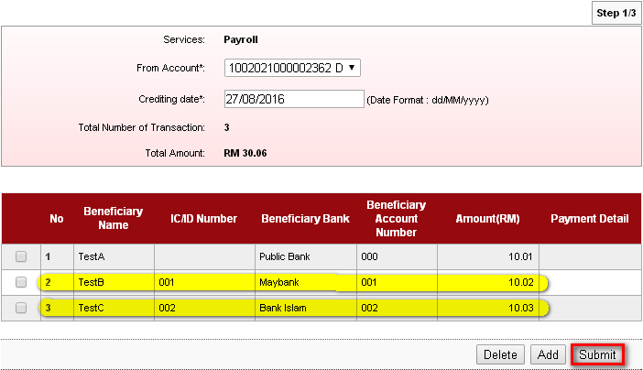
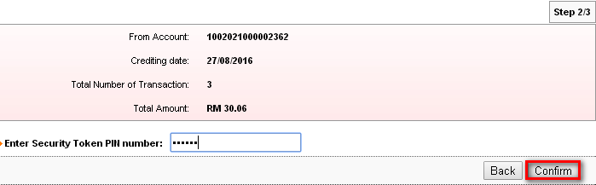
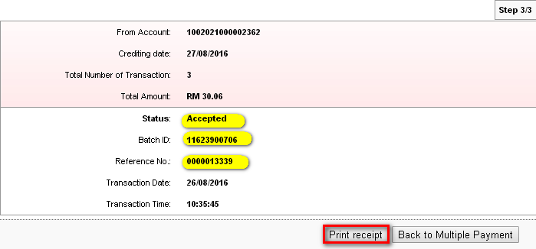
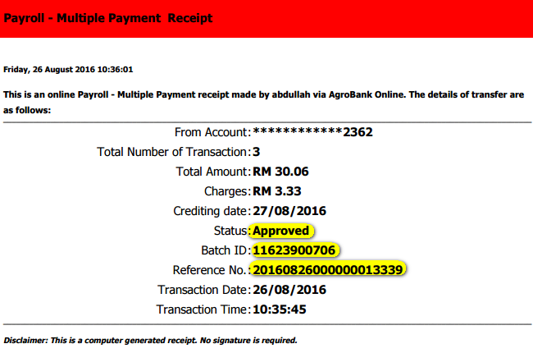

Payroll History Page
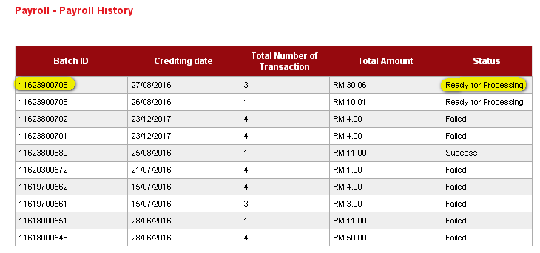

Reviewed By: (PMO)
Lizahwati |  |  | Name/Position : Lizahwati binti Basirun  Date :

