Test Issue Log |  |  |  |  |  | SCP ID# : 5987
Project Name: | [Internal Testing] Bulk Payment – Multiple Payment
Test Stage: | Unit Functionality Integration System Interface  Performance Regression Acceptance Pilot
Test Case Number: |  |  |  | Test Started Date: |  |  | 20/09/2016
Test Title: | [Internal Testing] Bulk Payment – Multiple User
Test Description: | - To ensure all function in Bulk Payment module can successfully performed.  https://10.6.6.20/bib.prod.kada/common/Login.do
Test Functionality: | - Bulk Payment:  -Single Debit Account  -Multiple Debit Account  -Duplicate  -Edit  -Delete
Test Procedure: | - Single Debit Account  - Login as Initiator and create new transaction with Single Debit Account Job Type.  - Submit the created transaction.  - View Bulk Payment History status before approve.  - Login as Approver and approve the transaction.  - Login as Initiator and view Bulk Payment History status after approved.  - Add (duplicate) new transaction to the submitted transaction.  - Submit the added transaction.  - View Bulk Payment History status before approve.  - Login as Approver and approve the transaction.  - Login as Initiator and view Bulk Payment History status after approved.  - Multiple Debit Account  - Login as Initiator and create new transaction with Multiple Debit Account Job Type.  - Submit the created transaction.  - View Bulk Payment History status before approve.  - Login as Approver and approve the transaction.  - Login as Initiator and view Bulk Payment History status after approved.  - Add (duplicate) new transaction to the submitted transaction.  - Submit the added transaction.  - View Bulk Payment History status before approve.  - Login as Approver and approve the transaction.  - Login as Initiator and view Bulk Payment History status after approved  - Edit  - Choose the Reference Number of the transaction.  - Click on the No. of the transaction  - Edit the details.  - Submit the edited transaction.  - View Bulk Payment History status before approve.  - Login as Approver and approve the transaction.  - Login as Initiator and view Bulk Payment History status after approved.  - Delete  - Choose the Reference Number of the transaction then click on Duplicate button.  - Click on checkbox of the transaction that need to be deleted.  - Click on delete button.  - On the confirm page, click on confirm button.  - Submit the transaction.  - View Bulk Payment History status before approve.  - Login as Approver and approve the transaction.  - Login as Initiator and view Bulk Payment History status after approved.
Test Result: | Pass: Fail: | Tested by: |  |  | Erni Suhaireen binti Zulkifli
Reason for Failure:
TEST DESCRIPTION

Multiple Payment

Single Debit Account

Create New
To create new transaction.
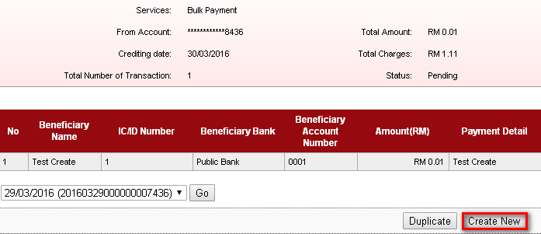

Choose on Job Type and Crediting Date.
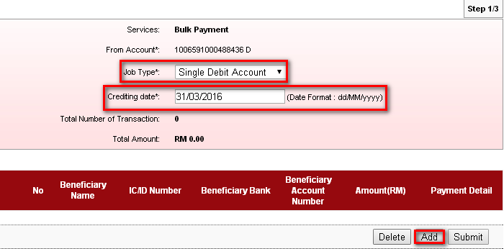

Fill on the blanks space.
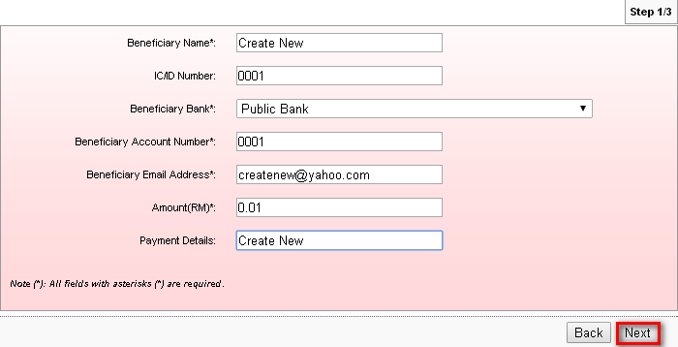
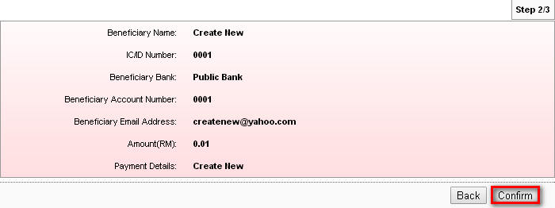
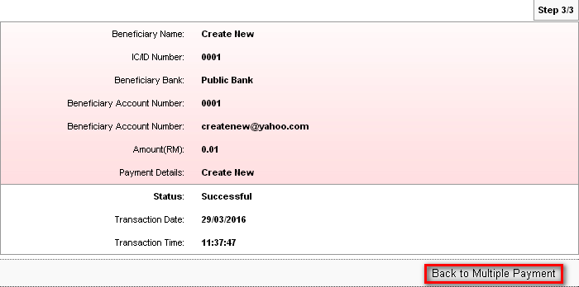
Submit the created transaction. If user sign out or go to other site before submit the created transaction. The transaction will lost.
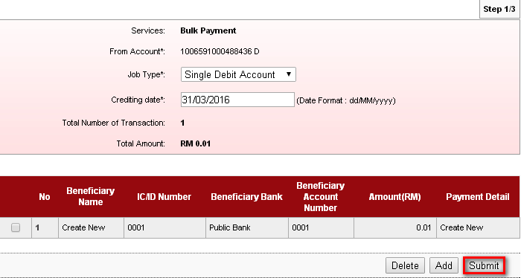
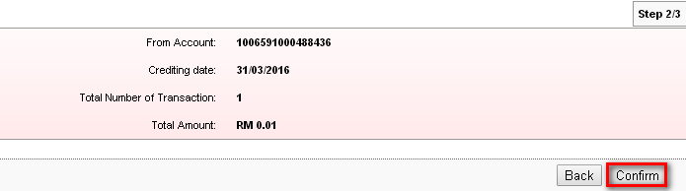
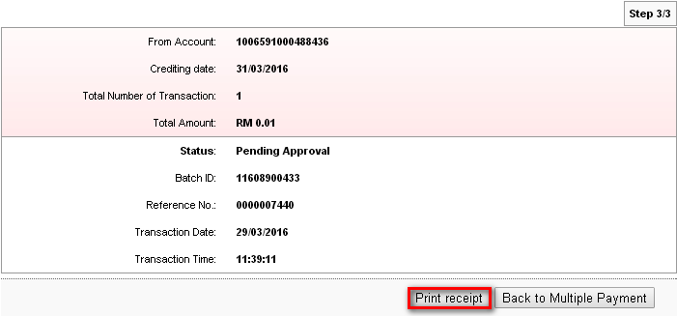
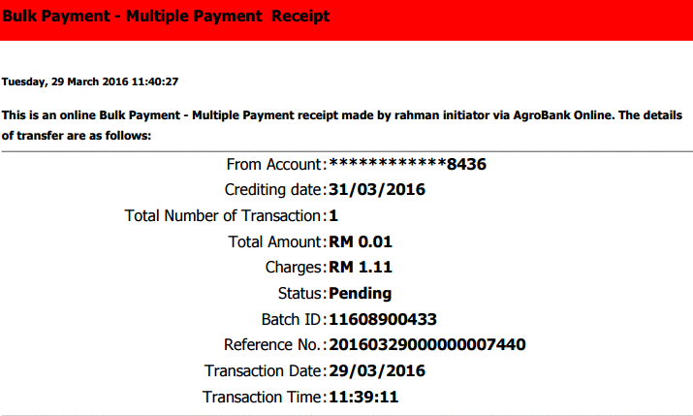

Bulk Payment History : Before Approved
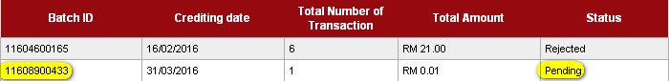

Approver : Authentication
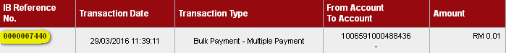
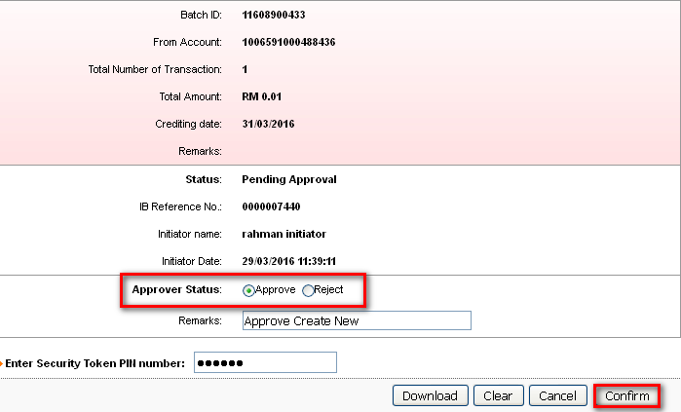
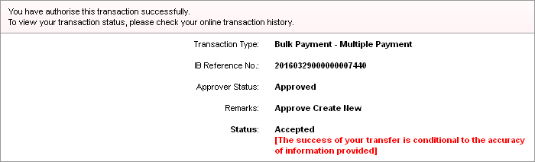

Bulk Payment History : After Approved
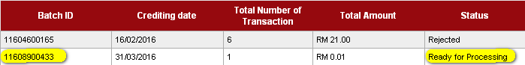

Add
To add another payment in one transaction, on the dropdown navigation (as highlighted), choose on created transaction that has been submit. Then click on ‘duplicate’.
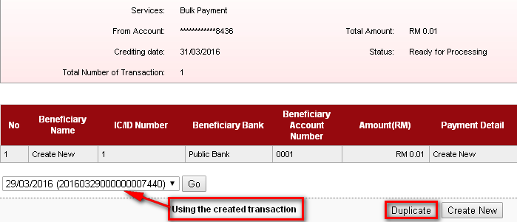
Choose job type and crediting date before click on Add.
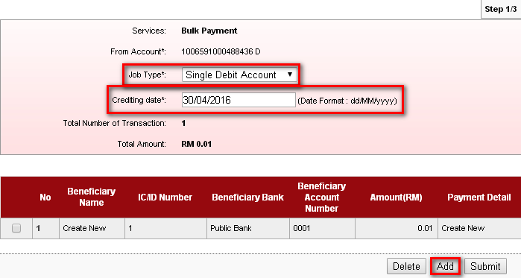

Fill on the blank space.
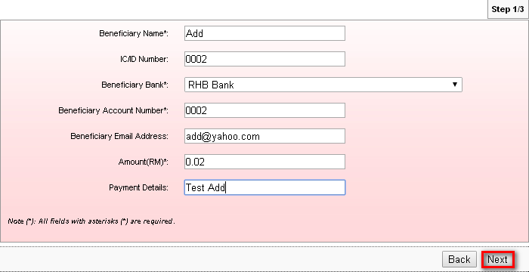
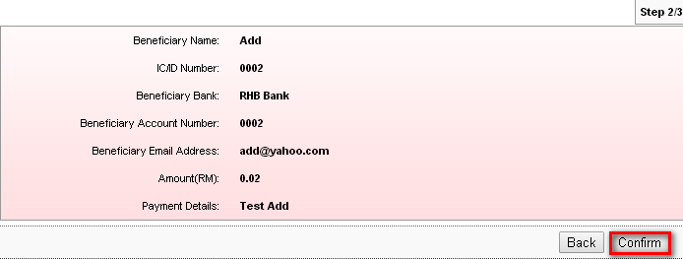

Click on ‘Back to Multiple Payment’ to add another one payment transaction or to submit added transaction.
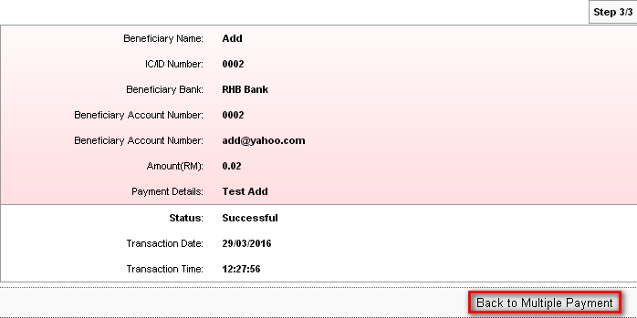
Screen display transaction that has been added before. Click on ‘Add’ to add another transaction. 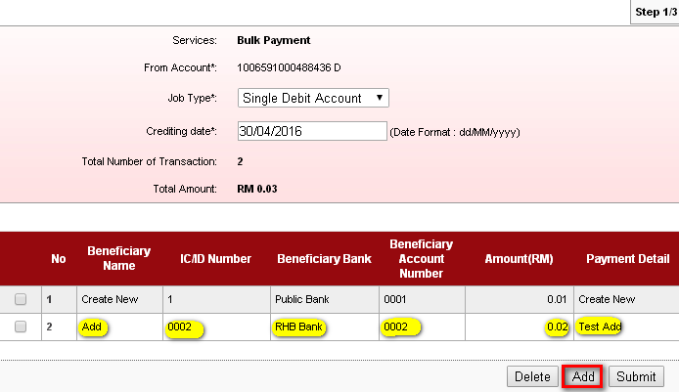

Fill on the blank space.
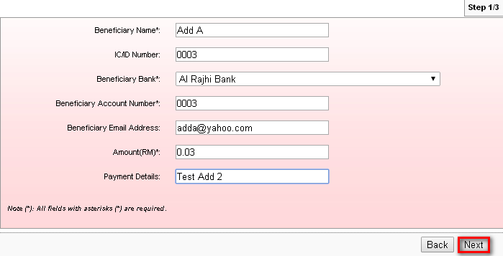
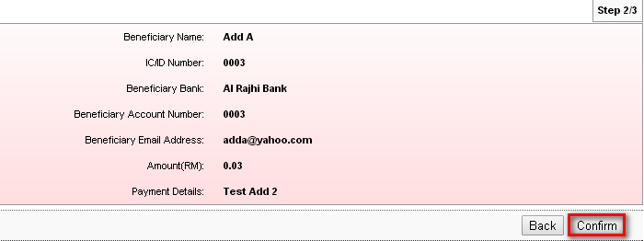

Click on ‘Back to Multiple Payment’ to submit.
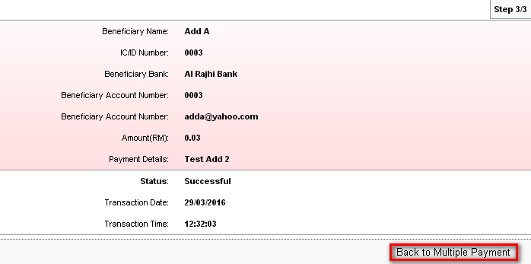

Submit
Screen display both transaction that has been added. Click on ‘Submit’ to submit transaction.
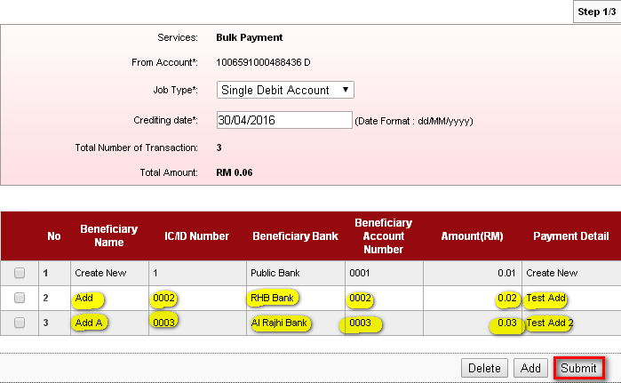
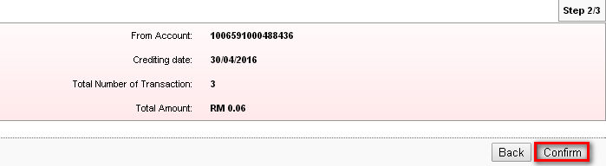
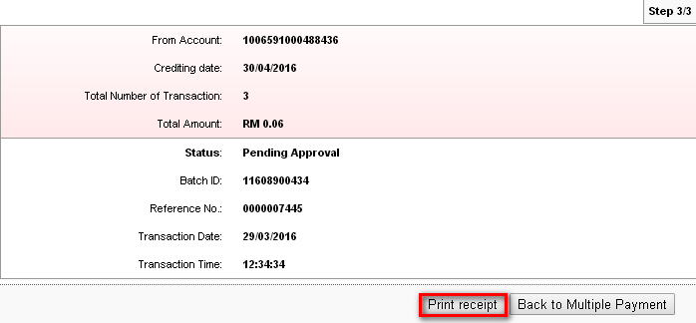
After added another transaction into one transaction, the payment reference number and batch id will not copy previous payment reference number and batch id. It will create new payment reference number and new batch id.
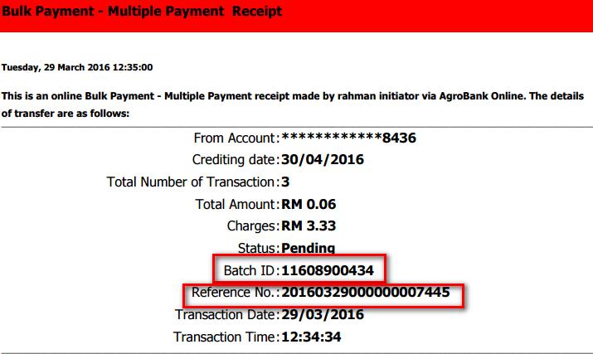

Bulk Payment History : Before Approved
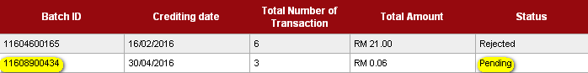

Approver : Authentication
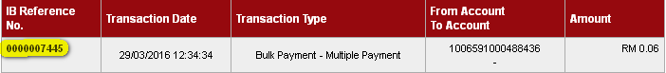
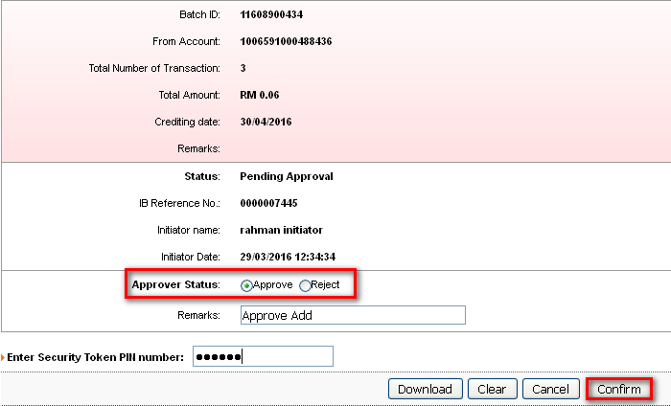
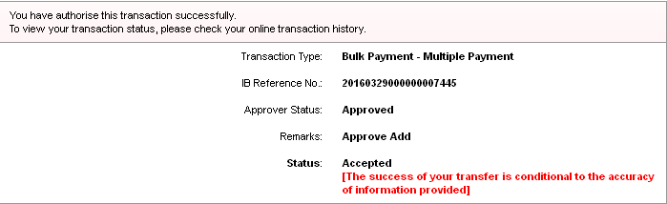

Bulk Payment History : After Approved
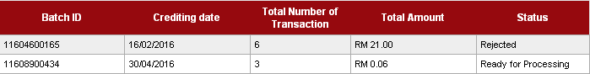
Result Page :
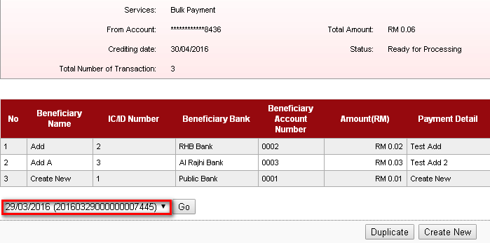

Multiple Debit Account

Create New
To create new transaction.
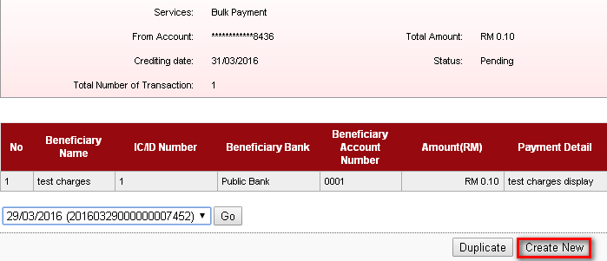
Choose on Job Type and Crediting Date.
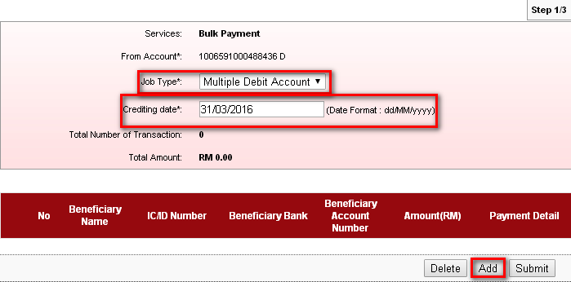

Fill on the blanks space.
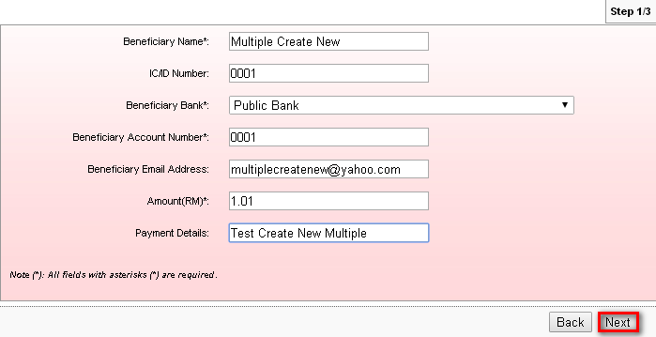
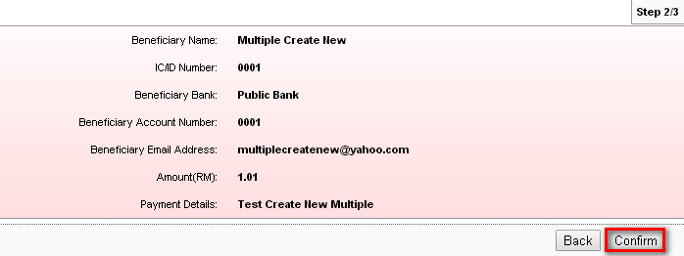
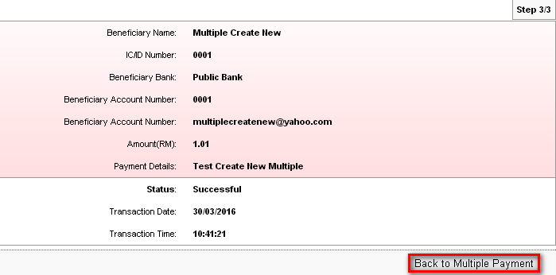

Submit the created transaction. If user sign out or go to other site before submit the created transaction. The transaction will lose.
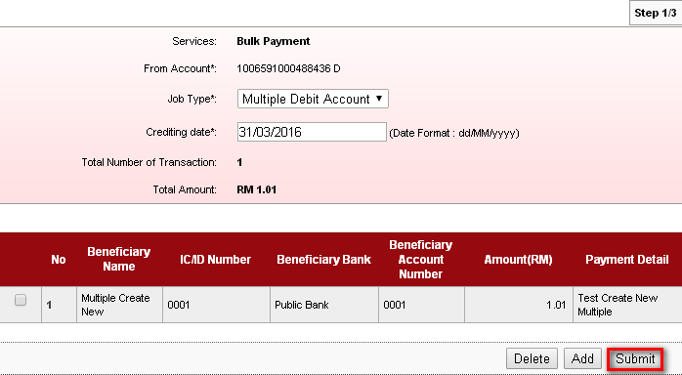
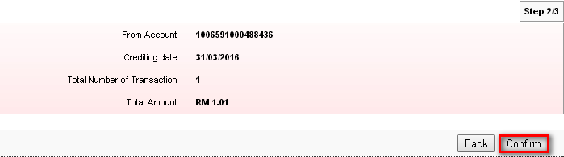
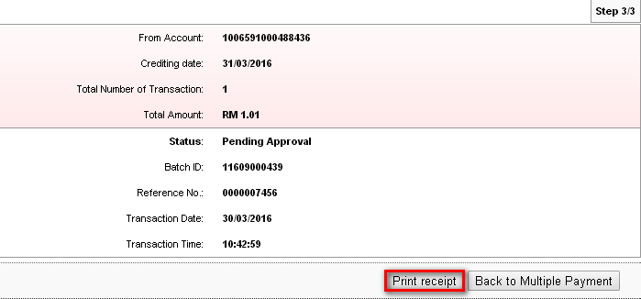
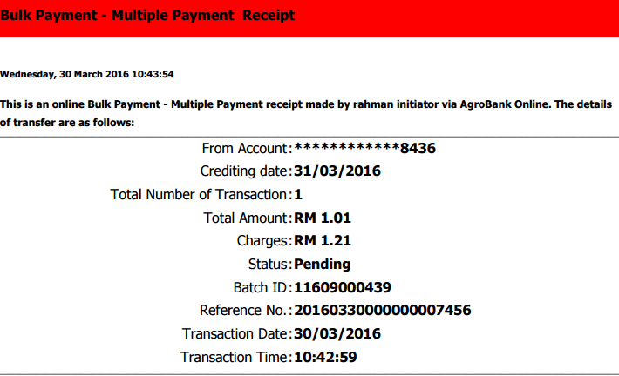

Bulk Payment History : Before Approved

Approver : Authentication
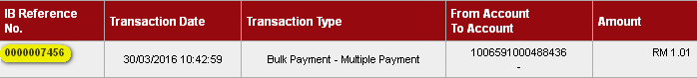
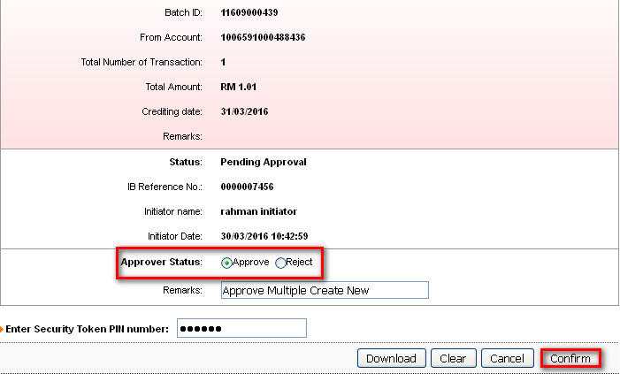
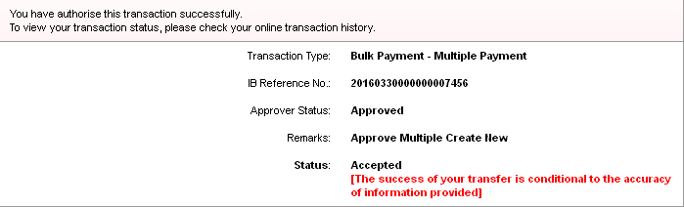

Bulk Payment History : After Approved

Add
To add another payment in one transaction, on the dropdown navigation (as highlighted), choose on created transaction that has been submit. Then click on ‘duplicate’.
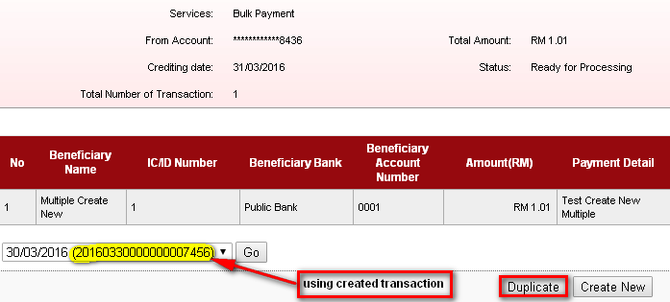
Choose job type and crediting date before click on Add.
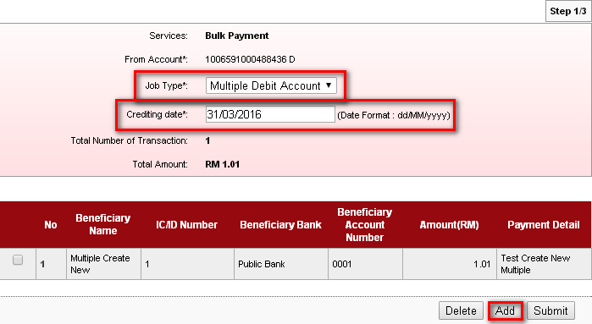

Fill on the blank space.
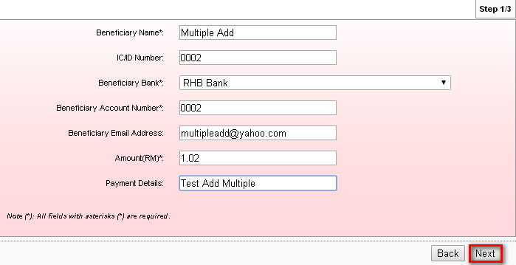
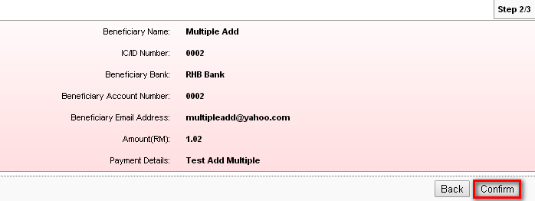

Click on ‘Back to Multiple Payment’ to add another one payment transaction or to submit added transaction.
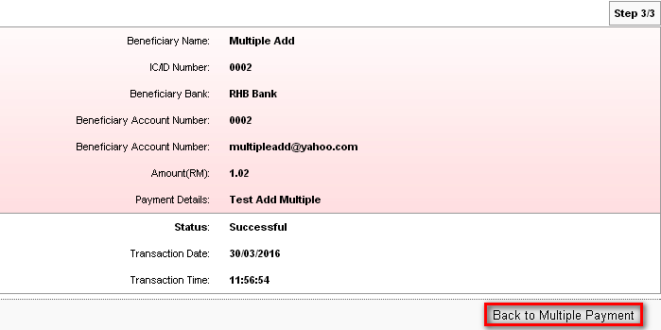
Screen display transaction that has been added before. Click on ‘Add’ to add another transaction.
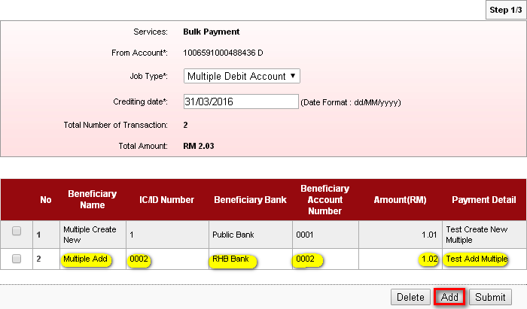

Fill on the blank space.
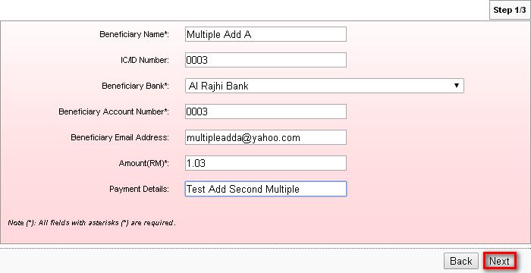
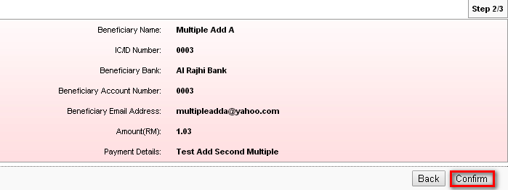
Click on ‘Back to Multiple Payment’ to submit.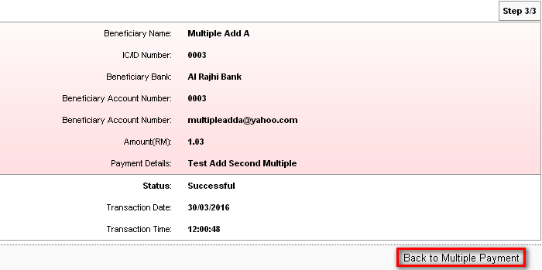

Submit
Screen display both transaction that has been added. Click on ‘Submit’ to submit transaction.
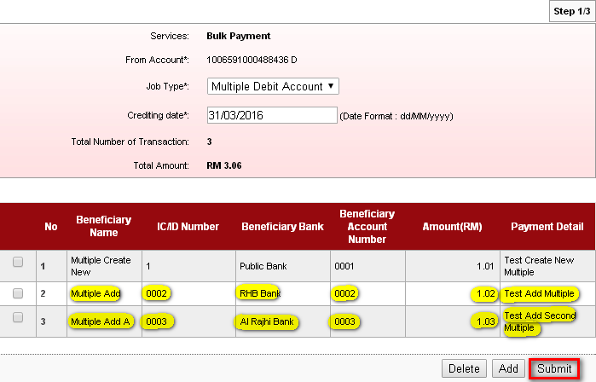
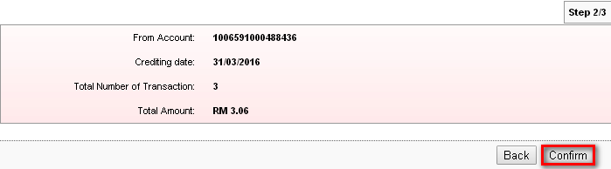
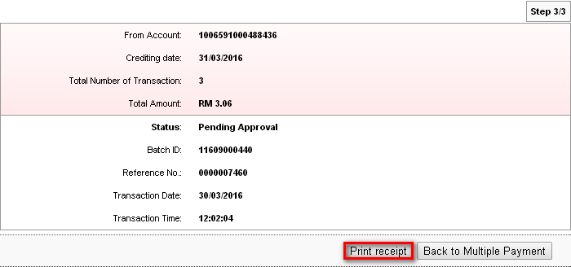
After added another transaction into one transaction, the payment reference number and batch id will not copy previous payment reference number and batch id. It will create new payment reference number and new batch id.

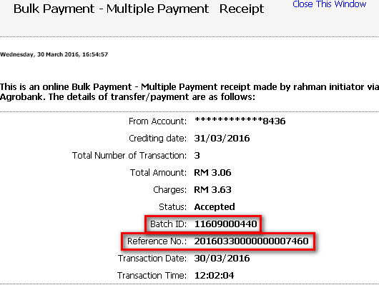

Bulk Payment History : Before Approved

Approver : Authentication
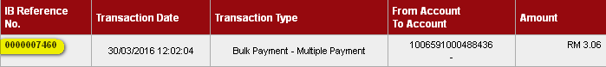
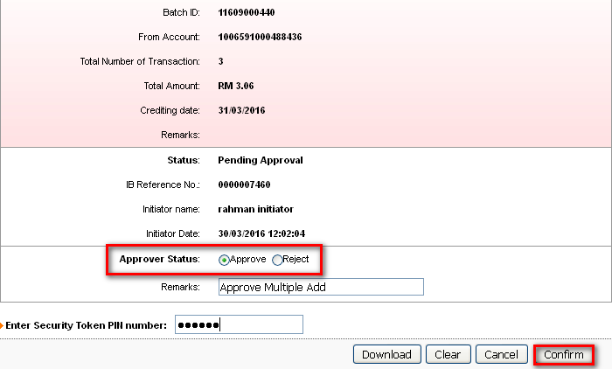
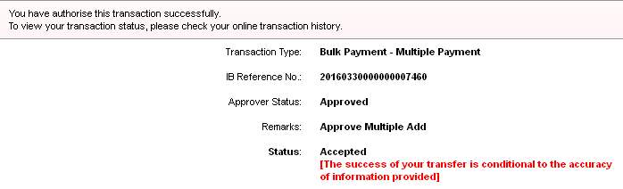

Bulk Payment History : After Approved

Result Page :
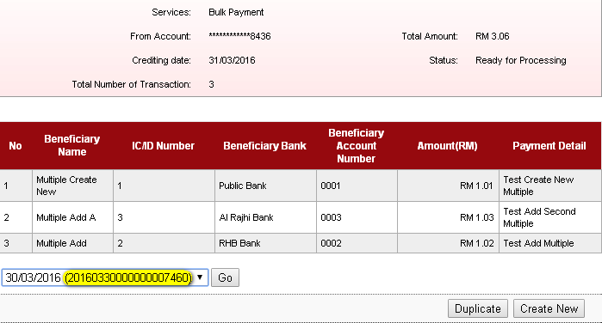

Duplicate
Duplicate function are used to submit all payment for next time.(example: next month salary payment)
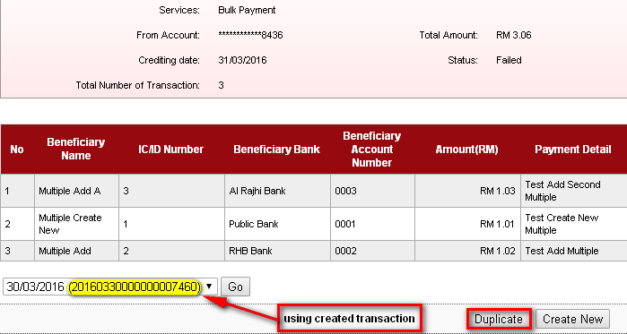
Choose on job type and crediting date.
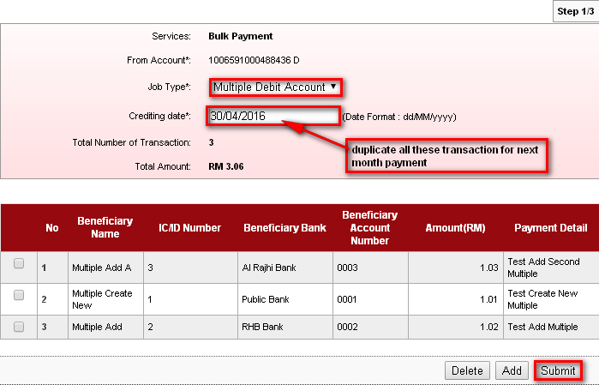
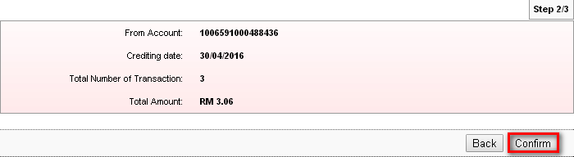
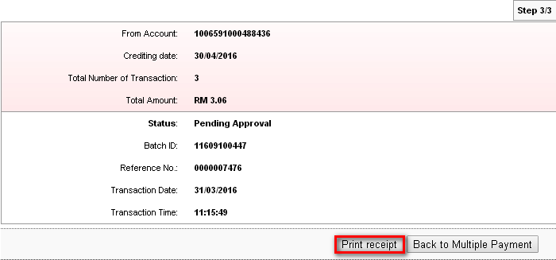
After duplicate the transaction, the payment reference number and batch id will not copy previous payment reference number and batch id. It will create new payment reference number and new batch id.
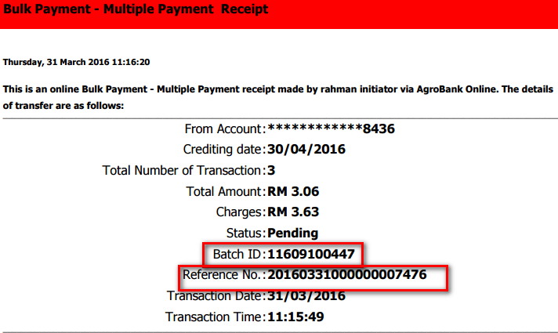

Bulk Payment History : Before Approved
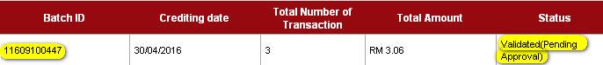

Approver : Authentication
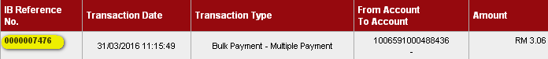
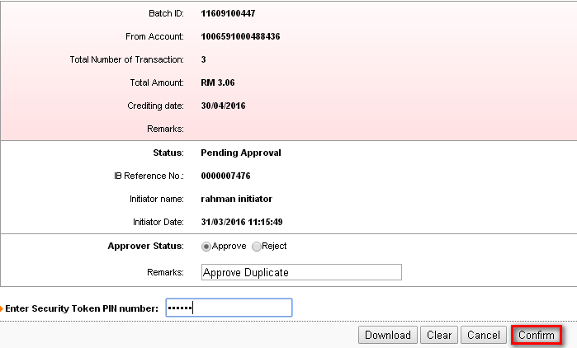
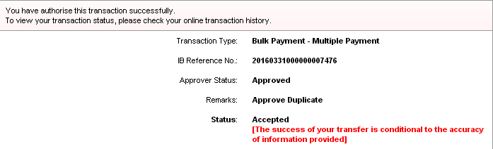

Bulk Payment History : After Approved
Result Page :
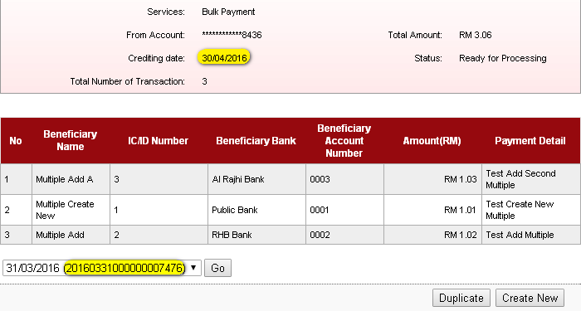

Edit
Edit can be done by clicking on the number of the transaction at the duplicate function. Edit can be used to edit the payment before proceed to duplicate the transaction. Choose on Transaction No. Then click on Duplicate.
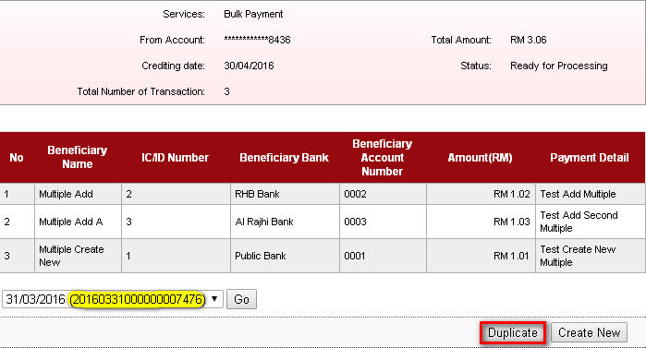
Example : On transaction No. 1, change Beneficiary Bank and Beneficiary Account Number.
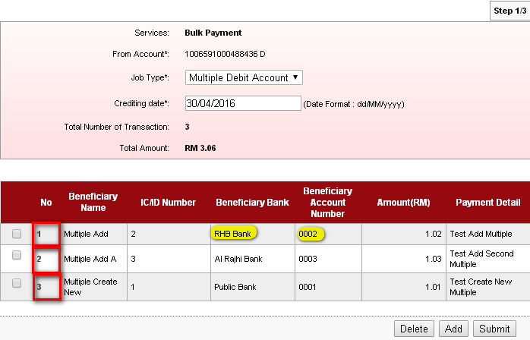

Change Details:
Beneficiary Bank : UOB Bank
Beneficiary Account Number : 0005

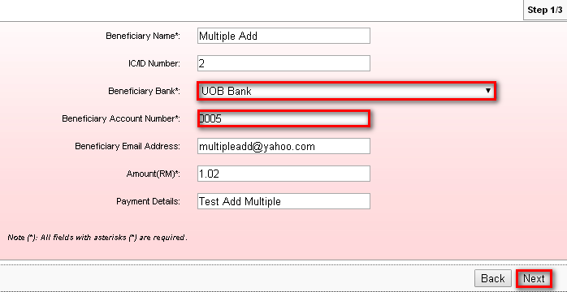
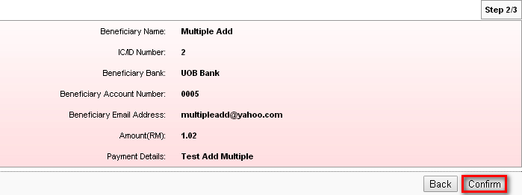

Click on ‘Back to Multiple Payment’ to proceed.
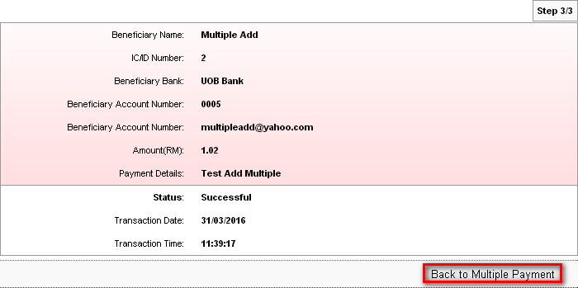
Screen display changes on the transaction No. 1.
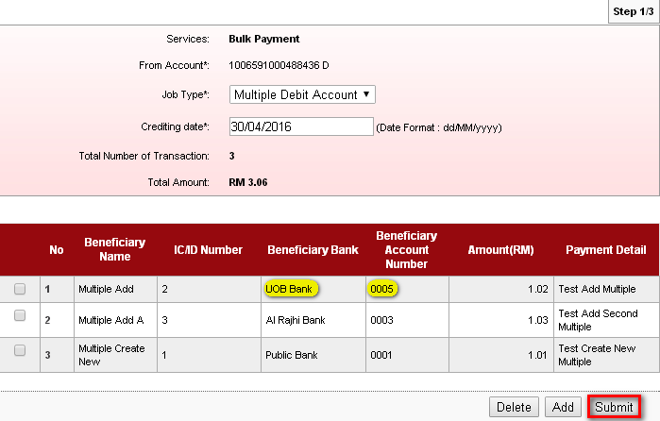

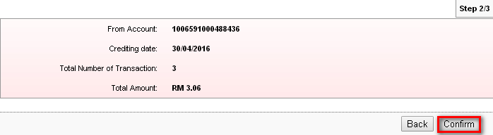
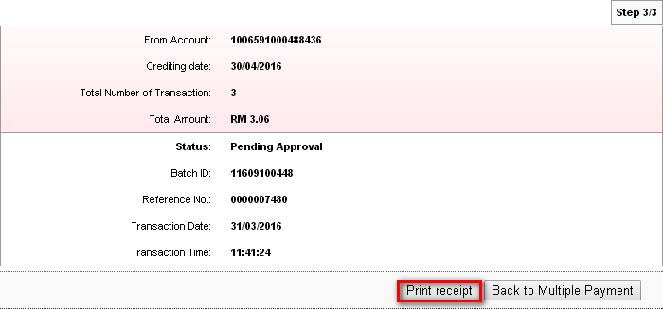
After make changes in any transaction, the payment reference number and batch id will not copy previous payment reference number and batch id. It will create new payment reference number and new batch id.
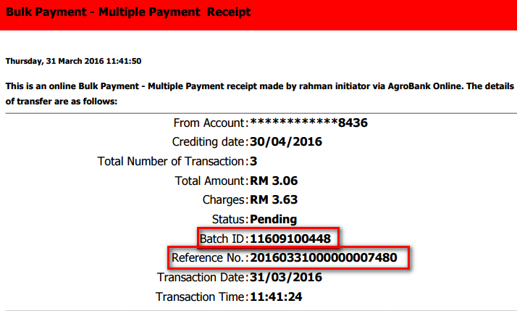

Bulk Payment History : After Approved

Approver : Authentication
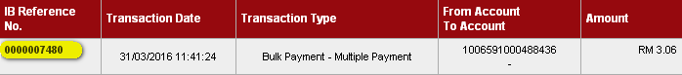
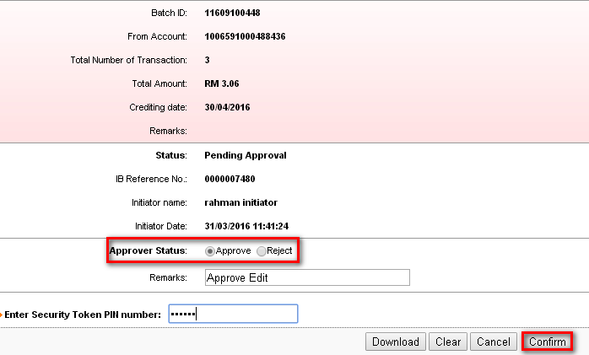
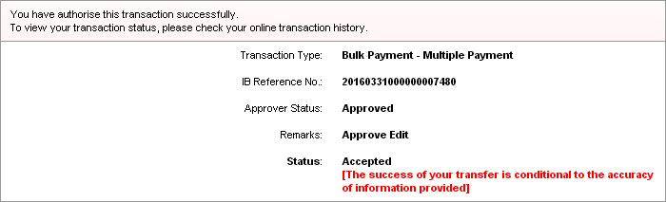

Bulk Payment History : Before Approved
Result Page :
Screen display changes on transaction No. 3.
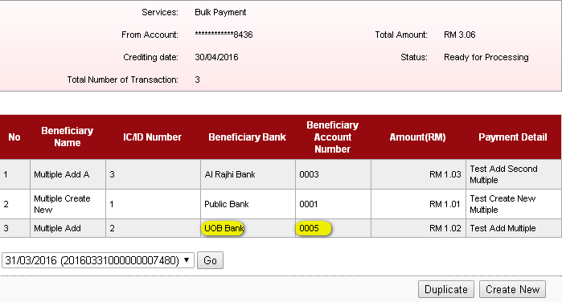

Delete
Delete function only can be done in duplicate function. Where in case, user want to delete one payment before duplicate the transaction.
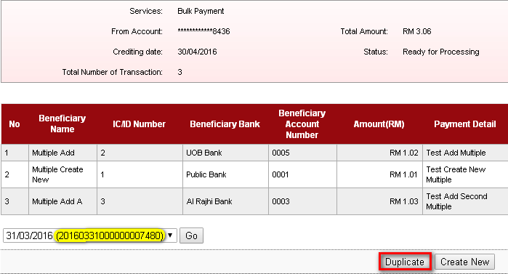
Example: Delete transaction No. 3. Click on the box then click on ‘Delete’.
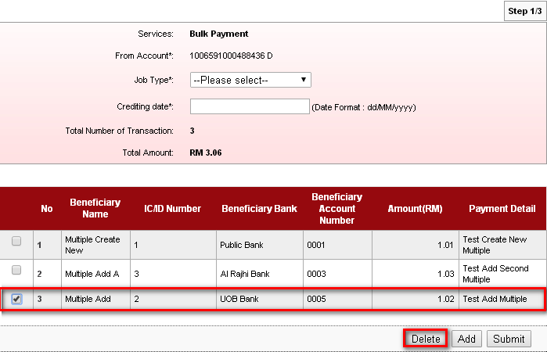
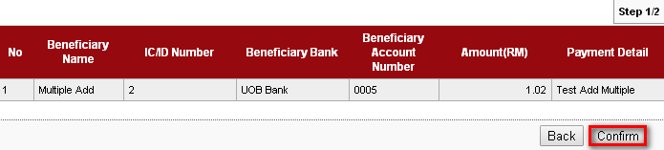
Click on ‘Back to Multiple Payment’ to proceed.
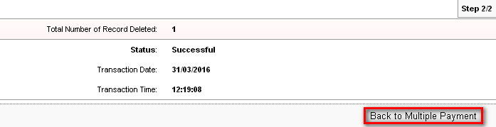
Screen display only two transaction after deleted transaction No. 3.
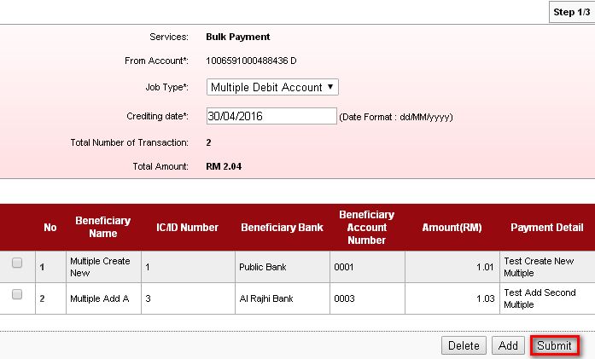
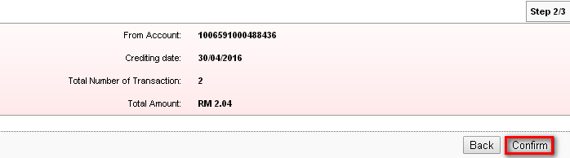
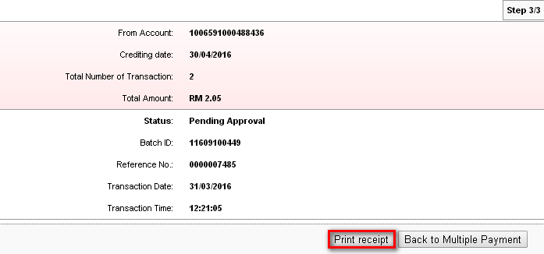
After deted any transaction, the payment reference number and batch id will not copy previous payment reference number and batch id. It will create new payment reference number and new batch id.
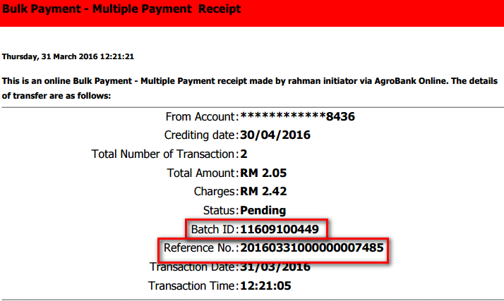

Bulk Payment History : Before Approved

Approver : Authentication
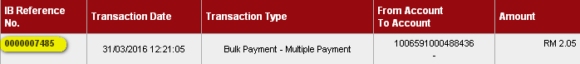
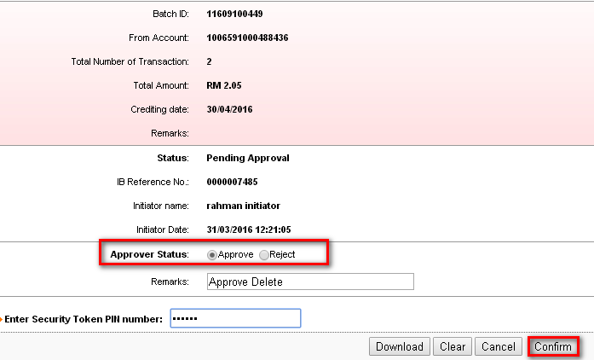
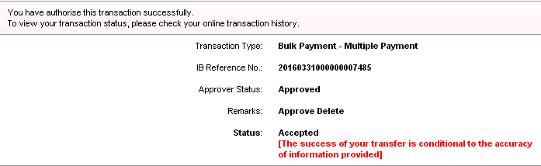

Bulk Payment History : After Approved
Result Page :
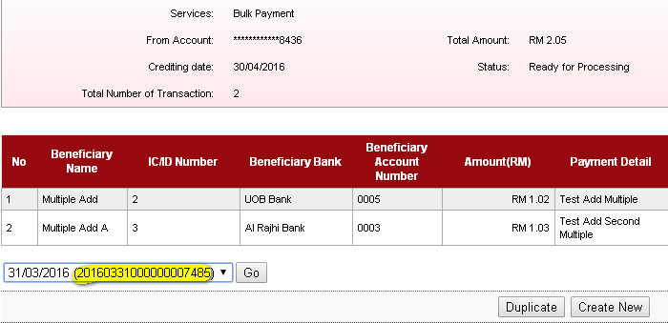

Reviewed By: (PMO)
Lizahwati |  |  | Name/Position : Lizahwati binti Basirun  Date :

