Test Issue Log |  |  |  |  |  | SCP ID# : 6379
Project Name: | AGRONetBiz (Business Internet Banking)
Test Stage: | Unit Functionality Integration System Interface  Performance Regression Acceptance Pilot
Test Case Number: |  |  |  | Test Started Date: |  |  | 15/03/2016
Test Title: | [Internal Testing] BIB Reported Issue
Test Description: | - To ensure last 3 AGRONet Transaction in Home displaying correctly.  - To ensure Approver Authorized Counter is correct  https://10.6.6.20/bib.prod.kada/common/Login.do
Test Functionality: | - Display last 3 AGRONet Transaction in Home displaying correctly.  - Initiator  - Single User  - Approver Authorized Counter is correct.  -Approver
Test Procedure: | - Display last 3 AGRONet Transaction in Home displaying correctly.  - Login as Initiator/Single User at BIB PROD KADA  - Perform Zakat Payment  - View at Home Page  - Approver Authorized Counter is correct.  - Login as Approver at BIB PROD KADA  - Perform
Test Result: | Pass: Fail: | Tested by: |  |  | Erni Suhaireen binti Zulkifli
Reason for Failure:
TEST DESCRIPTION

Display last 3 Agronet Transaction in Home

Initiator

Zakat
Perform zakat payment.
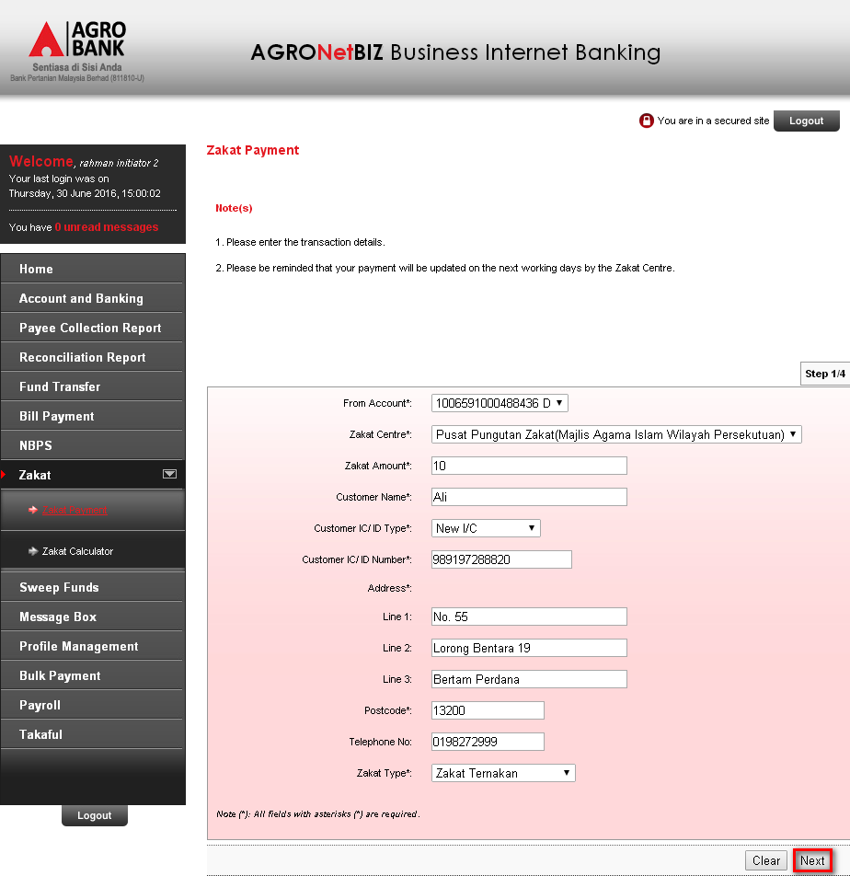

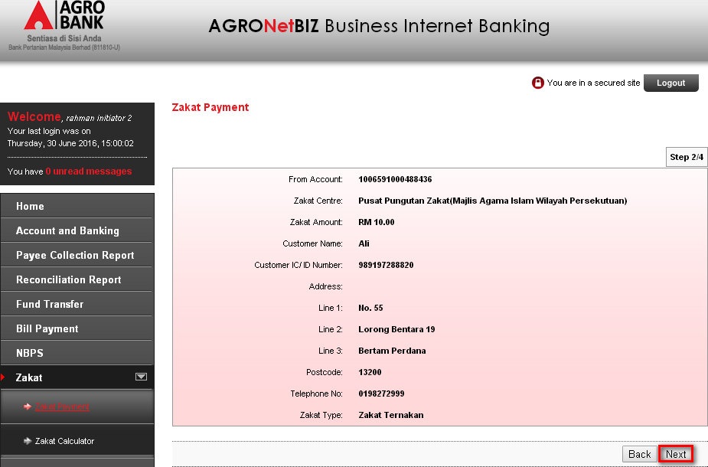
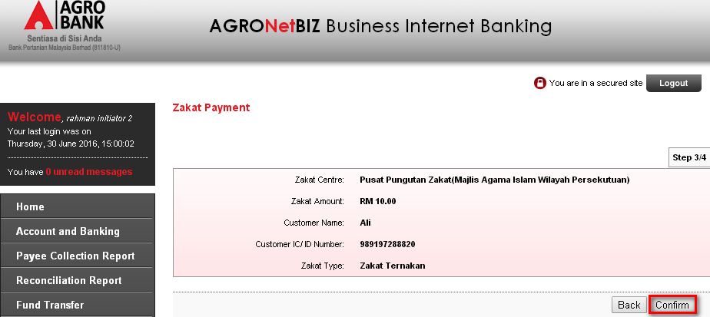

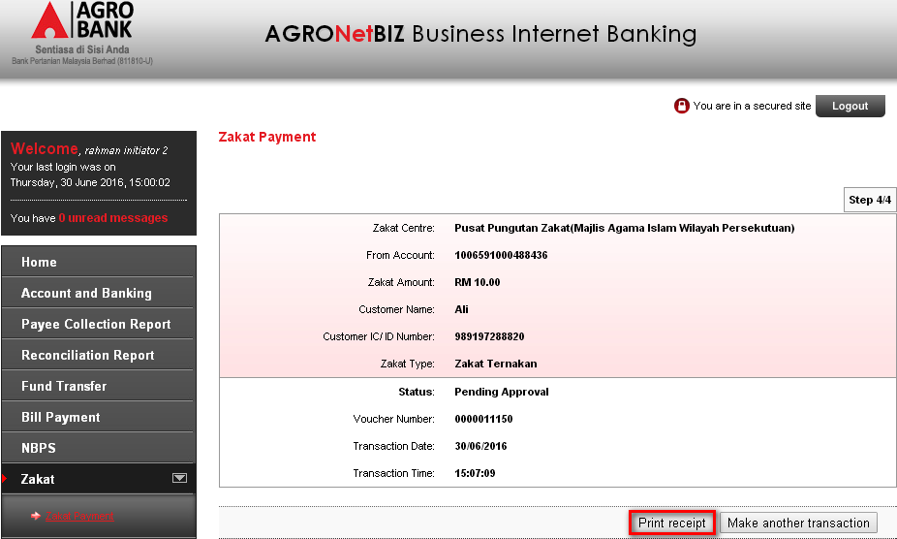
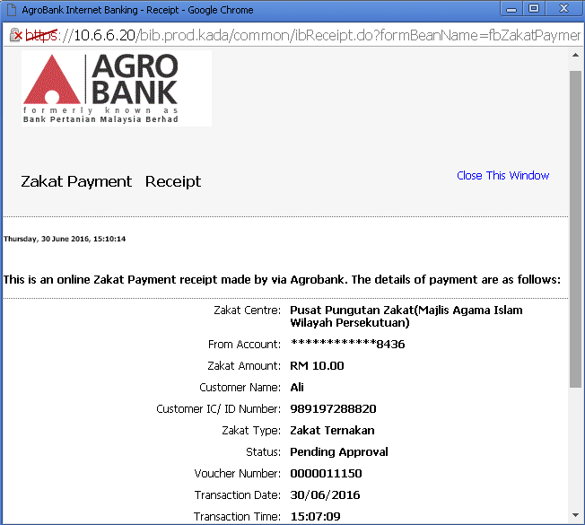

Result Page:
Zakat payment
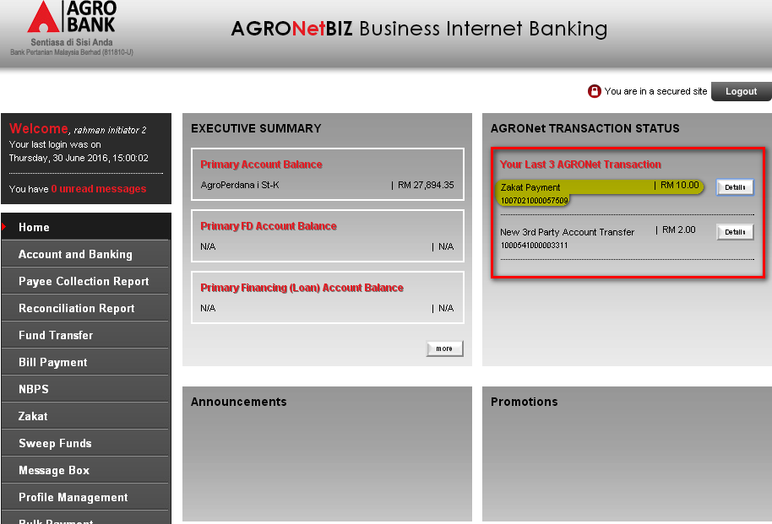

Single User

Zakat
Perform zakat payment.
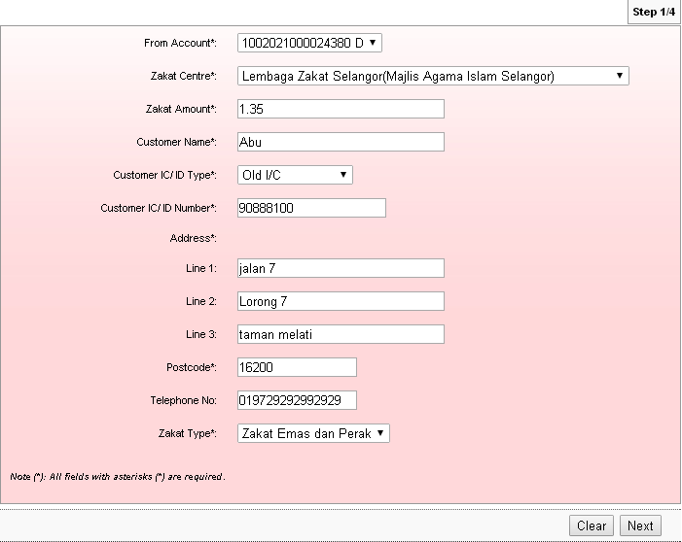

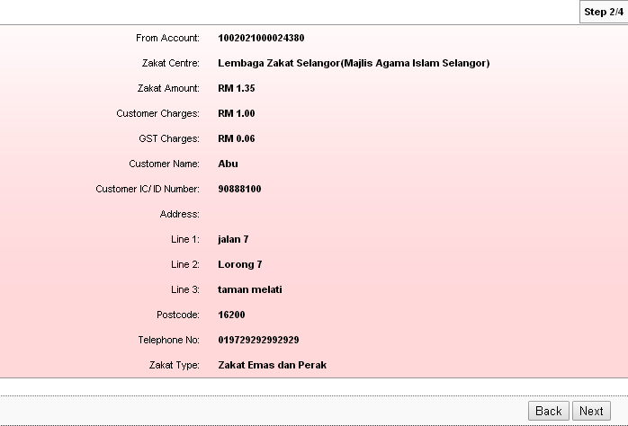

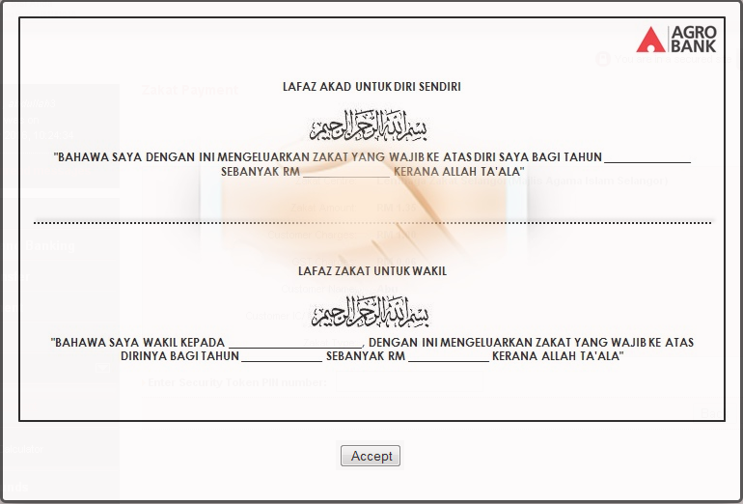
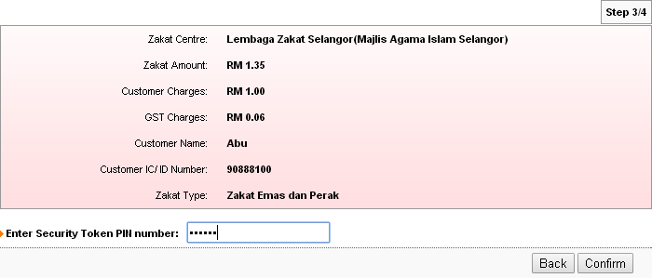

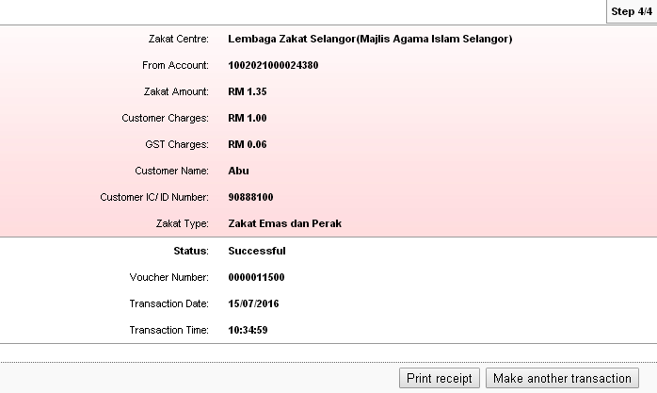

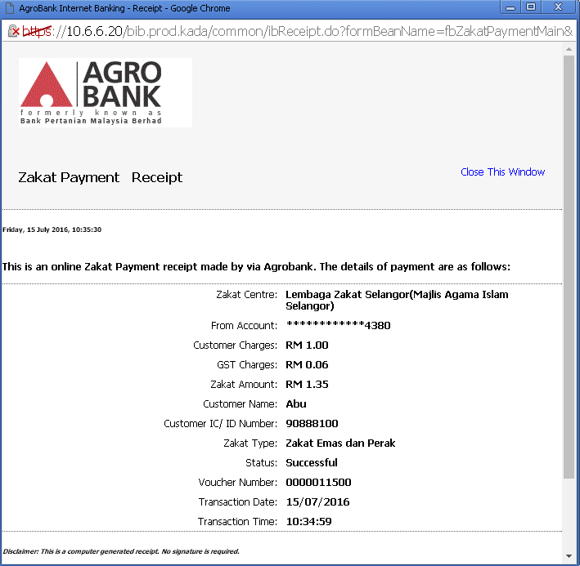

Result Page
Agronet Transaction History
Zakat payment has successfully been displayed at Agronet Transaction History.
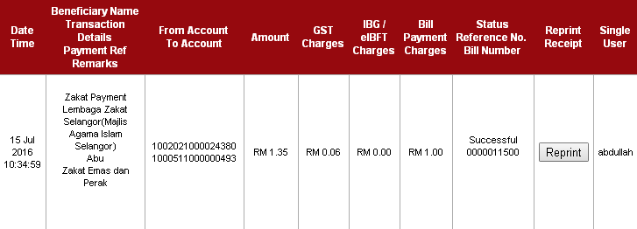
Home Page
Zakat payment has not been displayed at Home Page because the latest 3 transaction that been display at the home page was on 2017. So, the zakat payment that has been done which in 2016 will not appear at Home Page
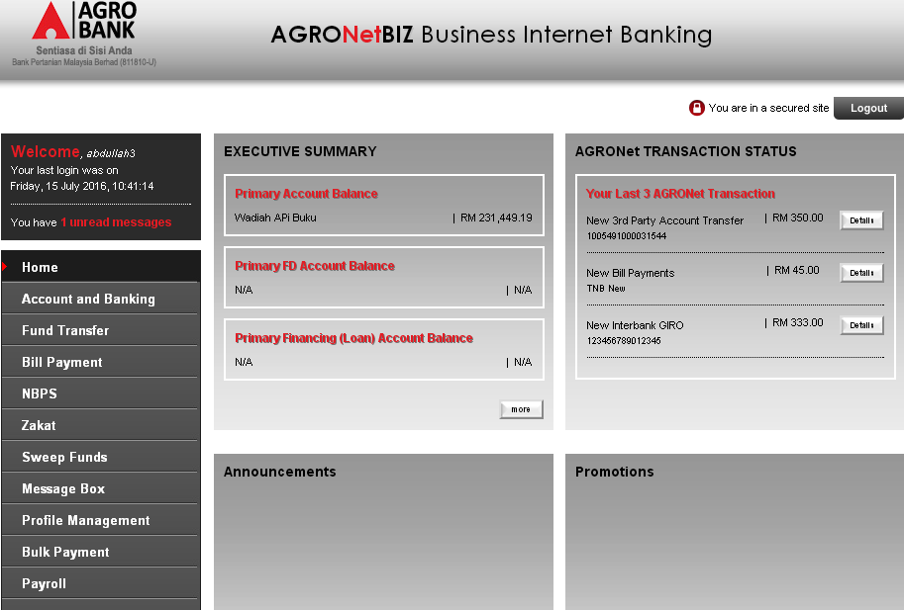

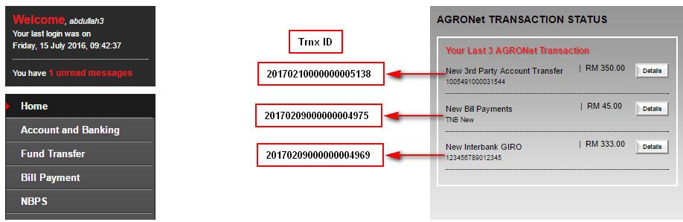

Transaction 20170210000000005138
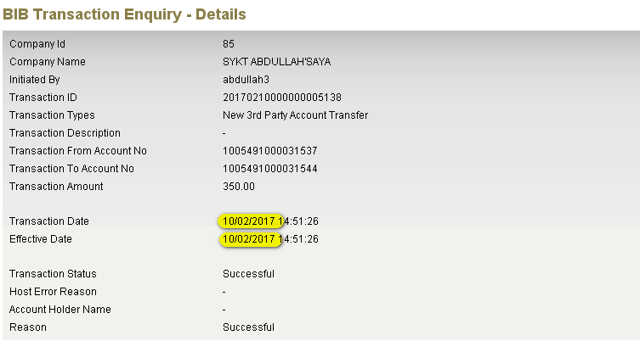

Transaction 20170209000000004975
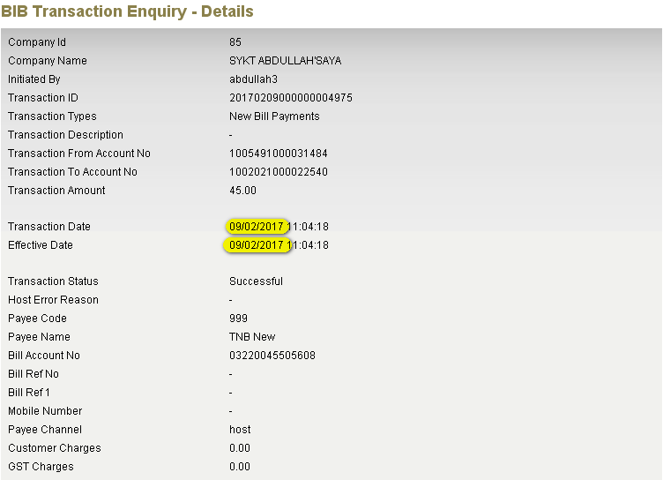
Transaction 20170209000000004969
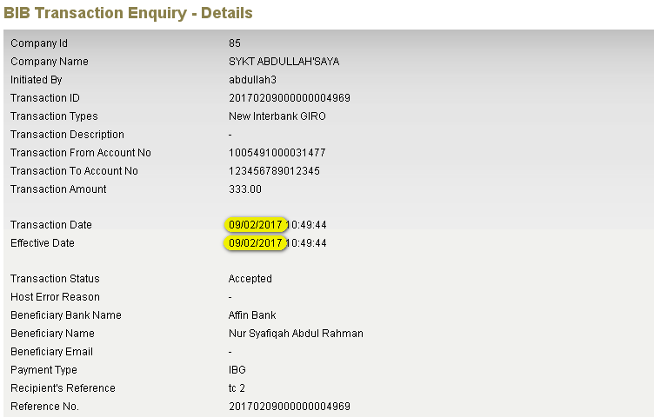

Approver Authorized Counter is correct

Last Three (3) Transactions at Home Page
Check the last three (3) transactions at home page with the authorization list.
Home Page before approve three latest transaction.
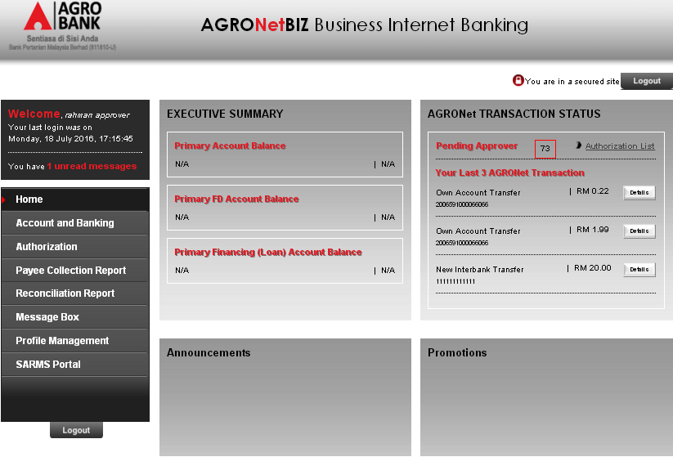

Three Transactions to Approve
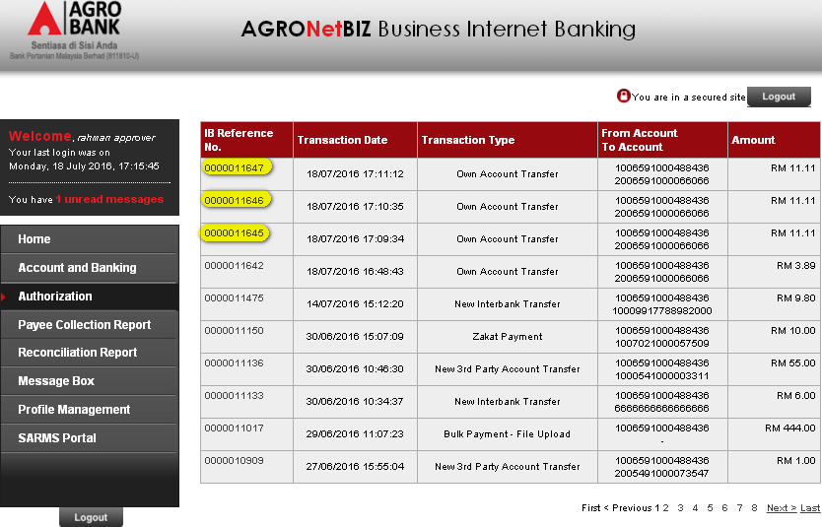

Approve transaction IB Ref: 0000011645
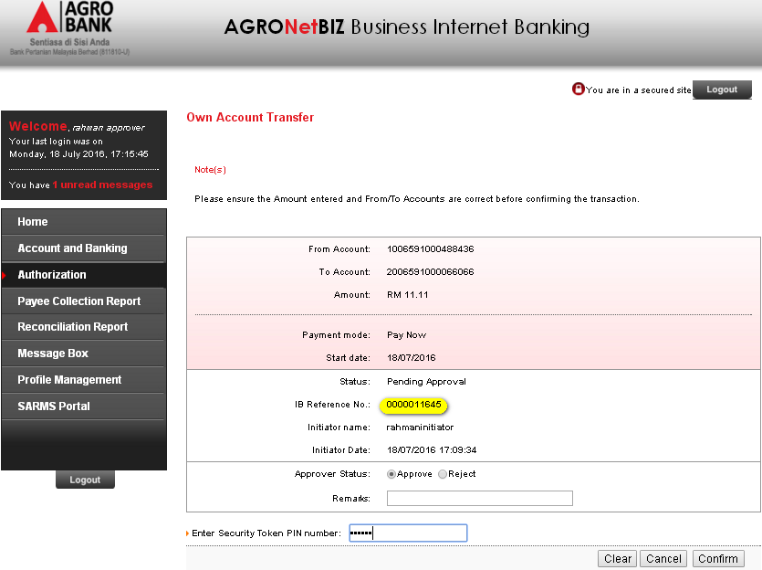
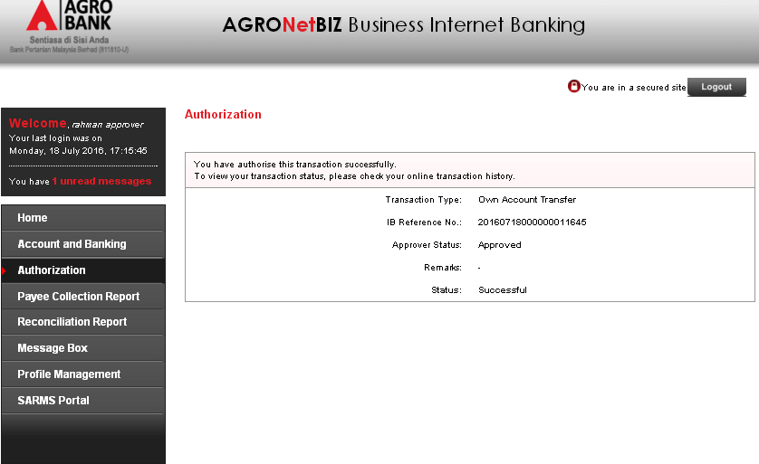

Approve transaction IB Ref: 0000011646
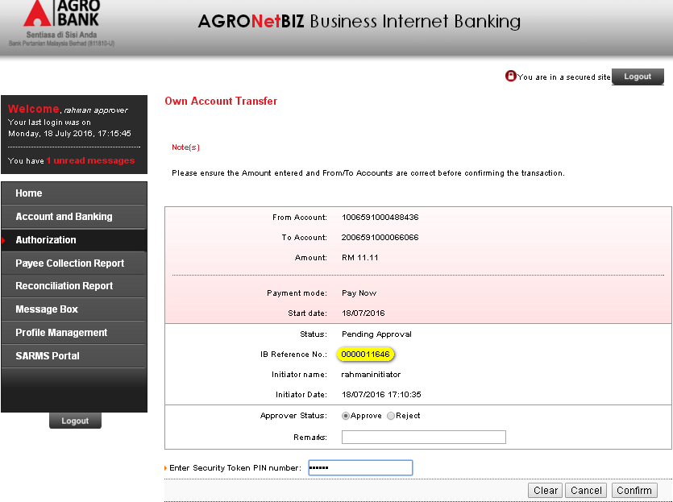
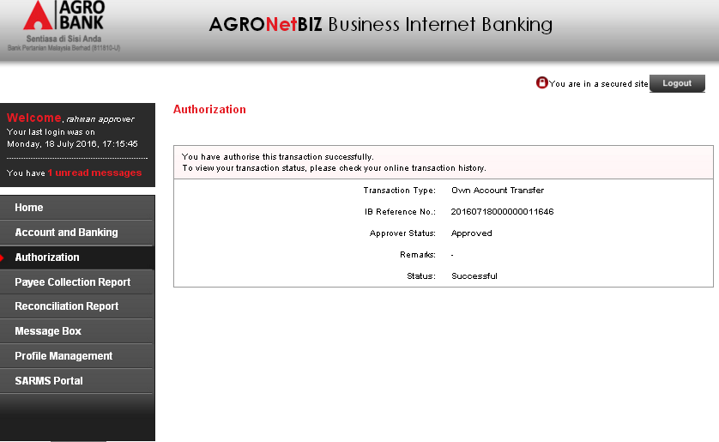

Approve transaction IB Ref: 0000011647
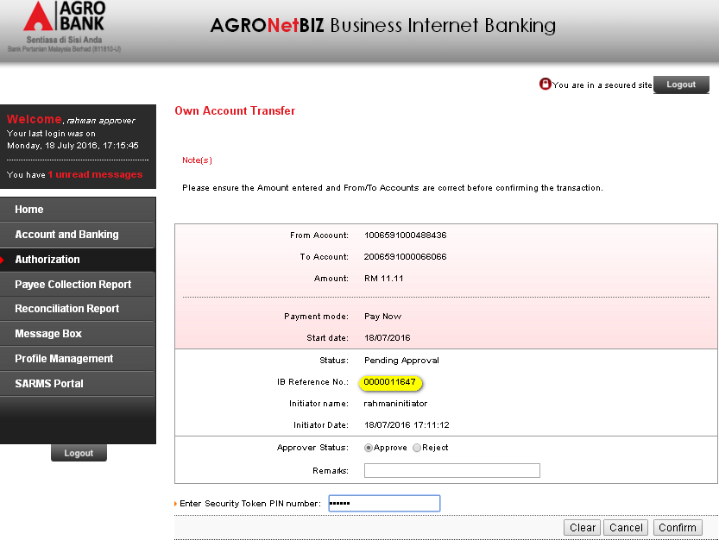
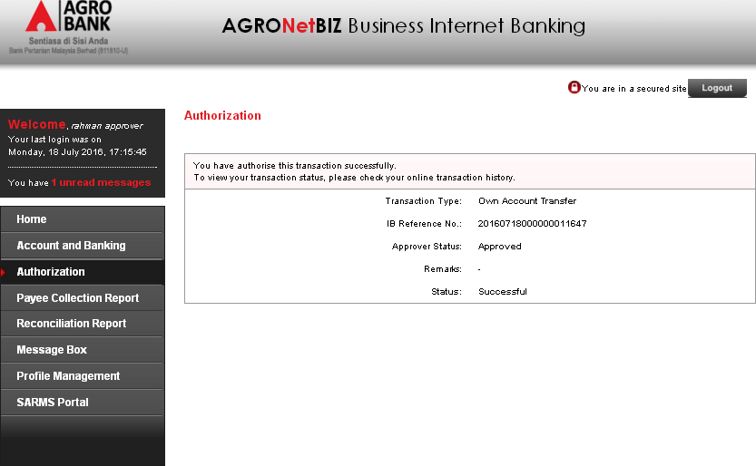

Home Page after approve the three transaction
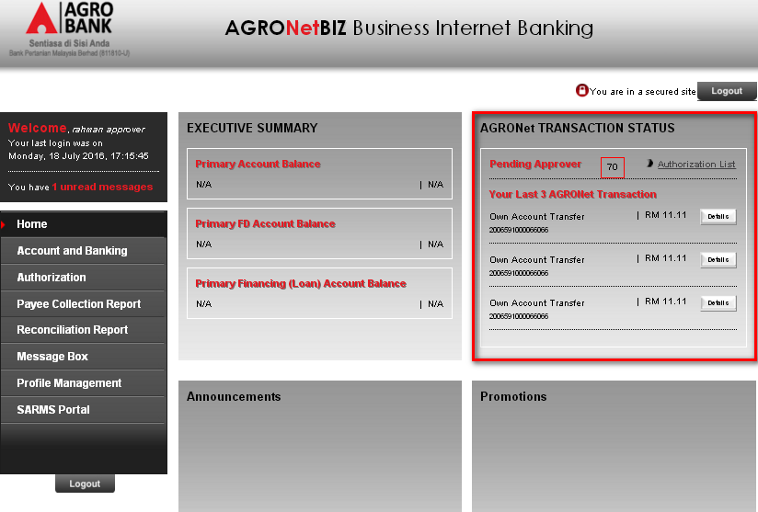

Approver Authorized Counter
To ensure total pending transaction that displayed at the Home Page is same as the Authorization Page.
Home Page
Total transaction at Home Page = 69
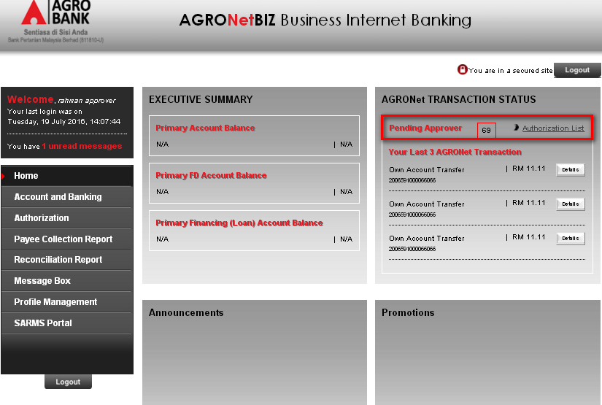

Authorization Page
Total transaction at Authorization Page = 69
Page 1
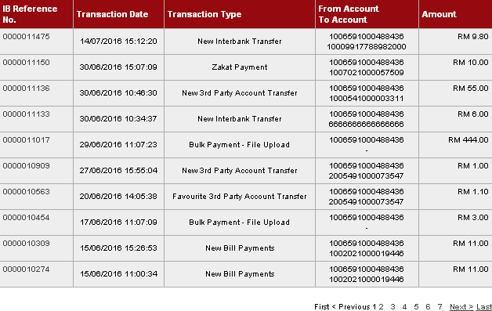
Page 2
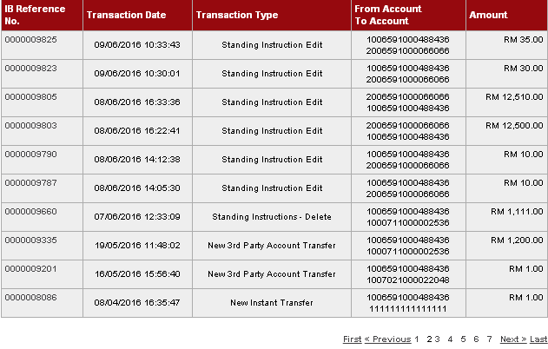

Page 3
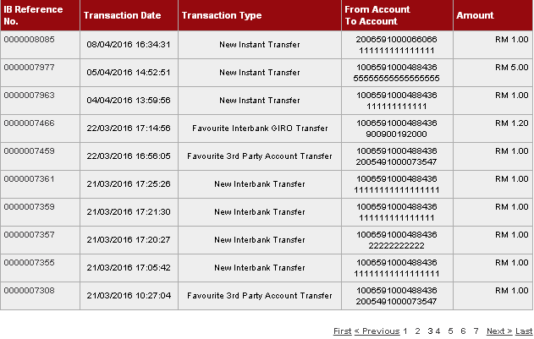
Page 4
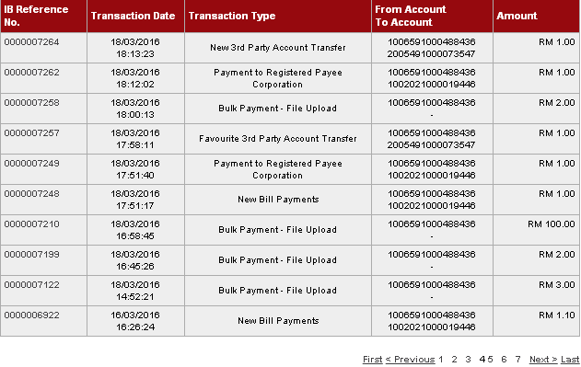

Page 5
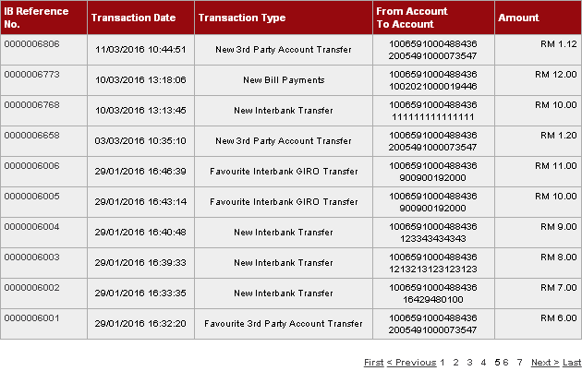
Page 6
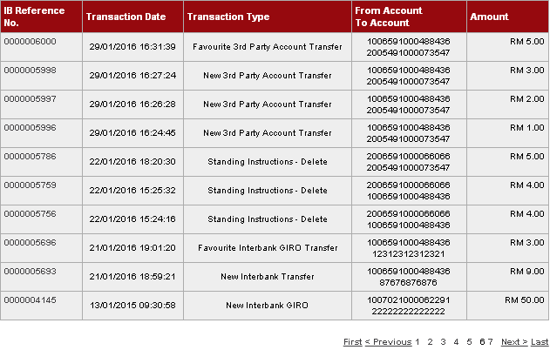

Page 7
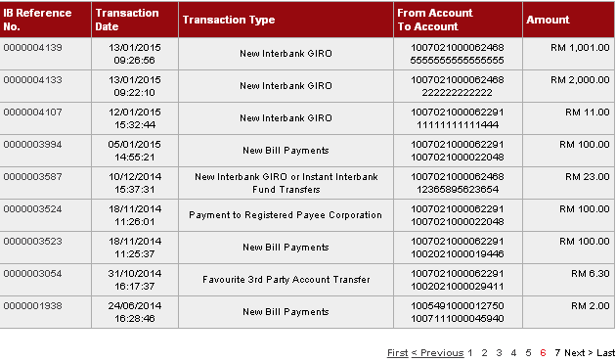

Reviewed By: (PMO)
Lizahwati |  |  | Name/Position : Lizahwati binti Basirun  Date : 20/09/2016

