Originator's Name: Chooi So Fun  Project: SMS Notification  Project Manager: Malarvily Muniandy / Christopher Gunn  Owner: PDM / RCB  Date Raised: 1.12.10  Phase/Process:  Functional Area: Consumer | Issue ID Number: UAT-SMS014  Related ID Number:  Priority: High / Medium / Low  Assigned to:  Target Resolution Date:  Actual Closed Date:
Status : Open / Investigate / Retest / Re-Open / Closed / Sign-Off (Circle one)
Category : Bugs / Set-up / Clarification / Repeated / Internal CR / CR (Circle one)
Description:
For Recurring Own Account
For unsuccessful transaction which is due to insufficient fund, should not send SMS to Sender and SMS Charges for Sender should be debited from account as principal amount is not debited.

(Refer to screen attached for further details).
Impact:

Investigation (Description):

Action:

Estimated Impact:

Recommendation:

Accepted (PENRIL/SA/IT):  Date: | Accepted (KFHMB):  Date:
Associated Risk Report: | Risk Report Accepted Date:
Associated Change Request Form: | Change Control Accepted on:

Account Balance before the transaction = RM201.00 (insufficient fund for principal portion)
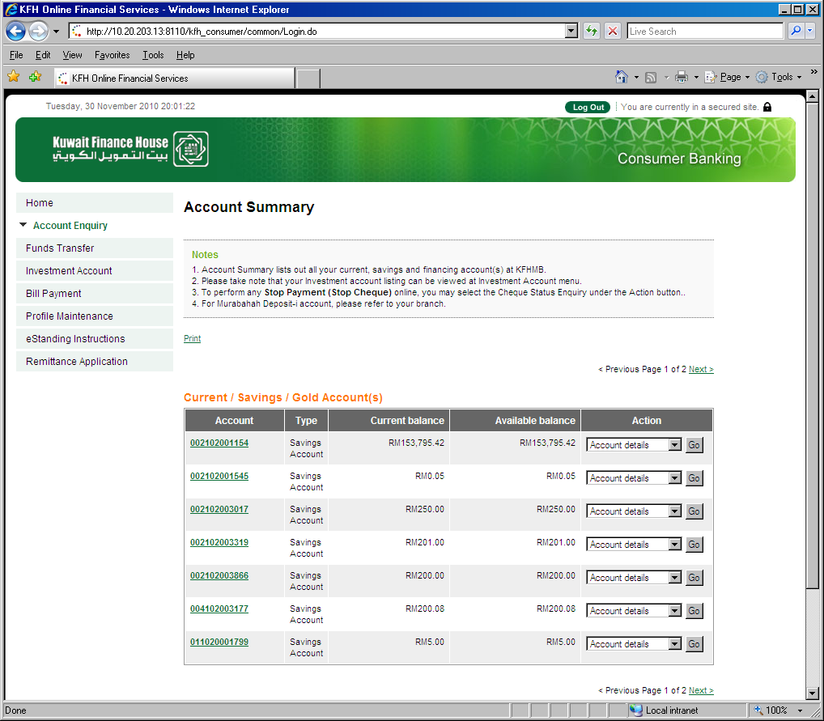
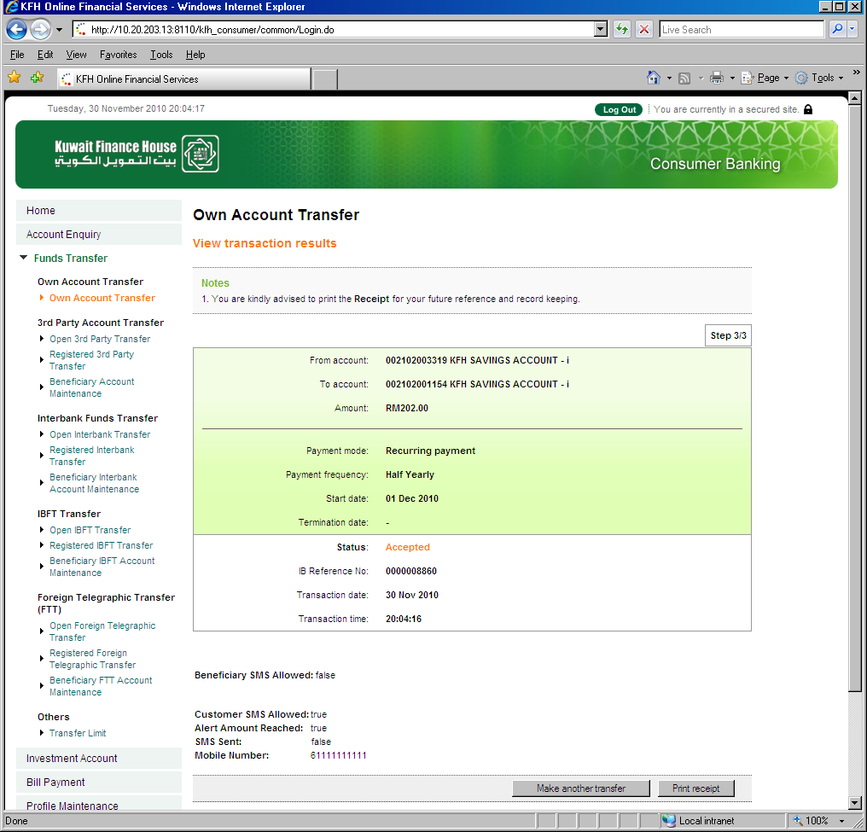
Transaction fails due to insufficient fund to cover Principal & SMS Charges for Sender
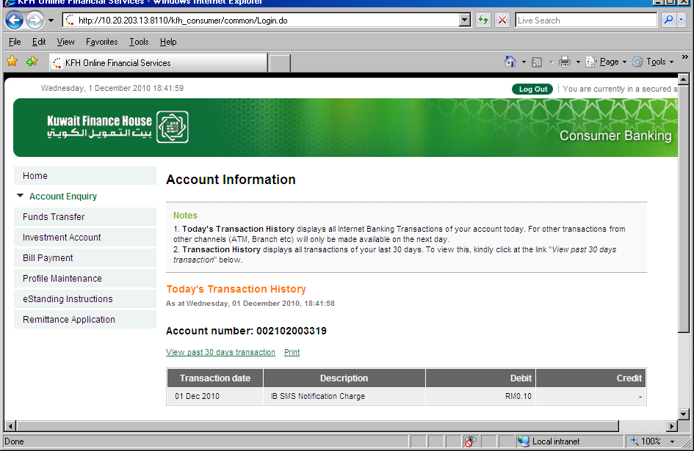

SI Transaction History:
