Test Issue Log |  |  |  |  |  | SCP ID# : 6523
Project Name: | [Internal Testing] Statutory Body
Test Stage: | Unit Functionality Integration System Interface  Performance Regression Acceptance Pilot
Test Case Number: |  |  |  | Test Started Date: |  |  | 18/08/2016
Test Title: | [Internal Testing] SOCSO
Test Description: | - To ensure all documents SOCSO can successfully be uploaded and perform the transaction.  - To ensure IBAM will display the transaction performed at BIB and to ensure it can be downloaded in PDF and EXCEL file.  https://10.6.6.20/bib.sit.lhdn/common/Login.do  https://10.6.6.20/ibam.sit.lhdn/common/Login.do
Test Functionality: | - Multiple User:  - SOCSO  - Single User:  - SOCSO  - IBAM-BIB Report  - SOCSO
Test Procedure: | - Multiple User  - Login as Initiator and perform SOCSO payment. Then go to SOCSO Transfer History and Agronet Transaction History to view the status.  - Login as Approver to approve the payment made.  - Login back to Initiator and go to SOCSO Transfer History and Agronet Transaction History to display the status.  - Single User  - Login as Single User and perform SOCSO payment.  - Go to SOCSO Transfer History and Agronet Transaction History to display the status.  - IBAM  - Login as Administrator and Maker/Checker.  - Go to BIB>Company Enquiry and search the company. On the Company details edit Payroll Flag to display on BIB  - In order to edit Statutory Bodies service to display on BIB, go to BIB>BIB Navigation>BIB>Payroll and click on ‘Edit’ link on ‘PYROLLSB’  - Go to BIB Report page to download the report (Administrator only)
Test Result: | Pass: Fail: | Tested by: |  |  | Erni Suhaireen binti Zulkifli
Reason for Failure:

1. Multiple User

1.1 Login as Initiator, go to Payroll navigation and select on SOCSO navigation link to upload SOCSO file to perform transaction.
Results:
System displays Statutory Bodies – SOCSO page.
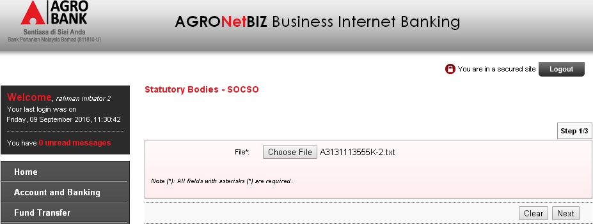

Upload the wrong data format file (blank the employer registration number)
Results:
Error message: SOCSO Registration No is required.
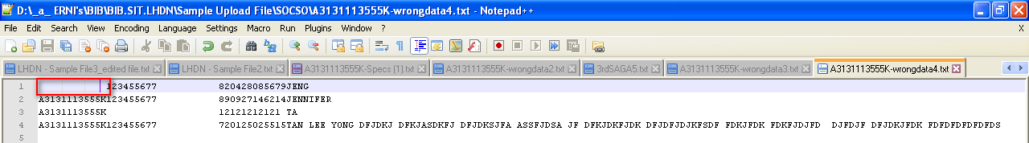
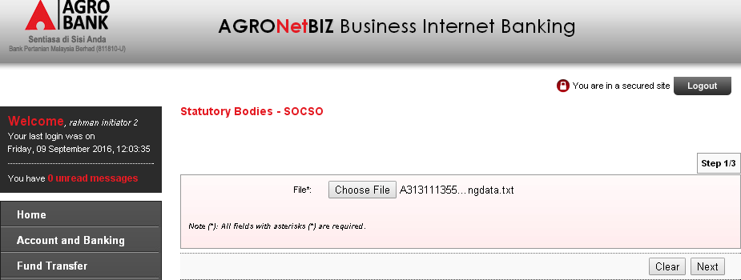

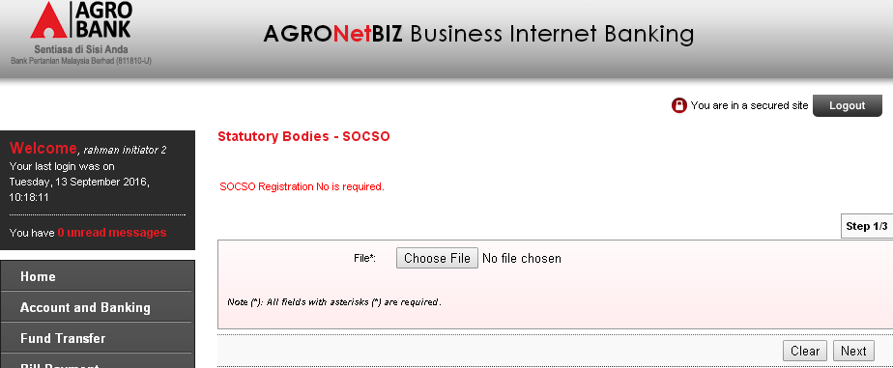

Upload the same file with the same file name and the same content.
Results:
Error message: Duplicate file name and file content
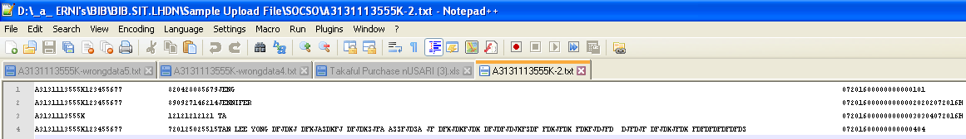
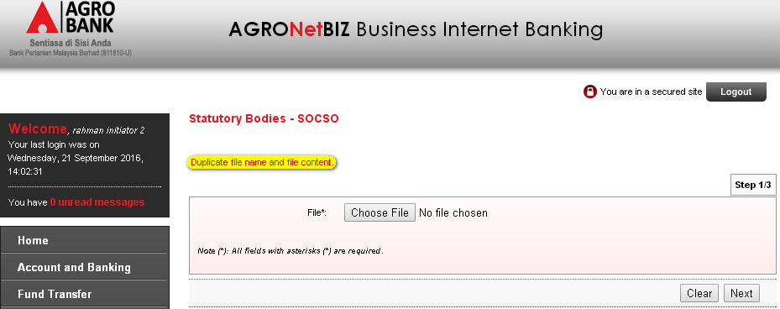

Upload the same file with different file name but same content.
Results:
System display Statutory Bodies – SOCSO details page.
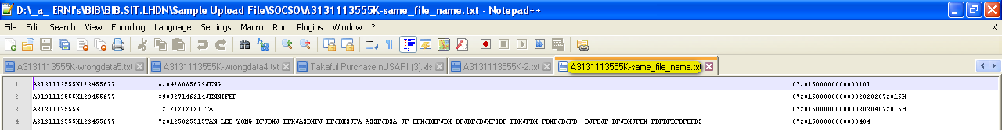
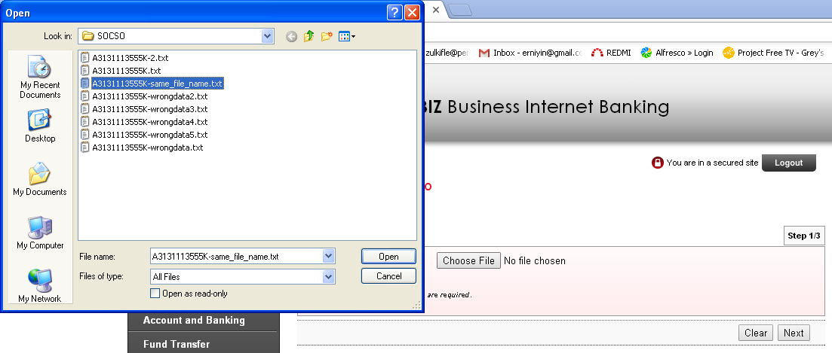
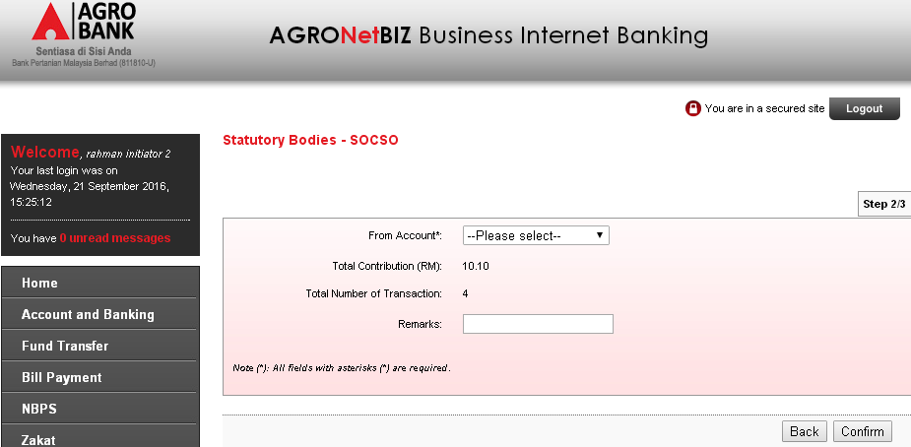

1.1.4 Upload the same file with different file name and different content.
Results:
System display Statutory Bodies – SOCSO details page.
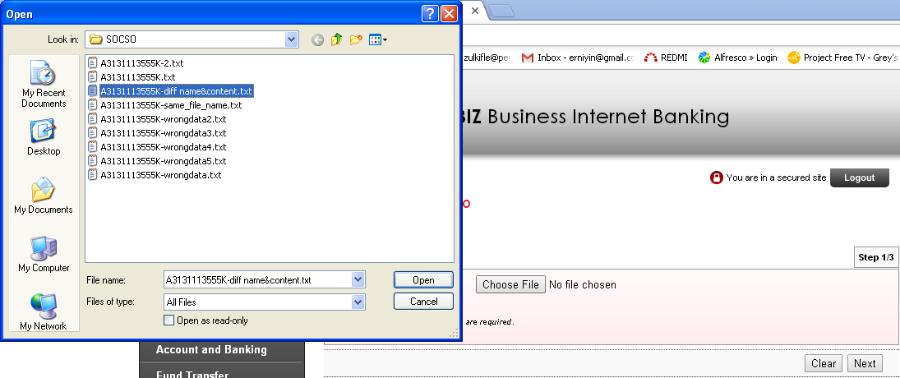
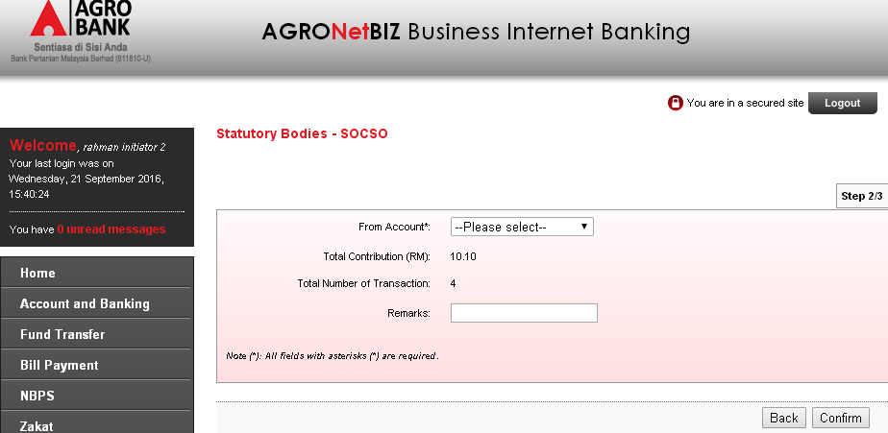

1.1.5 Upload the same file with same file name but different content.
Results:
Error message: Duplicate file name
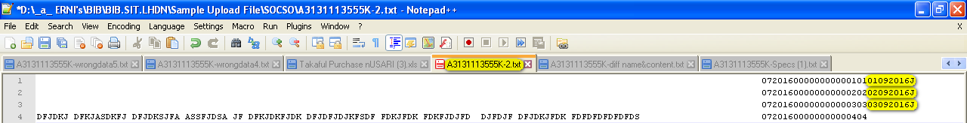
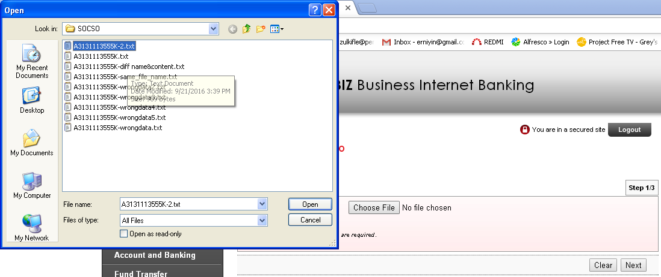
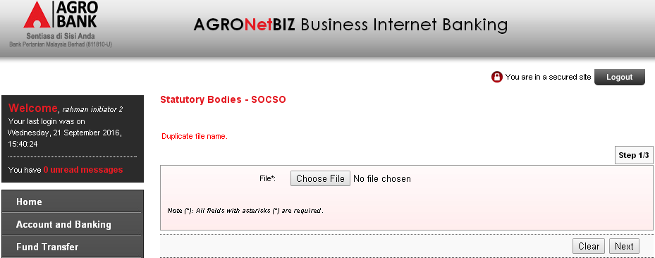

At the Statutory Bodies – SOCSO details page, choose on ‘From Account’ dropdown navigation and enter the ‘Remarks’. Then click on ‘Confirm’ button.
Results:
System will display Result Page.
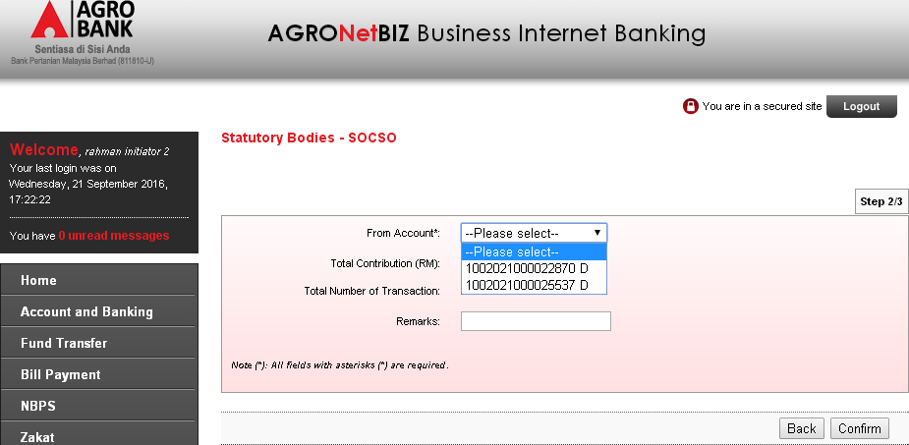

Unselect on ‘From Account’ dropdown navigation.
Results:
Error message: From Account is required.
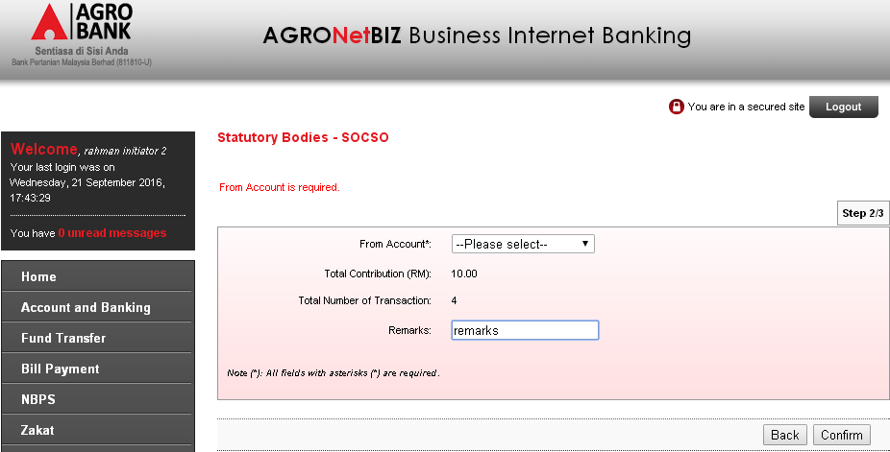

System display Result Page. Click on ‘Print Receipt’ button to print out the receipt or click on ‘Upload Another File’ button to upload another file.
Results:
System will print the receipt if click on ‘Print Receipt’ button or system will go to Statutory Body – SOCSO page to upload another file if click on ‘Upload Another File’ button.
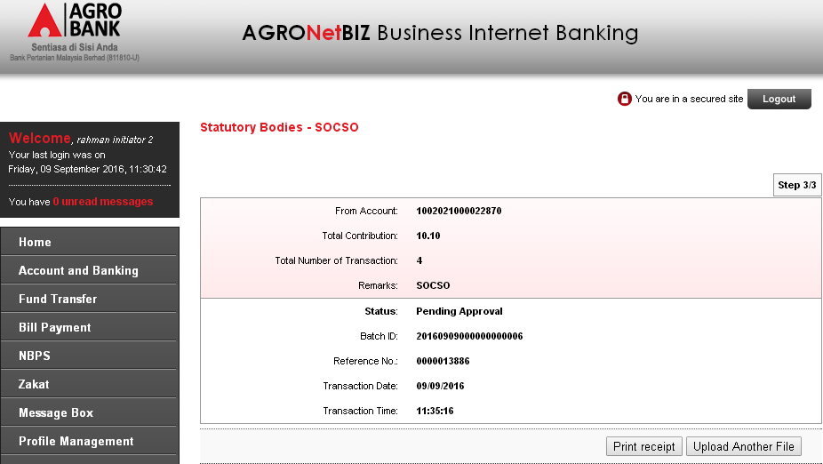

1.3.1 Click on ‘Print Receipt’ button.
Results:
System will print the receipt when click on ‘Print Receipt’ button
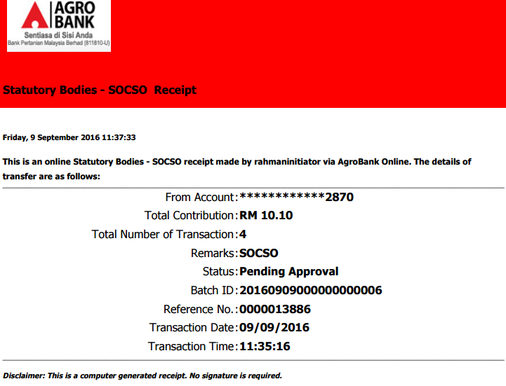
1.3.2 Click on ‘Upload Another File’ button.
Results:
System will go to Statutory Body – SOCSO page to upload another file if click on ‘Upload Another File’ button.
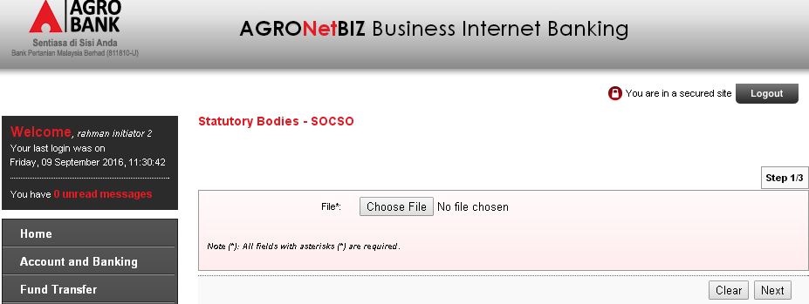

Go to SOCSO Transfer History page to display the status.
Results:
Status: Validated (Pending Approval)
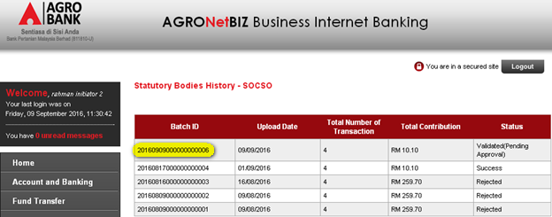

Go to Agronet Transaction History page to display the status.
Results:
Status: Pending for 2 Approver(s)
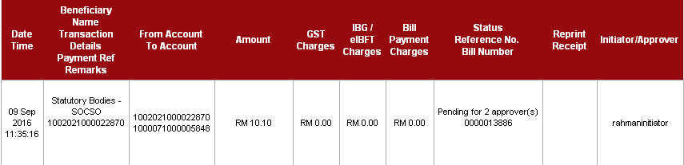

Login as Approver from Group A to approve the transaction. Select on ‘Approver Status’ radio button, enter the ‘Remarks’, enter the ‘Security Token PIN Number’, and then click on ‘Confirm’ button.
Results:
System will display result page.
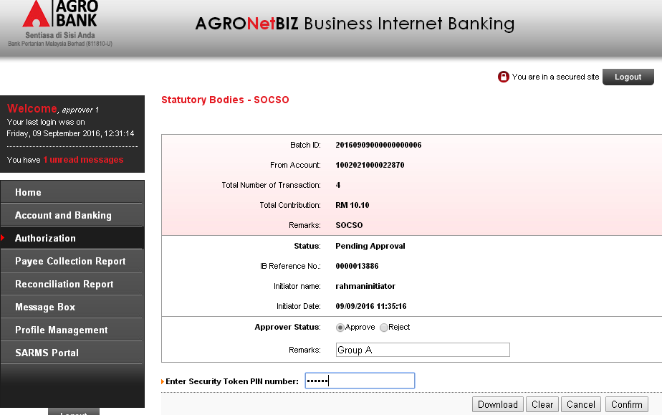

Unselect any action (Approve/Reject)
Results:
System display error message: Approver Status is required.
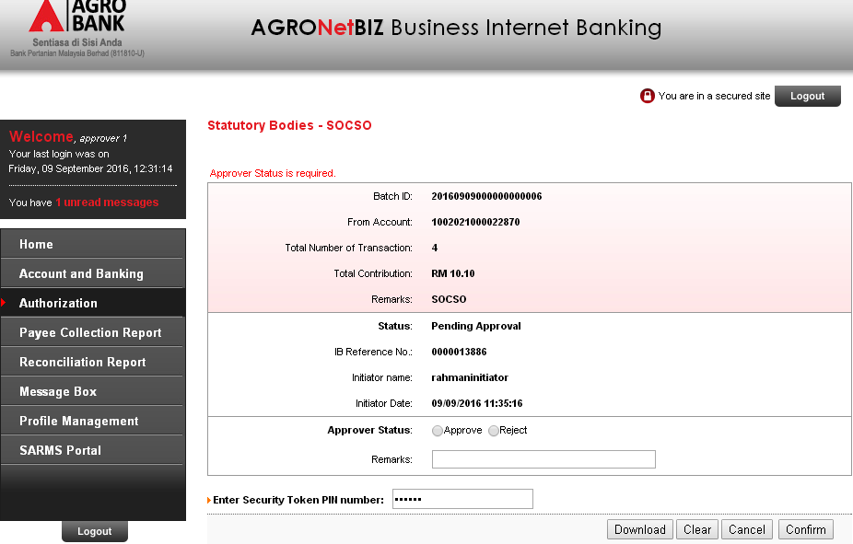

Does not enter the Security Token PIN number.
Results:
System display error message: Security Token PIN is required
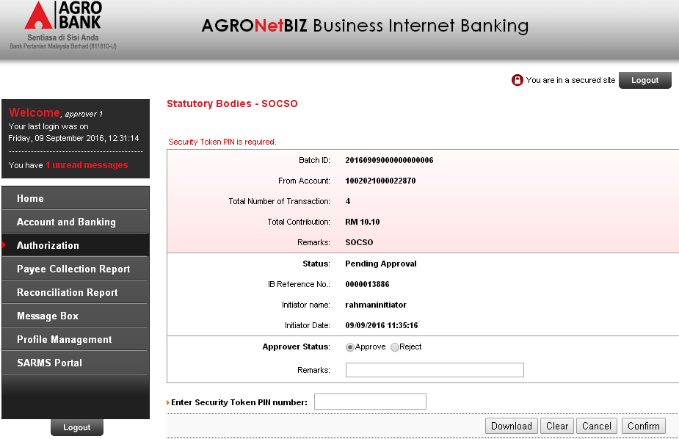

Enter the Security Token PIN number with alphabets.
Results:
System display error message: Security Token PIN must be numeric.
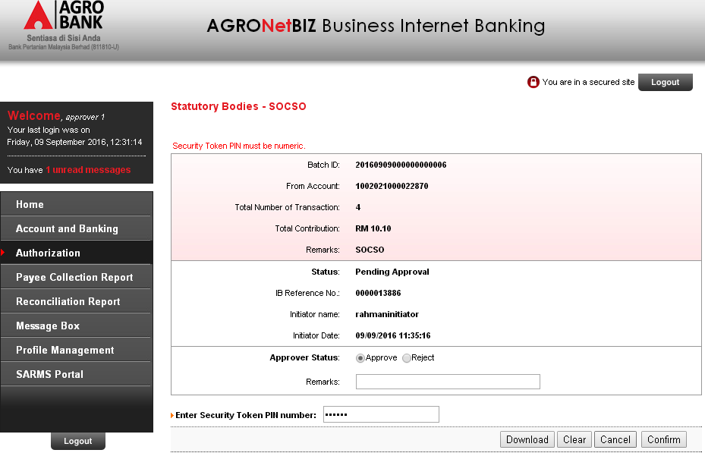

System displays result page.
Results:
Status: Pending Approval
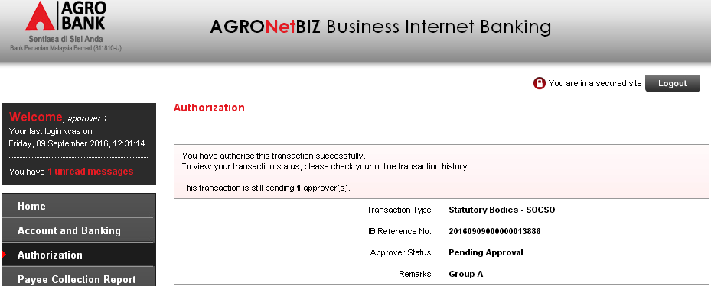

Login back as Initiator to display transaction status.
a) Results Agronet Transaction History:
Status: Pending for 1 Approver
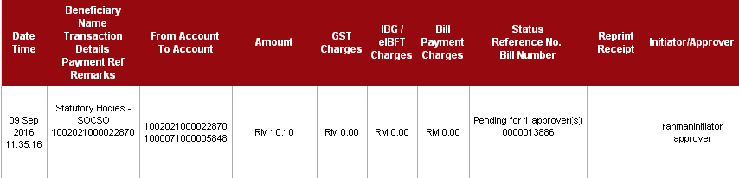
b) Results SOCSO Transfer History:
Status: Validated (Pending Approval)
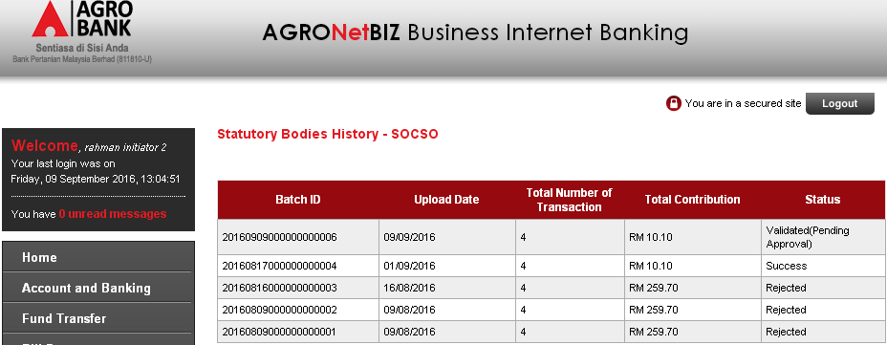

Login as Approver from group B to approve the transaction. Select on ‘Approver Status’ radio button, enter the ‘Remarks’, enter the ‘Security Token PIN Number’, and then click on ‘Confirm’ button.
Results:
System display Result Page.
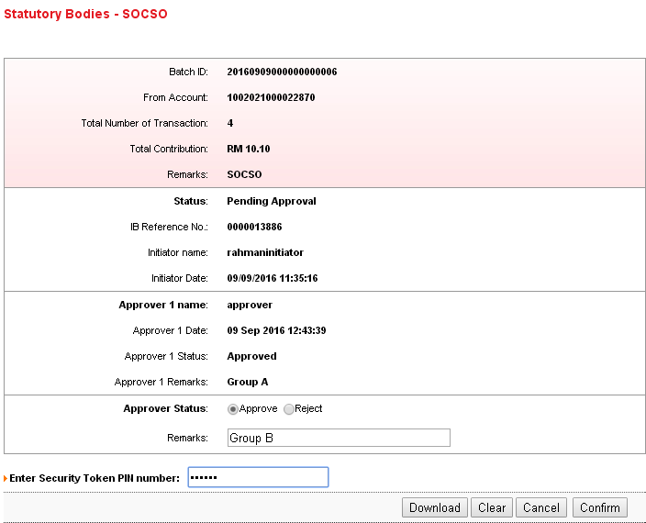

Unselect any action (Approve/Reject)
Results:
System display error message: Approver Status is required.
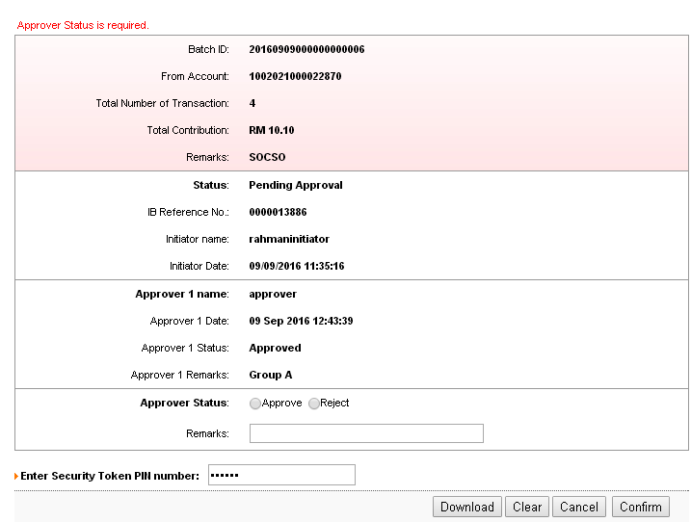

Does not enter the Security Token PIN number.
Results:
System display error message: Security Token PIN is required
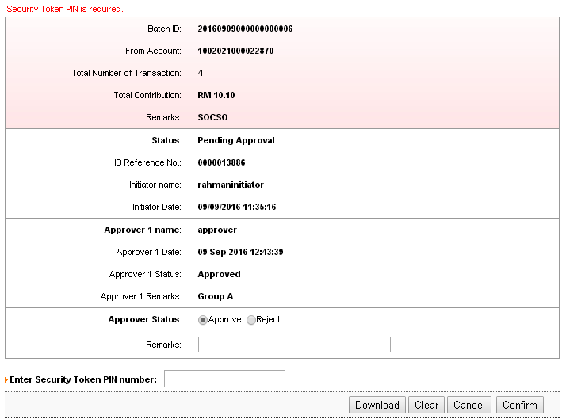

Enter the Security Token PIN number with alphabets.
Results:
System display error message: Security Token PIN must be numeric.
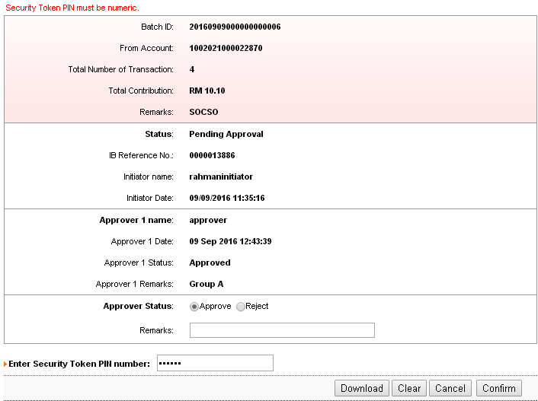

System displays result page.
Results:
Status: Accepted
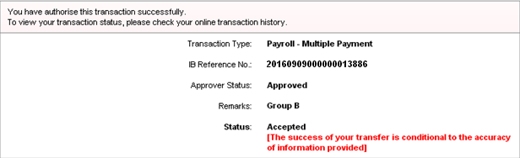

Login back as Initiator to display transaction status
a) Results Agronet Transaction History:
Status: Accepted
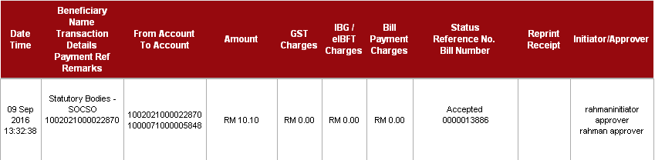
b) Results SOCSO Transfer History:
Status: Success
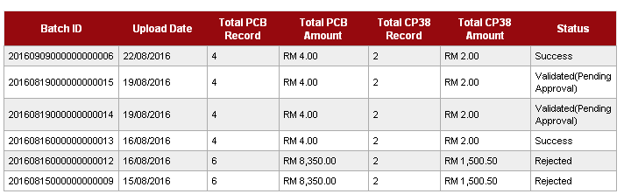

Single User

Login as Initiator, go to Payroll navigation and select on SOCSO navigation link to upload SOCSO file to perform transaction.
Results:
System displays Statutory Bodies – SOCSO page.
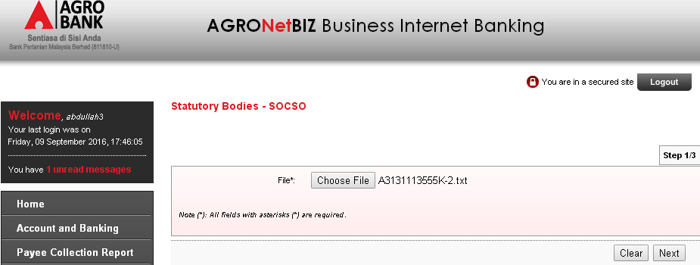

Upload the wrong data format file (blank the employer registration number)
Results:
Error message: SOCSO Registration No is required.
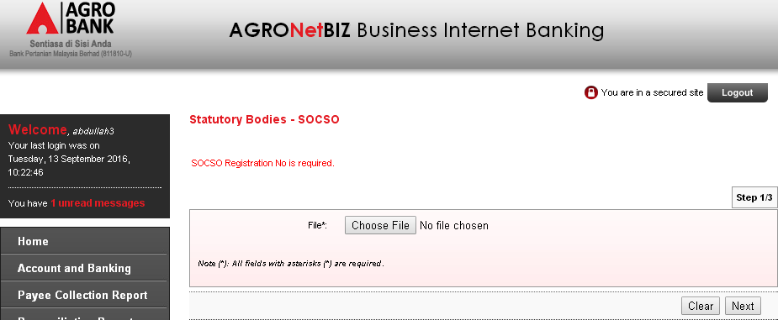

Upload the same file with different file name but same content.
Results:
System display Statutory Bodies – SOCSO details page.
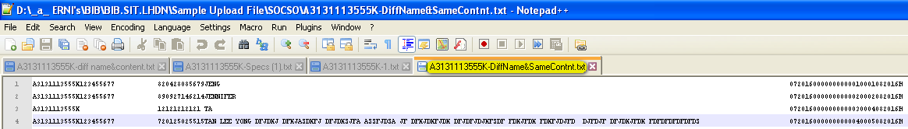
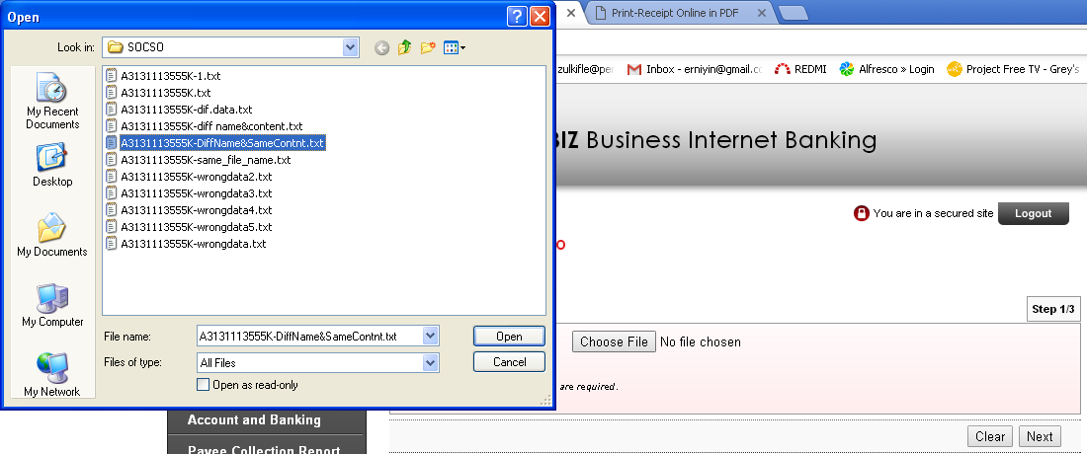
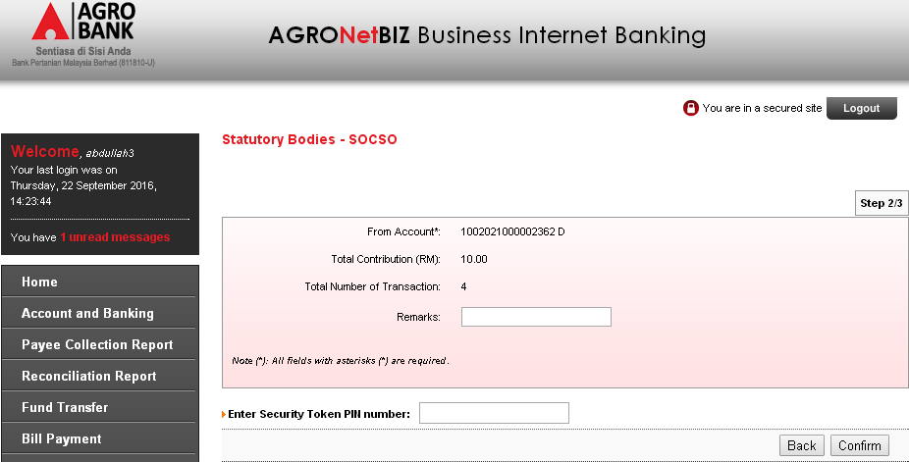

Upload the same file with different file name and different content.
Results:
System display Statutory Bodies – SOCSO details page.
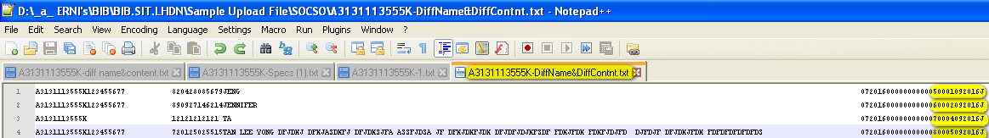
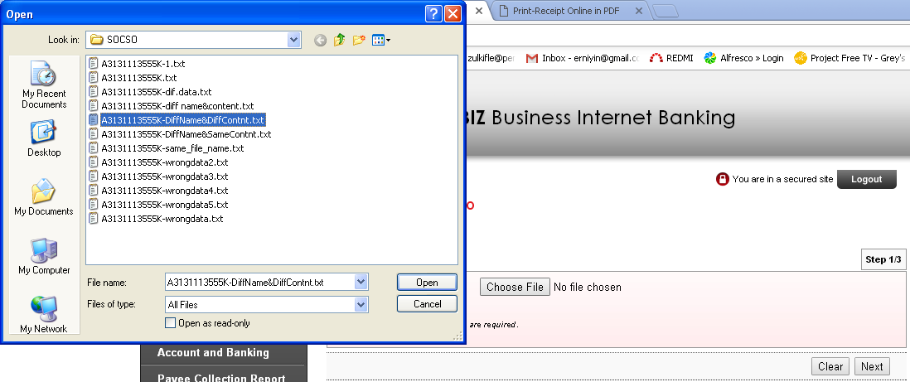
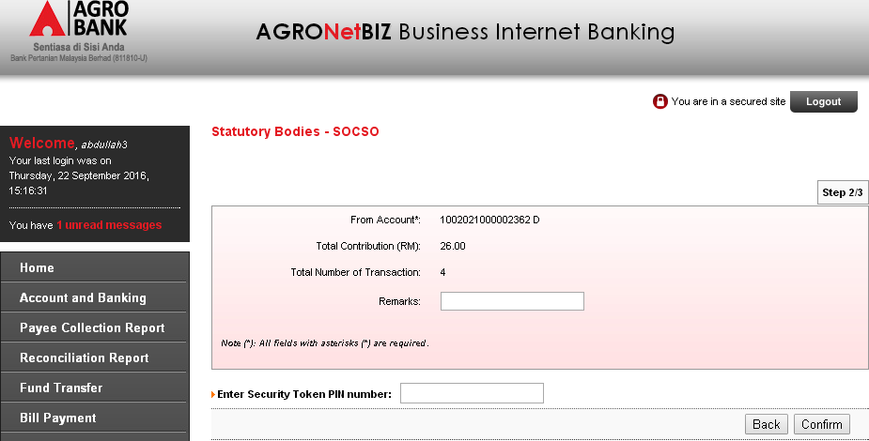

Upload the same file with same file name but different content.
Results:
Error message: Duplicate file name
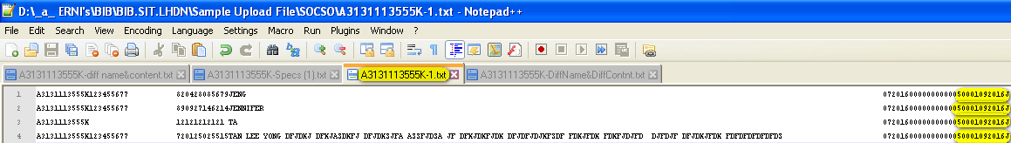
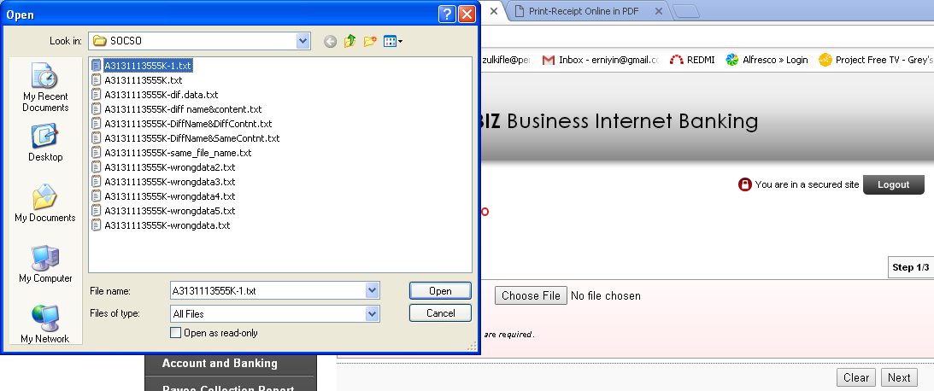
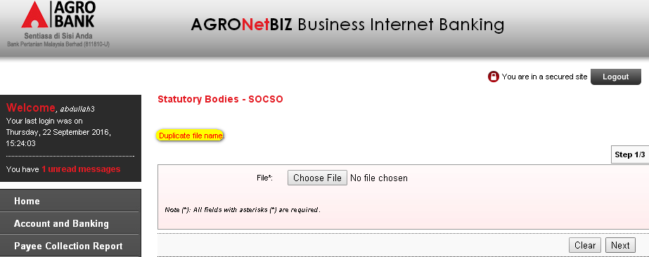

At the Statutory Bodies – SOCSO details page, choose on ‘From Account’ dropdown navigation and enter the ‘Remarks’. Then click on ‘Confirm’ button.
Results:
System will display Result Page.
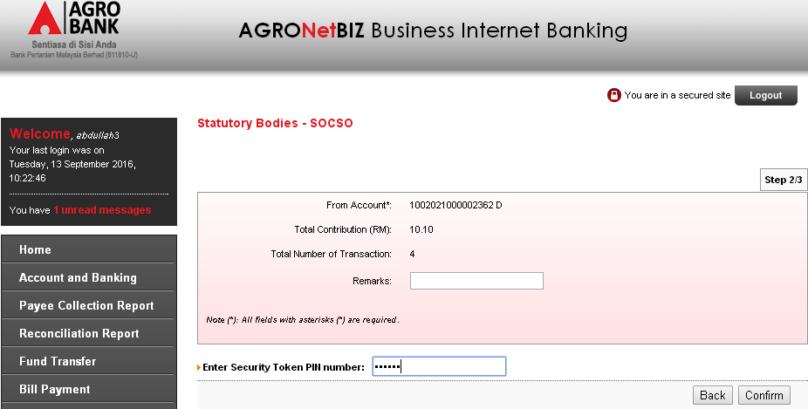

Unselect on ‘From Account’ dropdown navigation. Single User only has one account. Therefore, there is no selection on ‘From Account’ dropdown navigation.
Results:
Error message: From Account is required.

Does not enter the Security Token PIN Number.
Results:
Error message: Security Token PIN is required.
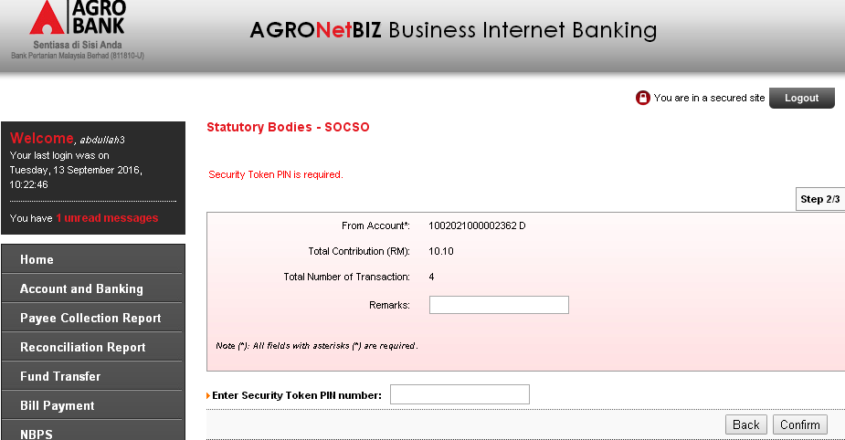

Enter Security Token PIN Number with alphabets/special character.
Results:
Error message: Security Token PIN must be numeric.
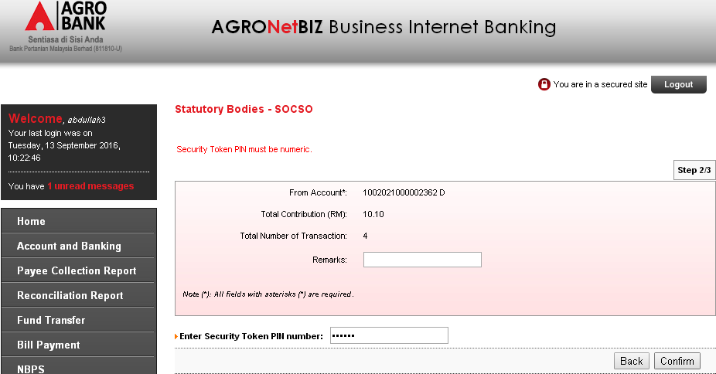

Enter the Security Token PIN Number with less than 6 characters.
Results:
Error message: Security Token PIN must consist of 6 characters/digits
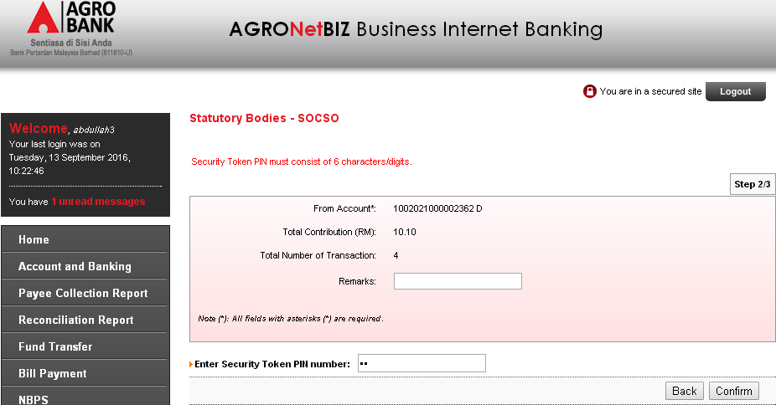

System display Result Page. Click on ‘Print Receipt’ button to print out the receipt or click on ‘Upload Another File’ button to upload another file.
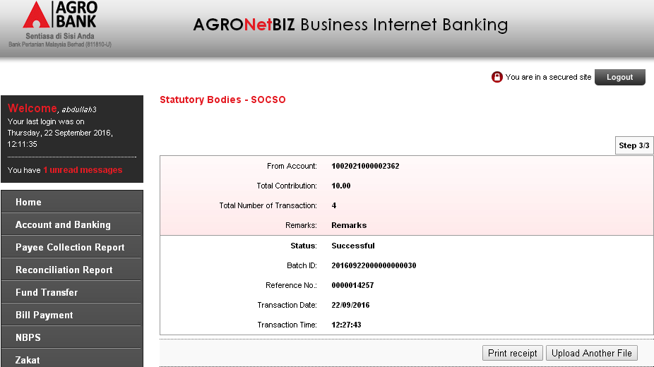

Click on ‘Print Receipt’ button.
Results:
System will print the receipt when click on ‘Print Receipt’ button.
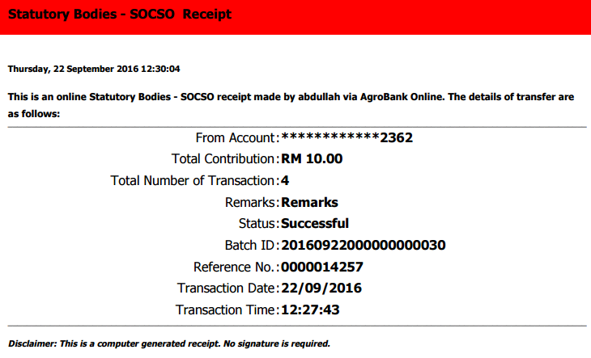

Click on ‘Upload Another File’ button.
Results:
System will go to Statutory Body – SOCSO page to upload another file if click on ‘Upload Another File’ button.
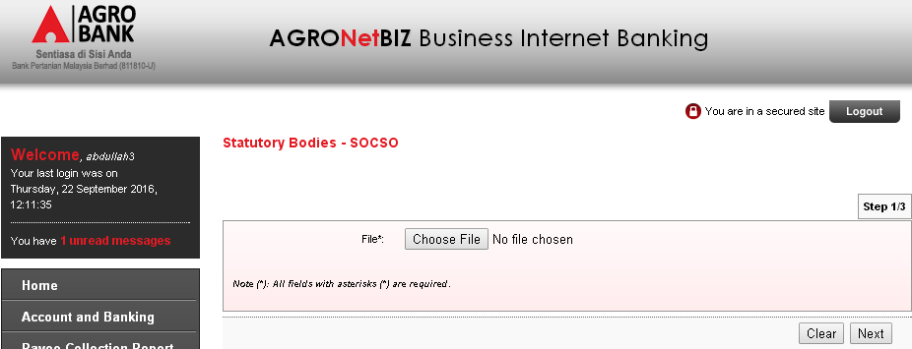

Go to SOCSO Transfer History page to display the status.
Results:
Status: Success
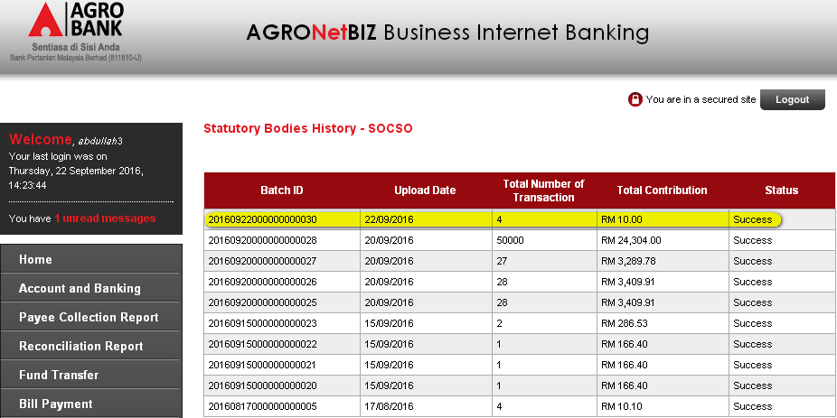

Go to Agronet Transaction History page to display the status.
Results:
Status: Success
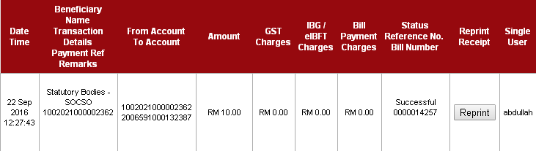

IBAM

3.1 Administrator
Edit Payroll Flag to display on BIB
Go to BIB>Company Enquiry and search the company name.
Results:
System display result for Search Company.
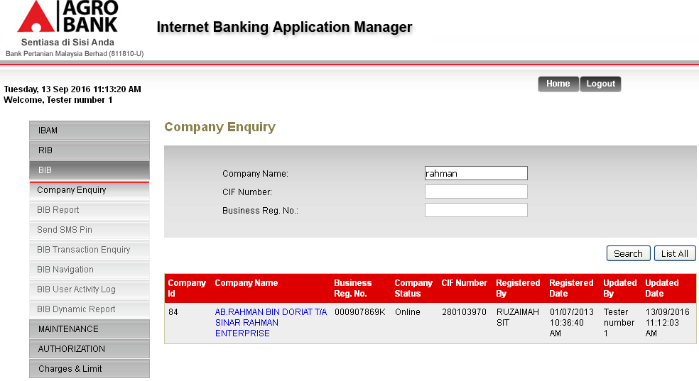

Click on the Company Name link navigation. At the Company Details page, click on ‘Edit’ button to edit on Payroll flag.
Results:
System display Edit Page for Company Details.
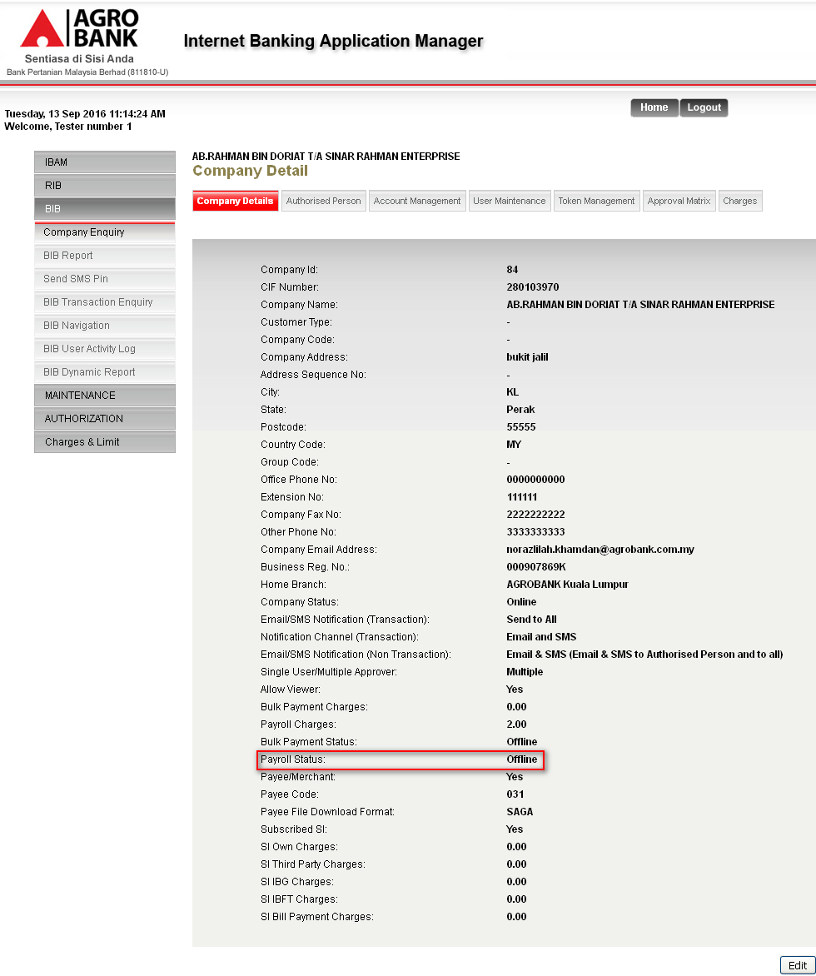

At the Edit page, click online on Payroll Status radio button navigation. Then click on ‘Next’ button.
Results:
System display Confirm Page.
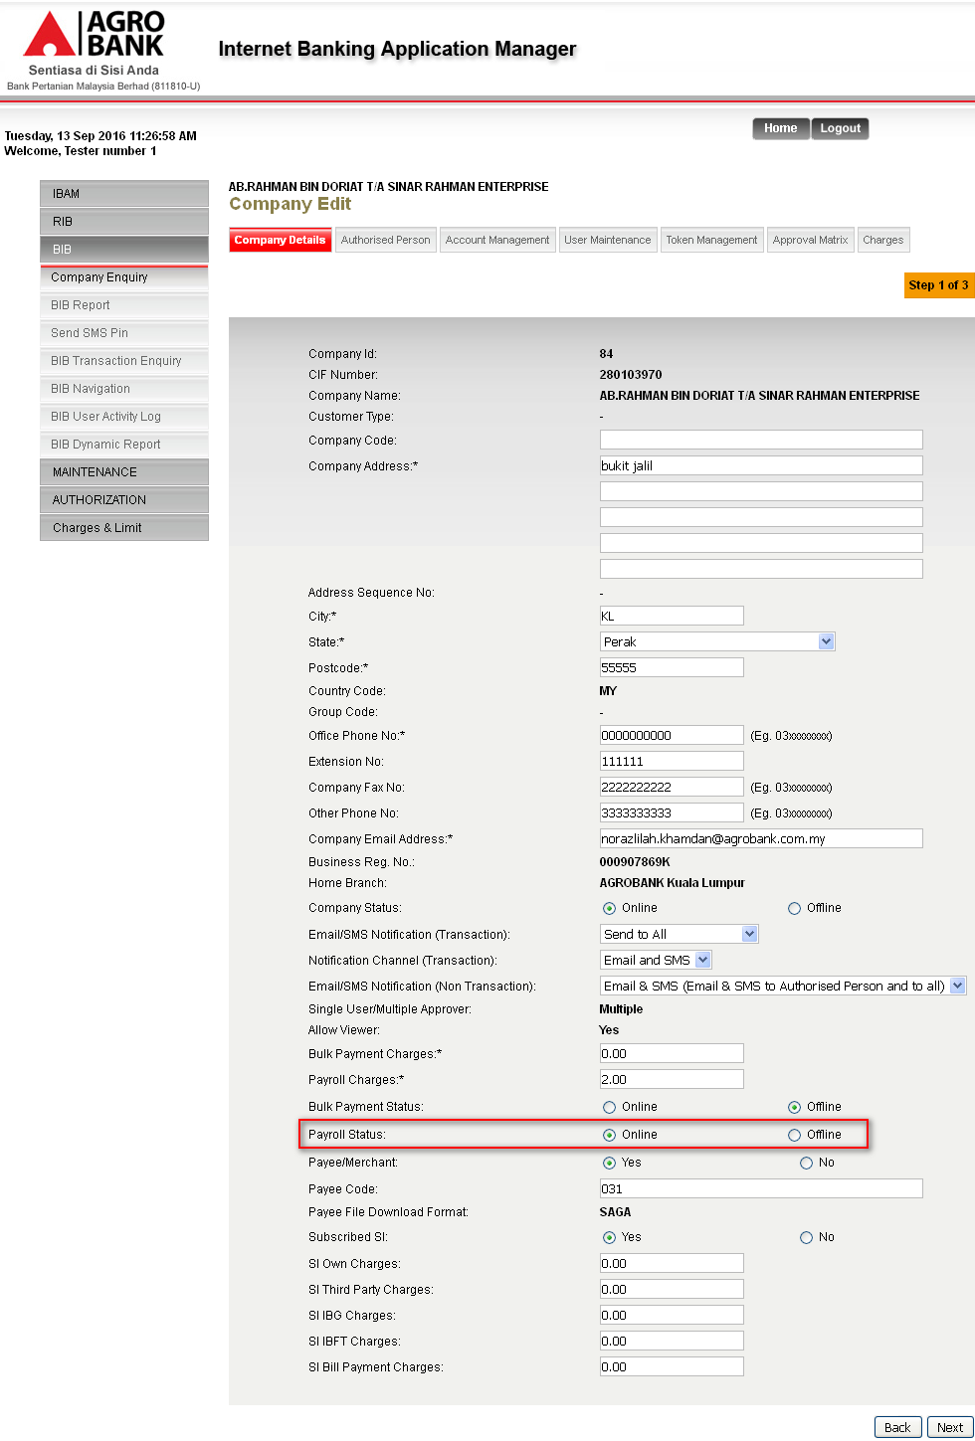

At the Confirm page, click on ‘Confirm’ button
Results:
System displays Result Page with Successful status.
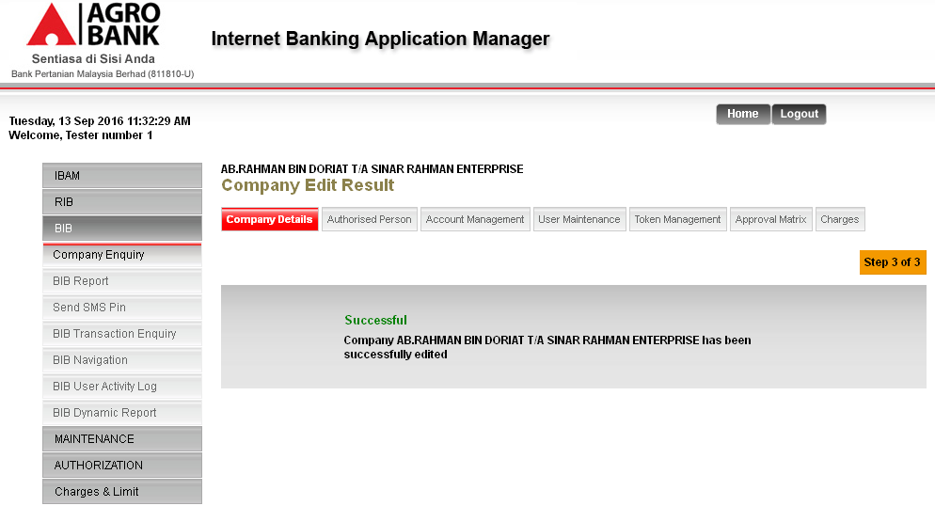
Login to BIB to display the navigation services.
Results:
User will able to view Payroll page. Statutory Bodies navigation will be inside the Payroll page.
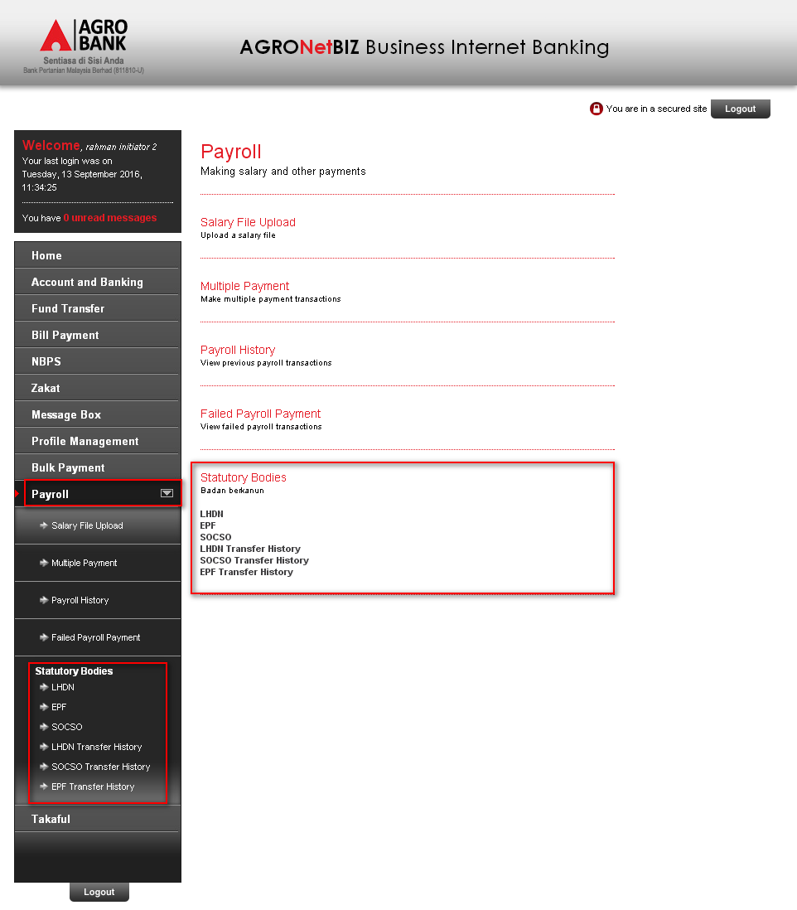

Edit Statutory Bodies service to display on BIB
Statutory Bodies page on BIB before edit Statutory Bodies service on IBAM:
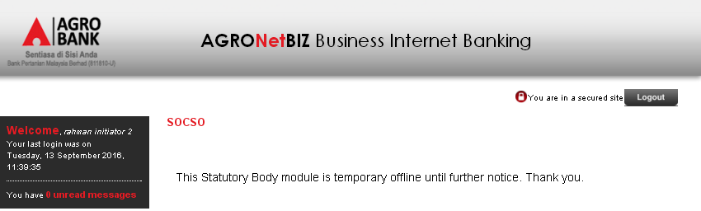
Login as Administrator on IBAM and go to BIB>BIB Navigation>BIB>Payroll and click on ‘Edit’ link on ‘PYROLLSB’
Results:
System will display Edit Page for Statutory Bodies.
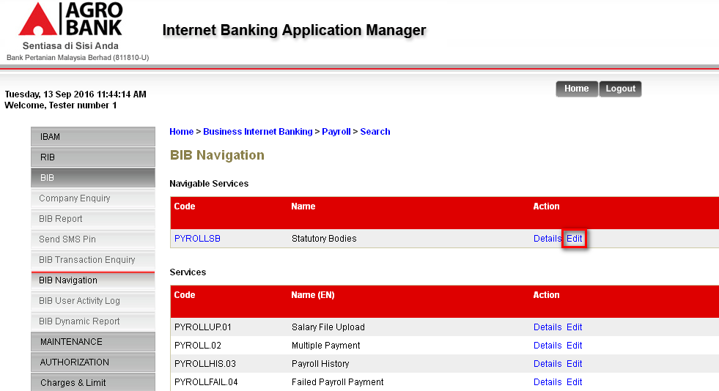

Choose ‘Online’ on Status dropdown navigation. Then click on ‘Next’ button.
Results:
System will display Confirm Page.
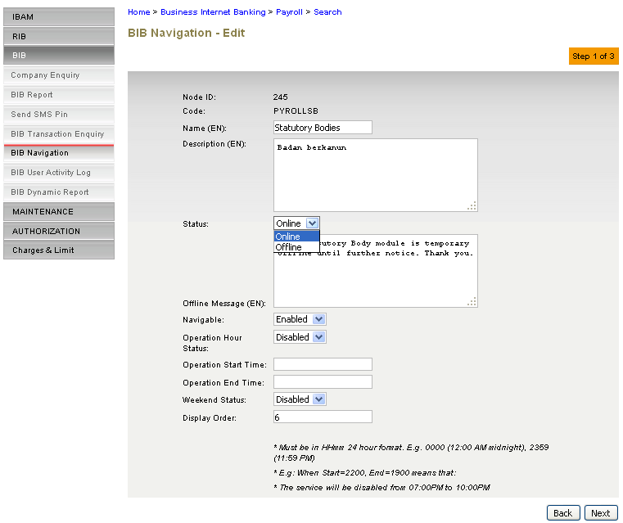

At the Confirm page click on ‘Confirm’ button.
Results:
System display Result Page.
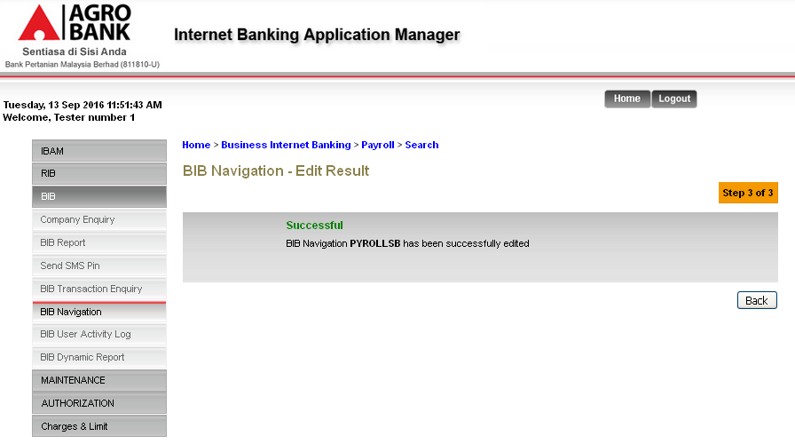
Login to BIB and go Payroll>Statutory Bodies, to display the navigation services.
Results:
User will able to see Statutory Bodies services.
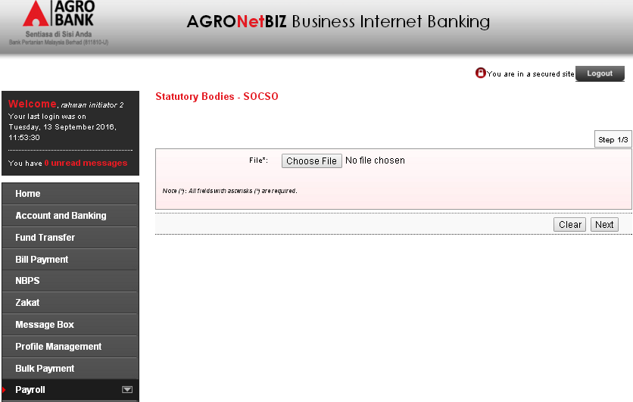

BIB Report
- PDF Format
Go to BIB Report to display all the Statutory Bodies Report. Choose on Report Type, File Type, Month and Year dropdown navigation. Then click on ‘Search’ button.
Results:
System will display result for the search item.
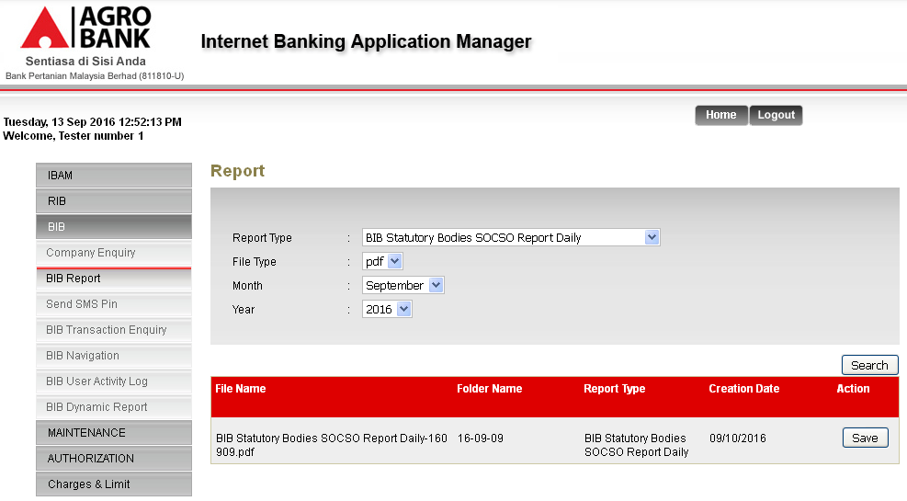

To download the file, click on ‘Save’ button.
Results:
System will download the report in PDF format.
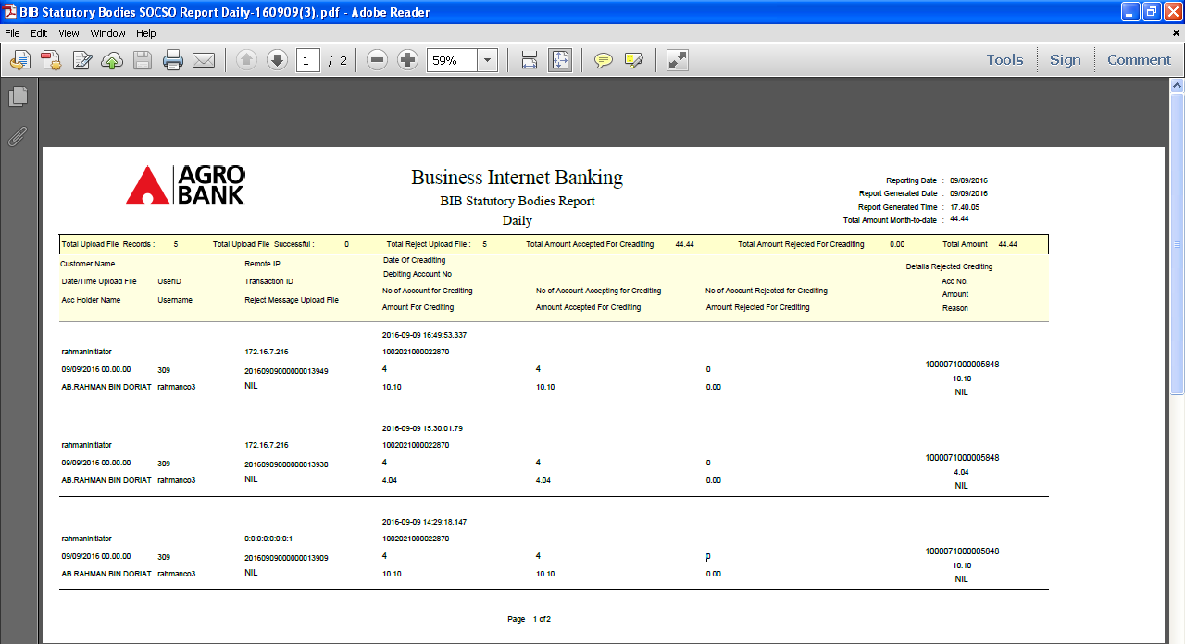
Page 1
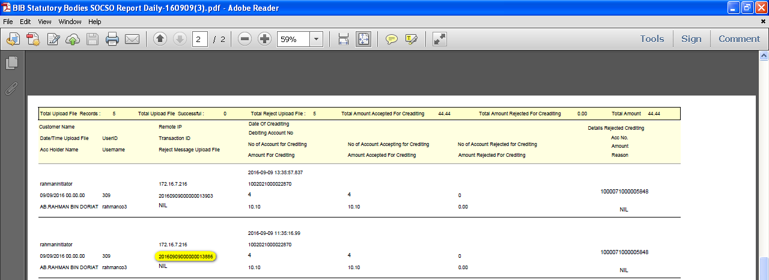
Page 2: The highlighted transaction ID is the report for the submitted SOCSO transaction

- EXCEL Format
Go to BIB Report to display all the Statutory Bodies Report. Choose on Report Type, File Type, Month and Year dropdown navigation. Then click on ‘Search’ button.
Results:
System will display result for the search item.
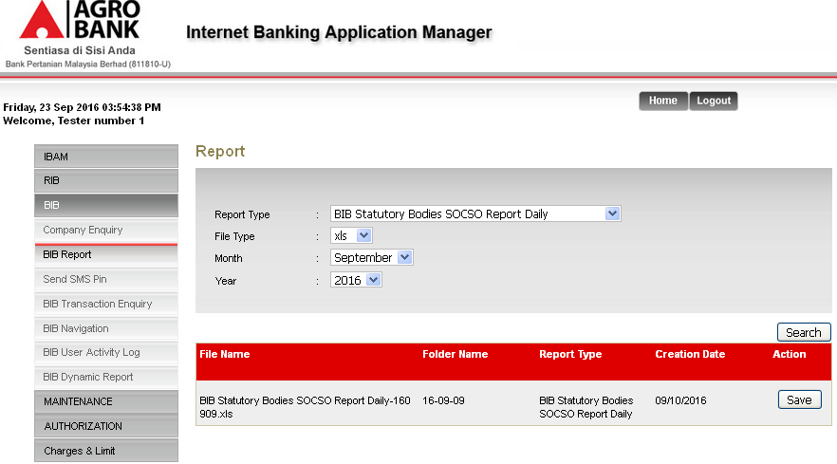

To download the file, click on ‘Save’ button.
Results:
System will download the report in EXCEL format.
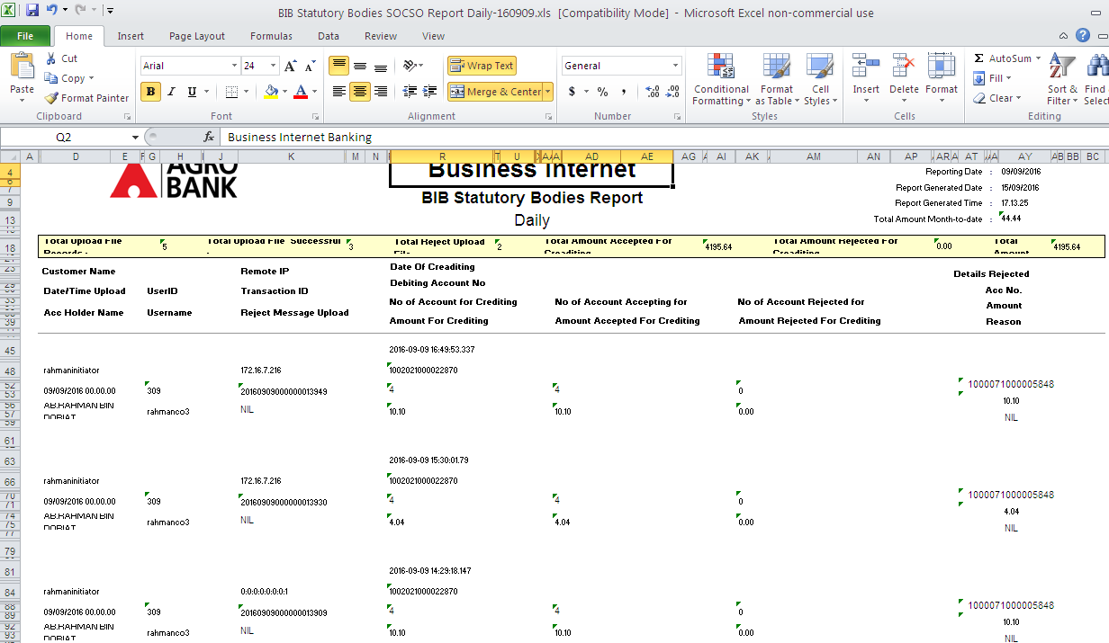
Page 1
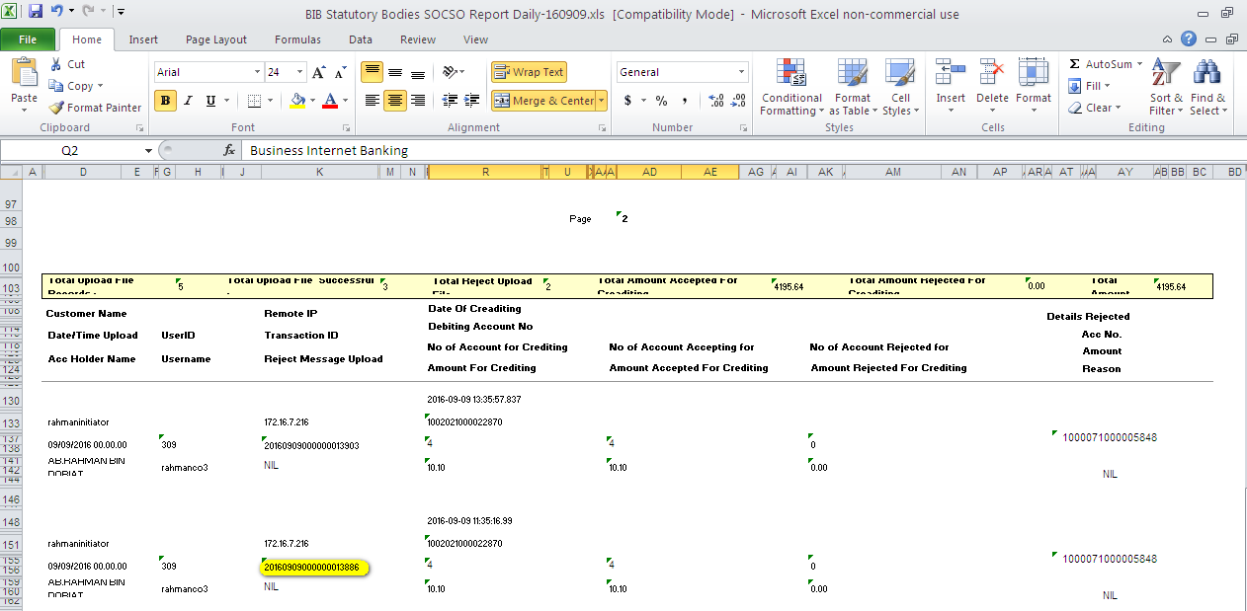
Page 2: The highlighted transaction ID is the report for the submitted SOCSO transaction

3.2 Maker/Checker
Maker: Edit Payroll Flag to display on BIB
BIB Statutory page before edit on Payroll Flag:
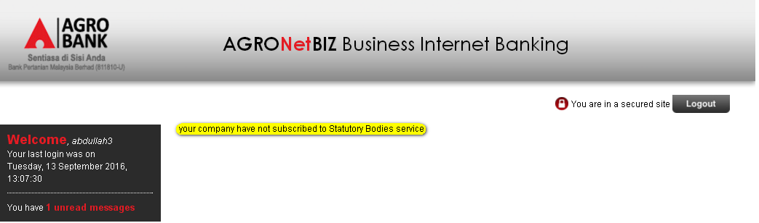
Go to BIB>Company Enquiry and search the company name.
Results:
System display result for Search Company.
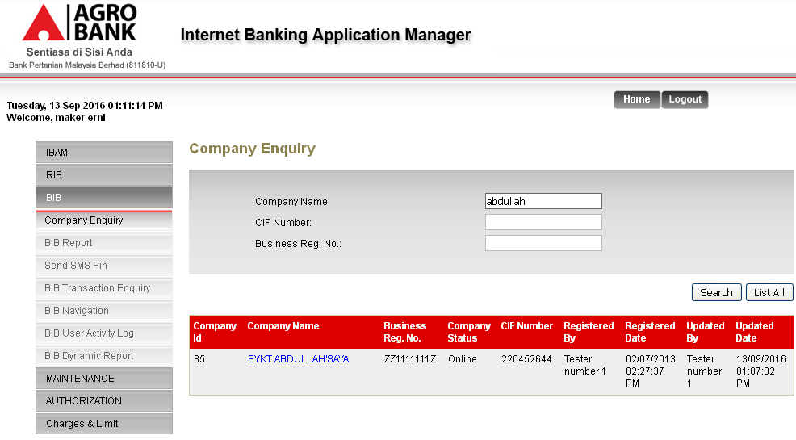

Click on the Company Name link navigation. At the Company Details page, click on ‘Edit’ button to edit on Payroll flag.
Results:
System display Edit Page for Company Details.
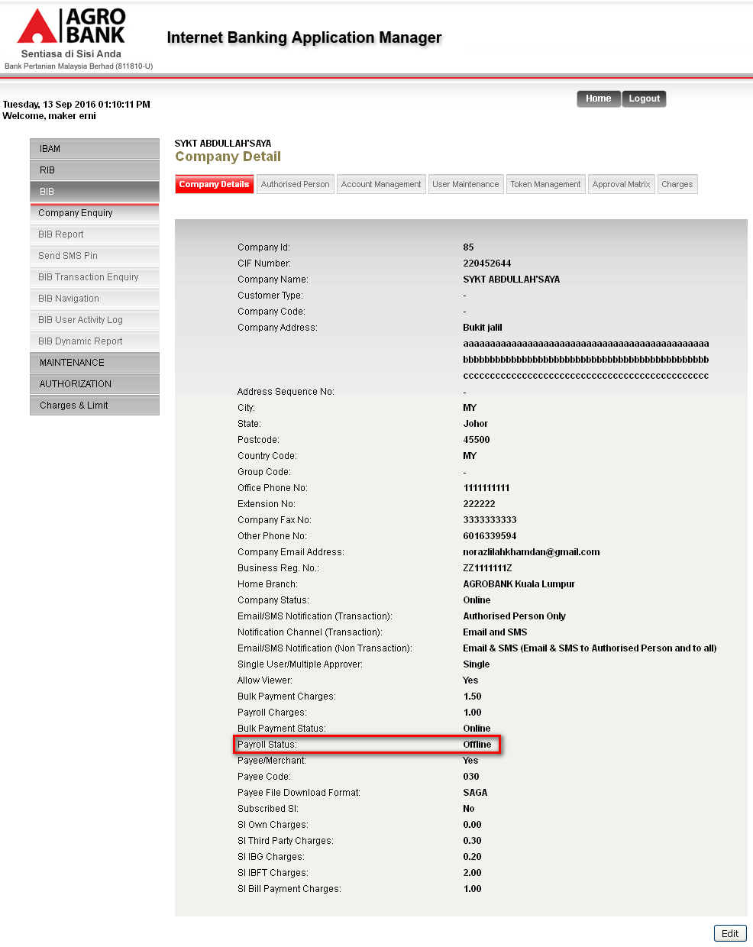

At the Edit page, click online on Payroll Status radio button navigation. Then click on ‘Next’ button.
Results:
System displays Confirm Page.
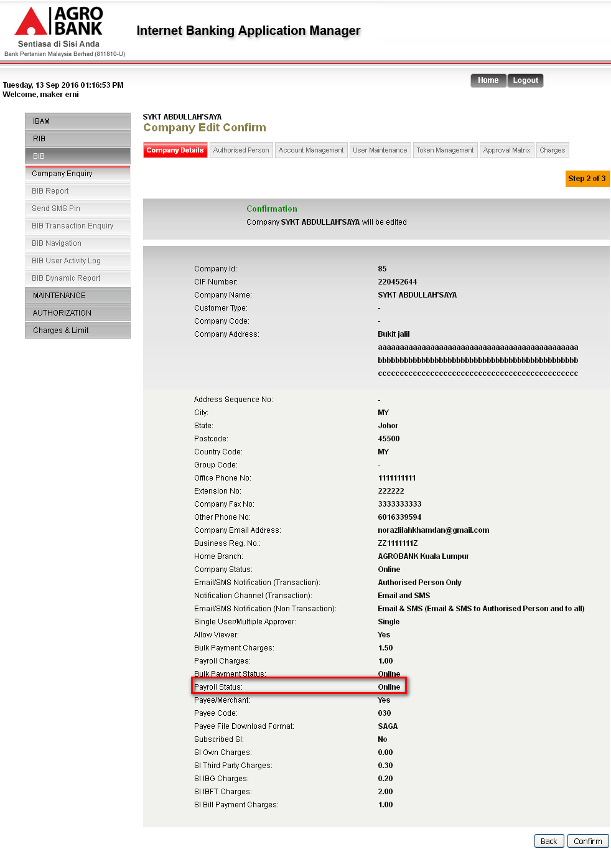

At the Confirm Page, click on Confirm button.
Results:
System will displays Result Page.
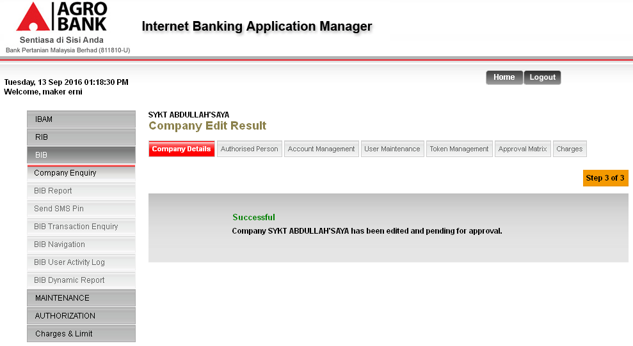

Checker: Approve the action
Login as Checker and got to Authentication>Approval to approve the created activity.
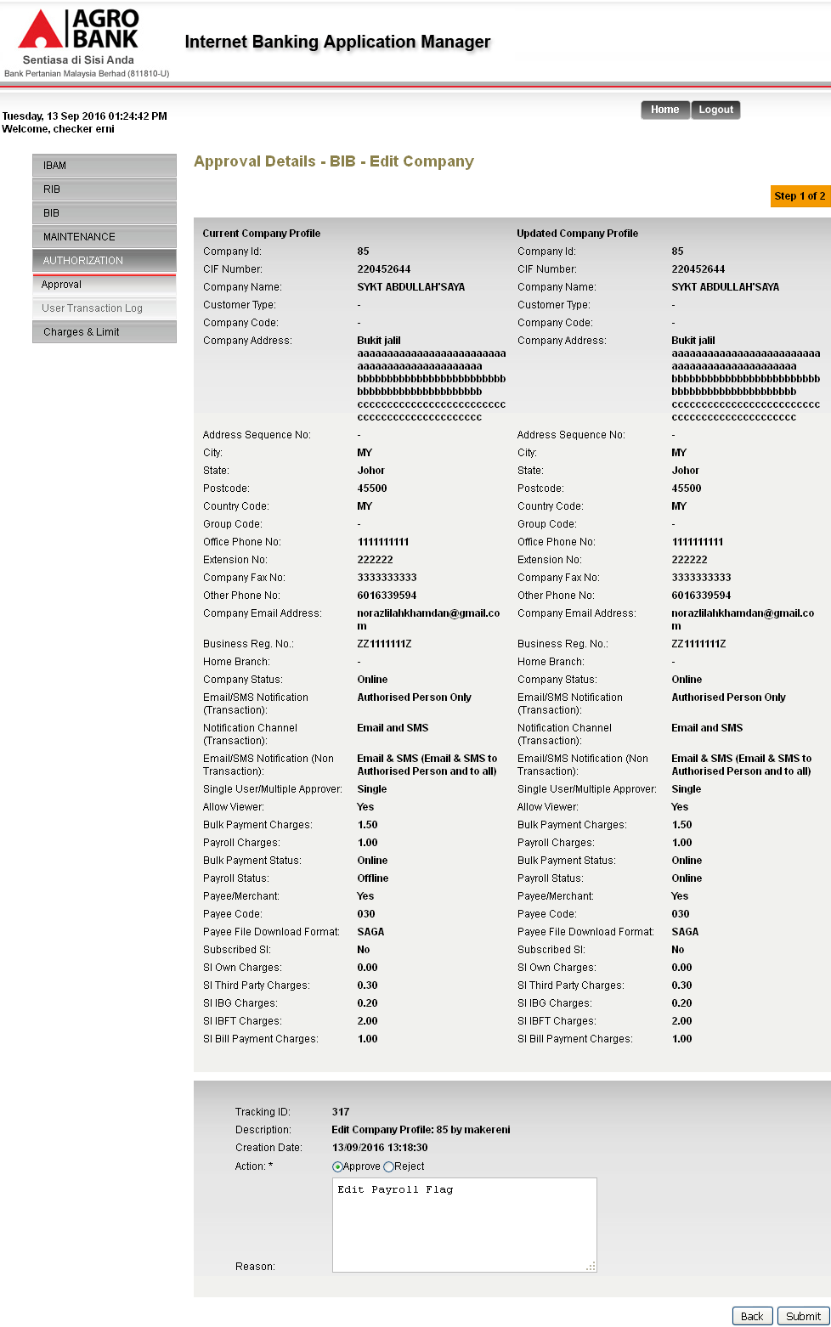

- Unselect any action.
Results:
Error message: Action is required.
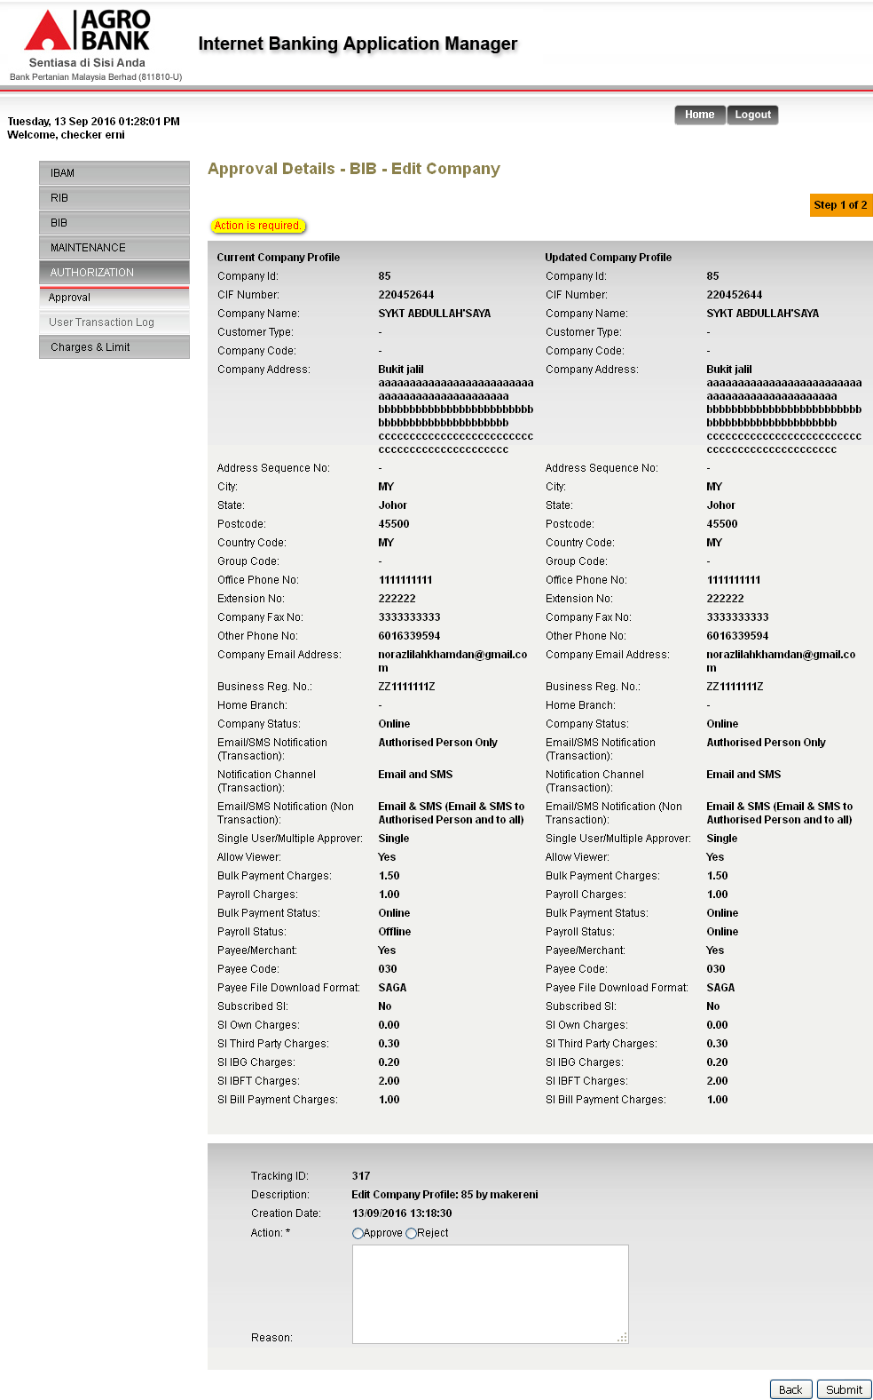

Click on ‘Submit’ button
Results:
System will display Result page.
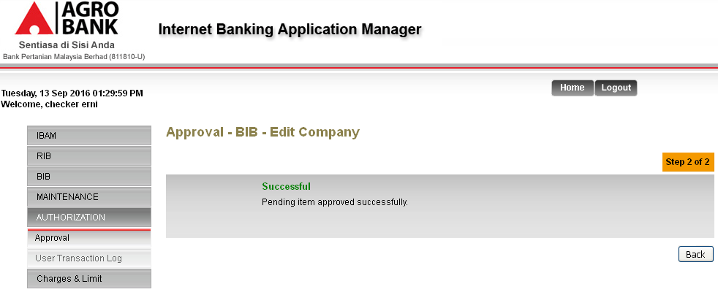
Login to BIB to display the changes made.
Results:
User will able to view Payroll page. Statutory Bodies navigation will be inside the Payroll page.
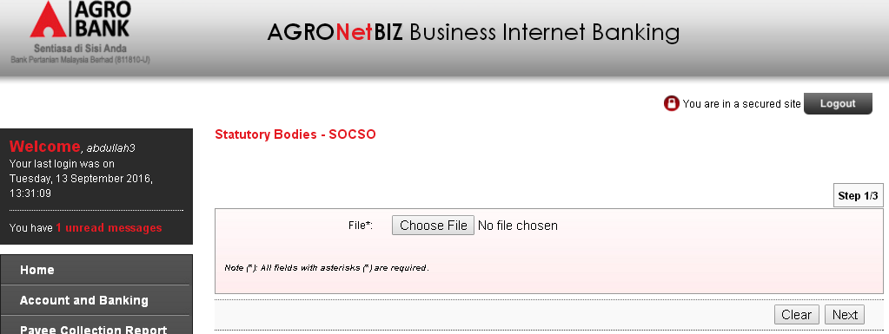

Maker: Edit Statutory Body service to display on BIB
Statutory Bodies page on BIB before edit Statutory Bodies service on IBAM:
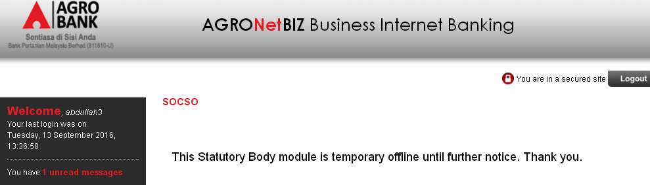
Login as Administrator on IBAM and go to BIB>BIB Navigation>BIB>Payroll and click on ‘Edit’ link on ‘PYROLLSB’
Results:
System will display Edit Page for Statutory Bodies.
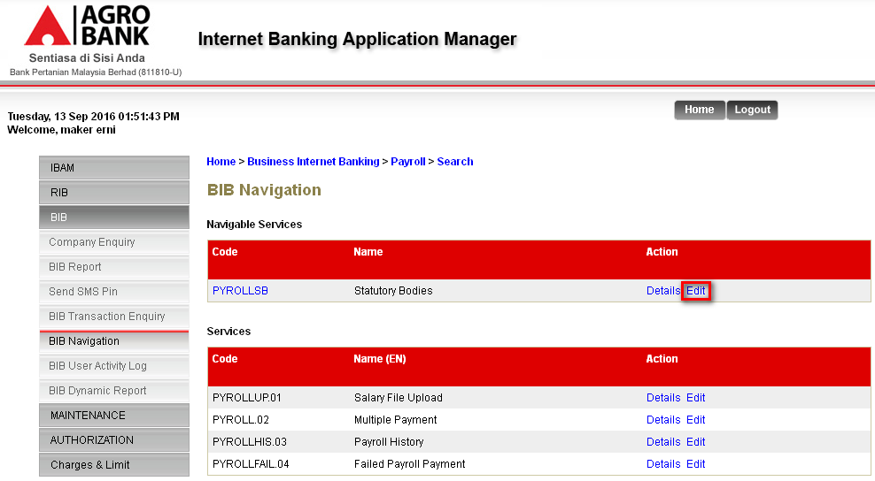

Choose ‘Online’ on Status dropdown navigation. Then click on ‘Next’ button.
Results:
System will display Confirm Page.
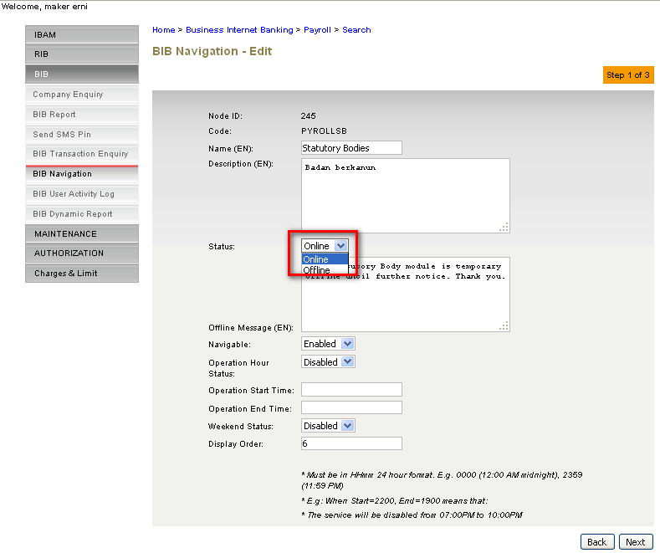

At the Confirm page click on ‘Confirm’ button.
Results:
System display Result Page.
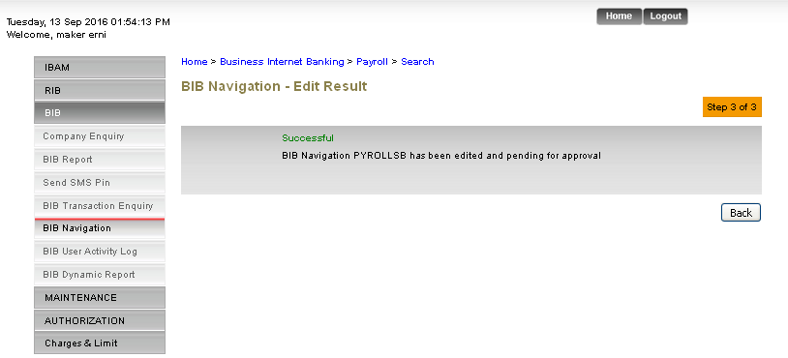
Checker: Approve the action
Login as Checker and got to Authentication>Approval to approve the created activity.
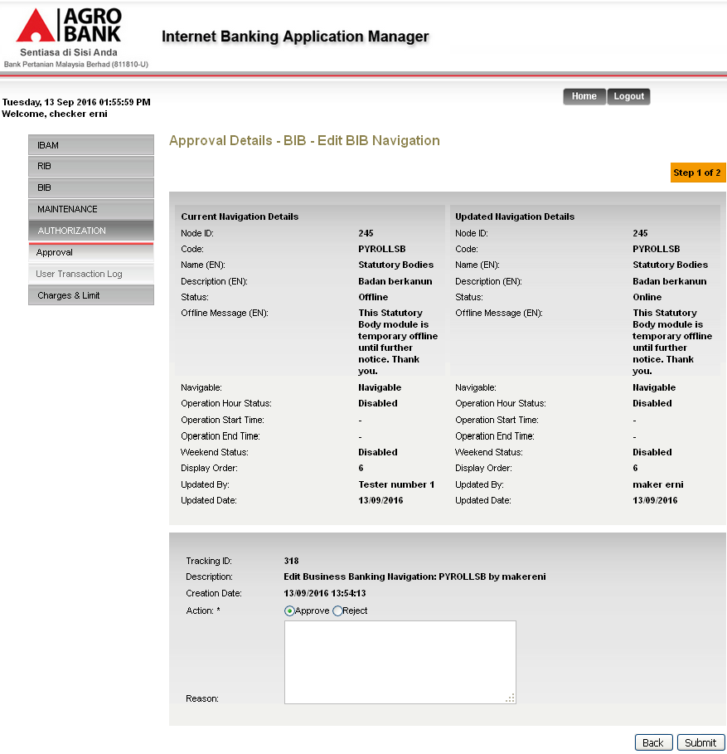

- Unselect any action.
Results:
Error message: Action is required.
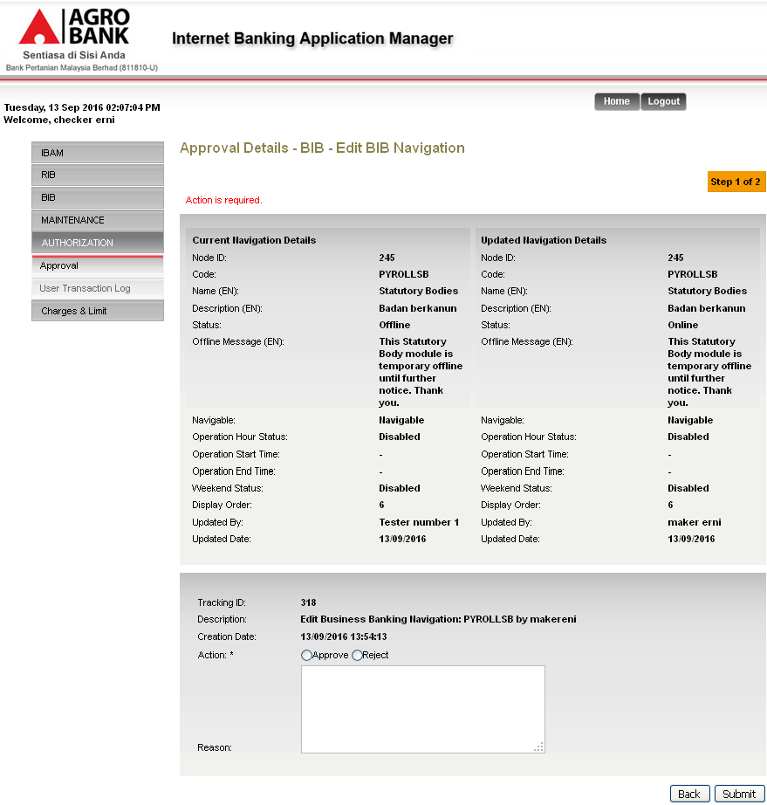

Click on ‘Submit’ button
Results:
System will display Result page.
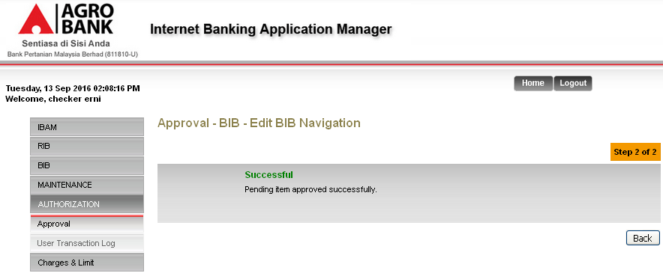
Login to BIB to display the changes made.
Results:
User will able to see Statutory Bodies services.
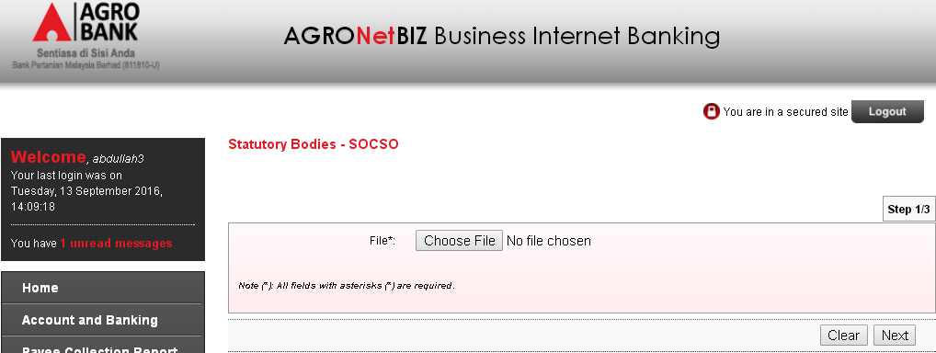

Reviewed By: (PMO)
Lizahwati |  |  | Name/Position : Lizahwati binti Basirun  Date :

