Bill Payments Issues

|  |  |  |  |  |  |
| --- | --- | --- | --- | --- | --- |
| **No** | **Transaction** | **DR Account** | **CR Account** | **Amount** | **Notes** |
| 1 | Bill Payment – Astro | CA KL Main | CA KL Main | 1.10 | Unsuccessful |
| 2 | Mobile Prepaid | CA KL Main | CA KL Main (ePay) |  | Unsuccessful |

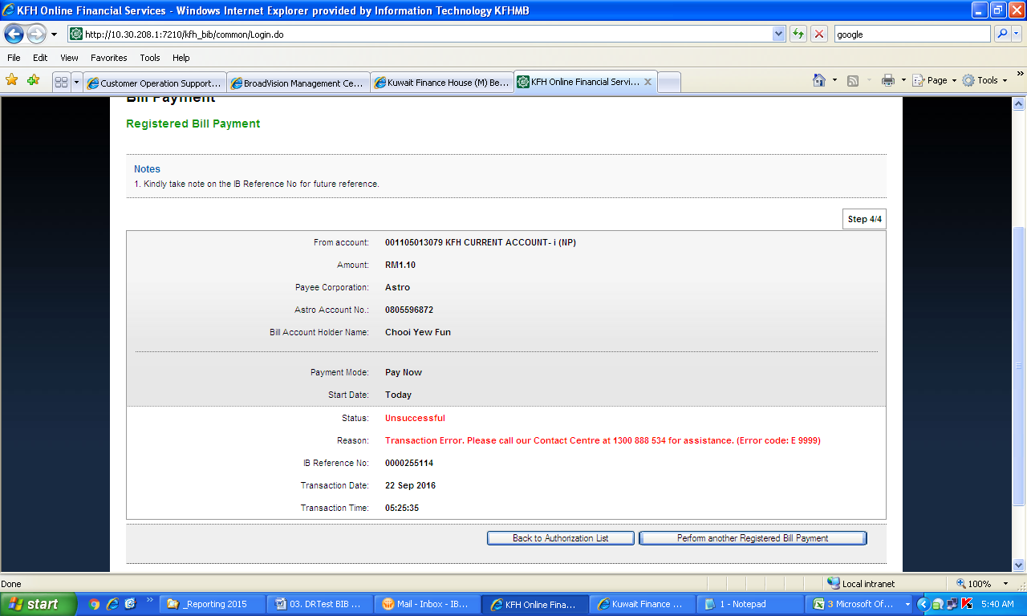

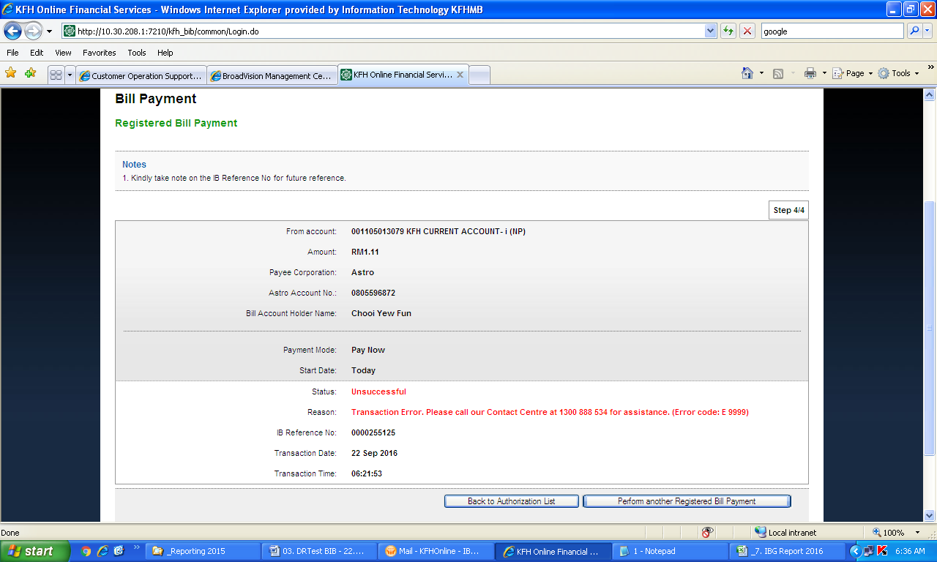

Perform Transaction – Confirmation page error

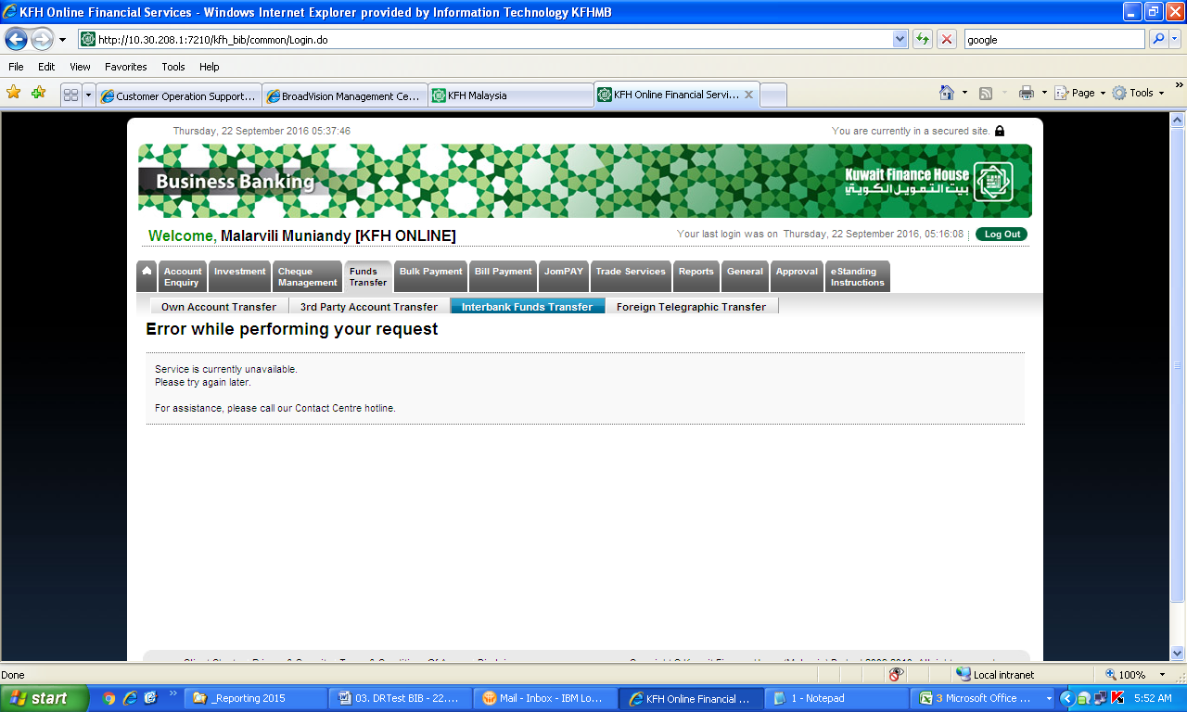

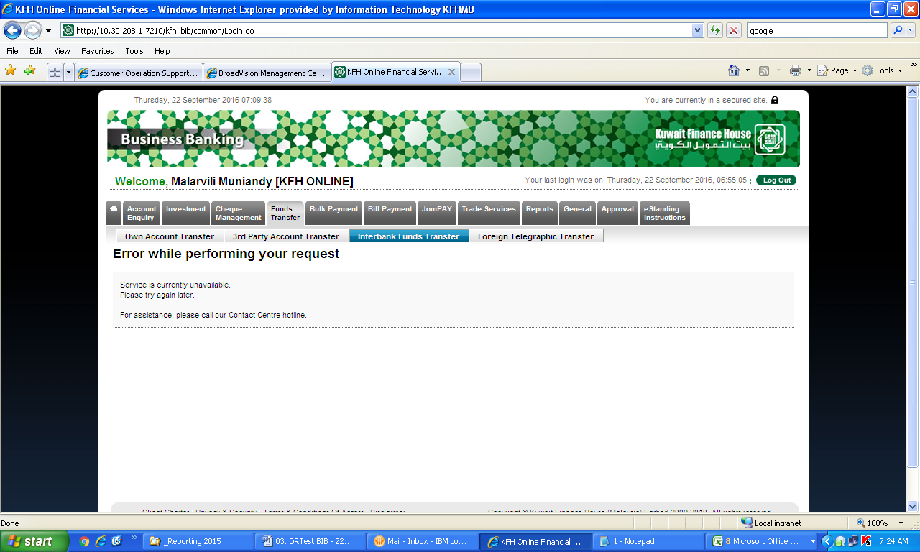

Proxy services provider - Prod

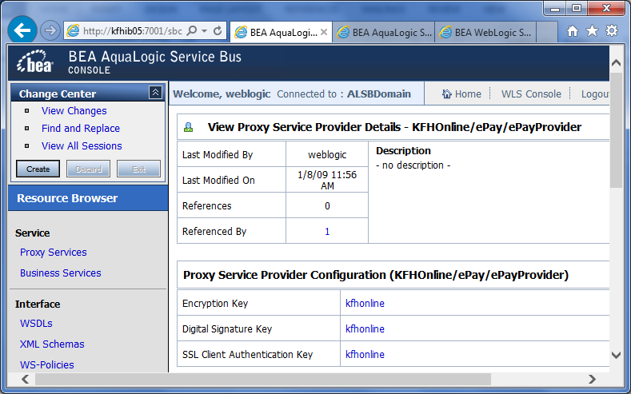

Proxy services provider - DR

