Test Issue Log |  |  |  |  |  | SCP ID# : 6523 (Parent Task)  SCP ID#: 6640
Project Name: | [Internal Testing] Statutory Body
Test Stage: | Unit Functionality Integration System Interface  Performance Regression Acceptance Pilot
Test Case Number: |  |  |  | Test Started Date: |  |  | 30/10/2016
Test Title: | Statutory Body - LHDN
Test Description: | - To ensure subject will display the correct error message.  - To ensure LHDN Transfer History has function to download the uploaded file.  https://10.6.6.20/bib.sit.takaful/common/Login.do
Test Functionality: | - BIB.SIT.LHDN:  - LHDN File Upload – display the correct error message  - LHDN Transfer History – has function to download the uploaded file.
Test Procedure: | - LHDN File Upload  - Login as Initiator/Single User and upload the file that has been edit to be “0000” on Deduction Year field.  - Display the error message.  (require the error message to be only: “Invalid Deduction Year”)  - Login as Initiator/Single User and upload the file that has been edit to be “00” on Deduction Month field.  - Display the error message.  (require the error message to be only: “Invalid Deduction Year”)  - LHDN Transfer History  - Login as Initiator/Single User.  - Go to LHDN Transfer History.  (require to new function that can download the uploaded file)
Test Result: | Pass: Fail: | Tested by: |  |  | Erni Suhaireen binti Zulkifli
Reason for Failure: | - LHDN File Upload – Failed to display the correct error message for Deduction Year field and Deduction Month field.  - LHDN Transfer History does not display function to download the uploaded file.  *please noted that these bug find when login as both Multiple User
TEST DESCRIPTION
  - LHDN File Upload
  - Enter the “Deduction Year” with zero number(0).
NO | RALAT | MESEJ KESALAHAN | STATUS
6 | Jika tahun potongan bukan dari tahun 1995 sehingga tahun semasa + 1 tahun.  Nota : Pihak bank perlu membenarkan tahun yang akan datang tetapi terhad kepada tahun semasa + 1 tahun. | Tahun Potongan Tidak Sah | 1.Jika tahun potongan bukan dari tahun 1995 sehingga tahun semasa:  Result : Tested and Failed.  No validation. File can be uploaded. To display error :  “Invalid Deduction Year”.  2.Tahun semasa+1 tahun :  Result : Tested and Pass  - >Tahun semasa + 1 tahun:  Result : Tested and failedNo validation. File can be uploaded. File can be uploaded. To display error “Invalid Deduction Year”
Error message results:

Current Result | Invalid Deduction Year.  Deduction Year is required.
Expected Result | Invalid Deduction Year.

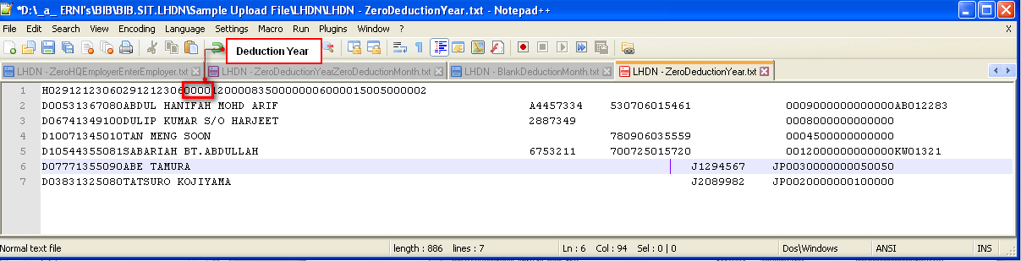
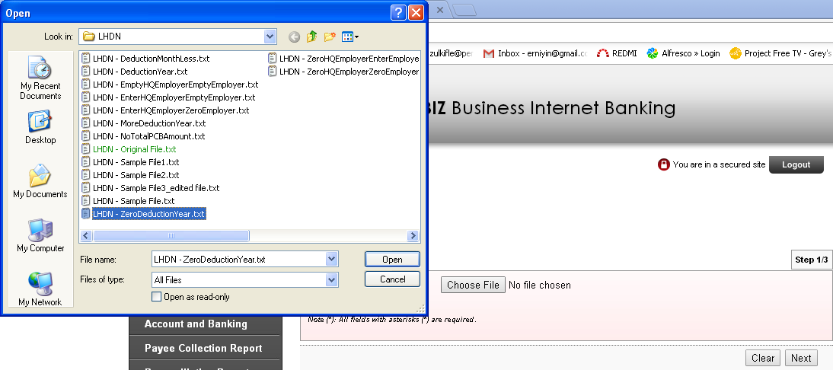
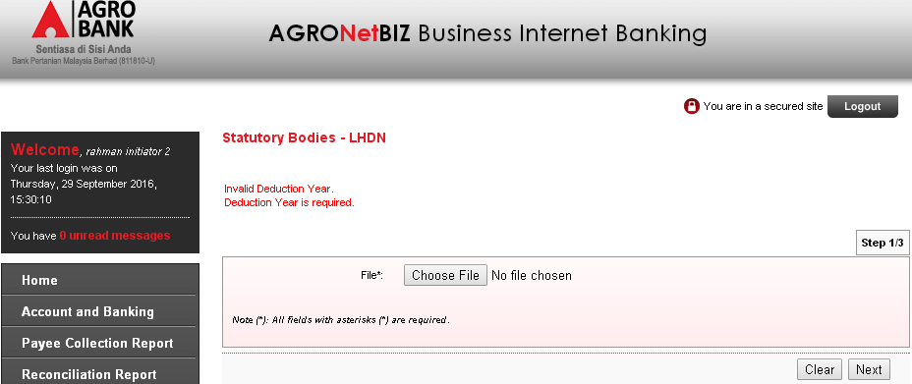

  - Enter the “Deduction Month” less than 01-12 (“00”)
NO | RALAT | MESEJ KESALAHAN | STATUS
7 | Jika bulan potongan selain dari 01 – 12 | Bulan Potongan Tidak Sah. | Result : Tested and failed.  No validation. File can be uploaded with mth of 13. To display error : “ Invalid Deduction Month”
Error message results:
Current Result | Invalid Deduction Month.  Deduction Month is required.
Expected | Invalid Deduction Month.
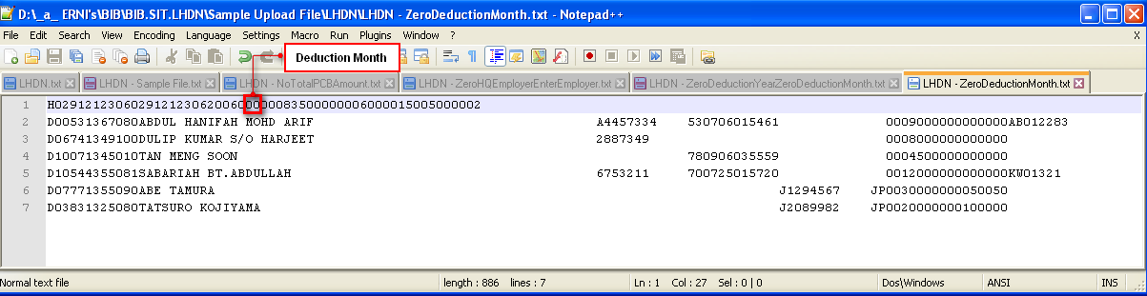
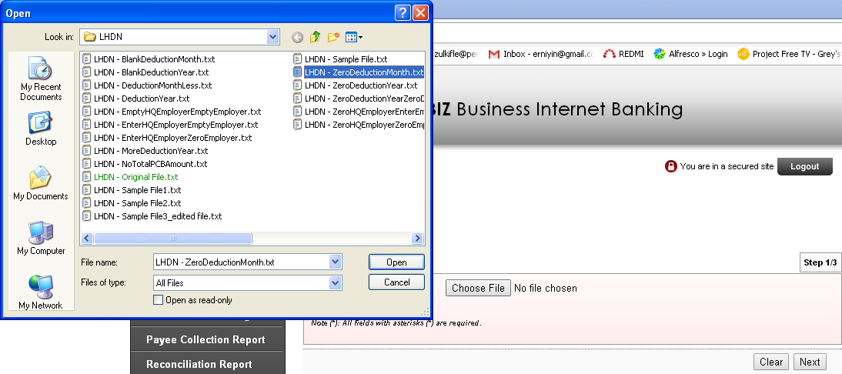
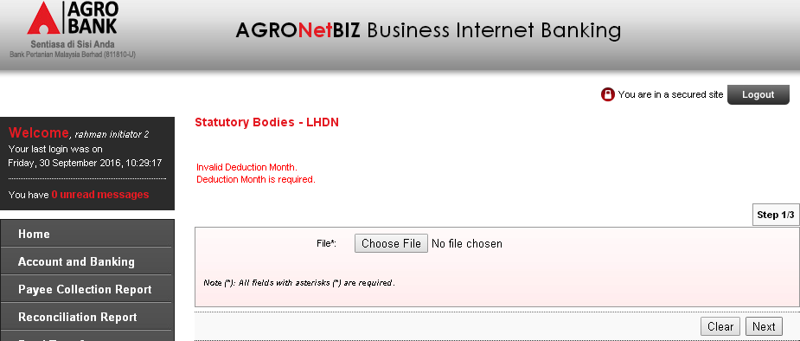

- Go to LHDN Transfer History to download the uploaded file.
Error message results:
Current Result | System does not display new updated requirement that require user to download the uploaded file.
Expected Result | Add new row to download the uploaded file that has been done on LHDN File Upload.

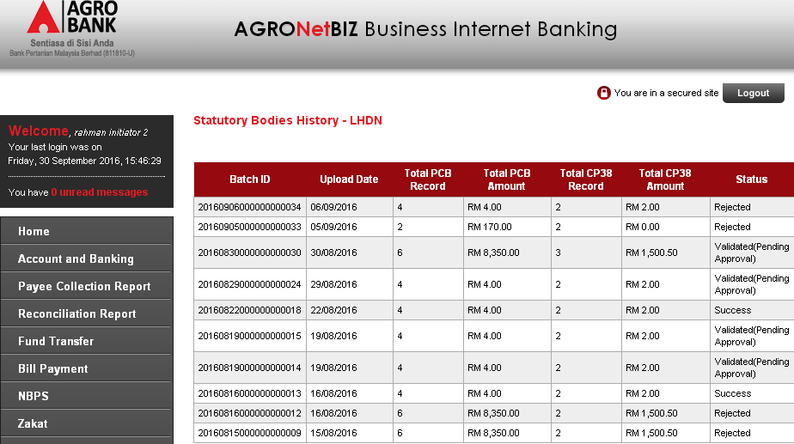

Reviewed By: (PMO)
Lizahwati |  |  | Name/Position : Lizahwati binti Basirun  Date :

