**URL –**

**http://www.kfh.com.my/kfhmb/v2/contentView.do?contentTypeId=3000&displayPage=%2Fver2%2Fcontent%2Fstandard.jsp&pageTypeId=12871&channelPath=%2Fver2%2Fv2_Navigation%2FOnline+Banking&programName=03_Services&contentId=12983**

**Services 🡪 e-Billers List**

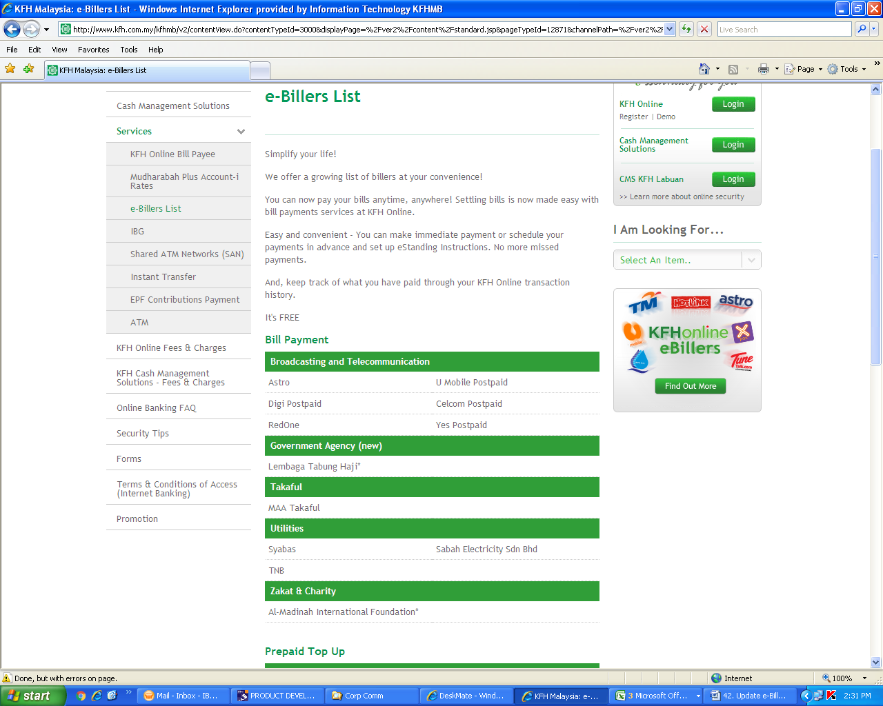

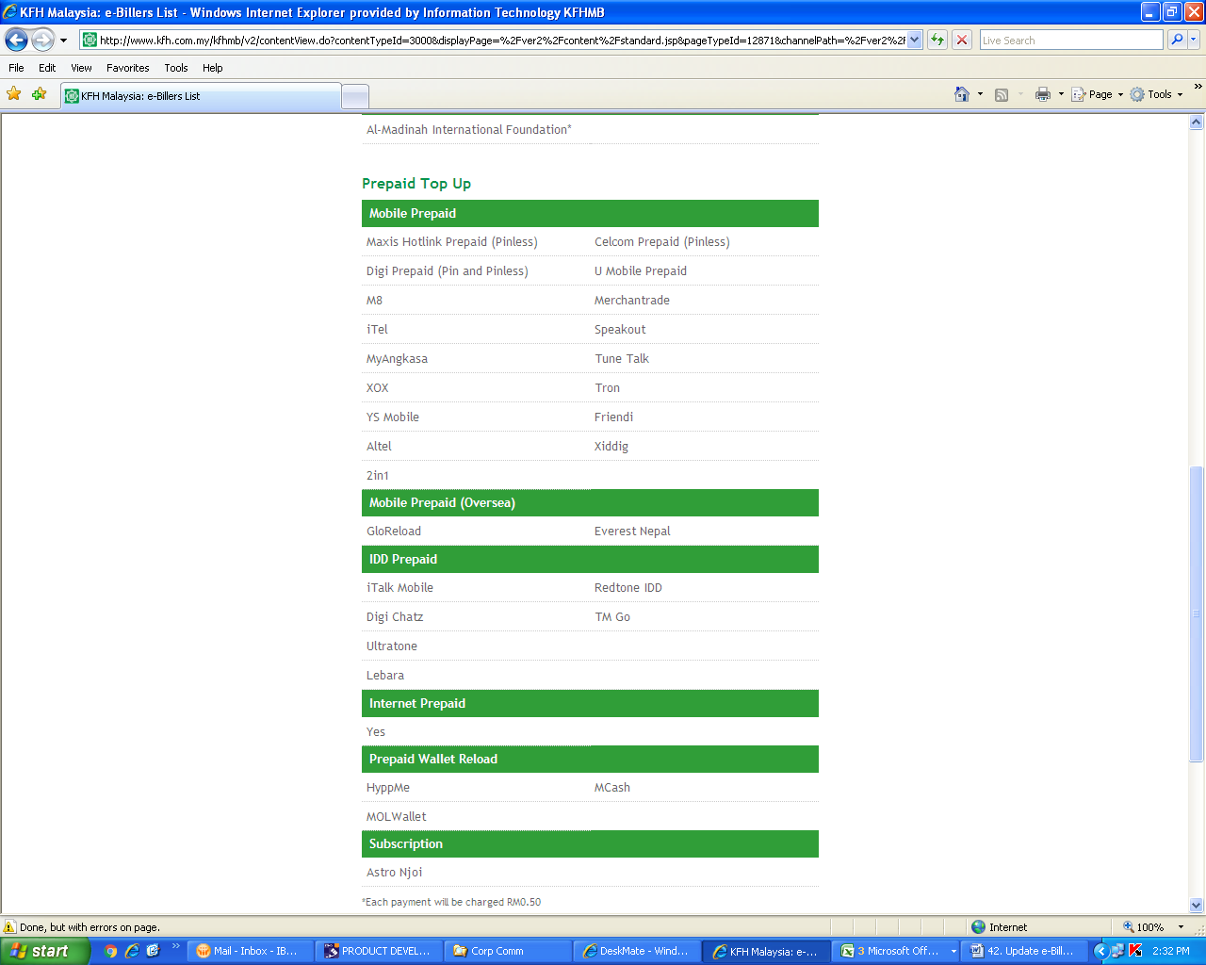

**Replace “GloReload” with “TreatsUp”**