View Executive details.

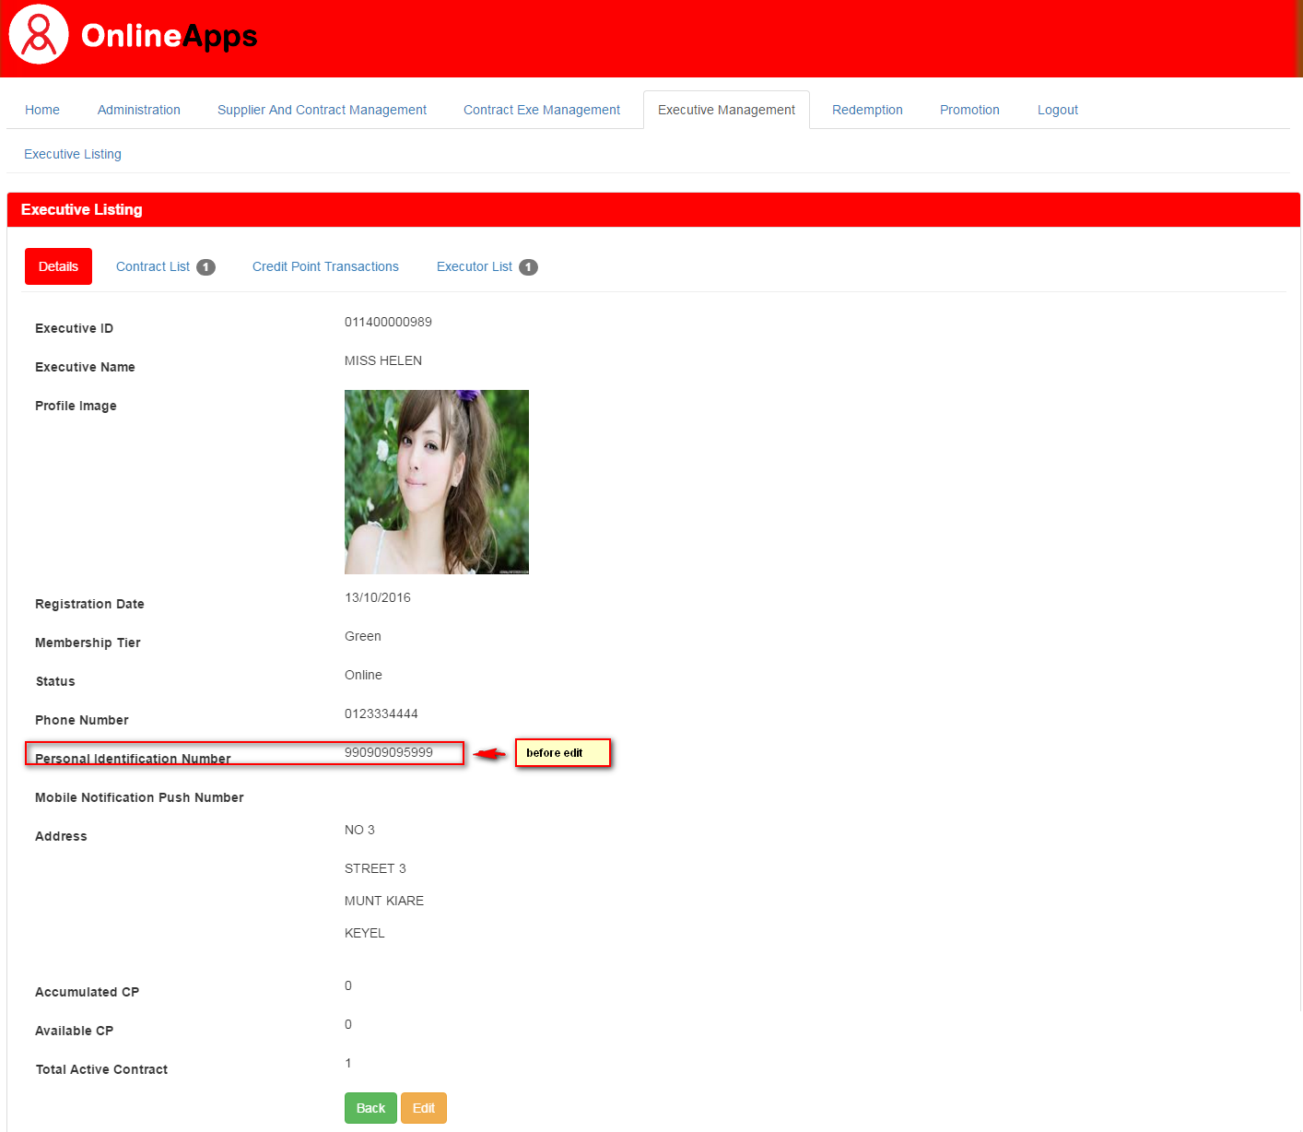

Edit Executive. For example, change Membership tier from Green to Silver

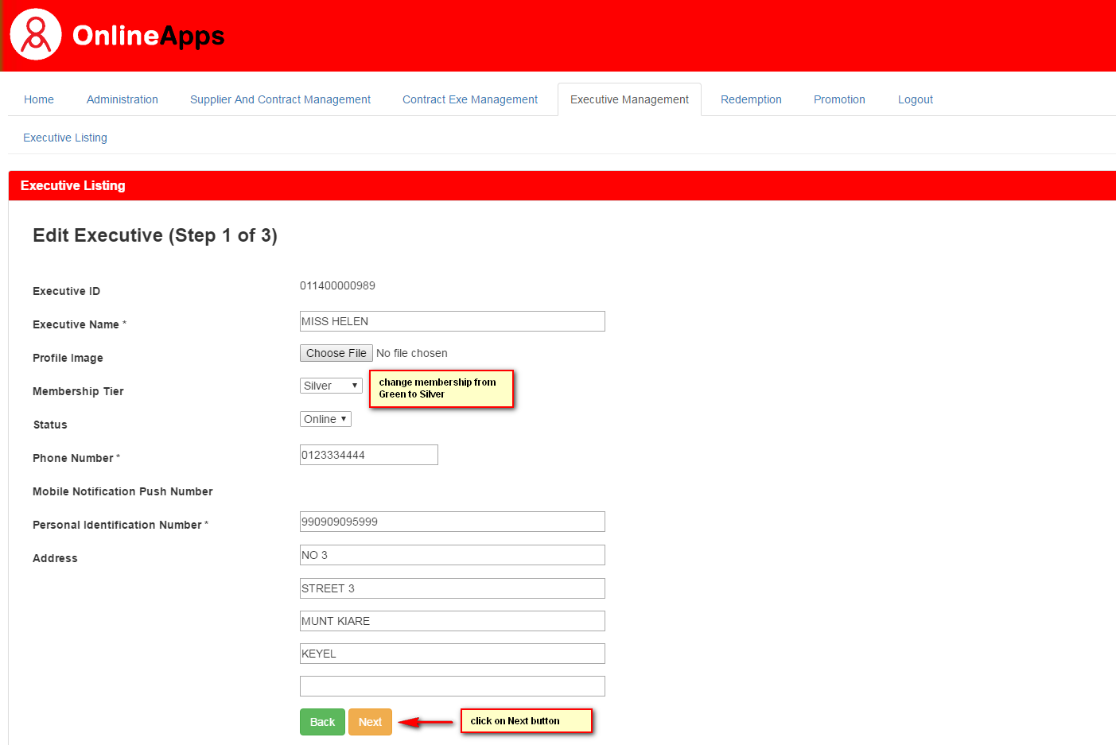

After click on Next button, Error Message appear.

