Test Issue Log |  |  |  |  |  | SCP ID# : 6689
Project Name: | [Internal Testing] IBAM Report – LHDN & SOCSO
Test Stage: | Unit Functionality Integration System Interface  Performance Regression Acceptance Pilot
Test Case Number: |  |  |  | Test Started Date: |  |  | 06/09/2016
Test Title: | [Internal Testing] BIB Report
Test Description: | - To ensure BIB Report display on current system meets the requirement needs.
Test Functionality: | - BIB Statutory Body LHDN Report Daily  -PDF  -EXCEL  - BIB Statutory Body SOCSO Report Daily  -PDF  -EXCEL
Test Procedure: | - BIB Statutory Body LHDN Report Daily  - Login as Administrator and go to BIB Report to download the report.  - BIB Statutory Body SOCSO Report Daily  - Login as Administrator and go to BIB Report to download the report.
Test Result: | Pass: Fail: | Tested by: |  |  | Erni Suhaireen binti Zulkifli
Reason for Failure: | BIB Statutory Body LHDN Report Daily  PDF Format  - Amount on Total Contribution Amount (MYR) at header does not equal to the Total Amount at the details. (Refer column 4).  - Total Amount at column 4 does not equal to the sum of PCB Amount and CP 38 Amount at column 3.  Excel Format  - Current system does not display those details on Header:  - Total File Upload, Company Name (Column 1)  - Total No of Records (Column 2)  - Total No of Success Records (Columns 3)  - Total Contribution Amount (MYR) (Column 4)  - Amount on Total Contribution Amount (MYR) at header does not equal to the Total Amount at the details. (Refer column 4).  - Total Amount at column 4 does not equal to the sum of PCB Amount and CP 38 Amount at column 3.  BIB Statutory Body SOCSO Report Daily  PDF Format  - No. of Records display on Report does not equal to total of record on upload file.  - Amount on Total Contribution Amount (MYR) at header does not equal to the Total Amount at the details. (Refer column 4).  Excel Format  - Current system does not display those details on Header:  - Total File Upload, Company Name (Column 1)  - Total No of Records (Column 2)  - Total No of Success Records (Columns 3)  - Total Contribution Amount (MYR) (Column 4)  - Amount on Total Contribution Amount (MYR) at header does not equal to the Total Amount at the details. (Refer column 4).  - No. of Records display on Report does not equal to total of record on upload file.
TEST DESCRIPTION
BIB Statutory Body LHDN Report Daily
PDF Format
- Amount on Total Contribution Amount (MYR) at header does not equal to the Total Amount at the details. (Refer column 4).
- Total Amount at column 4 does not equal to the sum of PCB Amount and CP 38 Amount at column 3.
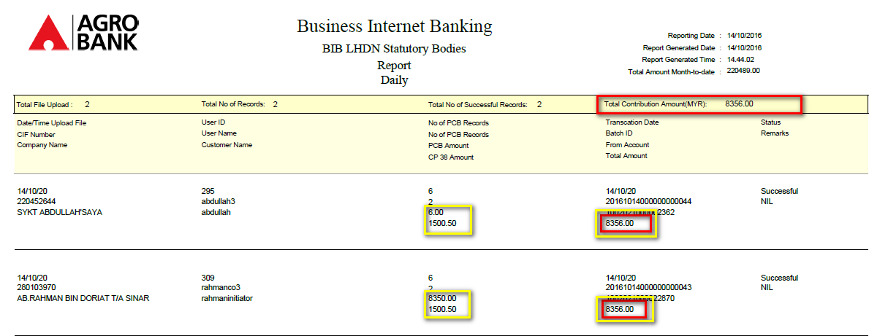

Excel Format
- Current system does not display those details on Header:
- Total File Upload, Company Name (Column 1)
- Total No of Records (Column 2)
- Total No of Success Records (Columns 3)
- Total Contribution Amount (MYR) (Column 4)
- Amount on Total Contribution Amount (MYR) at header does not equal to the Total Amount at the details. (Refer column 4).
- Total Amount at column 4 does not equal to the sum of PCB Amount and CP 38 Amount at column 3.

Sample of BIB Statutory Body Report Daily (Excel Format):
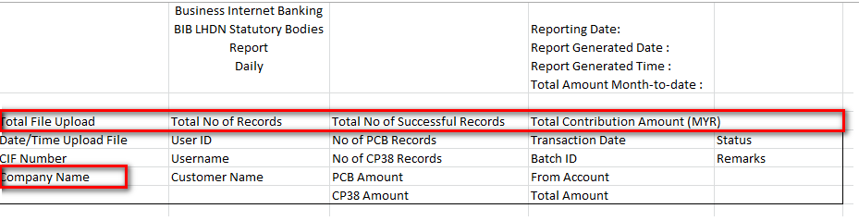Current System displayed:
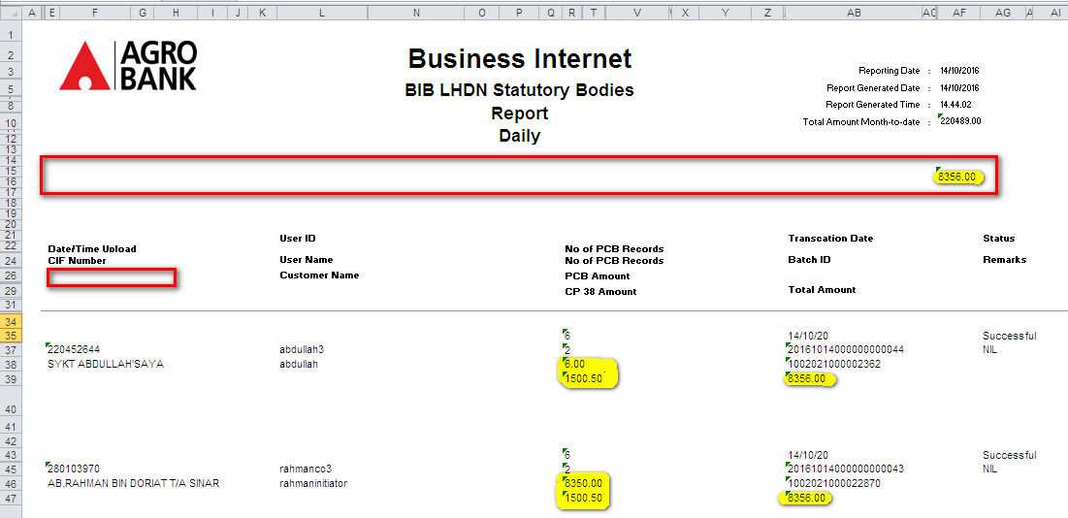

BIB Statutory Body SOCSO Report Daily
PDF Format
- No. of Records display on Report does not equal to total of record on upload file.
No. of Records display on Report: 2
Total Num. of Transaction: 4
Transaction Details
Transaction Batch ID: 20161014000000000039
Reference No.: 0000015104
Total Contribution: RM 20.00
Total Num. of Transaction: 4
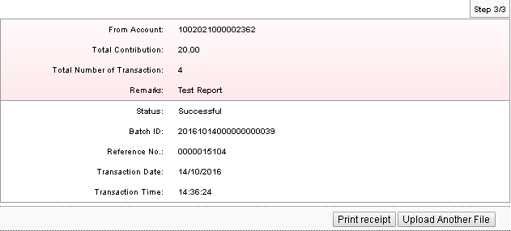
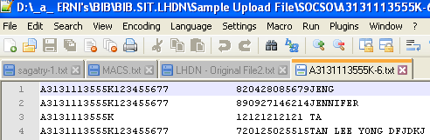
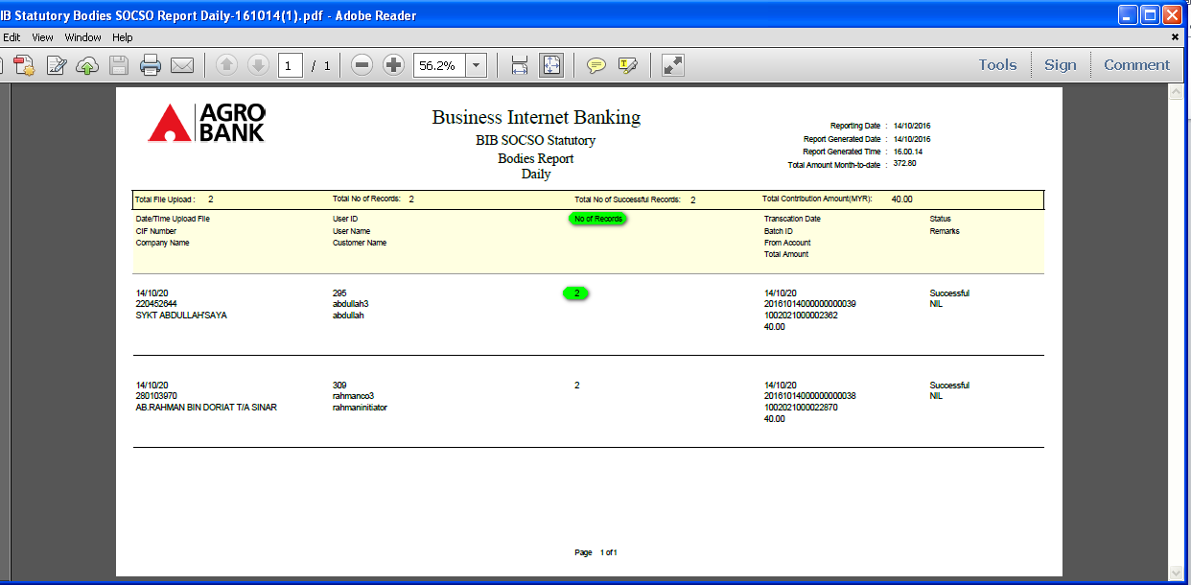

- Amount on Total Contribution Amount (MYR) at header does not equal to the Total Amount at the details. (Refer column 4).
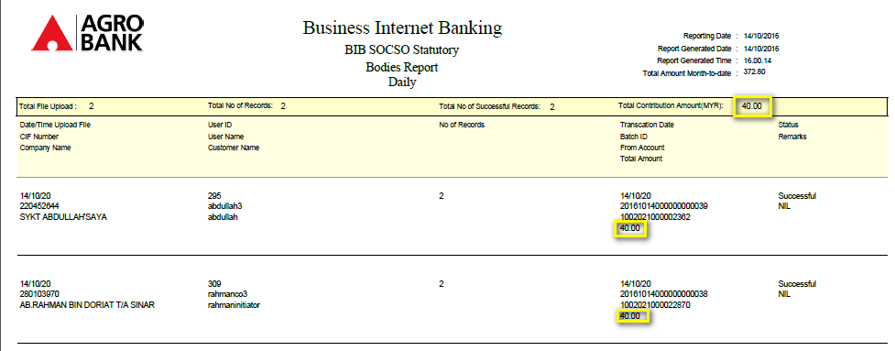

Excel Format
- Current system does not display those details on Header:
- Total File Upload, Company Name (Column 1)
- Total No of Records (Column 2)
- Total No of Success Records (Columns 3)
- Total Contribution Amount (MYR) (Column 4)
Sample of BIB Statutory Body Report Daily (Excel Format):
Current System displayed:
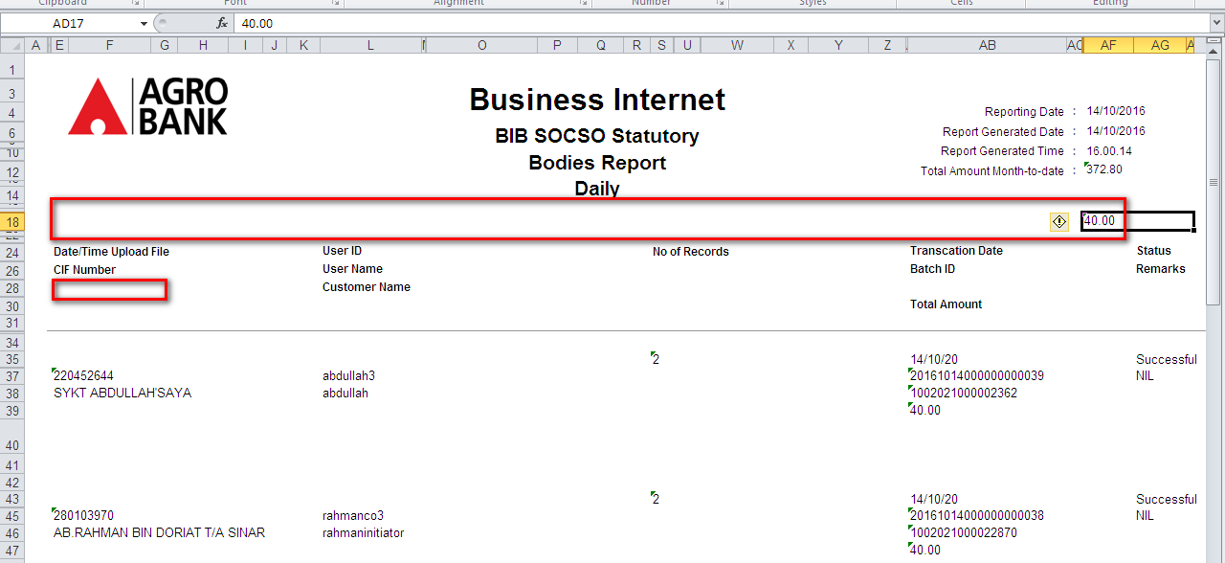

- Amount on Total Contribution Amount (MYR) at header does not equal to the Total Amount at the details. (Refer column 4).
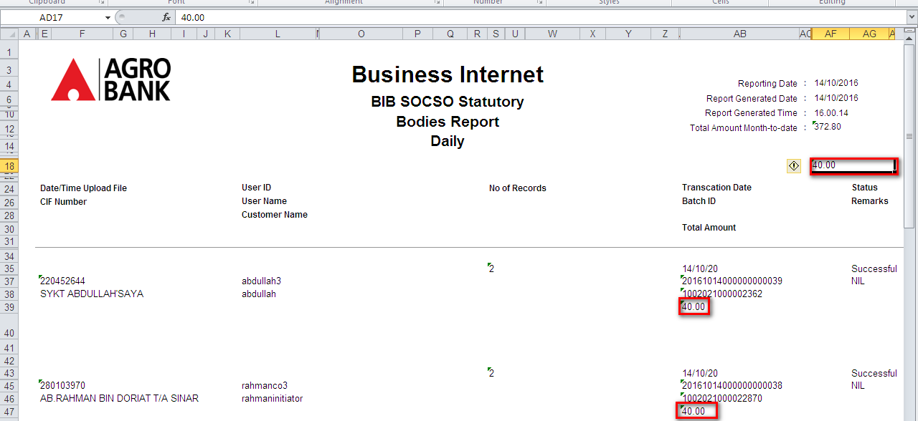

- No. of Records display on Report does not equal to total of record on upload file.
No. of Records display on Report: 2
Total Num. of Transaction: 4
Transaction Details
Transaction Batch ID: 20161014000000000039
Reference No.: 0000015104
Total Contribution: RM 20.00
Total Num. of Transaction: 4
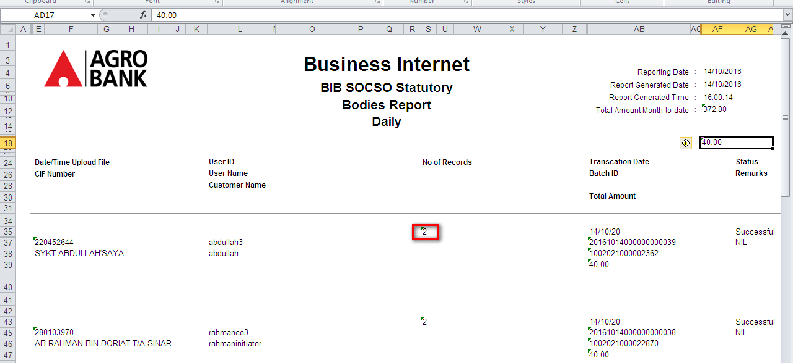

Reviewed By: (PMO)
Lizahwati |  |  | Name/Position : Lizahwati binti Basirun  Date :

