1. IBAM NOT DISPLAY DETAIL FOR COMPANY PROFILE BEFORE CHECKER APPROVE







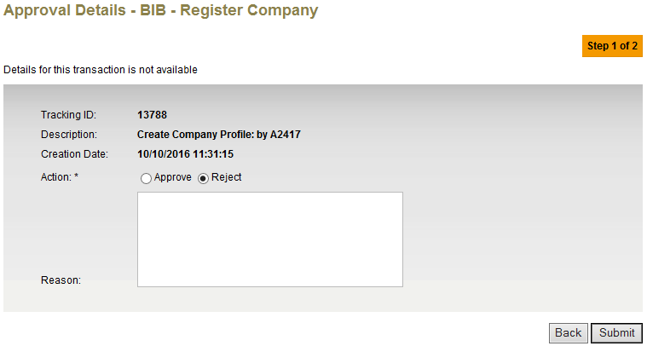

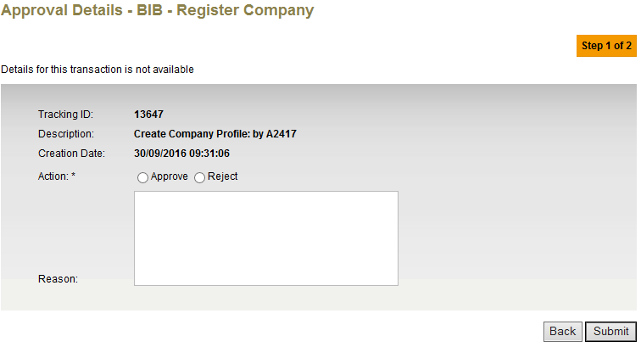

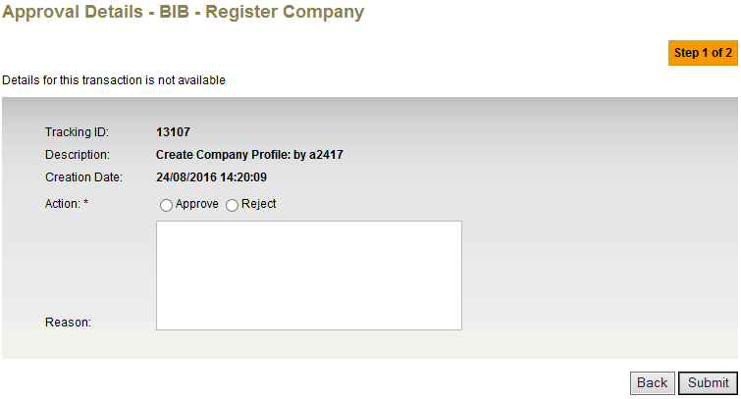

1. CHECKER UNABLE TO REJECT THE REQUEST



