Test Issue Log |  |  |  |  |  | SCP ID# : 6703
Project Name: | [Internal Testing] Statutory Body
Test Stage: | Unit Functionality Integration System Interface  Performance Regression Acceptance Pilot
Test Case Number: |  |  |  | Test Started Date: |  |  | 30/10/2016
Test Title: | Statutory Body - LHDN
Test Description: | - To ensure the new validation added applied on system  https://10.6.6.20/bib.sit.lhdn/common/Login.do
Test Functionality: | - LHDN – Employer Number Field
Test Procedure: | - LHDN File Upload  - Login as Initiator/Single User and upload the file that has been edit to be invalid employer number on Employer Number field.  - System throws error message : “Please register your employer number to LHDN department”
Test Result: | Pass: Fail: | Tested by: |  |  | Erni Suhaireen binti Zulkifli
Reason for Failure:
TEST DESCRIPTION
- Edit the LHDN file to be invalid employer number on Employer Number field.
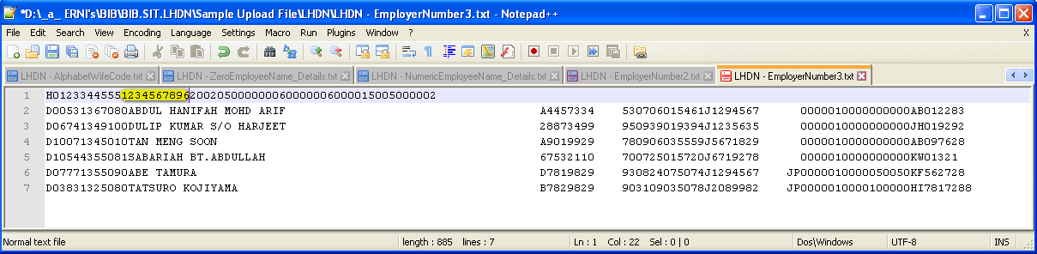
- Upload the file.
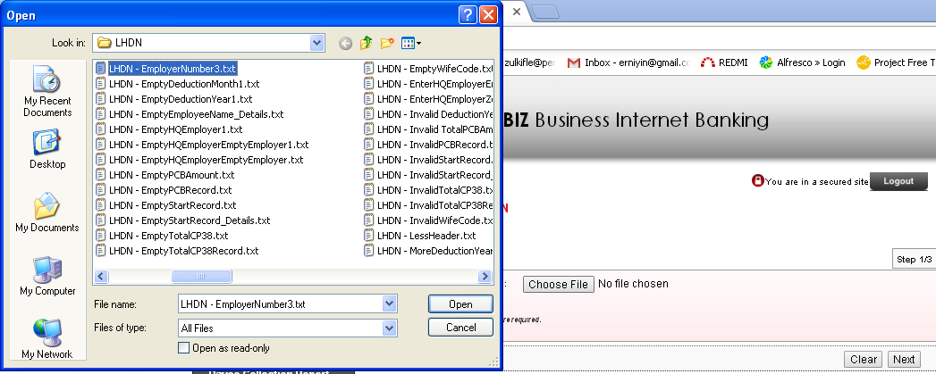
- System throws error message. 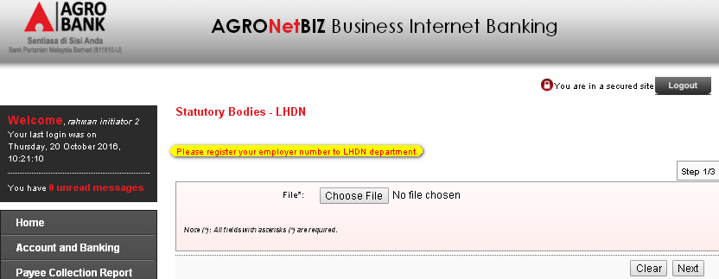
Reviewed By: (PMO)
Lizahwati |  |  | Name/Position : Lizahwati binti Basirun  Date :

