Test Issue Log |  |  |  |  |  | SCP ID# : 6689
Project Name: | [Internal Testing] IBAM Report – LHDN & SOCSO
Test Stage: | Unit Functionality Integration System Interface  Performance Regression Acceptance Pilot
Test Case Number: |  |  |  | Test Started Date: |  |  | 06/09/2016
Test Title: | [Internal Testing] BIB Report
Test Description: | - To ensure BIB Report display on current system meets the requirement needs.
Test Functionality: | - BIB Statutory Body LHDN Report Daily  -PDF  -EXCEL  - BIB Statutory Body SOCSO Report Daily  -PDF  -EXCEL
Test Procedure: | - BIB Statutory Body LHDN Report Daily  - Login as Administrator and go to BIB Report to download the report.  - BIB Statutory Body SOCSO Report Daily  - Login as Administrator and go to BIB Report to download the report.
Test Result: | Pass: Fail: | Tested by: |  |  | Erni Suhaireen binti Zulkifli
Reason for Failure: | BIB Statutory Body LHDN Report Daily  PDF Format  - Amount on Total Contribution Amount (MYR) at header does not equal to the Total Amount at the details. (Refer column 4).  - Total Amount at column 4 does not equal to the sum of PCB Amount and CP 38 Amount at column 3.  - There is only 2 Pending Approval Transaction, but the Total No. of Successful Records = 4  Excel Format  - Current system does not display those details on Header:  - Total File Upload, Company Name (Column 1)  - Total No of Records (Column 2)  - Total No of Success Records (Columns 3)  - Total Contribution Amount (MYR) (Column 4)  - Amount on Total Contribution Amount (MYR) at header does not equal to the Total Amount at the details. (Refer column 4).  - Total Amount at column 4 does not equal to the sum of PCB Amount and CP 38 Amount at column 3.  - There is only 2 Pending Approval Transaction, but the Total No. of Successful Records = 4  BIB Statutory Body SOCSO Report Daily  PDF Format  - No. of Records display on Report does not equal to total of record on upload file.  - Amount on Total Contribution Amount (MYR) at header does not equal to the Total Amount at the details. (Refer column 4).  - There is only 2 Pending Approval Transaction, but the Total No. of Successful Records = 3  Excel Format  - Current system does not display those details on Header:  - Total File Upload, Company Name (Column 1)  - Total No of Records (Column 2)  - Total No of Success Records (Columns 3)  - Total Contribution Amount (MYR) (Column 4)  - Amount on Total Contribution Amount (MYR) at header does not equal to the Total Amount at the details. (Refer column 4).  - No. of Records display on Report does not equal to total of record on upload file  - There is only 2 Pending Approval Transaction, but the Total No. of Successful Records = 3
TEST DESCRIPTION
BIB Statutory Body LHDN Report Daily
- Check whether these successful transactions were recorded on BIB Report IBAM.
  - Single User
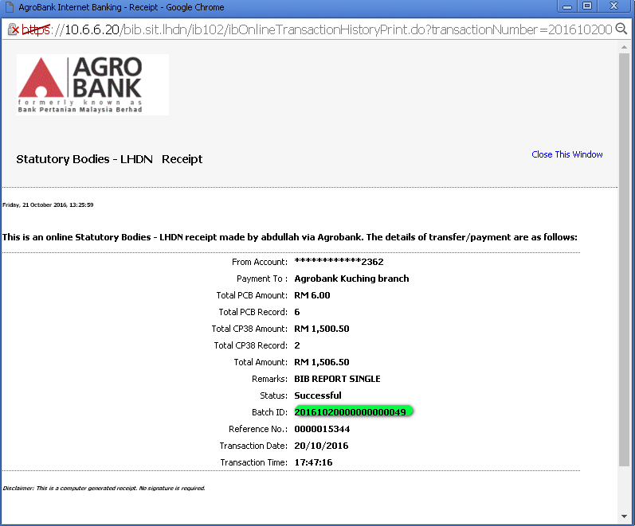

  - Multiple User
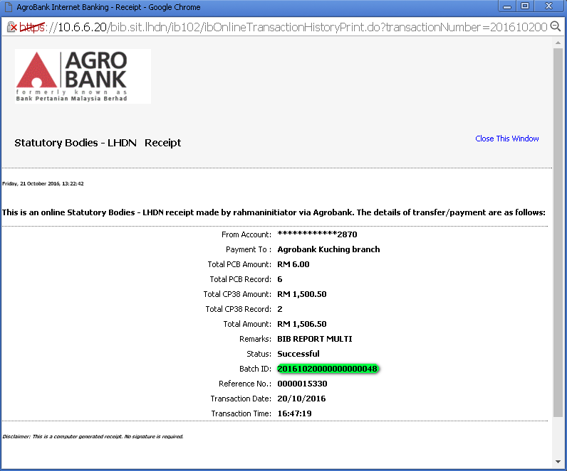

- Check whether the Pending Approval transaction was recorded on BIB Report
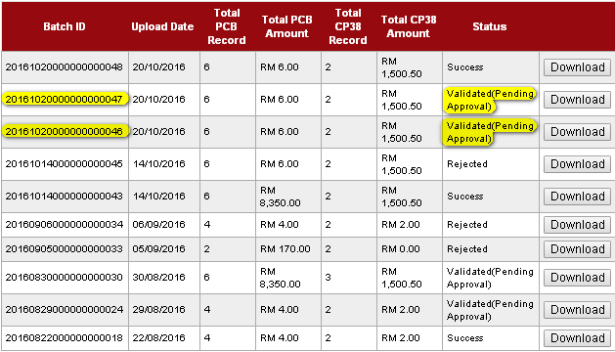

PDF Format
- On BIB Report page, Choose BIB Statutory Bodies LHDN Report Daily on Report Type, PDF on File Type, October on Month and 2016 on Year. Then click on “Search” button.
- Click on “Save” button of the selected report.
Result:
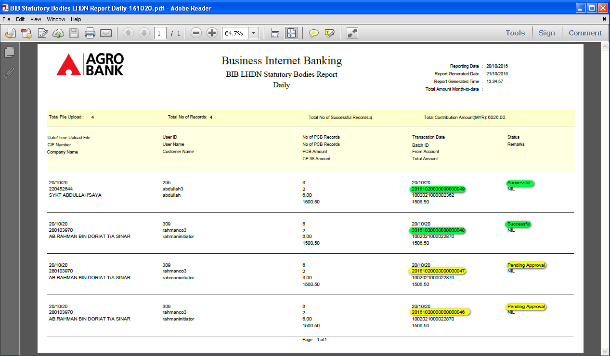
Bug Found:
- There is only 2 Pending Approval Transaction, but the Total No. of Successful Records = 4

Excel Format
- On BIB Report page, Choose BIB Statutory Bodies LHDN Report Daily on Report Type, Excelon File Type, October on Month and 2016 on Year. Then click on “Search” button.
- Click on “Save” button of the selected report.
Result:
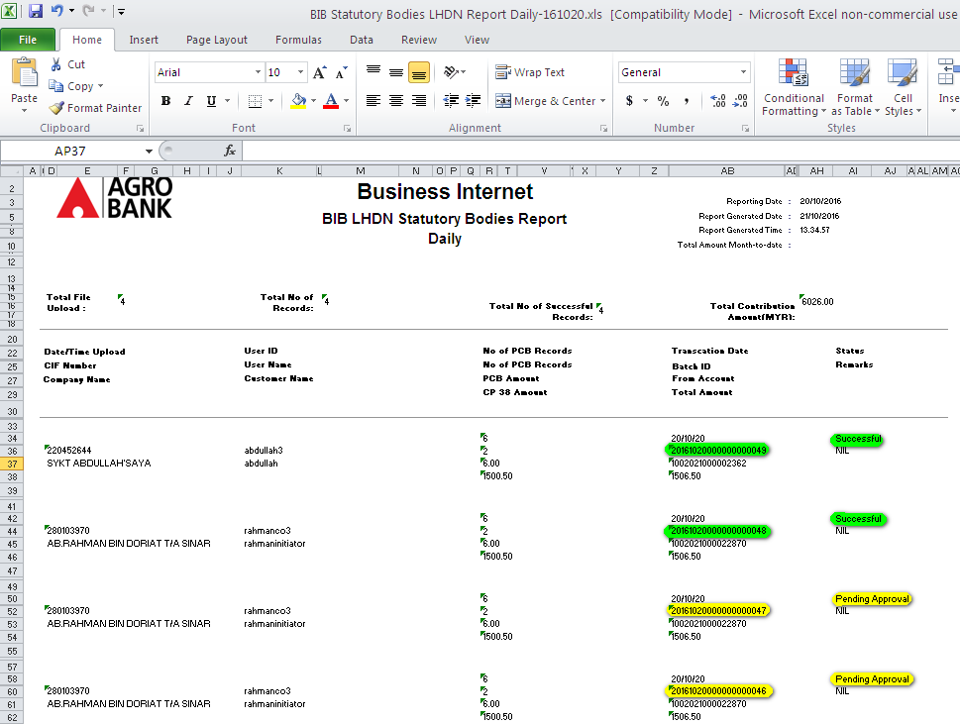
Bug Found:
- There is only 2 Pending Approval Transaction, but the Total No. of Successful Records = 4

BIB Statutory Body SOCSO Report Daily
- Check whether these successful transactions were recorded on BIB Report IBAM.
  - Single User
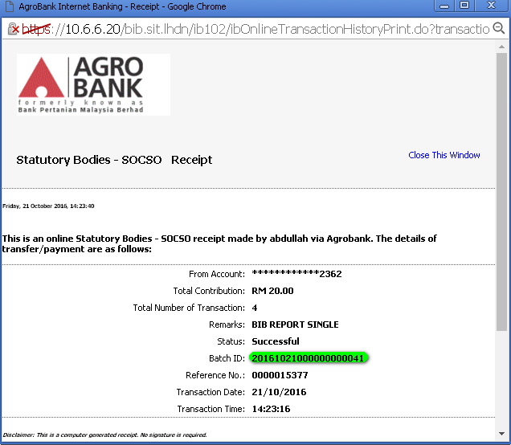

  - Multiple User
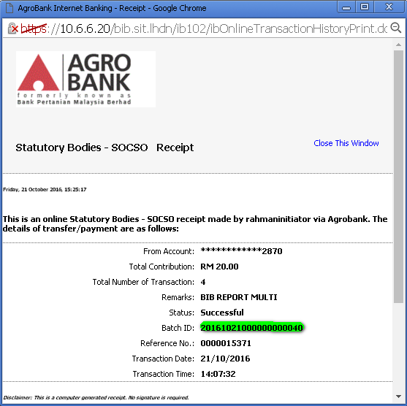

- Check whether the Pending Approval transaction was recorded on BIB Report
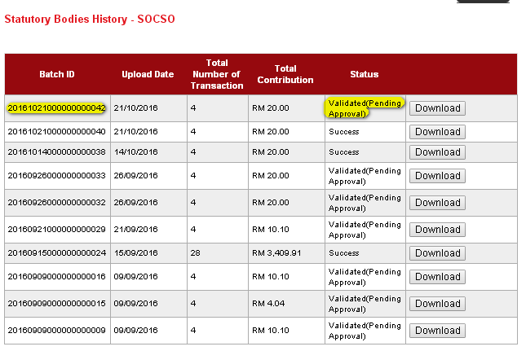

PDF Format
- On BIB Report page, Choose BIB Statutory Bodies SOCSO Report Daily on Report Type, PDF on File Type, October on Month and 2016 on Year. Then click on “Search” button.
- Click on “Save” button of the selected report.
Result:
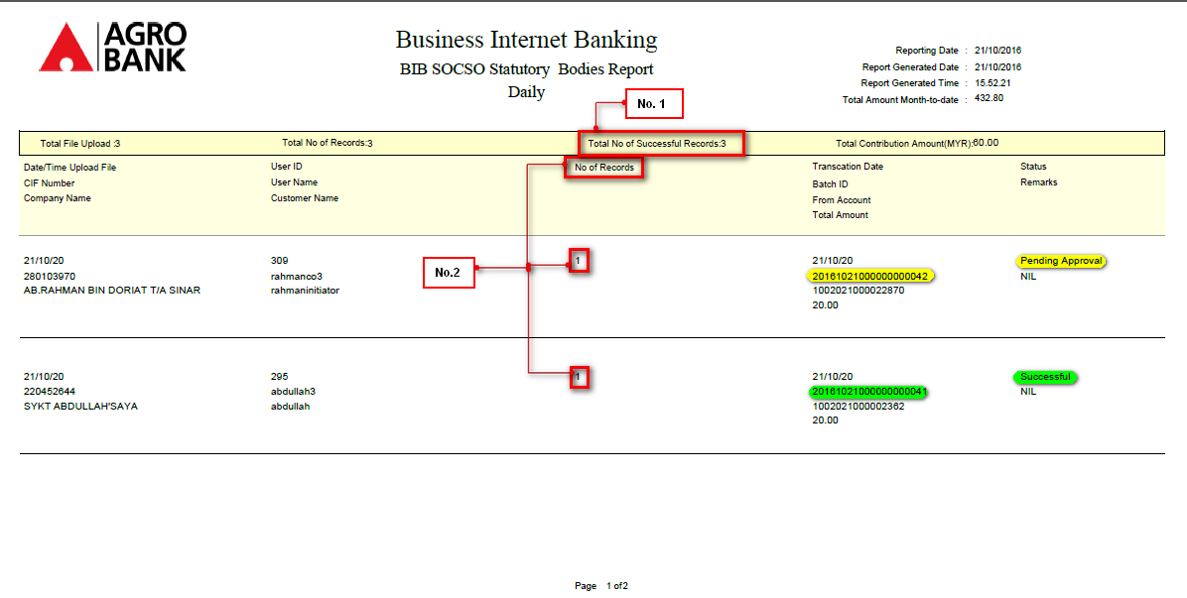
Page 1
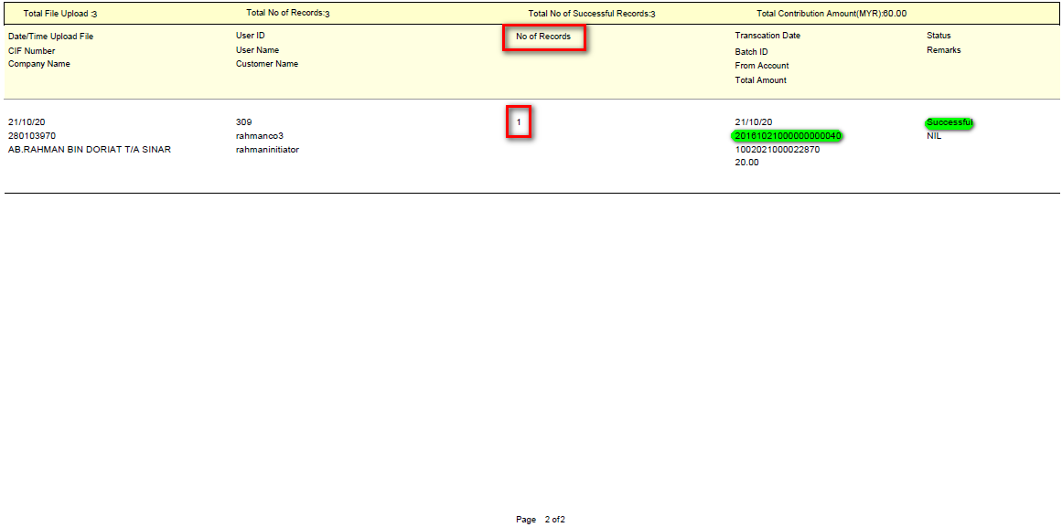
Page 2

Bug Found:
- No. of Records display on Report does not equal to total of record on upload file.
No. of Records display on Report: 2
Total Num. of Transaction: 4
Transaction Details
Transaction Batch ID: 20161020000000000040
Reference No.: 0000015371
Total Contribution: RM 20.00
Total Num. of Transaction: 4
Transaction Receipt:
Total Number of transaction is 4
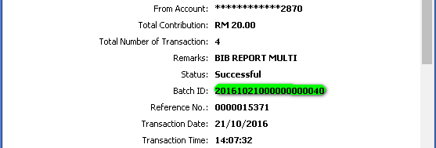
BIB Report:
No of Report is 1
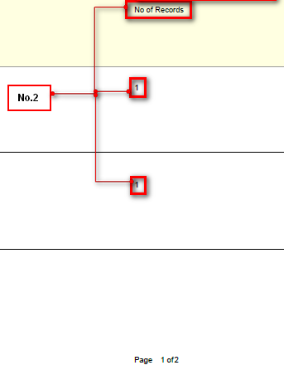

- There is only 2 Pending Approval Transaction, but the Total No. of Successful Records = 3

Excel Format
- On BIB Report page, Choose BIB Statutory Bodies SOCSO Report Daily on Report Type, Excel on File Type, October on Month and 2016 on Year. Then click on “Search” button.
- Click on “Save” button of the selected report.
Result:
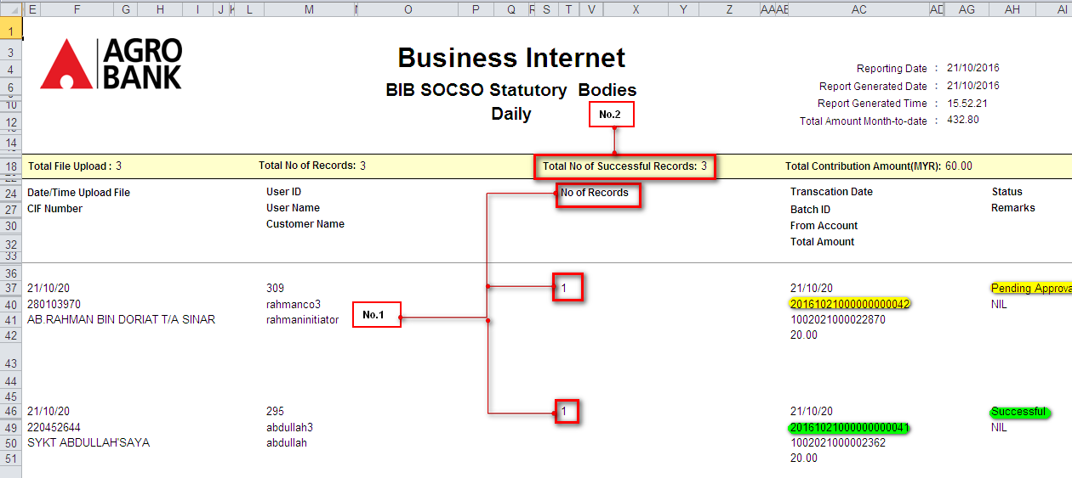
Page 1
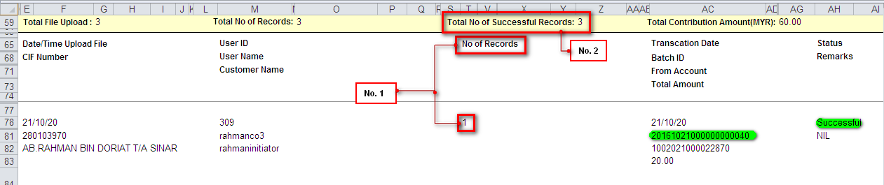
Page 2

Bug Found:
- No. of Records display on Report does not equal to total of record on upload file.
No. of Records display on Report: 2
Total Num. of Transaction: 4
Transaction Details
Transaction Batch ID: 20161020000000000040
Reference No.: 0000015371
Total Contribution: RM 20.00
Total Num. of Transaction: 4
Transaction Receipt:
Total Number of transaction is 4
BIB Report:
No of Report is 1
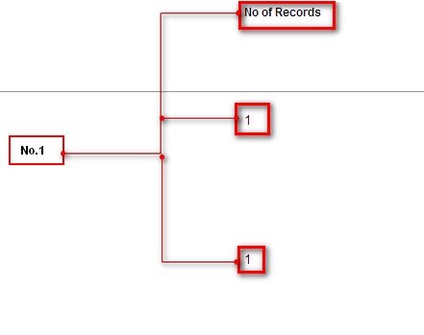
- There is only 2 Pending Approval Transaction, but the Total No. of Successful Records = 3
Reviewed By: (PMO)
Lizahwati |  |  | Name/Position : Lizahwati binti Basirun  Date :

