Internet Banking
Test Script – Takaful Payment BIB
(PENRIL/AGRO-IB/TS-023)
Revision: 01
10/06/2016

Prepared By:

Penril Datability (M) Sdn Bhd (816792-X)
Suite A-07-07 Plaza Mon’t Kiara
No. 2, Jalan Kiara, Mon’t Kiara
50480 Kuala Lumpur, Malaysia
Tel: (603) 6201 2622 Fax: (603) 6201 7622

REVISION
Rev. No | Date Updated | Description Of  Change | Updated By  <Name, Dept> | Reviewed By  <Name, Dept> | Approved By <Name, Dept>
00 | 10/06/2016 | Initial Release | Nurul Akmal binti Yusof  Penril Datability | Lizahwati Basirun  Penril Datability | Tan Lee Yong  Penril Datability
01 | 01/09/2016 | Updated based on URS v2.6 | Erni Suhaireen  Penril Datability | Lizahwati Basirun  Penril Datability | Tan Lee Yong  Penril Datability

TABLE OF CONTENTS

Business Internet Banking (BIB) 1
1. Role: Single User 1
1.1 Download Takaful Form 1
1.2 Takaful Purchase 2
1.3 Product Disclosure Sheet 10
2. Role: Initiator 11
2.1 Download Takaful Form 11
2.2 Takaful Purchase 12
2.3 Product Disclosure Sheet 21
3. Role: Approver 22
3.1 Authorization 22
Internet Banking Administrator Management (IBAM) 25
1. Role: Administrator 25
1.1 BIB Transaction Enquiry 25
1.2 BIB Report 27
ISSUES LOG 1

Business Internet Banking (BIB)

Role: Single User

Download Takaful Form
Test Ref : | AGRO/ Takaful Payment for BIB
Test Data Source: | AGRO-BRS-CR-20151216-Takaful Payment for BIB
Module / Screen: | BIB>Takaful>Download Takaful Form
Objectives: | Test basic system functionality that allows Single User role to download the Takaful form in order to fill up the details of the Takaful

Test Case# | Description | Area Path / Test Step | Expected Result | Test Result (Tick √) |  | Remarks / Comment
 |  |  |  | Pass | Fail
1.1 | Access to Takaful Module – Download Takaful Form | Agro-BIB>Takaful>Download Takaful Form  - Click on “Takaful” navigation.  - On the “Download Takaful Form” menu, click on the “Takaful Kasih Plus” | Display the page selection of Takaful form | √
1.2 | Access to Takaful Module – Download Takaful Form | Agro-BIB>Takaful>Download Takaful Form  - Click on “Download” button. | System display the page of downloaded Takaful Form in excel format. | √

Takaful Purchase

Purchase Takaful
Test Ref : | AGRO/ Takaful Payment for BIB
Test Data Source: | AGRO-BRS-CR-20151216-Takaful Payment for BIB
Module / Screen: | BIB>Takaful>Takaful Purchase
Objectives: | Test basic system functionality that allows Single User role to purchase Takaful using BIB system

Test Case# | Description | Area Path / Test Step | Expected Result | Test Result (Tick √) |  | Remarks / Comment
 |  |  |  | Pass | Fail
1.3 | Access to Purchase Takaful | Agro-BIB>Takaful>Purchase Takaful  - Choose on “Product” dropdown navigation.  - Choose on “Takaful” dropdown navigation. | System display pop up message  “This Takaful Plan is not eligible for a person who has physical disability”  System display Personal Takaful Bulk Page. | √
1.3.1 | Access to Purchase Takaful: Unselect on “Takaful Plan” dropdown navigation. | Agro-BIB>Takaful>Purchase Takaful  - Choose on “Product” dropdown navigation.  - Unselect on “Takaful” dropdown navigation. | Error Message  <Takaful Plan is required> | √
1.4 | Access to Purchase Takaful:  Perform Takaful Bulk | Agro-BIB>Takaful>Purchase Takaful>Takaful Bulk  - Choose on “From Account” dropdown navigation.  - Click on “Choose File” button to attached bulk file.  - Enter the “Total No. of Participants”. | System display confirm page. | √
1.4.1 | Access to Purchase Takaful:  Perform Takaful Bulk – Unselect on “From Account” dropdown. | Agro-BIB>Takaful>Purchase Takaful>Takaful Bulk  - Unselect on “From Account” dropdown navigation.  - Click on “Choose File” button to attached bulk file.  - Enter the “Total No. of Participants”. | Error Message  <From Account is required> | √
1.4.2 | Access to Purchase Takaful:  Perform Takaful Bulk – Unattached the bulk file. | Agro-BIB>Takaful>Purchase Takaful>Takaful Bulk  - Choose on “From Account” dropdown navigation.  - Unclick on “Choose File” button.  - Enter the “Total No. of Participants”. | Error Message  < File is required > | √
1.4.3 | Access to Purchase Takaful:  Perform Takaful Bulk –Does not enter the total no. of participants. | Agro-BIB>Takaful>Purchase Takaful>Takaful Bulk  - Choose on “From Account” dropdown navigation.  - Unclick on “Choose File” button.  - Does not enter the “Total No. of Participants”. | Error Message  < Total No. of Participants is required> | √
1.4.4 | Access to Purchase Takaful:  Perform Takaful Bulk –Attached other than Excel file type | Agro-BIB>Takaful>Purchase Takaful>Takaful Bulk  - Choose on “From Account” dropdown navigation.  - Click on “Choose File” button to attach other than Excel file type.  - Enter the “Total No. of Participants”. | Error Message  < Invalid File type> | √
1.4.5 | Access to Purchase Takaful:  Perform Takaful Bulk –The total no. of participants does not equal to the number entered on the file. | Agro-BIB>Takaful>Purchase Takaful>Takaful Bulk  - Choose on “From Account” dropdown navigation.  - Click on “Choose File” button to attached bulk file.  - Enter the different no. on “Total No. of Participants”. | Error Message  < Number of participant not same with File uploaded > | √
1.5 | Access to Purchase Takaful:  Perform Takaful Bulk – View Result Page | Agro-BIB>Takaful>Purchase Takaful>Takaful Bulk>Result Page.  - Enter the “Security Token PIN Number”.  - Click on “Confirm” button. | System display Result Page | √
1.5.1 | Access to Purchase Takaful:  Perform Takaful Bulk – View Result Page:  Enter security token with other than numeric character | Agro-BIB>Takaful>Purchase Takaful>Takaful Bulk>Result Page.  - Enter the “Security Token PIN Number” with other than numeric character  - Click on “Confirm” button. | Error Message  <Security Token must be numeric> | √
1.5.2 | Access to Purchase Takaful:  Perform Takaful Bulk – View Result Page:  Leave blank on “Security Token PIN Number”. | Agro-BIB>Takaful>Purchase Takaful>Takaful Bulk>Result Page.  - Leave blank on “Security Token PIN Number”.  - Click on “Confirm” button. | Error Message  <Security Token is required> | √
1.5.3 | Access to Purchase Takaful:  Perform Takaful Bulk – View Result Page:  Fill in Security Token PIN less than 6 digits | Agro-BIB>Takaful>Purchase Takaful>Takaful Bulk>Result Page.  - Fill in Security Token PIN less than 6 digits.  - Click on “Confirm” button. | Error Message  <Security Token PIN must consist of 6 digits.> | √
1.5.4 | Access to Purchase Takaful:  Perform Takaful Bulk – View Result Page:  Fill in invalid Security Token PIN | Agro-BIB>Takaful>Purchase Takaful>Takaful Bulk>Result Page.  - Fill in invalid Security Token PIN  - Click on “Confirm” button. | Error Message  <Invalid Security Token PIN.> |  |  | Require a valid security token.
1.5.6 | Access to Purchase Takaful:  Perform Takaful Bulk – View Result Page:  Fill in an expired/no longer valid Security Token PIN | Agro-BIB>Takaful>Purchase Takaful>Takaful Bulk>Result Page.  - Fill in an expired/no longer valid Security Token PIN  - Click on “Confirm” button. | Error Message  <Invalid Security Token PIN.> |  |  | Require a valid security token.
1.5.7 | Access to Purchase Takaful:  Perform Takaful Bulk – View Result Page:  Reach maximum length of attempt. | Agro-BIB>Takaful>Purchase Takaful>Takaful Bulk>Result Page.  - Reach maximum length of attempt of Security Token PIN  - Click on “Confirm” button. | Error Message  < Your Account has been locked. Please call Agro Bank’s Call Centre.> |  |  | Require a valid security token
1.5(a) | Access to Purchase Takaful: Perform Takaful Bulk – View result Page: Print Receipt | Agro-BIB>Takaful>Purchase Takaful>Takaful Bulk>Result Page.  - Click on “Print Receipt” button. | System displays the page of downloaded Takaful Bulk Receipts in PDF format. | √
1.5(b) | Access to Purchase Takaful: Perform Takaful Bulk – View result Page: Print Certificate | Agro-BIB>Takaful>Purchase Takaful>Takaful Bulk>Result Page.  - Click on “Print Receipt” button. | System displays the page of downloaded Takaful Bulk Certificate in PDF format. | √
1.5(c) | Access to Purchase Takaful: Perform Takaful Bulk – View result Page: Make another transaction | Agro-BIB>Takaful>Purchase Takaful>Takaful Bulk>Result Page.  - Click on “Make another transaction” button. | System display back on Personal Takaful Bulk Page. | √

Personal Takaful Inquiry
Test Ref : | AGRO/ Takaful Payment for BIB
Test Data Source: | AGRO-BRS-CR-20151216-Takaful Payment for BIB
Module / Screen: | BIB>Takaful>Personal Takaful Inquiry
Objectives: | Test basic system functionality that allows Single User role to display the Takaful purchase Inquiry and reprint the certificate and uploaded file using BIB system.

Test Case# | Description | Area Path / Test Step | Expected Result | Test Result (Tick √) |  | Remarks / Comment
 |  |  |  | Pass | Fail
1.6 | Access to Personal Takaful Inquiry page. | Agro-BIB>Takaful>Takaful Purchase>Personal Takaful Inquiry  - Click on “Personal Takaful Inquiry” page link. | System displays Personal Takaful Page. | √
1.7 | Access to Personal Takaful Inquiry page:  reprint Takaful Certificate | Agro-BIB>Takaful>Takaful Purchase>Personal Takaful Inquiry  - Click on “Reprint” button of the selected transaction. | System displays the page of downloaded Takaful Bulk Certificate in PDF format. | √
1.8 | Access to Personal Takaful Inquiry page:  Download File | Agro-BIB>Takaful>Takaful Purchase>Personal Takaful Inquiry  - Click on “Download File” button to print/save the uploaded file. | System will download the uploaded file in Excel format. | √

Agronet Transaction History
Test Ref : | AGRO/ Takaful Payment for BIB
Test Data Source: | AGRO-BRS-CR-20151216-Takaful Payment for BIB
Module / Screen: | BIB>Account and Banking>Agronet Transaction History
Objectives: | Test basic system functionality that allows Single User role to display the Takaful purchase history and reprint the receipt at Agronet Transaction History using BIB system.

Test Case# | Description | Area Path / Test Step | Expected Result | Test Result (Tick √) |  | Remarks / Comment
 |  |  |  | Pass | Fail
1.9 | Access to Agronet Transaction History: Display the Status | Agro-BIB>Account and Banking>Agronet Transaction History  - Go to Account and Banking page then select Agronet Transaction History on selected current account. | System will display Agronet Transaction History with the status of the submitted transaction. | √
1.10 | Access to Agronet Transaction History:  Reprint the receipt | Agro-BIB>Account and Banking>Agronet Transaction History  - Click on “Reprint” button of the selected transaction to print out/save the receipt. | System displays the page of downloaded Takaful Bulk Receipts in PDF format. | √

Product Disclosure Sheet
Test Ref : | AGRO/ Takaful Payment for BIB
Test Data Source: | AGRO-BRS-CR-20151216-Takaful Payment for BIB
Module / Screen: | BIB>Takaful>Product Disclosure Sheet
Objectives: | Test basic system functionality that allows Single User role to download the Product Disclosure Sheet

Test Case# | Description | Area Path / Test Step | Expected Result | Test Result (Tick √) |  | Remarks / Comment
 |  |  |  | Pass | Fail
1.9 | Access to Product Disclosure Sheet Page – Download Product Disclosure Sheet - Takaful Kasih Plus | Agro-BIB>Takaful>Product Disclosure Sheet  - Click on “Download” button. | System displays the page of downloaded Product Disclosure Sheet in PDF format. | √

Role: Initiator

Download Takaful Form
Test Ref : | AGRO/ Takaful Payment for BIB
Test Data Source: | AGRO-BRS-CR-20151216-Takaful Payment for BIB
Module / Screen: | BIB>Takaful>Download Takaful Form
Objectives: | Test basic system functionality that allows Initiator role to download the Takaful form in order to fill up the details of the Takaful

Test Case# | Description | Area Path / Test Step | Expected Result | Test Result (Tick √) |  | Remarks / Comment
 |  |  |  | Pass | Fail
2.1 | Access to Takaful Module – Download Takaful Form | Agro-BIB>Takaful>Download Takaful Form  - Click on “Takaful” navigation.  - On the “Download Takaful Form” menu, click on the “Takaful Kasih Plus” | Display the page selection of Takaful form | √
2.2 | Access to Takaful Module – Download Takaful Form | Agro-BIB>Takaful>Download Takaful Form  - Click on “Download” button. | System will download the Takaful Form in excel format. | √

Takaful Purchase

Purchase Takaful
Test Ref : | AGRO/ Takaful Payment for BIB
Test Data Source: | AGRO-BRS-CR-20151216-Takaful Payment for BIB
Module / Screen: | BIB>Takaful>Purchase Takaful
Objectives: | Test basic system functionality that allows Initiator role to purchase Takaful using BIB system

Test Case# | Description | Area Path / Test Step | Expected Result | Test Result (Tick √) |  | Remarks / Comment
 |  |  |  | Pass | Fail
2.3 | Access to Purchase Takaful | Agro-BIB>Takaful>Purchase Takaful  - Choose on “Product” dropdown navigation.  - Choose on “Takaful” dropdown navigation. | System display pop up message  “This takaful Plan is not eligible for a person who has physical disability”  System display Personal Takaful Bulk Page. | √
2.3.1 | Access to Purchase Takaful: Unselect on “Takaful Plan” dropdown navigation. | Agro-BIB>Takaful>Purchase Takaful  - Choose on “Product” dropdown navigation.  - Unselect on “Takaful” dropdown navigation. | Error Message  <Takaful Plan is required> | √
2.4 | Access to Purchase Takaful:  Perform Takaful Bulk | Agro-BIB>Takaful>Purchase Takaful>Takaful Bulk  - Choose on “From Account” dropdown navigation.  - Click on “Choose File” button to attached bulk file.  - Enter the “Total No. of Participants”. | System display confirm page. | √
2.4.1 | Access to Purchase Takaful:  Perform Takaful Bulk – Unselect on “From Account” dropdown. | Agro-BIB>Takaful>Purchase Takaful>Takaful Bulk  - Unselect on “From Account” dropdown navigation.  - Click on “Choose File” button to attached bulk file.  - Enter the “Total No. of Participants”. | Error Message  <From Account is required> | √
2.4.2 | Access to Purchase Takaful:  Perform Takaful Bulk – Unattached the bulk file. | Agro-BIB>Takaful>Purchase Takaful>Takaful Bulk  - Choose on “From Account” dropdown navigation.  - Unclick on “Choose File” button.  - Enter the “Total No. of Participants”. | Error Message  < File is required > | √
2.4.3 | Access to Purchase Takaful:  Perform Takaful Bulk –Does not enter the total no. of participants. | Agro-BIB>Takaful>Purchase Takaful>Takaful Bulk  - Choose on “From Account” dropdown navigation.  - Unclick on “Choose File” button.  - Does not enter the “Total No. of Participants”. | Error Message  < Total No. of Participants is required> | √
2.4.4 | Access to Purchase Takaful:  Perform Takaful Bulk –Attached other than Excel file type | Agro-BIB>Takaful>Purchase Takaful>Takaful Bulk  - Choose on “From Account” dropdown navigation.  - Click on “Choose File” button to attach other than Excel file type.  - Enter the “Total No. of Participants”. | Error Message  < Invalid File type> | √
2.4.5 | Access to Purchase Takaful:  Perform Takaful Bulk –The total no. of participants does not equal to the number entered on the file. | Agro-BIB>Takaful>Purchase Takaful>Takaful Bulk  - Choose on “From Account” dropdown navigation.  - Click on “Choose File” button to attached bulk file.  - Enter the different no. on “Total No. of Participants”. | Error Message  < Number of participant not same with File uploaded > | √
2.5 | Access to Purchase Takaful:  Perform Takaful Bulk – View Result Page | Agro-BIB>Takaful>Purchase Takaful>Takaful Bulk>Result Page.  - Click on “Confirm” button. | System display Result Page | √
2.5(a) | Access to Purchase Takaful: Perform Takaful Bulk – View result Page: Print Receipt | Agro-BIB>Takaful>Purchase Takaful>Takaful Bulk>Result Page.  - Click on “Print Receipt” button. | System displays the page of downloaded Takaful Bulk Receipts in PDF format. | √
2.5(b) | Access to Purchase Takaful: Perform Takaful Bulk – View result Page: Print Certificate | Agro-BIB>Takaful>Purchase Takaful>Takaful Bulk>Result Page.  - Click on “Print Receipt” button. | System displays the page of downloaded Takaful Bulk Certificate in PDF format. | √
2.5(c) | Access to Purchase Takaful: Perform Takaful Bulk – View result Page: Make another transaction | Agro-BIB>Takaful>Purchase Takaful>Takaful Bulk>Result Page.  - Click on “Make another transaction” button. | System display back on Personal Takaful Bulk Page. | √

Personal Takaful Inquiry
Test Ref : | AGRO/ Takaful Payment for BIB
Test Data Source: | AGRO-BRS-CR-20151216-Takaful Payment for BIB
Module / Screen: | BIB>Takaful>Personal Takaful Inquiry
Objectives: | Test basic system functionality that allows Single User role to display the Takaful purchase history and reprint the receipt using BIB system.

Test Case# | Description | Area Path / Test Step | Expected Result | Test Result (Tick √) |  | Remarks / Comment
 |  |  |  | Pass | Fail
2.6 | Access to Personal Takaful Inquiry page. | Agro-BIB>Takaful>Takaful Purchase>Personal Takaful Inquiry  - Click on “Personal Takaful Inquiry” page link. | System displays Personal Takaful Page. | √
2.7 | Access to Personal Takaful Inquiry page: reprint Takaful Certificate. | Agro-BIB>Takaful>Takaful Purchase>Personal Takaful Inquiry  - Click on “Reprint” button of the selected transaction. | System displays the page of downloaded Takaful Bulk Receipts in PDF format. | √
2.8 | Access to Personal Takaful Inquiry page:  Download File | Agro-BIB>Takaful>Takaful Purchase>Personal Takaful Inquiry  - Click on “Download File” button to print/save the uploaded file. | System will download the uploaded file in Excel format. | √

Agronet Transaction History
Test Ref : | AGRO/ Takaful Payment for BIB
Test Data Source: | AGRO-BRS-CR-20151216-Takaful Payment for BIB
Module / Screen: | BIB>Account and Banking>Agronet Transaction History
Objectives: | Test basic system functionality that allows Single User role to display the Takaful purchase history and reprint the receipt at Agronet Transaction History using BIB system.

Test Case# | Description | Area Path / Test Step | Expected Result | Test Result (Tick √) |  | Remarks / Comment
 |  |  |  | Pass | Fail
2.9 | Access to Agronet Transaction History: Display the Status | Agro-BIB>Account and Banking>Agronet Transaction History  - Go to Account and Banking page then select Agronet Transaction History on selected current account. | System will display Agronet Transaction History with the status of the submitted transaction. |  | √ | Status on Agronet Transaction History does not changed into Pending for Approver one (1) even when Approver from Group A has approved the transaction.  *refer screenshot
Screenshot:
- Initiate transaction with IB Ref. Number: 0000014812
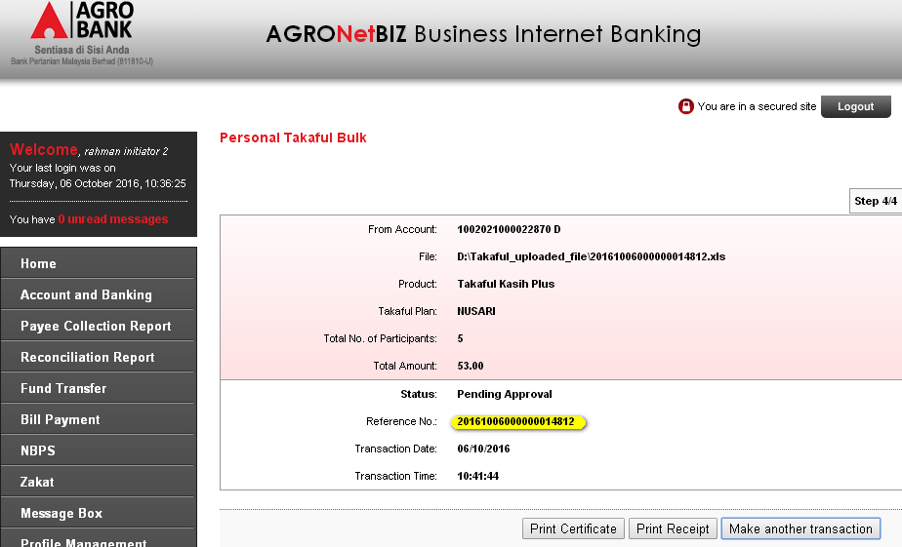
- Personal Takaful Inquiry
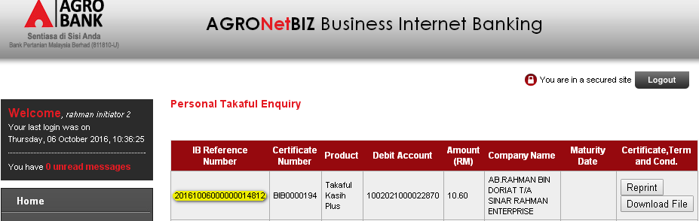
- Agronet transaction status before Approve from Group A and Group B approve.
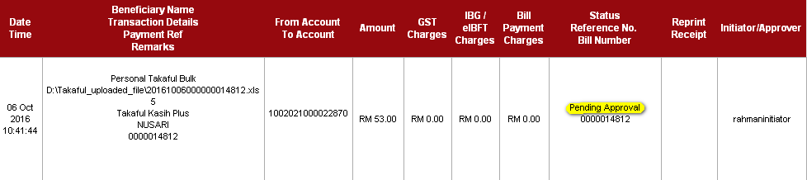

- Login as Approver Group A to approve the transaction.
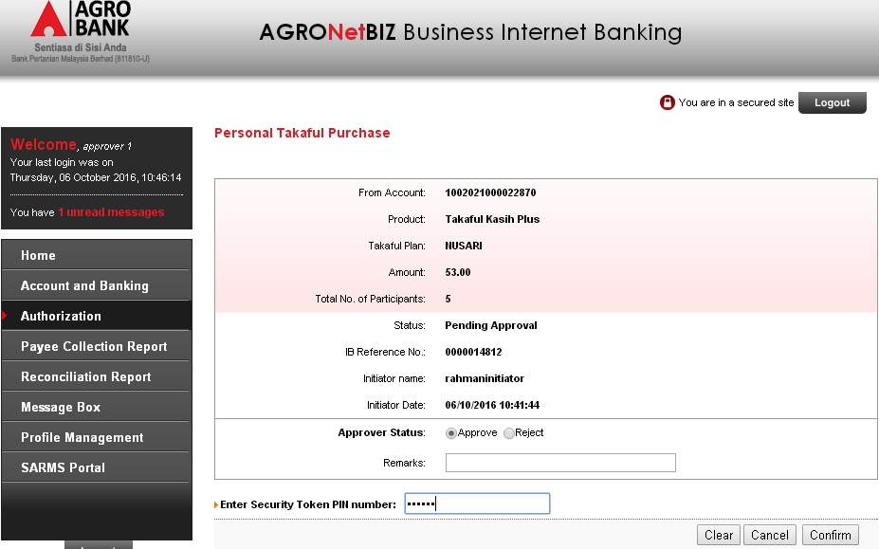
- Group A approve status: Pending Approval/The transaction is still pending 1 approver(s)
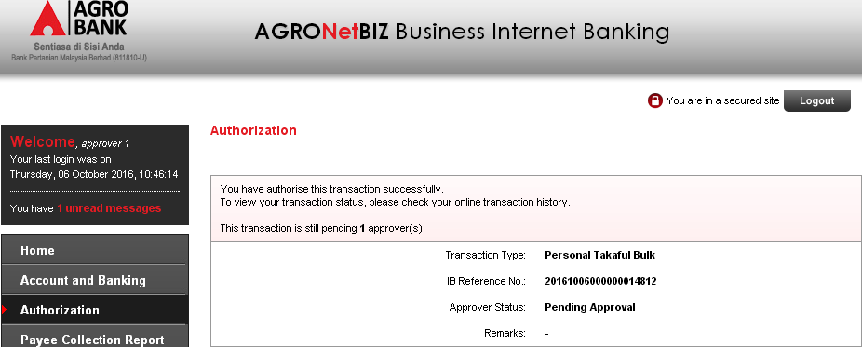

- Login back as Initiator to view the Agronet Transaction status.
Status: Pending Approval
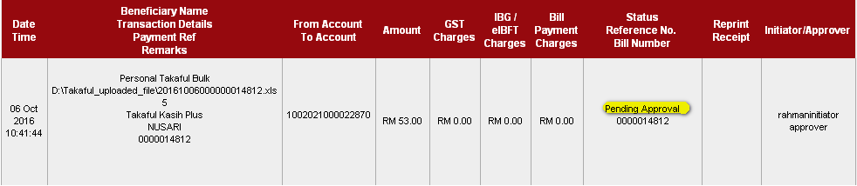
- Login as Approver Group B to approve the transaction.
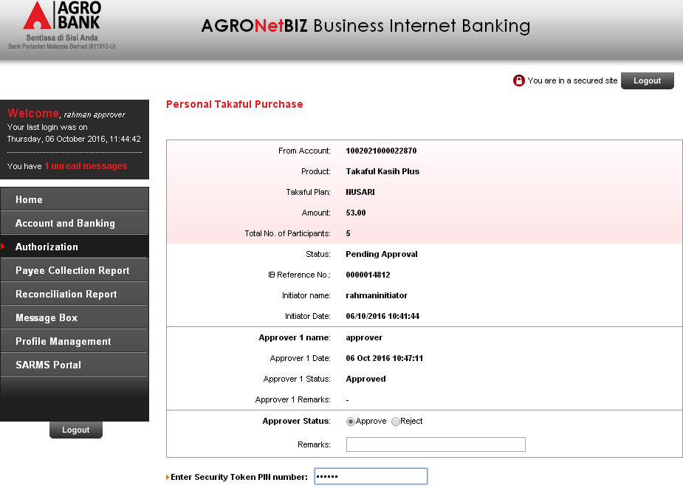

- Group B approve status: Successful
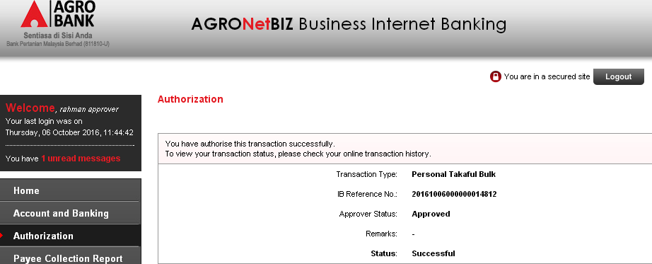
- Login back as Initiator to view the Agronet Transaction status.
Status: Successful
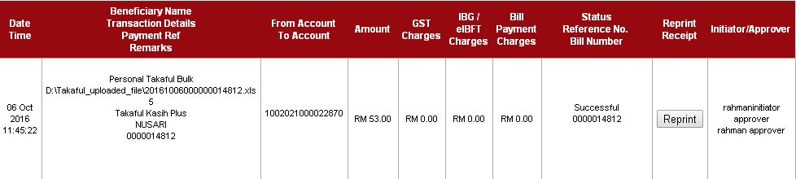
2.10 | Access to Agronet Transaction History:  Reprint the receipt | Agro-BIB>Account and Banking>Agronet Transaction History  - Click on “Reprint” button of the selected transaction to print out/save the receipt. | System displays the page of downloaded Takaful Bulk Receipts in PDF format. | √

Product Disclosure Sheet
Test Ref : | AGRO/ Takaful Payment for BIB
Test Data Source: | AGRO-BRS-CR-20151216-Takaful Payment for BIB
Module / Screen: | BIB>Takaful>Product Disclosure Sheet
Objectives: | Test basic system functionality that allows Single User role to download the Product Disclosure Sheet

Test Case# | Description | Area Path / Test Step | Expected Result | Test Result (Tick √) |  | Remarks / Comment
 |  |  |  | Pass | Fail
2.11 | Access to Product Disclosure Sheet Page – Download Product Disclosure Sheet - Takaful Kasih Plus | Agro-BIB>Takaful>Product Disclosure Sheet  - Click on “Download” button. | System displays the page of downloaded Product Disclosure Sheet in PDF format. | √

Role: Approver

Authorization
Test Ref : | AGRO/ Takaful Payment for BIB
Test Data Source: | AGRO-BRS-CR-20151216-Takaful Payment for BIB
Module / Screen: | BIB>Authorization
Objectives: | Test basic system functionality that allows Approver role to approve Takaful payment transaction using BIB system

Test Case# | Description | Area Path / Test Step | Expected Result  Pass | Test Result (Tick √)  Fail |  | Remarks / Comment
3.1 | View Authorization list | BIB >Authorization  - Click on “Authorization” navigation | Display transaction list with hyperlink to perform approval process | √
3.2.1 | Approve Takaful Payment – Enter valid data | BIB >Authorization>Takaful Payment  - Click on “Authorization” navigation  - Click On Personal Takaful purchase “IB Reference No” hyperlink  - Select “Approver Status”  - Enter “Remarks”  - Enter “Security Token PIN”  - Click “Confirm” button  - Click “Cancel” button  - Click “Clear” button | - Display result page with Takaful Payment’s details and status of the payment  If click Cancel:  Will go back to previous page  If click Clear:  Page will clear all the field | √
3.2.2 | Approve Takaful payment – Unselect and unfilled required field | BIB >Authorization>Takaful Payment  - Click on “Authorization” navigation  - Click On Takaful payment “IB Reference No” hyperlink  - Unselect “Approver Status”  - Enter “Remarks”  - Enter ” “ to “Security Token PIN”  - Click “Confirm” button | Error Message:  < Approver Status is required.>  <Security Token PIN is required.> | √
3.2.3 | Approve Takaful payment – Fill in Security Token PIN with other than numeric | BIB >Authorization> Takaful Payment  - Click on “Authorization” navigation  - Click On Takaful payment “IB Reference No” hyperlink  - Select “Approver Status”  - Enter “Remarks”  - Enter “123$%^” to “Security Token PIN”  - Click “Confirm” button | Error Message:  < Security Token PIN must be numeric.> | √
3.2.4 | Approve Takaful payment – Fill in Security Token PIN less than 6 digits | BIB >Authorization> Takaful Payment  - Click on “Authorization” navigation  - Click On Takaful payment “IB Reference No” hyperlink  - Unselect “Approver Status”  - Enter “Remarks”  - Enter “1234” to “Security Token PIN”  - Click “Confirm” button | Error Message:  <Security Token PIN must consist of 6 digits.> | √
3.2.5 | Approve Takaful payment – Fill in invalid Security Token PIN | BIB >Authorization> Takaful Payment  - Click on “Authorization” navigation  - Click On Takaful payment “IB Reference No” hyperlink  - Unselect “Approver Status”  - Enter “Remarks”  - Enter invalid Security Token PIN to “Security Token PIN”  - Click “Confirm” button | Error Message:  <Invalid Security Token PIN.> |  |  | Cannot by pass the security token
3.2.6 | Approve Takaful payment – Fill in an expired/no longer valid Security Token PIN | BIB >Authorization> Takaful Payment  - Click on “Authorization” navigation  - Click On Takaful payment “IB Reference No” hyperlink  - Unselect “Approver Status”  - Enter “Remarks”  - Enter expired/invalid Security Token PIN to “Security Token PIN”  - Click “Confirm” button | Error Message:  < Security Token PIN is expired.> |  |  | Cannot by pass the security token
3.2.7 | Approve Takaful payment – Reach maximum length of attempt. | BIB >Authorization> Takaful Payment  - Click on “Authorization” navigation  - Click On Takaful payment “IB Reference No” hyperlink  - Select “Approver Status”  - Enter “Remarks”  - Enter Security Token PIN several times  - Click “Confirm” button | Error Message:  < Your Account has been locked. Please call Agro Bank’s Call Centre.> |  |  | Cannot by pass the security token

Internet Banking Administrator Management (IBAM)

Role: Administrator

BIB Transaction Enquiry
Test Ref : | AGRO/ Takaful Payment for IBAM
Test Data Source: | AGRO-BRS-CR-20151216-Takaful Payment for IBAM
Module / Screen: | IBAM>BIB>BIB Transaction Enquiry
Objectives: | Test basic system functionality that allows Administrator to search the details of transaction.

Test Case# | Description | Area Path / Test Step | Expected Result | Test Result (Tick √) |  | Remarks / Comment
 |  |  |  | Pass | Fail
1.1 | Access to BIB Transaction Enquiry | Agro-IBAM>BIB>BIB Transaction Enquiry  - Entered all the required details of the transaction that need to be searched.  - Click on “search” button. | Display BIB Transaction – Search Result page | √
1.1(a) | Access to BIB Transaction Enquiry:  Click on “Clear” button | Agro-IBAM>BIB>BIB Transaction Enquiry  - Click on “Clear” button | System will clear up the entire field. | √
1.2 | Access to BIB Transaction Enquiry:  View the search result details | Agro-IBAM>BIB>BIB Transaction Enquiry  - Click on the transaction ID number. | System will displays the searched details | √
1.2(a) | Access to BIB Transaction Enquiry:  Click on “Back” button. | Agro-IBAM>BIB>BIB Transaction Enquiry  - Click on “Back” button. | System will go to the previous page. | √

1.3(a) | Access to BIB Transaction Enquiry:  Click on “Download” button | Agro-IBAM>BIB>BIB Transaction Enquiry  - Click on the transaction ID number. | System will download the uploaded bulk file by customer in Excel format. | √
1.3(b) | Access to BIB Transaction Enquiry:  Click on “Back” button | Agro-IBAM>BIB>BIB Transaction Enquiry  - Click on the “Back” button. | System will go back to previous page. | √

BIB Report
Test Ref : | AGRO/ Takaful Payment for IBAM
Test Data Source: | AGRO-BRS-CR-20151216-Takaful Payment for IBAM
Module / Screen: | IBAM>BIB>BIB Report
Objectives: | Test basic system functionality that allows Administrator to download the Monthly and Daily Report of Takaful Payment

Test Case# | Description | Area Path / Test Step | Expected Result | Test Result (Tick √) |  | Remarks / Comment
 |  |  |  | Pass | Fail
1.4(a) | Access to BIB Report | Agro-IBAM>BIB>BIB Report  - On the Report Type dropdown navigation, choose on “BIB Takaful Daily”.  - On the File Type dropdown navigation, Choose on “pdf”.  - Choose on Month dropdown navigation  - Choose on Year dropdown navigation | System will display the list of searched result  If no data on the selected date  System will display message:  “No Report Found.” | √
1.4(b) | Access to BIB Report | Agro-IBAM>BIB>BIB Report  - On the Report Type dropdown navigation, choose on “BIB Takaful Daily”.  - On the File Type dropdown navigation, Choose on “xls”.  - Choose on Month dropdown navigation  - Choose on Year dropdown navigation | System will display the list of searched result  If no data on the selected date  System will display message:  “No Report Found.” | √
1.5 | Access to BIB Report:  Download the report | Agro-IBAM>BIB>BIB Report  - Click on the “save” button to download the selected report. | System will download the report in PDF format. |  | √ | Bug in displaying Israq product type
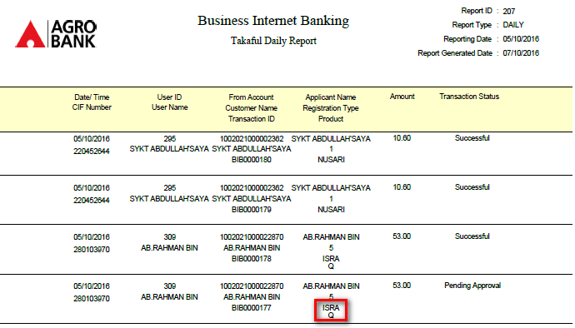

ISSUES LOG
Issue Log No. | Menu | Module | Issue Date | Test Case#  Description/Test Scenario | Actual Result | Screenshot  (if any) | Expected Result | Tester Name | Issue Status | Responsibility | Retest Status | Date-Close | Remarks / Action Taken | Severity | Root Cause

