Test Issue Log |  |  |  |  |  | SCP ID#: [UAT_TAK-003]
Project Name: | Agrobank Retail Internet Banking
Test Stage: | Unit Functionality Integration System Interface  Performance Regression Acceptance Pilot
Test Case Number: | Task #6729 |  | Test Started Date: |  |  |  | 26/10/2016
Test Title: | [UAT_Tak-003] : BIB > LOGIN - HOME
Test Description: | - To ensure Single User Company and Multiple User Company display Takaful module after login.  https://10.6.6.20/bib.uat.takaful/common/Login.do
Test Functionality: | - Single User Company  - Multiple User Company
Test Procedure: | - Single User Company  - Login as Single User (singlesamat1) on BIB.UAT.TAKAFUL  - Click on Takaful Module  - Multiple User Company  - Login as Multiple User (InitiatorSinar)on BIB.UAT.TAKAFUL  - Click on Takaful Module
Test Result: | Pass: Fail: | Tested by: |  |  | Erni Suhaireen binti Zulkifli
Reason for Failure:
TEST DESCRIPTION
- Single User Company
  - Login as Single User (singlesamat1) on BIB.UAT.TAKAFUL


  - Click on Takaful Module
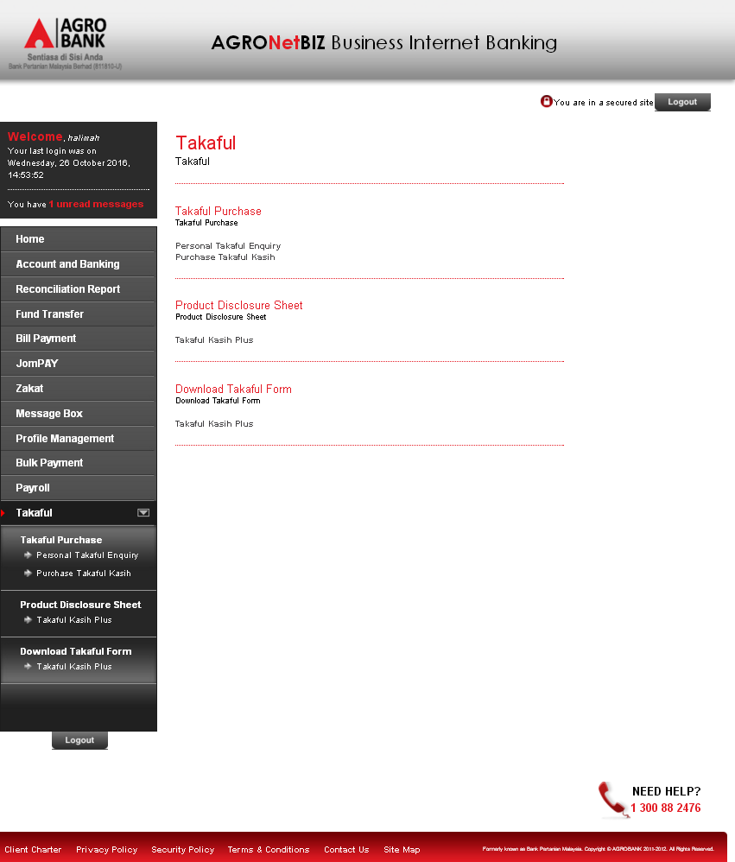

- Multiple User Company
  - Login as Multiple User (InitiatorSinar)on BIB.UAT.TAKAFUL


  - Click on Takaful Module
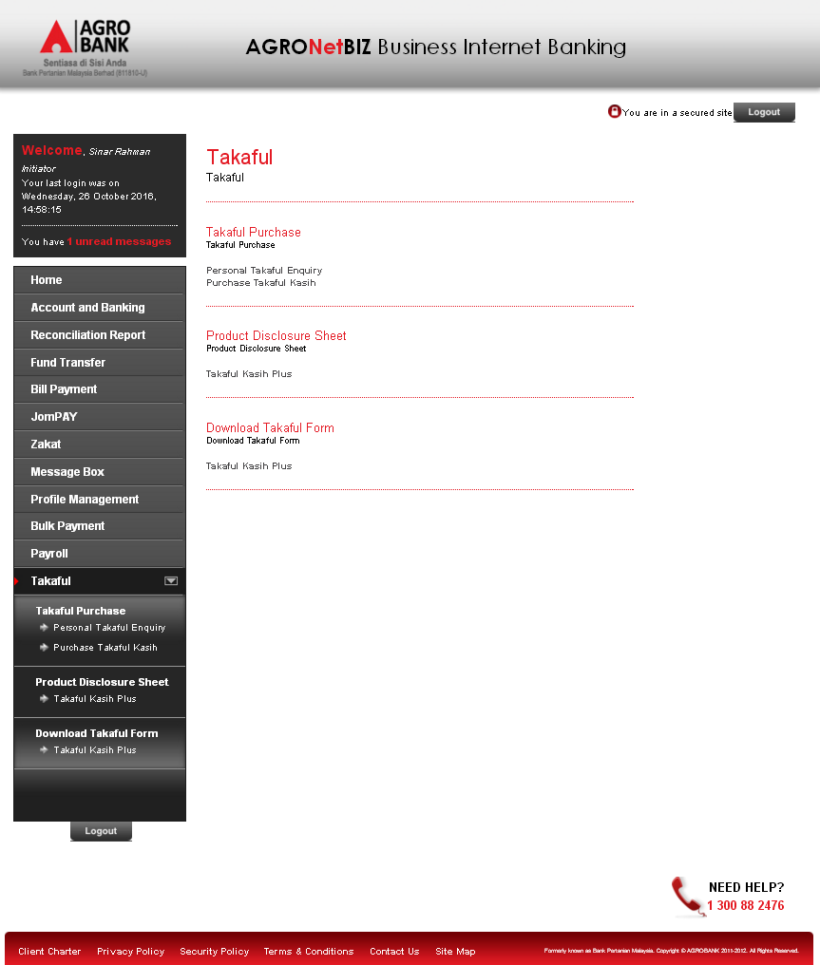

Reviewed By: (PMO)
 |  |  |  | Name/Position : Norhaidah Binti Md Dasuki / Senior Manager, Quality Assurance and Support  Date : 26/10/2016

