Test Issue Log |  |  |  |  |  | SCP ID#: [UAT_Tak-004]
Project Name: | Agrobank Retail Internet Banking
Test Stage: | Unit Functionality Integration System Interface  Performance Regression Acceptance Pilot
Test Case Number: | Task #6730 |  | Test Started Date: |  |  |  | 26/10/2016
Test Title: | [UAT_Tak-004] : BIB > LOGIN - HOME
Test Description: | - To ensure Multiple User (Approver) can be login.  https://10.6.6.20/bib.uat.takaful/common/Login.do
Test Functionality: | - Multiple User Company - Approver
Test Procedure: | - Login as Multiple User (approverSinar)on BIB.UAT.TAKAFUL.  - View Home Page.
Test Result: | Pass: Fail: | Tested by: |  |  | Erni Suhaireen binti Zulkifli
Reason for Failure:
TEST DESCRIPTION
- Login as Multiple User (approverSinar)on BIB.UAT.TAKAFUL.


- View Home Page.
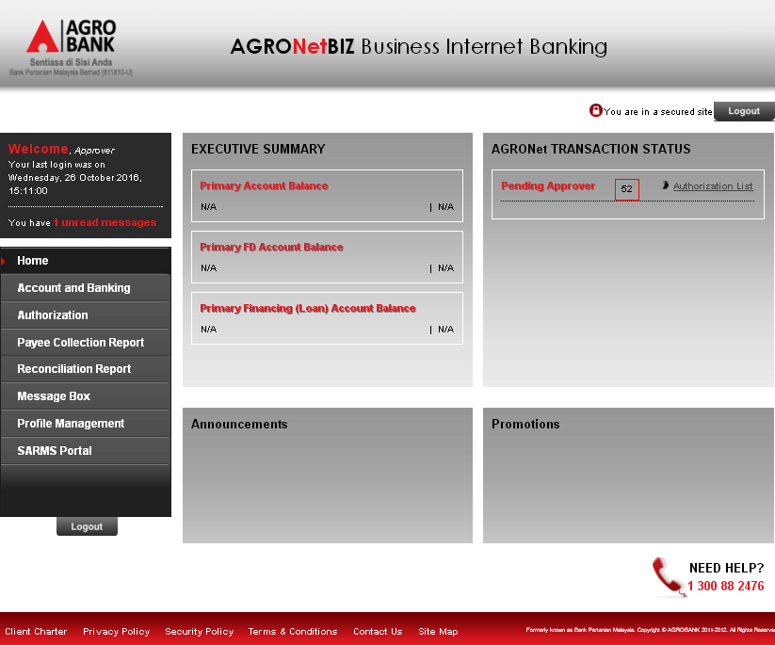

Reviewed By: (PMO)
 |  |  |  | Name/Position : Norhaidah Binti Md Dasuki / Senior Manager, Quality Assurance and Support  Date : 26/10/2016

