Test Issue Log |  |  |  |  |  | SCP ID# : 3433
Project Name: | AGROBANK BUSINESS INTERNET BANKING
Test Stage: | Unit Functionality Integration System Interface  Performance Regression Acceptance Pilot
Test Case Number: | Support #6724 |  |  | Test Started Date: |  |  | 26/03/2016
Test Title: | TEKUN NASIONAL - Approver not able approve bulk transaction, error “ Exceed Transaction Limit”
Test Description: | - To ensure transaction can be approved by Approve even Daily Limit has been set to be 0.00.  https://10.6.6.20/bib.prod.kada/common/Login.do
Test Functionality: | - IBAM : Company Daily Limit  - BIB: Perform Transaction – Initiator  - BIB: Approved Transaction - Approver
Test Procedure: | - Login to IBAM, to change the company limit to 0.00.  - Login to BIB as Initiator and perform transaction that over the daily limit set.  - Login to BIB as Approver and approve on transaction made.  - View Result Page.
Test Result: | Pass: Fail: | Tested by: |  |  | Erni Suhaireen binti Zulkifli
Reason for Failure:
TEST DESCRIPTION
- Login to IBAM, to change the company limit to 0.00.
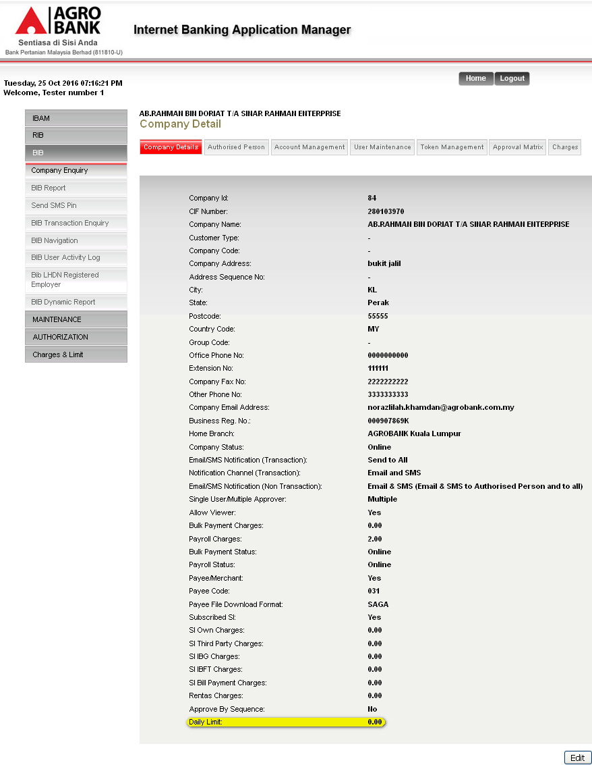

- Login to BIB as Initiator and perform transaction that over the daily limit set.
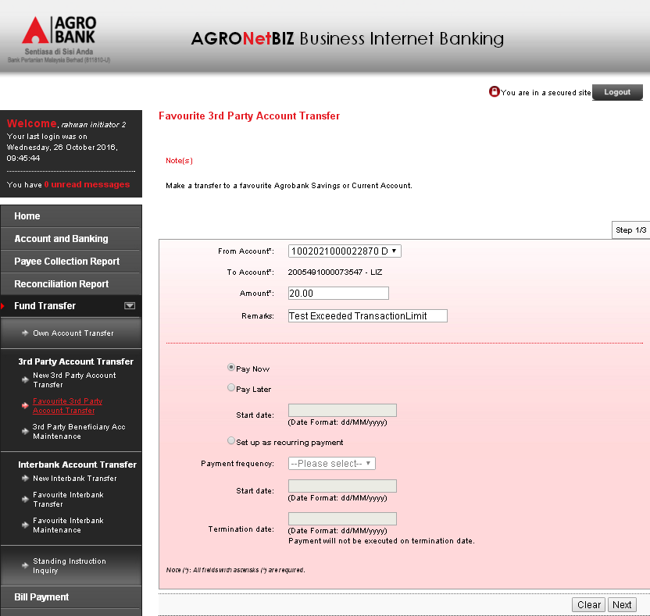

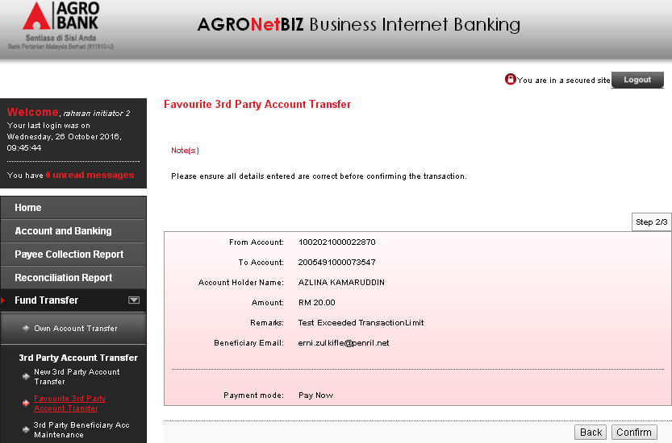

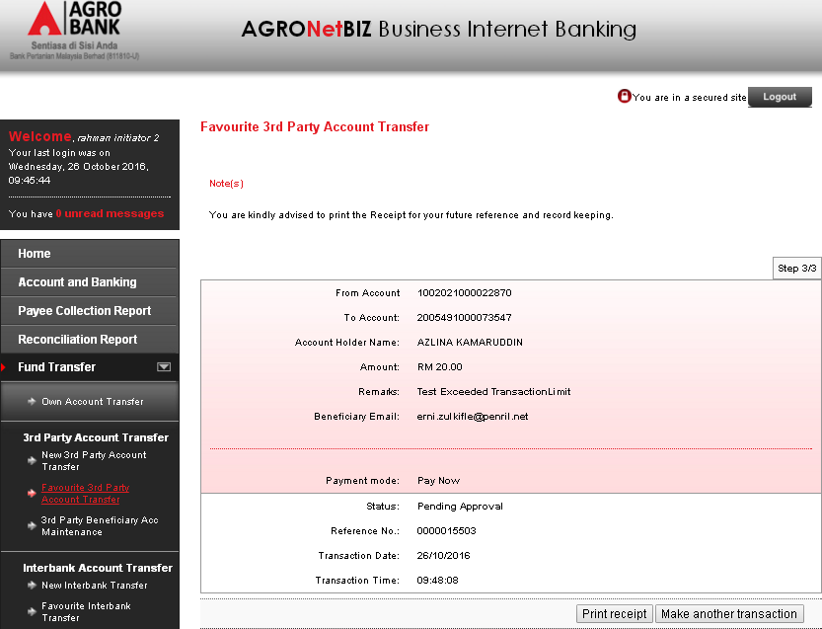

- Login to BIB as Approver and approve on transaction made.
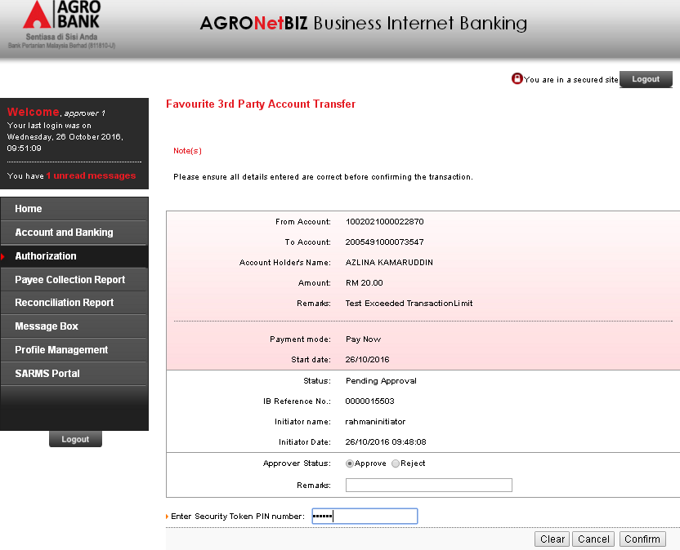
- Transaction has successfully been approved even Daily Limit has been set to be 0.00.
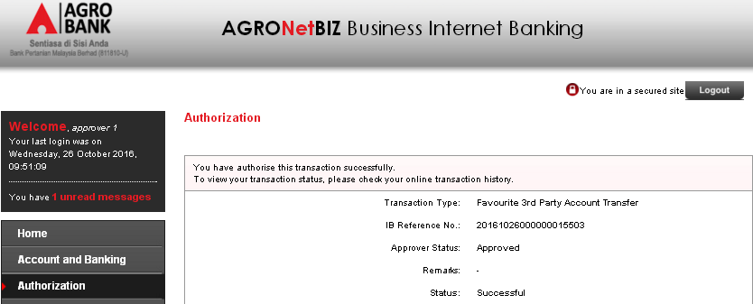

Agronet Transaction History:
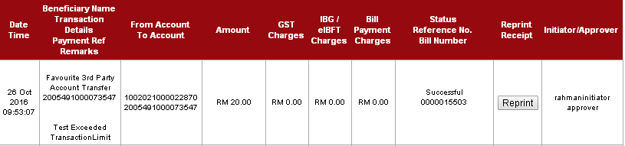

Reviewed By: (PMO)
 |  |  | Name/Position : Norhaidah Binti Md Dasuki / Senior Manager, Quality Assurance and Support  Date : 26/10/2016

