Test Issue Log |  |  |  |  |  | SCP ID# : 3433
Project Name: | AGROBANK BUSINESS INTERNET BANKING
Test Stage: | Unit Functionality Integration System Interface  Performance Regression Acceptance Pilot
Test Case Number: | Support #6724 |  |  | Test Started Date: |  |  | 26/10/2016
Test Title: | TEKUN NASIONAL - Approver not able approve bulk transaction, error “ Exceed Transaction Limit”
Test Description: | To ensure transaction can be approved by Approve even Daily Limit has been set to be 0.00.  https://10.6.6.20/bib.prod.kada/common/Login.do
Test Functionality: | IBAM  Company Enquiry > Company Details - Daily Limit  BIB  Bulk Payment  - Role – Initiator  - Role – Approver
Test Procedure: | IBAM  - Login to IBAM  - Access to BIB Company Details  - Change the company limit to 0.00.  BIB - Initiator  - Login to BIB as Initiator  - Click to Bulk Payment to perform Bulk Payment transaction that over the daily limit set.  BIB - Approver  - Login to BIB as Approver  - Click to Authorization sub-navigation to approve on related transaction made.  *Comfort Test:  1. Perform more than two monetary transaction (i.e. 3rd Party Transfer and Interbank Transfer) and approved.  2. Perform bulk transaction and approved.  Result: Approver shall able to approve transaction without error
Test Result: | Pass: Fail: | Tested by: |  |  | Erni Suhaireen binti Zulkifli
Reason for Failure:
TEST DESCRIPTION
- Test on IBAM to change the company limit to 0.00.
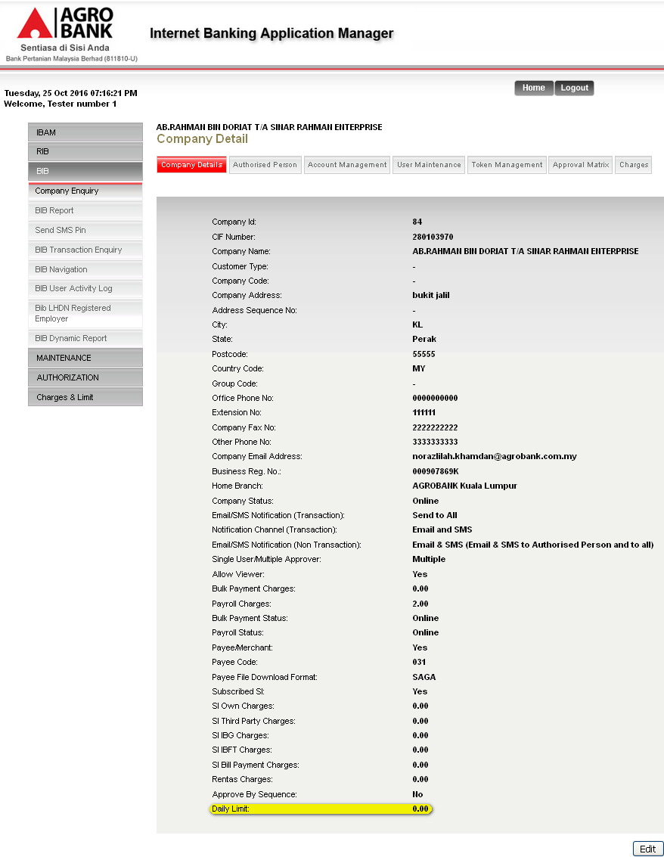

- Test on BIB to initiate Bulk Payment transaction that over the daily limit set.
  - Initiate Bulk Payment Transaction.
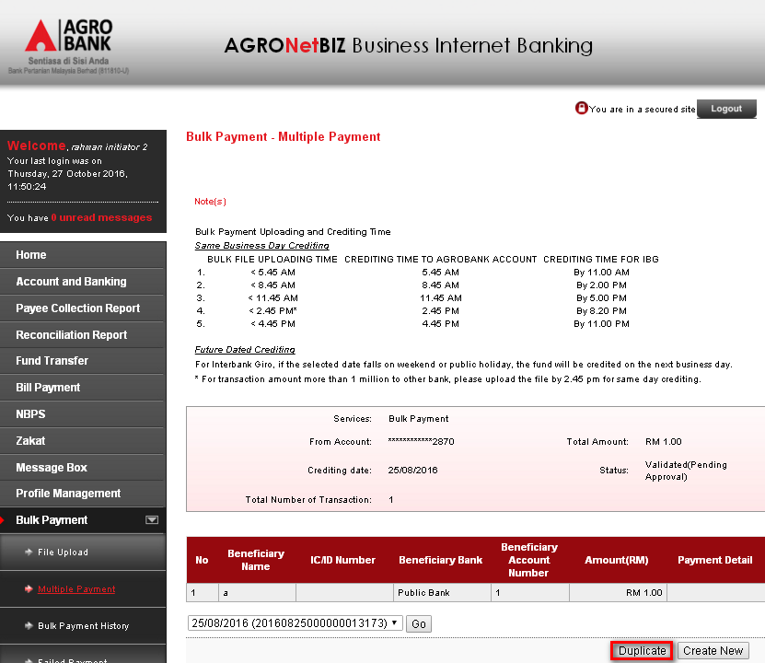

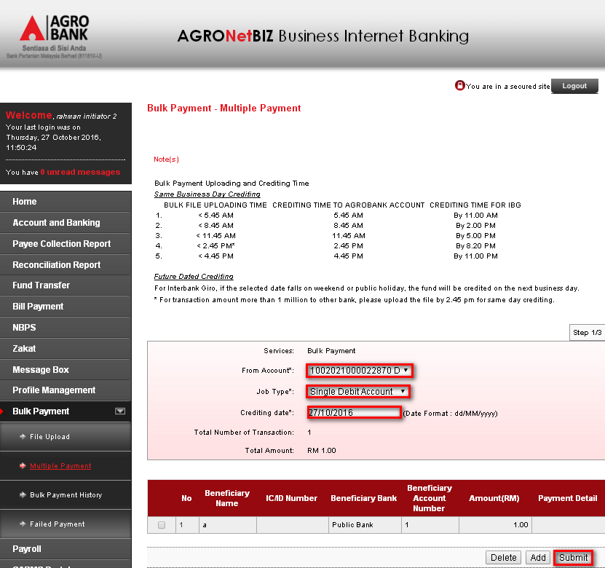

  - Initiate Bulk Payment Transaction confirm and result page.
Confirm Page:
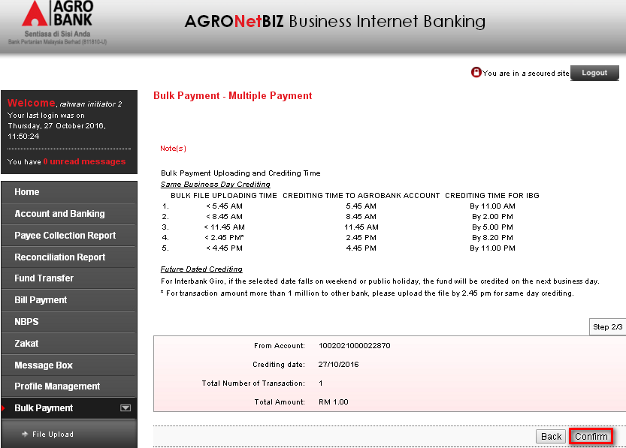

Result Page:
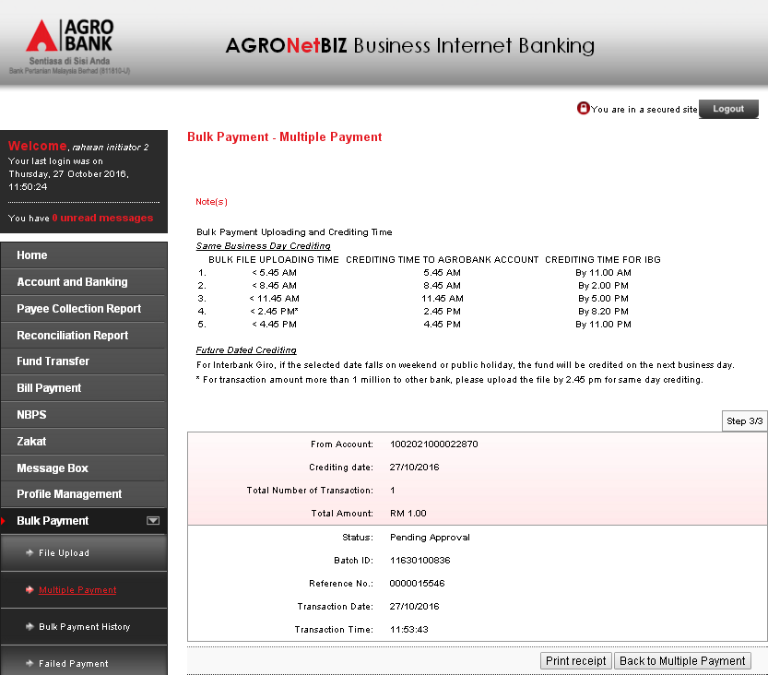
  - AgroNetBiz Transaction History
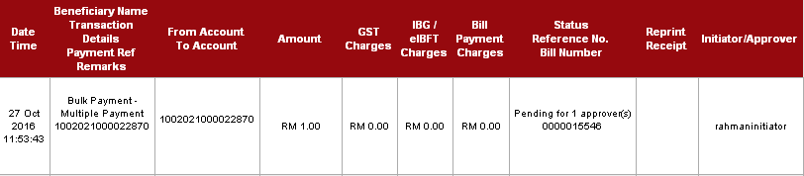

- Test on BIB to approve related Bulk Payment transaction that over the daily limit set.
  - Authorization List
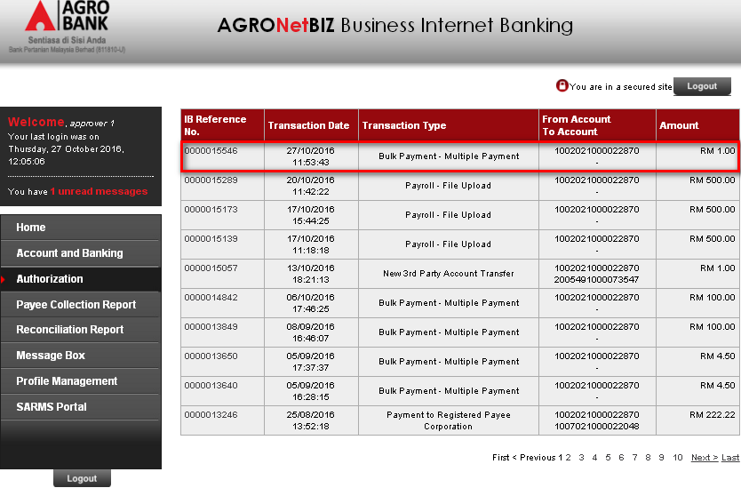

  - Bulk Payment Transaction details.
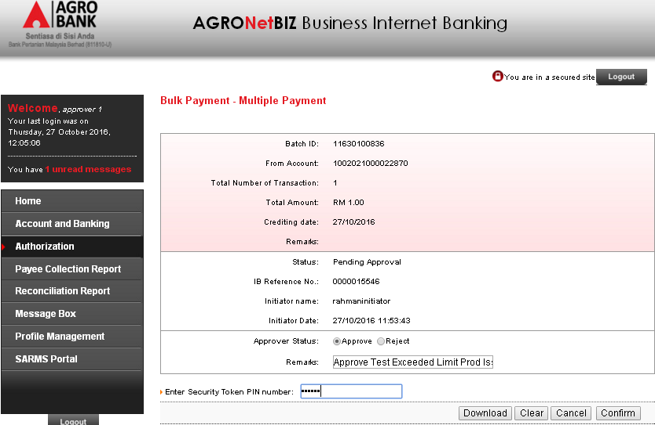
  - Bulk Payment Transaction result page.
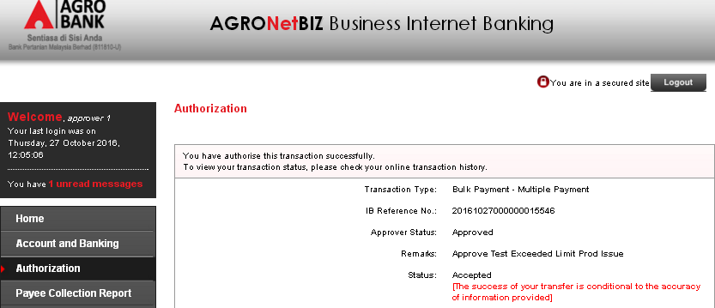
  - AgroNetBiz Transaction History
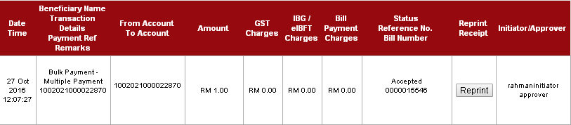

- Comfort Test:
IBAM
- Login to IBAM.SIT.PROD as Administrator.
- Go to BIB > Company Enquiry > Company Details.
- Click on “Edit” button. On the Edit Page, change Daily Limit to 0.00. Then click on “Next” button. On the Confirm Page, click on “Confirm” button.
Result: Company Limit has successfully been change to 0.00.
BIB – Initiator
- Login to BIB.PROD.KADA as Initiator.
- Go to Bulk Payment > Multiple Payment and perform the transaction.
- View Result Page and go to AgronetBiz Transaction History to view the transaction details.
Result: Bulk Payment transaction status is Pending for 1 Approver
BIB – Approver
- Login to BIB.PROD.KADA as Approver.
- Go to Authentication. Then click on “IB Reference No” of the transaction made.
- On the Bulk Payment Details page, choose on “Approve” action.
- View the Result Page.
Result: Transaction has successfully been Approved
- Login to BIB.PROD.KADA as Initiator and go to AgronetBiz Transaction History to view the transaction details.
Result: Status for Bulk Payment transaction has changed to Accepted status.

Reviewed By: (PMO)
 |  |  | Name/Position : Norhaidah Binti Md Dasuki / Senior Manager, Quality Assurance and Support  Date : 26/10/2016

